用“看板图”实现敏捷项目的可视化
作者 Kenji Hiranabe译者 郭晓刚 发布于 2007年9月13日 下午1时30分
社区 Agile 主题 敏捷技术 团队协作 协作
In Agile projects, it's a common practice to visualize and share project status in “big visible charts” on a wall of the project room. Lean systems also use such devices. "Kanban," in Japanese means, loosely translated, 'card or sign'. In a Lean production system, Kanban is a method which uses standard units or lot sizes with a single card attached to each. A new card is "pulled" into the system only when the work represented by an "in progress" card is completed.
在敏捷项目里，挂在墙上的“人人可见的大图表”是一种普遍的实践，它被用来共享项目的状态并将之可视化。精益系统里也有这样的设施。“看板”在日语里的大意是“卡片”或者“标志”的意思。在精益生产系统里，看板方法是给每个标准生产单元或者每个生产批量附上一张卡片。只有当一个“进行中”卡片所代表的工作完成后才会有一张新卡片被“拉”进系统。
In this paper, I explore visualization methods found widely in agile projects these days, and then propose using Kanban Boards to organize three viewpoints (Time, Task, and Team) so that the whole team understands the current status of the project and can work in an autonomous, motivated and collaborative manner. Finally, I introduce a software tool “TRICHORD” that implements Kanban Boards to realize project visualization from the three viewpoints.
在本文中，我将探究当今敏捷项目中广泛使用的各种可视化方法，并提出用看板图来组织三种视角（时间、任务和团队），目的是使整个团队都能理解项目的当前状态，并以一种自发、有动力且互相合作的方式来工作。最后，我将介绍“TRICHORD”这个软件工具，它用看板方法来实现这三个视角的项目可视化。

Visualization in Agile Projects
敏捷项目中的可视化
XP has a practice called “informative workspace” where you can see how the project is going on at a glance [Beck05]. A primitive way of doing this is just putting story cards or task cards on the wall. Other graphs and charts on the wall are sometimes called “information radiators” [Cockburn01] or “Visible Big Charts” [Jeffries04] and have become very common in today’s agile project room facilitates. Below, I show examples of the visualizations found in agile teams in Japan.
XP有一种实践叫做“信息化的工作空间”，从中你可以对项目的进行状态一目了然[Beck05]。把故事卡和任务卡挂到墙上是这项实践的一种基本实现方式。挂在墙上的其他图表有时候也被称为“信息辐射体”[Cockburn01]或者“人人可见的大图表”[Jeffries04]，它们在现今的敏捷项目空间设施里已经是很常见了。下面，我将展示在日本的敏捷团队中发现的一些可视化的例子。
The first example in Figure 1 is a Task Kanban Board named after the “Just-In-Time” (JIT) production method used in the TPS (Toyota Production System) [Poppendieck03, 07].
第一个例子是任务看板图，它的名字来自TPS（Toyota Production System）所用的“即时”（JIT）生产方式[Poppendieck03, 07]。
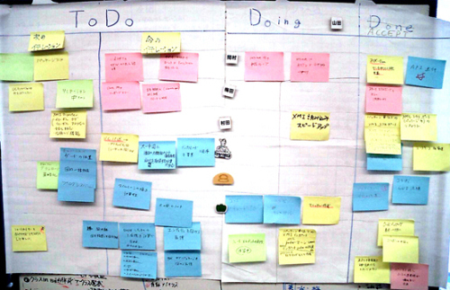
图1任务看板图
A Kanban means a ticket describing a task to do. In TPS, it is used to realize Just-In-Time “pull” production control. In Figure 1, a Kanban Board shows the current status of all the tasks to be done within this iteration. The tasks are represented by cards (Post-It Notes), and the statuses are presented by areas on the board separated and labeled ToDo, Doing, and Done. This Kanban Board helps the team understand how they are doing well as well as what to do next and makes the team self-directing.
看板是代表一项要完成的任务的标签。在TPS中，它被用来具体化即时的“拉”生产控制。在图1里，看板图显示了在本次迭代中要完成的所有任务的当前状态。任务用卡片（便笺纸）来代表，状态则由板上分别标有“未做”、“正做”和“做完”的三个区域来代表。看板图帮助团队理解当前做得如何，以及下一步要做什么，令团队能够自我引导。
Figure 2 is another type of Kanban Board, called “Feature Kanban Board”. (Highsmith just calls this a “Feature Card Whiteboard Layout”, but I categorize it as a Kanban Board. [Highsmith04]
图2是另一种类型的看板图，称为“特性看板图”（Highsmith叫它“特性白板布局卡”，但我把它归为看板图）[Highsmith04]。
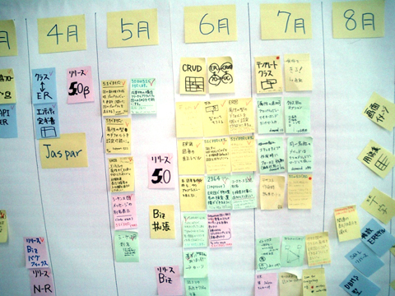
图2 特性看板图
The horizontal axis of this chart is a timeline and vertical areas in the timeline represent releases and each card posted to the areas represents one feature that will be implemented in the release. Contrary to the first example which is usually used within the development team, this Feature Kanban provides a high-level overview of the product’s road map so it should be shared with the whole extended team, including customers, marketing staff and management.
表的横轴代表时间线，线上的竖直区域代表发布，在区域中的卡片各自代表一项该次发布中要实现的特性。第一个例子常在开发团队中使用。跟第一个例子相比，特性看板图为产品路线图提供了一种更高层次的概观，因此分享范围应该被扩大到整个大团队，包括客户、市场员工和管理层。
Also, the “Parking Lot Chart” in Figure 3 is used to provide a top-level digested summary of project status (not to be confused with a “Parking Lot List,” a tool facilitators use to capture unresolved issues). It is first described in Feature Driven Development (FDD) [Palmer02], and is widely used in agile projects today. It is sometimes also called a “Project Dashboard”.
图3的“停车场图”被用来提供一种对项目状态的顶层摘要总结（注意不要同另一种“停车场列表”弄混，那是一种用来帮助捕获未解决的问题的工具）。它是在《Feature Driven Development》（FDD）[Palmer02]里首次提出来的，现在已在敏捷项目中广泛使用。有时候也被称为“项目仪表板（Project Dashboard）”。
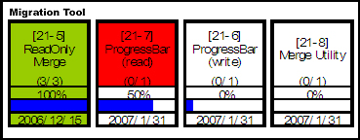
图3 停车场图
. Another type of visualization in Figure 4 is called a Burndown Chart.
图4所示的另一种可视化方式称为延烧图。
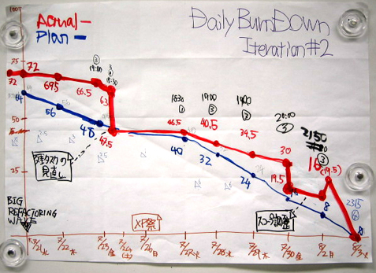
图4 延烧图
It is first described in Scrum [Schwaber01] to show the remaining backlog, and has now spread to most agile projects [Cockburn04], [Cohn05]. It captures the current status as well as the rate of progress of completing the remaining tasks.
这种表在Scrum[Schwaber01]中首次提出，用来显示剩余的未完成工作，现在已经延伸到了大多数敏捷项目中[Cockburn04][Cohn05]。它抓住了项目的当前状态以及完成剩余工作的进展比率。
The last interesting visualization in Figure 5 is called Niko-niko Calendar (or Smiley Calendar), a Japanese creation, showing team member’s mood for each day. Everyone puts a smiley mark onto their own calendar after the day’s work, before leaving the team room [Sakata06]. It looks at the project from the viewpoint of member’s mental health and motivation.
图5所示的最后一种有意思的可视化方式叫做表情日历（或笑脸日历），一种日本人的创造，它显示了团队成员每日的心情。当天工作结束后，每个人都在离开团队空间之前往自己的日历上画一个表情符号[Sakata06]。它从成员的精神健康和动力的角度来观察项目。
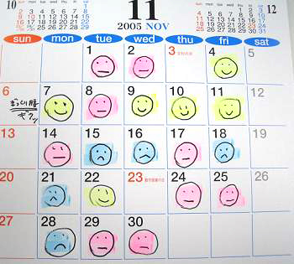
图5 表情日历

Kanban Board as Main Information Radiator
用看板图作为主要的信息辐射体
To summarize, the visualization tools mentioned are:
- Kanban Boards. Use a card as a token (Kanban) of a task, story, feature and stick them to a timeline (board). There are several levels of granularities.
- Burndown Charts. Count the number of Kanbans (backlog tasks) and track it in a timebox to show the trend of work accomplished. There are also several levels of granularities.
- Parking lot Charts. Summarize the top-level project status.
- Calendars. Other than Niko-niko calendars, there are a lot of variations of using calendars to show project status or plan.
总而言之，以上提到的可视化工具：
- 看板图：用卡片作为任务、故事、特性的象征（看板），并将它们依附在时间线上（看板图）。这里存在不同的粒度。
- 延烧图：计算看板（未完成任务）的数目，分时间段来跟踪它们，以显示出工作的完成趋势。这里也存在不同的粒度。
- 停车场图：总结最高层次上的项目状态。
- 表情日历：除了表情日历之外，还有很多日历变种可以用来显示项目的状态或者计划。
Note that between Kanban Boards, Burndown Charts, and Parking Lot Charts, Kanban Boards have the most detailed information. Burndown Charts and Parking Lot Charts can be drawn using the information of daily changing Kanban Boards. So hereafter I’ll discuss Kanban Boards as the main information radiators, and Burndown Charts and Parking lot Charts as sub-tool which summarize Kanbans visually.
注意在看板图、延烧图和停车场图三者之中，看板图的信息最详细。延烧图和停车场图可以用看板图的每日变化信息来绘制。因此后面我将把看板图作为主要的信息辐射体，而用延烧图和停车场图来作为辅助工具可视化地总结看板的变化趋势。

Organizing Kanbans from Three Viewpoints
从三个视角来组织看板
Looking closely at Kanban Boards, you can find three things expressed on them – time, task, and team. Here I try to organize Kanbans from these three viewpoints.
仔细观察看板图，你会发现上面表达了三项主题——时间、任务和团队。下面我尝试从这三个视角来组织看板。
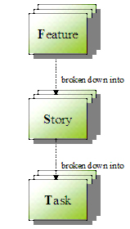
图6 时间与任务的分解

1. Time
1. 时间
In agile projects, time of a project is first broken into “Releases” and each release into “Iterations”, and each iteration into “Days”.
- A release is typically 1- to 6-months long and is the most coarse-grained timebox. It is a sync point of the whole team so everyone in the whole team should be interested in it.
- An iteration is the second level timebox. It is typically 1- to 4-week long and development teams use it as a major working, tracking and improvement cycle.
- And every day is the most fine-grained timebox, the team gets together in a stand-up meeting to share project status and problems.
在敏捷项目里，项目时间首先被分解成若干“发布”，每个发布又被分解成若干“迭代”，每个迭代又分解成若干“工作日”。
- 发布的时间长度一般为1到6个月，它是最粗粒度的时间盒。它是整个团队的一个同步点，因此团队中的每个人都应该对此感兴趣。
- 迭代是第二级的时间盒，长度一般为1到4周。开发团队用它来作为主要的工作、跟踪和改进周期。
- 工作日是最细粒度的时间盒，团队每天在站立会议上聚集在一起交流项目的状态和问题。

2. Task
2. 任务
There are also three levels of granularity for Tasks. Here I call the top level “Features” and each feature is broken down into “Stories”, and each story into the lowest level “Tasks”.
- A Feature is a function useful and meaningful to users.
- A Story is a testable piece of a Feature, also described in the words of users.
- And a Task is a work unit of a Story, commonly described in terms used by developers.
任务被分成三种粒度。我把顶层的叫做“特性”，每个特性都被分解成若干“故事”，而每个故事又被分解成若干最低层次的“任务”。
- 特性是对用户有用和有意义的一项功能。
- 故事是特性的一个可测试的片断，以用户的语言来描述。
- 任务是故事中的一个工作单元，通常以开发者的语言来描述。

3. Team
3. 团队
A project team consists of people working toward the same goal. Typically, a manager, customers, developers, business analysts, users, testers and other stakeholders should be members of the team. The whole team should share information on time and tasks to achieve the project goal.
项目团队由为了共同目标而工作的人们组成。一般团队的成员有一个经理，若干客户、开发人员、业务分析员、用户、测试员，以及其它利益相关的人。整个团队都应该分享时间和任务信息来达成项目的目标。

Kanban Board Maps Task to Time for the Team
用看板图为团队将任务映射到时间
Here I’d like to define a Kanban Board as a mapping between tasks and time for the team. Note that “time” and “task” both have a three-level breakdown structure, and the higher the breakdown levels are, the higher the level of management that should be involved with it. So, it is reasonable to set up Kanbans in combination of Release-Feature, Iteration-Story and Daily-Task as shown in Table 1, although there are many possible other combinations of time and task.
我乐于将看板图定义成一种团队中任务与时间之间的映射。请注意“时间”和“任务”都可以分解成三个层次，分解的层次越高，应该牵扯到的管理层次就越高。所以，如表1显示的，按照发布—特性、迭代—故事和工作日—任务的组合来设立看板是合理的，虽然其它时间与任务的组合也并非不可行。
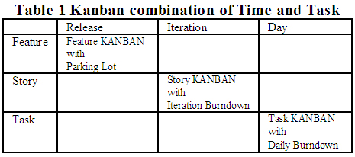
表1 用看板结合时间与任务
A “Feature Kanban” is good at giving the whole team a high-level view of the project. And it goes with a Parking Lot Chart to show the top level status.
“特性看板”擅长于向全团队提供项目的一个高度抽象的视角。还可以搭配停车场图来显示出顶层的状态。
A “Story Kanban” is at the middle level, the most widely and carefully seen in each iteration by the team, and it may be supported by an iteration Burndown Chart.
“故事看板”处在中间层次，向团队提供每次迭代的最广泛周密的信息，搭配迭代的延烧图会更有效。
A “Task Kanban” is at the lowest level, showing the current changing status daily, which may be supported by a daily Burndown Chart.
“任务看板”的层次最低，它显示出每日变动的当前状态，搭配每日的延烧图可能会更有帮助。
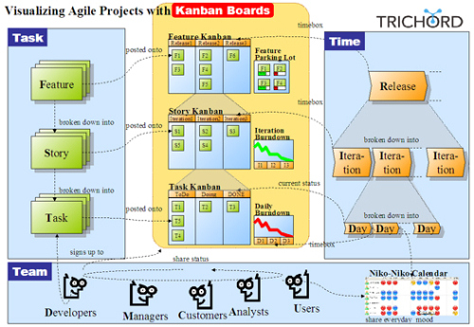
图7 概观——三种视角以及用作为任务到时间映射的看板图

TRICHORD
We have been developing an agile project management tool named “TRICHORD.” TRI refers to the three viewpoints (Time, Task, and Team) and CHORD means harmony.
我们正在开发一个名为“TRICHORD”的敏捷项目管理工具。TRI指的是三种视角（时间、任务和团队），CHORD则是和谐的意思。
It operates as a workplace to share project status across the whole team, providing the three levels of Kanban Boards – Feature Kanban (Release-Feature), Story Kanban (Story-Iteration), and Task Kanban (Daily-Task) – as described in Table 1. A Feature Kanban is supported by a Parking Lot Chart, Story and Task Kanbans are supported by Burndown Charts.
它作为全团队分享项目状态的一个工作空间来运作，里面提供如表1所示的三种层次的看板图——特性看板（发布—特性）、故事看板（故事—迭代）和任务看板（工作日—任务）。特性看板用停车场图来归纳，故事和任务看板用延烧图来归纳。
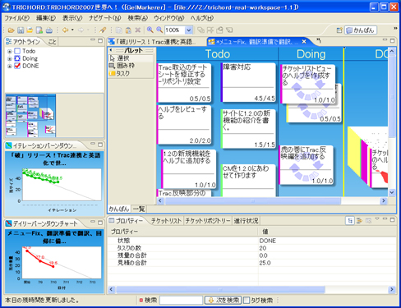
图8 TRICHORD（看板图+延烧图+停车场图）
In addition, TRICHORD has a Niko-Niko Calendar service to share the team's mood. It also works as a simple “twitter”-like SNS communication center in the projects.
另外，TRICHORD有一个表情日历服务来分享全团队的心情。它也类似项目中一个简单的“twitter”SNS交流中心。
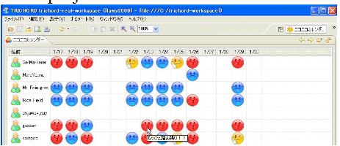
图9 TRICHORD表情日历
TRICHORD is implemented on the Eclipse RCP (Rich Client Platform), and optionally works with Trac (issue tracking system).
TRICHORD用Eclipse RCP实现，可与Trac（问题跟踪系统）协同工作。

Acknowledgements
致谢
Many thanks to Mary Poppendieck, who reviewed this paper thoroughly and provided lots of advice and suggestions.
非常感谢Mary Poppendieck，他从头到尾审阅了本文并提出了许多宝贵的建议。

References
参考资料
[Sakata06] Akira Sakata, “Niko-niko calendar”, 2006
http://www.geocities.jp/nikonikocalendar/index_en.html
[Beck05] Kent Beck, “Extreme Programming Explained 2nd”, 2005 Addison-Wesley
“信息化的工作空间”是一项XP实践。
[Cockburn01] Alistair Cockburn, “Agile Software Development”, 2001 Addison-Wesley
首次使用“信息辐射体”一词。
[Cockburn04] Alistair Cockburn, “Crystal Clear”, 2004 Addison-Wesley
文中认为 “延烧图”是一种有力的技巧。
[Cohn05] Mike Cohn, “Agile Estimating and Planning”, 2005 Prentice Hall
深入探讨了“延烧图”
[Jeffries04] Ron Jeffries, "Big Visible Chart", 2004
http://www.xprogramming.com/xpmag/BigVisibleCharts.htm
[Poppendieck03] Mary and Tom Poppendieck, “Lean Software Development”, 2003 Addison-Wesley
[Poppendieck07] Mary and Tom Poppendieck, “Implementing Lean Software Development”, 2006 Addison-Wesley
解释了TPS中的看板，及看板如何作为“拉”处理机制运作。
[Schwaber01] Ken Schwaber, et al. “Agile Software Development with SCRUM”, 2001 Prentice Hall
[Highsmith04] Jim Highsmith, “Agile Project Management”, 2004 Addison-Wesley
在这里，特性看板被称为白板上的特性分解结构和特性计划。
[Palmer02] Stephen R. Palmer et al., Practical Guide to Feature-Driven Development, 2002, Prentice Hall
首次介绍了Parking Lot Chart。

About the Author
关于作者
Kenji Hiranable is the CEO of Change Vision, Inc. He is the creator of JUDE, a UML and MindMap editor software, and has translated the books Lean Software Development, XP Installed, Agile Project Management, and other XP/Agile books into Japanese. Kenji thinks of software development as a form of communication game, and is always searching for better ways that makes it more productive, collaborative, and fun. Further information on TRICHORD is available at trichord.change-vision.com .
Kenji Hiranable是Change Vision, Inc的CEO。他是JUDE的作者（一个UML和MindMap编辑工具）。他还把《Lean Software Development》、《XP Installed》、《Agile Project Management》以及其他XP/Agile书籍翻译成日文。Kenji把软件开发看作是一种沟通游戏，并一直在寻求提高软件开发的生产效率、合作程度以及乐趣的更好途径。关于TRICHORD的更多信息请见trichord.change-vision.com。
查看英文原文：Visualizing Agile Projects using Kanban Boards

