**Name :** Patel Jeshankumar K. **Date :** 23/10/2023

**Roll No :** 045

**Semester :**  7th – Sem. **Year :** 2023-24

**Subject :** (701) – Application Development Using Full Stack

**Github :** <https://github.com/jeshanpatel1510/MEAN>

**Practical Assignment - 3**

1. Create Angular application with routing link assigned for following requirements:

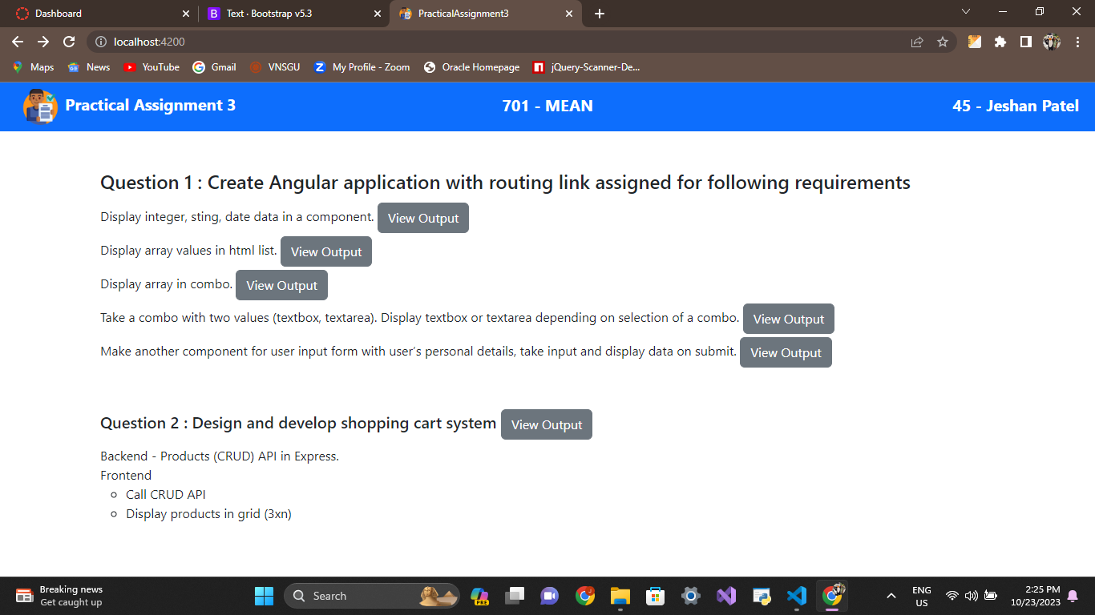

* Display integer, sting, date data in a component.

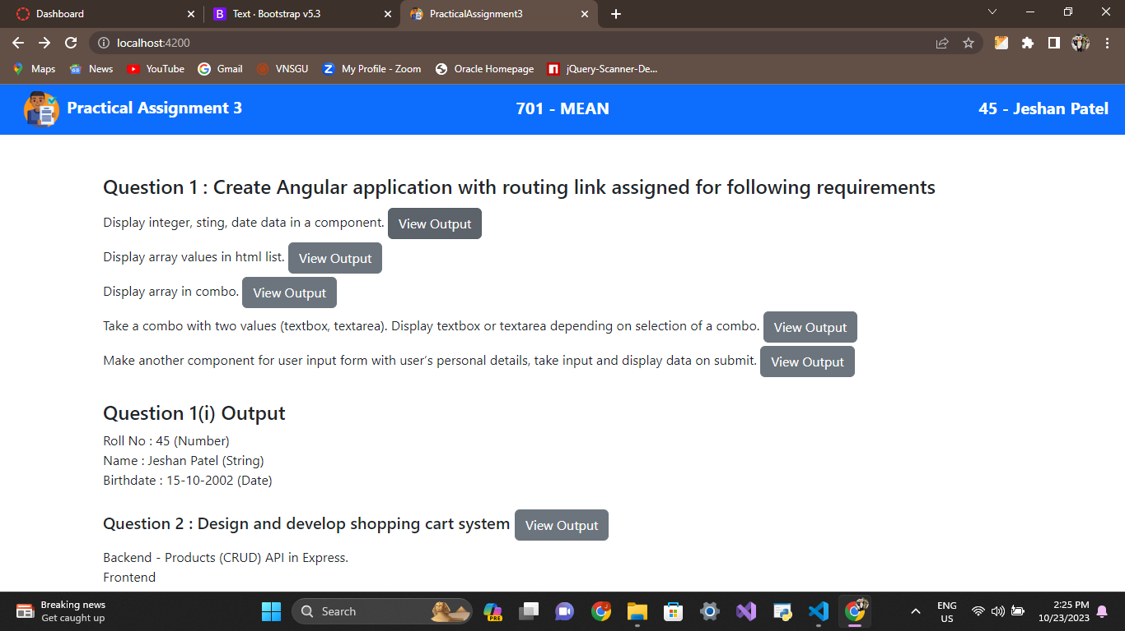

* Display array values in html list.

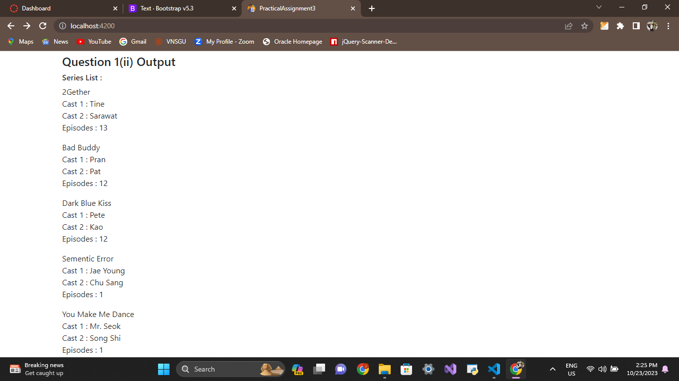

* Display array in combo.

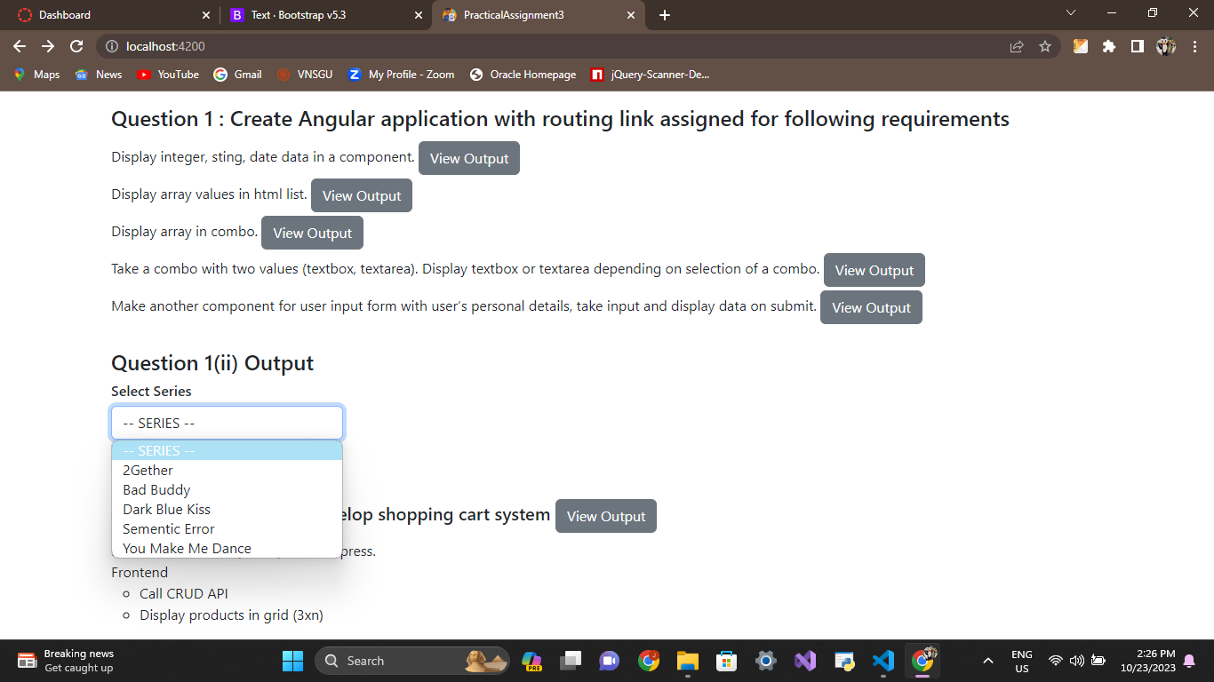

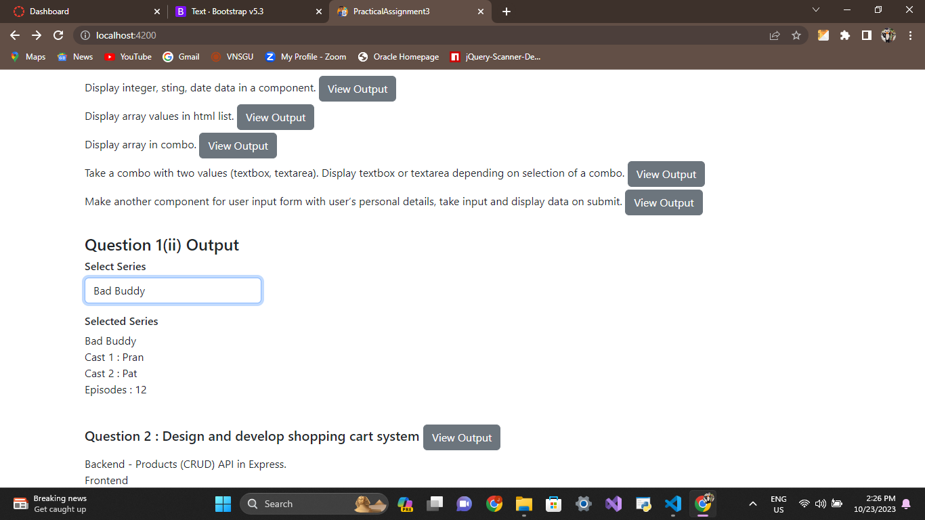

* Take a combo with two values (textbox, textarea). Display textbox or textarea depending on selection of a combo.

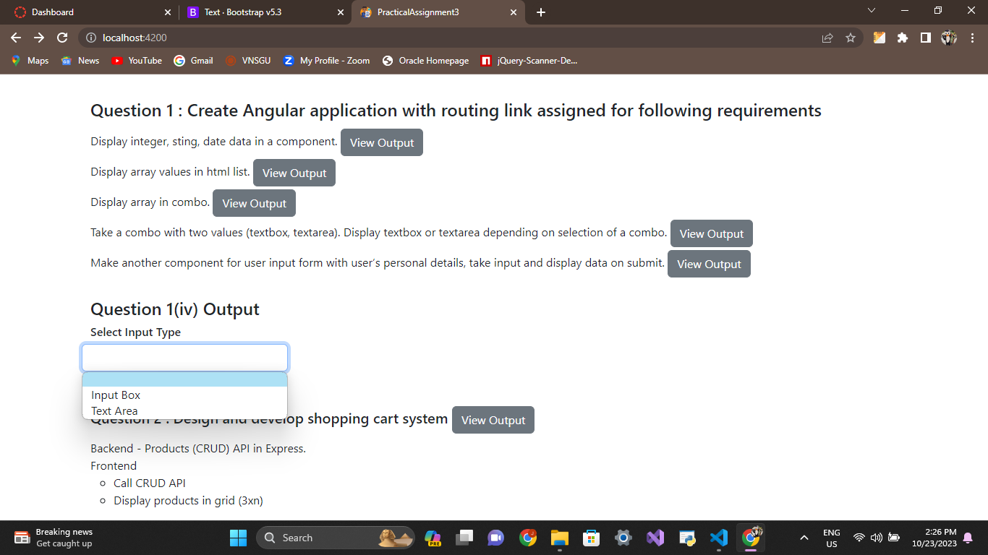

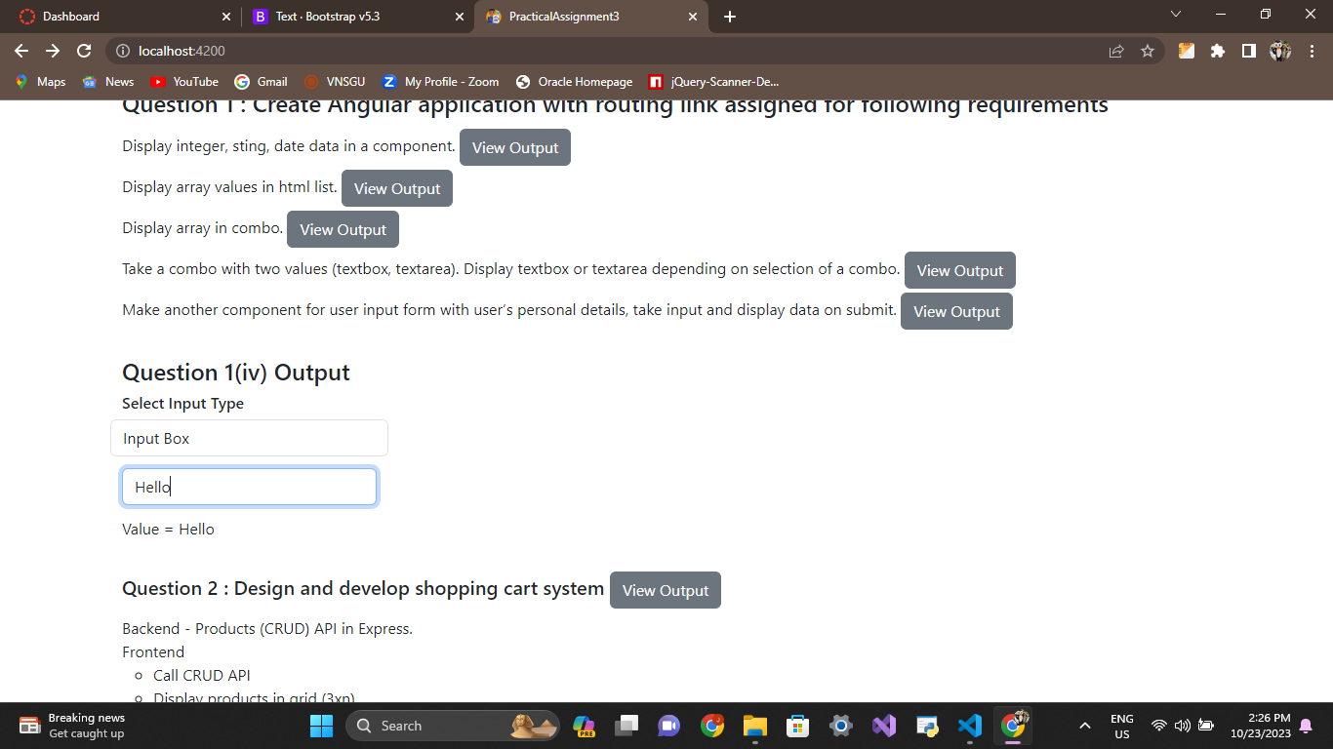

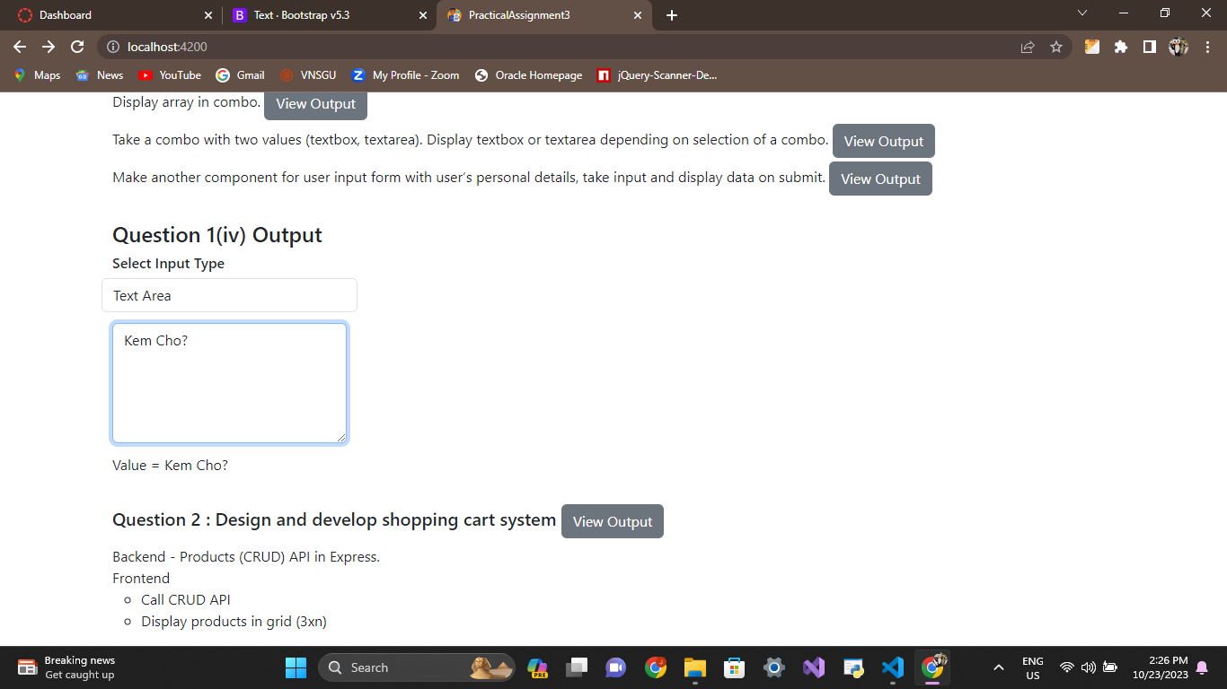

* Make another component for user input form with user’s personal details, take input

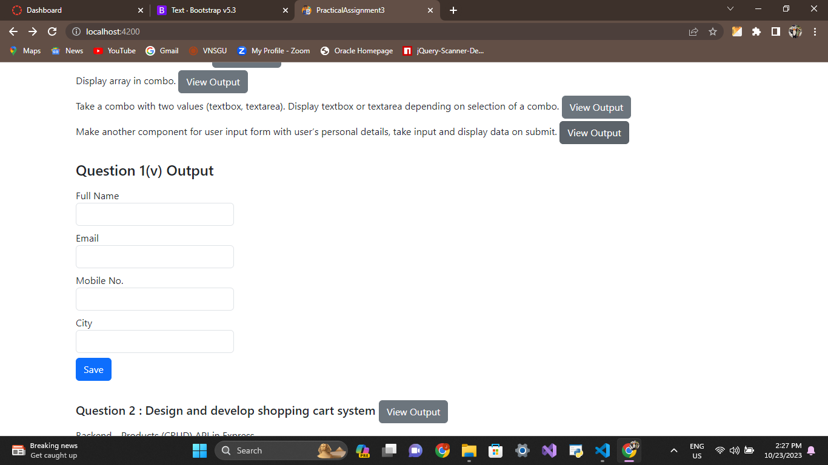

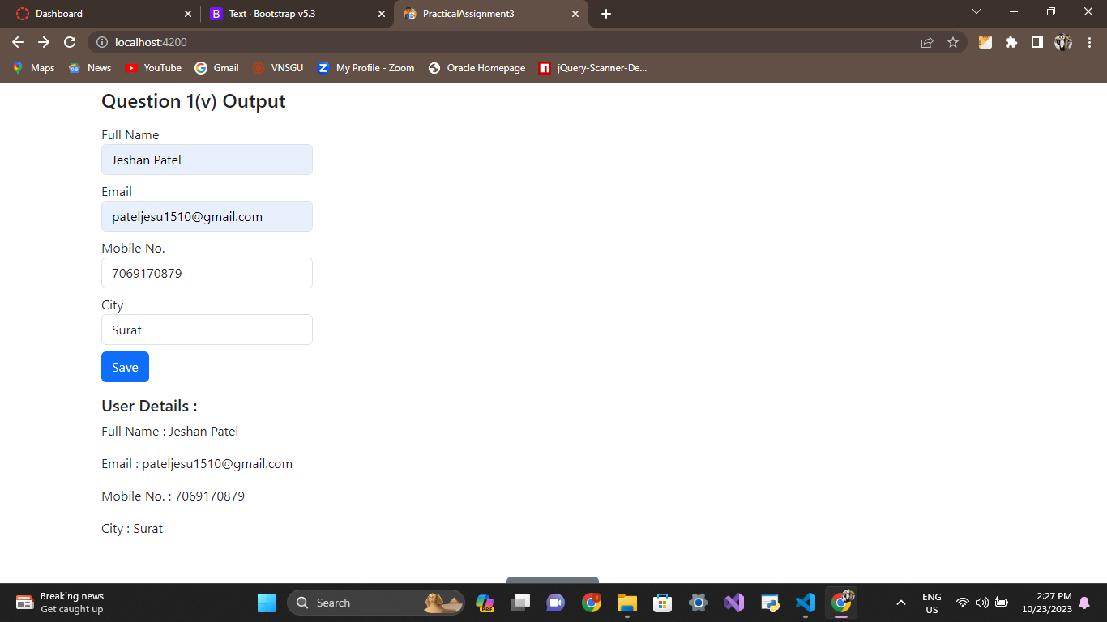

1. Design and develop shopping cart system.

* Backend - Products (CRUD) API in Express.
* Frontend

- Call CRUD API

Click To Go to Watchlist (Cart)

- Display products in grid (3xn)

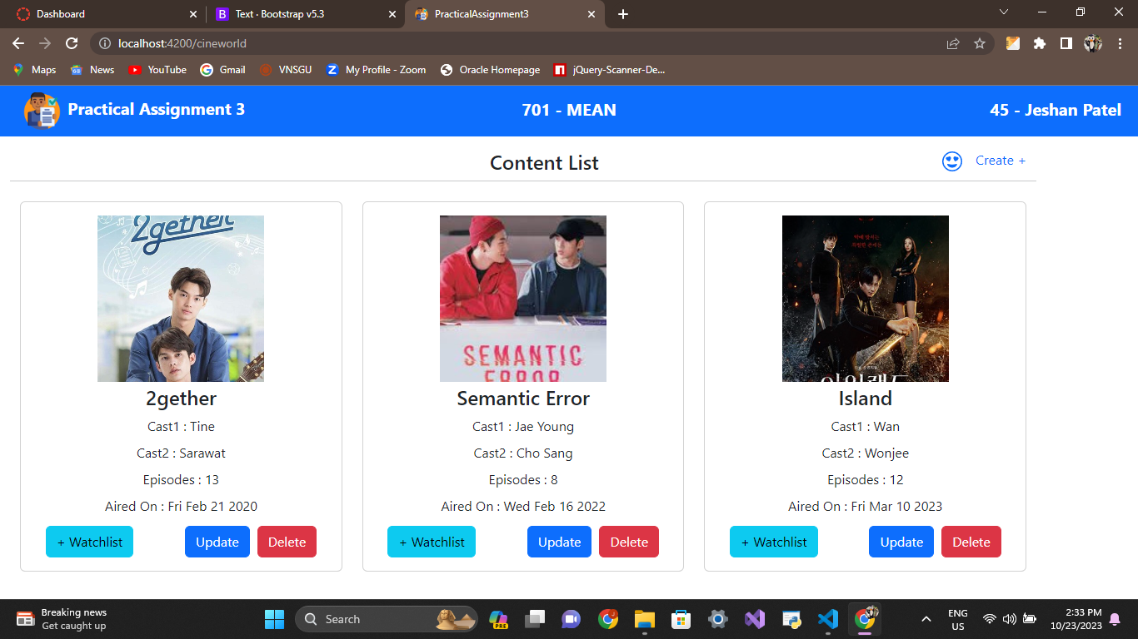

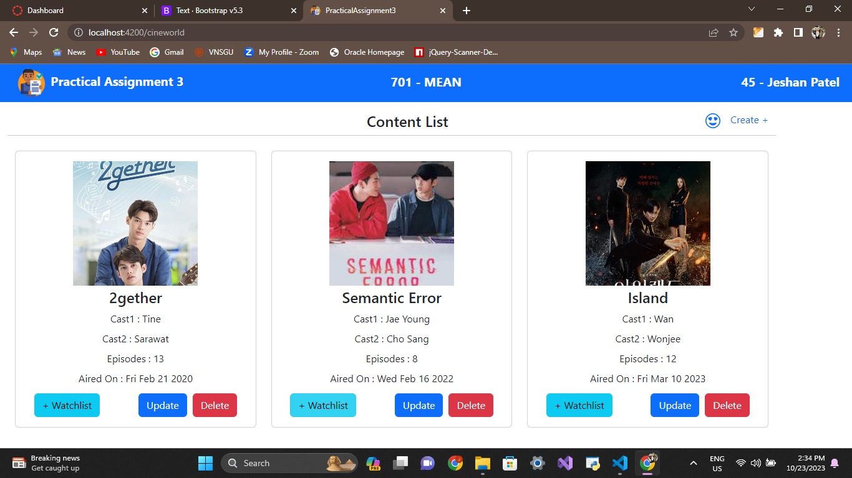

Click To Add to Watchlist (Cart)

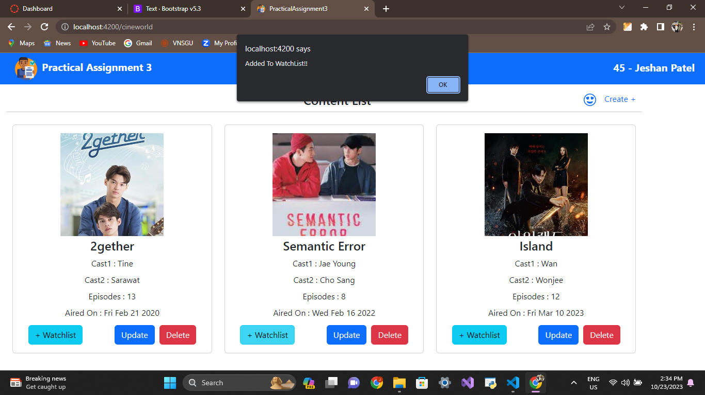

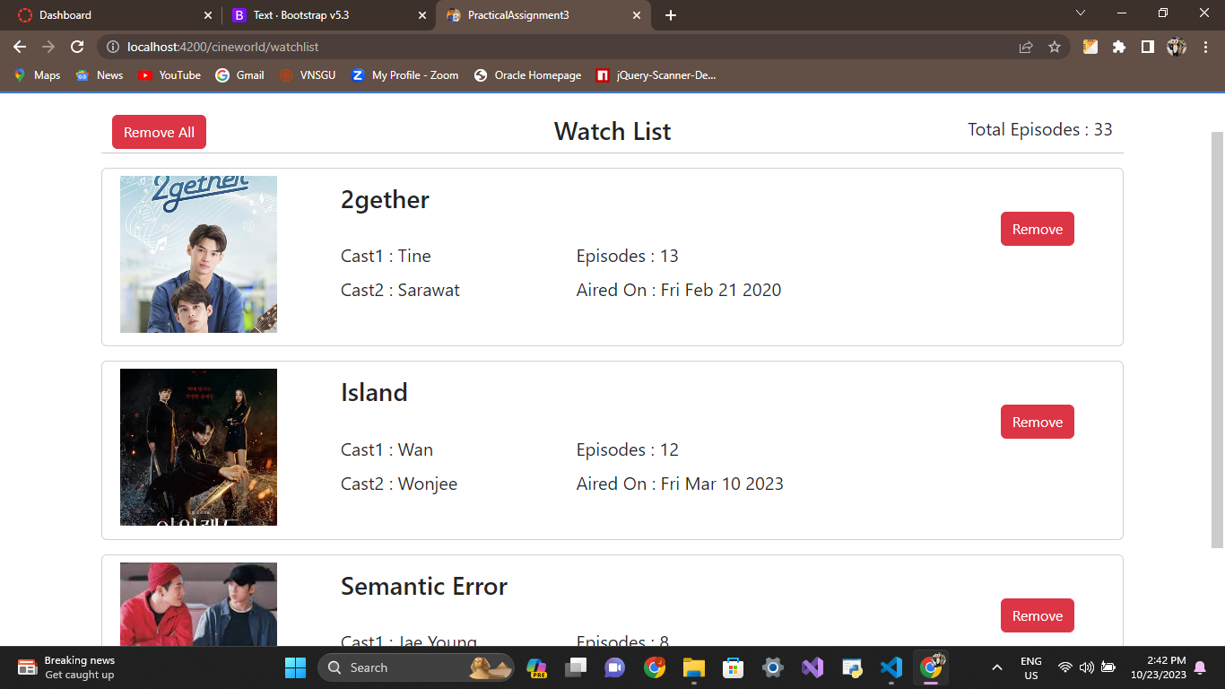

Click To Remove From Watchlist (Cart)

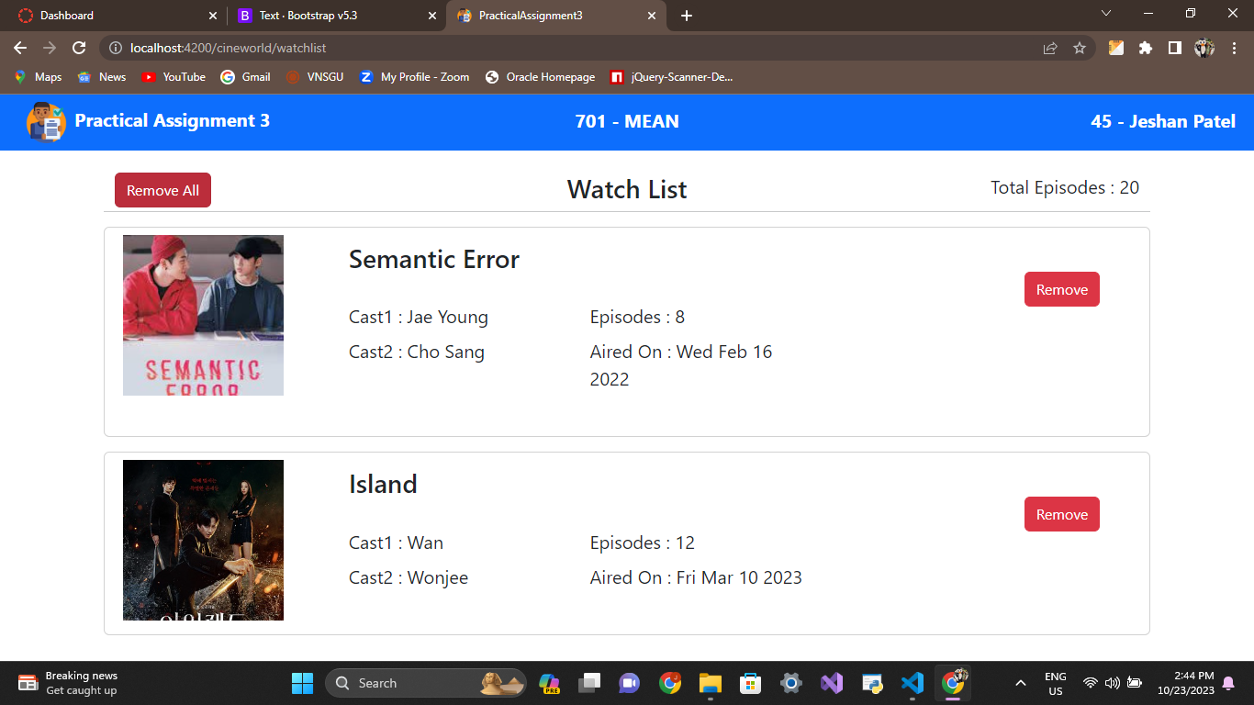

Click To Remove All Content From Watchlist (Cart)



