WIPRO CAPSTONE PROJECT REPORT

Name | Jeshika Kochak
Superset ID | 6169520
Organization | Wipro
Project Type | Capstone Project
Project Name | Automation Testing using Selenium Py-Test Framework
 | Automation Testing using Behave BDD Framework
Domain | E-commerce
Module Title | Myntra beauty section

SYNOPSIS
The Wipro Capstone Project focuses on automating the Myntra beauty section module using two separate automation frameworks: Selenium WebDriver with Python Py-Test framework and Behave BDD framework. The automation validates hovering beauty section, product added to cart, opening product listings page, opening product page, and the whole purchase workflow.
The framework was designed using the Page Object Model (POM) architecture to improve maintainability and reusability. Screenshots, logs, reports, and reusable utilities were integrated to support execution tracking and debugging.
The project includes both positive and negative testing scenarios using industry-standard automation testing practices.

PROJECT DESCRIPTION
The automation framework automates the end-to-end workflow of the Myntra beauty section module. The framework performs validates hovering beauty section, product added to cart, opening product listings page, opening product page, purchasing a product workflow.
Separate page classes were implemented for hovering beauty section, searching, product listings, and cart page using Selenium Python Page Object Model framework.
The project also includes Behave BDD implementation where selection of product scenarios are written in Gherkin syntax and integrated with Selenium automation scripts.

SELENIUM PYTEST FRAMEWORK

TEST STRATEGY
The project uses Selenium WebDriver with Python Py-Test framework for automation testing. The framework supports:
- End-to-End Testing
- Positive Testing
- Negative Testing
- Data-Driven Testing
Tools Used:
- Selenium WebDriver
- Py-Test
- Allure Reports
- Logging Module

TEST ENVIRONMENT

Operating System | Windows 11
IDE | PyCharm Unified Product
Browser | Google Chrome (or) Edge
Framework | Selenium WebDriver + Py-Test
Design Pattern | Page Object Model (POM)
Reporting Tool | Allure Reports

FRAMEWORK ARCHITECTURE
Myntra Beauty Section
├── config
├── logs
├── pages
├── reports
│ ├── allure-results
│ └── allure-report
├── screenshots
├── data
├── tests
├──tests_e2e
├── utils
├── conftest.py
├── pytest.ini
└── requirements.txt

TEST EXECUTION
The automation suite includes:
- 1 End-to-End Test Case
- 4 Positive Test Cases
- 2 Negative Test Cases
The End-to-End test validates the complete Myntra beauty section workflow from planner navigation until flight details verification.

SELENIUM TEST CASE SUMMARY
S. No | Test Type | Test Scenario | Expected Result | Status
1 | End-to-End | Buying a beauty product workflow | User successfully reaches Myntra login page  After placing the order | Passed
2 | Positive | Hovering over beauty menu | Hovers  successfully | Passed
3 | Positive | Opens product page | Page opens successfully | Passed
4 | Positive | Opens product listing page | Opens product  lists  successfully | Passed
5 | Positive | Adding a product to a cart | Added to cart successfully | Passed
6 | Negative | Invalid product search | Product appears which they shouldn’t be | Passed
7 | Negative | Add product without selecting size | Asks for selecting size | Passed

END-TO-END FLOW VALIDATION
The End-to-End automation validates the complete business workflow including:
- Opens Myntra homepage
- Hovers over beauty menu
- Select product category
- Opens first product
- Switches to product tab
- Selects size if available
- Adds product to bag
- Goes to shopping bag
- Selects quantity
- Selects donation
- Clicks place order
- Redirected to login page
POSITIVE TEST CASES
Positive Test Case 1 – Navigate to beauty menu
- User opens Myntra homepage
- Hovers over beauty menu
- Verify Lip Balm category visibility
Positive Test Case 2 – Open product from homepage
- Navigate to Beauty
- Open first available product
- Verify product detail page opens correctly
Positive Test Case 3 – Opens product listings
- Open product category listing
- Verify product listing page loads successfully
Positive Test Case 4 – Add product to cart
- Select a product
- Select size if required
- Add product to cart
- Verify cart update

NEGATIVE TEST CASES
Negative Test Case 1 – Invalid product Search
- Search for invalid/non-existent product
- Verify search results page handles invalid query correctly
Negative Test Case 2 – Add Product Without Selecting Size
- Attempt adding product without size selection
- Verify product is not added to cart
ALLURE REPORTS
- Integrated Allure Reports with Py-Test
- Generates professional execution reports
- Displays passed and failed test status
- Captures screenshots during execution
- Maintains execution history
- Displays step-by-step execution flow
- Helps debugging and tracking failures
- Provides detailed execution summary

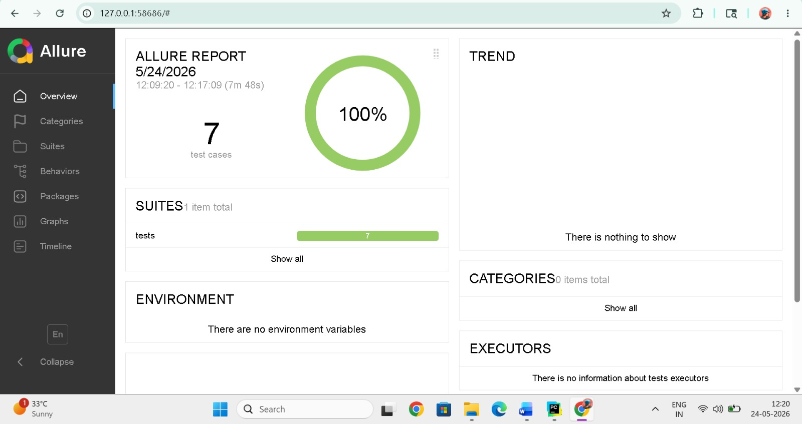

TEST OUTPUTS
The framework automatically captures screenshots during important execution stages including Myntra homepage navigation, Beauty menu interaction, product listing verification, product detail page validation, cart operations, invalid product search validation, and negative test case execution. Detailed execution logs are generated using the Python logging framework to support debugging, test monitoring, and complete execution traceability throughout the automation process.
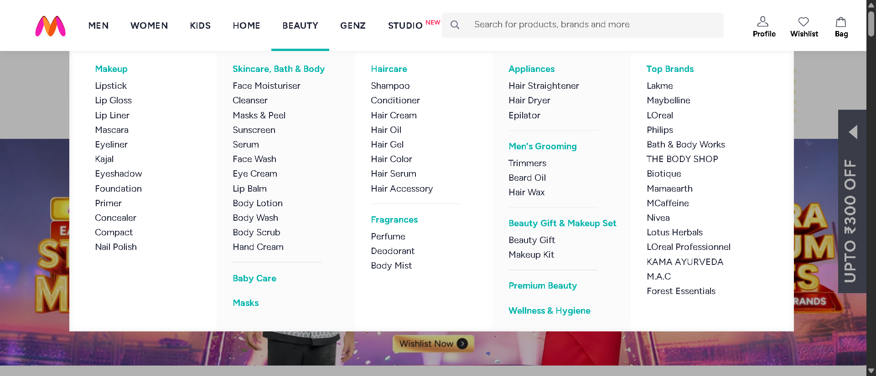
Fig 1: hovering on beauty section
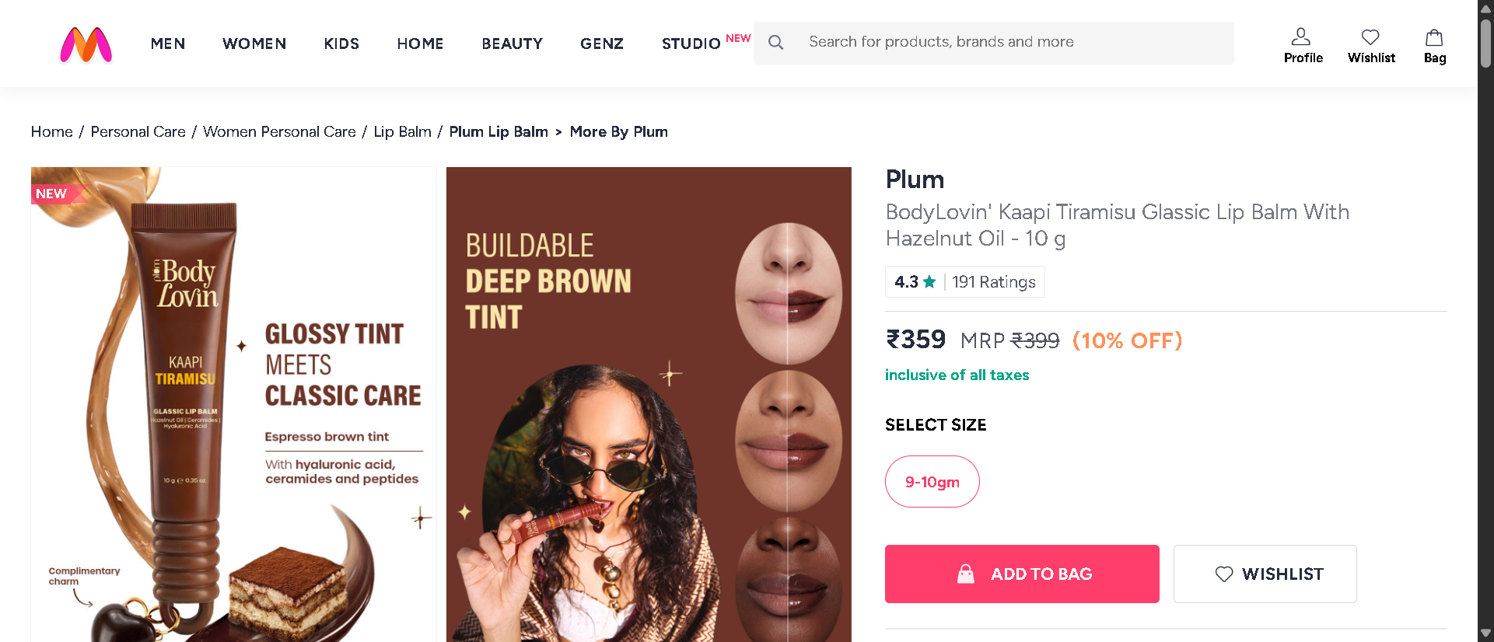
Fig 2: product page opens
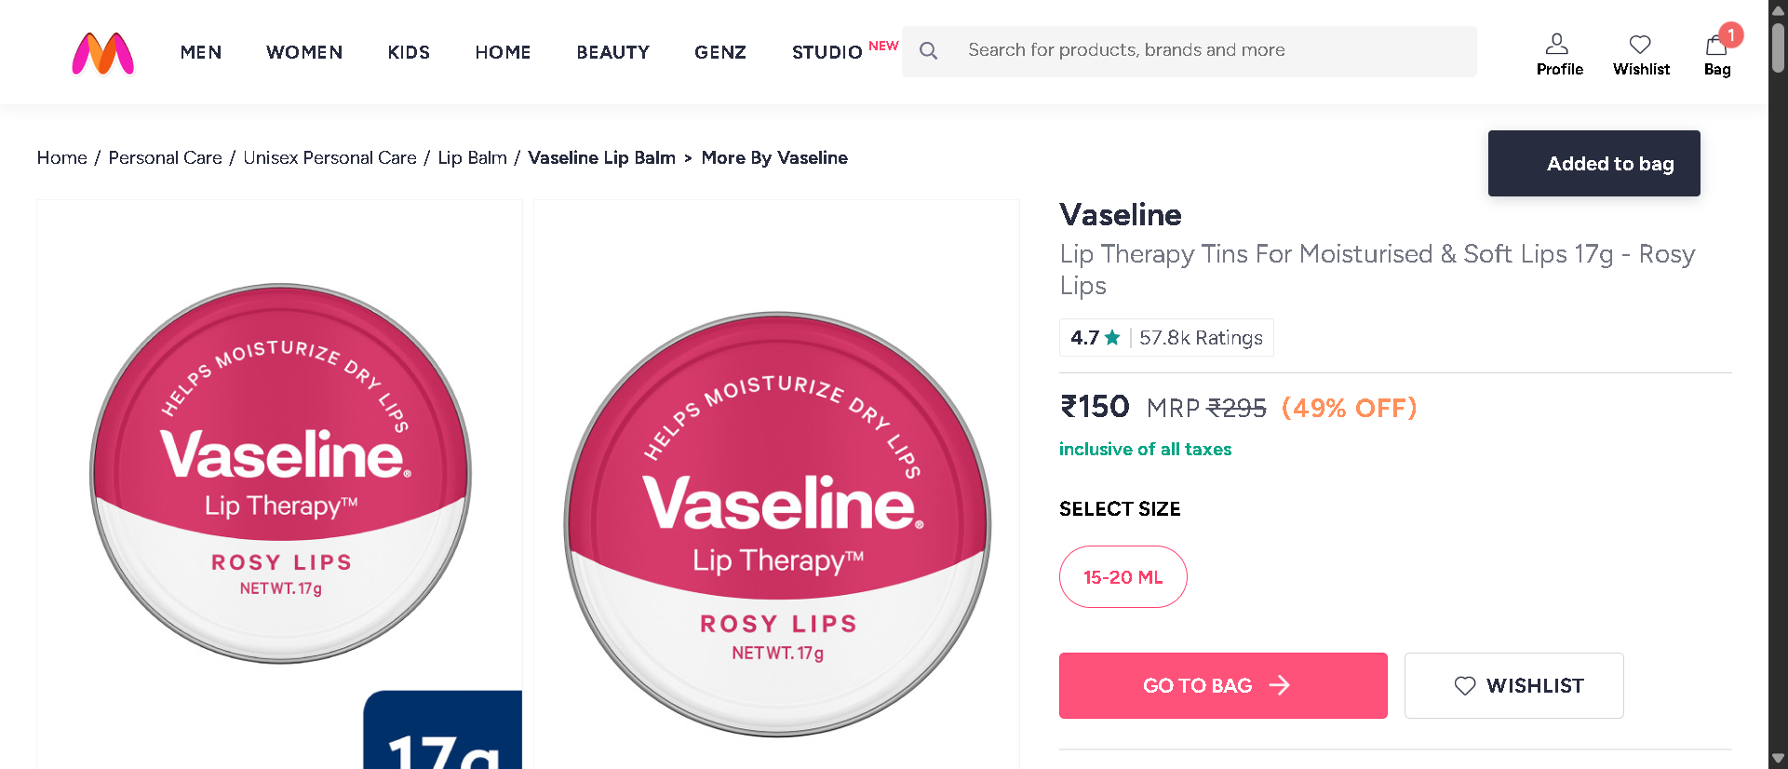
Fig 3: product added to cart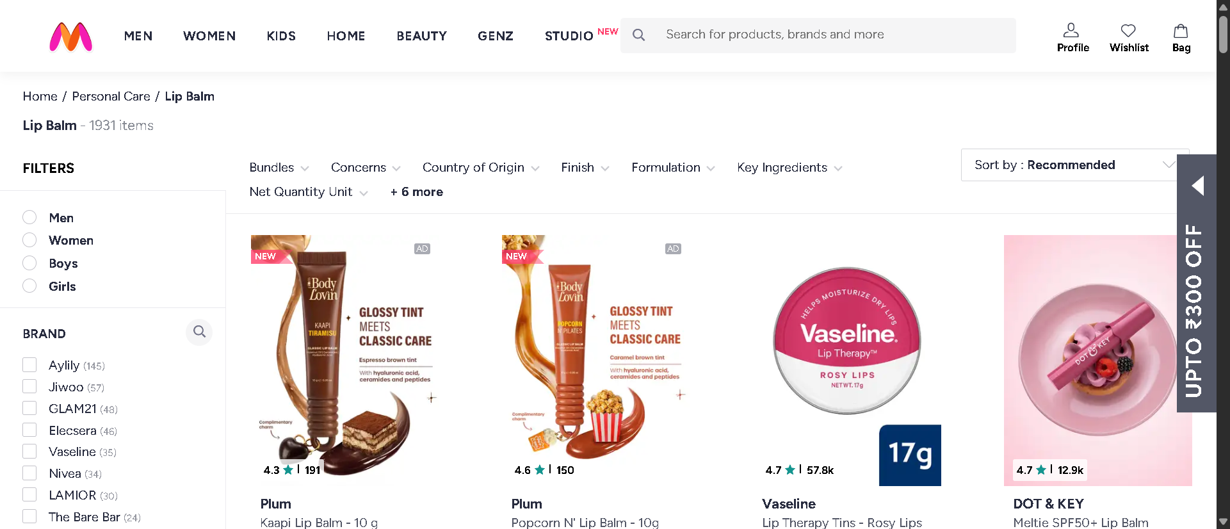
Fig 4: product listing page appears
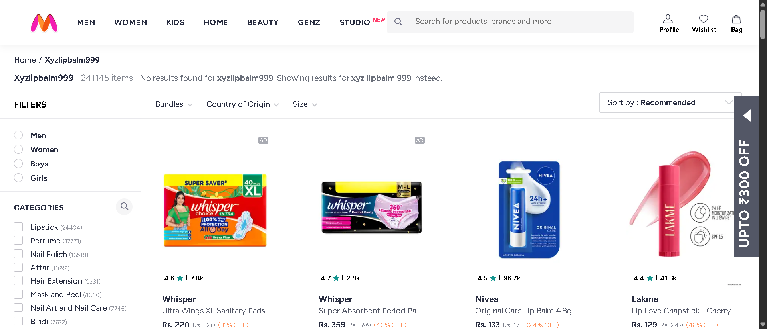Fig 5: Invalid search
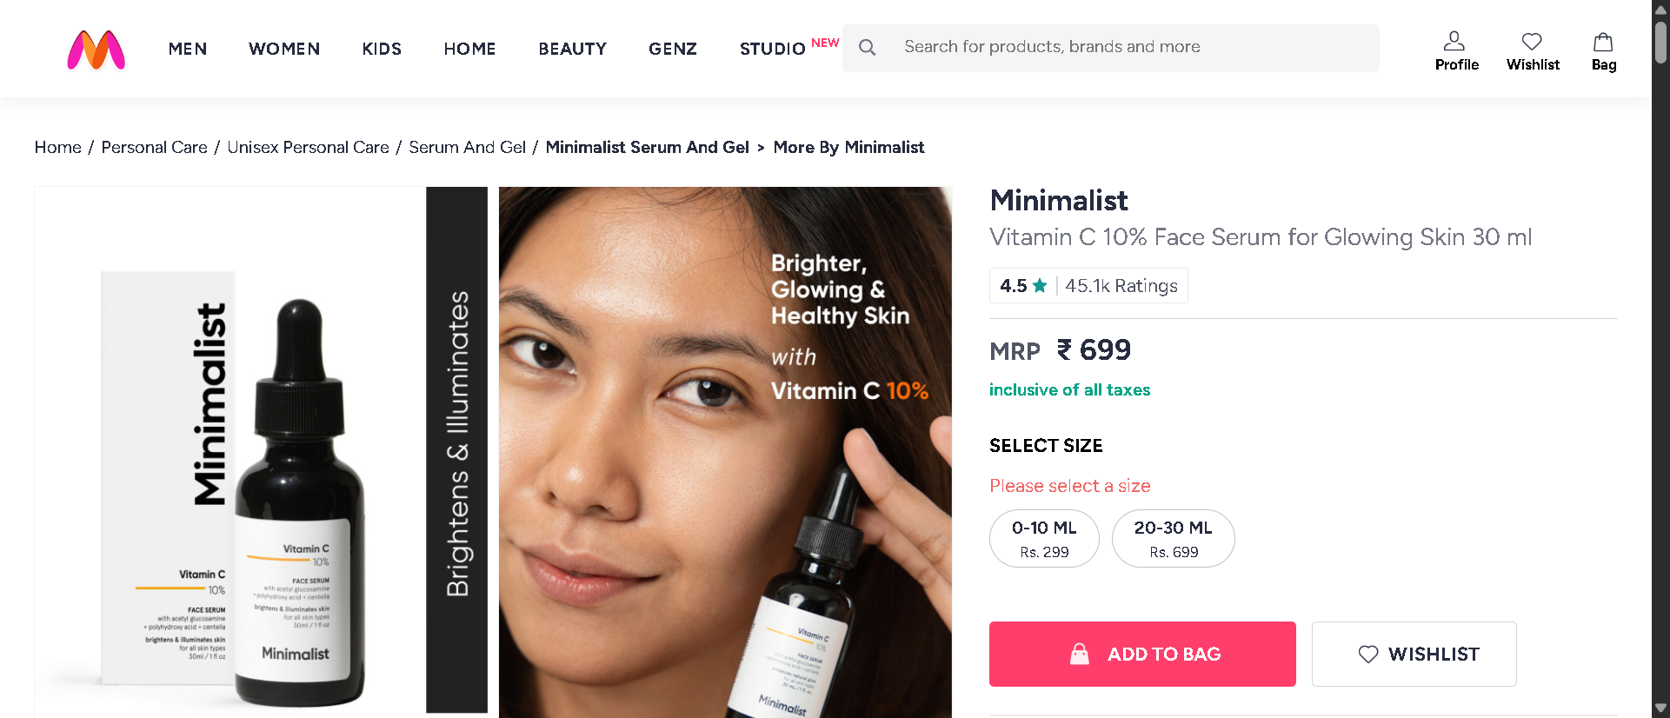
Fig 6: adding to cart without size selection

TEST REPORT
- Total Tests Executed: 7
- Tests Passed: 7
- Tests Failed: 0
- Automation Accuracy: 100%

CONCLUSION
The Selenium Py-Test automation framework successfully validates the Myntra Beauty web application using Positive, Negative, and Functional testing approaches.
The framework is designed using:
• Selenium WebDriver
• Py-Test Framework
• Page Object Model (POM)
• Allure Reporting
• Python Logging Framework
• Screenshot Capture Utility
• Data-Driven Testing
The automation framework improves:
• Test maintainability
• Code reusability
• Scalability
• Reporting quality
• Automation reliability
• Debugging efficiency
The framework successfully validates critical business workflows including Beauty menu navigation, product category verification, product listing validation, product detail page navigation, cart functionality, invalid product search handling, and negative cart validation scenarios.
All automated test cases executed successfully with professional Allure reporting, automatic screenshot capture, and detailed execution logs for effective test monitoring and debugging.

SELENIUM BDD FRAMEWORK

TEST STRATEGY
The project uses Selenium WebDriver with Python Behave BDD framework for automation testing. End-to-End Testing
- Positive Testing
- Negative Testing
- Data-Driven Testing
- Behavior-Driven Development (BDD)
Tools Used:
- Selenium WebDriver
- Py-Test
- Allure Reports
- Logging Module

TEST ENVIRONMENT
Operating System | Windows 11
IDE | PyCharm Unified Product
Browser | Google Chrome (or) Edge
Framework | Selenium WebDriver + Behave
Design Pattern | Page Object Model (POM)
Reporting Tool | Allure Reports
Test Approach | Behavior Driven Development

FRAMEWORK ARCHITECTURE
Myntra Beauty menu
├── config
├── features
│ ├── end_to_end.feature
│ ├── test_cases.feature
│ ├── environment.py
│ └── steps
│ ├── end_to_end.steps
│ └── test_cases.steps
├── reports
│ ├── allure-results
│ └── allure-report
├── screenshots
├── data
├── logs
├── utils
├── behave.ini
├── runtest.py
└── requirements.txt

TEST EXECUTION
The automation suite includes:
- 1 End-to-End Test Scenario
- 4 Positive Test Scenarios
- 2 Negative Test Scenarios
The End-to-End scenario validates the complete Myntra Beauty menu workflow from homepage to whole purchase workflow.
SELENIUM TEST CASE SUMMARY
S. No | Test Type | Test Scenario | Expected Result | Status
1 | End-to-End | Buying a beauty product workflow | User successfully reaches Myntra login page  After placing the order | Passed
2 | Positive | Hovering over beauty menu | Hovers  successfully | Passed
3 | Positive | Opens product page | Opens product page  successfully | Passed
4 | Positive | Adding a product to a cart | Added to cart successfully | Passed
5 | Positive | Opens product listing page | Opens product lists successfully | Passed
6 | Negative | Invalid product search | Product appears which they shouldn’t be | Passed
7 | Negative | Add product without selecting size | Asks for selecting size | Passed

END-TO-END FLOW VALIDATION
The End-to-End automation validates the complete business workflow including:
- Opens Myntra homepage
- Hovers over beauty menu
- Select product category
- Opens first product
- Switches to product tab
- Selects size if available
- Adds product to bag
- Goes to shopping bag
- Changes quantity
- Selects donation
- Clicks place order
- Redirected to login page
POSITIVE TEST SCENARIOS
Positive Test Scenario 1 – Navigate to Beauty Menu
- Open Myntra homepage
- Hover over Beauty menu
Positive Test Scenario 2 – Open Product from Homepage
- Open Myntra homepage
- Hover over Beauty menu
- Open product category
- Open first available product
Positive Test Scenario 3 – Open Product Listings
- Open Myntra homepage
- Hover over Beauty menu
- Open Lip Balm category
Positive Test Scenario 4 – Add Product to Cart
- Open Myntra homepage
- Hover over Beauty menu
- Open product category
- Open product
- Select product size if required
- Add product to shopping bag
NEGATIVE TEST SCENARIOS
Negative Test Scenario 1 – Invalid product Search
- Open Myntra homepage
- Search using invalid product keyword
Negative Test Scenario 2 – Add Product Without Selecting Size
- Open product detail page
- Click Add to Bag without selecting size
BDD IMPLEMENTATION
The framework follows Behaviour Driven Development using:
- Feature Files
- Step Definition Files
- Gherkin Syntax
- Given-When-Then Structure

ALLURE REPORTS
- Integrated Allure Reports with Behave BDD
- Generates professional execution reports
- Displays passed and failed scenario status
- Captures screenshots during execution
- Maintains execution history
- Displays step-by-step scenario execution flow
- Helps debugging and tracking failures
- Provides detailed execution summary


TEST OUTPUTS
The framework automatically captures screenshots during important execution stages including Myntra homepage navigation, Beauty menu interaction, product category navigation, product listing verification, product detail page validation, shopping bag verification, checkout navigation, and login redirection validation. Detailed execution logs are generated using the Python logging framework for effective debugging, execution monitoring, and complete test execution traceability throughout the automation lifecycle.
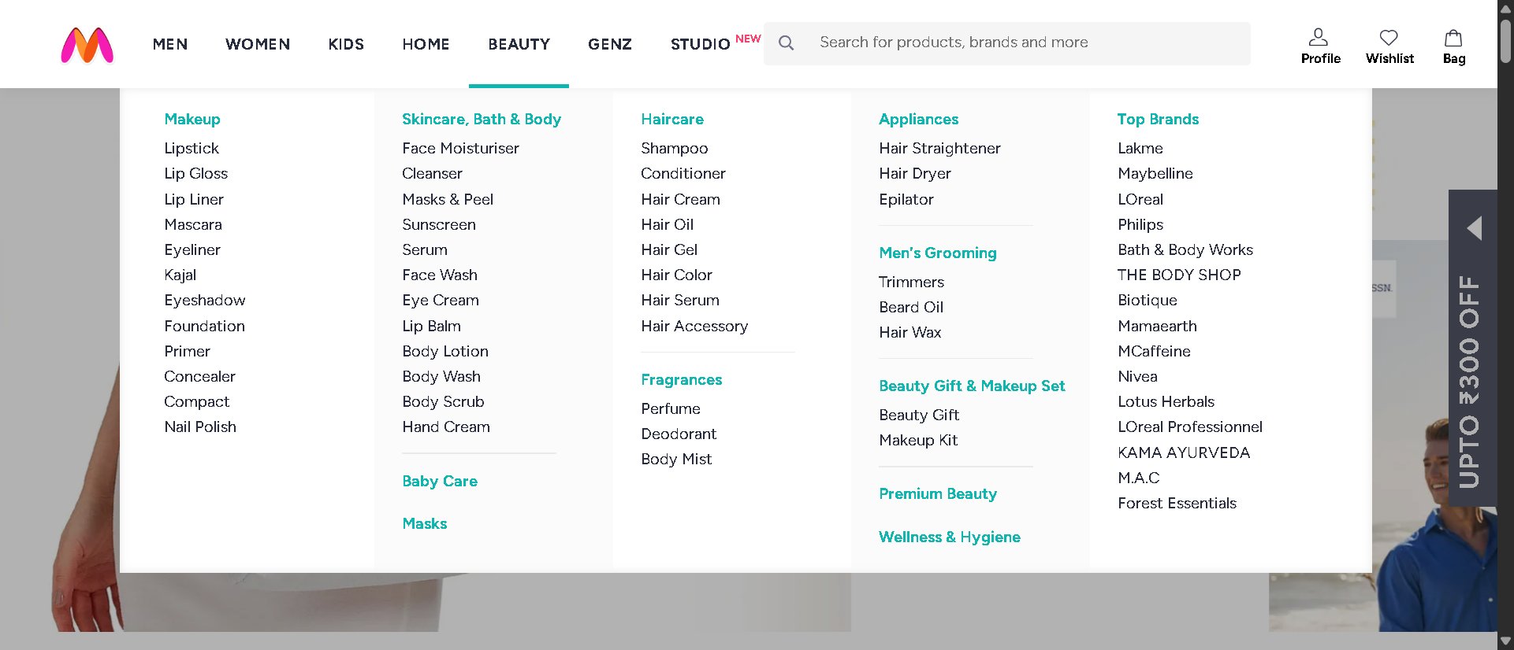
Fig 1: hovering over beauty menu
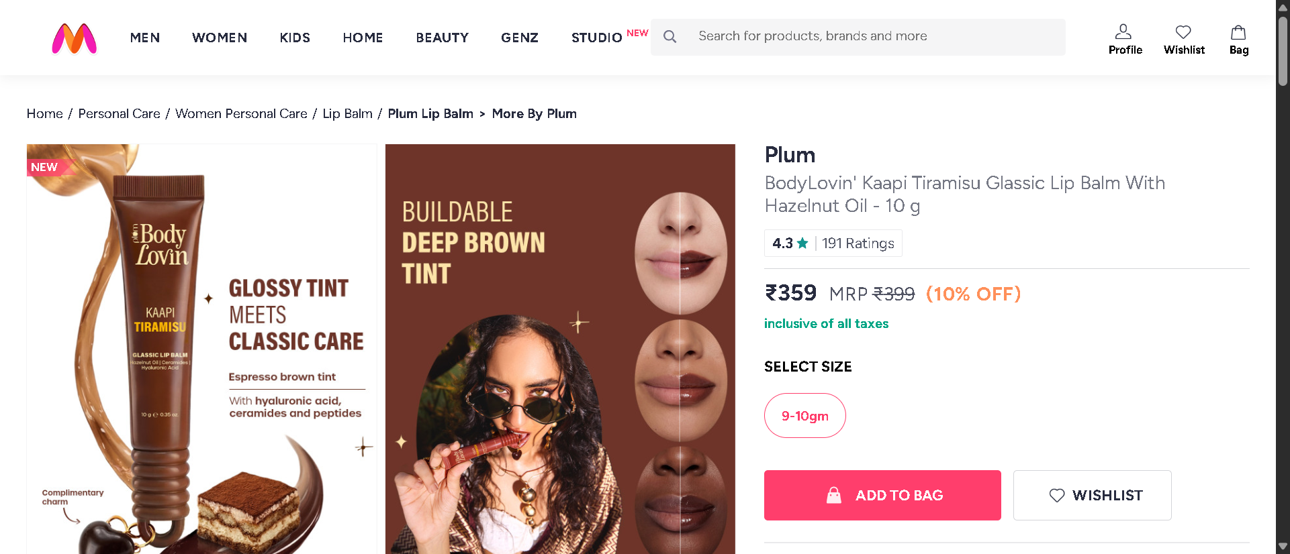
Fig 2: product page opens
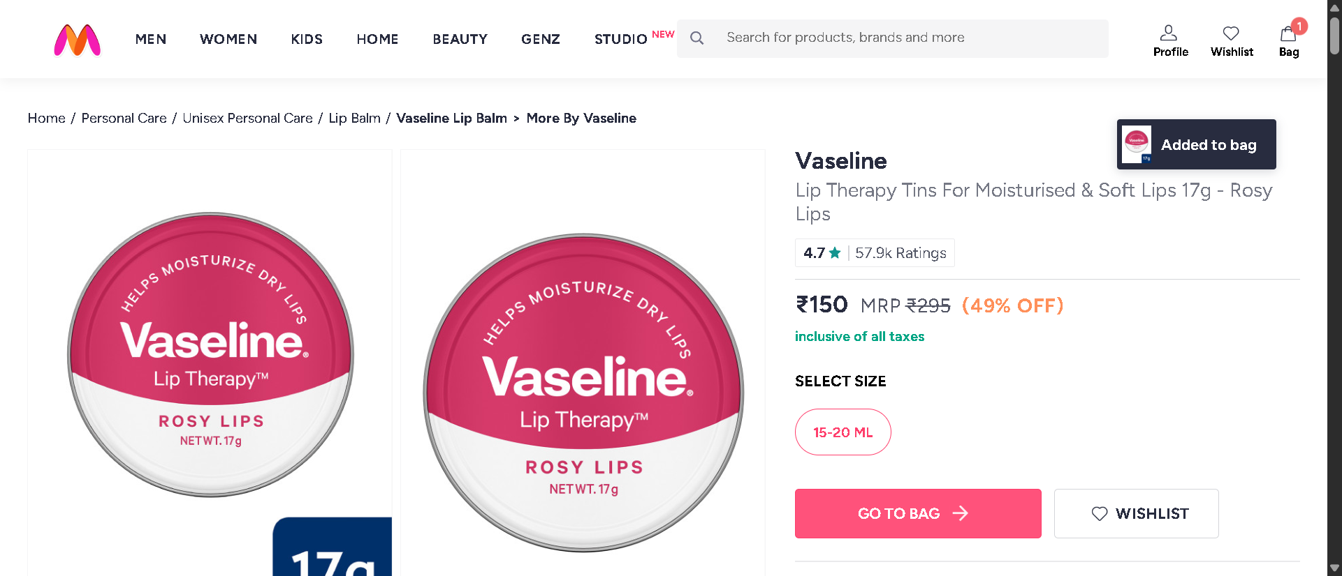
Fig 3: added to cart
Fig 4: product listing page appears
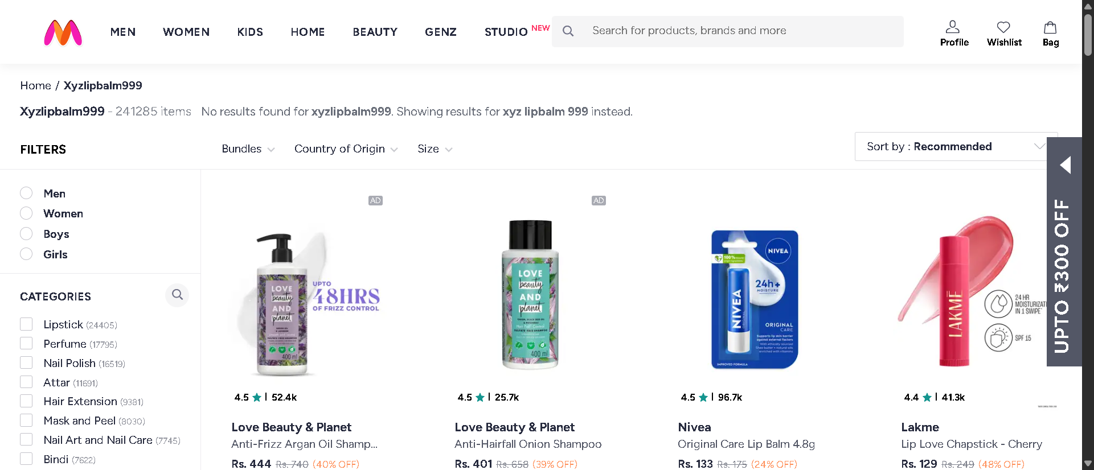
Fig 5: Invalid card selection
Fig 6: size not selected

TEST REPORT
- Total Scenarios Executed: 7
- Scenarios Passed: 7
- Scenarios Failed: 0
- Automation Accuracy: 100%
CONCLUSION
The Selenium Behave BDD automation framework successfully validates the Myntra Beauty web application using the Behaviour Driven Development (BDD) methodology.
The framework is implemented using:
• Selenium WebDriver
• Behave BDD Framework
• Gherkin Feature Files
• Step Definition Files
• Page Object Model (POM)
• Allure Reporting
• Python Logging Framework
• Screenshot Capture Utility
• Data-Driven Testing (Scenario Outline Parameterization)
The framework validates complete business workflows including:
• Myntra Homepage Navigation
• Beauty Menu Interaction
• Lip Balm Category Navigation
• Product Listing Verification
• Product Detail Page Validation
• Add to Cart Functionality
• Shopping Bag Verification
• Quantity Update Validation
• Donation Selection Validation
• Place Order Navigation
• Login Page Redirection Verification
• Invalid Product Search Validation
• Add Product Without Size Selection (Negative Testing)
The implementation of Feature Files and the Given–When–Then structure improves readability, maintainability, and collaboration between technical and non-technical stakeholders by representing test scenarios in a business-readable format.
The framework also includes:
• Allure Reports
• Automatic Screenshot Evidence
• Detailed Execution Logs
• Positive Testing
• Negative Testing
• End-to-End Business Flow Testing
• Reusable Page Object Components
• Config-Driven Test Execution
All scenarios executed successfully with accurate validations, detailed reporting, and automated browser interaction.
Overall, this project demonstrates a professional real-world BDD automation framework for e-commerce web application testing, featuring scalable architecture, reusable automation components, structured reporting, and reliable automated testing practices.

