Machine Learning Analysis for Blood Diagnosis Short Notes
1. White‑Box Methodological Framework
This study incorporates a white‑box interpretability strategy to complement predictive modelling. Rather than relying solely on classification accuracy, the analysis examines relationships between input parameters and model outputs using:
• Correlation matrices to assess feature interactions
• Feature‑importance rankings from ensemble models
• Rule‑based baseline comparisons
• Clinical parameter interpretation
This approach enables validation that learned patterns align with domain knowledge and provides a principled justification for machine learning over deterministic threshold logic.
2. CBC-Based Model Interpretation (Multiple Myeloma)
Rule‑Based Baseline Metrics
Accuracy: 0.9833
Precision: 0.9756
Recall: 1.0000
F1 Score: 0.9877
Machine Learning Model Performance
Accuracy: 1.0000
Interpretation:
Deterministic rule systems assume independent, linear thresholds across variables, whereas clinical diagnostics depend on multivariate physiological interactions. Machine learning models approximate nonlinear decision boundaries and probabilistic relationships, resulting in improved generalization and reliability.

Clinical Parameters:

Feature | Full Form / Meaning | Physiological Role | Clinical Interpretation
Hb | Hemoglobin | Measures oxygen-carrying protein concentration | Low: anemia → abnormal oxygen transport; High: possible dehydration/polycythemia
RBC | Red Blood Cell Count | Indicates number of erythrocytes circulating | Low: impaired production/destruction → abnormal; High: possible compensatory response or disorder
MCV | Mean Corpuscular Volume | Average size of red blood cells | Low: microcytic cells → commonly thalassemia/iron deficiency; High: macrocytic cells → B12/folate deficiency or other disorders
MCH | Mean Corpuscular Hemoglobin | Hemoglobin quantity per red cell | Low: hypochromic cells → reduced oxygen capacity; High: atypical composition or macrocytosis
Platelets | Platelet Count | Reflects clotting potential and marrow activity | Low: marrow dysfunction or disease; High: inflammation, stress, or pathology
M Protein | Monoclonal Protein | Abnormal antibody produced by plasma cells | High: strong indicator of multiple myeloma — dominant diagnostic signal

CBC Feature Importance Charts: (for all models used)
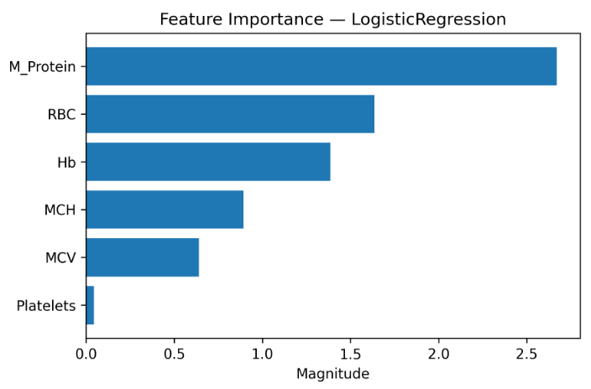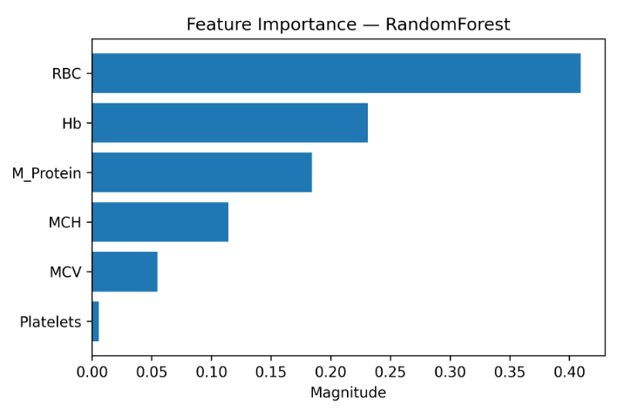
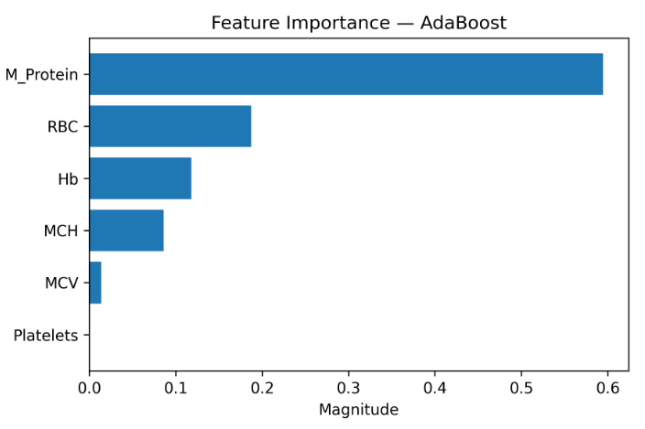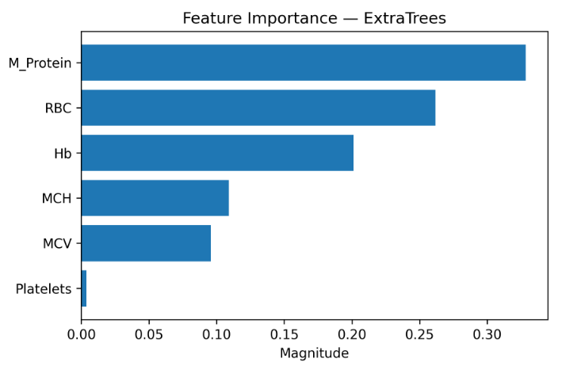
Correlation Insights:
• Strong coupling between MCV and MCH
• Moderate intra‑index relationships across hematological measures
• M Protein exhibits relative independence, acting as primary discriminative signal
Out‑of‑Distribution Detection: 1/60
1 anomalous sample detected among 60 indicates capacity to identify unfamiliar feature space regions.
Predictive Uncertainty:
STD Threshold: 0.1310
Entropy Threshold: 0.3135
These thresholds operationalize confidence of the model gating for downstream decision validation.

3. Scatter Morphology Model Interpretation (Multiple Myeloma 2nd dataset of scatter plot values)
Rule‑Based Accuracy: 0.4667
Machine Learning Accuracy: ≈ 0.97–0.98
Interpretation:
Threshold logic fails due to geometric nonlinear separability inherent to spatial morphology features. Machine learning models capture curvature in decision surfaces and feature interactions, producing substantial performance gains.
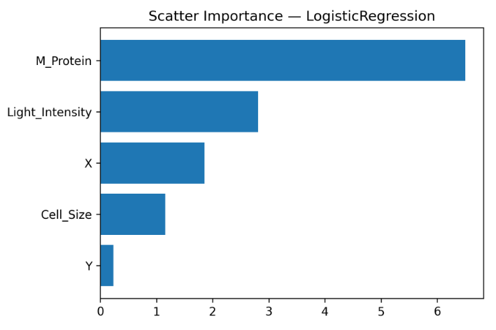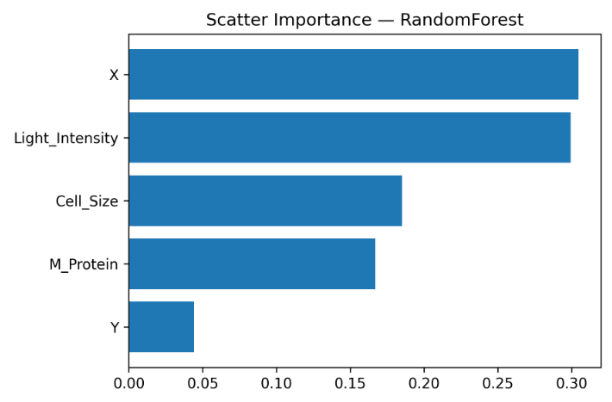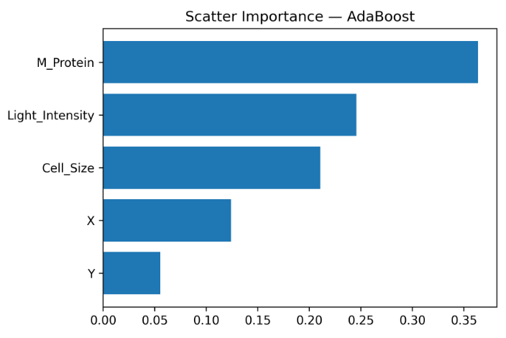
Conclusion:
Morphological classification tasks exhibit high structural complexity requiring adaptive modelling.
4. HPLC Dataset (Thalassemia detection):
Rule‑Based Accuracy: 0.2267
Machine Learning Accuracy: ≈ 99%
Interpretation:
Hemoglobin fraction dynamics represent nonlinear biochemical interactions beyond deterministic threshold capability. Ensemble models capture compositional relationships among fractions and morphological indices.
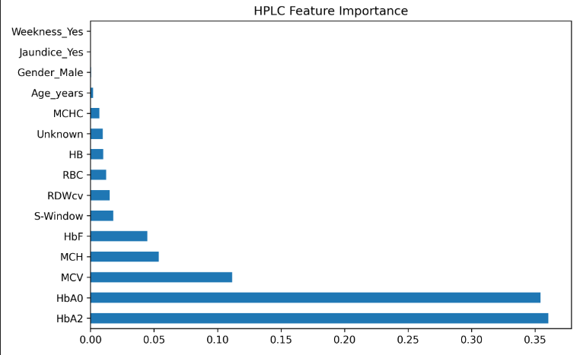

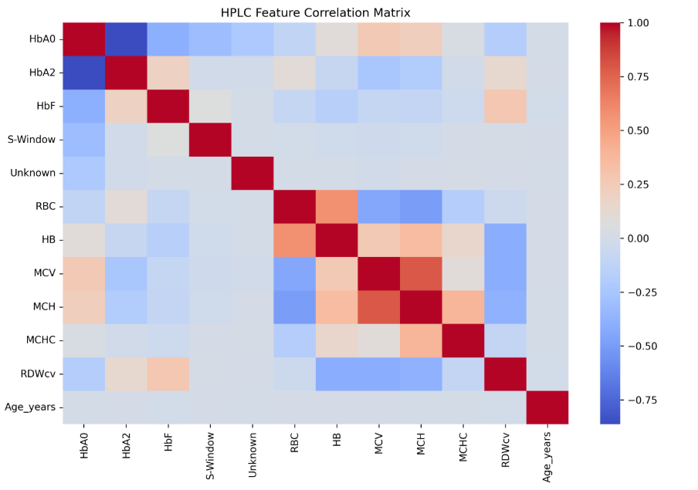
Insights:
Primary Influential Variables: HbA2 and HbA0
Secondary Contributions: MCV, MCH, HbF
Correlation Structure Insights:
Positive Coupling: Directly proportional
RBC ↔ HB ↔ MCV ↔ MCH
Reflects shared physiological measurement domain
Moderate Association:
HbF ↔ RDWcv Indicates linkage between hemoglobin variation and cell heterogeneity
Negative Compensation: Inversely proportional
HbA0 ↔ HbA2
Represents biochemical substitution dynamics
Interpretation:
The observed relationships validate biological plausibility and confirm absence of spurious data structure artefacts.
Overall Conclusion:
Across modalities, machine learning consistently improves diagnostic reliability while
white‑box interpretability confirms alignment with domain‑consistent physiological patterns.

