GenAI Application – SQL Data Types and Constraints
- Create Database: GenAI_App
create database GenAI_App;
use GenAI_App;
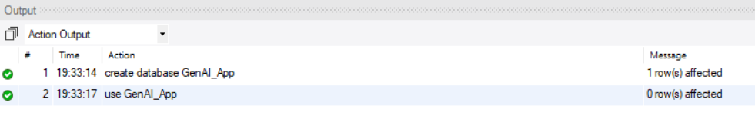
- Create a table named Users with the following columns:
- user_id – Integer, Primary Key
- username – Maximum 50 characters, cannot be NULL
- email – Maximum 100 characters, must be unique
- age – Integer, must be 18 or above
- phone – Fixed 10 characters
- registration_date – Date
- account_status – Default value should be 'Active'
create table Users(
user_id int primary key,
username varchar(50) not null,
email varchar(100) unique,
age int check (age >= 18),
phone varchar(10),
registration_date date,
account_status varchar(50) default 'Active'
);
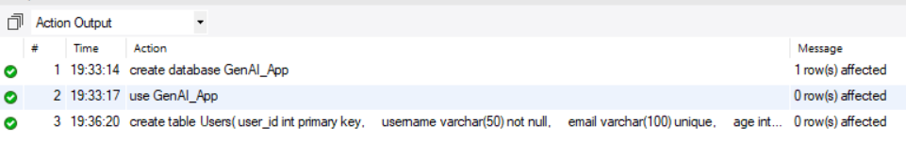

- Create a table named AI_Models with:
- model_id – Integer, Primary Key
- model_name – Maximum 50 characters, cannot be NULL
- model_version – Maximum 20 characters
- is_available – Boolean, default value TRUE

create table AI_Models(
model_id int primary key,
model_name varchar(50) not null,
model_version varchar(20),
is_available boolean default TRUE
);
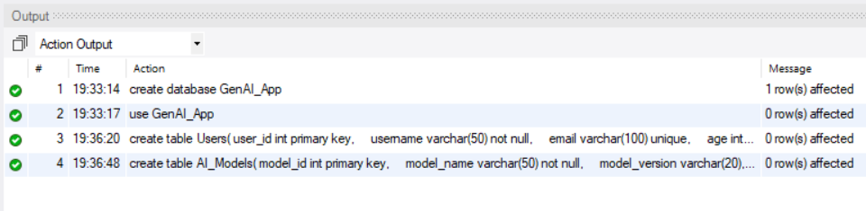
- Create a table named Conversations with:
- chat_id – Integer, Primary Key
- user_id – Integer, Foreign Key referencing Users
- model_id – Integer, Foreign Key referencing AI_Models
- user_prompt – Text, cannot be NULL
- ai_response – Text
- token_count – Integer, must be zero or above
- chat_time – Date and Time
create table Conversations(
chat_id int primary key,
user_id int,
model_id int,
user_prompt text not null,
ai_response text,
token_count int check (token_count >= 0),
chat_time datetime,
foreign key (user_id) references Users(user_id),
foreign key (model_id) references AI_Models(model_id)
);
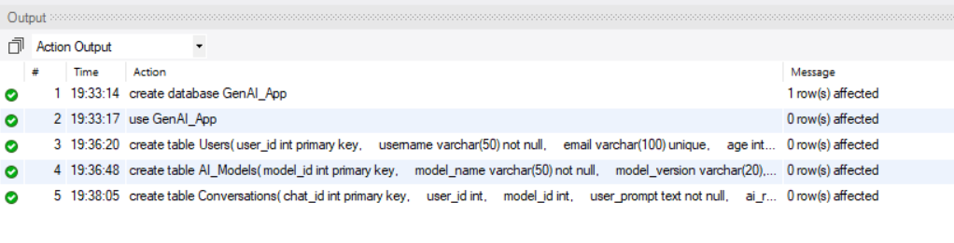
- Payments Table
create table Payments (
payment_id int primary key,
user_id int,
amount decimal(10,2),
payment_date datetime,
payment_status varchar(20) default 'Pending',
foreign key (user_id) references Users(user_id)
);
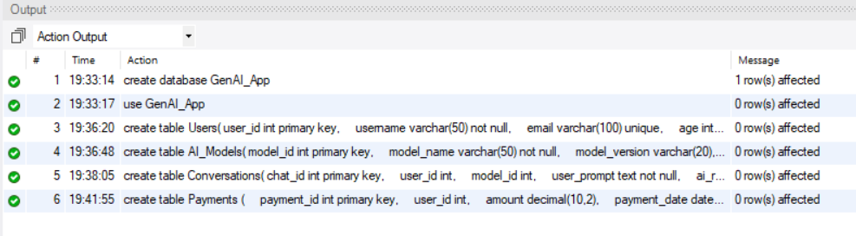

Queries and Tasks
- Display all records from the four tables
select * from Users;
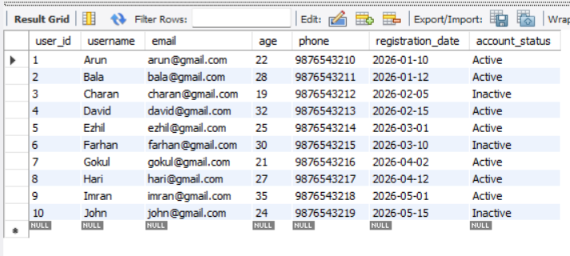
select * from AI_Models;
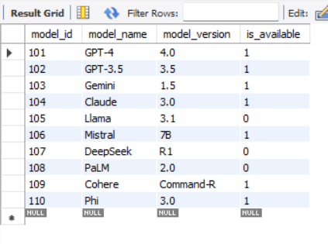

select * from Conversations;
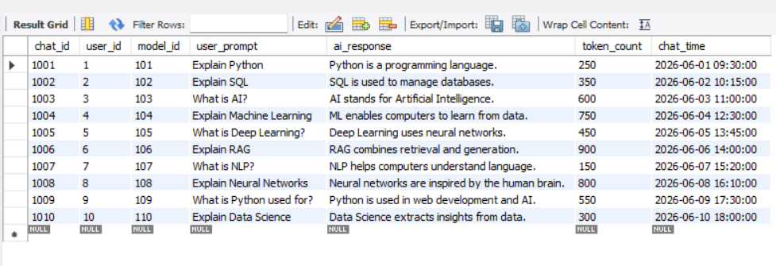
select * from Payments;
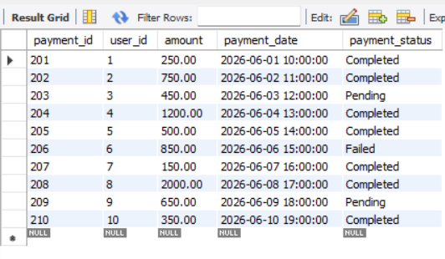

- Display only the username and email of all users
select username,email from Users;
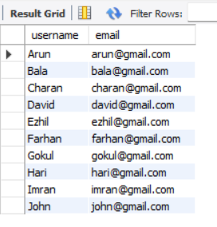

- Display users whose age is greater than 25
select * from Users
where age > 25;
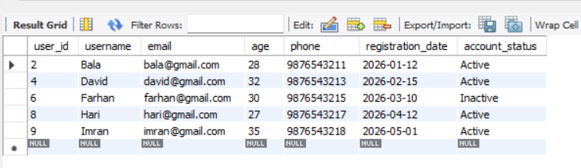

- Display AI Models that are currently available
select * from AI_Models
where is_available = TRUE;
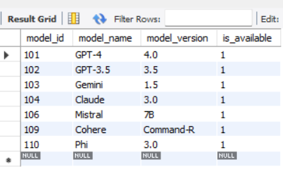

- Display Conversations where token_count is greater than 500
select * from Conversations
where token_count > 500;
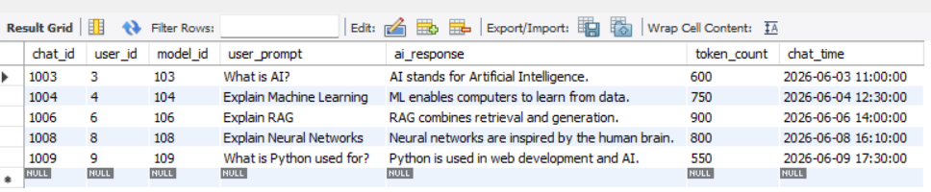

- Display Payments with an amount greater than 500
select * from Payments
where amount > 500;
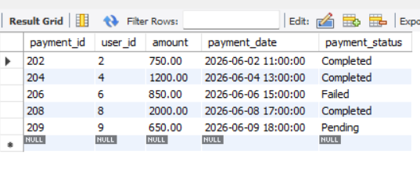
- Try inserting a duplicate email into the Users table. Observe the result
insert into Users values
(11,"Jeshu","david@gmail.com",23,8015012051,"2025-11-15","Active");
- Try inserting a user below 18 years of age. Observe the result
insert into Users values
(12,"Adam","adam21@gmail.com",15,7512095610,"2025-01-23","Active");
- Insert a payment without specifying payments_status.check the default value
insert into Payments (payment_id,user_id,amount,payment_date)
values (211,10,1500.05,"2026-10-20 01:15:25");
select * from Payments
where payment_id = 211;


