DDL – DATA DEFINITION LANGUAGES – ASSIGNMENT
Name: Jeshu Denzil Deve
QUESTIONS:
- Create a database named MovieBooking

create database MovieBooking;
use MovieBooking;
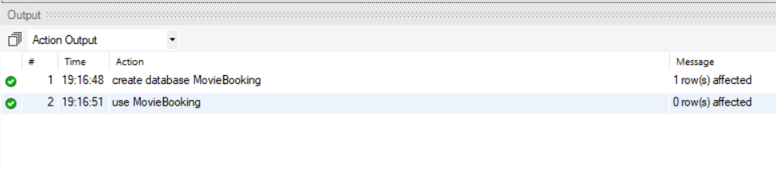
- Create a table named Movies with the following columns: Movie_ID, Movie_Name, Genre, Language, Duration, Release_Year

create table Movies
(
Movie_ID int,
Movie_Name varchar(30),
Genre varchar(30),
Language varchar(30),
Duration int,
Release_Year int
);
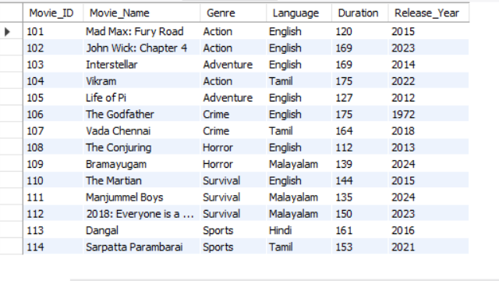
- Create a table named Customers with: Customer_ID, Customer_Name, Email, Phone, Age

create table Customers
(
Customer_ID int,
Customer_Name varchar(30),
Email varchar(30),
Phone varchar(10),
Age int
);
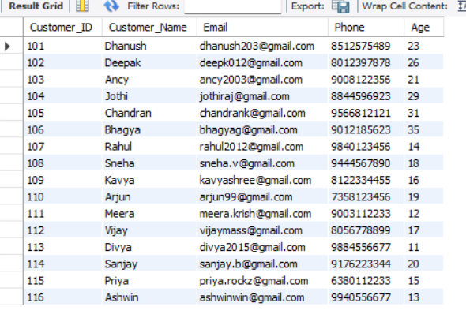

- Create a table named Bookings with: Booking_ID, Customer_ID, Movie_ID, Theatre_ID, Booking_Date, Tickets, Total_Amount.

create table Bookings
(
Booking_ID int,
Customer_ID int,
Movie_ID int,
Theatre_ID int,
Booking_Date varchar(30),
Tickets int,
Total_Amount int
);
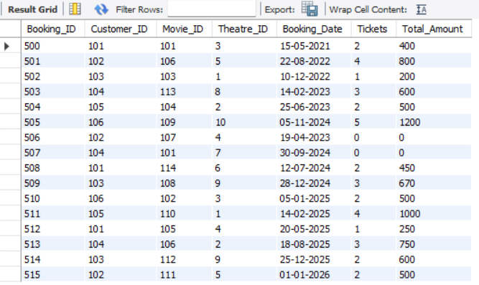

Theatres Table:
create table Theatres
(
Theatre_ID int,
Theatre_Name varchar(30),
Location varchar(30),
Price int
);
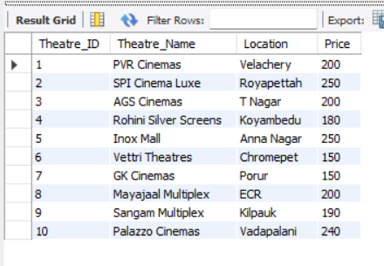
- Add a new column Rating to the Movies table
alter table Movies add column Rating int;
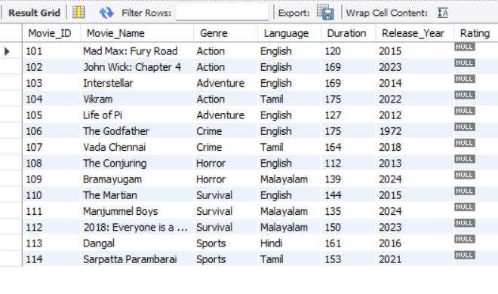
- Add a new column Seat_Type to the Bookings table
alter table Bookings add column Seat_Type varchar(30);
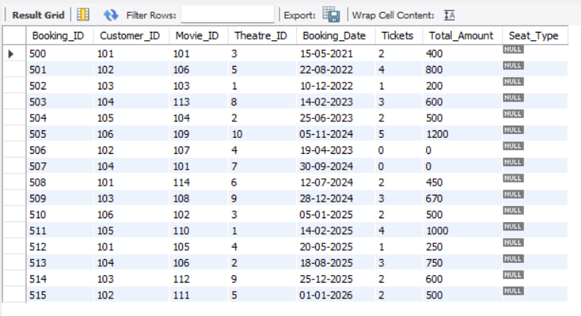

- Change the size of the Movie_Name column to VARCHAR(150)
alter table Movies modify Movie_Name varchar(150);
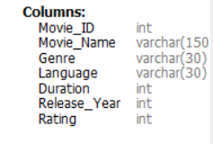

- Rename the column Phone to Mobile_Number in the Customers table
alter table Customers rename column Phone to Mobile_Number;
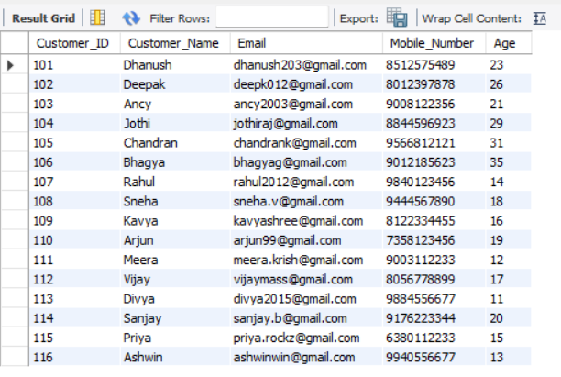
- Rename the table Theatres to Cinema_Halls
rename table Theatres to Cinema_Halls;
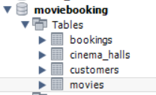
- Remove the Rating column from the Movies Table
alter table Movies drop column Rating;
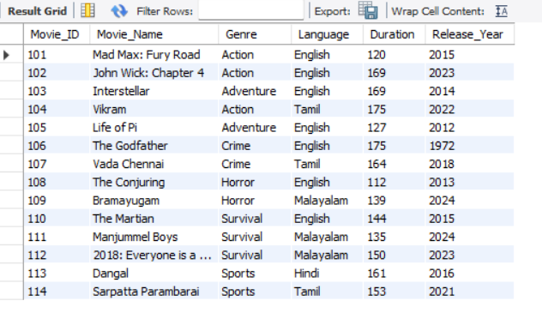

- Create a backup table named Movies_Backup using the structure and data of the Movies table
create table Movies_Backup as
select * from Movies;
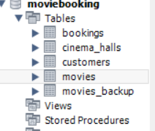

- Display the structure of all four tables
desc Bookings;
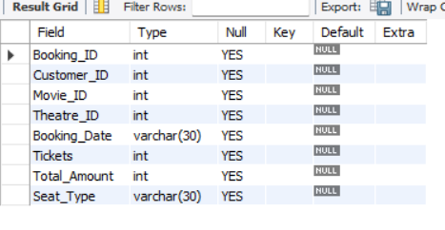
desc Customers;
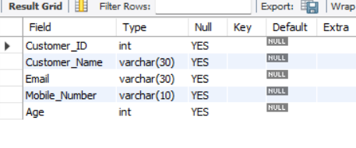
desc Movies;
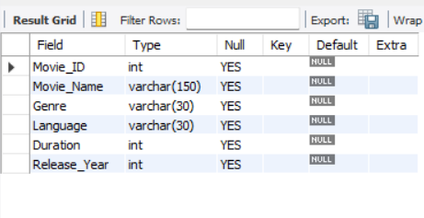
desc Cinema_Halls;
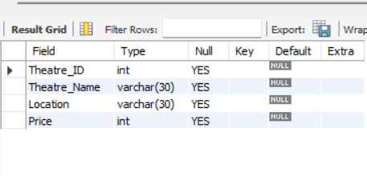
- Display all databases available in MySQL
show databases;
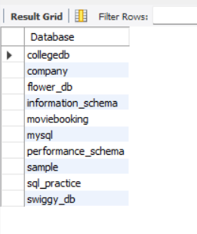
- Delete the entire Movies_Backup table from the database
drop table Movies_Backup;
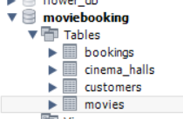
- Delete all bookings where the number of tickets is 0
delete from Bookings
where Tickets = 0;
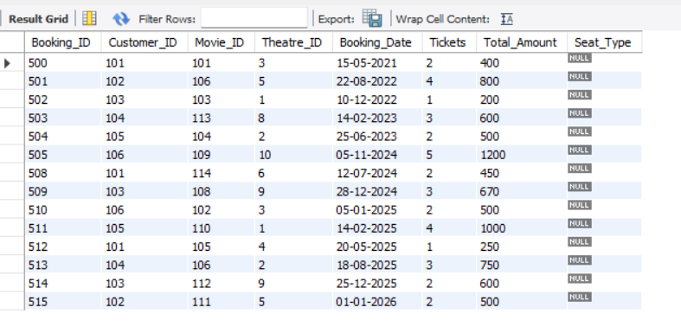

- A particular customer permanently deleted their account. Delete the customer whose Customer_ID is 105
delete from Customers
where Customer_ID = 105;
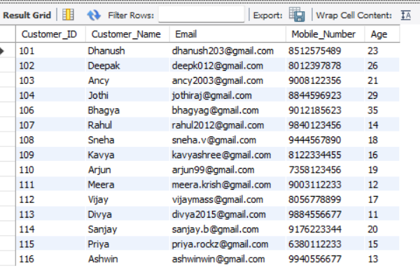
- A theatre has stopped operating. Delete the theatre record with Theatre_ID = 4
delete from Cinema_Halls
where Theatre_ID = 4;
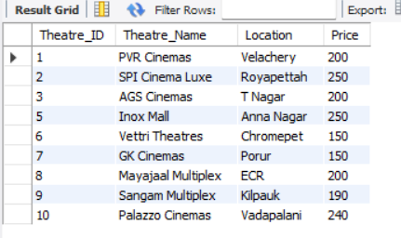
- Remove all booking records made before 2025-01-01.
delete from Bookings
where str_to_date(Booking_Date, '%d-%m-%Y') < '2025-01-01';
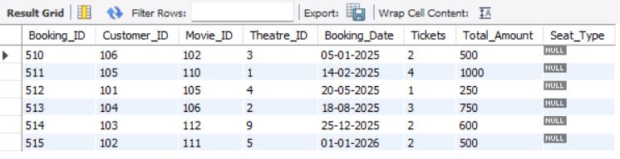
- Delete all movies belonging to the Horror genre.
delete from Movies
where Genre = "Horror";
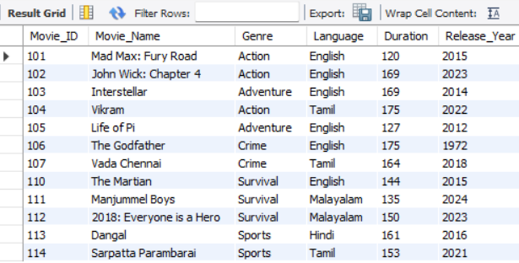

- A movie is no longer available in the application. Delete the movie with Movie_ID = 110
delete from Movies
where Movie_ID = 110;
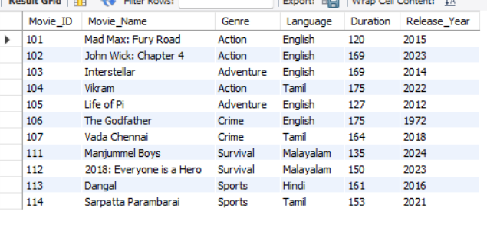
- Delete all customers whose age is below 18
delete from Customers
where Age < 18;
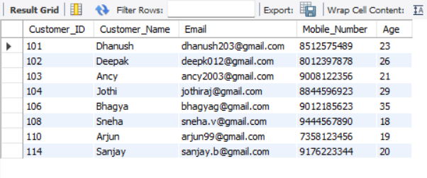
- The management wants to clear all booking records while keeping the Bookings table structure. Write a query for this requirement.
truncate table Bookings;


