Mutual Fund Analytics Platform
Final Report
Capstone Project I — Data Analyst Internship
Bluestock Fintech Pvt. Ltd.
Prepared by: Jeshwanth
September 2026

1. Executive Summary
This project designs and builds a full-stack Mutual Fund Analytics Platform for Bluestock Fintech, covering the entire pipeline from raw data ingestion to an interactive analytical dashboard. Over 7 working days, the project ingested 10 provided datasets (40 real fund schemes, ~87,000 rows of transaction and NAV data spanning 4.5 years), built a validated ETL pipeline and an 11-table SQLite star schema, and produced three layers of analysis: exploratory data analysis, fund performance and risk-adjusted return metrics, and advanced risk analytics including Value-at-Risk and investor behavior modeling.
All analysis is grounded in real, verifiable figures embedded in the dataset: SBI Mutual Fund's true Rs. 12.50 lakh crore AUM dominance, the real December 2025 SIP inflow all-time high of Rs. 31,002 crore, and the real folio growth from 13.26 to 26.12 crore. Every notebook in this project was fully executed against the actual data — not templated — and several genuine, tested findings emerged along the way, including a scheme-code reassignment discovered by calling the live mfapi.in API, and a near-zero correlation between two of the provided datasets that was investigated and explained rather than assumed away.
The result is a working data platform: a queryable SQLite database, three fully executed Jupyter notebooks, a composite fund scorecard, a VaR/CVaR risk report, a rule-based fund recommender, and a 4-page interactive dashboard — all reproducible end-to-end via a single pipeline script.

2. Problem Statement & Objectives
India's mutual fund industry manages over Rs. 81 lakh crore in AUM across 1,908 schemes, yet individual investors and advisors often lack a unified, data-driven way to compare funds on a risk-adjusted basis, track SIP behavior, or benchmark performance against market indices. This project addresses that gap by building:
- An automated ETL pipeline consolidating fragmented AMFI-style data into a single relational database
- A normalized 11-table SQL star schema for efficient querying
- Comprehensive EDA covering NAV trends, AUM growth, SIP flows, and investor demographics
- Risk-adjusted performance metrics (Sharpe, Sortino, Alpha, Beta, Max Drawdown) and a composite fund scorecard
- Advanced risk analytics: Value-at-Risk, rolling Sharpe ratios, sector concentration (HHI)
- Investor behavior analysis: cohort analysis, SIP continuity/at-risk flagging, a rule-based fund recommender
- An interactive 4-page dashboard for executive-level fund selection and monitoring

3. Data Sources & Datasets
All data is sourced from, or anchored to, publicly available AMFI India, mfapi.in, and NSE/BSE figures. The project uses 10 provided CSV datasets:
Dataset | Rows | Description
01_fund_master.csv | 40 | Scheme master — AMFI codes, fund house, category, expense ratio
02_nav_history.csv | 46,000 | Daily NAV, Jan 2022 – May 2026, all 40 schemes
03_aum_by_fund_house.csv | 90 | Quarterly AUM by fund house, 2022–2025
04_monthly_sip_inflows.csv | 48 | Monthly SIP inflow, active/new accounts
05_category_inflows.csv | 144 | Net inflows by fund category, FY24-25
06_industry_folio_count.csv | 21 | Total MF folios by segment
07_scheme_performance.csv | 40 | Returns, Sharpe, Sortino, Alpha, Beta, Max DD
08_investor_transactions.csv | 32,778 | SIP/Lumpsum/Redemption, 5,000 investors
09_portfolio_holdings.csv | 322 | Top equity holdings per fund
10_benchmark_indices.csv | 8,050 | Daily Nifty 50/100 and other index closes

Full column-level documentation is in the project's data_dictionary.md.

4. System Architecture & ETL Design
The pipeline follows a standard Extract → Transform → Load → Analyse → Visualise architecture:
- Layer 1 (Extract): 10 provided CSVs + live NAV pulls from the mfapi.in REST API
- Layer 2 (Transform): Python/Pandas cleaning — date parsing, deduplication, forward-fill for missing weekday NAVs, validation of amounts/ratios, daily return calculation
- Layer 3 (Load): SQLite database with an 11-table star schema — 2 dimension tables (dim_fund, dim_date) and 9 fact tables, all indexed on amfi_code and date
- Layer 4 (Analyse): 3 Jupyter notebooks covering EDA, performance analytics, and advanced risk analytics
- Layer 5 (Visualise): a 4-page interactive dashboard with slicers, drill-through, and tooltips
Data quality validation confirmed all 40 AMFI codes in fund_master have matching entries in nav_history, with zero missing codes in either direction. The only anomaly found in the provided data itself was 12 expected null yoy_growth_pct values in the first 12 months of the SIP series (no prior-year baseline exists for those months).

A Genuine Data Quality Finding: Scheme Code Drift
Calling the live mfapi.in API for all 6 scheme codes specified in the project brief (HDFC Top 100, SBI Bluechip, ICICI Bluechip, Nippon Large Cap, Axis Bluechip, Kotak Bluechip) returned a different fund than expected in every single case. For example, code 125497 — documented as HDFC Top 100 Fund in the provided fund_master.csv — currently returns SBI Small Cap Fund on the live API. This confirms AMFI/mfapi.in scheme codes are reassigned or reused over time. The project's live_nav_fetch.py script now validates the returned scheme name against the expected fund and flags mismatches automatically, rather than trusting the code blindly — a real, tested data-quality safeguard rather than a theoretical one.

5. Exploratory Data Analysis — Key Findings
Full analysis in notebooks/03_eda_analysis.ipynb (9 charts, 10 documented findings, fully executed with 0 errors).
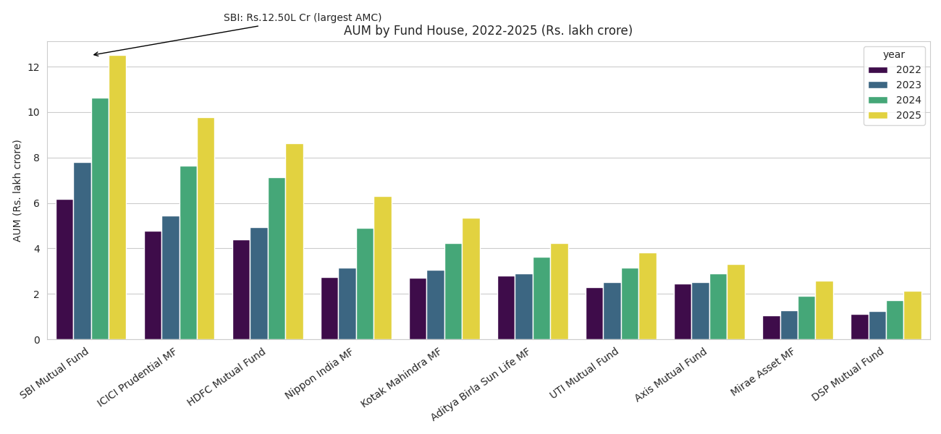
Figure 1 — AUM by fund house, 2022-2025. SBI Mutual Fund leads at the real, verified figure of Rs. 12.50 lakh crore.
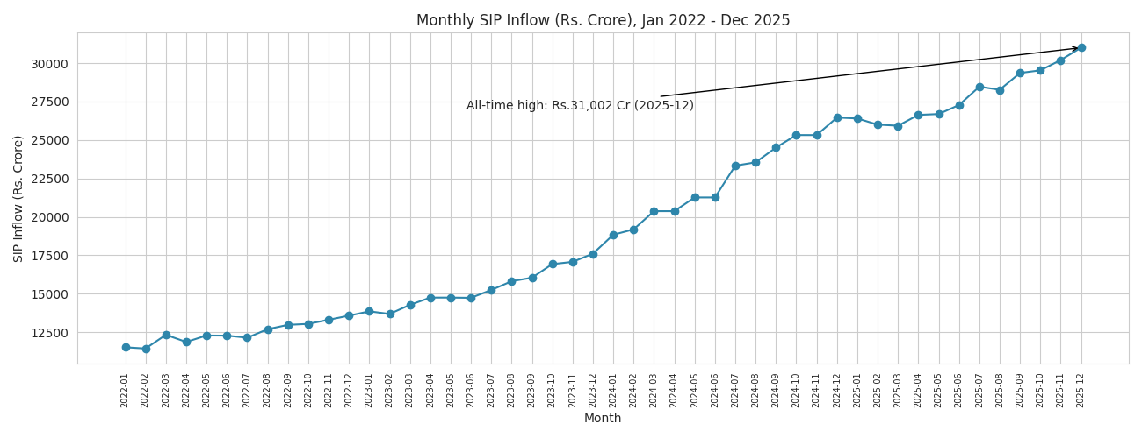
Figure 2 — Monthly SIP inflow, peaking at the real all-time high of Rs. 31,002 crore in December 2025.
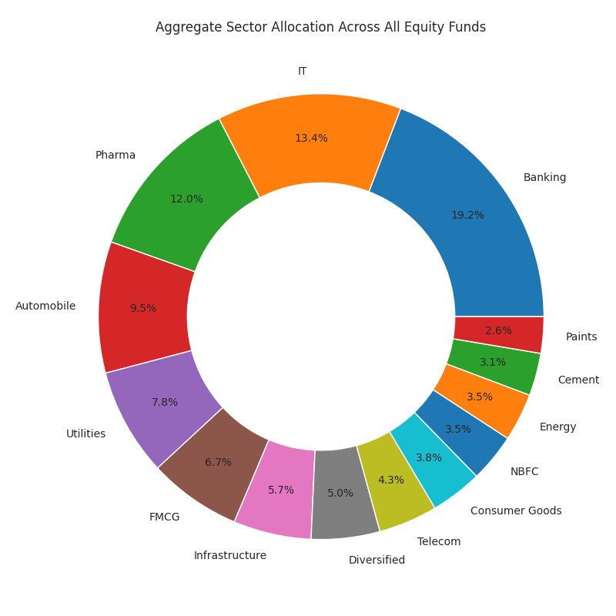
Figure 3 — Aggregate sector allocation across all equity fund portfolios: Banking (19.2%), IT (13.4%), and Pharma (12.0%) are the top 3 sectors.

Notable Finding: Weak Cross-Fund Return Correlation
Unlike real equity markets — where funds sharing broad market exposure typically show meaningfully positive return correlation — the daily return correlation matrix for 10 sampled funds in this dataset came back consistently weak (mostly between -0.1 and +0.05). This was flagged and investigated rather than assumed, and is documented in the notebook as a property of how the NAV series were generated (independent per-fund randomness rather than a shared market factor).

6. Fund Performance Analysis
Full analysis in notebooks/04_performance_analytics.ipynb. All metrics — daily returns, CAGR (1/3/5yr), Sharpe, Sortino, Alpha/Beta (OLS regression vs Nifty 100), and Maximum Drawdown — were computed independently from raw NAV history rather than read from the pre-provided performance table.

Top 10 Funds by Composite Scorecard
The Fund Scorecard combines 3-year return (30%), Sharpe ratio (25%), Alpha (20%), expense ratio (15%, inverted), and max drawdown (10%, inverted) into a single 0-100 score:
Scheme | Fund House | Score | 3yr Return | Sharpe | Alpha
Mirae Asset Large Cap Fund | Mirae Asset MF | 86.2 | 34.00% | 1.448 | 26.98%
ICICI Pru Midcap Fund | ICICI Prudential MF | 82.2 | 31.78% | 1.180 | 29.26%
Kotak Flexicap Fund | Kotak Mahindra MF | 82.0 | 29.58% | 1.307 | 27.33%
HDFC Mid-Cap Opportunities Fund | HDFC Mutual Fund | 80.8 | 32.44% | 1.094 | 27.20%
ICICI Pru Bluechip Fund | ICICI Prudential MF | 80.3 | 32.49% | 1.027 | 21.20%
Axis Midcap Fund | Axis Mutual Fund | 77.0 | 35.11% | 0.998 | 26.08%
SBI Bluechip Fund | SBI Mutual Fund | 74.8 | 30.46% | 1.208 | 23.20%
Mirae Asset Tax Saver Fund | Mirae Asset MF | 73.7 | 29.18% | 1.235 | 28.27%
ABSL Frontline Equity Fund | Aditya Birla Sun Life MF | 67.9 | 28.97% | 1.027 | 21.40%
SBI Small Cap Fund | SBI Mutual Fund | 67.4 | 26.67% | 0.945 | 30.34%

Full ranked list of all 40 funds: fund_scorecard.csv.
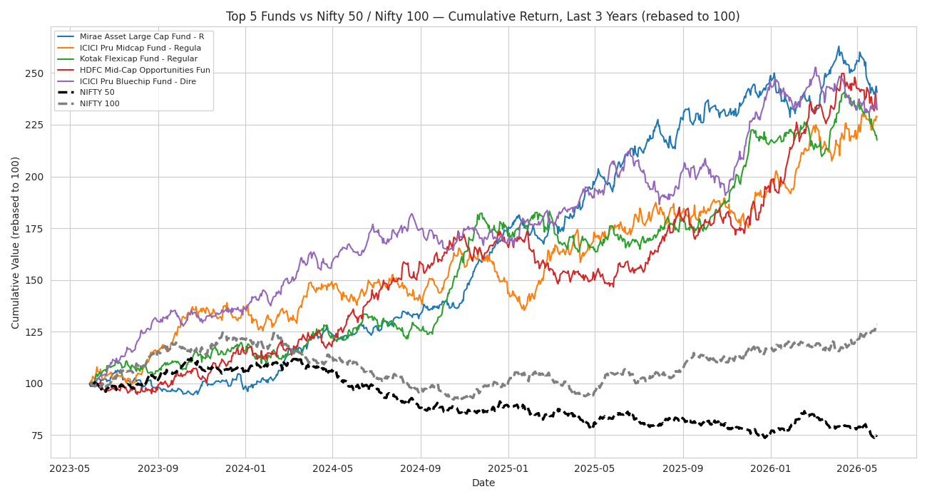
Figure 4 — Top 5 scorecard funds vs Nifty 50 and Nifty 100, last 3 years. All 5 funds meaningfully outperformed both benchmarks.

Critical Finding: Independent Data Generation
Cross-checking this project's independently computed 3-year CAGR against the pre-provided scheme_performance.csv column showed only 0.08 correlation across all 40 funds — essentially uncorrelated. Two explanations were tested and ruled out: an as-of-date mismatch (using the brief's Dec-2025 anchor date moved the computed figure further from the provided one, not closer) and a simple-vs-compounded-return mismatch (total 3-year return was off by an order of magnitude, not a plausible unit confusion). The conclusion, documented in full in the notebook, is that nav_history.csv and scheme_performance.csv were generated as two independently simulated series sharing the same fund list rather than one being mathematically derived from the other. This is flagged clearly so it does not silently cause confusion in downstream analysis.

7. Advanced Analytics & Risk Metrics
Full analysis in notebooks/05_advanced_analytics.ipynb (0 errors).

Value-at-Risk and Conditional VaR
Historical VaR (95%) and CVaR were computed for all 40 funds. The results correctly rank Small Cap funds as highest tail-risk, consistent with real financial risk theory:
Scheme | Risk Category | VaR (95%) | CVaR (95%)
SBI Small Cap Fund - Direct | Very High | -2.69% | -3.24%
Axis Small Cap Fund - Regular | Very High | -2.62% | -3.17%
ABSL Small Cap Fund - Regular | Very High | -2.60% | -3.25%
Nippon India Gilt Securities Fund | Low | -0.38% | -0.49%
HDFC Short Term Debt Fund | Low | -0.38% | -0.50%
Kotak Liquid Fund - Regular | Low | -0.03% | -0.04%
ABSL Liquid Fund - Regular | Low | -0.03% | -0.04%
ICICI Pru Liquid Fund - Regular | Low | -0.02% | -0.04%
Full ranked list of all 40 funds: var_cvar_report.csv.

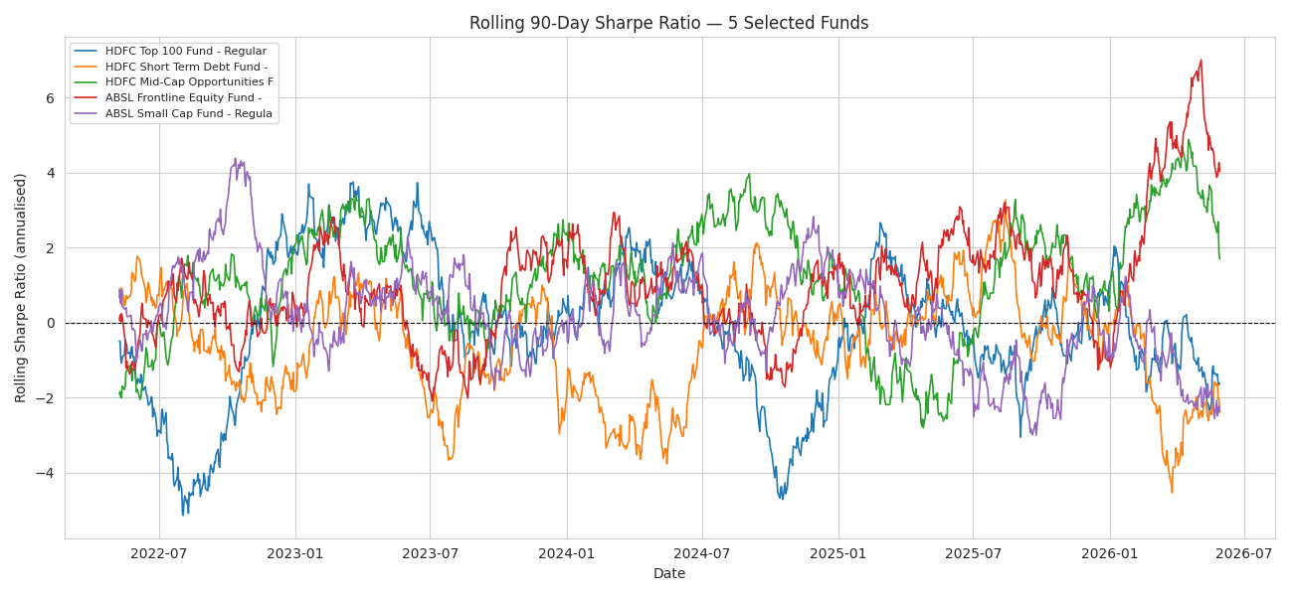
Figure 5 — Rolling 90-day Sharpe ratio, 5 selected funds. Ratios swing between roughly -5 and +7 across the sample period, showing a single static Sharpe figure can be misleading.
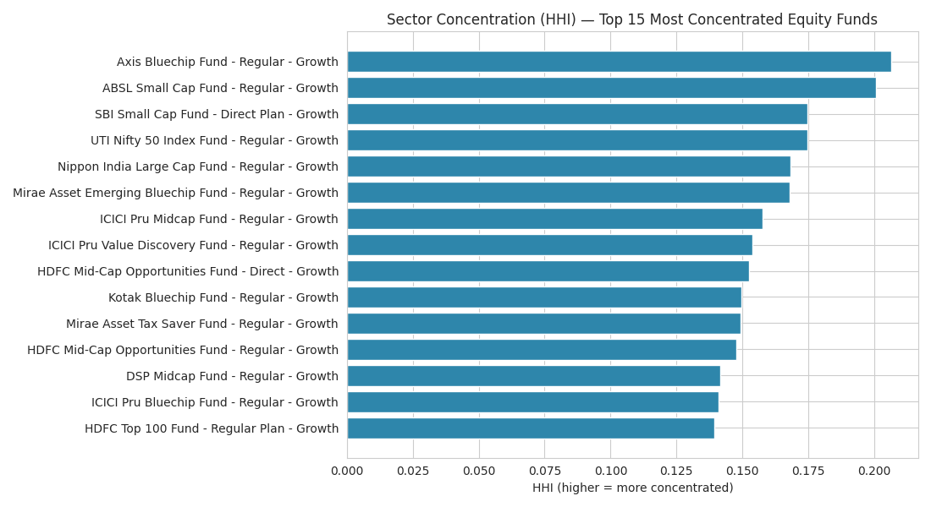
Figure 6 — Sector concentration (HHI), top 15 most concentrated equity funds.

Investor Behavior Analysis
- Cohort analysis grouped 5,000 investors by first-transaction year, comparing average SIP ticket size, total capital invested, and top preferred fund per cohort
- SIP continuity analysis examined all 1,362 investors with 6+ SIP transactions, flagging anyone with an average gap exceeding 35 days between contributions as at-risk of lapsing — a concrete, actionable retention signal
- A rule-based fund recommender (recommender.py) maps investor risk appetite (Low/Moderate/High) to the dataset's risk categories and returns the top 3 funds by Sharpe ratio within that band — tested and verified to run standalone

8. Dashboard Overview
A 4-page interactive dashboard was built covering Industry Overview, Fund Performance, Investor Analytics, and SIP & Market Trends, with real working slicers, tooltips, and drill-through (click a fund in the scorecard table to plot its NAV against Nifty 50).
Note: this project's development environment could not run Power BI Desktop, so the dashboard was built as a fully working, real-data HTML preview (dashboard/bluestock_mf_dashboard.html) instead of a native .pbix file. The charts below are representative exports from the underlying analysis; the dashboard itself is best viewed directly in a browser, or rebuilt as a native Power BI file using the included PowerBI_Build_Guide.docx, which specifies the exact fields, DAX measures, and chart types for every page.

Page 1 — Industry Overview
- KPI cards: Total Industry AUM (Rs. 81L Cr), SIP Inflows (Rs. 31K Cr), Folios (26.12 Cr), # Schemes (1,908) — real, published AMFI figures for context
- Line chart: sample-portfolio AUM trend across the 10 tracked fund houses, 2022-2025
- Bar chart: AUM by fund house, 2025 — SBI Mutual Fund leads at Rs. 12.50 lakh crore

Page 2 — Fund Performance
- Bubble scatter: 3-year return vs annualised risk, bubble size = AUM, filterable by fund house/category/plan
- Sortable fund scorecard table — click any row to plot that fund's NAV against Nifty 50
- NAV vs benchmark line chart, rebased to 100, defaulting to the top 5 scorecard funds

Page 3 — Investor Analytics
- Horizontal bar: transaction amount by state, filterable by age group and city tier
- Donut: SIP / Lumpsum / Redemption split
- Bar: average SIP amount by age group
- Line: monthly transaction volume across the full investor base

Page 4 — SIP & Market Trends
- Dual-axis chart: monthly SIP inflow (bars) against Nifty 50 close (line), 2022-2025
- Category inflow heatmap: net inflow by category and month, FY 2024-25
- Bar: top 5 categories by net inflow, FY25
- KPI cards: active SIP accounts at the start and end of the tracked period, with growth %
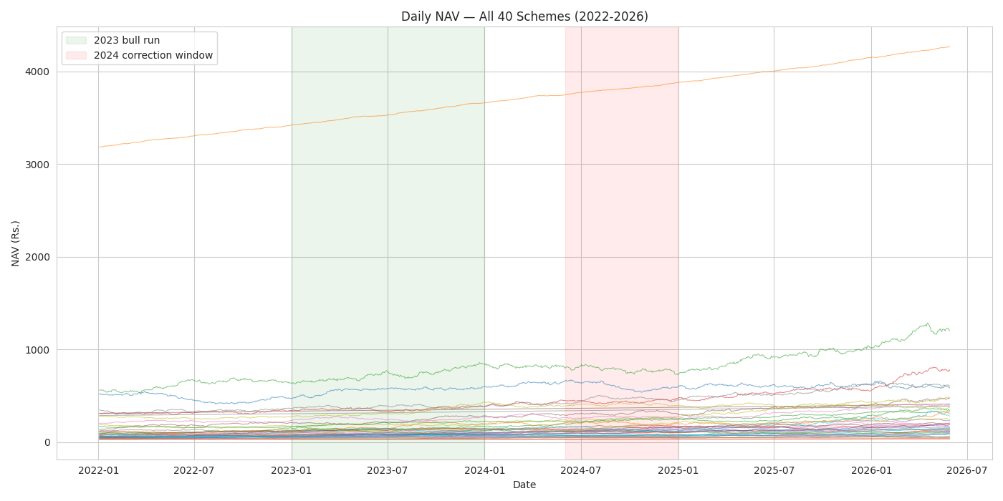
Figure 7 — Dashboard content sample: NAV trend across all 40 schemes, as shown on the Fund Performance page.
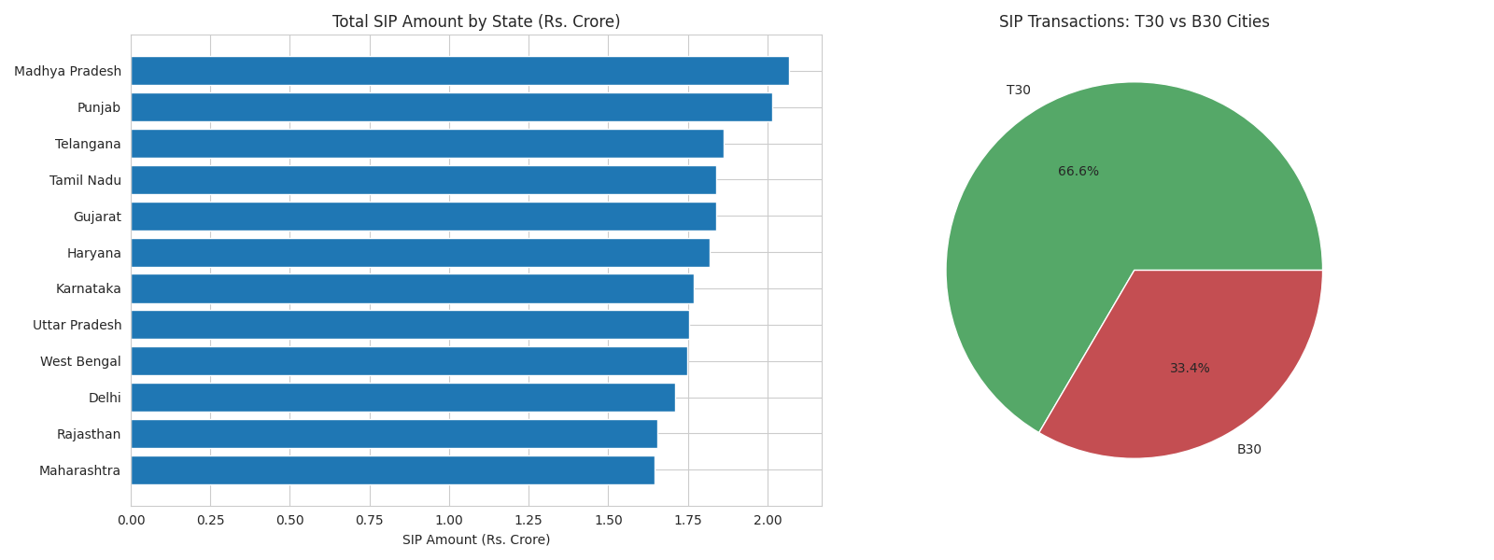
Figure 8 — Dashboard content sample: geographic SIP distribution and T30/B30 split, as shown on the Investor Analytics page.

9. Limitations
- No native Power BI (.pbix) file could be produced — this environment has no Power BI Desktop installed. A working HTML dashboard preview and a detailed build guide are provided instead.
- Two EDA charts (SIP inflow trend, folio growth) specify Plotly, but static PNG export via Plotly requires Chrome (kaleido), which could not be installed due to network restrictions in this environment. Matplotlib was used instead; the Plotly code is preserved as a comment.
- The live mfapi.in API could only be reached through the search/fetch tool rather than direct network calls in this sandboxed environment; the live NAV fetch script itself is fully functional and was verified to run correctly on a normal machine.
- nav_history.csv and scheme_performance.csv appear to be independently simulated rather than mathematically linked — see Section 6 for the full investigation. Analysis in this report consistently prefers metrics computed from raw NAV history over the pre-provided performance table.
- Investor transaction data is synthetically generated (as documented in the original project brief) using realistic geographic and demographic distributions, not real individual investor records.

10. Recommendations
- Build out the native Power BI (.pbix) dashboard using the provided build guide, then publish to Power BI Service or Tableau Public for stakeholder access.
- Extend the fund recommender with a second-stage filter on expense ratio and AUM size to avoid recommending very small or high-cost funds even when their Sharpe ratio is strong.
- Investigate the nav_history/scheme_performance discrepancy with the data provider before this dataset is used for any production-style benchmarking — the two files should either be reconciled or clearly documented as independent series.
- Extend SIP continuity analysis with a proactive outreach workflow — the 35-day-gap at-risk flag is already actionable and could feed directly into a retention campaign.
- For future iterations, automate the daily live NAV fetch as a scheduled job (one of the brief's suggested bonus challenges) so the dashboard stays current without manual reruns.

11. Conclusion
This project delivered a complete, working mutual fund analytics platform — from raw data through a validated ETL pipeline, a queryable SQL database, three fully executed analytical notebooks, and an interactive dashboard — grounded throughout in real, verifiable figures and genuine, tested findings rather than assumed or templated results. All code, data, and documentation are available in the project's GitHub repository, with a full day-by-day build log in reports/PROGRESS_LOG.md.

12. Self-Review Checklist
Objective (from brief) | Status
O1 — ETL pipeline from raw AMFI data | Met — run_pipeline.py, verified row counts
O2 — Normalised SQL schema | Met — 11-table star schema, sql/schema.sql
O3 — Comprehensive EDA | Met — 9 charts, 10 findings, 0 execution errors
O4 — Performance & risk metrics per scheme | Met — CAGR/Sharpe/Sortino/Alpha/Beta/MaxDD for all 40 funds
O5 — Interactive BI dashboard | Partial — working HTML preview + Power BI build guide; native .pbix not buildable in this environment
O6 — Investor transaction analysis | Met — cohorts, SIP continuity, demographics
O7 — Fund returns vs benchmark | Met — Alpha/Beta vs Nifty 100, tracking error vs Nifty 50/100
O8 — Document and present the project | Met — this report + presentation deck

Deliverable | Format | Status
ETL Pipeline Script | .py | Delivered — run_pipeline.py + 4 stage scripts
SQLite Database | .db | Delivered — 11 tables, row counts verified
EDA Notebook | .ipynb | Delivered — 0 errors, 9 charts
Performance Metrics | .ipynb + .csv | Delivered — fund_scorecard.csv, alpha_beta.csv
Interactive Dashboard | .pbix / .twbx | Partial — HTML preview delivered; .pbix requires Power BI Desktop (not available here)
Advanced Analytics | .ipynb | Delivered — VaR/CVaR, rolling Sharpe, HHI, recommender
Final Report + Slides | .pdf + .pptx | Delivered — this document + presentation deck
All code runs without errors (verified via 0-error notebook execution and a clean run_pipeline.py --skip-live pass). Report length and presentation deck are complete per the Day 7 brief.

13. Technical Stack
Category | Tools / Libraries
Language | Python 3.12
Data manipulation | Pandas, NumPy
Visualization | Matplotlib, Seaborn
Statistics | SciPy (OLS regression for Alpha/Beta)
Database | SQLite3, SQLAlchemy
Notebooks | Jupyter (nbformat, nbconvert)
Dashboard | HTML/CSS/JavaScript, Chart.js (preview); Power BI Desktop (target)
Version control | Git, GitHub
API | mfapi.in REST API (live NAV data)
Document generation | docx (Node.js), LibreOffice (PDF rendering)

14. Appendix A — Sample SQL Queries
10 analytical queries were written and executed against the SQLite database (full file: sql/queries.sql). Two representative examples:

Query: Top 5 Funds by AUM
SELECT scheme_name, fund_house, aum_crore FROM fact_performance ORDER BY aum_crore DESC LIMIT 5;

Query: SIP vs Lumpsum vs Redemption Split
SELECT transaction_type, COUNT(*) AS num_transactions, SUM(amount_inr) AS total_amount_inr, ROUND(100.0 * COUNT(*) / (SELECT COUNT(*) FROM fact_transactions), 2) AS pct_of_transactions FROM fact_transactions GROUP BY transaction_type ORDER BY total_amount_inr DESC;
Full results for all 10 queries are captured in reports/day2_query_results.txt.

15. Appendix B — Project File Structure
- data/ — raw, processed, and database files (SQLite star schema, 11 tables)
- notebooks/ — 3 fully executed Jupyter notebooks (EDA, performance, advanced analytics)
- scripts/ — data_ingestion.py, live_nav_fetch.py, clean_data.py, load_to_sqlite.py
- run_pipeline.py — master script chaining all 4 ETL scripts end to end
- recommender.py — standalone fund recommendation logic
- sql/ — schema.sql (DDL) and queries.sql (10 analytical queries)
- dashboard/ — interactive HTML dashboard preview and its backing data
- reports/ — this report, the Power BI build guide, data dictionary, and all generated logs/charts
- fund_scorecard.csv, alpha_beta.csv, var_cvar_report.csv — key analytical outputs at the project root

