JAVA PROGRAMMING LAB
Name: Jeshwanth Manchi
Roll No.: 160125737100
Class: IT2

Case Study 1: Employee Salary Processing

AIM :
To develop a Java program using the Java 8 Stream API, Lambda Expression, filter() and forEach() to identify and display employees earning more than ₹50,000.

Description:
A company maintains employee details such as name, department, and salary. The HR department wants to identify employees earning more than ₹50,000.
The employee records are stored in a collection. Using the Java 8 Stream API, the records can be filtered based on salary. A Lambda Expression specifies the condition, and forEach() displays the selected employees.
This approach reduces lengthy loops and makes employee data processing simple and readable.

CODE :
import java.util.*;
class Employee {
String name;
String department;
double salary;
Employee(String name, String department, double salary) {
this.name = name;
this.department = department;
this.salary = salary;
}
void display() {
System.out.println("Name: " + name);
System.out.println("Department: " + department);
System.out.println("Salary: ₹" + salary);
System.out.println();
}
}
public class Main {
public static void main(String[] args) {
List<Employee> employees = Arrays.asList(
new Employee("Anvesh", "IT", 65000),
new Employee("Rahul", "HR", 48000),
new Employee("Priya", "Finance", 72000),
new Employee("Kiran", "IT", 45000),
new Employee("Sneha", "Marketing", 58000)
);
System.out.println("Employees earning more than ₹50,000:");
employees.stream()
.filter(e -> e.salary > 50000)
.forEach(e -> e.display());
}
}

Sample Output:
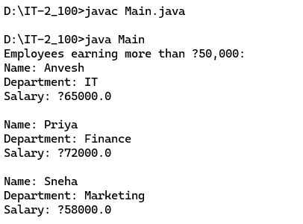

Case Study 2: Student Result Processing

AIM:
To develop a Java program using the Stream API and Lambda Expression to identify students who scored 75 marks or above and display their details.
Description:
A college needs to process student results and identify students who have scored 75 or more marks. Instead of checking each student's marks manually, Java's Stream API makes the process easier and faster.
Student details such as name, roll number, and marks are stored in an ArrayList. The filter() method selects students who scored 75 or above, a Lambda Expression defines the condition, and forEach() displays the qualified students' details.
This program helps the examination department process results efficiently and can also be extended to find the highest marks, calculate average marks, and identify scholarship-eligible students.
CODE:

import java.util.ArrayList;
import java.util.List;

class Student {
String name;
int rollNo;
int marks;

Student(String name, int rollNo, int marks) {
this.name = name;
this.rollNo = rollNo;
this.marks = marks;
}

void display() {
System.out.println("Name: " + name
+ ", Roll No: " + rollNo
+ ", Marks: " + marks);
}
}

public class StudentResult {
public static void main(String[] args) {
List<Student> students = new ArrayList<>();

students.add(new Student("Rahul", 101, 85));
students.add(new Student("Priya", 102, 72));
students.add(new Student("Arjun", 103, 90));
students.add(new Student("Sneha", 104, 68));
students.add(new Student("Kiran", 105, 78));

System.out.println("Students scoring 75 or above:");

students.stream()
.filter(s -> s.marks >= 75)
.forEach(s -> s.display());
}
}

Output:
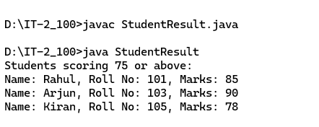

WEEK-9

Program 1: Lambda Expression
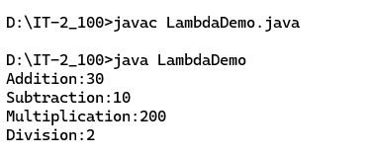

Program 2: Functional Interface with Lambda
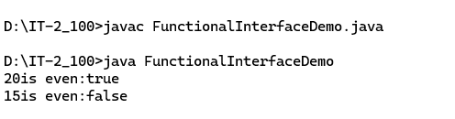

Program 3: Stream API
