# Cloud Computing AWS Assignment

Name: Jeshwanth Reddy (M15744088)

Email: depajy@mail.uc.edu

**Website URL**

<ec2-54-209-97-186.compute-1.amazonaws.com>

**Registration page**

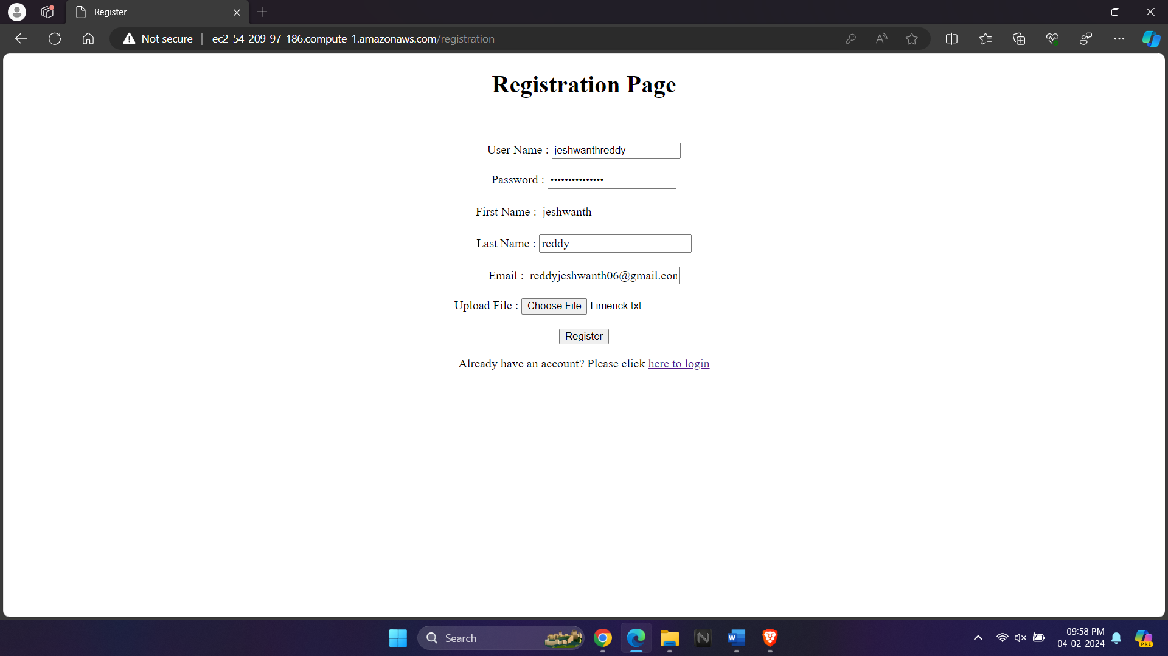

**Login page:**

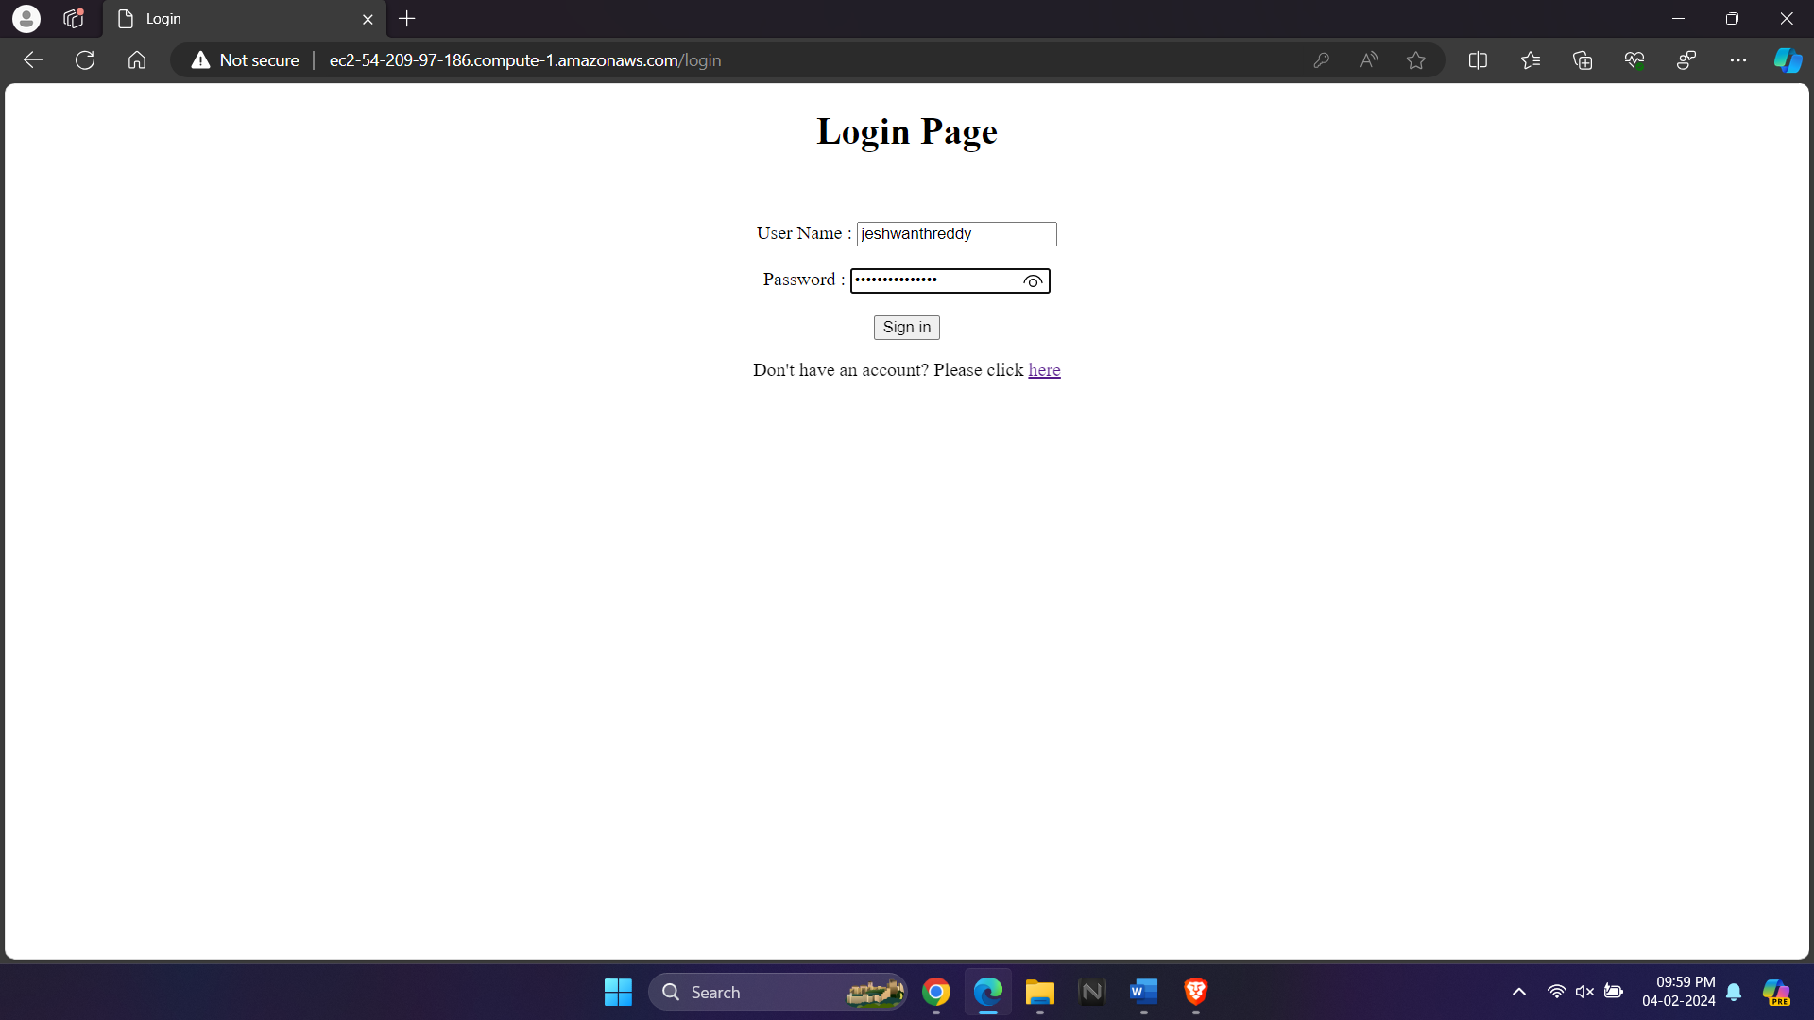

**Output Page**

