TASK 2 of Linux Project

This is a report on how I create the VM for the webserver and the part of the configuration

VM #2 – Web Server VM:

Create a VM Linux server installation following these guidelines:

•

CentOS 7 should be used for this server

•

The server should be deployed

WITHOUT

a GUI

•

Must be connected to the classroom / SAIT network (can be via NAT if needed)

•

Manual partitioning should be chosen during installation and the following

separate partitions created of appropriate size:

o

/

o

/boot

o

swap

o

/var

o

/opt

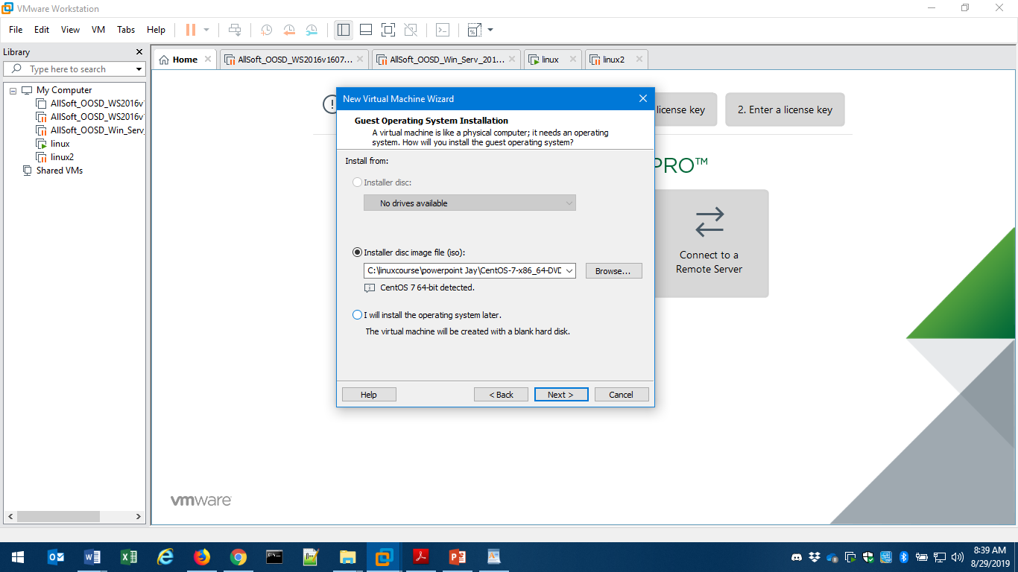

I create a new linux vm using the same file and configuration used in the class

For the software selection I selected basic web server

I will install a full stack Lamp after

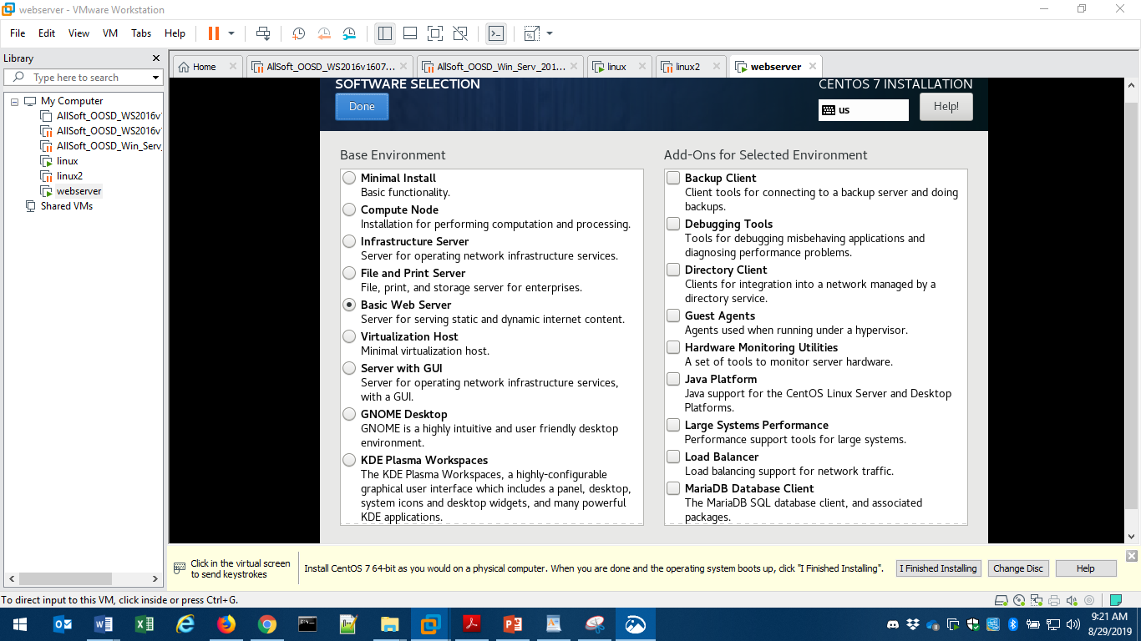

I added the partition with their sizes

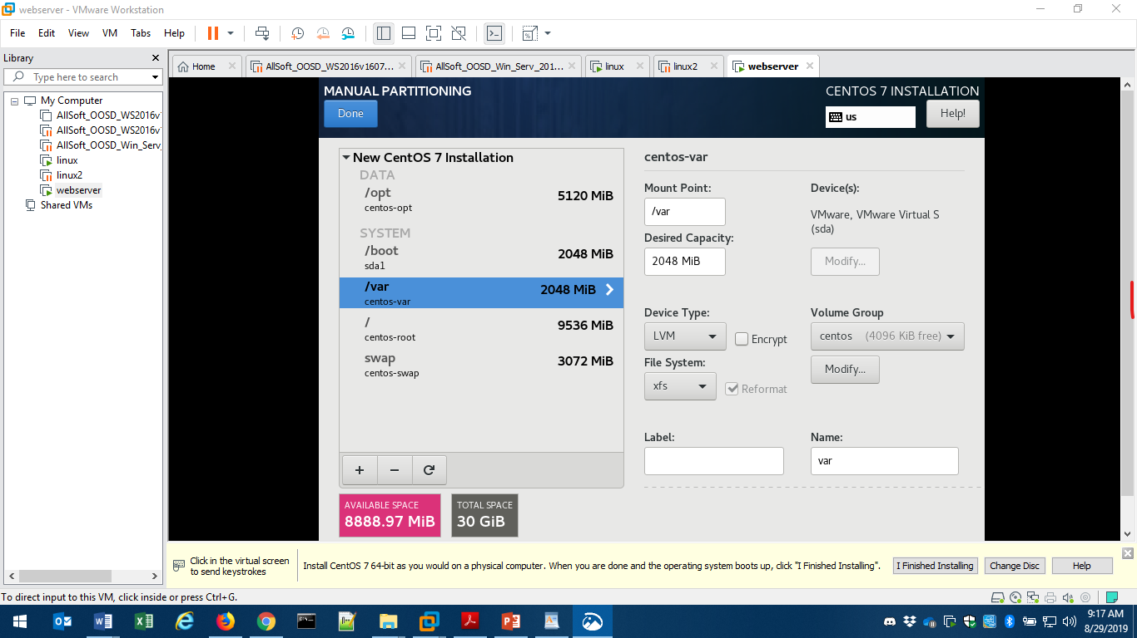

I activate network by clicking on network tab and I set date and time by clicking on the date and time tab

During installing I set a root and admin user

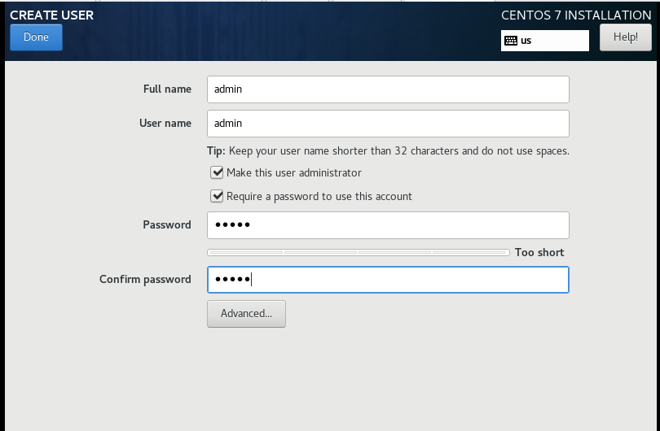

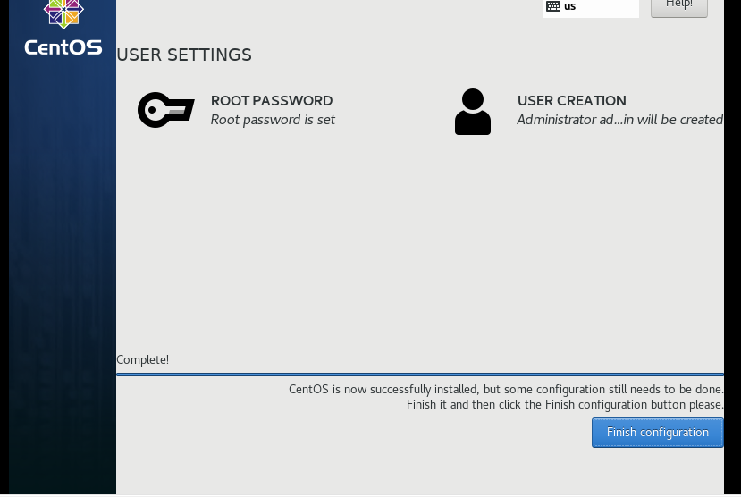

Click on finish configuration, will ask to reboot click on reboot

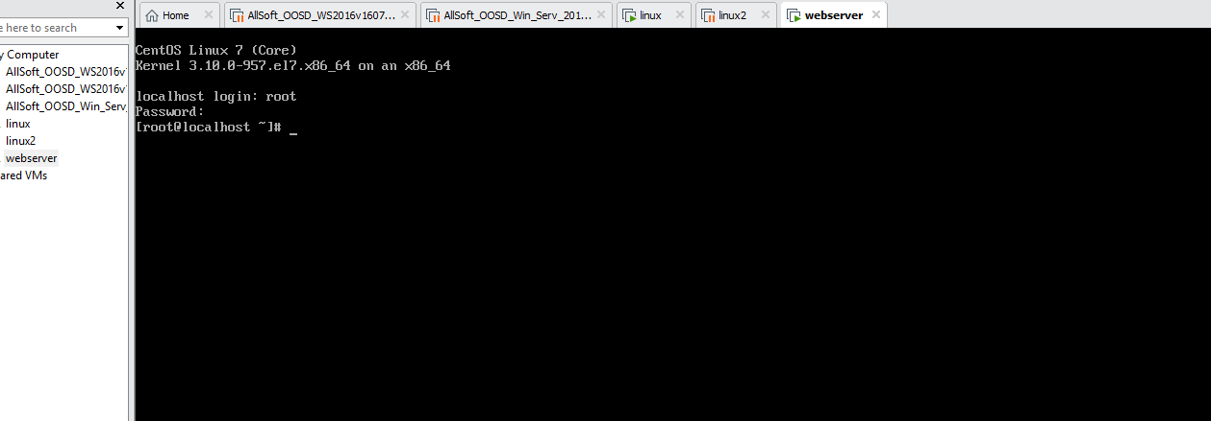

Will ask u to login , I loged in as root

U have to run an update by typing

1. $ sudo yum update

The system will prompt tow times you just say yes

U should have this screen at the end

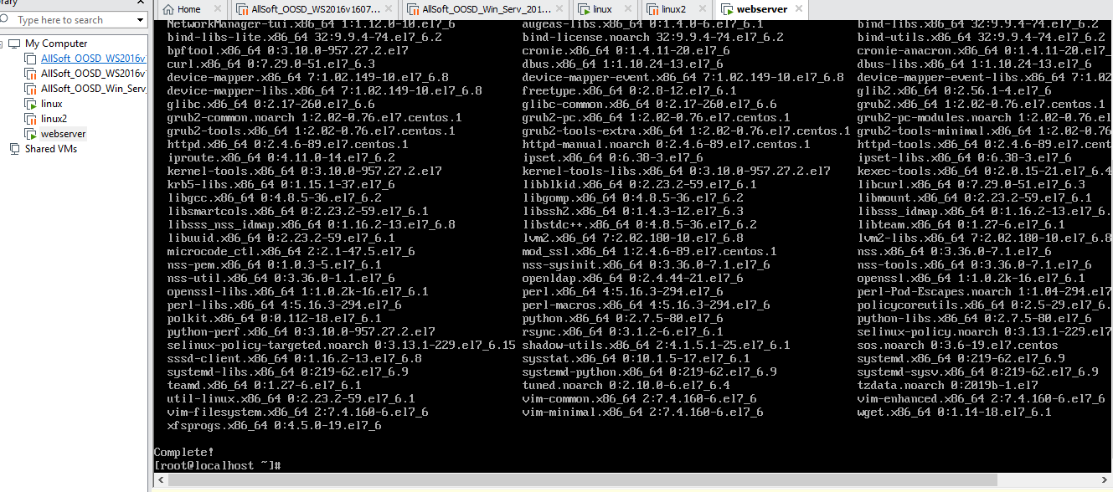

Second step of installing Lamp is to run install of Apache

1. $ sudo yum install httpd

When prompted to confirm the installation, press Y and Enter to proceed.

In our case its already installed

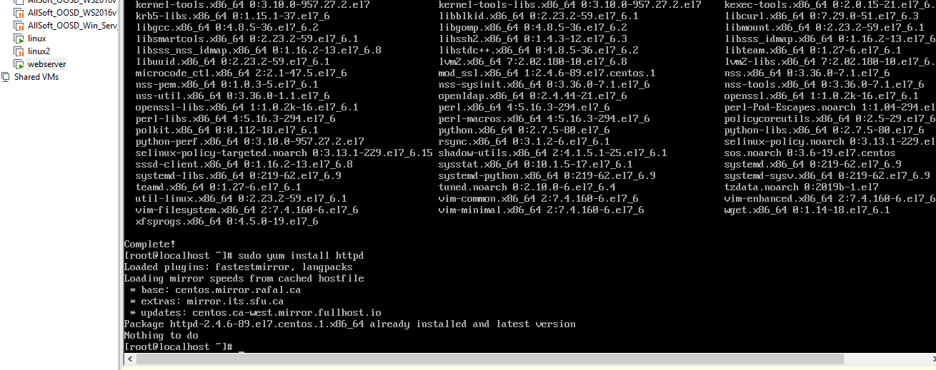

We need to start the apache server

Next, we need to start Apache service by running the command below:

1. $ sudo systemctl start httpd.service

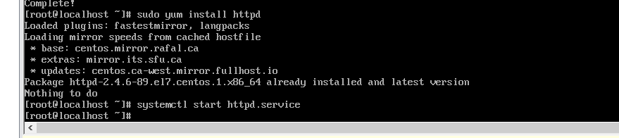

Next, you need to activate Apache to start during system boot using the command below:

1. $ sudo systemctl enable httpd.service

U should get this page

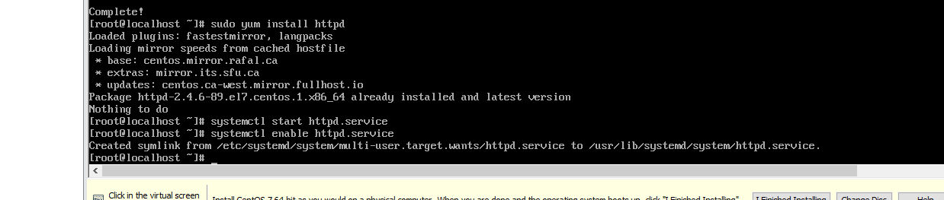

U need to install Mariadb on your webserver to do that

U need to run this command

$ sudo yum install mariadb-server mariadb

Confirm the installation, by pressing Y and Enter.

Now that the MariaDB installation was completed successfully, we can run the command below to start the service.

$ sudo systemctl start mariadb

U should get this screen when starting mariadb

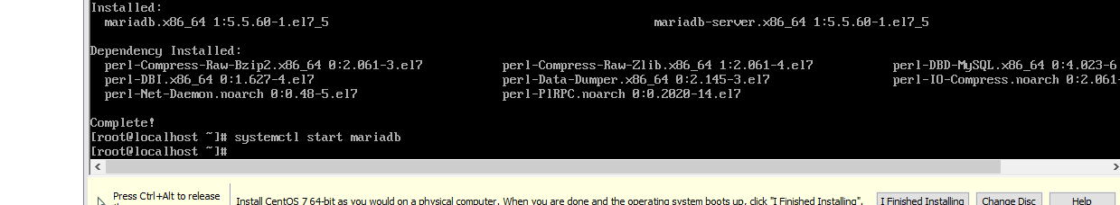

We can install PHP and MySQL extension using the yum package installer by typing the command below:

1. sudo yum install php php-mysql

Confirm the installation, by pressing **Y**and **Enter**.

U should get this page after installing that

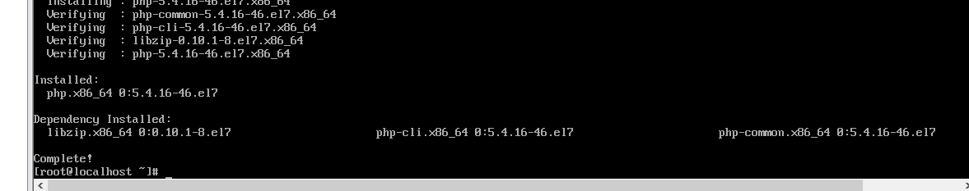

We need to restart Apache web server one more time for it to work with PHP by typing:

1. $ sudo systemctl restart httpd.service

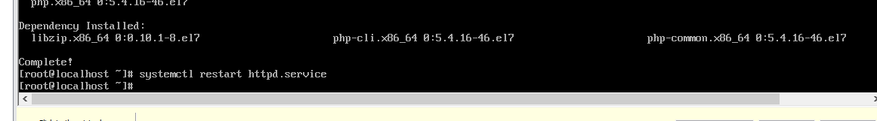

We need to open apache port 80 using this command

sudo iptables -I INPUT -p tcp --dport 80 -j ACCEPT

then we need to create a web page index.html in the following directory

vim /var/www/html/index.html

putting this code and save

<html>

<h1>Hello world</h1>

</html>

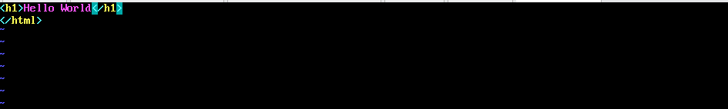

Then u need to type this command to get the ip adress

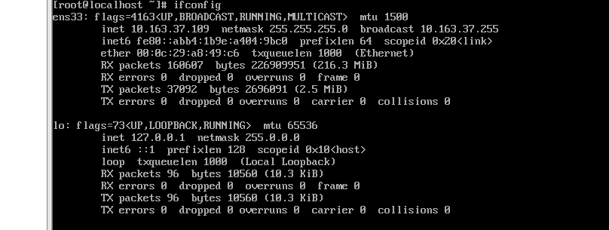

My ip address is 10.163.37.109

U just need to open firefox or any web browser into your desktop

And type the following addresses

10.163.37.109/index.html

U should be able to see this

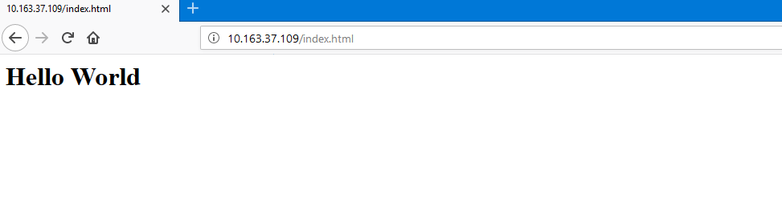

The firewall should be enabled and configured appropriately to allow http and ssh

access to the server, but no non-required network access

To start and enable firewalld u need to type this 2 commands



To allow http and ssh type the following command

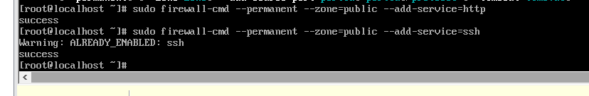

A cron job should back up the web page content to another disk partition by

creating a tar file. This backup should run hourly. The job should be a script that

also creates a log file related to the backup it is performing.

First we need to create a separate partition and

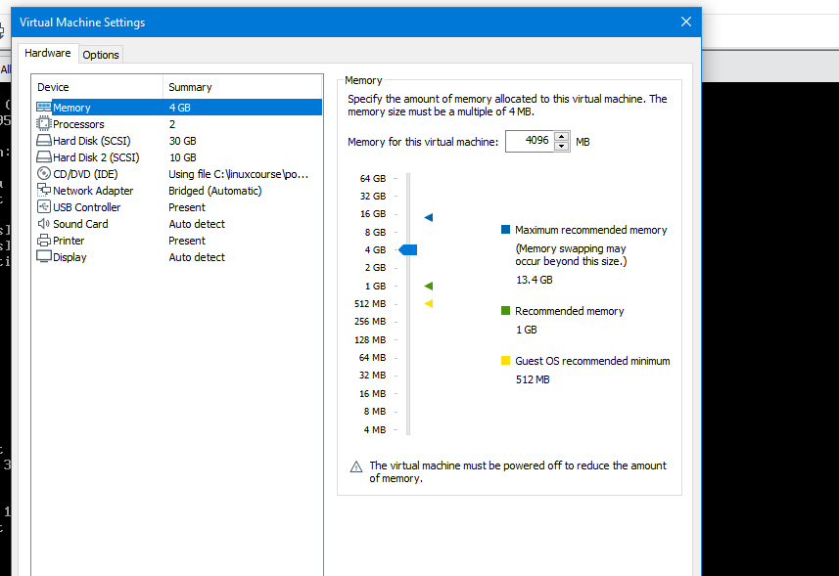

Reboot machine and type this command

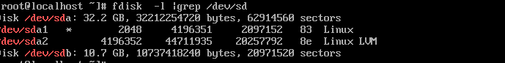

U need to set a partition using

Fdisk /dev/sdb

Formatting a new partition using

Mkfs.ext4 /dev/sdb

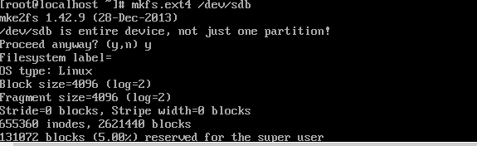

Create a new folder

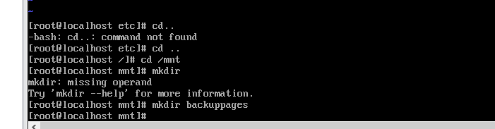

Mount the partition

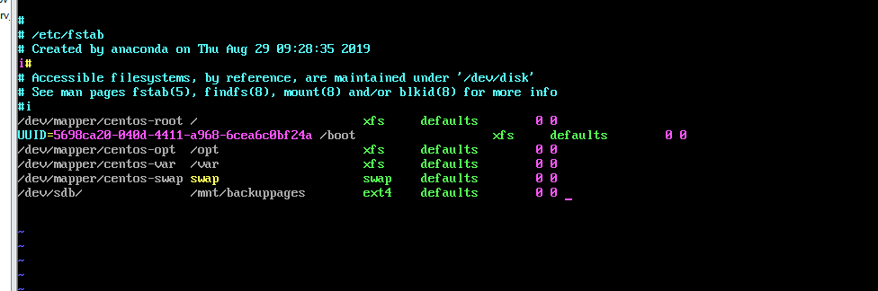

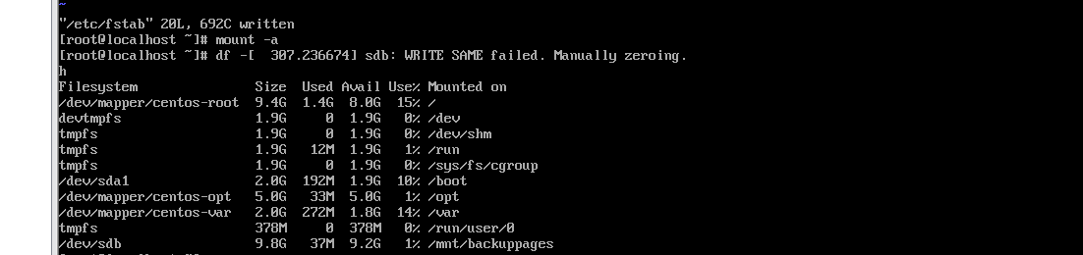

Create a script backup.sh

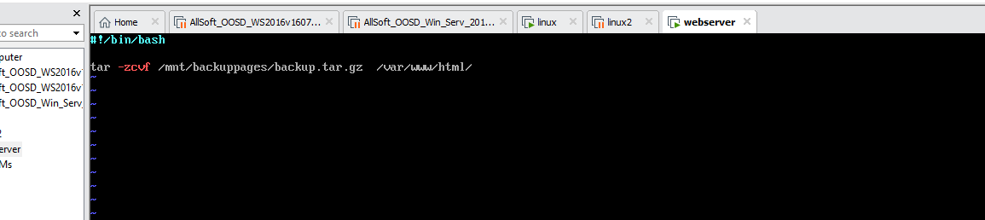

Add the command to the crontab

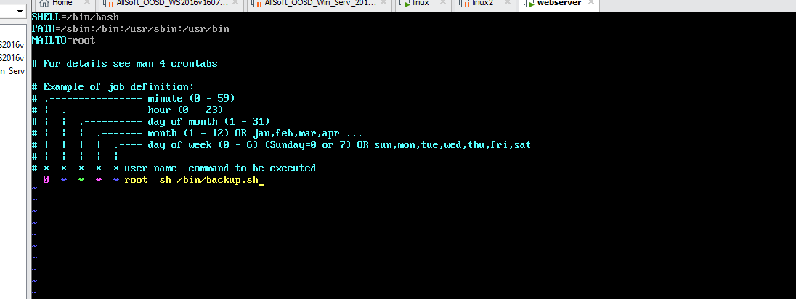

This server should have the NFS share from the File Server mounted.

