TASK #3

1. Go to <https://www.centos.org/>

2. Click on “Get Centos Now” and then click on “DVD ISO”

3. Once you download is complete, go to VMWare Workstation.

4. Click on “Create a New Virtual Machine”

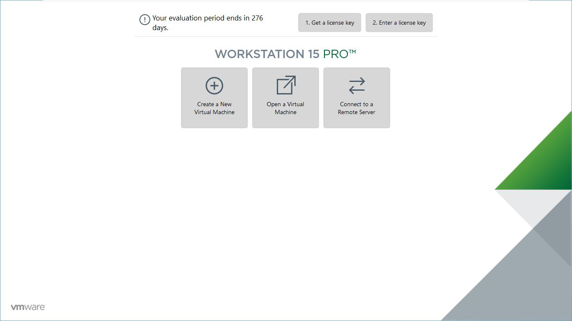

5. Choose “Custom (advance) option, then click Next

6. Virtual Hardware Compatibility, choose Workstation 15.x then click Next

7. Choose the file you dowloaded and click Next

8. Virtual Machine image: you can write any name you want for your virtual image, then click Next

9. Memory for this virtual machine: 4096MB, click Next

10. Choose NAT instead of bridged networking as sometimes bridged networking doesn’t work

11. IO Controller types: LSI Logic

12. Virtual Disk type: SCSI

13. Choose “Create a new virtual disk”

14. Maximum disk size: 30 GB

15. Click Next on default option and uncheck the “Power on this virtual machine after creation”.

16. Click Finish

Below in the installation summary which you have to work on.

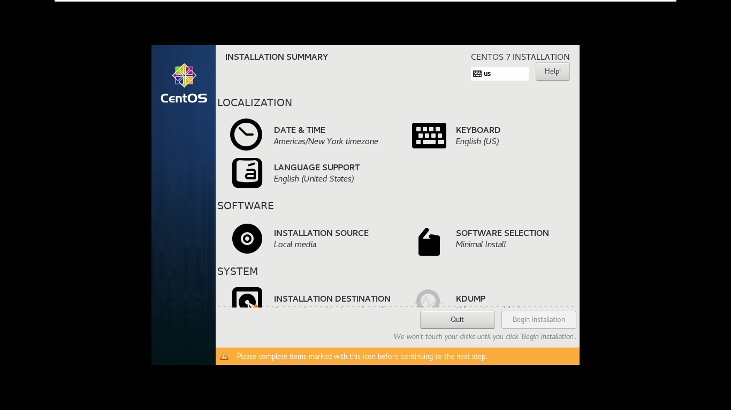

Choose File and Print Server

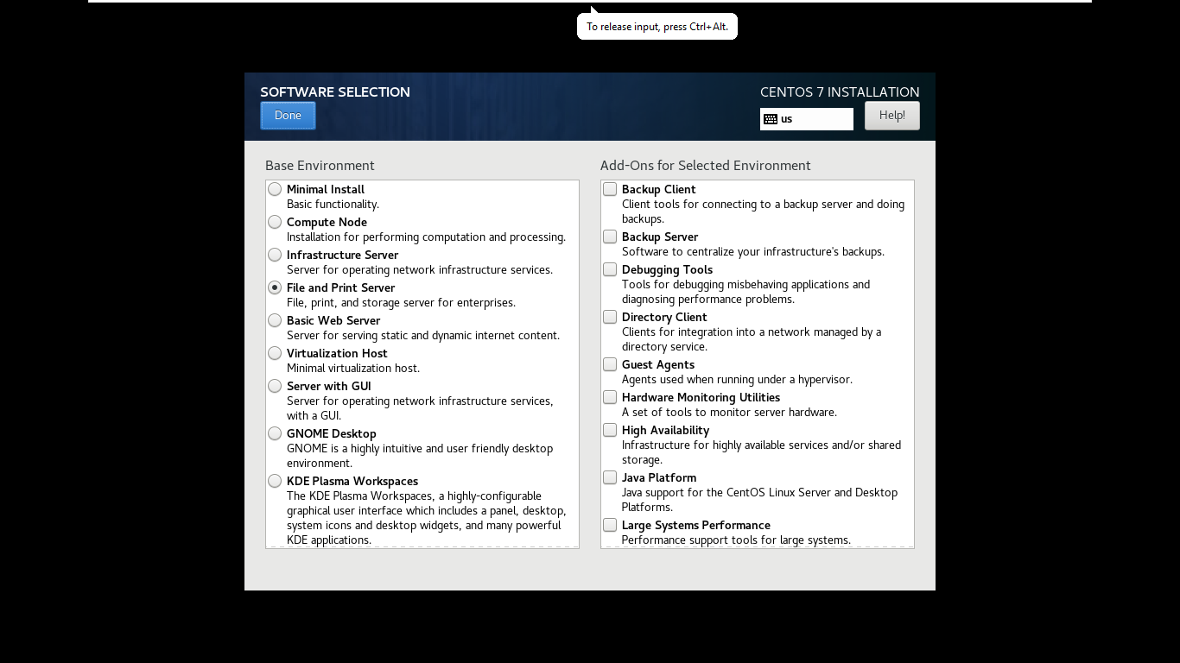

Make sure /share and /share2 has same size.

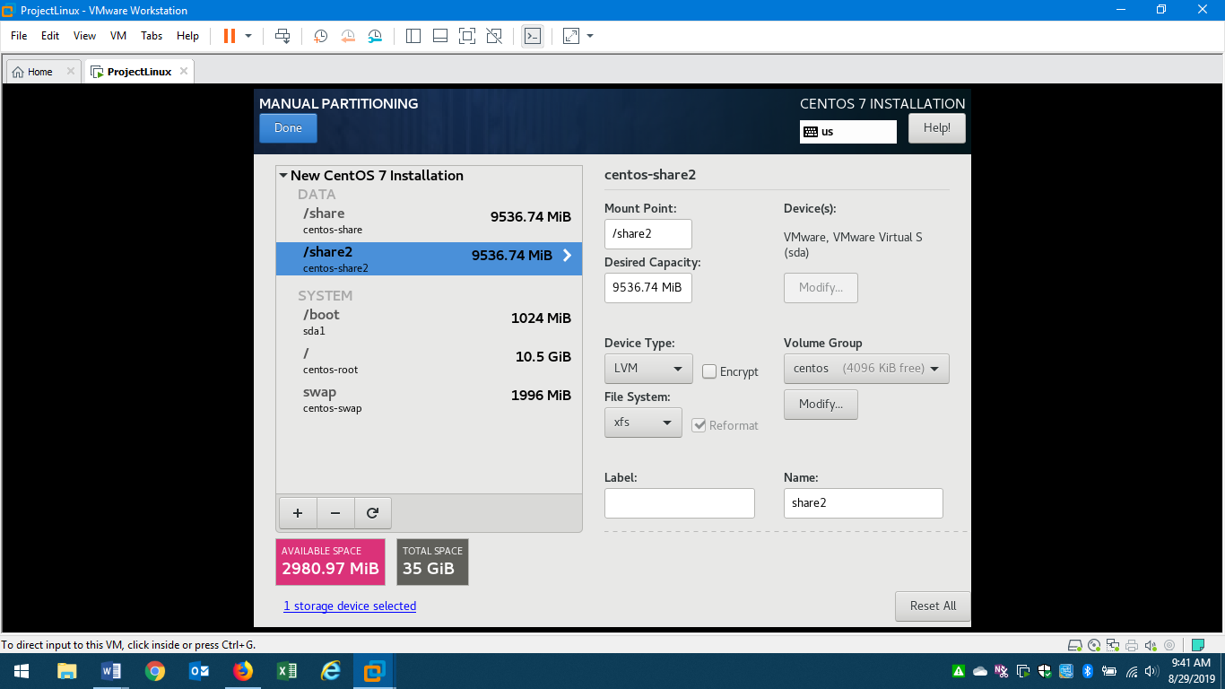

Click on “ON” for Network connection

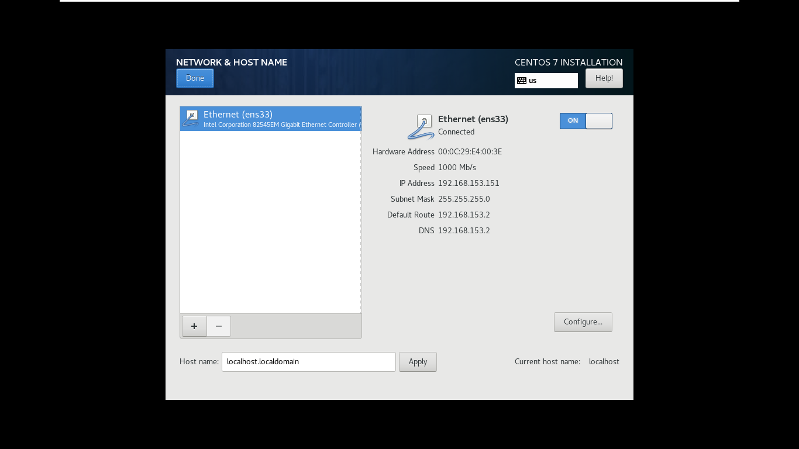

At the end, this is how your screen should look like.

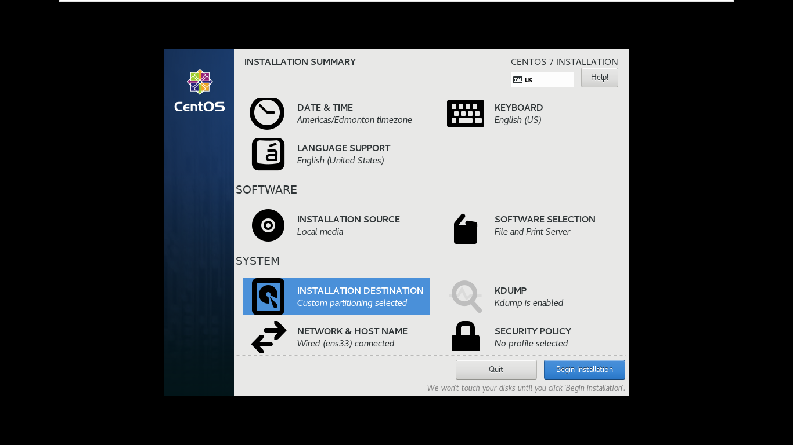

Now you need to Install Samba service

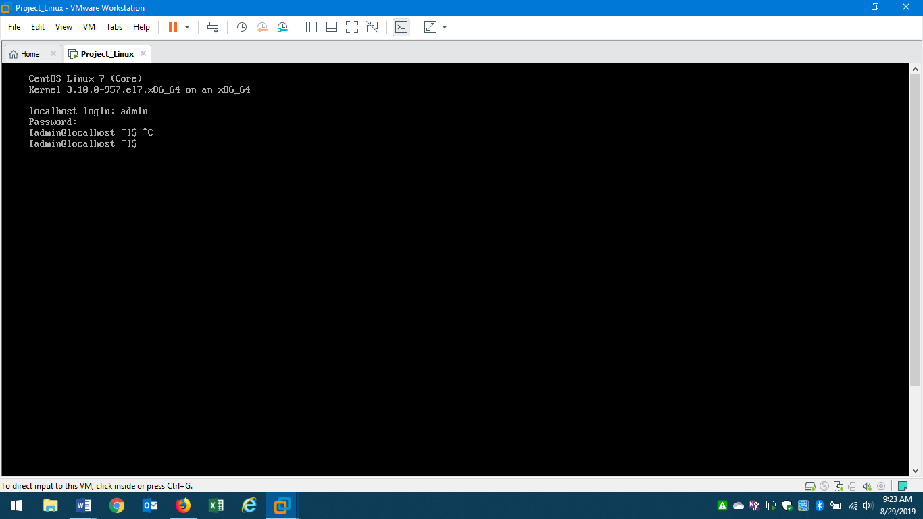

Show Samba installation is Complete

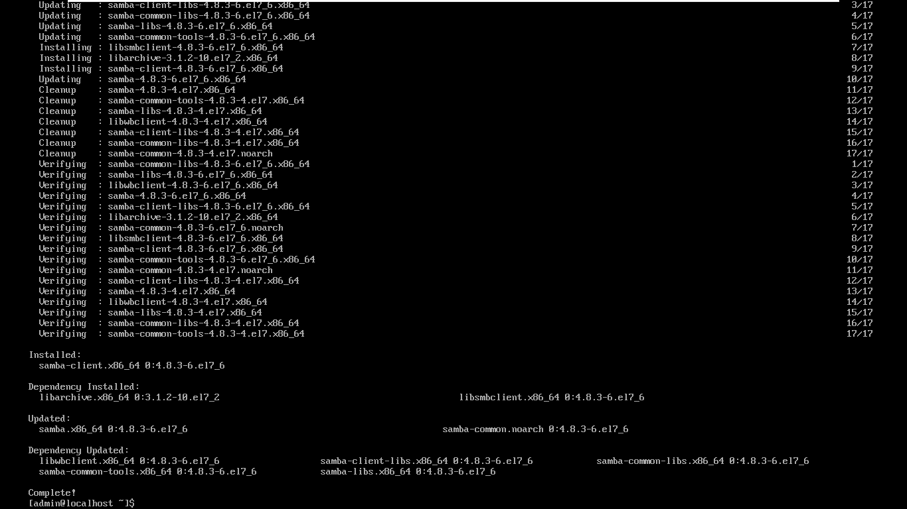

Write below commands to set up Shares with Samba

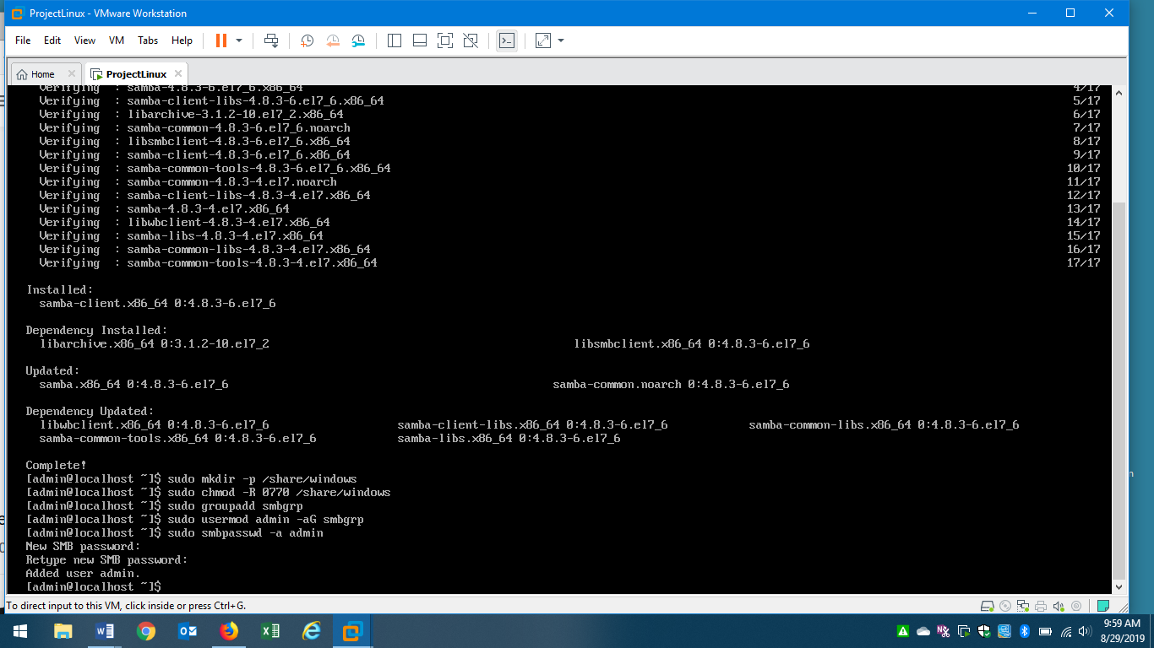

Once you get the IP address, go to host and enter your credentials.

