**Executive Summary**

The Ram Wireless home office in Virginia faces inefficiencies in outdated regional service area assignments, increasing travel costs and reducing productivity, particularly in offices like Staunton, Warrenton, Richmond, and Tappahannock. COO Melissa Jones and Regional Manager Vance Larson engaged Verve Consulting to optimize store assignments while balancing costs, staff satisfaction, and productivity.

We are a group of graduate students—Riddhi Rungta, Gauri V Nair, Sarath S, Jesin K Joy, and Adarsh Bharathwaj—pursuing a Master’s in Decision Analytics. This project was assigned as part of our coursework to apply optimization techniques to real-world business problems. Our work was divided into two phases: in Phase I, completed in October 2024, we explored optimization methods using spreadsheet models, and in Phase II, we refined our approach, implemented the model in AMPL, and provided detailed recommendations.

The project aimed to reassign 43 stores to four regional offices—Staunton, Warrenton, Richmond, and Tappahannock—while minimizing travel costs, including mileage and salary for travel time. The solution had to respect feasibility constraints, ensuring that staff hours available at each office were not exceeded. Initial nearest-office assignments violated these constraints, necessitating an optimization model.

Using Mixed Integer Linear Programming (MILP) in Solver, AMPL, and Python, we developed a cost-effective solution that met all constraints. The total optimized cost was $195,479.31, slightly higher than the nearest-office assignment but feasible and practical. Geographic anomalies were identified in six store assignments, with Stafford County notably assigned to Richmond instead of closer Warrenton, despite shorter distance and time. Reassigning Stafford to Warrenton reduced costs but violated feasibility constraints, exceeding available merchandising hours in Warrenton by 98.38 hours.

We recommend implementing the optimized assignments to balance costs and constraints. Adjustments for geographically anomalous assignments can be explored to further enhance the solution’s practicality and efficiency.

**Essential Components of this optimization problem**

**Problem Statement**

Ram Wireless seeks to realign store assignments for Staunton, Richmond, Warrenton, and Tappahannock regional offices to minimize travel costs, which include both mileage and employee salary expenses. Each store must be assigned to a regional office in a way that reduces unnecessary travel time, allowing employees more time for store-related work. Additionally, each regional office’s available hours for each task area must be respected. This phase extends the analysis by explicitly incorporating constraints related to area-specific availability of hours and examining how the assignment aligns geographically to ensure practical implementation.

**Data:** [Realignment_Data](https://docs.google.com/spreadsheets/d/1sTPwyc7ygoGAdVtQGwjI82LMN4XMYFQk/edit?gid=1455537597%23gid=1455537597)

**Data Definition**

$R=\left\{Staunton, Richmond, Warrenton, Tappahannock\right\}$ be the set of regional offices $S=\left\{ Albemarle county, Amherst county, Augusta county, …. \right\}$ 
 be the set of stores $A=\left\{ Inventory, Payroll, Hiring, Marketing, Merchandising \right\}$ 
 be the areas for each store. $mileage_cost$ 
 = state mileage rate, which is $0.585 per mile $salary_per_hour=$ 
 the salary being paid to the employees ($26 per hour) $mileage_{ji}=$ 
the distance in miles from store $j$ to regional office $i, i∈R and j∈S$ $travel_time_{ji}=$ 
 time required in hours to travel from a store $j$ to a regional office $i, i∈R and j∈S$ $base_hours_required_{ja}=$ 
 hours required annually by each store $j$ in area $a, j∈S and a∈A$ $hours_available_{ia}=$ 
 employee hours available annually in regional office $i$ in each area $a, i∈R and a∈A$ $round_trips_{ja}=$ 
number of annual round trips required by store $j$ in area $a, j∈S and a∈A$

For round trips, we took the annual trips and then in a new sheet, we doubled it to make round trips for our calculation.

**Objective in Words**

Decide the assignment of stores to regional office ( i.e., which regional office each store must be assigned to )

Such that the **total cost** ( mileage cost + salary cost ) is **minimized**

Subject to the following constraints:

1. Each store must be assigned to only one regional office
2. The hours required by stores assigned to a regional office for each area must not exceed the hours available in that office for that area.

**Assumptions:**

1. Salary costs for travel are based on annual round trips, doubling the distance to account for return trips.
2. The base hours required for each area (e.g., inventory, payroll) and the number of trips per year are consistent across all stores. This is an estimate given by the employees.
3. External factors such as traffic, weather, or unforeseen delays are not considered in the travel time or cost calculations.

**Decision Variables**

Let $x_{ji}$ be the binary decision variable such that,

$x_{ji}=\left\{\begin{aligned}1, store j is assigned to regional office i, i∈R ;j∈S \\ 0, otherwise, i∈R ;j∈S \end{aligned}\right.$

**Algebraic Formulation**

**Minimize $\sum_{j∈S}{\sum_{i∈R}{x_{ji}*( mileage_cost*mileage_{ji}* \sum_{a∈A}{round_trips_{ja} +salary_per_hour *travel_time_{ji}*\sum_{a∈A}{round_trips_{ja})}}}}$**   
 **:Total_Cost**

**Subject to the constraints:**

**AssignEachStoreOnce: $$\sum_{i∈R}{x_{ji}}=1 , j∈S$$**

**HoursConstraint**: $$\sum_{j∈S}{x_{ij}*(base_hours_required_{ja}+round_trips_{ja}*travel_time_{ji})}≤hours_available_{ia}, i ∈R, a∈A$$

**Modeling Methodology**

First, we divided our data in different sheets for the purpose of easy importing. Other than round trips, no other calculation was done in the excel spreadsheet. The optimization problem was approached using **Mixed Integer Linear Programming (MILP)**, which is particularly effective for solving problems with both continuous and discrete decision variables. To ensure robustness and consistency, **Solver, Python, and AMPL** were utilized to model and solve the problem. The results from all three methods aligned, confirming the reliability of the approach.

**Implementation**

An implementation of the above problem using AMPL and Python is as follows:

**Results**

The optimization results indicate that the total cost of $195,479.31 was achieved under the provided constraints. The optimization successfully achieves the objective of minimizing costs while satisfying the operational and assignment constraints.

Assignment of the stores to the regional offices is detailed below:

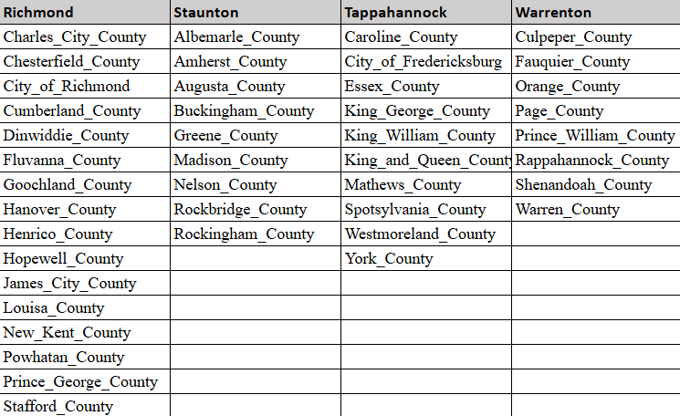

Employee hours annually used at each regional office in each department area is given below:

|  |  |  |  |  |  |
| --- | --- | --- | --- | --- | --- |
| **Regional Offices** | **Inventory** | **Payroll** | **Hiring** | **Marketing** | **Merchandising** |
| Richmond | 2584.8 | 2730.2 | 1097.58 | 1128.62 | 671.4 |
| Tappahannock | 735.24 | 943.98 | 1783.04 | 374.1 | 708.28 |
| Warrenton | 755.96 | 1418.44 | 1514.58 | 624.9 | 828.78 |
| Staunton | 1836.42 | 3399.58 | 7594.92 | 1075.22 | 457.88 |

**Unusuality, Mitigation and Ramifications**

The solution found in Part B for the assignment of stores to regional offices does not entirely make sense when considering the geographic regions demarcated by the assignments. We referred to the [Virginia Map](https://docs.google.com/document/d/1IYXrbYlPBAMLTfh6lAMgo4x8uPYPEa9vv-GEe6TIrA8/edit?tab=t.0) and found the following unusuality. Six counties are not being assigned to the closest regional office, which increases travel time and subsequently raises costs. The most notable one is Stafford County, while the others include Madison County, City of Fredericksburg, Fluvanna County, Greene County, and Spotsylvania County.

Upon further examinations we noticed that these discrepancies arise due to violations of feasibility constraints despite cost reductions when assigning these counties to their closest regional offices.

The most unusual thing we noticed was Stafford County assignment. It was assigned to Richmond rather than Warrenton which was the closest. The mileage to Warrenton was 42 miles and the time taken was 0.96 hours whereas the mileage to Richmond was 67 miles and the time taken was 1.08 hours.

For fixing this issue, we assigned it to Warrenton instead of Richmond. That reduced the costs; however, this allocation violates the feasibility constraint as the required merchandising hours exceed the available hours in the merchandising area in Warrenton by 98.38 hours. This implied that the hours available was not enough for that store to be allocated there. This led to feasibility issues.

Similarly, Madison County could have been assigned to Warrenton instead of Staunton for cost efficiency, but this was infeasible as Warrenton lacked the merchandising hours needed.

The City of Fredericksburg faces a similar issue. Assigning it to Warrenton instead of Tappahannock would reduce costs but exceeds the available hours in both merchandising and inventory areas in Warrenton.

Fluvanna County, if assigned to Staunton instead of Richmond, would have reduced costs but violated the payroll area feasibility constraint due to insufficient available hours in Staunton.

For Greene County, assigning it to Staunton instead of Warrenton would lower costs but violates payroll area constraints in Staunton.

Finally, Spotsylvania County, which could have been allocated to Warrenton instead of Tappahannock for cost reduction, exceeds the available merchandising hours in Warrenton, rendering this allocation infeasible.

In conclusion, while assigning these counties to their closest regional offices would minimize costs, the feasibility constraints related to the availability of resources in merchandising, payroll, and inventory areas necessitated these allocations. These constraints ensure that operational requirements are met, even if it means higher travel costs and less geographic alignment.

Link to the workings for Part C: [Link to the workings for Part C](https://docs.google.com/spreadsheets/d/1v3LyUZ5LWOIbiIU1HZiqS78Tm3NPftgJU7A5fHTmLjQ/edit?gid=0%23gid=0)

**Conclusion**

**Recommendations**

**Appendix**

Interaction with the AI can be found here: [AI Interaction](https://chatgpt.com/share/674e0089-dee8-8009-b667-b7753ab2f2dd)