Network Output

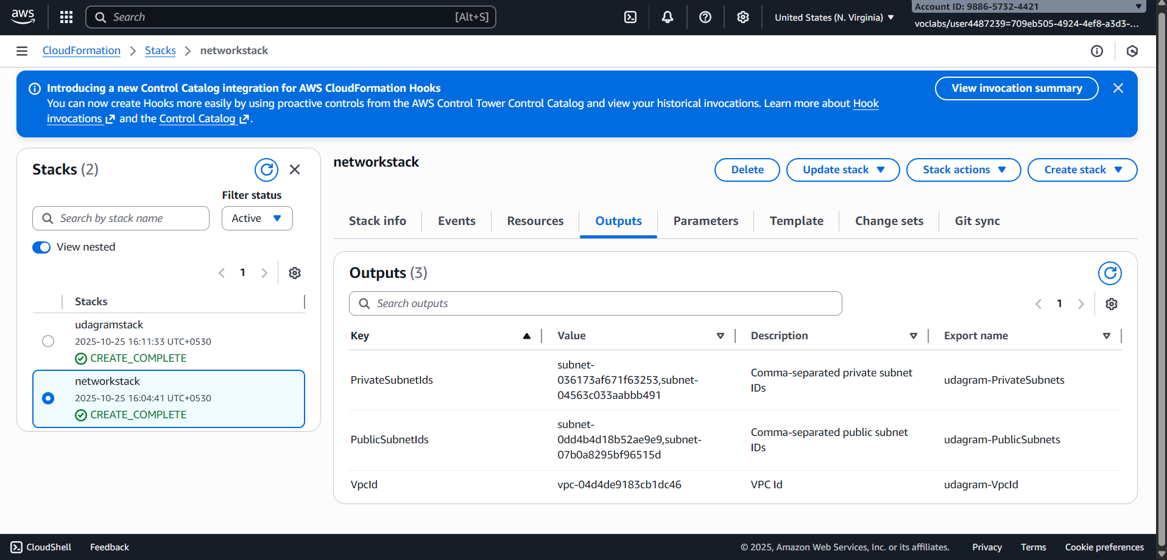

Load Balancer Link

<http://udagra-loadb-ue8ds9nspdsv-274501811.us-east-1.elb.amazonaws.com/>

Output

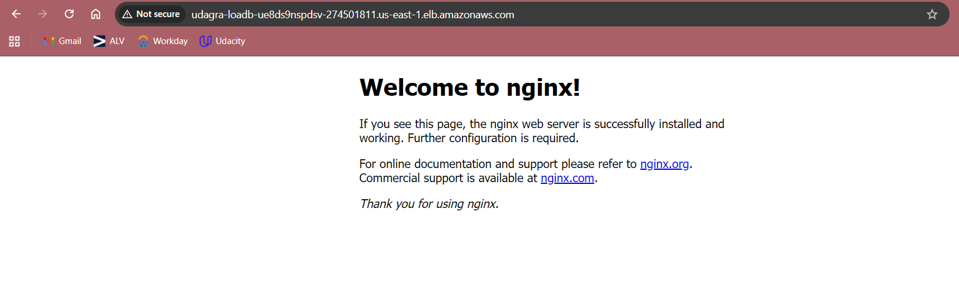

Udagram Output

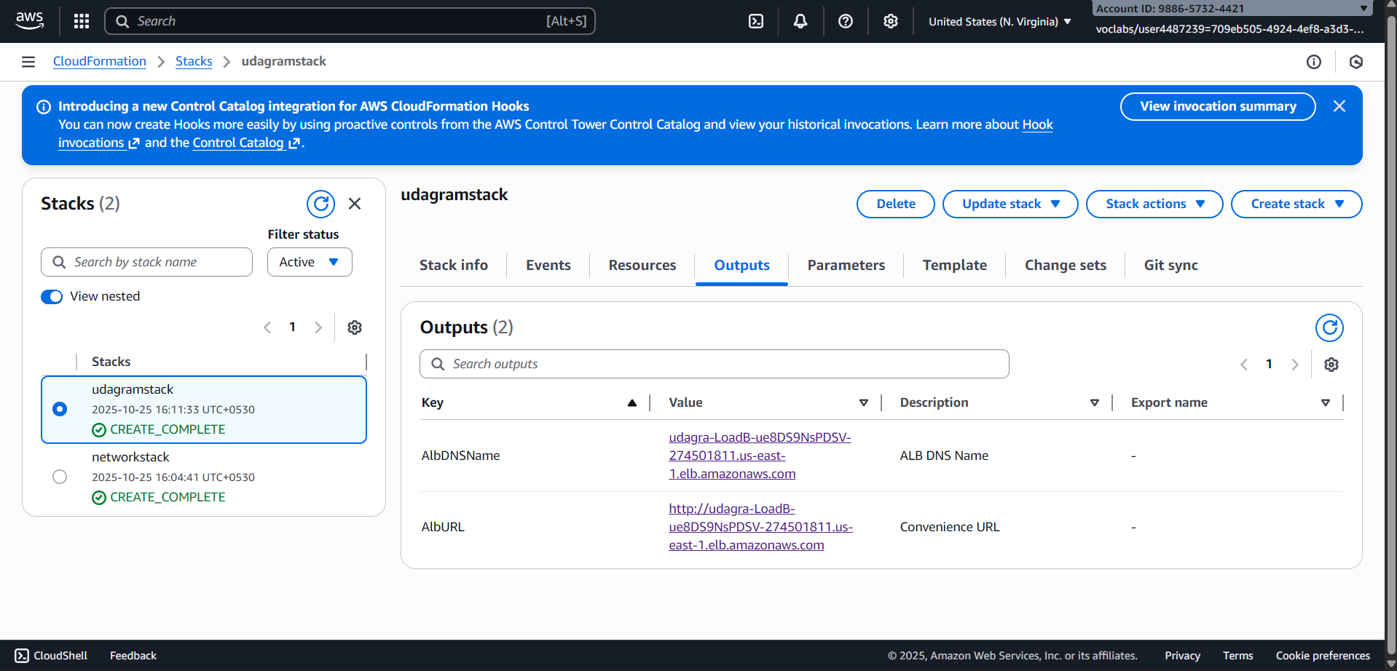

Target Groups

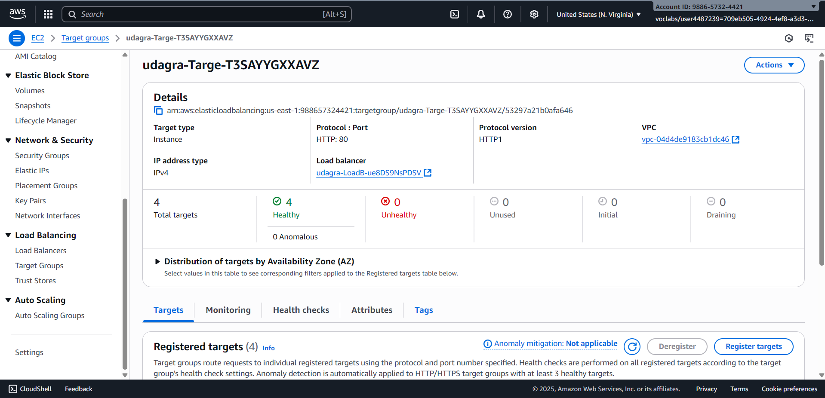

Listeners and Rules

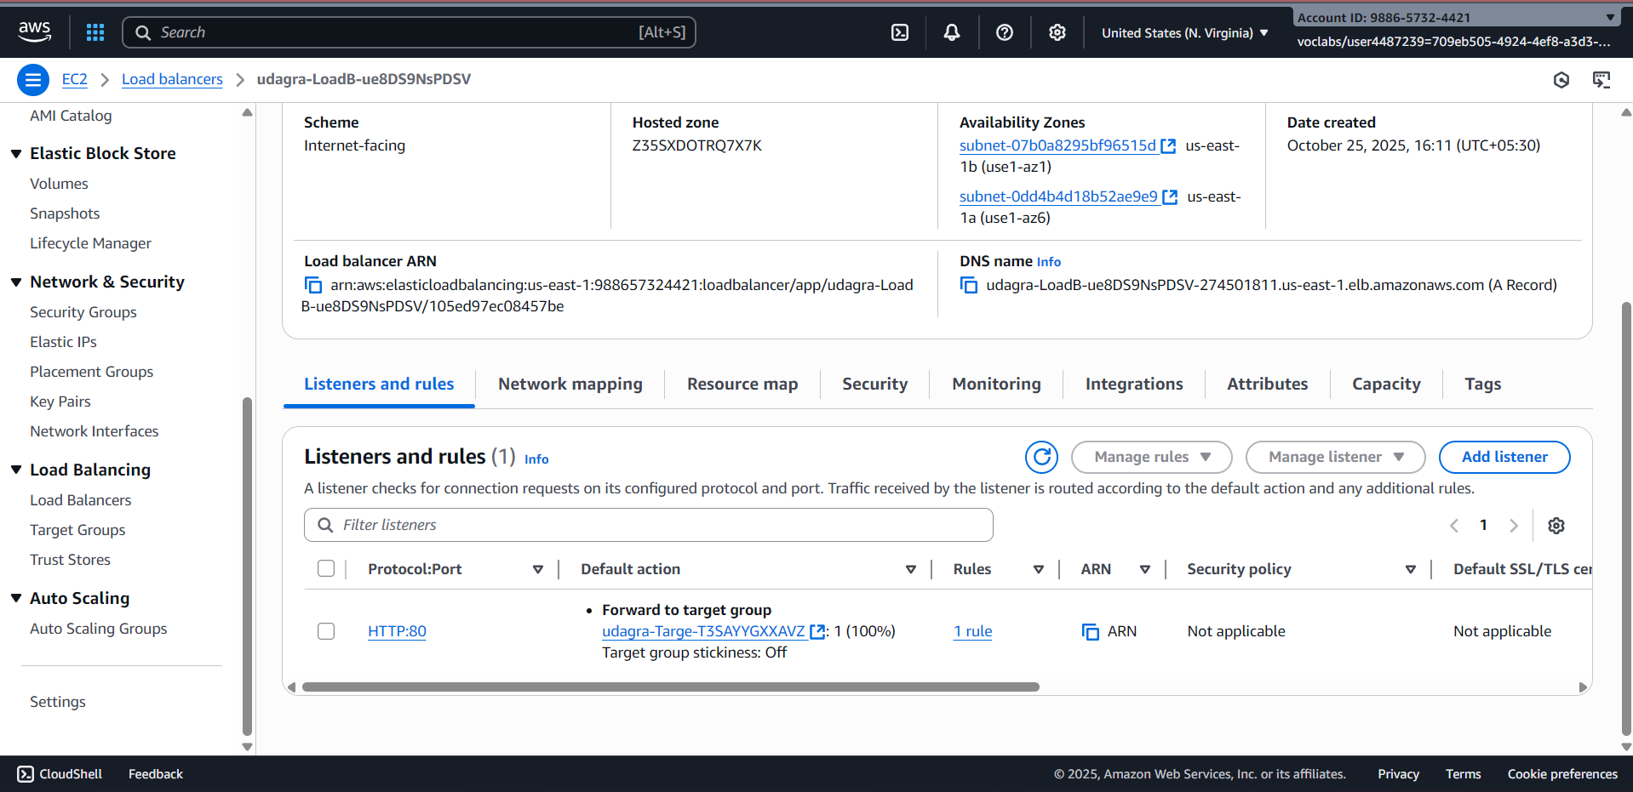

Infrastructure Diagram

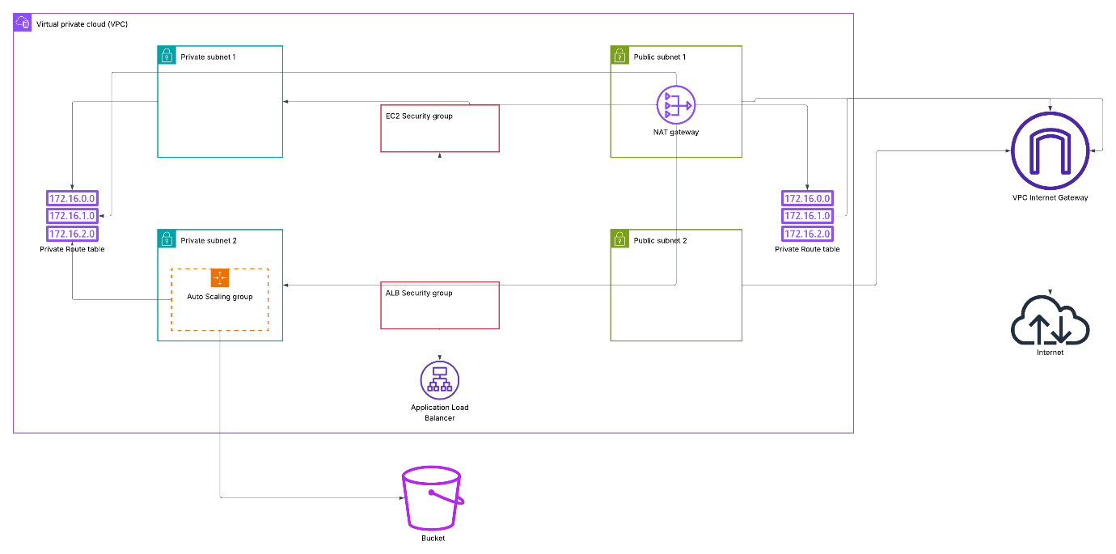

Updates

Udagram stack creation

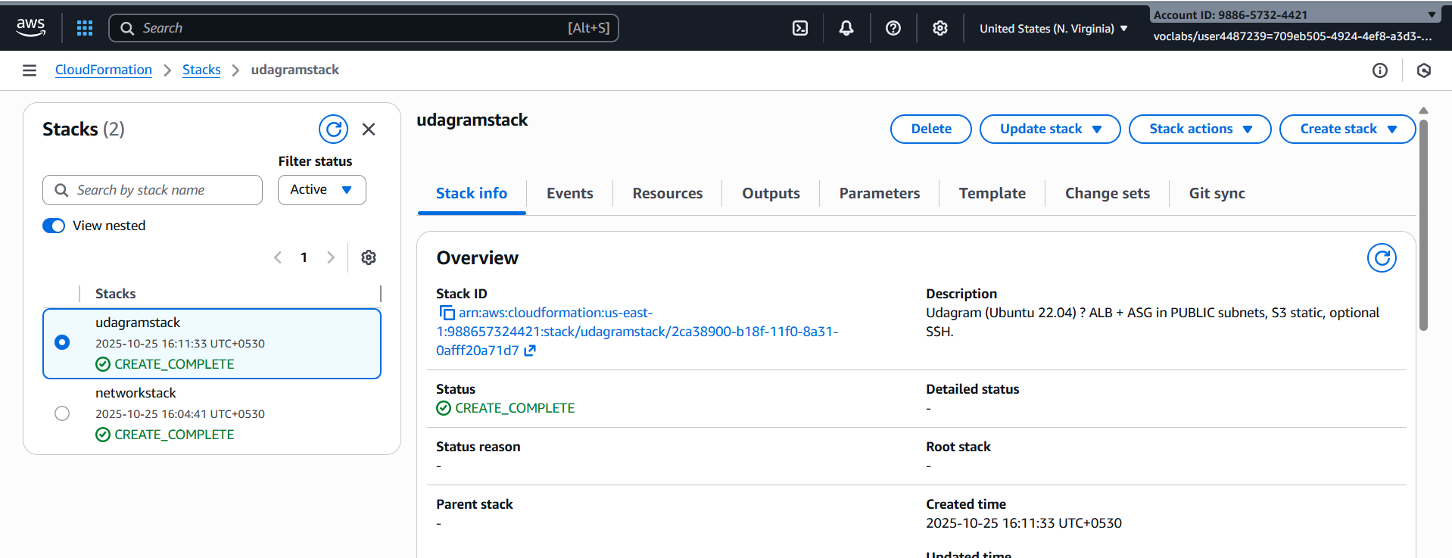

Udagram stack output

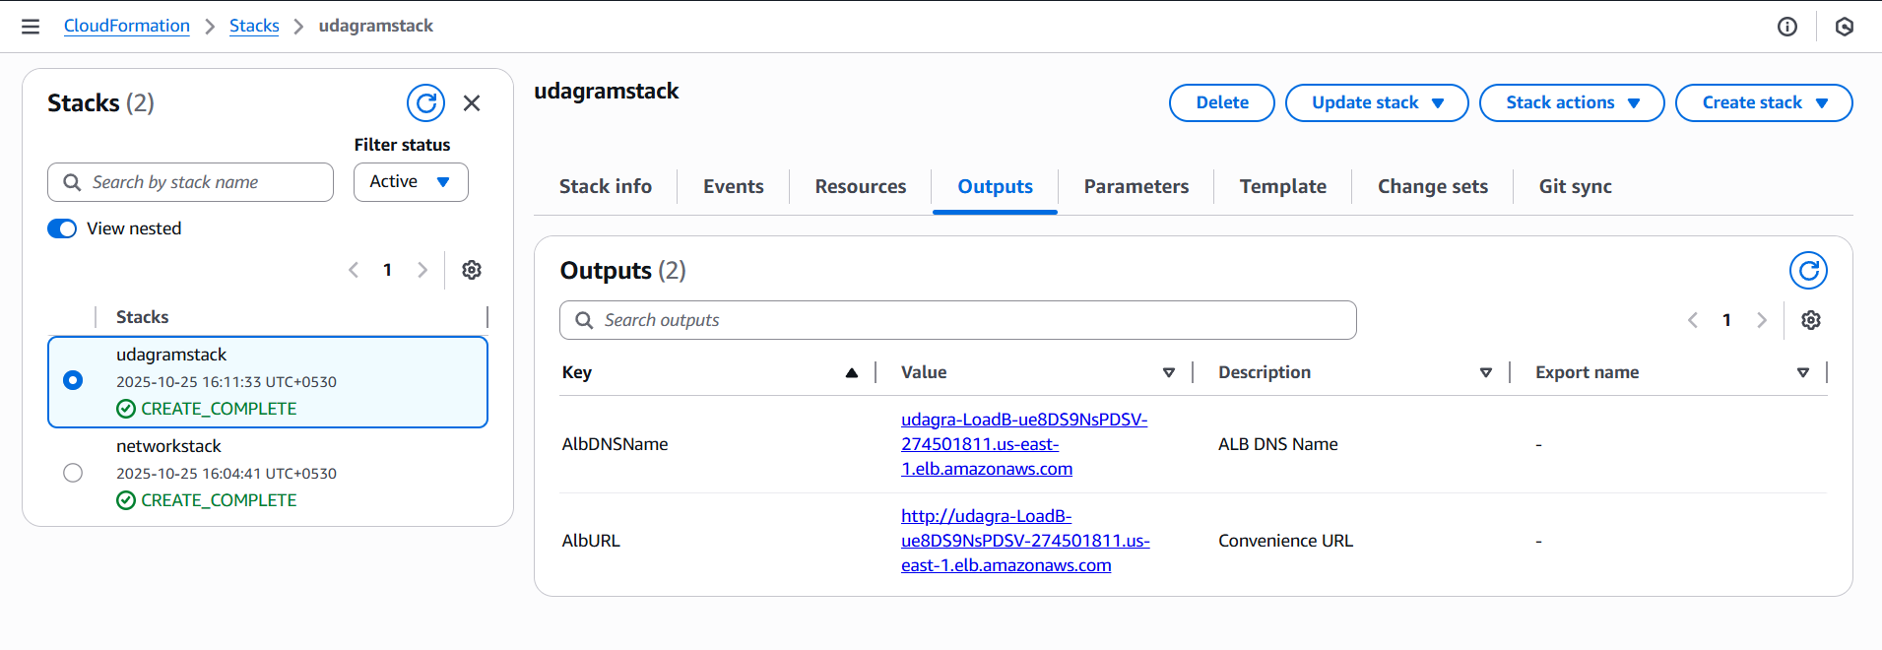

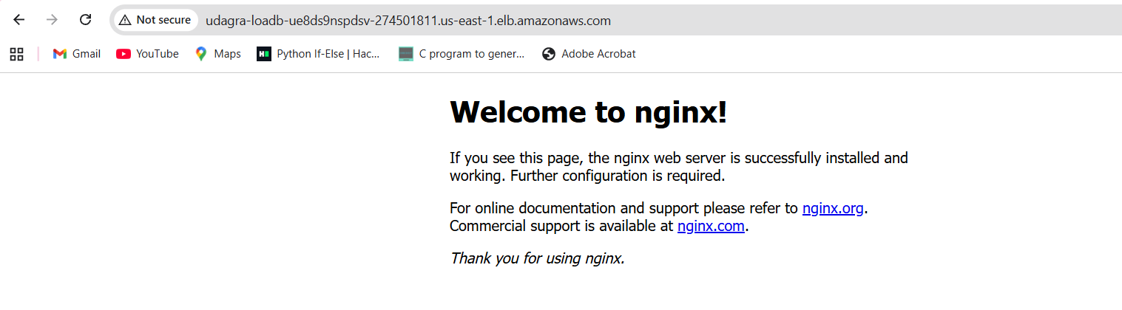

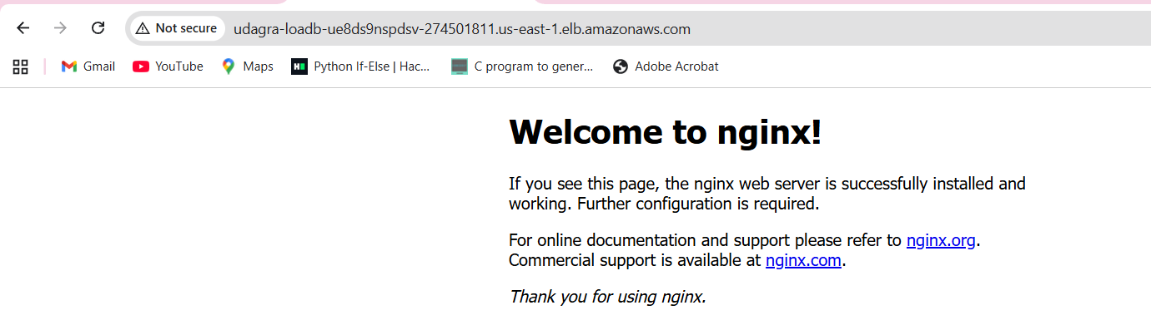

Network stack creation

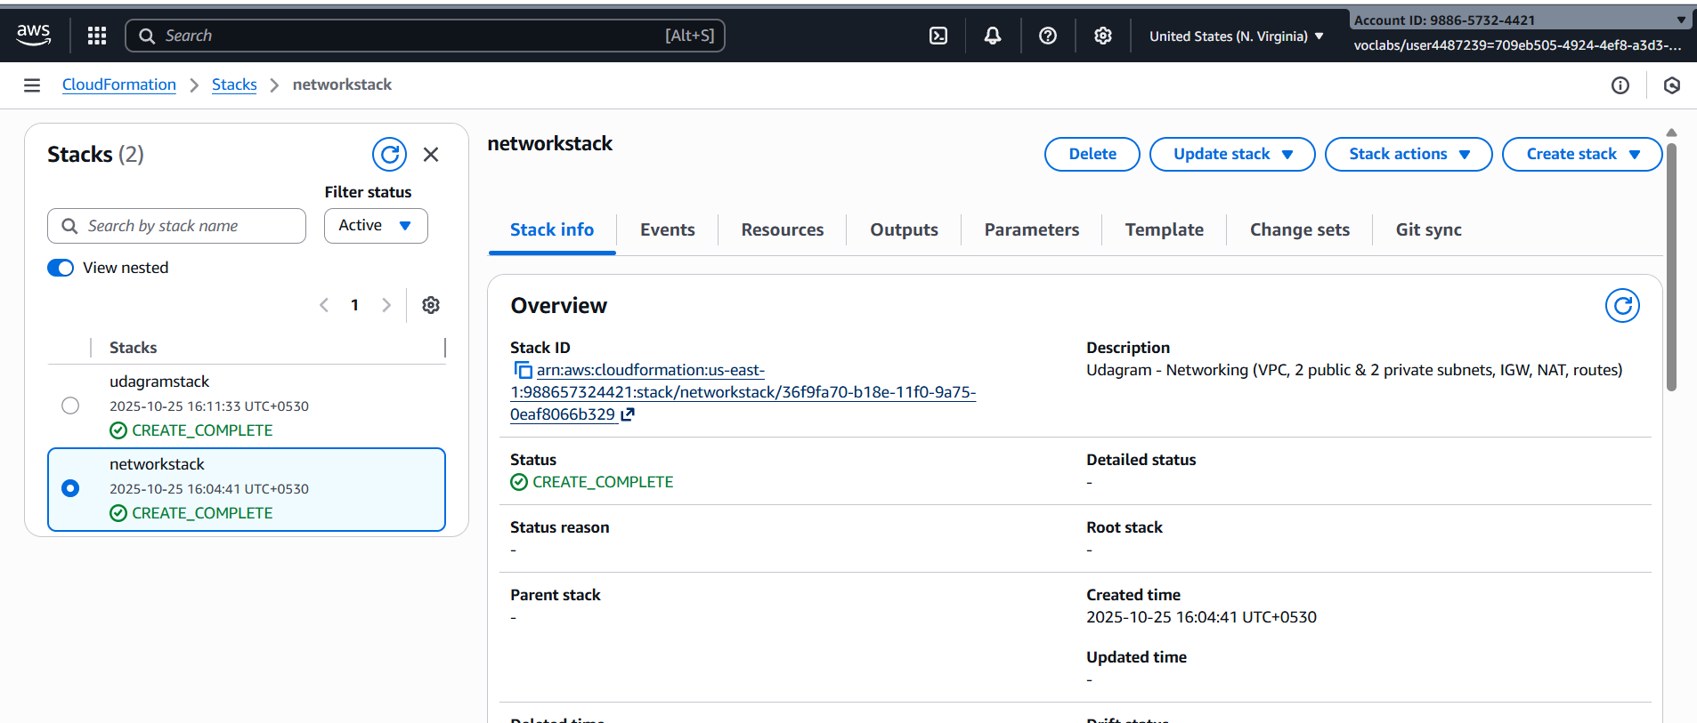

Network stack output

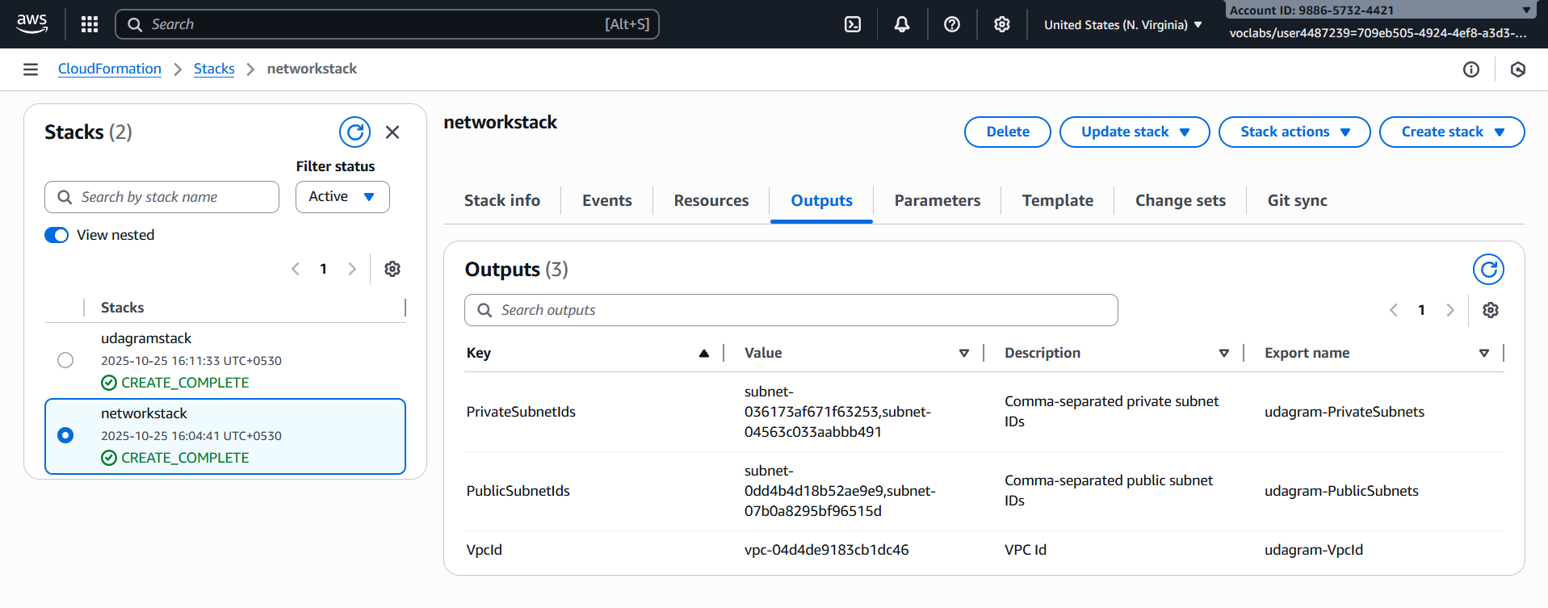

S3 bucket with index.html

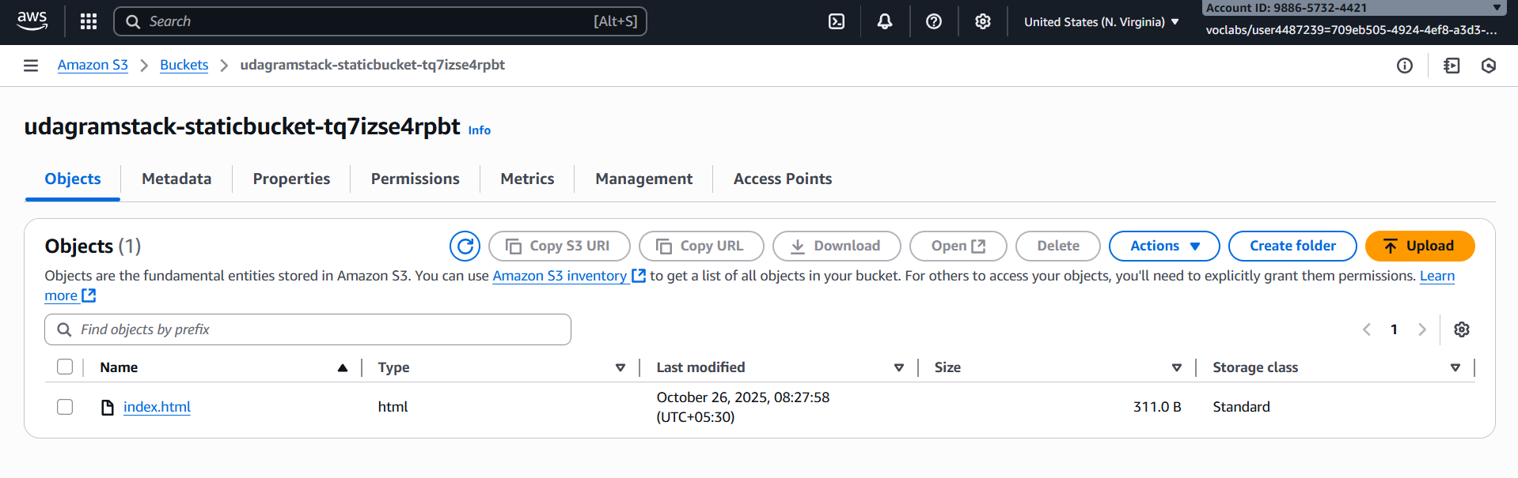

Output for s3 bucket

<https://udagramstack-staticbucket-tq7izse4rpbt.s3.us-east-1.amazonaws.com/index.html>

