NAME : B. JESLY
ROLL NUMBER : 26001277
BRANCH : CSM-7
SUBJECT : PYTHON

1.Attendance Recovery Computation.
2.ATM Transaction Sequence Simulation.
3.Student Performance Trend Analysis.
4.Repeated Transaction Detection.
5.Password Policy Validation.
6.String-Based Examination Answer Evaluation.
7.Text Compression Using Character Runs.
8.Multi-Stage Examination Eligibility System.
9.Student Marks Matrix Analysis.
10.Tuple-Based Product Catalogue Audit.

1.Attendance recovery computation.

Problem statement:
Calculate a student's current attendance percentage and determine how many consecutive classes the student must attend to reach the required attendance percentage.
Objective
Use arithmetic and a loop to determine the attendance recovery target.
Assumptions
Classes attended and held are non-negative whole numbers; held is greater than zero. Every future class is attended. The target is 75%.
Algorithm:
- Read total classes and attended classes.
- Calculate the current attendance percentage.
- Read the required attendance percentage.
- If attendance is already sufficient, display zero additional classes.
- Otherwise, calculate the minimum consecutive classes required.
Pseudocode
INPUT attended, held percentage = attended / held * 100
extra = 0
WHILE (attended + extra) / (held + extra) < 0.75 extra = extra + 1
OUTPUT percentage, extra Python program:
total = int(input("Enter total classes held: ")) attended = int(input("Enter classes attended: ")) required = float(input("Enter required attendance percentage: "))

if total <= 0 or attended < 0 or attended > total:
print("Invalid class details") elif required <= 0 or required > 100: print("Invalid required percentage") else:
percentage = attended / total * 100 print("Current attendance:", round(percentage, 2), "%")

if percentage >= required:
print("Eligible for attendance requirement") print("Additional classes required: 0") else:
classes = 0 while (attended + classes) / (total + classes) * 100 < required:
classes += 1

print("Additional consecutive classes required:", classes)
screen shot(output)
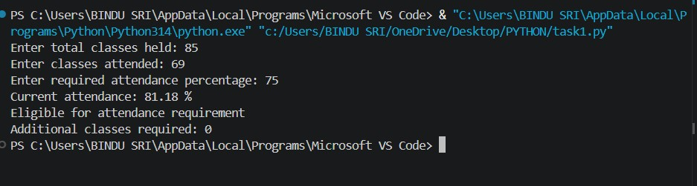
Flow chart:
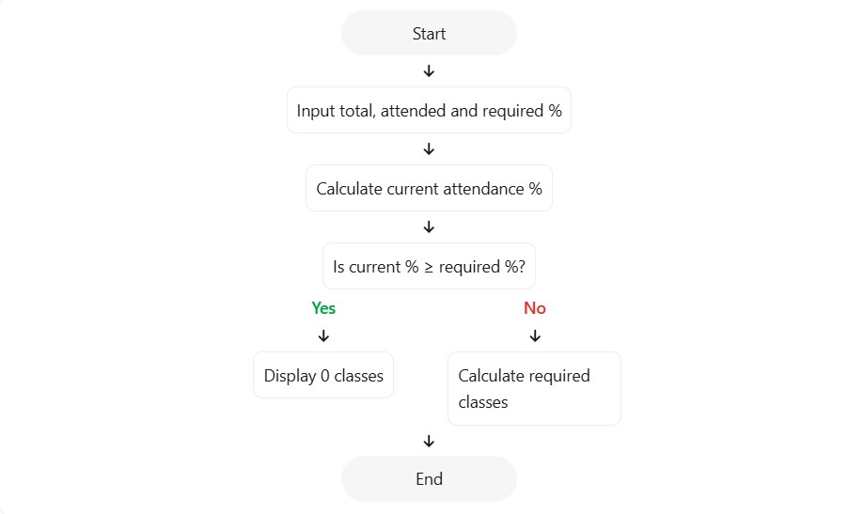
The program calculates attendance percentage and uses a loop to find the minimum additional classes required to reach the specified attendance threshold.

Develop a Python program that simulates ATM transactions. The program should process deposits and withdrawals, update the account balance, reject invalid withdrawals, and display the final balance.

- Perform deposit and withdrawal operations.
- Prevent withdrawals exceeding the available balance.
- Display the final account balance.

- The initial balance is non-negative.
- The user performs three transactions.
- Transaction type is either deposit (D) or withdrawal (W).
- Transaction amounts must be positive.

- Start.
- Input the initial balance.
- Repeat three times: o Input transaction type and amount. o Validate the amount.
o Add deposits to the balance. o Subtract withdrawals if sufficient funds are available.
- Display the final balance.
- Stop.

BEGIN
INPUT balance

IF balance < 0 THEN
PRINT "Invalid balance"
ELSE
REPEAT 3 TIMES
INPUT transaction_type, amount

IF amount <= 0 THEN
PRINT "Invalid amount" ELSE IF transaction_type = "D" THEN balance = balance + amount ELSE IF transaction_type = "W" THEN IF amount <= balance THEN balance = balance - amount
ELSE
PRINT "Insufficient balance"
END IF
ELSE
PRINT "Invalid transaction"
END IF
END REPEAT

PRINT balance
END IF
END

balance = float(input("Enter initial balance: "))

if balance < 0:
print("Invalid balance") else:
for i in range(3):
transaction = input("Enter D for deposit or W for withdrawal: ").upper() amount = float(input("Enter amount: "))

if amount <= 0:
print("Invalid amount") elif transaction == "D": balance += amount print("Deposit successful") elif transaction == "W": if amount <= balance: balance -= amount print("Withdrawal successful") else:
print("Insufficient balance") else:
print("Invalid transaction")

print("Final balance:", balance)
screenshot(output)
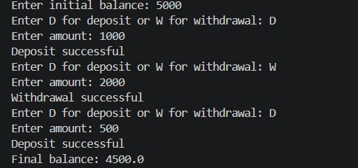

Flow chart:
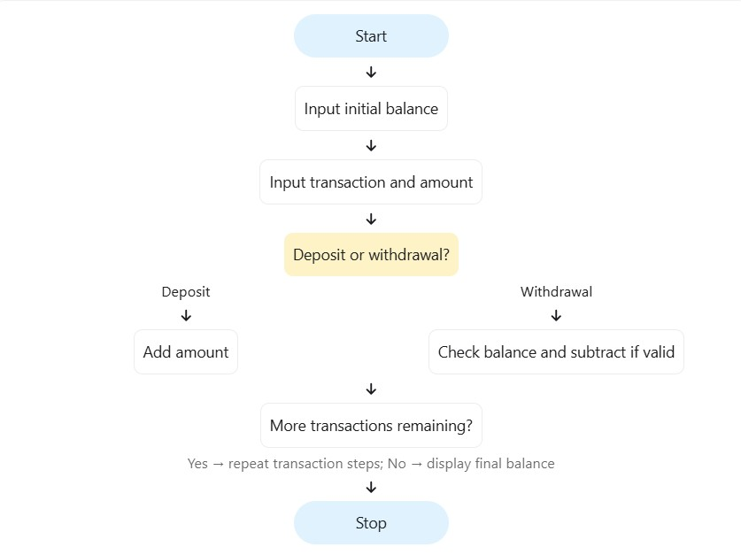
The program demonstrates how loops and conditional statements can simulate basic ATM transactions while maintaining a valid balance.

Develop a Python program to compare a student's marks in three examinations, calculate the improvement or decline, and classify the student's performance.

Store examination marks in a list.
Calculate changes between examinations.
Calculate average marks.
Classify overall performance.

Marks are between 0 and 100.
Three examination scores are provided.
Average of 75 or more is classified as Excellent.
Average of 50 or more is classified as Good.
Average below 50 is classified as Needs Improvement.

- Start.
- Input marks for three examinations.
- Validate all marks.
- Calculate the average.
- Calculate the changes between consecutive examinations.
- Display improvement or decline.
- Classify the performance using the average.
- Stop.

BEGIN
INPUT marks for three examinations

IF any mark is less than 0 or greater than 100 THEN
PRINT "Invalid marks" ELSE average = SUM(marks) / 3

change1 = marks[1] - marks[0] change2 = marks[2] - marks[1]

PRINT average, change1, change2

IF average >= 75 THEN
PRINT "Excellent"
ELSE IF average >= 50 THEN
PRINT "Good"
ELSE
PRINT "Needs Improvement"
END IF
END IF
END

marks = []

for i in range(3):
score = int(input("Enter examination marks: ")) marks.append(score)

if any(score < 0 or score > 100 for score in marks):
print("Invalid marks") else:
average = sum(marks) / len(marks)

print("Average marks:", average) print("Change from Exam 1 to Exam 2:", marks[1] - marks[0]) print("Change from Exam 2 to Exam 3:", marks[2] - marks[1])

if average >= 75:
print("Performance: Excellent") elif average >= 50:
print("Performance: Good") else:
print("Performance: Needs Improvement")
screenshot(output)
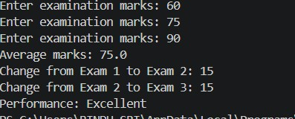
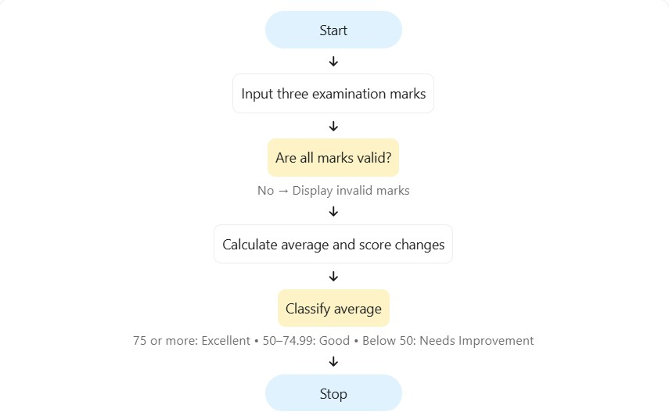
The program uses lists, loops, arithmetic operations, and conditional statements to analyse changes in student performance.

Develop a Python program to examine a list of transaction identifiers and identify duplicate identifiers.

Store transaction IDs in a list.
Detect repeated transaction IDs.
Display the duplicate IDs without repeating them in the output.

Transaction IDs are strings.
IDs are compared exactly, including uppercase and lowercase letters.
A duplicate is an ID that occurs more than once.

- Start.
- Input transaction IDs separated by spaces.
- Split the input into a list.
- Create an empty list for duplicates.
- Examine each ID.
- If the ID occurs more than once and has not already been recorded, add it to the duplicate list.
- Display the duplicate list.
- Stop.

BEGIN
INPUT transaction IDs SPLIT input into a list duplicates = empty list

FOR each ID in transaction list
IF ID occurs more than once
AND ID is not in duplicates THEN
ADD ID to duplicates
END IF
END FOR

IF duplicates is empty THEN
PRINT "No duplicates"
ELSE
PRINT duplicates
END IF
END

transactions = input("Enter transaction IDs separated by spaces: ").split()

duplicates = []

for transaction in transactions: if transactions.count(transaction) > 1: if transaction not in duplicates: duplicates.append(transaction)

if duplicates:
print("Duplicate transactions:", duplicates) else:
print("No duplicate transactions")

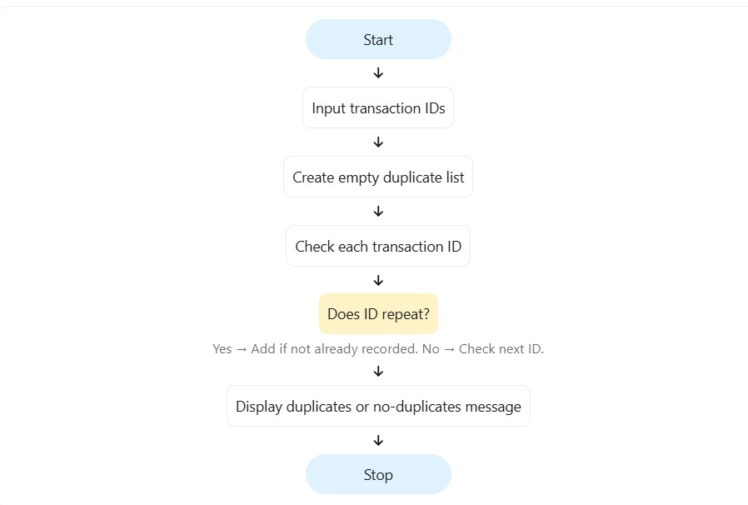

The program uses lists and conditional statements to identify repeated transaction identifiers

Develop a Python program to validate a sample password using simple rules for minimum length, uppercase letters, lowercase letters, digits, and special characters.

Check whether the password satisfies the given rules.
Display each rule that is not satisfied. Report whether the password is valid.

A valid password must contain:
At least 8 characters.
At least one uppercase letter.
At least one lowercase letter.
At least one digit.
At least one special character.
For this exercise, any character that is not a letter or digit is treated as a special character.

- Start.
- Input a password.
- Check its length.
- Check for uppercase and lowercase letters.
- Check for digits and special characters.
- Display every failed rule.
- If no rules fail, display valid password.
- Stop.

BEGIN
INPUT password
valid = TRUE

IF length(password) < 8 THEN
PRINT "Minimum length not satisfied" valid = FALSE
END IF

IF no uppercase letter THEN PRINT "Uppercase letter missing" valid = FALSE
END IF

IF no lowercase letter THEN PRINT "Lowercase letter missing" valid = FALSE
END IF

IF no digit THEN PRINT "Digit missing" valid = FALSE
END IF

IF no special character THEN PRINT "Special character missing" valid = FALSE
END IF

IF valid THEN
PRINT "Password is valid"
END IF
END

password = input("Enter a sample password: ") valid = True

if len(password) < 8:
print("Minimum 8 characters required") valid = False

if not any(ch.isupper() for ch in password):
print("At least one uppercase letter required") valid = False

if not any(ch.islower() for ch in password):
print("At least one lowercase letter required") valid = False

if not any(ch.isdigit() for ch in password):
print("At least one digit required") valid = False

if not any(not ch.isalnum() for ch in password): print("At least one special character required") valid = False

if valid:
print("Password is valid") else:
print("Password is invalid")

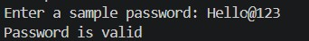
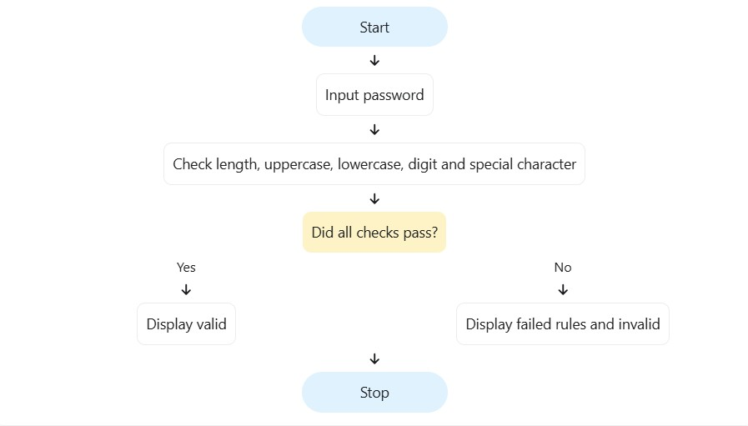
The program demonstrates string operations and conditional statements for checking whether a password satisfies specified rules.

Develop a Python program to compare a student's answers with an answer key, calculate correct, incorrect, and unanswered questions, and compute the final score.
Objective
Compare student answers with the answer key.
Count correct, incorrect, and unanswered responses.
Calculate the score using positive and negative marking.

There are five questions.
Each correct answer earns 2 marks.
Each incorrect answer loses 0.5 marks.
An unanswered question receives 0 marks.
A dash (-) represents an unanswered question.

- Start.
- Store the answer key.
- Input five student answers.
- Validate the number of answers.
- Compare each answer with the key.
- Count correct, incorrect, and unanswered responses.
- Calculate the score.
- Display the results.
- Stop.

BEGIN
key = ["A", "B", "C", "D", "A"]
INPUT student answers

IF number of answers is not 5 THEN
PRINT "Invalid number of answers" ELSE correct = 0 incorrect = 0 unanswered = 0

FOR each answer and key pair IF answer = "-" THEN unanswered = unanswered + 1 ELSE IF answer = key answer THEN correct = correct + 1 ELSE
incorrect = incorrect + 1
END IF
END FOR

score = correct * 2 - incorrect * 0.5 PRINT correct, incorrect, unanswered, score
END IF
END

key = ["A", "B", "C", "D", "A"]

answers = input(
"Enter 5 answers separated by spaces (use - if unanswered): "
).upper().split()

if len(answers) != 5:
print("Invalid number of answers") else:
correct = 0 incorrect = 0 unanswered = 0

for i in range(5): if answers[i] == "-": unanswered += 1 elif answers[i] == key[i]:
correct += 1
else:
incorrect += 1

score = correct * 2 - incorrect * 0.5

print("Correct answers:", correct) print("Incorrect answers:", incorrect) print("Unanswered questions:", unanswered) print("Final score:", score)

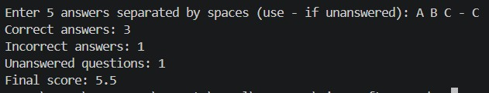
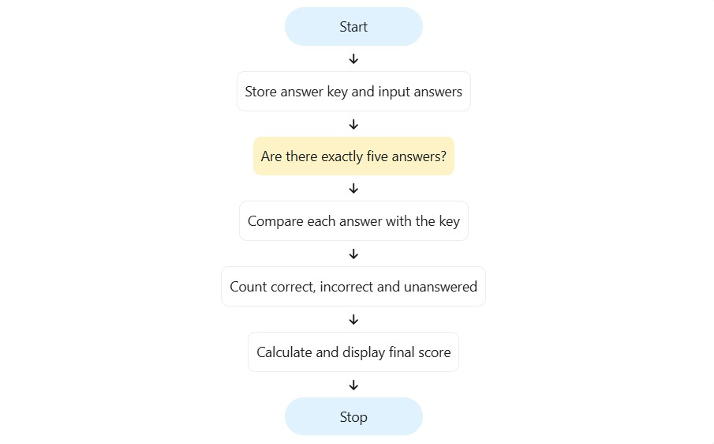
The program uses strings, lists, loops, and conditional statements to evaluate examination answers and calculate scores.

Develop a Python program to compress a string by grouping consecutive repeated characters and counting how many times each character occurs consecutively.
For example, aaabbc becomes a3b2c1.

Identify consecutive repeated characters.
Count each character run.
Generate a compressed string.
Compare the original and compressed lengths.

The input contains at least one character.
Characters are case-sensitive.
The compression format stores each character followed by its count.

- Start.
- Input a string.
- Set the current character to the first character.
- Count consecutive occurrences.
- When the character changes, append the character and count to the compressed string.
- Append the final character run.
- Display the compressed string and lengths.
- Stop.

BEGIN
INPUT text compressed = "" count = 1

FOR i from 1 to length(text) - 1 IF text[i] = text[i - 1] THEN count = count + 1 ELSE compressed = compressed + text[i - 1] + count count = 1 END IF
END FOR

compressed = compressed + last character + count

PRINT compressed
PRINT length(text), length(compressed) END

text = input("Enter a string: ")

if text == "":
print("Please enter a non-empty string") else:
compressed = "" count = 1

for i in range(1, len(text)): if text[i] == text[i - 1]:
count += 1 else:
compressed += text[i - 1] + str(count) count = 1

compressed += text[-1] + str(count)

print("Original string:", text) print("Compressed string:", compressed) print("Original length:", len(text)) print("Compressed length:", len(compressed))

if len(compressed) < len(text):
print("Compression reduces the length") else:
print("Compression does not reduce the length")

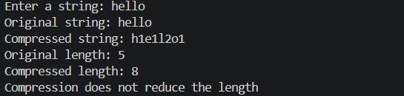
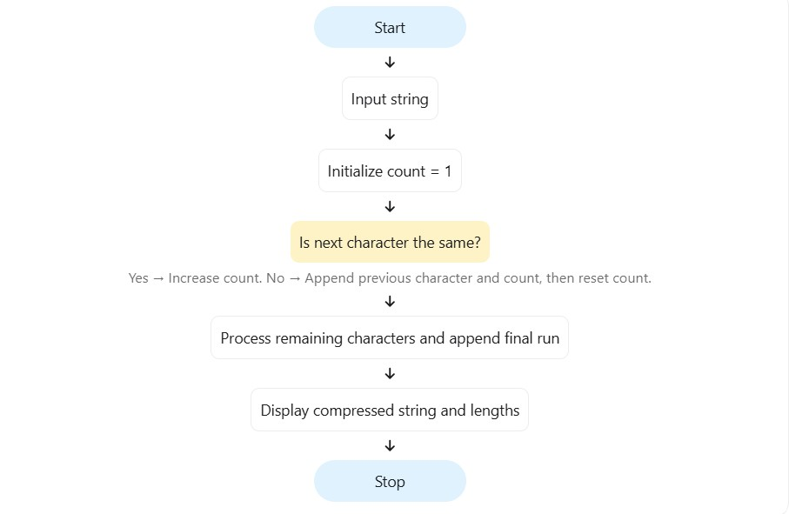
The program demonstrates string processing, loops, and counters to implement a simple character-run compression method.

Develop a Python program to determine whether a student is eligible to attend the final examination based on attendance, laboratory completion, internal marks, and fee clearance.

Check four examination eligibility conditions.
Identify unmet requirements.
Display the final eligibility status.

Attendance must be at least 75%.
All required laboratory work must be completed.
Internal marks must be at least 20 out of 40.
Examination fees must be paid.
All conditions must be satisfied for eligibility.

- Start.
- Input attendance, laboratory status, internal marks, and fee status.
- Validate attendance and internal marks.
- Check each eligibility condition.
- Record all unmet requirements.
- If no conditions are unmet, display eligible.
- Otherwise, display not eligible and the reasons.
- Stop.

BEGIN
INPUT attendance, lab_completed, internal_marks, fees_paid

IF attendance is outside 0 to 100
OR internal_marks is outside 0 to 40 THEN
PRINT "Invalid input" ELSE reasons = empty list

IF attendance < 75 THEN
ADD "Attendance below 75%" to reasons
END IF

IF lab_completed is FALSE THEN
ADD "Laboratory work incomplete" to reasons
END IF

IF internal_marks < 20 THEN
ADD "Insufficient internal marks" to reasons END IF

IF fees_paid is FALSE THEN
ADD "Fees not paid" to reasons
END IF

IF reasons is empty THEN
PRINT "Eligible"
ELSE
PRINT "Not eligible"
PRINT reasons
END IF
END IF
END

attendance = float(input("Enter attendance percentage: ")) lab = input("Is laboratory work completed? (yes/no):
").lower() internal = int(input("Enter internal marks out of 40: ")) fees = input("Are examination fees paid? (yes/no):
").lower()

if not (0 <= attendance <= 100 and 0 <= internal <= 40): print("Invalid input") elif lab not in ("yes", "no") or fees not in ("yes", "no"):
print("Invalid yes/no input") else:
reasons = []

if attendance < 75:
reasons.append("Attendance below 75%")

if lab == "no":
reasons.append("Laboratory work incomplete")

if internal < 20:
reasons.append("Insufficient internal marks")

if fees == "no":
reasons.append("Examination fees not paid")

if len(reasons) == 0:
print("Student is eligible for the examination") else:
print("Student is not eligible") for reason in reasons:
print("-", reason)

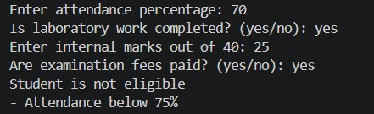
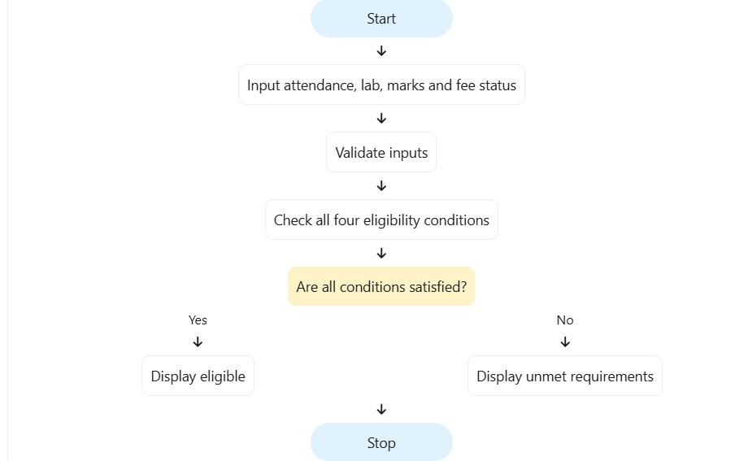
The program uses multiple conditional statements and a list to determine examination eligibility and report all unmet requirements.

Develop a Python program to store marks of students in multiple subjects using a nested list. Calculate each student's average and identify the student with the highest average.

Represent marks using a nested list.
Calculate student-wise averages.
Calculate subject-wise averages.
Identify the top-performing student.

There are three students and three subjects.
Each mark is between 0 and 100.
Student names are stored separately.
The highest average determines the top performer.

- Start.
- Store student names and marks.
- Calculate the average of each student's marks.
- Calculate the average for each subject.
- Identify the student with the highest average.
- Display all averages and the top performer.
- Stop.

BEGIN
names = ["Anu", "Bala", "Charan"] marks = [[80, 75, 90],
[70, 85, 80],
[90, 95, 85]]

FOR each student
average = SUM(student marks) / 3
PRINT student name and average
END FOR

FOR each subject column calculate subject average
PRINT subject average
END FOR

find student with maximum average
PRINT top student
END

names = ["Anu", "Bala", "Charan"]

marks = [
[80, 75, 90],
[70, 85, 80],
[90, 95, 85]
]

student_averages = []

for i in range(len(marks)):
average = sum(marks[i]) / len(marks[i]) student_averages.append(average) print(names[i], "average:", average)

for j in range(3):
total = 0

for i in range(3):
total += marks[i][j]

print("Subject", j + 1, "average:", total / 3)

top_index =
student_averages.index(max(student_averages))

print("Top student:", names[top_index]) print("Highest average:", student_averages[top_index])

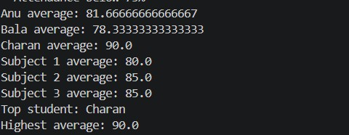
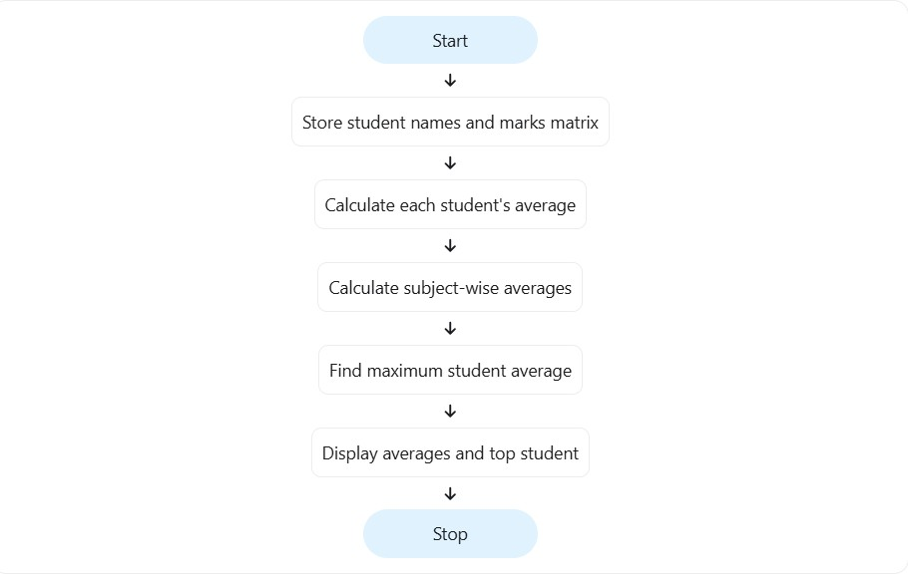
The program demonstrates nested lists and nested loops to calculate student-wise and subject-wise statistics

Develop a Python program to store product details in tuples. Each tuple contains a product ID, price, and stock quantity. Calculate the total inventory value and identify products that need replenishment.

Store product details using tuples.
Calculate the inventory value for each product.
Calculate the total inventory value. Identify products with low stock.

Each product is represented by a tuple: (product_id, price, quantity).
Prices and stock quantities are non-negative.
Products with fewer than 10 units require replenishment.
Inventory value is calculated as price multiplied by quantity.

- Start.
- Store product details in a list of tuples.
- Initialize total inventory value to zero.
- Read each tuple using tuple unpacking.
- Calculate each product's inventory value.
- Add it to the total inventory value.
- Identify products with stock below 10 units.
- Display the results.
- Stop.

BEGIN
products = list of product tuples
total_value = 0

FOR each product tuple
UNPACK product_id, price, quantity

value = price * quantity total_value = total_value + value

PRINT product_id and value

IF quantity < 10 THEN
PRINT "Replenishment required"
END IF
END FOR

PRINT total_value
END

products = [
("P101", 50, 20),
("P102", 100, 5),
("P103", 75, 8),
("P104", 40, 15)
]

total_value = 0

for product in products:
product_id, price, quantity = product

value = price * quantity total_value += value

print("Product ID:", product_id) print("Inventory value:", value)

if quantity < 10:
print("Replenishment required")

print()

print("Total inventory value:", total_value)



