CHAPTER 4
DISCUSSIONS OF FINDINGS
The Existing Processes for Orders, and Customer Management at Happy Stem

Existing Process of Ordering for Happy Stem

Personal Visit
Accept Payment
Process Order
Accept Order
Order via Social Media/ Walk in

Manager/Florist Clients

Figure 3. Existing Use Case Diagram of Happy Stem by Carmencita

Figure 3 shows the use case diagram of the existing manual processes of Happy Stem by Carmencita's ordering and product management system. The Manager/Florist and the Customers are the two actors involved in the current system. Customers who wish to purchase floral products must either visit the shop in person at Zone 4, Bangued, Abra or contact the owner through channels such as phone calls or social media platforms like Facebook. Customers may inquire about available bouquets, gift boxes, and event flower decorations, and place their orders verbally or through direct messages to the owner.
The Manager/Florist manually receives and records all orders, coordinates with customers regarding design preferences and pickup or delivery schedules and accepts payment directly from the customer either in person or through digital transfers. This manual and fragmented process is prone to miscommunication, missed orders, and difficulty in managing multiple transactions simultaneously, particularly during peak seasons such as Valentine's Day, Christmas, and graduation events.

Secured and User-Friendly Web-Based Online Floral Shop System with its Features
Online Floral Shop System for Happy Stem by Carmencita
Login/Registration

Browse Dashboard
Add to Cart

Place Order
Cancel order
Down Payment

Client Manager
Edit Product Details

Edit Product Catalogue

Manage/Process Orders
Viewer
Logout

Figure 4. Proposed System Use Case Diagram of Happy Stem by Carmencita

Figure 4 presents the use case diagram of the proposed Online Floral Shop System for Happy Stem by Carmencita. The system will involve two primary actors: the Customer (Online User) and the Administrator/Owner. Customers will be able to register and log in to the platform, browse the digital product catalog featuring bouquets, floral gift boxes, and add items to a virtual shopping cart, place and confirm orders with specified delivery or pickup details, and process payments online, all within a single unified digital platform.
The Administrator/Manager, on the other hand, will have access to manage product listings including adding, editing, and removing floral items and their descriptions, monitor and process incoming customer orders, update product availability, and view transaction records through the admin dashboard. Both actors will be able to log out of the system upon completing their respective transactions. The proposed system is designed to eliminate the inefficiencies and inconsistencies of the existing manual process by consolidating all customer-facing and administrative operations into one accessible and organized digital platform, enabling Happy Stem by Carmencita to serve its customers more conveniently and professionally.

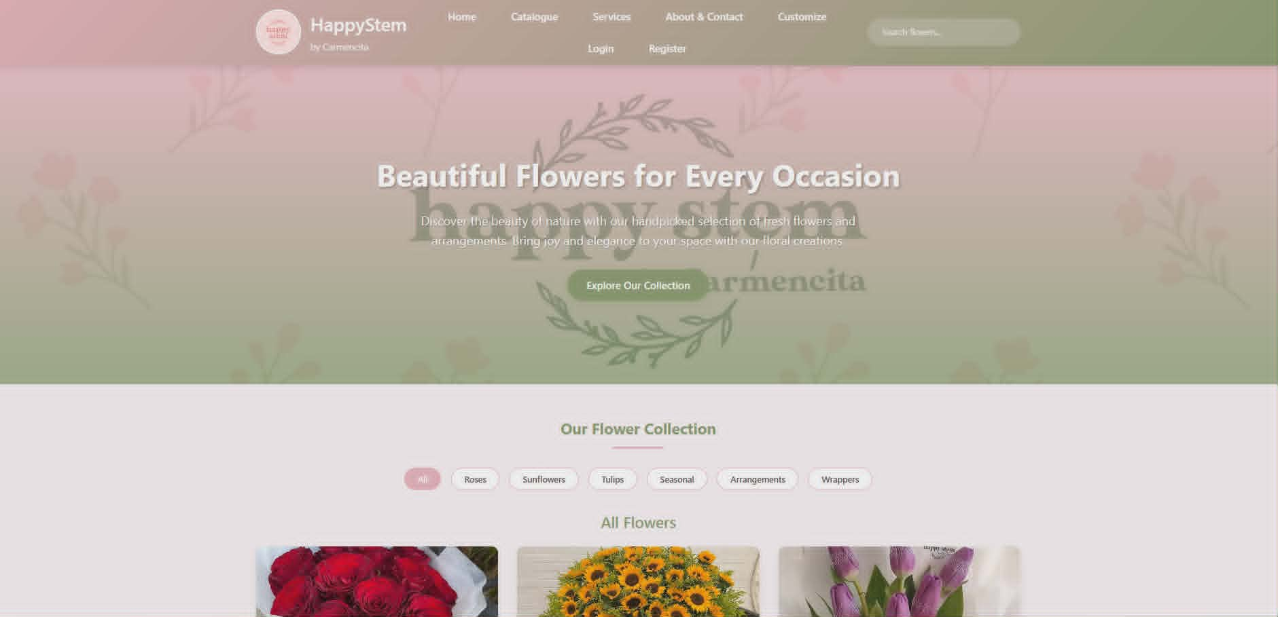
Plate 4.1 Home Screen. The home screen, this serves as the virtual front door of the flower shop. The home page is where the user can see the different tabs, and when user click “Explore Our Collection” button it will scroll down and makes it quick to navigate to the unique "Collections," "Seasonal" and "Arrangement" options and more. Customers can also click the “search bar” option to browse more about their favorite flowers and their prices.

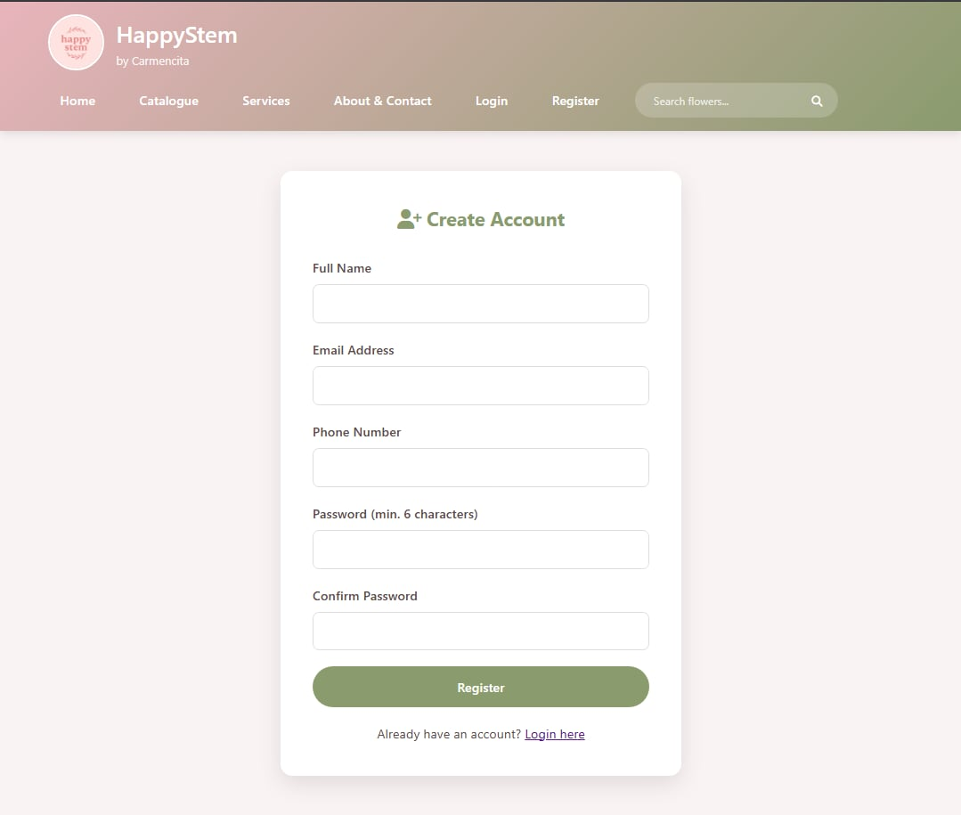
Plate 4.2 User’s Account Registration Screen. The Account Registration screen allows users to create an account by filling out the registration form. The customer needs to provide its full name, Email address, Phone Number, and Password. Once all fields are filled out, user can click Register button to proceed.

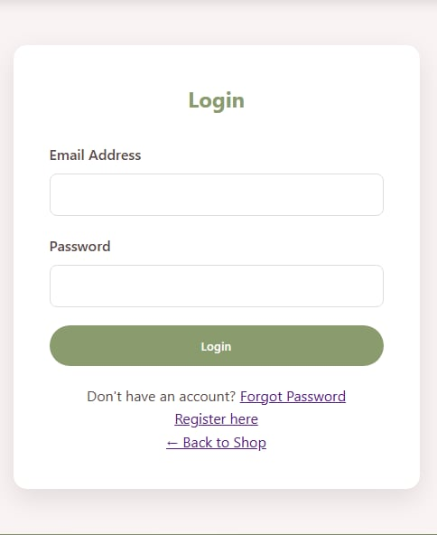

Plate 4.3 User’s Log in Screen. A user can log in if they already have an account. The login form requires them to enter two pieces of information: the Email address and the password.

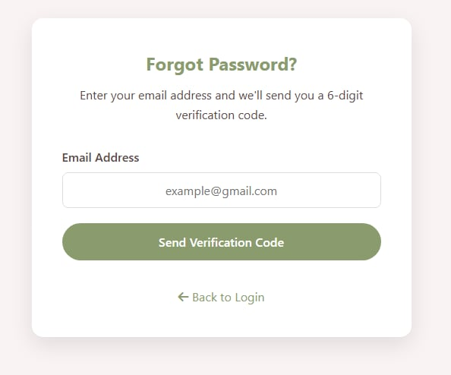
Plate 4.4 User’s Forgot Password Screen. This “user forgot password screen” is displayed when a user clicks the Forgot Password in the Login screen. It prompts the user to enter their registered email address as the first step in the password reset process. This comes after the Login screen, which requires both an email and password to proceed.

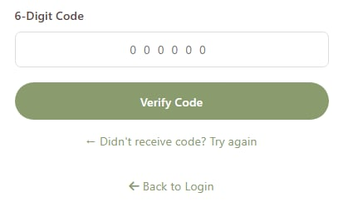
Plate 4.4.1 User’s Forgot Password Screen. This plate shows the next step of the forgot password flow. After the user submits their email, this screen shows a follow-up action for confirmation message, a prompt to check their email for a reset link, or a form to enter a new password.

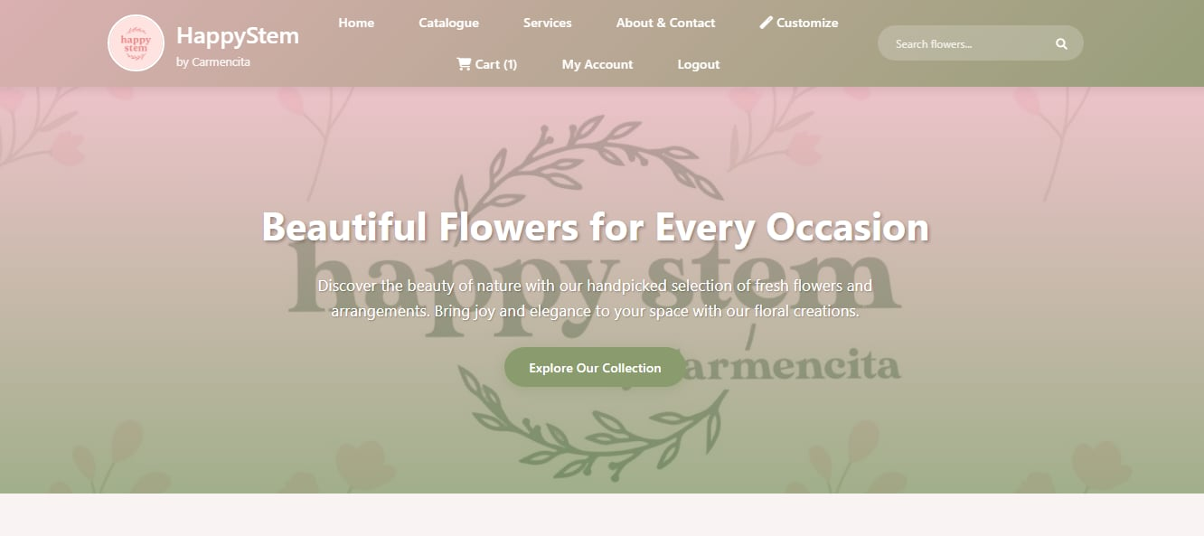

Plate 4.5 Logged-in User Home Screen. Upon logging-in the home screen will appear. On this screen, customers can access the Home, Catalogue, Services, About & Contact, Cart Section, Logout, and Search bar.

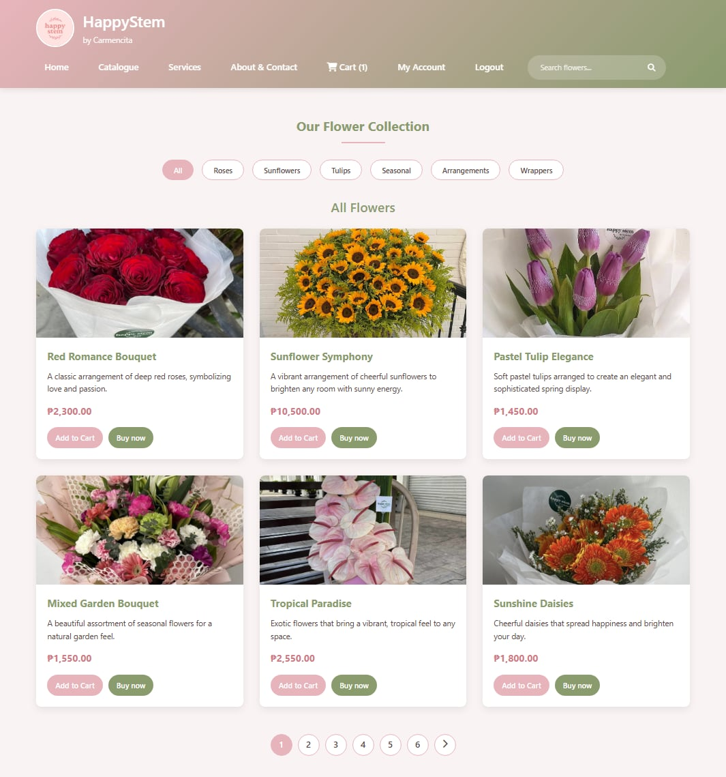

Plate 4.6 Catalogue This shows the main product browsing page. It shows all the flowers that are available, as well as the tabs for Roses, Sunflowers, Tulips, Seasonal, Arrangements, and Wrappers. The two buttons on each product card: "Add to Cart" and "Buy now" allow user to buy product and add it to shopping cart. The screen also shows a picture of the product, its name, a short description, and its price.

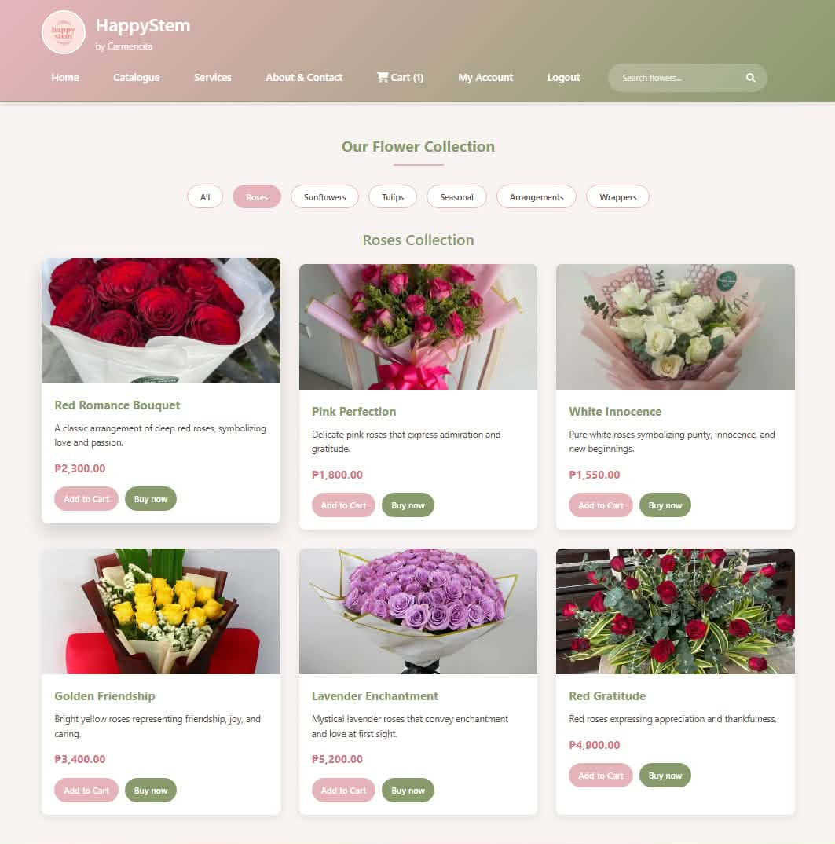

Plate 4.7 Roses Catalogue. This page shows the Roses Collection, filtered specifically for rose products. It displays the rose bouquets in a grid layout. Each card shows a photo of the bouquet, a short description of what the roses symbolize and its price

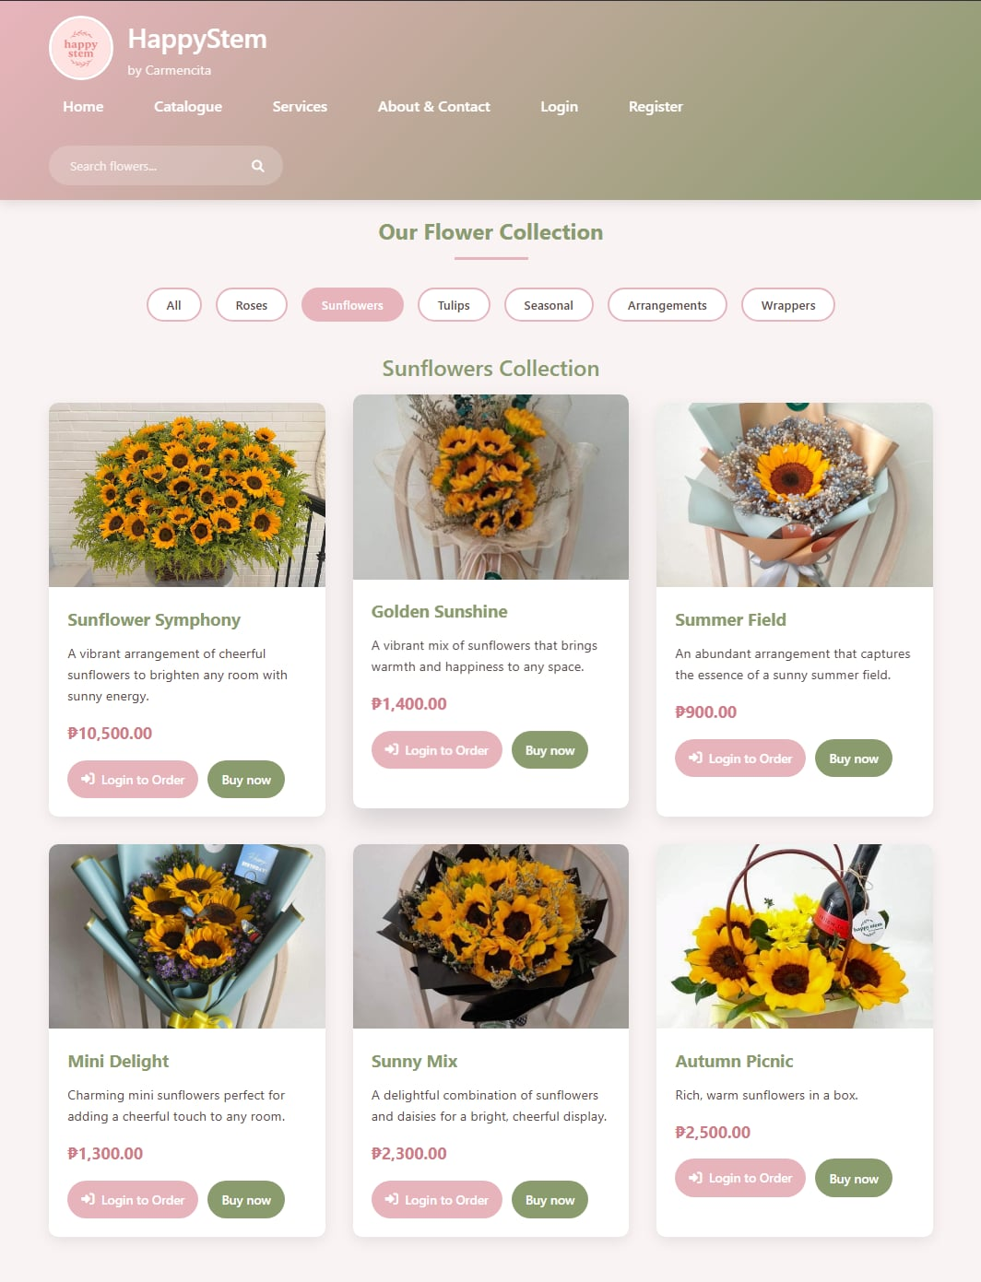

Plate 4.8 Sunflowers Catalogue. The sunflower (Helianthus annuus) is a tall, vibrant annual plant known for its large flower heads that track the sun. This page shows the Sunflowers Collection with six sunflower-based products.

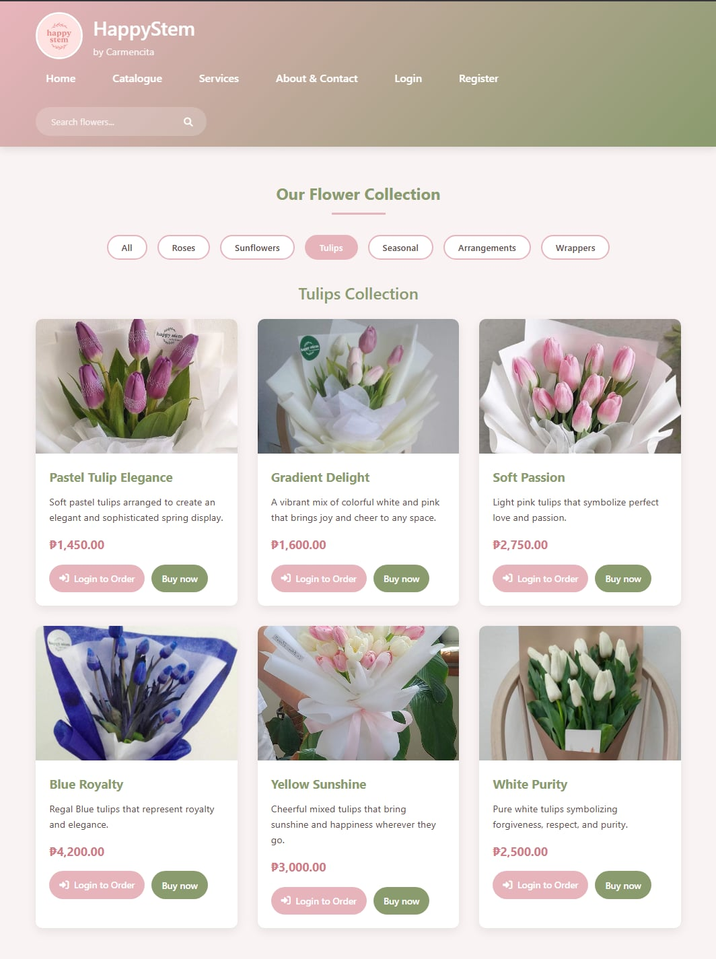
Plate 4.9 Tulips Catalogue. The tulip (Tulipa) is a renowned, spring-blooming perennial flower known for its vibrant, cup-shaped blooms in a wide spectrum of colors. This page shows the Tulips Collection, featuring six tulip varieties. Each card briefly describes the meaning behind the color of the tulips.
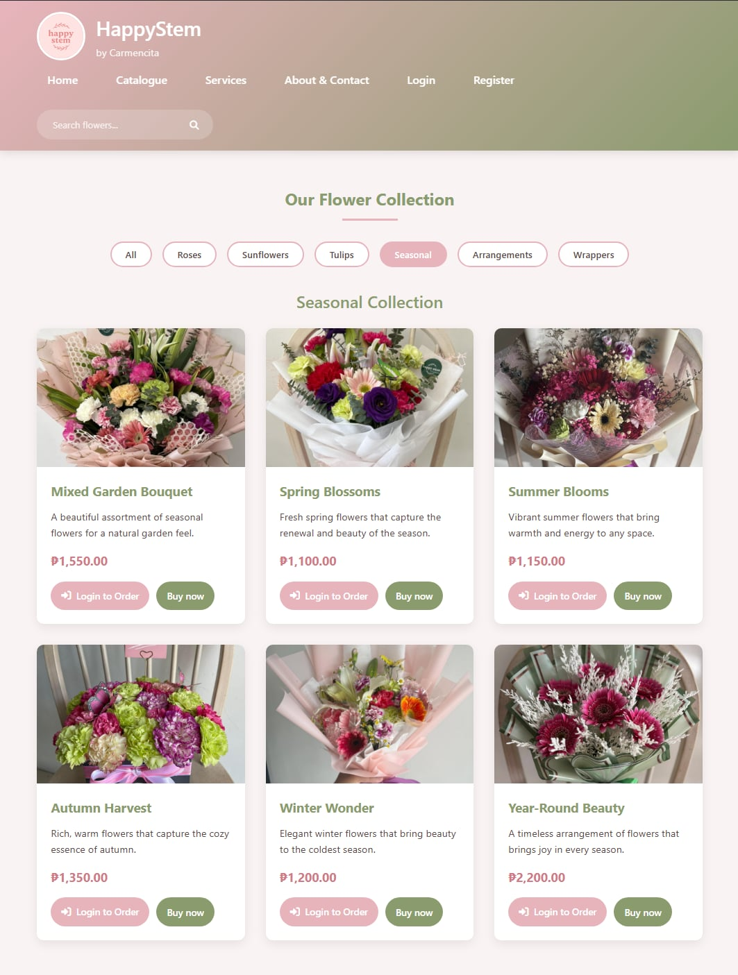
Plate 4.10 Seasonal Catalogue. The Seasonal Collection screen on this page shows flowers that are at their best at different times of the year. The seasonal approach to floristry means that the flowers are picked and arranged in a way that matches the seasons. Each bouquet stands for a season or mood, so customers can pick arrangements that fit the time of year or event.

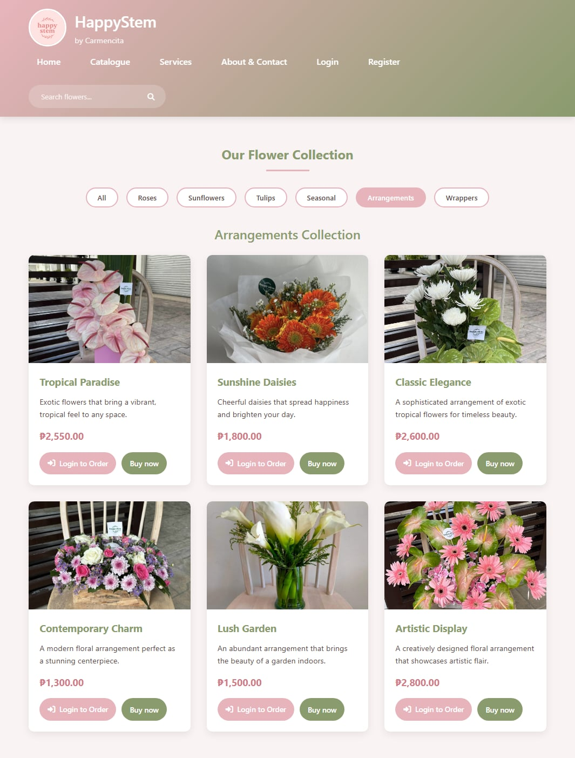
Plate 4.11 Arrangement Catalogue. The arrangements include everything from tropical styles that are out of the ordinary to modern centerpieces and vase displays that look like gardens. They can be used in a variety of settings and for different tastes.

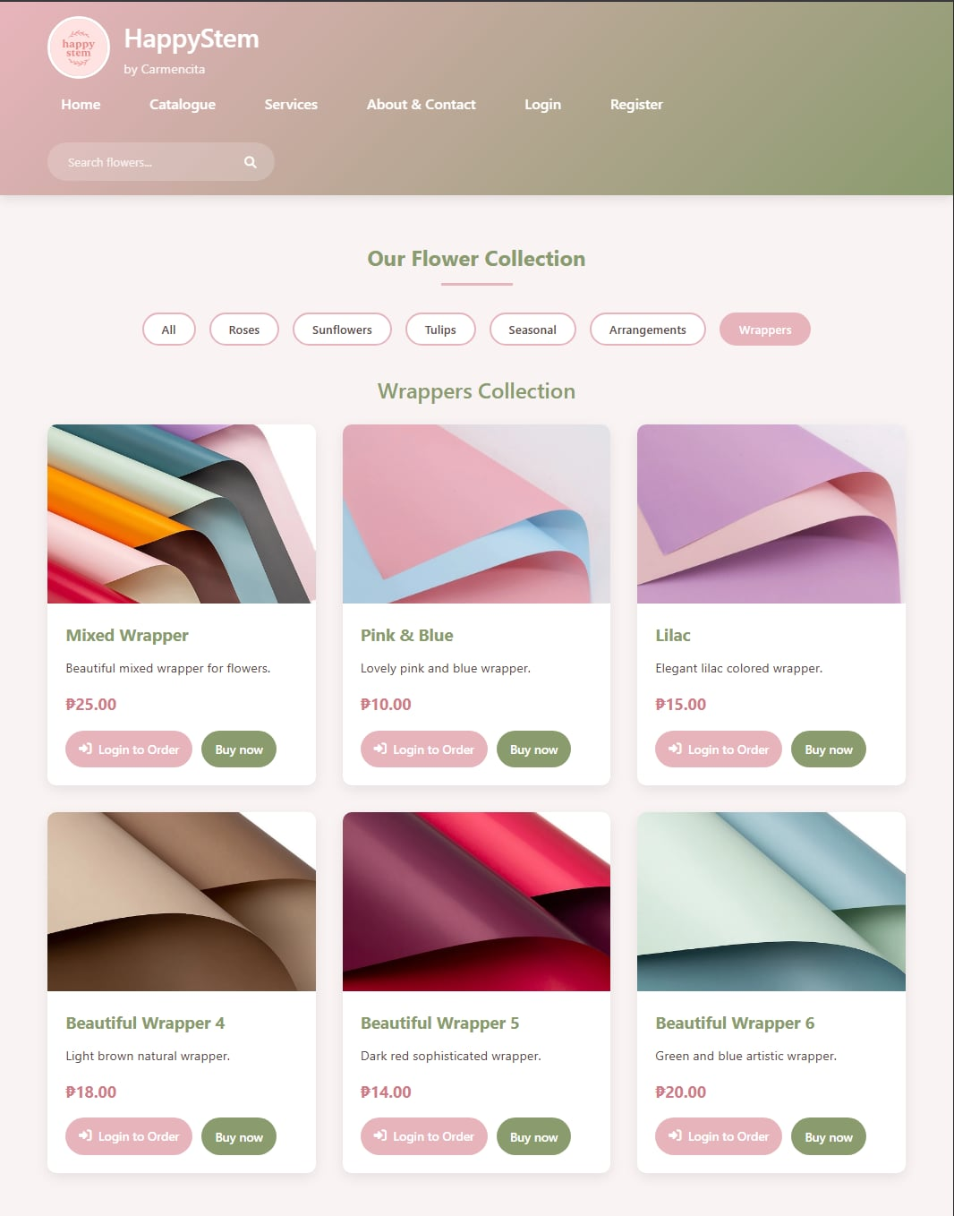
Plate 4.12 Wrappers Catalogue. The wrappers catalogue displays the different wrappers available. The flower shop uses a variety of wrapping materials, such as papers, films, and fabrics. Giving clients a lot of options for customization, like choosing materials that fit the theme, adding branded elements, including personalized messages and ribbons, and choosing eco-friendly options to make each bouquet stand out and look great.

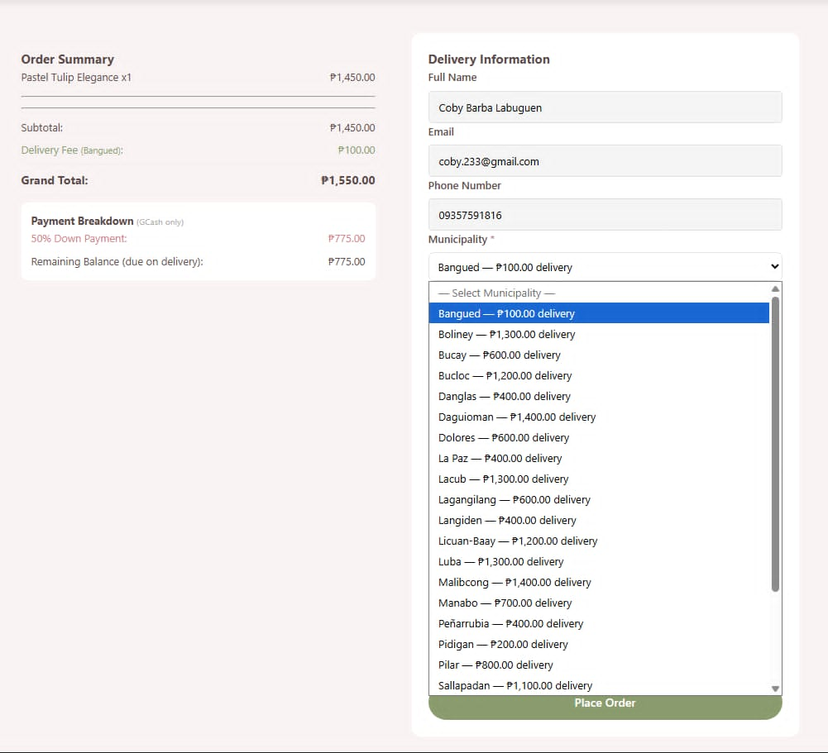

Plate 4.13 Buy now Screen. When you click the "Buy button, on something you want to buy this is the screen you will see. It is where you start the checkout process. On the side of the screen, you will see a form that says Delivery Information. This is where you put in your Full Name, Email, Phone Number and Delivery Address. User also have to pay a shipping fee. You can choose when you want the product to be delivered by picking a Preferred Delivery Date. At the bottom of the screen there is a button that says, "Place Order". When user click this button, users are confirming that they want to buy the product, and they are submitting the order. The "Place Order" button is what you click to finish the order.

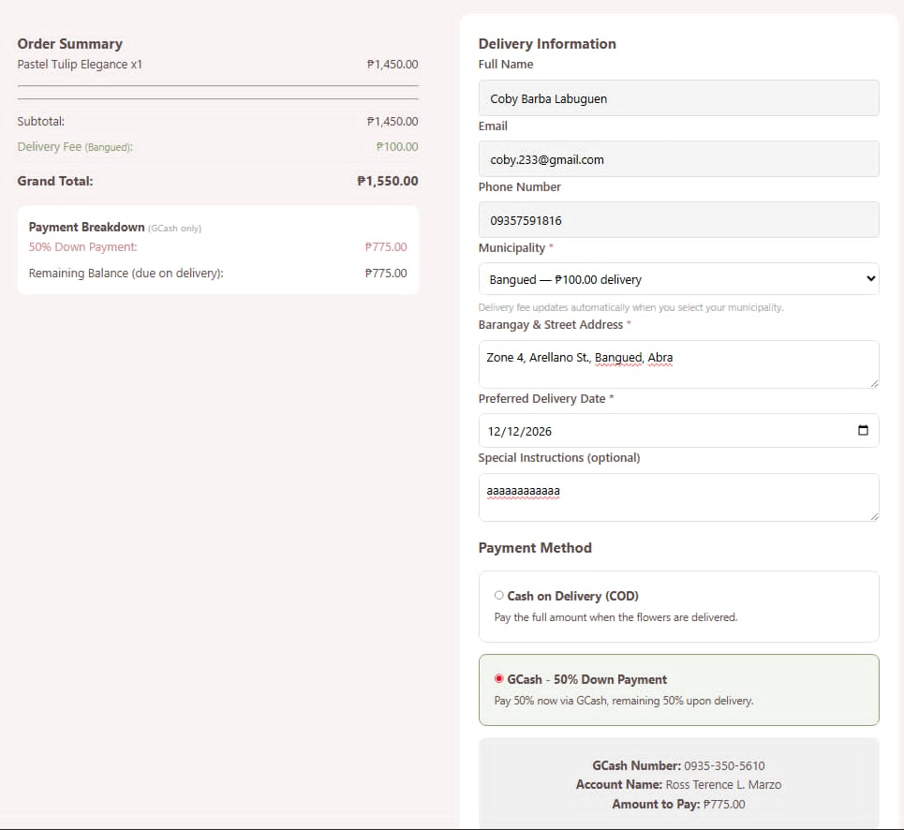

Plate 4.13.1 Buy now Screen. When user click the "Buy button, on something the user wants to buy this is the screen they will see. It is where user start the checkout process. On the side of the screen, user will see a form that says Delivery Information. This is where the user put in its Full Name, Email, Phone Number and Delivery Address. User also must pay a shipping fee. User can choose when the product to be delivered by picking a Preferred Delivery Date. At the bottom of the screen there is a button that says, "Place Order". When user click this button, users are confirming that they want to buy the product, and they are submitting the order. The "Place Order" button is what the user clicks to finish the order.
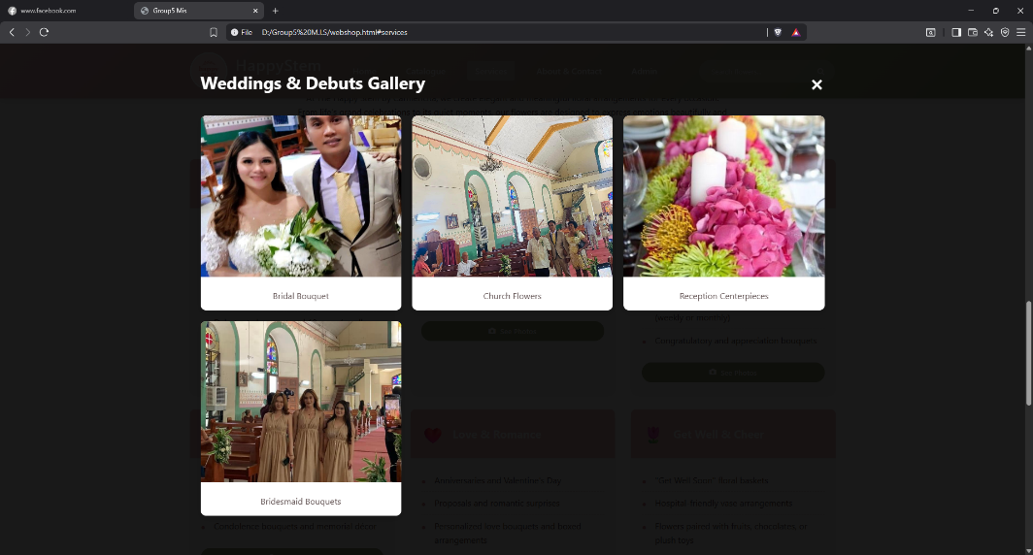

Plate 4.14 Services. The part of the website shows all the services they have. They do custom flower arrangements that are made for parties, special wedding flowers and flower delivery. You can also click on the "See Photos" button to look at the pictures they have and see the flowers they like to show off in detail.

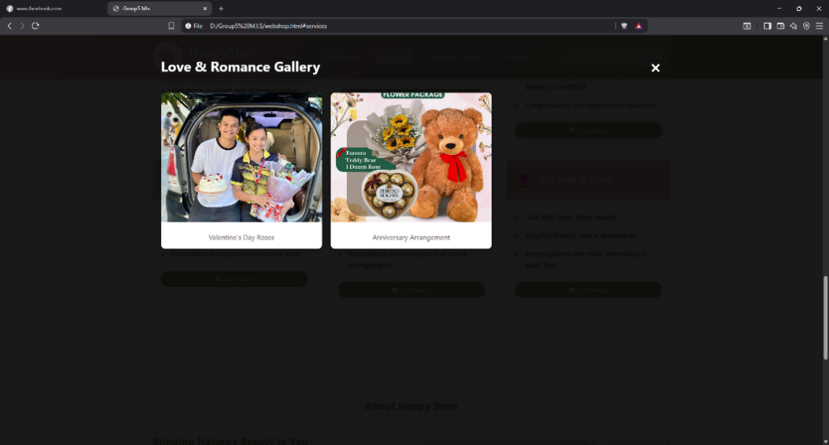

Plate 4.14.1 Services. The part of the website shows all the services they have. They do custom flower arrangements that are made for parties, special wedding flowers and flower delivery. You can also click on the "See Photos" button to look at the pictures they have and see the flowers they like to show off in detail.

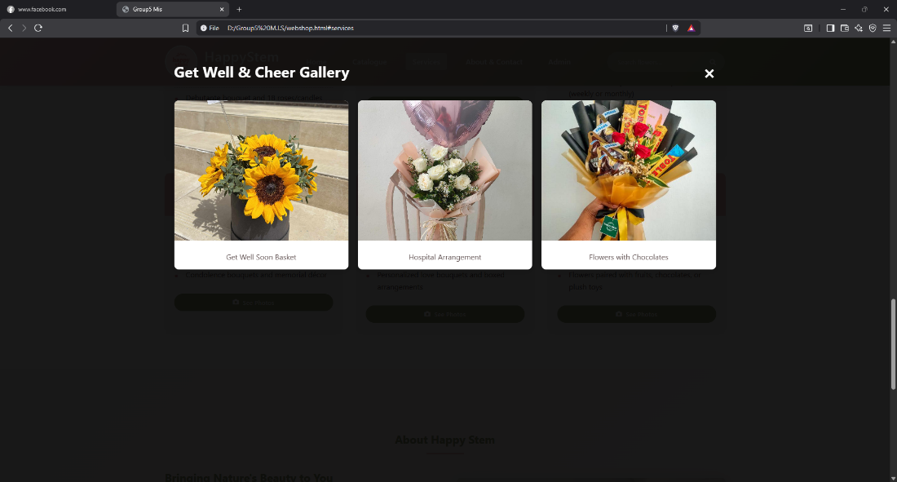

Plate 4.14.2 Services. The part of the website shows all the services they have. They do custom flower arrangements that are made for parties, special wedding flowers and flower delivery. You can also click on the "See Photos" button to look at the pictures they have and see the flowers they like to show off in detail.

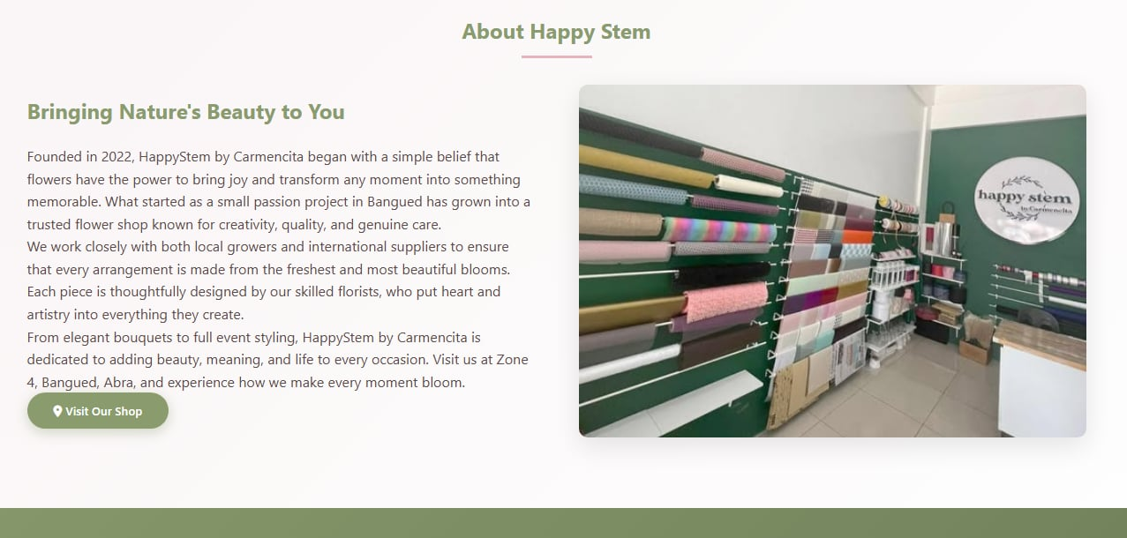
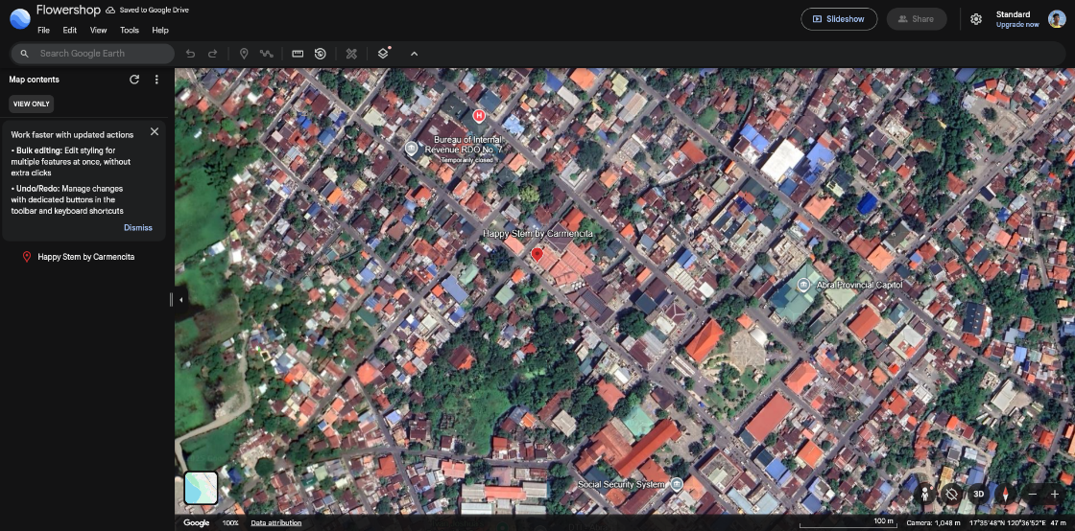

Plate 4.15 About & Contact. This part of the website displays the story behind the happy stem. The screen shows the background of happy stem. Upon clicking the “Visit our Shop it directs the user to a map leading to the location of happy stem. Moreover, it shows the contact info of the Happy stem.

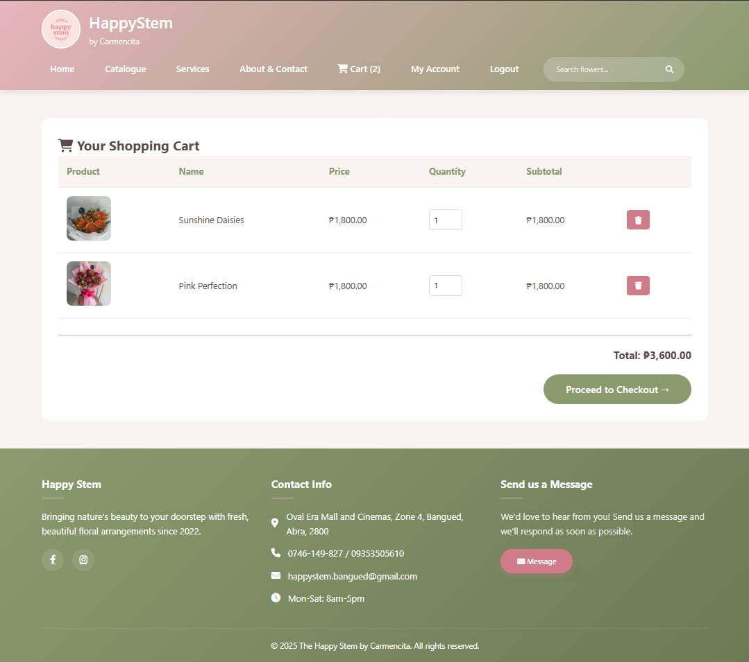

Plate 4.15.1 About & Contact. This part of the website displays the contact info of the Happy stem.

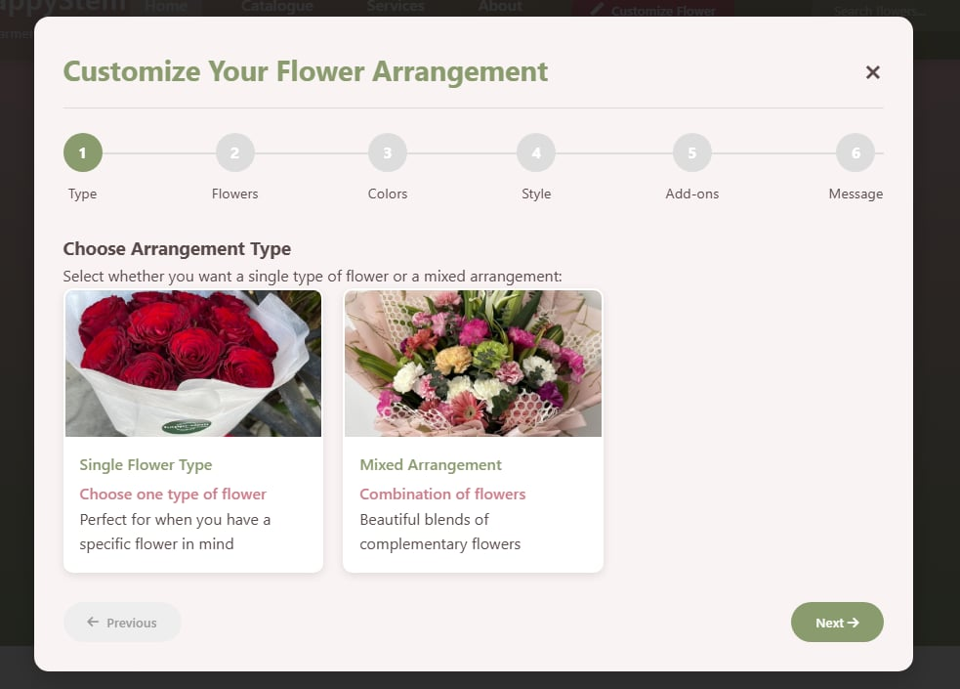

Plate 4.16 Customize Screen. This screen is where people can make their flower orders the way they like them. It is the step in making their flowers special. The customer can start making a bouquet or arrangement that's just right for a certain occasion, like a birthday or wedding or they can pick the colors and flowers they like. The screen will walk the customer through each step of making their flowers so they get what they want and are happy with their order. The flower orders can be personalized to fit the customers preferences, for their orders.

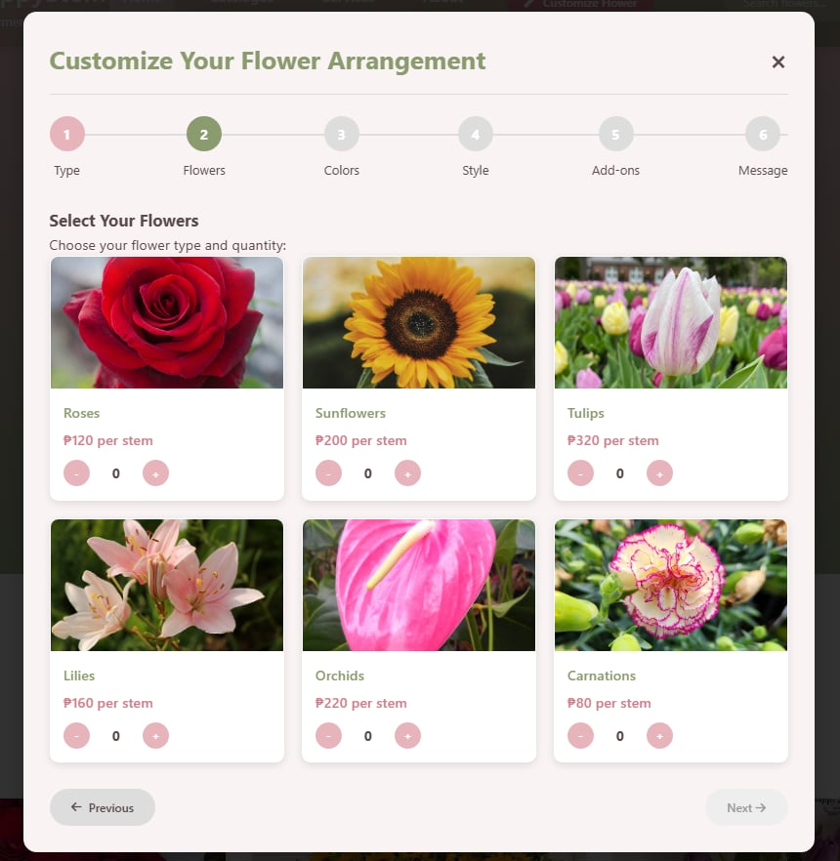

Plate 4.16.1 Customize Screen. This screen represents the second step of the customization process, where customers further refine their floral selections. can choose the kind of flowers you want to make your bouquet look nice.

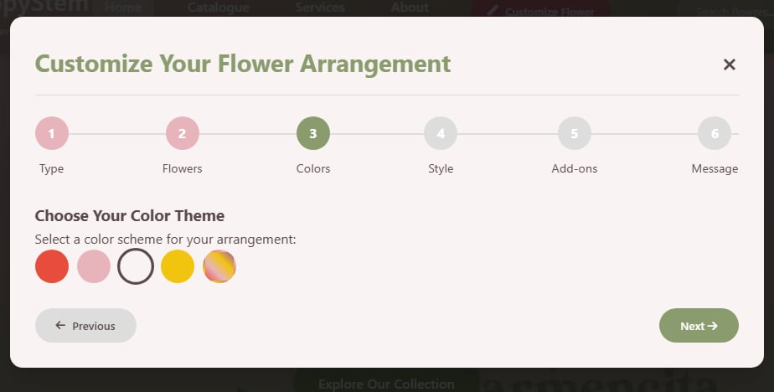

Plate 4.16.2 Customize Screen. This screen represents the third step of the customization process; it allows the customer to choose his/her desired color theme for the arrangement.

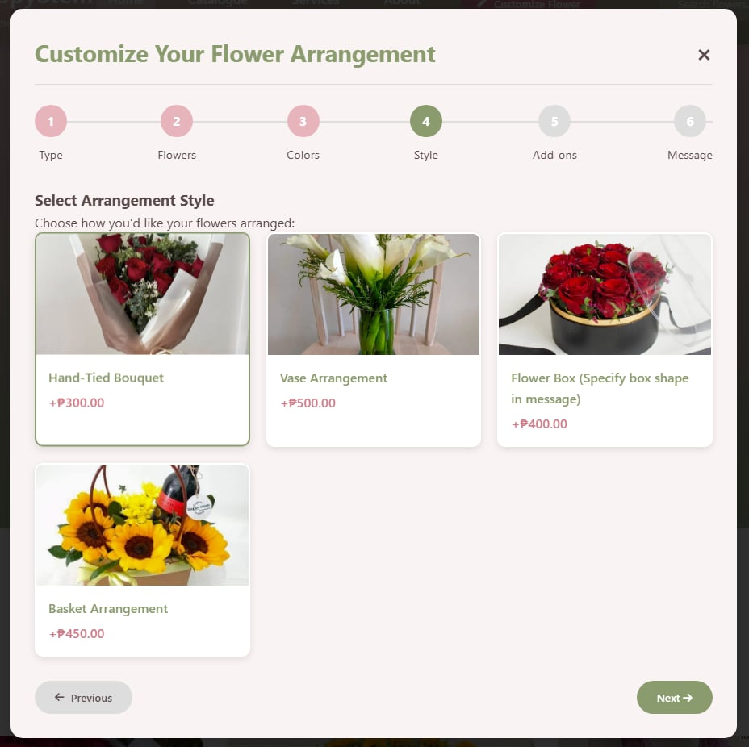
Plate 4.16.3 Customize Screen. This shows the fourth step of customization of the flower arrangement. User can choose the arrangement style he/she desires. Hand-tied bouquet”, “Vase arrangement”, “Flower box”, and “Basket arrangement” are the choices that user can choose.

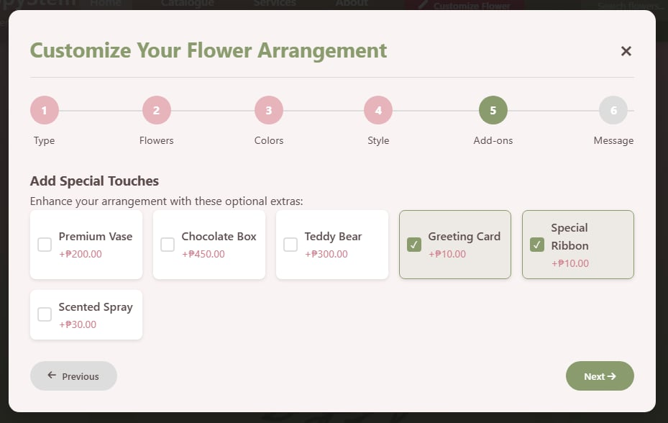

Plate 4.16.4 Customize Screen. This screen displays different add-ons accessories. Each add-on is displayed as a selectable card with a checkbox, and customers may choose multiple items simultaneously.

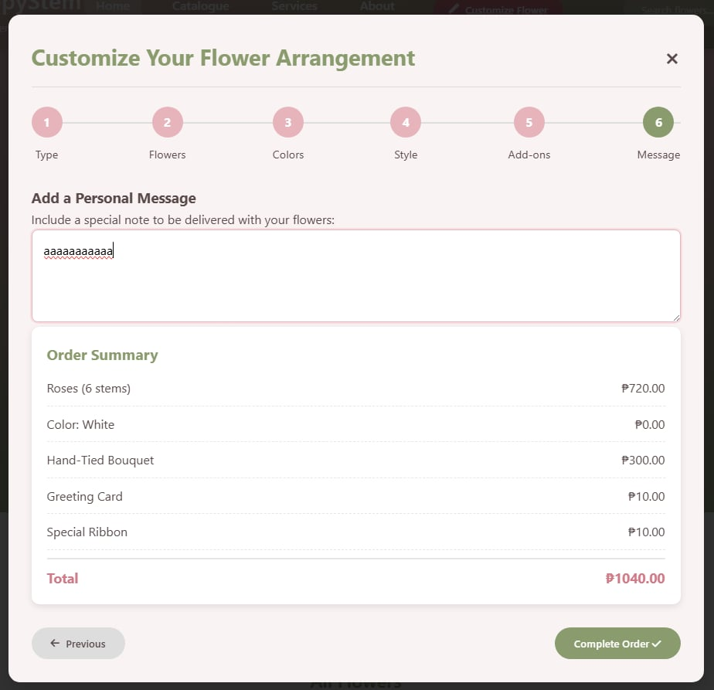

Plate 4.16.5 Customize Screen. This screen represents the final confirmation step of the customization flow, where the customer reviews the complete order details. The screen displays the order summary, and a personal message box is displayed for user to input any note to be delivered with the flower.


Plate 4.17 Shopping Cart Screen. The Shopping Cart screen provides customers with a consolidated view of all the floral products they have selected for purchase. Each item listed in the cart displays the product name, thumbnail image, selected quantity, and individual price. Customers can remove unwanted items or proceed to checkout from this screen. The total order amount is automatically calculated and displayed at the bottom, giving customers a clear overview of their pending purchase before confirming the transaction.

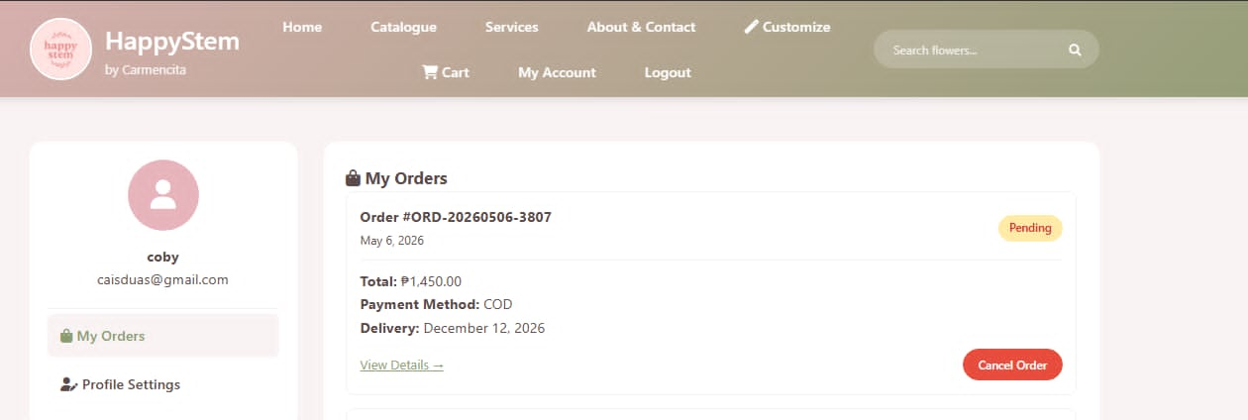

Plate 4.18 My Account Screen “My Orders”. This screen displays the transaction history section within the customer's account profile. It allows customers to view a list of all their past and ongoing orders. This feature gives customers full visibility into their purchase records and enables them to track whether their orders are pending, confirmed, or already delivered. Moreover, customers have the capability to cancel their orders by clicking the “Cancel Order” button.

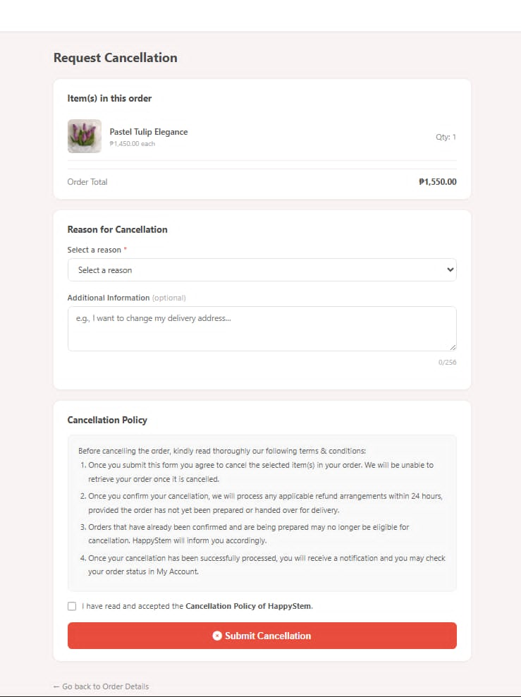

Plate 4.18.1 My Account Screen “My Orders: Cancel Order”. This screen displays the cancellation section; it allows customers cancel their order. The page has a dropdown menu open showing all the reasons a customer might want to cancel their order. Below is the cancellation policy, for customers to be aware of the terms and conditions for cancelling their orders.
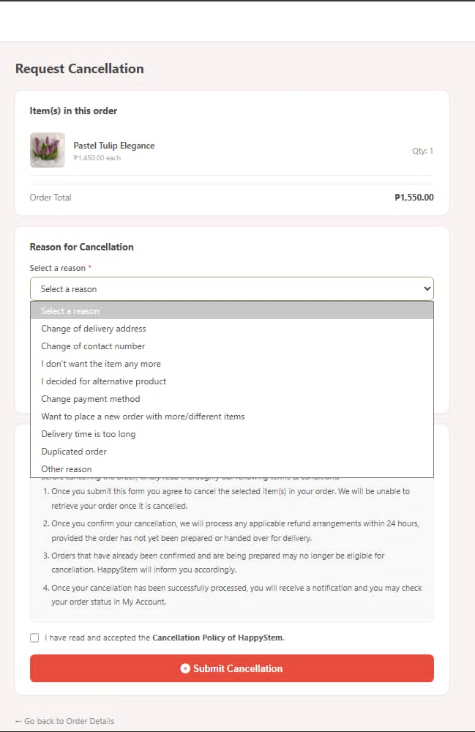

Plate 4.18.2 My Account Screen “My Orders: Cancel Order”. This screen displays the cancellation section; it allows customers cancel their order. The page has a dropdown menu open showing all the reasons a customer might want to cancel their order. Below is the cancellation policy, for customers to be aware of the terms and conditions for cancelling their orders.

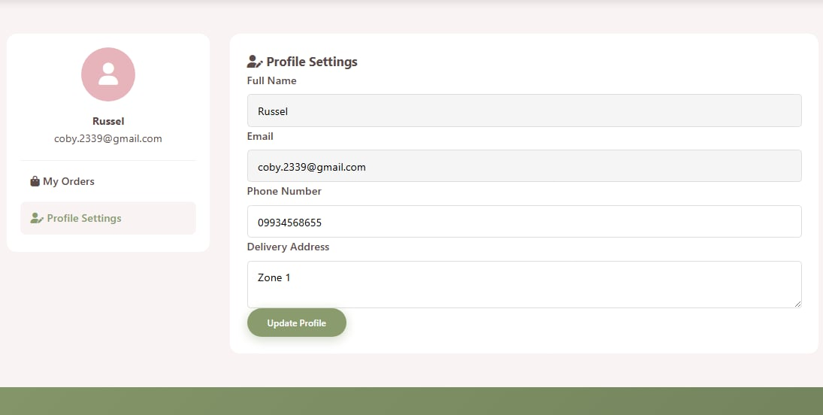

Plate 4.18.3 My Account Screen “Profile Settings”. The My Account screen provides logged-in customers with a personalized dashboard where they can view and manage their account information. This includes their registered name, email address, contact number, and delivery address on file. Customers can update their personal details and password from this screen to ensure their account information remains accurate and current.

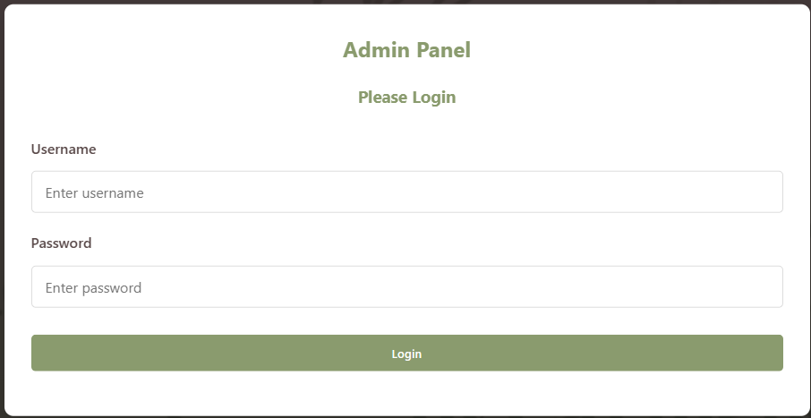

Plate 4.19 Administrators’ Login Screen. Through the pictures provided, admin can login the account by username and password, once the login process is done, by clicking login button, it will proceed to the admin panel

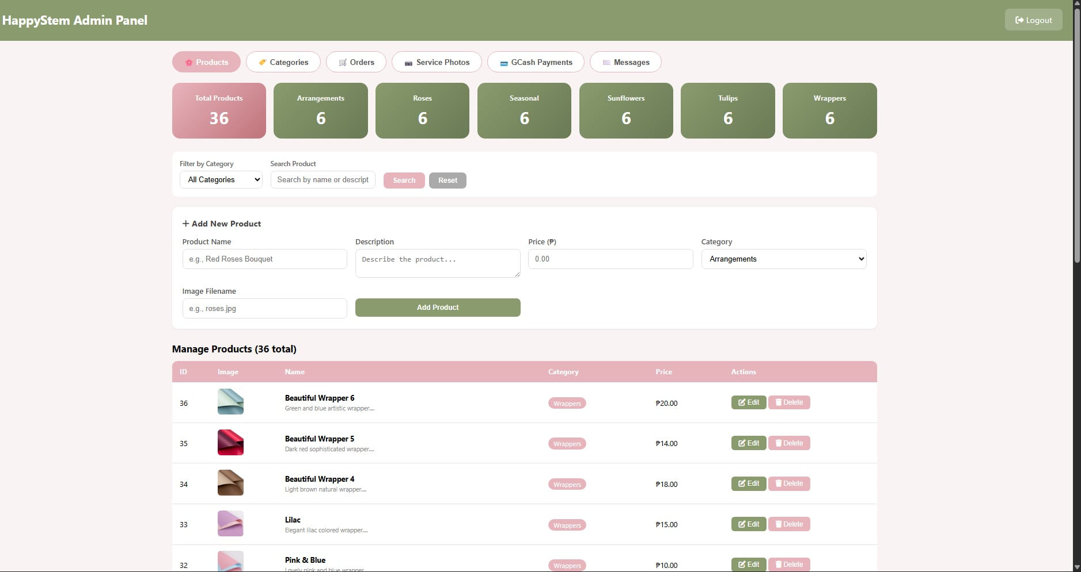

Plate 4.20 Admin Products Panel. The screenshot displays the Products page of the Happy Stem Admin Panel, with the Products tab highlighted in pink in the top navigation bar alongside the other tabs: Categories, Service Photos, GCash Payments, and Messages, with a Logout button on the upper right. This panel is the administrator's interface for managing the store's product listings. It allows the admin to view, add, edit, and delete products such as bouquets, gift boxes, and wrappers, along with their descriptions, images, and pricing.

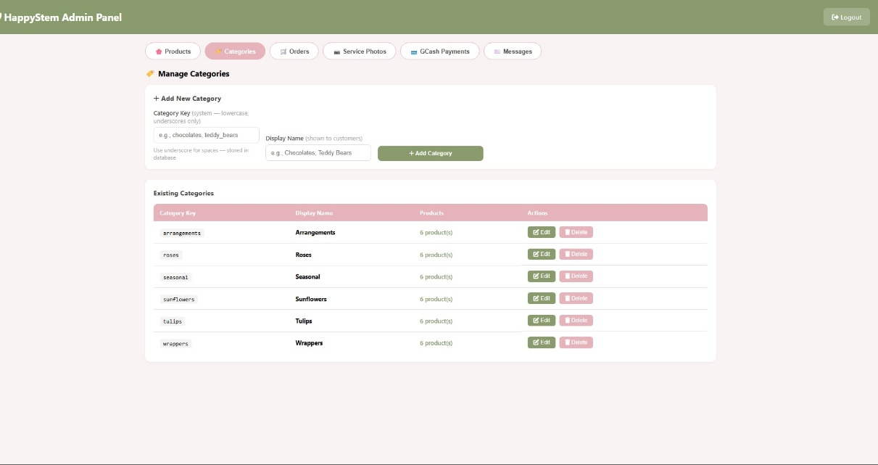

Plate 4.20.1 Admin Categories Panel. This panel enables the administrator to organize products into categories. It provides a structured way to group and manage the different types of items offered by the shop, making it easier to maintain and navigate the product catalog.

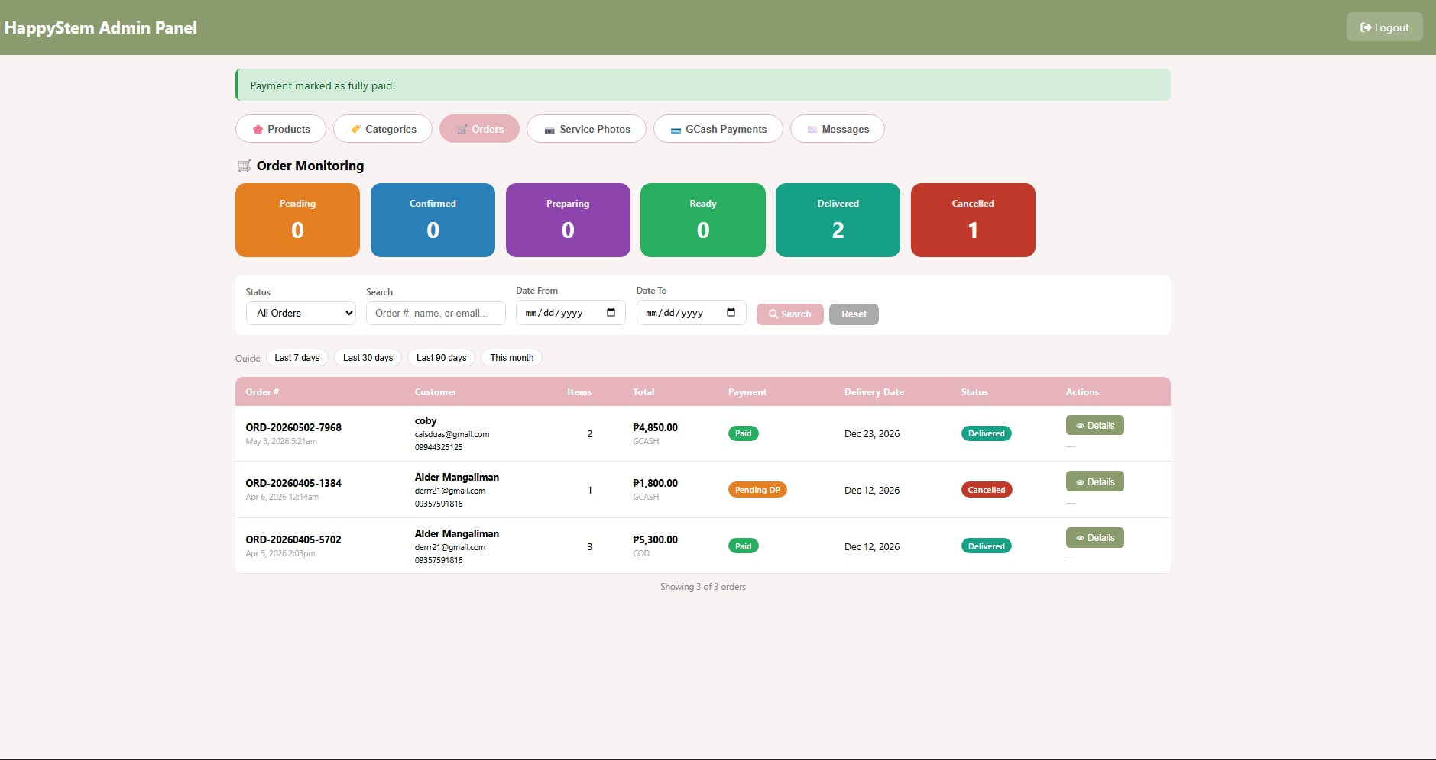

Plate 4.20.2 Admin Orders Panel. The Happy Stem Admin Orders Panel serves as a centralized management tool of the system. Its core purpose is to allow administrators to monitor, manage, and track customer orders.

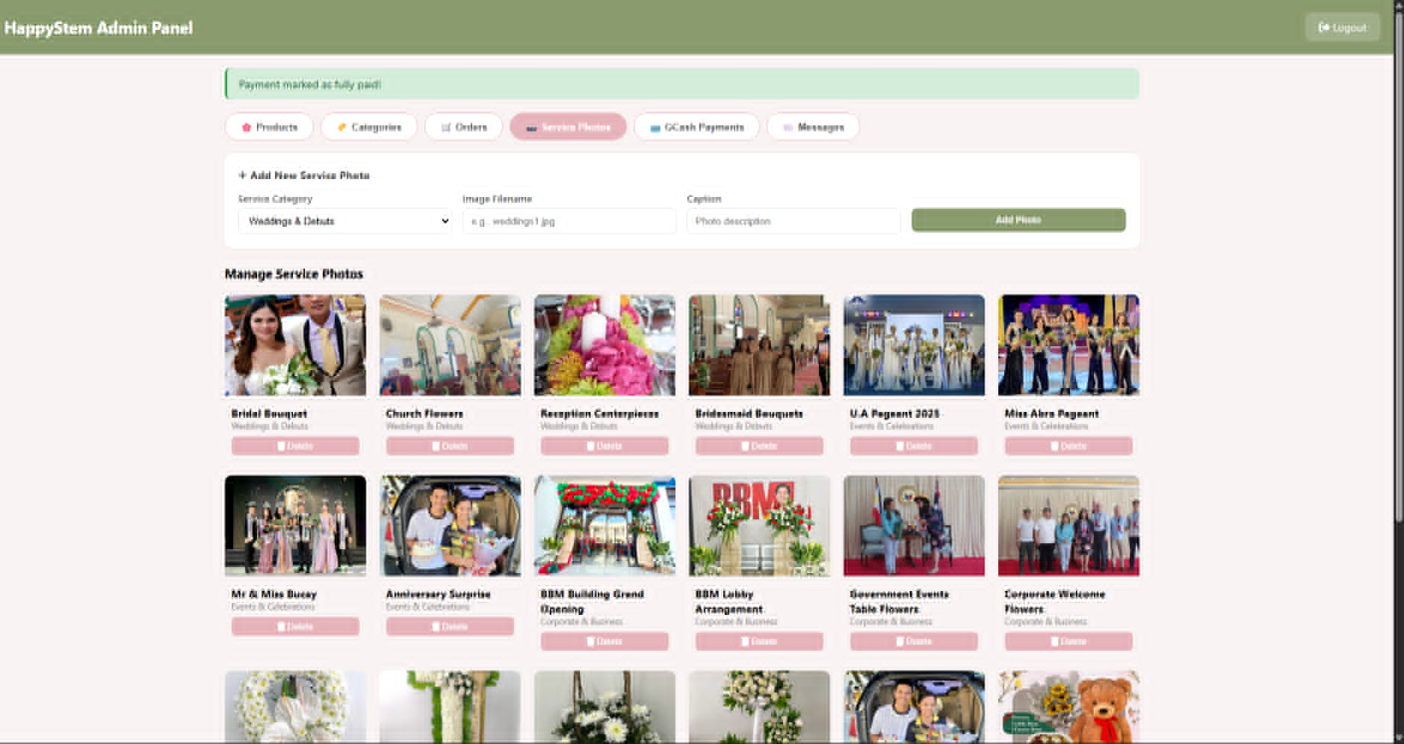

Plate 4.20.3 Admin Services Panel. This panel handles the management of services offered by the shop, such as event decoration packages or delivery options. The admin can add, update, or remove service entries from this interface. Each photo card includes its title, category label, and a red Delete button.

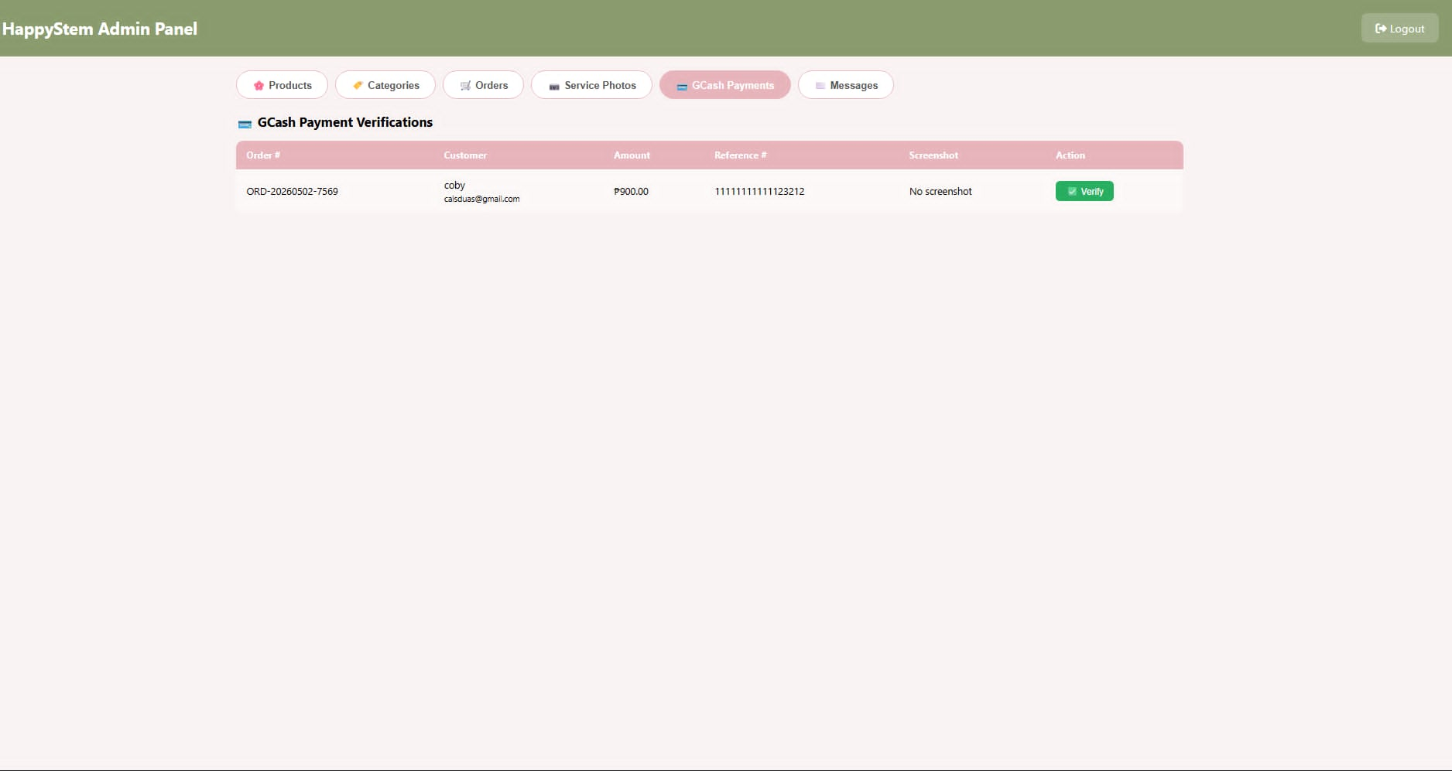

Plate 4.20.4 Admin Gcash Payment Panel. The screenshot displays the GCash Payments page of the Happy Stem Admin Panel, with the GCash Payments tab highlighted in pink in the top navigation bar. This panel shows the administrator's interface for managing GCash payment configurations or viewing GCash-related transaction details. It supports the system's online payment gateway functionality, allowing the admin to oversee payment processing.

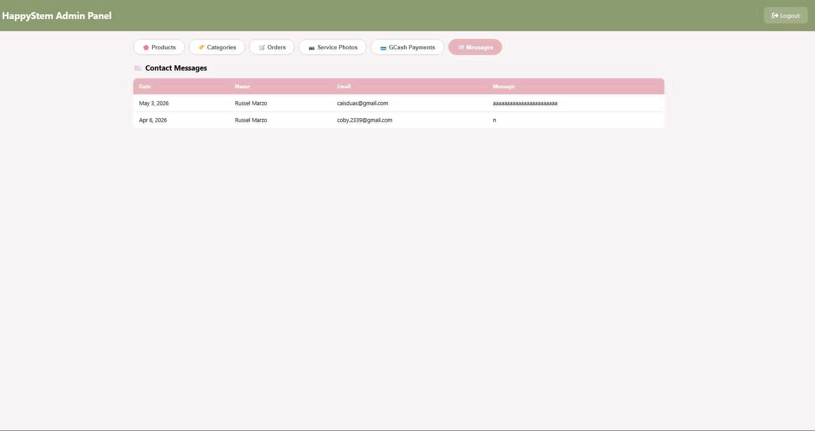

Plate 4.20.5 Admin Messages Panel. Messages page of the Happy Stem Admin Panel, with the Messages tab highlighted in pink in the top navigation bar. The main content area contains a white card titled "Messages," which holds a table with four columns: Date, Name, Email, and Message. This panel displays messages sent by customers. The administrator can view customer messages submitted to shop management directly from this interface.

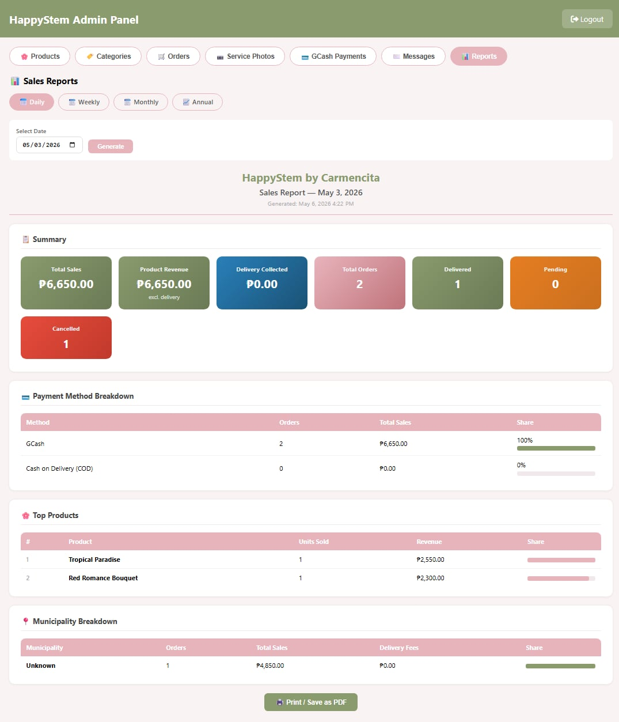

Plate 4.20.6 Admin Reports Panel “Daily Sales Report”. These images show the sales reports of the happy stem daily, weekly, monthly and annually. Moreover, it shows the payment method breakdown, top products and municipality breakdowns.

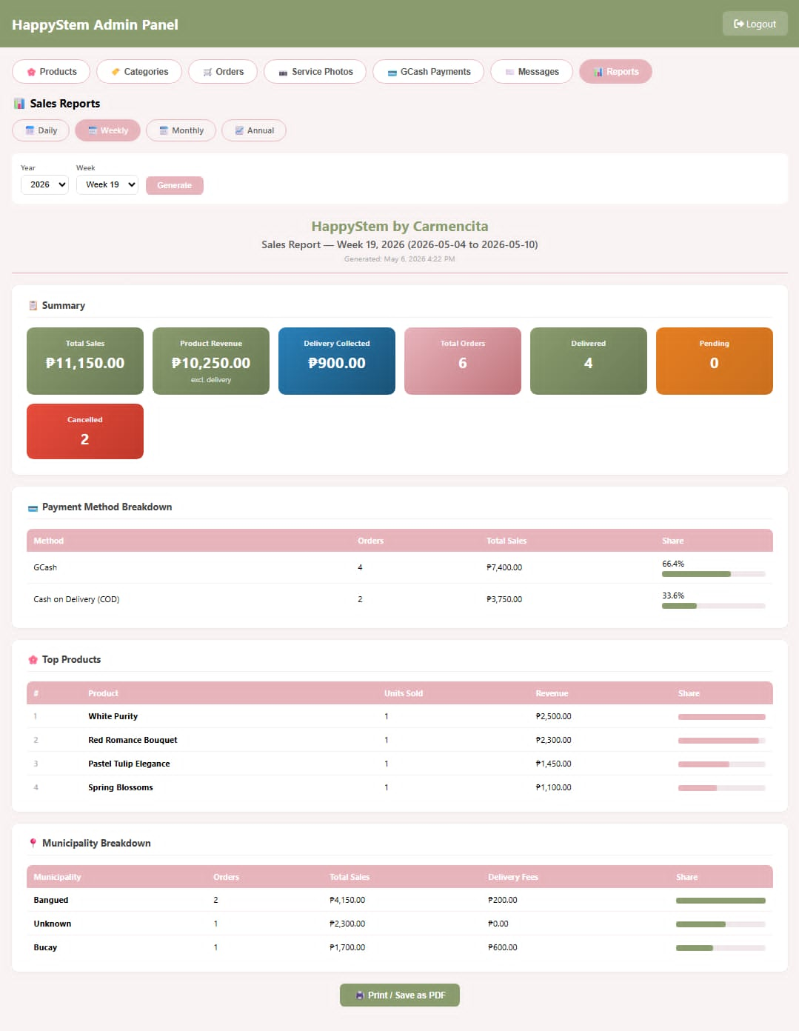

Plate 4.20.7 Admin Reports Panel “Weekly Sales Report”. These images show the sales reports of the happy stem daily, weekly, monthly and annually. Moreover, it shows the payment method breakdown, top products and municipality breakdowns.

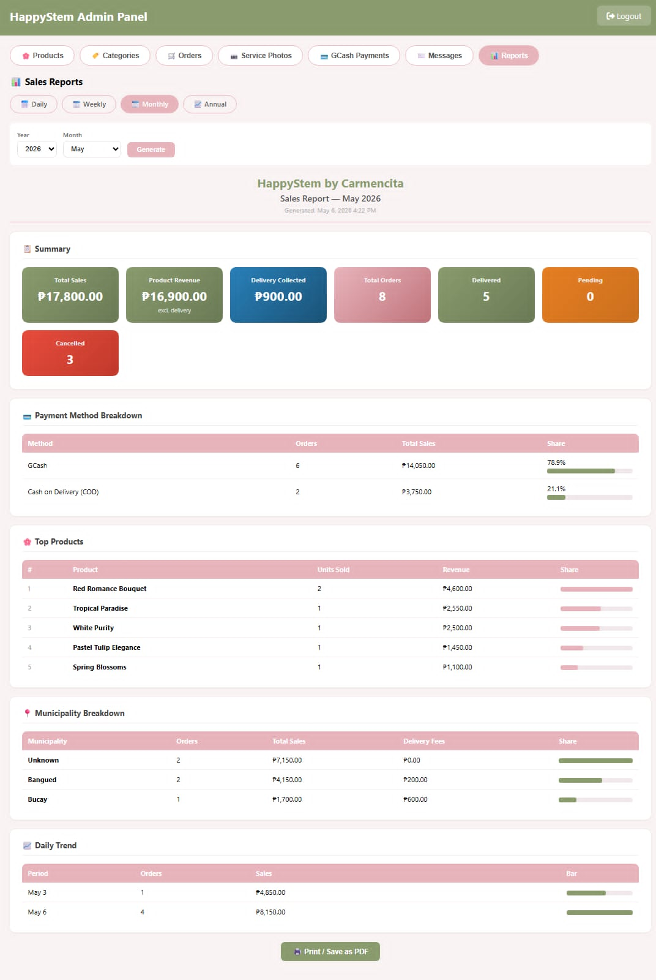

Plate 4.20.8 Admin Reports Panel “Monthly Sales Report”. These images show the sales reports of the happy stem daily, weekly, monthly and annually. Moreover, it shows the payment method breakdown, top products and municipality breakdowns.

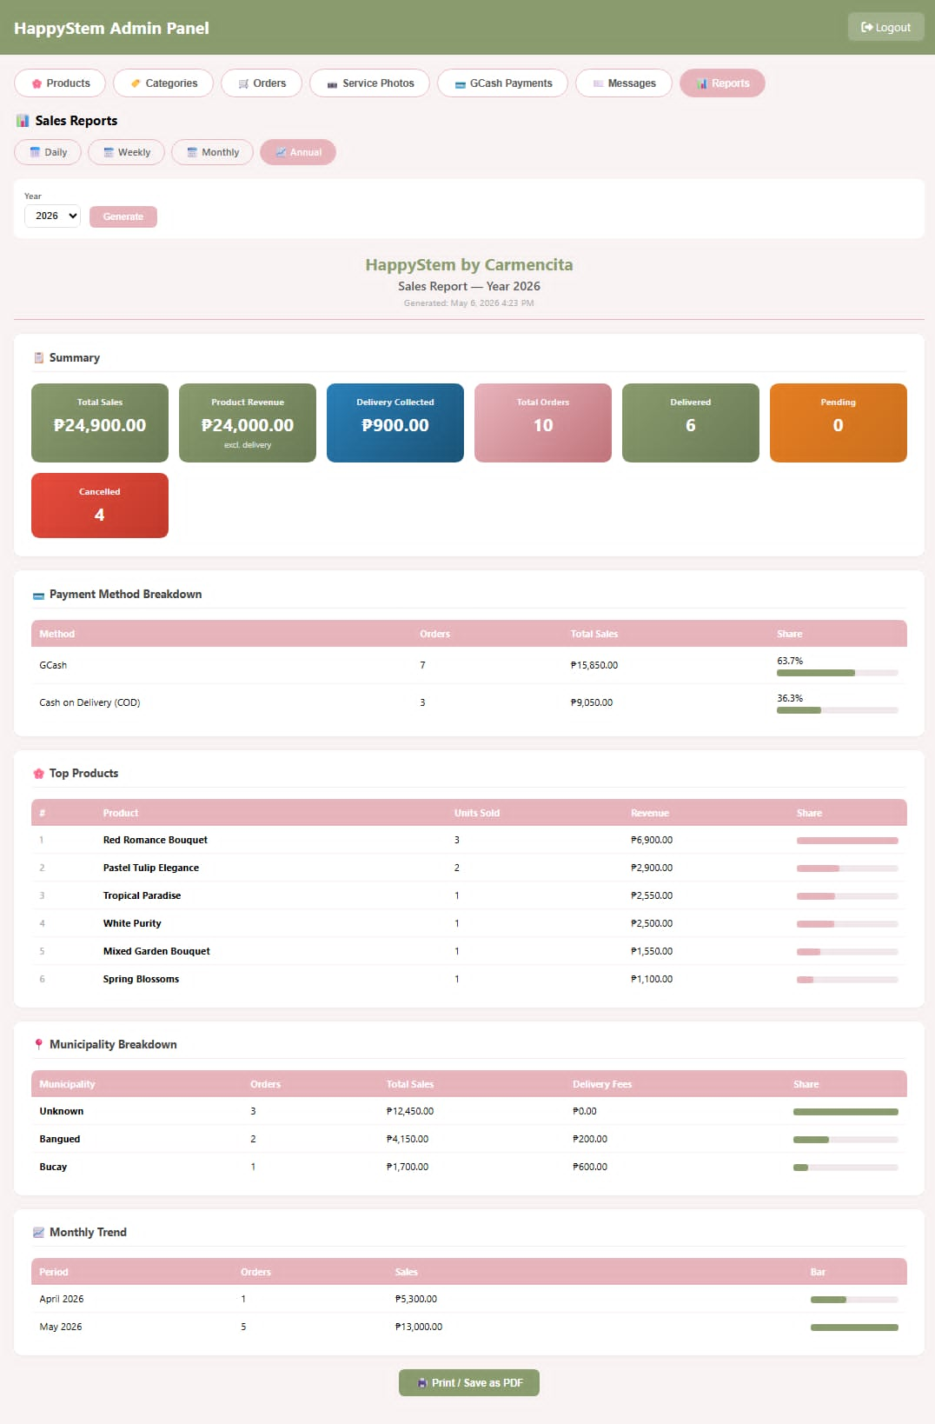

Plate 4.20.9 Admin Reports Panel “Annual Sales Report”. These images show the sales reports of the happy stem daily, weekly, monthly and annually. Moreover, it shows the payment method breakdown, top products and municipality breakdowns.

Functional and Non-Functional Requirements of the System
Functional Requirements
Functional Requirements describe the specific behaviors and capabilities that the system must provide to enable users to perform their intended tasks. The system has two primary user roles: the Administrator and the Customer. The following table summarizes the functional requirements for each user type.

Table 1. Functional Requirements of the System
Users | Description
Administrator | - Provides a dashboard interface for monitoring transaction records.  - Provides a dashboard interface for monitoring and tracking customer orders.  - Provides an interface to add, edit, and delete product listings including bouquets, gift boxes, and event decoration packages with descriptions, images, and pricing.  - Provides the ability to edit homepage content and featured product to visiting customers.
Customer | - Provides an interface to register a new account and log in to access ordering features.  - Provides an interactive digital catalog for browsing available floral products with images, descriptions, and real-time pricing.  - Provides a virtual shopping cart for selecting and reviewing items before finalizing an order.  - Provides an order placement module for submitting delivery details including address, preferred delivery date, and special instructions.  - Provides an online payment gateway for completing transactions securely.  - Provides a Contact Us section for submitting customer feedback, ratings, and messages to shop management.

However, the non-functional requirements define the quality criteria that govern the operation of the Happy Stem system, grounded in the ISO/IEC 25010 software quality model. ISO/IEC 25010 is an international standard published by the International Organization for Standardization that defines a structured quality model for evaluating software products and ICT systems. These requirements ensure that the Happy Stem system is not only functional but also secure, reliable, maintainable, and accessible to all its users. Each non-functional requirement identified for the system directly corresponds to a recognized quality characteristic under ISO/IEC 25010, ensuring that the platform is developed and evaluated against internationally accepted software quality standards.
Table 2. Non-Functional Requirements
Non-Functional Requirements | Description
Availability | - The system has to be something that customers and the administrator can use at any time when the shop's open. This is about how the system works and if people can get to it when they need to. The system being accessible is very important because customers and the administrator need to be able to use it all the time when the shop's open.
Accessibility | - The system must be able to run on different platforms and devices with minimal changes. It must be compatible with commonly used web browsers on both desktop and mobile operating systems to ensure that all customers can access the platform without specialized software.
Integrity | - The system must ensure that all transaction data, product information, and customer records are accurate, consistent, and protected from unauthorized modification.
Maintainability | - The system must be capable of being maintained and updated cost-effectively over its expected operational lifetime. This includes the ability to incorporate additional requirements, modify existing features, and extend functionality as the shop's offerings grow.
Reliability | - The System for Happy Stem needs to work so it can handle customer orders show product information and take care of transactions without any problems. A reliable system ensures that both the administrator and customers can depend on the platform to function correctly every time it is accessed, thereby maintaining the trust and confidence of its users and supporting the uninterrupted daily operations of the shop.
Security | - All data inside the system, including customer information, payment details, and administrative records, must be protected against unauthorized access, data breaches, and malicious attacks through appropriate authentication and encryption mechanisms.
Usability | - The system must provide an interface that is easy to understand and navigate for users of varying digital literacy levels. The system has to be easy for all users to navigate, including the systems interface, which's what the users will be interacting with.

Minimum Hardware and Software Requirements of the System
Software
Administrator Software Requirements
Table 3. Administrator Software Requirements of the System
Requirements | Description
Operating System | Windows 11
Backend and Database | PHP (Version 7.4 or higher / 8.x)  MySQL (Version 5.7 or higher)
Web Browser | Google Chrome  Mozilla Firefox  Microsoft Edge
Development Tools | Visual Studio Code  phpMyAdmin

Customer Software Requirements

Table 4. Customer Software Requirements of the System
Requirements | Description
Operating System | Windows 10 or Higher  Android 10+ or iOS 14+
Web Browser | Google Chrome  Mozilla Firefox  Microsoft Edge  Safari

Hardware
Administrator Hardware Requirements
Table 5. Administrator Hardware Requirements
Requirements | Description
Processor | Intel Core i5 11th generation
RAM | 16GB
Storage | 500GB
Monitor | Full HD (1920 x 1080)

Customer Hardware Requirements
Table 6. Administrator Hardware Requirements
Requirements | Description
Processor | Intel Core i3 / AMD Ryzen 3 (desktop/laptop)  Android64-bit ARMv8 octa-core, 1.2GHz+ (e.g. Snapdragon 4-series, Helio G85)  iOS Apple A13 Bionic (iPhone 11 / SE 2nd gen)
RAM | 16GB or Higher
Storage | 500GB
Screen Size | 6 inches - mobile phone  17-18 inches - laptop  24-27 inches - monitor

