ASSIGNMENT

Introduction to Machine Learning

SUBMITTED TO
Prof. Soumia Chandran M
DEPT. OF MCA
GECT

SUBMITTED BY
JESNA THEJASWINI JOHN
S4 MCA
R0LL NO – 13
GECT

1.How do you choose the best split in the decision tree algorithm?
Decision tree learning is one of the predictive modeling approaches used in statistics, data mining and machine learning. It uses a decision tree(as a predictive model) to go from observations about an item (represented in the branches) to conclusions about the item's target value (represented in the leaves). Tree models where the target variable can take a discrete set of values are called classification trees; in these tree structures, leaves represent class labels and branches represent conjunctions of features that lead to those class labels. Decision trees where the target variable can take continuous values (typically real numbers) are called regression trees.
In decision analysis, a decision tree can be used to visually and explicitly represent decisions and decision making. In data mining, a decision tree describes data (but the resulting classification tree can be an input for decision making). This page deals with decision trees in data mining.

A tree is built by splitting the source set, constituting the root node of the tree, into subsets - which constitute the successor children. The splitting is based on a set of splitting rules based on classification features.This process is repeated on each derived subset in a recursive manner called recursive partitioning. The recursion is completed when the subset at a node has all the same values of the target variable, or when splitting no longer adds value to the predictions. This process of top-down induction of decision trees(TDIDT) is an example of a greedy algorithm, and it is by far the most common strategy for learning decision trees from data.
Decision tree uses entropy and information gain to select a feature which gives the best split.we can say that best split is when we can separate the classes accurately based on that feature.A score measure has to be used in order to decide which is the best split, what is the best feature to use at the current node and with which threshold. Since the idea is to generate the purest learning subsets in terms of the output labels, the basic principle is to measure the purity improvement made by any candidate split, yielding score measures based on the class purity improvement between the sub-sample reaching the current node and those of its resulting two sub-sub-samples.For example, let us say we have to classify the type of people coming to the theatre as couples, friends, family and the attributes are show timings, no, of tickets, etc.We know that lovers get 2 tickets, families get 3 or 4 tickets and a friends group might get more than 4 tickets. (In most cases)Therefore to find the class, no. of tickets might be the best split rather than show timings.

2.Give a sample scenario where decision tree can be used for classifying data?
A decision tree works by splitting a set of training data into sub-sets based on features and a target feature. It does this based on multiple features, creating a tree of sub sets of the data. The leaf nodes contain the predictions used for new queries to the trained model. The following example will help us to understand how this works.
Suppose we had a data set of different animals with a number of different features for each animal, and with each animal classified as “mammal,” “bird”, “reptile”, “insect”, “mollusc” and “amphibian”. Given the same attributes for an animal not in our original training data, how can we predict what class of animal it is?
Intuitively we might split the data as follows:

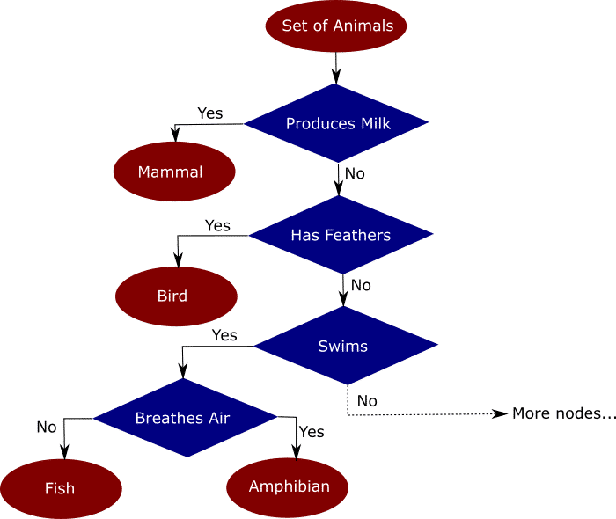

Splitting the data into a tree based on the features available makes it easy to classify new input data points. How accurately the tree classifies new data points depends on how well the decisions in the tree reflect reality.

3.Why decision tree algorithm is considered as greedy algorithm?
“Greedy Approach is based on the concept of Heuristic Problem Solving by making an optimal local choice at each node. By making these local optimal choices, we reach the approximate optimal solution globally.”
The algorithm can be summarized as :
1. At each stage (node), pick out the best feature as the test condition.
2. Now split the node into the possible outcomes (internal nodes).
3. Repeat the above steps until all the test conditions have been exhausted into leaf nodes.
A tree is built by splitting the source set, constituting the root node of the tree, into subsets - which constitute the successor children. The splitting is based on a set of splitting rules based on classification features. This process is repeated on each derived subset in a recursive manner called recursive partitioning. The recursion is completed when the subset at a node has all the same values of the target variable, or when splitting no longer adds value to the predictions. This process of top-down induction of decision trees(TDIDT) is an example of a greedy algorithm, and it is by far the most common strategy for learning decision trees from data.

4.What is difference between simple linear and multiple linear regressions?
Linear regression is one of the most common techniques of regression analysis. Multiple regression is a broader class of regressions that encompasses linear and nonlinear regressions with multiple explanatory variables.
Linear Regression
Linear regression is also called simple linear regression. It establishes the relationship between two variables using a straight line. Linear regression attempts to draw a line that comes closest to the data by finding the slope and intercept that define the line and minimize regression errors.
Many data relationships do not follow a straight line, so statisticiansuse nonlinear regression instead. The two are similar in that both track a particular response from a set of variables graphically. But nonlinear models are more complicated than linear models because the function is created through a series of assumptions that may stem from trial and error.
Multiple Regression
If two or more explanatory variables have a linear relationship with the dependent variable, the regression is called a multiple linear regression. It is rare that a dependent variable is explained by only one variable. In this case, an analyst uses multiple regression, which attempts to explain a dependent variable using more than one independent variable. Multiple regressions can be linear and nonlinear. Multiple regressions are based on the assumption that there is a linear relationship between both the dependent and independent variables. It also assumes no major correlation between the independent variables.

5.Explain the purpose of Ordinary Least Square Estimation in linear regression?
This method of regression analysis begins with a set of data points to be plotted on an x- and y-axis graph. An analyst using the least squares method will generate a line of best fit that explains the potential relationship between independent and dependent variables.
In regression analysis, dependent variables are illustrated on the vertical y-axis, while independent variables are illustrated on the horizontal x-axis. These designations will form the equation for the line of best fit, which is determined from the least squares method.
Ordinary least squares (OLS) is a type of linear least squaresmethod for estimating the unknown parametersin a linear regression model. OLS chooses the parameters of a linear function of a set of explanatory variables by the principle of least squares: minimizing the sum of the squares of the differences between the observed dependent variable(values of the variable being observed) in the given dataset and those predicted by the linear function.
Geometrically, this is seen as the sum of the squared distances, parallel to the axis of the dependent variable, between each data point in the set and the corresponding point on the regression surface – the smaller the differences, the better the model fits the data. The resulting estimator can be expressed by a simple formula, especially in the case of a simple linear regression, in which there is a single regressor on the right side of the regression equation
The method estimates the relationship by minimizing the sum of the squares in the difference between the observed and predicted values of the dependent variable configured as a straight line. In this entry, OLS regression will be discussed in the context of a bivariate model, that is, a model in which there is only one independent variable ( X ) predicting a dependent variable ( Y ). However, the logic of OLS regression is easily extended to the multivariate model in which there are two or more independent variables. So ordinary least squares regression is a statistical method that produces the one straight line that minimizes the total squared error.

6.Explain the use of correlation in linear regression?
Simple linear regression relates X to Y through an equation of the form Y = a + bX.Correlation quantifies the direction and strength of the relationship between two numeric variables, X and Y, and always lies between -1.0 and 1.0. Simple linear regression relates X to Y through an equation of the form Y = a + bX.We use linear regression or correlation when you want to know whether one measurement variable is associated with another measurement variable; you want to measure the strength of the association (r2); or you want an equation that describes the relationship and can be used to predict unknown values.If the computed correlation coefficient is small (in particular, near to zero), you know only, that your variables are not associated in a linear way. However, they might be associated according to a non-linear relationship. It is a nknown fact, that points (x,y) following an exact nonlinear functional interdependence (like half of a circular dependence), when subjected to correlation evaluation, yield a correlation coefficient equal to zero.

