多种数据显示页目录
1． 预备知识 1
（1) 多数据表Json 1
（2) dataset转为json 1
2． 建立显示详细信息的三个相关文件 2
3． 编写index.html 3
（1) 引入js 4
（2) 引入导航 4
（3) 显示内容的table和ul 4
4． 编写index.js 4
5． 编写多种数据显示功能的后台代码 5
（1) Model项目里增加student类并序列化 5
（2) IDAL项目里新建接口文件Istudent.cs 7
（3) SqlserverDAL项目里新建类文件student.cs 7
（4) 在DALFactory项目 DataAccess类里增加Createstudent方法 8
（5) 在BLL项目里增加student.cs类文件 8
（6) 编辑WEB项目里的index.Ashx 8

预备知识

多数据表Json
格式如下：
{ "programmers": [
{ "firstName": "Brett", "lastName":"McLaughlin", "email": "aaaa" },
{ "firstName": "Jason", "lastName":"Hunter", "email": "bbbb" },
{ "firstName": "Elliotte", "lastName":"Harold", "email": "cccc" }
],
"authors": [
{ "firstName": "Isaac", "lastName": "Asimov", "genre": "science fiction" },
{ "firstName": "Tad", "lastName": "Williams", "genre": "fantasy" },
{ "firstName": "Frank", "lastName": "Peretti", "genre": "christian fiction" }
],
"musicians": [
{ "firstName": "Eric", "lastName": "Clapton", "instrument": "guitar" },
{ "firstName": "Sergei", "lastName": "Rachmaninoff", "instrument": "piano" }
] }

dataset转为json
已封装为DataConvertJson类的Dataset2Json方法
/// <summary>
/// DataSet转换成Json格式
/// </summary>
/// <param name="ds">DataSet</param>
/// <returns></returns>
public static string Dataset2Json(DataSet ds)
{
StringBuilder json = new StringBuilder();

foreach (DataTable dt in ds.Tables)
{
string ss = DataTable2Json(dt);
ss= ss.Remove(0, 1);
json.Append(ss);
json.Remove(json.Length - 1,1);
json.Append(",");

}
if (json.Length > 0)
{
json.Insert(0, "{");
json.Remove(json.Length - 1, 1);
json.Append("}");
}
return json.ToString();
}

/// <summary>
/// dataTable转换成Json格式
/// </summary>
/// <param name="dt"></param>
/// <returns></returns>
public static string DataTable2Json(DataTable dt)
{
StringBuilder jsonBuilder = new StringBuilder();
jsonBuilder.Append("{\"");
jsonBuilder.Append(dt.TableName);
jsonBuilder.Append("\":[");
// jsonBuilder.Append("[");
for (int i = 0; i < dt.Rows.Count; i++)
{
jsonBuilder.Append("{");
for (int j = 0; j < dt.Columns.Count; j++)
{
jsonBuilder.Append("\"");
jsonBuilder.Append(dt.Columns[j].ColumnName);
jsonBuilder.Append("\":\"");
jsonBuilder.Append(dt.Rows[i][j].ToString().Replace("\\", "\\\\"));
jsonBuilder.Append("\",");
}
jsonBuilder.Remove(jsonBuilder.Length - 1, 1);
jsonBuilder.Append("},");
}
jsonBuilder.Remove(jsonBuilder.Length - 1, 1);
jsonBuilder.Append("]");
jsonBuilder.Append("}");
return jsonBuilder.ToString();
}

建立显示详细信息的三个相关文件
Index.html、index.js 、index.ashx

编写index.html
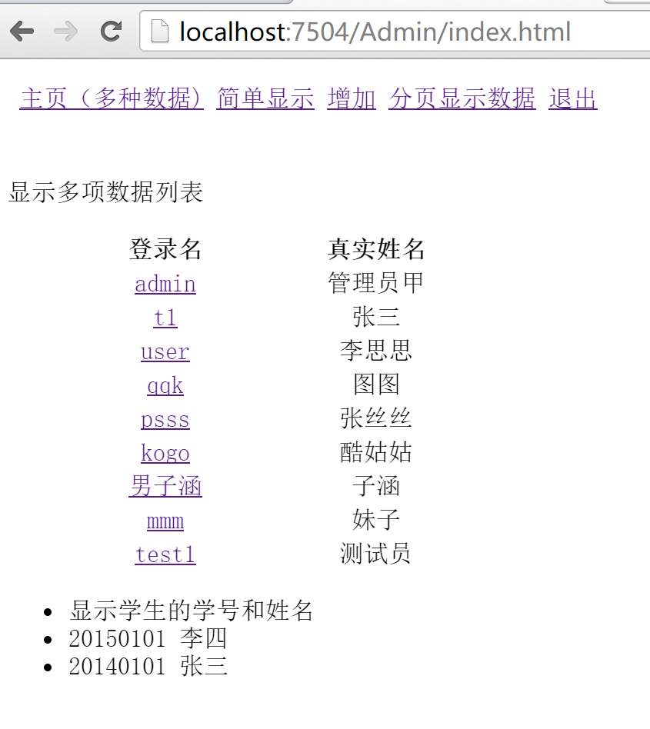
<!DOCTYPE html>
<html>
<head>
<meta http-equiv="Content-Type" content="text/html; charset=utf-8"/>
<title></title>
<meta charset="utf-8" />
<script src="../Scripts/jquery-1.10.2.min.js" type="text/javascript"></script>
<script src="js/index.js" type="text/javascript"></script>

</head>
<body>
<iframe src="nav.html" height="50" frameborder="0" width="100%" scrolling="no"></iframe>
<p>显示多项数据列表</p>
<div >
<table id="showlist" class="table table-hover table-striped">
<thead>
<tr>
<th width="200px" >登录名</th>
<th >真实姓名</th>
</tr>

</thead>
</table>

</div>
<div >
<ul id="top5">
<li>显示学生的学号和姓名</li>
</ul>

</div>
</body>
</html>

引入js
<script src="../Scripts/jquery-1.10.2.min.js" type="text/javascript"></script>
<script src="js/index.js" type="text/javascript"></script>

引入导航
<iframe src="nav.html" height="50" frameborder="0" width="100%" scrolling="no"></iframe>

显示内容的table和ul
<table id="showlist" class="table table-hover table-striped">
<thead>
<tr>
<th width="200px" >登录名</th>
<th >真实姓名</th>
</tr>

</thead>
</table>

<ul id="top5">
<li>显示学生的学号和姓名</li>
</ul>

编写index.js
$(document).ready(function () {

$.ajax({
type: "Post",
url: "ashx/index.ashx",
data: { "Action": "Show" },
dataType: "json",
success: function (data) {

var tbody = $('#showlist');
if (jQuery.isEmptyObject(data)) { //json数据为空

alert("无数据");
}
else
{
//用json返回数据行时
$.each(data.Admin, function (index, item) {//显示数据1
var str = '<tr>\
<td style="text-align: center; ">\
<a href="show.html?UserID='
+ item.adminID + '">'+ item.LoginID
+ '</a>\
</td>\
<td style="text-align: center; ">' + item.AdminName
+ '</td>\
<\tr>';
tbody.append(str);
});

tbody = $('#top5');
$.each(data.top5, function (index, item) {//显示数据2
var str = '<li>' + item. stuNo+' '+item.stuRealName + '</li>';
tbody.append(str);
});
}

},
error: function (err) {
alert(err);
}
});

});

编写多种数据显示功能的后台代码
这里需要的admin表的getlist功能在前面已实现，就不再描述了。主要介绍获取student表里的数据的方法。

Model项目里增加student类并序列化
在Model项目里新建类并命名为student.cs,编写代码。

using System;
namespace Model
{
/// <summary>
/// student:实体类(属性说明自动提取数据库字段的描述信息)
/// </summary>
[Serializable]
public class student
{
public student()
{}
#region Model
private int _stuid;
private string _stuloginname;
private string _stuloginpwd;
private bool _stustate;
private string _sturealname;
private string _stuno;
private bool _stusex;
private int _gradeid;
private int _classid;
/// <summary>
///
/// </summary>
public int stuID
{
set{ _stuid=value;}
get{return _stuid;}
}
/// <summary>
///
/// </summary>
public string stuLoginName
{
set{ _stuloginname=value;}
get{return _stuloginname;}
}
/// <summary>
///
/// </summary>
public string stuLoginPWD
{
set{ _stuloginpwd=value;}
get{return _stuloginpwd;}
}
/// <summary>
///
/// </summary>
public bool stuState
{
set{ _stustate=value;}
get{return _stustate;}
}
/// <summary>
///
/// </summary>
public string stuRealName
{
set{ _sturealname=value;}
get{return _sturealname;}
}
/// <summary>
///
/// </summary>
public string stuNo
{
set{ _stuno=value;}
get{return _stuno;}
}
/// <summary>
///
/// </summary>
public bool stuSex
{
set{ _stusex=value;}
get{return _stusex;}
}
/// <summary>
///
/// </summary>
public int gradeID
{
set{ _gradeid=value;}
get{return _gradeid;}
}
/// <summary>
///
/// </summary>
public int classID
{
set{ _classid=value;}
get{return _classid;}
}
#endregion Model

}
}

IDAL项目里新建接口文件Istudent.cs
在IDAL项目里新建接口并命名为Istudent.Cs,增加一个GetNameNoList方法的定义。
using System;
using System.Data;
namespace IDAL
{
/// <summary>
/// 接口层student
/// </summary>
public interface Istudent
{
DataSet GetNameNoList(int top);
}
}

SqlserverDAL项目里新建类文件student.cs
在SqlserverDAL项目里新建类文件并命名为student.Cs，实现Istudent接口,编写实现GetNameNoList方法的代码。

using System;
using System.Data;
using System.Text;
using System.Data.SqlClient;
using IDAL;

namespace SQLServerDAL
{
/// <summary>
/// 数据访问类:student
/// </summary>
public class student:Istudent
{
public student()
{}
#region Method

public DataSet GetNameNoList(int Top)
{
StringBuilder strSql = new StringBuilder();
strSql.Append("select ");
if (Top > 0)
{
strSql.Append(" top " + Top.ToString());
}
strSql.Append(" stuNo,stuRealName ");
strSql.Append(" FROM student ");

strSql.Append(" order by stuID desc");
return DbHelperSQL.Query(strSql.ToString());
}
}
}

在DALFactory项目 DataAccess类里增加Createstudent方法
/// <summary>
/// 创建student数据层接口。
/// </summary>
public static IDAL.Istudent Createstudent()
{

string ClassNamespace = AssemblyPath +".student";
object objType=CreateObject(AssemblyPath,ClassNamespace);
return (IDAL.Istudent)objType;
}

在BLL项目里增加student.cs类文件
在BLL项目里新建类文件并命名为student.Cs，定义Istudent接口字段，并通过工厂方法动态创建实例，增加GetNameNoList方法
using System;
using System.Data;
using System.Collections.Generic;

using Model;
using DALFactory;
using IDAL;
namespace BLL
{
/// <summary>
/// student
/// </summary>
public partial class student
{
private readonly Istudent dal=DataAccess.Createstudent();
public student()
{}
#region BasicMethod
public DataSet GetNameNoList(int Top)
{
return dal.GetNameNoList(Top);
}
}
}

编辑WEB项目里的index.Ashx
using System;
using System.Collections.Generic;
using System.Linq;
using System.Web;
using System.Data;
namespace web.Admin.ashx
{
/// <summary>
/// l2 的摘要说明
/// </summary>
public class index : IHttpHandler, System.Web.SessionState.IRequiresSessionState
{

public void ProcessRequest(HttpContext context)
{
context.Response.ContentType = "text/plain";
string json = "{}";
string action = context.Request.Form["Action"];

if (action == "Show")
{

BLL.Admin bll = new BLL.Admin();
DataSet ds = bll.GetList("");//获取所有的用户
ds.Tables[0].TableName = "Admin";//修改数据表的名字

BLL.student bll1 = new BLL.student();
DataSet dstop5 = bll1.GetNameNoList(5);//获取前5个学生

DataTable top5 = dstop5.Tables[0].Copy();//获取数据表
top5.TableName = "top5"; //改名
ds.Tables.Add(top5);//把前5个用户的数据表，加到数据集ds中

//返回列表
json = Web.DataConvertJson.Dataset2Json(ds);//转换

}

context.Response.Write(json);
}

public bool IsReusable
{
get
{
return false;
}
}
}
}

