* 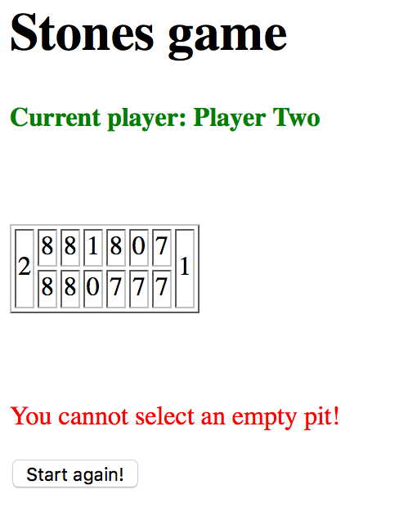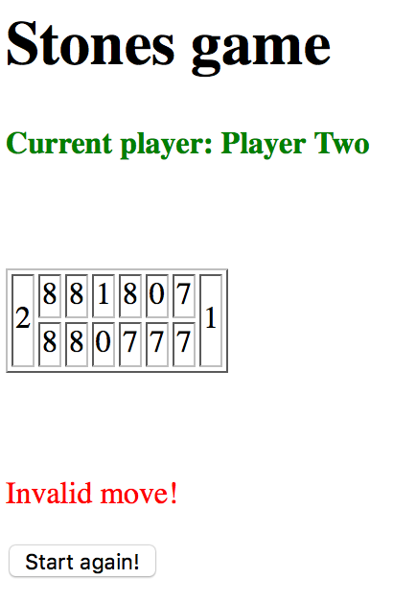I called this game **Stones game** and I've implemented it using Spring MVC 4 and an autowired service to manage the progress of the game.
* This game is currently build using AngularJS on the front end.
* For build and quick runtime I've used the Tomcat7 pluging. I preferred not to use JETTY at this point given that it would delay the development of the application.
* To make the project run you have to run **bower install** so that all the angular script are installed in the web container.
* In order to run it locally you have to use the maven plugin for tomcat: **mvn tomcat7:run**
* The game has been implemented with focus on the implementation of the backend and **Junit** tests.
* In case you run into problems running this game, please contact me at **jofisaes@gmail.com**

