**BSkyOpenNewDataset( datasetName='Dataset1')**

**Open Dataset**

**Anova (1 Way and 2 Way)**

[Digging.plots.final.10.06.20.xlsx.data.for.Anova.in.R] - C:\Users\User\Documents\Marg I\Clean data D&R trials\Digging plots final 10.06.20.xlsx

|  |  |  |  |  |  |  |
| --- | --- | --- | --- | --- | --- | --- |
| **Plot** | **n** | **mean** | **median** | **min** | **max** | **sd variance** |
| Control | 24 | 30 | 30 | 25 | 35 | 3.6116 13.0435 |
| Digging | 24 | 30 | 30 | 20 | 40 | 5.3161 28.2609 |

# `summarise()` ungrouping output (override with `.groups` argument)

***Summaries for X_Epiphytes by factor variable Plot***

# `summarise()` ungrouping output (override with `.groups` argument)

***Summaries for X_Epiphytes by factor variable Time***

|  |  |  |  |  |  |  |
| --- | --- | --- | --- | --- | --- | --- |
| **Time** | **n** | **mean** | **median** | **min** | **max** | **sd** |
| T1 | 12 | 27.5 | 27.5 | 20 | 35 | 3.9886 |
| T2 | 12 | 28.3333 | 27.5 | 25 | 35 | 3.8925 |
| T3 | 12 | 32.5 | 35 | 25 | 40 | 4.5227 |
| T4 | 12 | 31.6667 | 30 | 25 | 40 | 3.8925 |

**variance**

15.9091

15.1515

20.4546

15.1515

# `summarise()` regrouping output by 'Plot' (override with `.groups` argument)

***Summaries for X_Epiphytes by factor variables Plot*Time***

|  |  |  |  |  |  |  |
| --- | --- | --- | --- | --- | --- | --- |
| **Plot** | **Time** | **N** | **mean** | **median** | **min** | **max** |
| Control | T1 | 6 | 30 | 30 | 25 | 35 |
| Control | T2 | 6 | 28.3333 | 27.5 | 25 | 35 |
| Control | T3 | 6 | 31.6667 | 32.5 | 25 | 35 |
| Control | T4 | 6 | 30 | 30 | 25 | 35 |
| Digging | T1 | 6 | 25 | 25 | 20 | 30 |
| Digging | T2 | 6 | 28.3333 | 27.5 | 25 | 35 |
| Digging | T3 | 6 | 33.3333 | 35 | 25 | 40 |
| Digging | T4 | 6 | 33.3333 | 32.5 | 30 | 40 |

|  |  |
| --- | --- |
| **Sd** | **variance** |
| 3.1623 | 10 |
| 4.0825 | 16.6667 |
| 4.0825 | 16.6667 |
| 3.1623 | 10 |
| 3.1623 | 10 |
| 4.0825 | 16.6667 |
| 5.164 | 26.6667 |
| 4.0825 | 16.6667 |

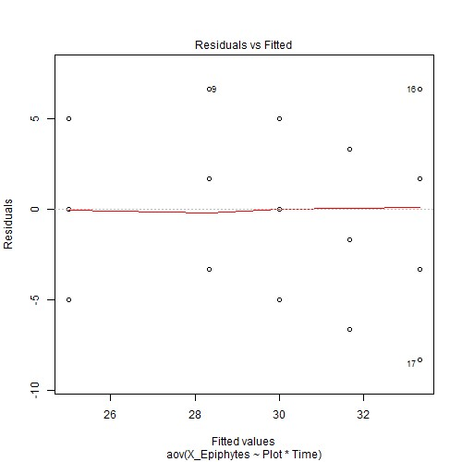

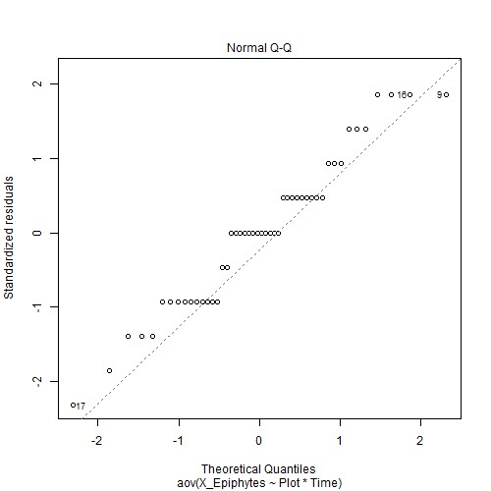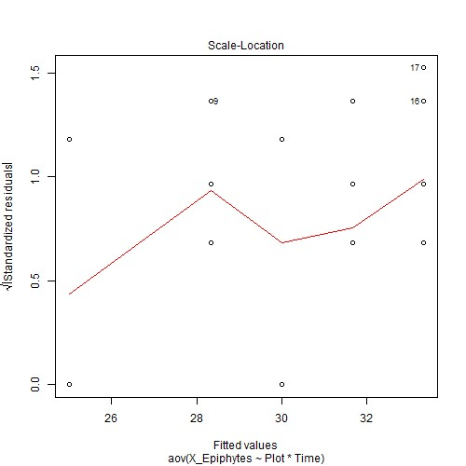

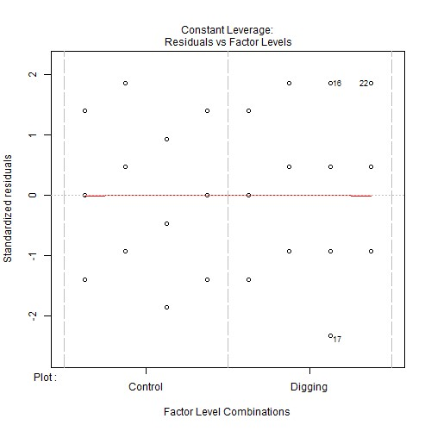

***Anova table with type III sum of squares for X_Epiphytes by Plot*Time***

|  |  |  |  |  |  |
| --- | --- | --- | --- | --- | --- |
|  | **Df** | **Sum Sq** | **Mean Sq** | **F value** | **Pr(>F)** |
| **Plot** | 1 | 0.0000 | 0.0000 | 0.0000 | 1 |
| **Time** | 3 | 216.6667 | 72.2222 | 4.6847 | 0.0068 ** |
| **Plot:Time** | 3 | 116.6667 | 38.8889 | 2.5225 | 0.0714 . |
| **Residuals** | 40 | 616.6667 | 15.4167 | NA | NA |

*Note.* Signif. codes: 0 '***' 0.001 '**' 0.01 '*' 0.05 '.' 0.1 ' ' 1

# NOTE: Results may be misleading due to involvement in interactions

***Estimated Marginal Means for X_Epiphytes by Plot***

|  |  |  |  |  |  |
| --- | --- | --- | --- | --- | --- |
| **Plot** | **emmean** | **SE** | **df** | **lower.CL** | **upper.CL** |
| Control | 30 | 0.8015 | 40 | 28.3802 | 31.6198 |
| Digging | 30 | 0.8015 | 40 | 28.3802 | 31.6198 |

# NOTE: Results may be misleading due to involvement in interactions

***Estimated Marginal Means for X_Epiphytes by Time***

|  |  |  |  |  |  |
| --- | --- | --- | --- | --- | --- |
| **Time** | **emmean** | **SE** | **df** | **lower.CL** | **upper.CL** |
| T1 | 27.5 | 1.1335 | 40 | 25.2092 | 29.7908 |
| T2 | 28.3333 | 1.1335 | 40 | 26.0425 | 30.6241 |
| T3 | 32.5 | 1.1335 | 40 | 30.2092 | 34.7908 |
| T4 | 31.6667 | 1.1335 | 40 | 29.3759 | 33.9575 |

***Estimated Marginal Means for X_Epiphytes by Plot*Time***

|  |  |  |  |  |  |  |
| --- | --- | --- | --- | --- | --- | --- |
| **Plot** | **Time** | **emmean** | **SE** | **df** | **lower.CL** | **upper.CL** |
| Control | T1 | 30 | 1.6029 | 40 | 26.7603 | 33.2397 |
| Digging | T1 | 25 | 1.6029 | 40 | 21.7603 | 28.2397 |
| Control | T2 | 28.3333 | 1.6029 | 40 | 25.0937 | 31.573 |
| Digging | T2 | 28.3333 | 1.6029 | 40 | 25.0937 | 31.573 |
| Control | T3 | 31.6667 | 1.6029 | 40 | 28.427 | 34.9064 |
| Digging | T3 | 33.3333 | 1.6029 | 40 | 30.0937 | 36.573 |
| Control | T4 | 30 | 1.6029 | 40 | 26.7603 | 33.2397 |
| Digging | T4 | 33.3333 | 1.6029 | 40 | 30.0937 | 36.573 |

***Levene's test for homogenity of variances (center=mean) for X_Epiphytes against Plot***

|  |  |  |  |
| --- | --- | --- | --- |
|  | **Df** | **F value** | **Pr(>F)** |
| **group** | 1 | 4 | 0.0514 . |
|  | 46 | NA | NA |

*Note.* Signif. codes: 0 '***' 0.001 '**' 0.01 '*' 0.05 '.' 0.1 ' ' 1

***Levene's test for homogenity of variances (center=mean) for X_Epiphytes against Time***

|  |  |  |  |
| --- | --- | --- | --- |
|  | **Df** | **F value** | **Pr(>F)** |
| **group** | 3 | 0.2444 | 0.8648 |
|  | 44 | NA | NA |

*Note.* Signif. codes: 0 '***' 0.001 '**' 0.01 '*' 0.05 '.' 0.1 ' ' 1

# Results are averaged over the levels of: Time

***Post-hoc tests for X_Epiphytes by Plot (using method = pairwise)***

|  |  |
| --- | --- |
| **contrast estimate SE df t.ratio** | **p.value** |
| Control - 0.0000 1.1335 40 0.0000  Digging | 1 |
| *Note.* Signif. codes: 0 '***' 0.001 '**' 0.01 '*' 0.05 '.' 0.1 ' ' 1  Results are averaged over the levels of: Plot  P value adjustment: tukey method for comparing a family of 4 estimates  ***Post-hoc tests for X_Epiphytes by Time (using method = pairwise)*** |  |
| **contrast estimate SE df t.ratio** | **p.value** |

T1 - T2 -0.8333 1.6029 40 -0.5199 0.9538

T1 - T3 -5 1.6029 40 -3.1193 0.017 *

T1 - T4 -4.1667 1.6029 40 -2.5994 0.0602 .

|  |  |  |  |  |  |  |  |  |  |  |  |  |  |
| --- | --- | --- | --- | --- | --- | --- | --- | --- | --- | --- | --- | --- | --- |
| **contrast** | | | **estimate** | | **SE** | | **df** | | **t.ratio** | | **p.value** | | |
| T2 - T3 | | | -4.1667 | | 1.6029 | | 40 | | -2.5994 | | 0.0602 . | | |
| T2 - T4 | | | -3.3333 | | 1.6029 | | 40 | | -2.0795 | | 0.1773 | | |
| T3 - T4 | | | 0.8333 | | 1.6029 | | 40 | | 0.5199 | | 0.9538 | | |
| *Note.* Signif. codes: 0 '***' 0.001 '**' 0.01 '*' 0.05 '.' 0.1 ' ' 1  P value adjustment: tukey method for comparing a fam ***Simple effects for X_Epiphytes by Plot*Time (using method =*** | | | | | | | ily of 8 est  ***pairwise)*** | | imates | |  | | |
| **contrast estimate SE df t.ratio** | | | | | | | | | | | **p.value** | | |
| Control,T1 Digging,T1 | 5 | | 2.2669 | | 40 | | 2.2056 | | 0.3701 | | |
| Control,T1 Control,T2 | 1.6667 | | 2.2669 | | 40 | | 0.7352 | | 0.9953 | | |
| Control,T1 Digging,T2 | 1.6667 | | 2.2669 | | 40 | | 0.7352 | | 0.9953 | | |
| Control,T1 Control,T3 | -1.6667 | | 2.2669 | | 40 | | -0.7352 | | 0.9953 | | |
| Control,T1 Digging,T3 | -3.3333 | | 2.2669 | | 40 | | -1.4704 | | 0.8181 | | |
| Control,T1 Control,T4 | -0.0000 | | 2.2669 | | 40 | | -0.0000 | | 1 | | |
| Control,T1 Digging,T4 | -3.3333 | | 2.2669 | | 40 | | -1.4704 | | 0.8181 | | |
| Digging,T1 Control,T2 | -3.3333 | | 2.2669 | | 40 | | -1.4704 | | 0.8181 | | |
| Digging,T1 Digging,T2 | -3.3333 | | 2.2669 | | 40 | | -1.4704 | | 0.8181 | | |
| Digging,T1 Control,T3 | -6.6667 | | 2.2669 | | 40 | | -2.9409 | | 0.0909 . | | |
| Digging,T1 Digging,T3 | -8.3333 | | 2.2669 | | 40 | | -3.6761 | | 0.0145 * | | |
| Digging,T1 Control,T4 | -5 | | 2.2669 | | 40 | | -2.2056 | | 0.3701 | | |
| Digging,T1 Digging,T4 | -8.3333 | | 2.2669 | | 40 | | -3.6761 | | 0.0145 * | | |
| Control,T2 Digging,T2 | -0.0000 | | 2.2669 | | 40 | | -0.0000 | | 1 | | |
| Control,T2 Control,T3 | -3.3333 | | 2.2669 | | 40 | | -1.4704 | | 0.8181 | | |
| Control,T2 Digging,T3 | -5 | | 2.2669 | | 40 | | -2.2056 | | 0.3701 | | |
| Control,T2 Control,T4 | -1.6667 | | 2.2669 | | 40 | | -0.7352 | | 0.9953 | | |
| Control,T2 Digging,T4 | -5 | | 2.2669 | | 40 | | -2.2056 | | 0.3701 | | |
| Digging,T2 Control,T3 | -3.3333 | | 2.2669 | | 40 | | -1.4704 | | 0.8181 | | |
| Digging,T2 Digging,T3 | -5 | | 2.2669 | | 40 | | -2.2056 | | 0.3701 | | |
| Digging,T2 Control,T4 | -1.6667 | | 2.2669 | | 40 | | -0.7352 | | 0.9953 | | |
| Digging,T2 Digging,T4 | -5 | | 2.2669 | | 40 | | -2.2056 | | 0.3701 | | |
| Control,T3 Digging,T3 | -1.6667 | | 2.2669 | | 40 | | -0.7352 | | 0.9953 | | |
| Control,T3 Control,T4 | 1.6667 | | 2.2669 | | 40 | | 0.7352 | | 0.9953 | | |
| Control,T3 Digging,T4 | -1.6667 | | 2.2669 | | 40 | | -0.7352 | | 0.9953 | | |
| **contrast** | | | **estimate** | | **SE** | | **df** | | **t.ratio** | | | **p.value** | |
| Digging,T3 Control,T4 | | | 3.3333 | | 2.2669 | | 40 | | 1.4704 | | | 0.8181 | |
| Digging,T3 Digging,T4 | | | 0.0000 | | 2.2669 | | 40 | | 0.0000 | | | 1 | |
| Control,T4 Digging,T4 | | | -3.3333 | | 2.2669 | | 40 | | -1.4704 | | | 0.8181 | |

*Note.* Signif. codes: 0 '***' 0.001 '**' 0.01 '*' 0.05 '.' 0.1 ' ' 1

***Comparing means compactly for X_Epiphytes by Plot using pairwise comparison (p values adjusted using tukey)***

|  |  |  |  |  |  |  |
| --- | --- | --- | --- | --- | --- | --- |
| **Plot** | **emmean** | **SE** | **df** | **lower.CL** | **upper.CL** | **.group** |
| Digging | 30 | 0.8015 | 40 | 29.9494 | 30.0506 | 1 |
| Control | 30 | 0.8015 | 40 | 29.9494 | 30.0506 | 1 |

***Comparing means compactly for X_Epiphytes by Time using pairwise comparison (p values adjusted using tukey)***

|  |  |  |  |  |  |  |
| --- | --- | --- | --- | --- | --- | --- |
| **Time** | **emmean** | **SE** | **df** | **lower.CL** | **upper.CL** | **.group** |
| T1 | 27.5 | 1.1335 | 40 | 27.4285 | 27.5715 | 1 |
| T2 | 28.3333 | 1.1335 | 40 | 28.2618 | 28.4049 | 12 |
| T4 | 31.6667 | 1.1335 | 40 | 31.5951 | 31.7382 | 12 |
| T3 | 32.5 | 1.1335 | 40 | 32.4285 | 32.5715 | 2 |

***Comparing means compactly for X_Epiphytes by Plot*Time using pairwise comparison (p values adjusted using tukey)***

|  |  |  |  |  |  |  |
| --- | --- | --- | --- | --- | --- | --- |
| **Plot** | **Time** | **emmean** | **SE** | **df** | **lower.CL** | **upper.CL** |
| Digging | T1 | 25 | 1.6029 | 40 | 24.8988 | 25.1012 |
| Control | T2 | 28.3333 | 1.6029 | 40 | 28.2322 | 28.4345 |
| Digging | T2 | 28.3333 | 1.6029 | 40 | 28.2322 | 28.4345 |
| Control | T1 | 30 | 1.6029 | 40 | 29.8988 | 30.1012 |
| Control | T4 | 30 | 1.6029 | 40 | 29.8988 | 30.1012 |
| Control | T3 | 31.6667 | 1.6029 | 40 | 31.5655 | 31.7678 |
| Digging | T3 | 33.3333 | 1.6029 | 40 | 33.2322 | 33.4345 |
| Digging | T4 | 33.3333 | 1.6029 | 40 | 33.2322 | 33.4345 |

**.group**

1

12

12

12

12

12

2

2

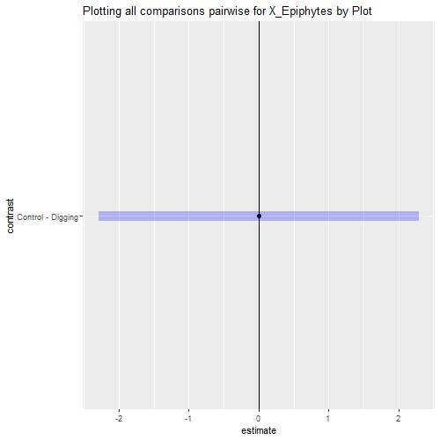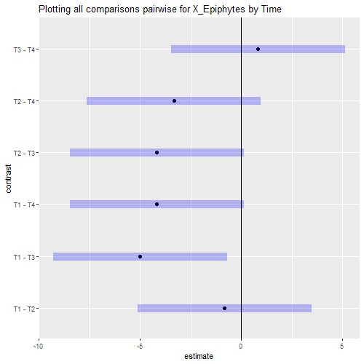

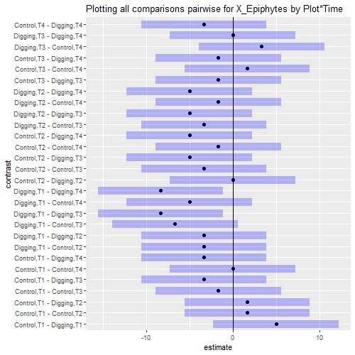

# Interaction plot with Confidence Intervals

