# Anova (1 Way and 2 Way)

[Digging.plots.final.10.06.20.xlsx.Anova.in.R] - C:\Users\User\Documents\Marg I\Clean data D&R trials\Digging plots final 10.06.20.xlsx

## `summarise()` ungrouping output (override with `.groups` argument)

***Summaries for Sand___ by factor variable Plot***

|  |  |  |  |  |  |  |
| --- | --- | --- | --- | --- | --- | --- |
| **Plot** | **n** | **mean** | **median** | **min** | **max** | **sd** |
| Control | 24 | 84.7742 | 85.355 | 79.32 | 86.69 | 1.7609 |
| Digging | 24 | 84.5292 | 85.335 | 80.42 | 88.68 | 2.5351 |

**variance**

3.1007

6.4268

## `summarise()` ungrouping output (override with `.groups` argument)

***Summaries for Sand___ by factor variable Time***

|  |  |  |  |  |  |  |
| --- | --- | --- | --- | --- | --- | --- |
| **Time** | **n** | **mean** | **median** | **min** | **max** | **sd** |
| T1 | 12 | 81.9333 | 81.02 | 79.32 | 86.04 | 1.9041 |
| T2 | 12 | 85.7567 | 85.575 | 85.33 | 86.85 | 0.4464 |
| T3 | 12 | 86.5317 | 86.405 | 85.29 | 88.68 | 1.0565 |
| T4 | 12 | 84.385 | 83.845 | 82.79 | 86.69 | 1.3112 |

### variance

3.6256

0.1993

1.1162

1.7192

## `summarise()` regrouping output by 'Plot' (override with `.groups` argument)

***Summaries for Sand___ by factor variables Plot*Time***

|  |  |  |  |  |  |  |  |  |
| --- | --- | --- | --- | --- | --- | --- | --- | --- |
| **Plot** | | **Time** | | **n** | **mean** | **median** | **min** | **max** |
| Control | | T1 | | 6 | 83.0833 | 83.185 | 79.32 | 86.04 |
| Control | | T2 | | 6 | 85.5933 | 85.575 | 85.33 | 85.85 |
| Control | | T3 | | 6 | 86.2 | 86.3 | 85.29 | 86.68 |
| Control | | T4 | | 6 | 84.22 | 83.695 | 82.79 | 86.69 |
| Digging | | T1 | | 6 | 80.7833 | 80.89 | 80.42 | 81.04 |
| Digging | | T2 | | 6 | 85.92 | 85.745 | 85.38 | 86.85 |
| Digging | | T3 | | 6 | 86.8633 | 86.56 | 85.29 | 88.68 |
| Digging | | T4 | | 6 | 84.55 | 84.38 | 83.18 | 86.69 |
| **sd** | **variance** | |
| 2.1743 | 4.7278 | |
| 0.2235 | 0.0499 | |
| 0.5107 | 0.2608 | |
| 1.4767 | 2.1806 | |
| 0.2729 | 0.0745 | |
| 0.5697 | 0.3245 | |
| 1.3895 | 1.9307 | |
| 1.2394 | 1.5362 | |
|  |  | |

***Anova table with type III sum of squares for Sand___ by Plot*Time***

|  |  |  |  |  |  |
| --- | --- | --- | --- | --- | --- |
|  | **Df** | **Sum Sq** | **Mean Sq** | **F value** | **Pr(>F)** |
| **Plot** | 1 | 0.7203 | 0.7203 | 0.5198 | 0.4751 |
| **Time** | 3 | 146.5905 | 48.8635 | 35.2642 | <.001*** |
| **Plot:Time** | 3 | 17.1166 | 5.7055 | 4.1176 | 0.0123 * |
| **Residuals** | 40 | 55.4255 | 1.3856 | NA | NA |

*Note.* Signif. codes: 0 '***' 0.001 '**' 0.01 '*' 0.05 '.' 0.1 ' ' 1

## NOTE: Results may be misleading due to involvement in interactions

***Estimated Marginal Means for Sand___ by Plot***

|  |  |  |  |  |  |
| --- | --- | --- | --- | --- | --- |
| **Plot** | **emmean** | **SE** | **df** | **lower.CL** | **upper.CL** |
| Control | 84.7742 | 0.2403 | 40 | 84.2885 | 85.2598 |
| Digging | 84.5292 | 0.2403 | 40 | 84.0435 | 85.0148 |

## NOTE: Results may be misleading due to involvement in interactions

***Estimated Marginal Means for Sand___ by Time***

|  |  |  |  |  |  |
| --- | --- | --- | --- | --- | --- |
| **Time** | **emmean** | **SE** | **df** | **lower.CL** | **upper.CL** |
| T1 | 81.9333 | 0.3398 | 40 | 81.2465 | 82.6201 |
| T2 | 85.7567 | 0.3398 | 40 | 85.0699 | 86.4434 |
| T3 | 86.5317 | 0.3398 | 40 | 85.8449 | 87.2185 |
| T4 | 84.385 | 0.3398 | 40 | 83.6982 | 85.0718 |

***Estimated Marginal Means for Sand___ by Plot*Time***

|  |  |  |  |  |  |  |
| --- | --- | --- | --- | --- | --- | --- |
| **Plot** | **Time** | **emmean** | **SE** | **df** | **lower.CL** | **upper.CL** |
| Control | T1 | 83.0833 | 0.4806 | 40 | 82.1121 | 84.0546 |
| Digging | T1 | 80.7833 | 0.4806 | 40 | 79.8121 | 81.7546 |
| Control | T2 | 85.5933 | 0.4806 | 40 | 84.6221 | 86.5646 |
| Digging | T2 | 85.92 | 0.4806 | 40 | 84.9488 | 86.8912 |
| Control | T3 | 86.2 | 0.4806 | 40 | 85.2288 | 87.1713 |
| Digging | T3 | 86.8633 | 0.4806 | 40 | 85.8921 | 87.8346 |
| Control | T4 | 84.22 | 0.4806 | 40 | 83.2488 | 85.1912 |
| Digging | T4 | 84.55 | 0.4806 | 40 | 83.5787 | 85.5212 |

***Levene's test for homogenity of variances (center=mean) for Sand___ against Plot***

|  |  |  |  |
| --- | --- | --- | --- |
|  | **Df** | **F value** | **Pr(>F)** |
| **Group** | 1 | 2.3616 | 0.1312 |
|  | 46 | NA | NA |

*Note.* Signif. codes: 0 '***' 0.001 '**' 0.01 '*' 0.05 '.' 0.1 ' ' 1

***Levene's test for homogenity of variances (center=mean) for Sand___ against Time***

|  |  |  |  |
| --- | --- | --- | --- |
|  | **Df** | **F value** | **Pr(>F)** |
| **group** | 3 | 2.7298 | 0.0552 . |
|  | 44 | NA | NA |

*Note.* Signif. codes: 0 '***' 0.001 '**' 0.01 '*' 0.05 '.' 0.1 ' ' 1

## Results are averaged over the levels of: Time

***Post-hoc tests for Sand___ by Plot (using method = pairwise)***

|  |  |  |  |  |  |  |  |  |  |  |  |  |  |  |
| --- | --- | --- | --- | --- | --- | --- | --- | --- | --- | --- | --- | --- | --- | --- |
| **contrast** | | | **estimate** | | **SE** | | **df** | | | **t.ratio** | | | **p.value** | |
| Control Digging | | | 0.245 | | 0.3398 | | 40 | | | 0.721 | | | 0.4751 | |
| *Note.* Signif. codes: 0 '***' 0.001 '**' 0.01 | | | '*' 0.05 '.' 0.1 ' ' 1 | |  | |  | | |  | | |  | |
| Results are averaged over the levels of: Plot  P value adjustment: tukey method for comparing a family of 4 estimates  ***Post-hoc tests for Sand___ by Time (using method = pairwise)*** | | | | | | | | | | | | |  | |
| **contrast** | | | **estimate** | | **SE** | | **df** | | | **t.ratio** | | | **p.value** | |
| T1 - T2 | | | -3.8233 | | 0.4806 | | 40 | | | -7.956 | | | <.001*** | |
| T1 - T3 | | | -4.5983 | | 0.4806 | | 40 | | | -9.5687 | | | <.001*** | |
| T1 - T4 | | | -2.4517 | | 0.4806 | | 40 | | | -5.1017 | | | <.001*** | |
| T2 - T3 | | | -0.775 | | 0.4806 | | 40 | | | -1.6127 | | | 0.3832 | |
| T2 - T4 | | | 1.3717 | | 0.4806 | | 40 | | | 2.8543 | | | 0.0330 * | |
| T3 - T4 | | | 2.1467 | | 0.4806 | | 40 | | | 4.467 | | | <.001*** | |
| *Note.* Signif. codes: 0 '***' 0.001 '**' 0.01 | | | '*' 0.05 '.' 0.1 ' ' 1 | |  | |  | | |  | | |  | |
| P value adjustment: tukey method for comparing a family of 8 estimates  ***Simple effects for Sand___ by Plot*Time (using method = pairwise)*** | | | | | | | | | | | | |  | |
| **contrast estimate SE df t.ratio** | | | | | | | | | | | | | **p.value** | |
| Control,T1 Digging,T1 | 2.3 | | 0.6796 | | 40 | | 3.3843 | | | 0.0313 * | | |
| Control,T1 Control,T2 | -2.51 | | 0.6796 | | 40 | | -3.6933 | | | 0.0139 * | | |
| Control,T1 Digging,T2 | -2.8367 | | 0.6796 | | 40 | | -4.1739 | | | 0.0036 ** | | |
| Control,T1 Control,T3 | -3.1167 | | 0.6796 | | 40 | | -4.5859 | | | 0.0011 ** | | |
| Control,T1 Digging,T3 | -3.78 | | 0.6796 | | 40 | | -5.562 | | | <.001*** | | |
| Control,T1 Control,T4 | -1.1367 | | 0.6796 | | 40 | | -1.6725 | | | 0.7041 | | |
| **contrast** | | | **estimate** | | **SE** | | **df** | | **t.ratio** | | | **p.value** | | |
| Control,T1 Digging,T4 | | | -1.4667 | | 0.6796 | | 40 | | -2.1581 | | | 0.3976 | | |
| Digging,T1 Control,T2 | | | -4.81 | | 0.6796 | | 40 | | -7.0775 | | | <.001*** | | |
| Digging,T1 Digging,T2 | | | -5.1367 | | 0.6796 | | 40 | | -7.5582 | | | <.001*** | | |
| Digging,T1 Control,T3 | | | -5.4167 | | 0.6796 | | 40 | | -7.9702 | | | <.001*** | | |
| Digging,T1 Digging,T3 | | | -6.08 | | 0.6796 | | 40 | | -8.9462 | | | <.001*** | | |
| Digging,T1 Control,T4 | | | -3.4367 | | 0.6796 | | 40 | | -5.0568 | | | <.001*** | | |
| Digging,T1 Digging,T4 | | | -3.7667 | | 0.6796 | | 40 | | -5.5423 | | | <.001*** | | |
| Control,T2 Digging,T2 | | | -0.3267 | | 0.6796 | | 40 | | -0.4807 | | | 0.9997 | | |
| Control,T2 Control,T3 | | | -0.6067 | | 0.6796 | | 40 | | -0.8927 | | | 0.9851 | | |
| Control,T2 Digging,T3 | | | -1.27 | | 0.6796 | | 40 | | -1.8687 | | | 0.5792 | | |
| Control,T2 Control,T4 | | | 1.3733 | | 0.6796 | | 40 | | 2.0207 | | | 0.4814 | | |
| Control,T2 Digging,T4 | | | 1.0433 | | 0.6796 | | 40 | | 1.5352 | | | 0.7840 | | |
| Digging,T2 Control,T3 | | | -0.28 | | 0.6796 | | 40 | | -0.412 | | | 0.9999 | | |
| Digging,T2 Digging,T3 | | | -0.9433 | | 0.6796 | | 40 | | -1.388 | | | 0.8573 | | |
| Digging,T2 Control,T4 | | | 1.7 | | 0.6796 | | 40 | | 2.5014 | | | 0.2243 | | |
| Digging,T2 Digging,T4 | | | 1.37 | | 0.6796 | | 40 | | 2.0158 | | | 0.4845 | | |
| Control,T3 Digging,T3 | | | -0.6633 | | 0.6796 | | 40 | | -0.976 | | | 0.9753 | | |
| Control,T3 Control,T4 | | | 1.98 | | 0.6796 | | 40 | | 2.9134 | | | 0.0967 . | | |
| Control,T3 Digging,T4 | | | 1.65 | | 0.6796 | | 40 | | 2.4278 | | | 0.2563 | | |
| Digging,T3 Control,T4 | | | 2.6433 | | 0.6796 | | 40 | | 3.8894 | | | 0.0081 ** | | |
| Digging,T3 Digging,T4 | | | 2.3133 | | 0.6796 | | 40 | | 3.4039 | | | 0.0298 * | | |
| Control,T4 Digging,T4 | | | -0.33 | | 0.6796 | | 40 | | -0.4856 | | | 0.9997 | | |

*Note.* Signif. codes: 0 '***' 0.001 '**' 0.01 '*' 0.05 '.' 0.1 ' ' 1

***Comparing means compactly for Sand___ by Plot using pairwise comparison (p values adjusted using tukey)***

|  |  |  |  |  |  |  |
| --- | --- | --- | --- | --- | --- | --- |
| **Plot emmean SE** | | | **df lower.CL upper.CL** | | | **.group** |
| Digging 84.5292 0.2403 | | | 40 84.514 84.5443 | | | 1 |
| Control 84.7742 0.2403 | | | 40 84.759 84.7893 | | | 1 |
| ***Comparing means compactly for Sand___ by Time using pairwise comparison (p values adjusted using tukey)*** | | | | | |  |
| **Time** | **emmean** | **SE** | **df** | **lower.CL** | **upper.CL** | **.group** |
| T1 | 81.9333 | 0.3398 | 40 | 81.9119 | 81.9548 | 1 |
| T4 | 84.385 | 0.3398 | 40 | 84.3636 | 84.4064 | 2 |
| T2 | 85.7567 | 0.3398 | 40 | 85.7352 | 85.7781 | 3 |
| T3 | 86.5317 | 0.3398 | 40 | 86.5102 | 86.5531 | 3 |

***Comparing means compactly for Sand___ by Plot*Time using pairwise comparison (p values adjusted using tukey)***

|  |  |  |  |  |  |  |
| --- | --- | --- | --- | --- | --- | --- |
| **Plot** | **Time** | **emmean** | **SE** | **df** | **lower.CL** | **upper.CL** |
| Digging | T1 | 80.7833 | 0.4806 | 40 | 80.753 | 80.8137 |
| Control | T1 | 83.0833 | 0.4806 | 40 | 83.053 | 83.1137 |
| Control | T4 | 84.22 | 0.4806 | 40 | 84.1897 | 84.2503 |
| Digging | T4 | 84.55 | 0.4806 | 40 | 84.5197 | 84.5803 |
| Control | T2 | 85.5933 | 0.4806 | 40 | 85.563 | 85.6237 |
| Digging | T2 | 85.92 | 0.4806 | 40 | 85.8897 | 85.9503 |
| Control | T3 | 86.2 | 0.4806 | 40 | 86.1697 | 86.2303 |
| Digging | T3 | 86.8633 | 0.4806 | 40 | 86.833 | 86.8937 |

**.group**

1

2

23

23

34

34

34

4

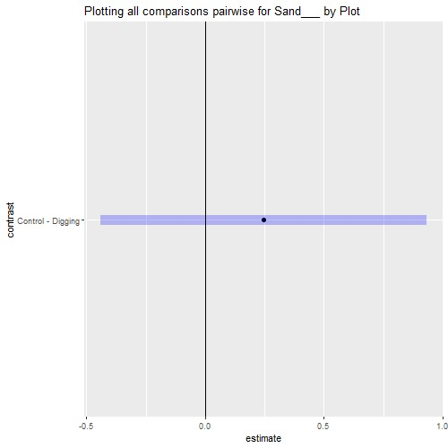

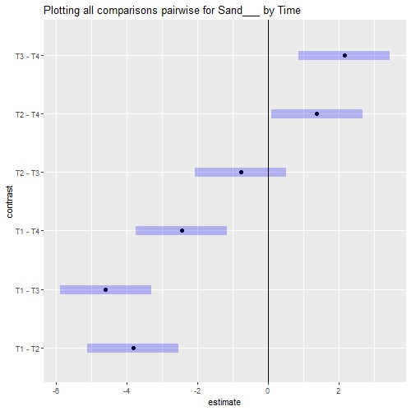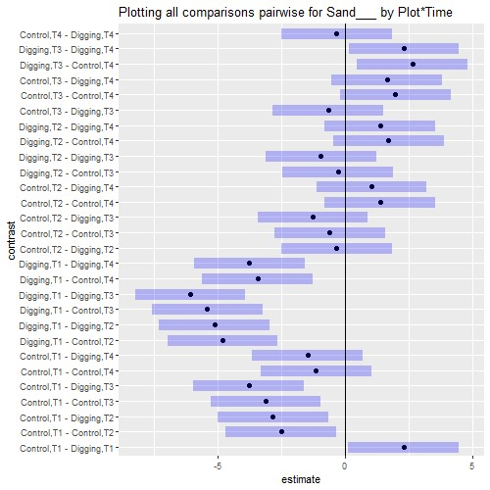

## Interaction plot with Confidence Intervals

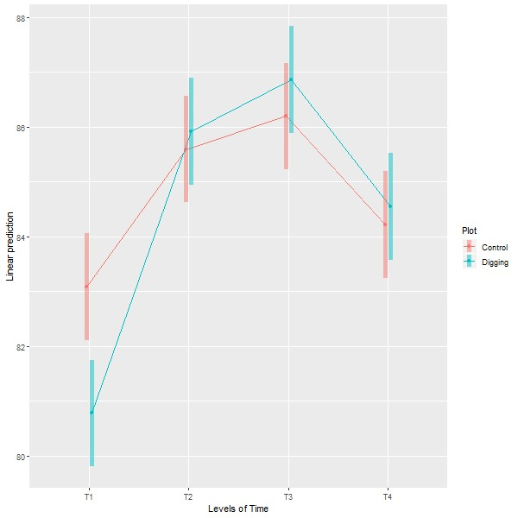

# Anova (1 Way and 2 Way)

[Digging.plots.final.10.06.20.xlsx.Anova.in.R] - C:\Users\User\Documents\Marg I\Clean data D&R trials\Digging plots final 10.06.20.xlsx

## `summarise()` ungrouping output (override with `.groups` argument)

***Summaries for Silt___ by factor variable Plot***

|  |  |  |  |  |  |  |
| --- | --- | --- | --- | --- | --- | --- |
| **Plot** | **n** | **mean** | **median** | **min** | **max** | **sd** |
| Control | 24 | 12.6192 | 11.77 | 9.11 | 20.5 | 2.8059 |
| Digging | 24 | 13.2092 | 11.805 | 9.3 | 19.5 | 3.5968 |

**variance**

7.8729

12.9371

## `summarise()` ungrouping output (override with `.groups` argument)

***Summaries for Silt___ by factor variable Time***

|  |  |  |  |  |  |  |
| --- | --- | --- | --- | --- | --- | --- |
| **Time** | **n** | **mean** | **median** | **min** | **max** | **sd** |
| T1 | 12 | 17.9283 | 18.885 | 13.77 | 20.5 | 1.9187 |
| T2 | 12 | 10.8117 | 11.09 | 9.11 | 12.01 | 0.98 |
| T3 | 12 | 11.52 | 11.6 | 9.3 | 13.16 | 1.1826 |
| T4 | 12 | 11.3967 | 11.31 | 9.83 | 12.45 | 0.9843 |

### variance

3.6813

0.9605

1.3987

0.9688

## `summarise()` regrouping output by 'Plot' (override with `.groups` argument)

***Summaries for Silt___ by factor variables Plot*Time***

|  |  |  |  |  |  |  |  |  |
| --- | --- | --- | --- | --- | --- | --- | --- | --- |
| **Plot** | | **Time** | | **n** | **mean** | **median** | **min** | **max** |
| Control | | T1 | | 6 | 16.7533 | 16.68 | 13.77 | 20.5 |
| Control | | T2 | | 6 | 10.81 | 11.26 | 9.11 | 12.01 |
| Control | | T3 | | 6 | 11.6867 | 11.665 | 10.3 | 13.16 |
| Control | | T4 | | 6 | 11.2267 | 11.195 | 9.83 | 12.42 |
| Digging | | T1 | | 6 | 19.1033 | 18.975 | 18.87 | 19.5 |
| Digging | | T2 | | 6 | 10.8133 | 10.64 | 10.11 | 12.01 |
| Digging | | T3 | | 6 | 11.3533 | 11.535 | 9.3 | 13.16 |
| Digging | | T4 | | 6 | 11.5667 | 11.755 | 9.83 | 12.45 |
| **sd** | **variance** | |
| 2.1704 | 4.7105 | |
| 1.241 | 1.54 | |
| 1.0819 | 1.1705 | |
| 0.9934 | 0.9868 | |
| 0.2735 | 0.0748 | |
| 0.757 | 0.573 | |
| 1.3564 | 1.8399 | |
| 1.0369 | 1.0751 | |

***Anova table with type III sum of squares for Silt___ by Plot*Time***

|  |  |  |  |  |  |
| --- | --- | --- | --- | --- | --- |
|  | **Df** | **Sum Sq** | **Mean Sq** | **F value** | **Pr(>F)** |
| **Plot** | 1 | 4.1772 | 4.1772 | 2.7916 | 0.1026 |
| **Time** | 3 | 405.7066 | 135.2355 | 90.3776 | <.001*** |
| **Plot:Time** | 3 | 13.0705 | 4.3568 | 2.9117 | 0.0461 * |
| **Residuals** | 40 | 59.8535 | 1.4963 | NA | NA |

*Note.* Signif. codes: 0 '***' 0.001 '**' 0.01 '*' 0.05 '.' 0.1 ' ' 1

## NOTE: Results may be misleading due to involvement in interactions

***Estimated Marginal Means for Silt___ by Plot***

|  |  |  |  |  |  |
| --- | --- | --- | --- | --- | --- |
| **Plot** | **emmean** | **SE** | **df** | **lower.CL** | **upper.CL** |
| Control | 12.6192 | 0.2497 | 40 | 12.1145 | 13.1238 |
| Digging | 13.2092 | 0.2497 | 40 | 12.7045 | 13.7138 |

## NOTE: Results may be misleading due to involvement in interactions

***Estimated Marginal Means for Silt___ by Time***

|  |  |  |  |  |  |
| --- | --- | --- | --- | --- | --- |
| **Time** | **emmean** | **SE** | **df** | **lower.CL** | **upper.CL** |
| T1 | 17.9283 | 0.3531 | 40 | 17.2146 | 18.642 |
| T2 | 10.8117 | 0.3531 | 40 | 10.098 | 11.5253 |
| T3 | 11.52 | 0.3531 | 40 | 10.8063 | 12.2337 |
| T4 | 11.3967 | 0.3531 | 40 | 10.683 | 12.1104 |

***Estimated Marginal Means for Silt___ by Plot*Time***

|  |  |  |  |  |  |  |
| --- | --- | --- | --- | --- | --- | --- |
| **Plot** | **Time** | **emmean** | **SE** | **df** | **lower.CL** | **upper.CL** |
| Control | T1 | 16.7533 | 0.4994 | 40 | 15.744 | 17.7626 |
| Digging | T1 | 19.1033 | 0.4994 | 40 | 18.094 | 20.1126 |
| Control | T2 | 10.81 | 0.4994 | 40 | 9.8007 | 11.8193 |
| Digging | T2 | 10.8133 | 0.4994 | 40 | 9.804 | 11.8226 |
| Control | T3 | 11.6867 | 0.4994 | 40 | 10.6774 | 12.696 |
| Digging | T3 | 11.3533 | 0.4994 | 40 | 10.344 | 12.3626 |
| Control | T4 | 11.2267 | 0.4994 | 40 | 10.2174 | 12.236 |
| Digging | T4 | 11.5667 | 0.4994 | 40 | 10.5574 | 12.576 |

***Levene's test for homogenity of variances (center=mean) for Silt___ against Plot***

|  |  |  |  |
| --- | --- | --- | --- |
|  | **Df** | **F value** | **Pr(>F)** |
| **Group** | 1 | 0.7052 | 0.4054 |
|  | 46 | NA | NA |

*Note.* Signif. codes: 0 '***' 0.001 '**' 0.01 '*' 0.05 '.' 0.1 ' ' 1

***Levene's test for homogenity of variances (center=mean) for Silt___ against Time***

|  |  |  |  |
| --- | --- | --- | --- |
|  | **Df** | **F value** | **Pr(>F)** |
| **group** | 3 | 1.297 | 0.2874 |
|  | 44 | NA | NA |

*Note.* Signif. codes: 0 '***' 0.001 '**' 0.01 '*' 0.05 '.' 0.1 ' ' 1

## Results are averaged over the levels of: Time

***Post-hoc tests for Silt___ by Plot (using method = pairwise)***

|  |  |  |  |  |  |
| --- | --- | --- | --- | --- | --- |
| **contrast** | **estimate** | **SE** | **df** | **t.ratio** | **p.value** |
| Control Digging | -0.59 | 0.3531 | 40 | -1.6708 | 0.1026 |

*Note.* Signif. codes: 0 '***' 0.001 '**' 0.01 '*' 0.05 '.' 0.1 ' ' 1

## Results are averaged over the levels of: Plot P value adjustment: tukey method for comparing a family of 4 estimates

***Post-hoc tests for Silt___ by Time (using method = pairwise)***

|  |  |  |  |  |  |  |  |  |  |  |  |  |  |  |
| --- | --- | --- | --- | --- | --- | --- | --- | --- | --- | --- | --- | --- | --- | --- |
| **contrast** | | | **estimate** | | **SE** | | **df** | | **t.ratio** | | | **p.value** | | |
| T1 - T2 | | | 7.1167 | | 0.4994 | | 40 | | 14.2507 | | | <.001*** | | |
| T1 - T3 | | | 6.4083 | | 0.4994 | | 40 | | 12.8323 | | | <.001*** | | |
| T1 - T4 | | | 6.5317 | | 0.4994 | | 40 | | 13.0793 | | | <.001*** | | |
| T2 - T3 | | | -0.7083 | | 0.4994 | | 40 | | -1.4184 | | | 0.4956 | | |
| T2 - T4 | | | -0.585 | | 0.4994 | | 40 | | -1.1714 | | | 0.6481 | | |
| T3 - T4 | | | 0.1233 | | 0.4994 | | 40 | | 0.247 | | | 0.9946 | | |
| *Note.* Signif. codes: 0 '***' 0.001 '**' 0.01 '*' 0.05 '.' 0.1 ' ' 1  P value adjustment: tukey method for comparing a family of 8 estimates  ***Simple effects for Silt___ by Plot*Time (using method = pairwise)*** | | | | | | |  | |  | | |  | | |
| **contrast estimate SE df t.ratio** | | | | | | | | | | | | **p.value** | | |
| Control,T1 Digging,T1 | -2.35 | | 0.7062 | | 40 | | -3.3275 | | | 0.0362 * | | |
| Control,T1 Control,T2 | 5.9433 | | 0.7062 | | 40 | | 8.4154 | | | <.001*** | | |
| Control,T1 Digging,T2 | 5.94 | | 0.7062 | | 40 | | 8.4107 | | | <.001*** | | |
| Control,T1 Control,T3 | 5.0667 | | 0.7062 | | 40 | | 7.1741 | | | <.001*** | | |
| Control,T1 Digging,T3 | 5.4 | | 0.7062 | | 40 | | 7.6461 | | | <.001*** | | |
| Control,T1 Control,T4 | 5.5267 | | 0.7062 | | 40 | | 7.8254 | | | <.001*** | | |
| Control,T1 Digging,T4 | 5.1867 | | 0.7062 | | 40 | | 7.344 | | | <.001*** | | |
| Digging,T1 Control,T2 | 8.2933 | | 0.7062 | | 40 | | 11.7429 | | | <.001*** | | |
| Digging,T1 Digging,T2 | 8.29 | | 0.7062 | | 40 | | 11.7382 | | | <.001*** | | |
| Digging,T1 Control,T3 | 7.4167 | | 0.7062 | | 40 | | 10.5016 | | | <.001*** | | |
| Digging,T1 Digging,T3 | 7.75 | | 0.7062 | | 40 | | 10.9736 | | | <.001*** | | |
| Digging,T1 Control,T4 | 7.8767 | | 0.7062 | | 40 | | 11.1529 | | | <.001*** | | |
| Digging,T1 Digging,T4 | 7.5367 | | 0.7062 | | 40 | | 10.6715 | | | <.001*** | | |
| Control,T2 Digging,T2 | -0.0033 | | 0.7062 | | 40 | | -0.0047 | | | 1 | | |
| Control,T2 Control,T3 | -0.8767 | | 0.7062 | | 40 | | -1.2413 | | | 0.9142 | | |
| Control,T2 Digging,T3 | -0.5433 | | 0.7062 | | 40 | | -0.7693 | | | 0.9938 | | |
| Control,T2 Control,T4 | -0.4167 | | 0.7062 | | 40 | | -0.59 | | | 0.9988 | | |
| Control,T2 Digging,T4 | -0.7567 | | 0.7062 | | 40 | | -1.0714 | | | 0.9591 | | |
| Digging,T2 Control,T3 | -0.8733 | | 0.7062 | | 40 | | -1.2366 | | | 0.9158 | | |
| **contrast** | | | **estimate** | | **SE** | | **df** | | | **t.ratio** | | | **p.value** | |
| Digging,T2 Digging,T3 | | | -0.54 | | 0.7062 | | 40 | | | -0.7646 | | | 0.9940 | |
| Digging,T2 Control,T4 | | | -0.4133 | | 0.7062 | | 40 | | | -0.5853 | | | 0.9989 | |
| Digging,T2 Digging,T4 | | | -0.7533 | | 0.7062 | | 40 | | | -1.0667 | | | 0.9601 | |
| Control,T3 Digging,T3 | | | 0.3333 | | 0.7062 | | 40 | | | 0.472 | | | 0.9997 | |
| Control,T3 Control,T4 | | | 0.46 | | 0.7062 | | 40 | | | 0.6513 | | | 0.9978 | |
| Control,T3 Digging,T4 | | | 0.12 | | 0.7062 | | 40 | | | 0.1699 | | | 1.0000 | |
| Digging,T3 Control,T4 | | | 0.1267 | | 0.7062 | | 40 | | | 0.1794 | | | 1.0000 | |
| Digging,T3 Digging,T4 | | | -0.2133 | | 0.7062 | | 40 | | | -0.3021 | | | 1.0000 | |
| Control,T4 Digging,T4 | | | -0.34 | | 0.7062 | | 40 | | | -0.4814 | | | 0.9997 | |

*Note.* Signif. codes: 0 '***' 0.001 '**' 0.01 '*' 0.05 '.' 0.1 ' ' 1

***Comparing means compactly for Silt___ by Plot using pairwise comparison (p values adjusted using tukey)***

|  |  |  |  |  |  |  |
| --- | --- | --- | --- | --- | --- | --- |
| **Plot** | **emmean** | **SE** | **df** | **lower.CL** | **upper.CL** | **.group** |
| Control | 12.6192 | 0.2497 | 40 | 12.6034 | 12.6349 | 1 |
| Digging | 13.2092 | 0.2497 | 40 | 13.1934 | 13.2249 | 1 |

***Comparing means compactly for Silt___ by Time using pairwise comparison (p values adjusted using tukey)***

|  |  |  |  |  |  |  |
| --- | --- | --- | --- | --- | --- | --- |
| **Time** | **emmean** | **SE** | **df** | **lower.CL** | **upper.CL** | **.group** |
| T2 | 10.8117 | 0.3531 | 40 | 10.7894 | 10.8339 | 1 |
| T4 | 11.3967 | 0.3531 | 40 | 11.3744 | 11.419 | 1 |
| T3 | 11.52 | 0.3531 | 40 | 11.4977 | 11.5423 | 1 |
| T1 | 17.9283 | 0.3531 | 40 | 17.9061 | 17.9506 | 2 |

***Comparing means compactly for Silt___ by Plot*Time using pairwise comparison (p values adjusted using tukey)***

|  |  |  |  |  |  |  |
| --- | --- | --- | --- | --- | --- | --- |
| **Plot** | **Time** | **emmean** | **SE** | **df** | **lower.CL** | **upper.CL** |
| Control | T2 | 10.81 | 0.4994 | 40 | 10.7785 | 10.8415 |
| Digging | T2 | 10.8133 | 0.4994 | 40 | 10.7818 | 10.8448 |
| Control | T4 | 11.2267 | 0.4994 | 40 | 11.1951 | 11.2582 |
| Digging | T3 | 11.3533 | 0.4994 | 40 | 11.3218 | 11.3849 |
| Digging | T4 | 11.5667 | 0.4994 | 40 | 11.5351 | 11.5982 |
| Control | T3 | 11.6867 | 0.4994 | 40 | 11.6552 | 11.7182 |
| Control | T1 | 16.7533 | 0.4994 | 40 | 16.7218 | 16.7848 |
| Digging | T1 | 19.1033 | 0.4994 | 40 | 19.0718 | 19.1349 |

**.group**

1

1

1

1

1

1

2

3

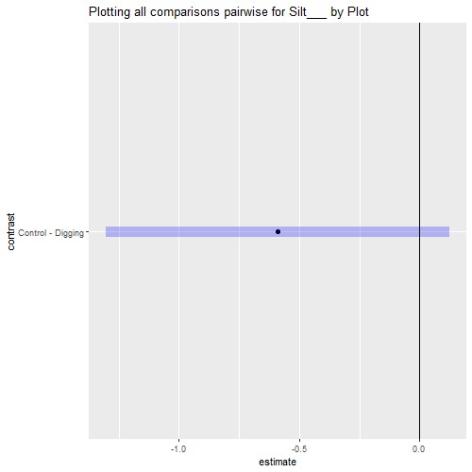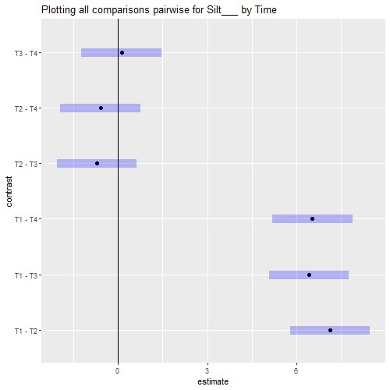

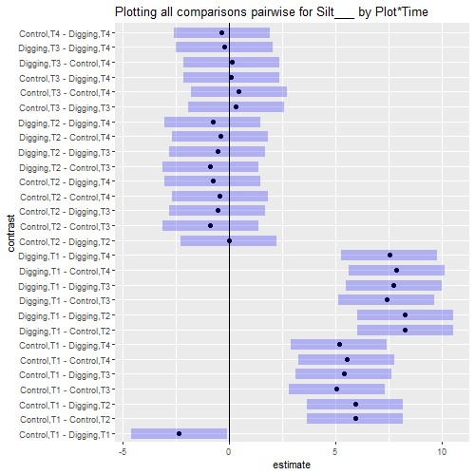

## Interaction plot with Confidence Intervals

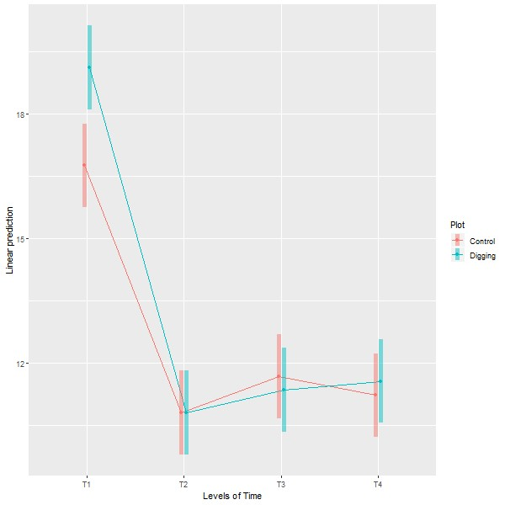

# Anova (1 Way and 2 Way)

[Digging.plots.final.10.06.20.xlsx.Anova.in.R] - C:\Users\User\Documents\Marg I\Clean data D&R trials\Digging plots final 10.06.20.xlsx

## `summarise()` ungrouping output (override with `.groups` argument)

***Summaries for Clay___ by factor variable Plot***

|  |  |  |  |  |  |  |
| --- | --- | --- | --- | --- | --- | --- |
| **Plot** | **n** | **mean** | **median** | **Min** | **max** | **sd** |
| Control | 24 | 2.6067 | 2.85 | 0.11 | 5.89 | 1.8808 |
| Digging | 24 | 2.2617 | 2.355 | 0.08 | 4.4 | 1.5526 |

**variance**

3.5376

2.4106

## `summarise()` ungrouping output (override with `.groups` argument)

***Summaries for Clay___ by factor variable Time***

|  |  |  |  |  |  |  |
| --- | --- | --- | --- | --- | --- | --- |
| **Time** | **n** | **mean** | **median** | **Min** | **max** | **sd** |
| T1 | 12 | 0.1383 | 0.13 | 0.08 | 0.23 | 0.0453 |
| T2 | 12 | 3.4317 | 2.85 | 2.61 | 5.35 | 1.0143 |
| T3 | 12 | 1.9483 | 1.86 | 1.22 | 3.02 | 0.5626 |
| T4 | 12 | 4.2183 | 3.935 | 3.48 | 5.89 | 0.8086 |

### variance

0.0021

1.0289

0.3166

0.6539

## `summarise()` regrouping output by 'Plot' (override with `.groups` argument)

***Summaries for Clay___ by factor variables Plot*Time***

|  |  |  |  |  |  |  |  |  |
| --- | --- | --- | --- | --- | --- | --- | --- | --- |
| **Plot** | | **Time** | | **n** | **mean** | **median** | **min** | **max** |
| Control | | T1 | | 6 | 0.1633 | 0.17 | 0.11 | 0.23 |
| Control | | T2 | | 6 | 3.5967 | 2.9 | 2.61 | 5.35 |
| Control | | T3 | | 6 | 2.1133 | 1.86 | 1.4 | 3.02 |
| Control | | T4 | | 6 | 4.5533 | 4.2 | 3.48 | 5.89 |
| Digging | | T1 | | 6 | 0.1133 | 0.11 | 0.08 | 0.15 |
| Digging | | T2 | | 6 | 3.2667 | 2.79 | 2.61 | 4.35 |
| Digging | | T3 | | 6 | 1.7833 | 1.895 | 1.22 | 2.1 |
| Digging | | T4 | | 6 | 3.8833 | 3.86 | 3.48 | 4.4 |
| **sd** | **variance** | |
| 0.0472 | 0.0022 | |
| 1.2254 | 1.5015 | |
| 0.7157 | 0.5123 | |
| 1.038 | 1.0773 | |
| 0.028 | 0.0008 | |
| 0.8346 | 0.6966 | |
| 0.3447 | 0.1188 | |
| 0.303 | 0.0918 | |

***Anova table with type III sum of squares for Clay___ by Plot*Time***

|  |  |  |  |  |  |
| --- | --- | --- | --- | --- | --- |
|  | **Df** | **Sum Sq** | **Mean Sq** | **F value** | **Pr(>F)** |
| **Plot** | 1 | 1.4283 | 1.4283 | 2.8556 | 0.0988 . |
| **Time** | 3 | 116.2217 | 38.7406 | 77.4545 | <.001*** |
| **Plot:Time** | 3 | 0.5793 | 0.1931 | 0.3861 | 0.7636 |
| **Residuals** | 40 | 20.0069 | 0.5002 | NA | NA |

*Note.* Signif. codes: 0 '***' 0.001 '**' 0.01 '*' 0.05 '.' 0.1 ' ' 1

## NOTE: Results may be misleading due to involvement in interactions

***Estimated Marginal Means for Clay___ by Plot***

|  |  |  |  |  |  |
| --- | --- | --- | --- | --- | --- |
| **Plot** | **emmean** | **SE** | **df** | **lower.CL** | **upper.CL** |
| Control | 2.6067 | 0.1444 | 40 | 2.3149 | 2.8984 |
| Digging | 2.2617 | 0.1444 | 40 | 1.9699 | 2.5534 |

## NOTE: Results may be misleading due to involvement in interactions

***Estimated Marginal Means for Clay___ by Time***

|  |  |  |  |  |  |
| --- | --- | --- | --- | --- | --- |
| **Time** | **emmean** | **SE** | **df** | **lower.CL** | **upper.CL** |
| T1 | 0.1383 | 0.2042 | 40 | -0.2743 | 0.551 |
| T2 | 3.4317 | 0.2042 | 40 | 3.019 | 3.8443 |
| T3 | 1.9483 | 0.2042 | 40 | 1.5357 | 2.361 |
| T4 | 4.2183 | 0.2042 | 40 | 3.8057 | 4.631 |

***Estimated Marginal Means for Clay___ by Plot*Time***

|  |  |  |  |  |  |  |
| --- | --- | --- | --- | --- | --- | --- |
| **Plot** | **Time** | **emmean** | **SE** | **df** | **lower.CL** | **upper.CL** |
| Control | T1 | 0.1633 | 0.2887 | 40 | -0.4202 | 0.7469 |
| Digging | T1 | 0.1133 | 0.2887 | 40 | -0.4702 | 0.6969 |
| Control | T2 | 3.5967 | 0.2887 | 40 | 3.0131 | 4.1802 |
| Digging | T2 | 3.2667 | 0.2887 | 40 | 2.6831 | 3.8502 |
| Control | T3 | 2.1133 | 0.2887 | 40 | 1.5298 | 2.6969 |
| Digging | T3 | 1.7833 | 0.2887 | 40 | 1.1998 | 2.3669 |
| Control | T4 | 4.5533 | 0.2887 | 40 | 3.9698 | 5.1369 |
| Digging | T4 | 3.8833 | 0.2887 | 40 | 3.2998 | 4.4669 |

***Levene's test for homogenity of variances (center=mean) for Clay___ against Plot***

|  |  |  |  |
| --- | --- | --- | --- |
|  | **Df** | **F value** | **Pr(>F)** |
| **group** | 1 | 0.5351 | 0.4682 |
|  | 46 | NA | NA |

*Note.* Signif. codes: 0 '***' 0.001 '**' 0.01 '*' 0.05 '.' 0.1 ' ' 1

***Levene's test for homogenity of variances (center=mean) for Clay___ against Time***

|  |  |  |  |
| --- | --- | --- | --- |
|  | **Df** | **F value** | **Pr(>F)** |
| **group** | 3 | 2.6024 | 0.0639 . |
|  | 44 | NA | NA |

*Note.* Signif. codes: 0 '***' 0.001 '**' 0.01 '*' 0.05 '.' 0.1 ' ' 1

## Results are averaged over the levels of: Time

***Post-hoc tests for Clay___ by Plot (using method = pairwise)***

|  |  |  |  |  |  |
| --- | --- | --- | --- | --- | --- |
| **contrast** | **estimate** | **SE** | **df** | **t.ratio** | **p.value** |
| Control Digging | 0.345 | 0.2042 | 40 | 1.6899 | 0.0988 . |

*Note.* Signif. codes: 0 '***' 0.001 '**' 0.01 '*' 0.05 '.' 0.1 ' ' 1

## Results are averaged over the levels of: Plot P value adjustment: tukey method for comparing a family of 4 estimates

***Post-hoc tests for Clay___ by Time (using method = pairwise)***

|  |  |  |  |  |  |  |  |  |  |  |  |  |  |  |
| --- | --- | --- | --- | --- | --- | --- | --- | --- | --- | --- | --- | --- | --- | --- |
| **contrast** | | | **estimate** | | **SE** | | **df** | | **t.ratio** | | | | **p.value** | |
| T1 - T2 | | | -3.2933 | | 0.2887 | | 40 | | -11.4065 | | | | <.001*** | |
| T1 - T3 | | | -1.81 | | 0.2887 | | 40 | | -6.2689 | | | | <.001*** | |
| T1 - T4 | | | -4.08 | | 0.2887 | | 40 | | -14.1311 | | | | <.001*** | |
| T2 - T3 | | | 1.4833 | | 0.2887 | | 40 | | 5.1375 | | | | <.001*** | |
| T2 - T4 | | | -0.7867 | | 0.2887 | | 40 | | -2.7246 | | | | 0.0451 * | |
| T3 - T4 | | | -2.27 | | 0.2887 | | 40 | | -7.8622 | | | | <.001*** | |
| *Note.* Signif. codes: 0 '***' 0.001 '**' 0.01 '*' 0.05 '.' 0.1 ' ' 1  P value adjustment: tukey method for comparing a fam  ***Simple effects for Clay___ by Plot*Time (using method = pairwise)*** | | | | | | | ily of 8 es | | timates | | | |  | |
| **contrast estimate SE df t.ratio** | | | | | | | | | | | | | **p.value** | |
| Control,T1 Digging,T1 | 0.05 | | 0.4083 | | 40 | | 0.1225 | | | 1 | | |
| Control,T1 Control,T2 | -3.4333 | | 0.4083 | | 40 | | -8.4085 | | | <.001*** | | |
| Control,T1 Digging,T2 | -3.1033 | | 0.4083 | | 40 | | -7.6003 | | | <.001*** | | |
| Control,T1 Control,T3 | -1.95 | | 0.4083 | | 40 | | -4.7757 | | | <.001*** | | |
| Control,T1 Digging,T3 | -1.62 | | 0.4083 | | 40 | | -3.9675 | | | 0.0065 ** | | |
| Control,T1 Control,T4 | -4.39 | | 0.4083 | | 40 | | -10.7514 | | | <.001*** | | |
| Control,T1 Digging,T4 | -3.72 | | 0.4083 | | 40 | | -9.1105 | | | <.001*** | | |
| Digging,T1 Control,T2 | -3.4833 | | 0.4083 | | 40 | | -8.5309 | | | <.001*** | | |
| Digging,T1 Digging,T2 | -3.1533 | | 0.4083 | | 40 | | -7.7227 | | | <.001*** | | |
| Digging,T1 Control,T3 | -2 | | 0.4083 | | 40 | | -4.8981 | | | <.001*** | | |
| Digging,T1 Digging,T3 | -1.67 | | 0.4083 | | 40 | | -4.0899 | | | 0.0046 ** | | |
| Digging,T1 Control,T4 | -4.44 | | 0.4083 | | 40 | | -10.8739 | | | <.001*** | | |
| Digging,T1 Digging,T4 | -3.77 | | 0.4083 | | 40 | | -9.233 | | | <.001*** | | |
| Control,T2 Digging,T2 | 0.33 | | 0.4083 | | 40 | | 0.8082 | | | 0.9917 | | |
| Control,T2 Control,T3 | 1.4833 | | 0.4083 | | 40 | | 3.6328 | | | 0.0163 * | | |
| Control,T2 Digging,T3 | 1.8133 | | 0.4083 | | 40 | | 4.441 | | | 0.0016 ** | | |
| Control,T2 Control,T4 | -0.9567 | | 0.4083 | | 40 | | -2.3429 | | | 0.2968 | | |
| Control,T2 Digging,T4 | -0.2867 | | 0.4083 | | 40 | | -0.7021 | | | 0.9965 | | |
| Digging,T2 Control,T3 | 1.1533 | | 0.4083 | | 40 | | 2.8246 | | | 0.1174 | | |
| **contrast** | | | **estimate** | | **SE** | | **df** | | | **t.ratio** | | **p.value** | | |
| Digging,T2 Digging,T3 | | | 1.4833 | | 0.4083 | | 40 | | | 3.6328 | | 0.0163 * | | |
| Digging,T2 Control,T4 | | | -1.2867 | | 0.4083 | | 40 | | | -3.1511 | | 0.0558 . | | |
| Digging,T2 Digging,T4 | | | -0.6167 | | 0.4083 | | 40 | | | -1.5103 | | 0.7974 | | |
| Control,T3 Digging,T3 | | | 0.33 | | 0.4083 | | 40 | | | 0.8082 | | 0.9917 | | |
| Control,T3 Control,T4 | | | -2.44 | | 0.4083 | | 40 | | | -5.9757 | | <.001*** | | |
| Control,T3 Digging,T4 | | | -1.77 | | 0.4083 | | 40 | | | -4.3349 | | 0.0022 ** | | |
| Digging,T3 Control,T4 | | | -2.77 | | 0.4083 | | 40 | | | -6.7839 | | <.001*** | | |
| Digging,T3 Digging,T4 | | | -2.1 | | 0.4083 | | 40 | | | -5.143 | | <.001*** | | |
| Control,T4 Digging,T4 | | | 0.67 | | 0.4083 | | 40 | | | 1.6409 | | 0.7233 | | |

*Note.* Signif. codes: 0 '***' 0.001 '**' 0.01 '*' 0.05 '.' 0.1 ' ' 1

***Comparing means compactly for Clay___ by Plot using pairwise comparison (p values adjusted using tukey)***

|  |  |  |  |  |  |  |
| --- | --- | --- | --- | --- | --- | --- |
| **Plot emmean SE** | | | **df lower.CL upper.CL** | | | **.group** |
| Digging 2.2617 0.1444 | | | 40 2.2526 2.2708 | | | 1 |
| Control 2.6067 0.1444 | | | 40 2.5976 2.6158 | | | 1 |
| ***Comparing means compactly for Clay___ by Time using pairwise comparison (p values adjusted using tukey)*** | | | | | |  |
| **Time** | **emmean** | **SE** | **df** | **lower.CL** | **upper.CL** | **.group** |
| T1 | 0.1383 | 0.2042 | 40 | 0.1255 | 0.1512 | 1 |
| T3 | 1.9483 | 0.2042 | 40 | 1.9355 | 1.9612 | 2 |
| T2 | 3.4317 | 0.2042 | 40 | 3.4188 | 3.4445 | 3 |
| T4 | 4.2183 | 0.2042 | 40 | 4.2055 | 4.2312 | 4 |

***Comparing means compactly for Clay___ by Plot*Time using pairwise comparison (p values adjusted using tukey)***

|  |  |  |  |  |  |  |
| --- | --- | --- | --- | --- | --- | --- |
| **Plot** | **Time** | **emmean** | **SE** | **df** | **lower.CL** | **upper.CL** |
| Digging | T1 | 0.1133 | 0.2887 | 40 | 0.0951 | 0.1316 |
| Control | T1 | 0.1633 | 0.2887 | 40 | 0.1451 | 0.1816 |
| Digging | T3 | 1.7833 | 0.2887 | 40 | 1.7651 | 1.8016 |
| Control | T3 | 2.1133 | 0.2887 | 40 | 2.0951 | 2.1316 |
| Digging | T2 | 3.2667 | 0.2887 | 40 | 3.2484 | 3.2849 |
| Control | T2 | 3.5967 | 0.2887 | 40 | 3.5784 | 3.6149 |
| Digging | T4 | 3.8833 | 0.2887 | 40 | 3.8651 | 3.9016 |
| Control | T4 | 4.5533 | 0.2887 | 40 | 4.5351 | 4.5716 |

**.group**

1

1

2

23

34

4

4

4

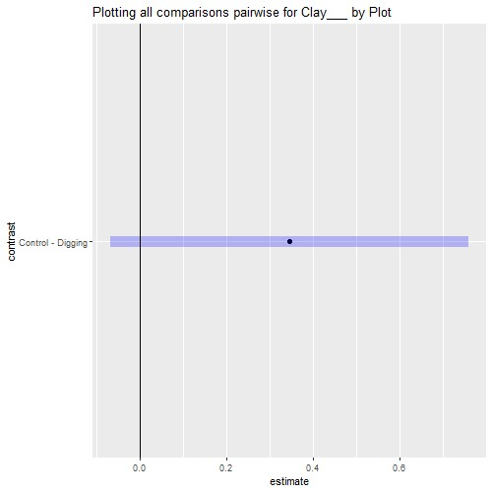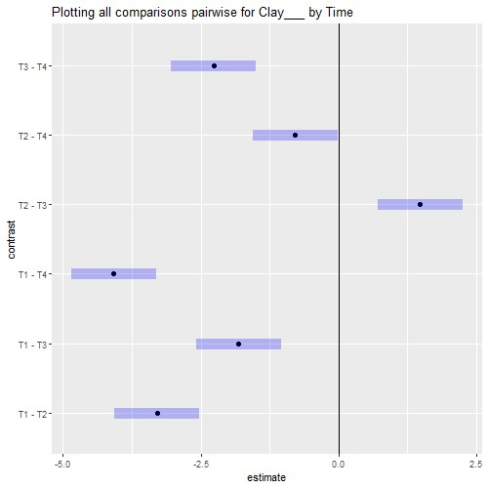

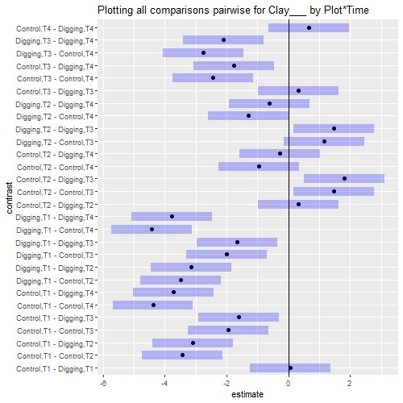

## Interaction plot with Confidence Intervals

