**BSkyOpenNewDataset( datasetName='Dataset1')**

**Open Dataset**

**Anova (1 Way and 2 Way)**

[Digging.plots.final.10.06.20.xlsx.data.for.Anova.in.R] - C:\Users\User\Documents\Marg I\Clean data D&R trials\Digging plots final 10.06.20.xlsx

`summarise()` ungrouping output (override with `.groups` argument)

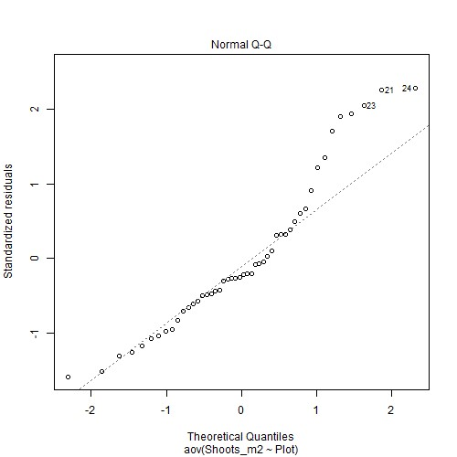

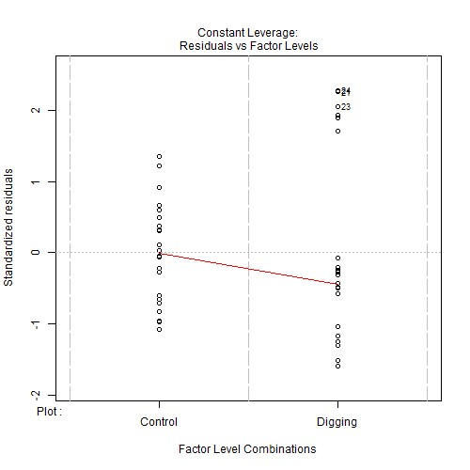

***Levene's test for homogenity of variances (center=mean) for Shoots_m2 against Plot***

|  |  |  |  |
| --- | --- | --- | --- |
|  | **Df** | **F value** | **Pr(>F)** |
| **Group** | 1 | 2.6551 | 0.1101 |
|  | 46 | NA | NA |

*Note.* Signif. codes: 0 '***' 0.001 '**' 0.01 '*' 0.05 '.' 0.1 ' ' 1

***Post-hoc tests for Shoots_m2 by Plot (using method = pairwise)***

|  |  |  |  |  |  |
| --- | --- | --- | --- | --- | --- |
| **contrast** | **estimate** | **SE** | **df** | **t.ratio** | **p.value** |
| Control Digging | 970 | 144.7675 | 46 | 6.7004 | <.001*** |

*Note.* Signif. codes: 0 '***' 0.001 '**' 0.01 '*' 0.05 '.' 0.1 ' ' 1

***Comparing means compactly for Shoots_m2 by Plot using pairwise comparison (p values adjusted using tukey)***

|  |  |  |  |  |  |  |
| --- | --- | --- | --- | --- | --- | --- |
| **Plot** | **emmean** | **SE** | **df** | **lower.CL** | **upper.CL** | **.group** |
| Digging | 1151.333 | 102.3661 | 46 | 1144.879 | 1157.788 | 1 |
| Control | 2121.333 | 102.3661 | 46 | 2114.879 | 2127.788 | 2 |

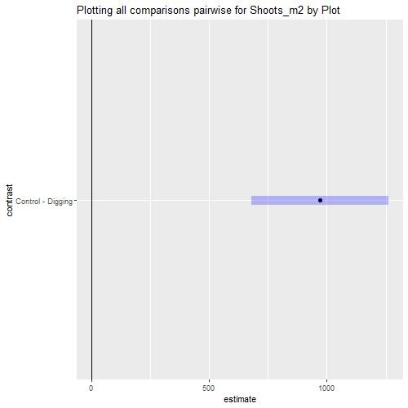

**Anova (1 Way and 2 Way)**

[Digging.plots.final.10.06.20.xlsx.data.for.Anova.in.R] - C:\Users\User\Documents\Marg I\Clean data D&R trials\Digging plots final 10.06.20.xlsx

`summarise()` ungrouping output (override with `.groups` argument)

***Summaries for Shoots_m2 by factor variable Plot***

|  |  |  |  |  |  |  |
| --- | --- | --- | --- | --- | --- | --- |
| **Plot** | **n** | **Mean** | **median** | **min** | **max** | **sd** |
| Control | 24 | 2121.333 | 2116 | 1592 | 2784 | 337.5547 |
| Digging | 24 | 1151.333 | 970 | 368 | 2272 | 623.7309 |

**variance**

113943.2

389040.2

`summarise()` ungrouping output (override with `.groups` argument)

***Summaries for Shoots_m2 by factor variable Time***

**Time n mean median min max sd**

|  |  |  |  |  |  |  |
| --- | --- | --- | --- | --- | --- | --- |
| T1 | 12 | 1169.667 | 1116 | 368 | 2136 | 709.1638 |
| T2 | 12 | 1542.667 | 1334 | 868 | 2720 | 685.546 |
| T3 | 12 | 1631 | 1376 | 916 | 2784 | 686.1712 |
| T4 | 12 | 2202 | 2216 | 1824 | 2568 | 195.3607 |

**variance** 502913.3

469973.3

470830.9

38165.82

`summarise()` regrouping output by 'Plot' (override with `.groups` argument)

***Summaries for Shoots_m2 by factor variables Plot*Time***

|  |  |  |  |  |  |  |  |  |
| --- | --- | --- | --- | --- | --- | --- | --- | --- |
| **Plot** | | **Time** | | **n** | **mean** | **median** | **min** | **max** |
| Control | | T1 | | 6 | 1833.333 | 1786 | 1592 | 2136 |
| Control | | T2 | | 6 | 2156 | 2092 | 1652 | 2720 |
| Control | | T3 | | 6 | 2236 | 2278 | 1640 | 2784 |
| Control | | T4 | | 6 | 2260 | 2290 | 1824 | 2568 |
| Digging | | T1 | | 6 | 506 | 524 | 368 | 640 |
| Digging | | T2 | | 6 | 929.3333 | 924 | 868 | 1016 |
| Digging | | T3 | | 6 | 1026 | 1038 | 916 | 1112 |
| Digging | | T4 | | 6 | 2144 | 2130 | 1988 | 2272 |
| **Sd** | **variance** | |
| 196.6547 | 38673.07 | |
| 358.6642 | 128640 | |
| 391.281 | 153100.8 | |
| 252.7798 | 63897.6 | |
| 103.1891 | 10648 | |
| 49.746 | 2474.667 | |
| 65.3238 | 4267.2 | |
| 109.5153 | 11993.6 | |

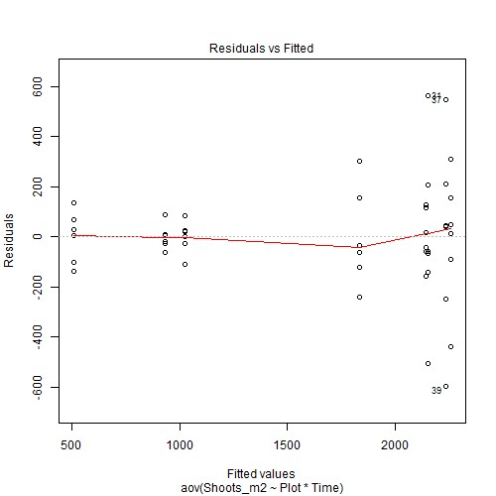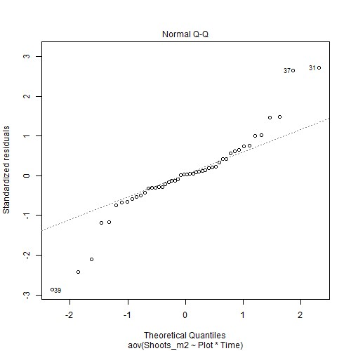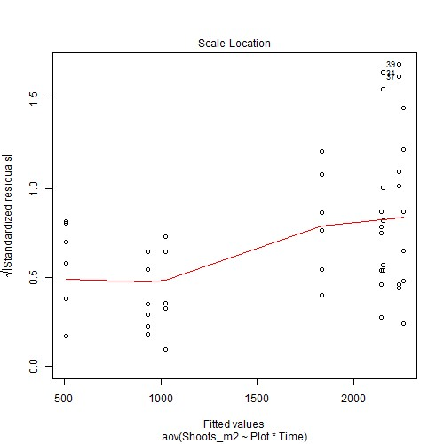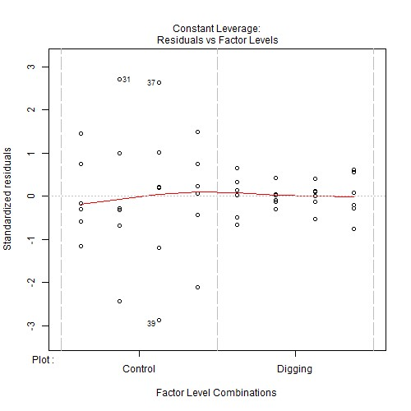

***Anova table with type III sum of squares for Shoots_m2 by Plot*Time***

|  |  |  |  |  |  |
| --- | --- | --- | --- | --- | --- |
|  | **Df** | **Sum Sq** | **Mean Sq** | **F value** | **Pr(>F)** |
| **Plot** | 1 | 11290800 | 11290800 | 218.3406 | <.001*** |
| **Time** | 3 | 6558701 | 2186234 | 42.2772 | <.001*** |
| **Plot:Time** | 3 | 2941443 | 980480.9 | 18.9605 | <.001*** |
| **Residuals** | 40 | 2068475 | 51711.87 | NA | NA |

*Note.* Signif. codes: 0 '***' 0.001 '**' 0.01 '*' 0.05 '.' 0.1 ' ' 1

NOTE: Results may be misleading due to involvement in interactions

***Estimated Marginal Means for Shoots_m2 by Plot***

|  |  |  |  |  |
| --- | --- | --- | --- | --- |
| **Plot emmean SE df lower.CL** | | | | **upper.CL** |
| Control 2121.333 46.4183 40 2027.518 | | | | 2215.148 |
| Digging 1151.333 46.4183 40 1057.518 | | | | 1245.148 |
| NOTE: Results may be misleading due to involvement in interactions  ***Estimated Marginal Means for Shoots_m2 by Time*** | | | |  |
| **Time emmean** | **SE** | **df** | **lower.CL** | **upper.CL** |
| T1 1169.667 | 65.6454 | 40 | 1036.992 | 1302.341 |
| T2 1542.667 | 65.6454 | 40 | 1409.992 | 1675.341 |
| T3 1631 | 65.6454 | 40 | 1498.326 | 1763.674 |
| T4 2202 | 65.6454 | 40 | 2069.326 | 2334.674 |

***Estimated Marginal Means for Shoots_m2 by Plot*Time***

|  |  |  |  |  |  |  |
| --- | --- | --- | --- | --- | --- | --- |
| **Plot** | **Time** | **emmean** | **SE** | **df** | **lower.CL** | **upper.CL** |
| Control | T1 | 1833.333 | 92.8367 | 40 | 1645.704 | 2020.963 |
| Digging | T1 | 506 | 92.8367 | 40 | 318.3701 | 693.6299 |
| Control | T2 | 2156 | 92.8367 | 40 | 1968.37 | 2343.63 |
| Digging | T2 | 929.3333 | 92.8367 | 40 | 741.7035 | 1116.963 |
| Control | T3 | 2236 | 92.8367 | 40 | 2048.37 | 2423.63 |
| Digging | T3 | 1026 | 92.8367 | 40 | 838.3701 | 1213.63 |
| Control | T4 | 2260 | 92.8367 | 40 | 2072.37 | 2447.63 |
| Digging | T4 | 2144 | 92.8367 | 40 | 1956.37 | 2331.63 |

***Levene's test for homogenity of variances (center=mean) for Shoots_m2 against Plot***

|  |  |  |  |
| --- | --- | --- | --- |
|  | **Df** | **F value** | **Pr(>F)** |
| **Group** | 1 | 2.6551 | 0.1101 |
|  | 46 | NA | NA |

*Note.* Signif. codes: 0 '***' 0.001 '**' 0.01 '*' 0.05 '.' 0.1 ' ' 1

***Levene's test for homogenity of variances (center=mean) for Shoots_m2 against Time***

|  |  |  |  |
| --- | --- | --- | --- |
|  | **Df** | **F value** | **Pr(>F)** |
| **Group** | 3 | 9.6508 | <.001*** |
|  | 44 | NA | NA |

*Note.* Signif. codes: 0 '***' 0.001 '**' 0.01 '*' 0.05 '.' 0.1 ' ' 1

Results are averaged over the levels of: Time

***Post-hoc tests for Shoots_m2 by Plot (using method = pairwise)***

|  |  |  |  |  |  |  |  |  |  |  |  |  |  |  |
| --- | --- | --- | --- | --- | --- | --- | --- | --- | --- | --- | --- | --- | --- | --- |
| **contrast** | | | | **estimate** | | | **SE df t.ratio** | | | | | | **p.value** | |
| Control Digging | | | | 970 | | | 65.6454 40 14.7764 | | | | | | <.001*** | |
| *Note.* Signif. codes: 0 '***' 0.001 '**' 0.01 | | | | '*' 0.05 '.' 0.1 ' ' 1 | | |  | | | | | |  | |
| Results are averaged over the levels of: Plot  P value adjustment: tukey method for comparing a family of 4 estimates  ***Post-hoc tests for Shoots_m2 by Time (using method = pairwise)*** | | | | | | | | | | | | |  | |
| **contrast** | | | | **estimate** | | | **SE** | | **df** | | **t.ratio** | | **p.value** | |
| T1 - T2 | | | | -373 | | | 92.8367 | | 40 | | -4.0178 | | 0.0014 ** | |
| T1 - T3 | | | | -461.3333 | | | 92.8367 | | 40 | | -4.9693 | | <.001*** | |
| T1 - T4 | | | | -1032.333 | | | 92.8367 | | 40 | | -11.1199 | | <.001*** | |
| T2 - T3 | | | | -88.3333 | | | 92.8367 | | 40 | | -0.9515 | | 0.7773 | |
| T2 - T4 | | | | -659.3333 | | | 92.8367 | | 40 | | -7.1021 | | <.001*** | |
| T3 - T4 | | | | -571 | | | 92.8367 | | 40 | | -6.1506 | | <.001*** | |
| *Note.* Signif. codes: 0 '***' 0.001 '**' 0.01 | | | | '*' 0.05 '.' 0.1 ' ' 1 | | | | |  | |  | |  | |
| P value adjustment: tukey method for comparing a family of 8 estimates  ***Simple effects for Shoots_m2 by Plot*Time (using method = pairwise)*** | | | | | | | | | | | | |  | |
| **contrast estimate SE df t.ratio** | | | | | | | | | | | | | **p.value** | |
| Control,T1 Digging,T1 | 1327.333 | | | 131.2909 | | | 40 | | 10.1099 | | <.001*** | |
| Control,T1 Control,T2 | -322.6667 | | | 131.2909 | | | 40 | | -2.4576 | | 0.2430 | |
| Control,T1 Digging,T2 | 904 | | | 131.2909 | | | 40 | | 6.8855 | | <.001*** | |
| Control,T1 Control,T3 | -402.6667 | | | 131.2909 | | | 40 | | -3.067 | | 0.0681 . | |
| Control,T1 Digging,T3 | 807.3333 | | | 131.2909 | | | 40 | | 6.1492 | | <.001*** | |
| Control,T1 Control,T4 | -426.6667 | | | 131.2909 | | | 40 | | -3.2498 | | 0.0439 * | |
| Control,T1 Digging,T4 | -310.6667 | | | 131.2909 | | | 40 | | -2.3662 | | 0.2853 | |
| Digging,T1 Control,T2 | -1650 | | | 131.2909 | | | 40 | | -12.5675 | | <.001*** | |
| **contrast** | | | **estimate** | | | **SE** | | | **df** | | **t.ratio** | | **p.value** | |
| Digging,T1 Digging,T2 | | | -423.3333 | | | 131.2909 | | | 40 | | -3.2244 | | 0.0467 * | |
| Digging,T1 Control,T3 | | | -1730 | | | 131.2909 | | | 40 | | -13.1769 | | <.001*** | |
| Digging,T1 Digging,T3 | | | -520 | | | 131.2909 | | | 40 | | -3.9607 | | 0.0066 ** | |
| Digging,T1 Control,T4 | | | -1754 | | | 131.2909 | | | 40 | | -13.3597 | | <.001*** | |
| Digging,T1 Digging,T4 | | | -1638 | | | 131.2909 | | | 40 | | -12.4761 | | <.001*** | |
| Control,T2 Digging,T2 | | | 1226.667 | | | 131.2909 | | | 40 | | 9.3431 | | <.001*** | |
| Control,T2 Control,T3 | | | -80 | | | 131.2909 | | | 40 | | -0.6093 | | 0.9986 | |
| Control,T2 Digging,T3 | | | 1130 | | | 131.2909 | | | 40 | | 8.6068 | | <.001*** | |
| Control,T2 Control,T4 | | | -104 | | | 131.2909 | | | 40 | | -0.7921 | | 0.9926 | |
| Control,T2 Digging,T4 | | | 12 | | | 131.2909 | | | 40 | | 0.0914 | | 1 | |
| Digging,T2 Control,T3 | | | -1306.667 | | | 131.2909 | | | 40 | | -9.9525 | | <.001*** | |
| Digging,T2 Digging,T3 | | | -96.6667 | | | 131.2909 | | | 40 | | -0.7363 | | 0.9953 | |
| Digging,T2 Control,T4 | | | -1330.667 | | | 131.2909 | | | 40 | | -10.1353 | | <.001*** | |
| Digging,T2 Digging,T4 | | | -1214.667 | | | 131.2909 | | | 40 | | -9.2517 | | <.001*** | |
| Control,T3 Digging,T3 | | | 1210 | | | 131.2909 | | | 40 | | 9.2162 | | <.001*** | |
| Control,T3 Control,T4 | | | -24 | | | 131.2909 | | | 40 | | -0.1828 | | 1.0000 | |
| Control,T3 Digging,T4 | | | 92 | | | 131.2909 | | | 40 | | 0.7007 | | 0.9965 | |
| Digging,T3 Control,T4 | | | -1234 | | | 131.2909 | | | 40 | | -9.399 | | <.001*** | |
| Digging,T3 Digging,T4 | | | -1118 | | | 131.2909 | | | 40 | | -8.5154 | | <.001*** | |
| Control,T4 Digging,T4 | | | 116 | | | 131.2909 | | | 40 | | 0.8835 | | 0.9859 | |

*Note.* Signif. codes: 0 '***' 0.001 '**' 0.01 '*' 0.05 '.' 0.1 ' ' 1

***Comparing means compactly for Shoots_m2 by Plot using pairwise comparison (p values adjusted using tukey)***

|  |  |  |  |  |  |  |
| --- | --- | --- | --- | --- | --- | --- |
| **Plot** | **emmean** | **SE** | **df** | **lower.CL** | **upper.CL** | **.group** |
| Digging | 1151.333 | 46.4183 | 40 | 1148.404 | 1154.262 | 1 |
| Control | 2121.333 | 46.4183 | 40 | 2118.404 | 2124.262 | 2 |

***Comparing means compactly for Shoots_m2 by Time using pairwise comparison (p values adjusted using tukey)***

|  |  |  |  |  |  |  |
| --- | --- | --- | --- | --- | --- | --- |
| **Time** | **emmean** | **SE** | **df** | **lower.CL** | **upper.CL** | **.group** |
| T1 | 1169.667 | 65.6454 | 40 | 1165.524 | 1173.809 | 1 |
| T2 | 1542.667 | 65.6454 | 40 | 1538.524 | 1546.809 | 2 |
| T3 | 1631 | 65.6454 | 40 | 1626.858 | 1635.142 | 2 |
| T4 | 2202 | 65.6454 | 40 | 2197.858 | 2206.142 | 3 |

***Comparing means compactly for Shoots_m2 by Plot*Time using pairwise comparison (p values adjusted using tukey)***

|  |  |  |  |  |  |  |
| --- | --- | --- | --- | --- | --- | --- |
| **Plot** | **Time** | **emmean** | **SE** | **Df** | **lower.CL** | **upper.CL** |
| Digging | T1 | 506 | 92.8367 | 40 | 500.1419 | 511.8581 |
| Digging | T2 | 929.3333 | 92.8367 | 40 | 923.4752 | 935.1915 |
| Digging | T3 | 1026 | 92.8367 | 40 | 1020.142 | 1031.858 |
| Control | T1 | 1833.333 | 92.8367 | 40 | 1827.475 | 1839.191 |
| Digging | T4 | 2144 | 92.8367 | 40 | 2138.142 | 2149.858 |
| Control | T2 | 2156 | 92.8367 | 40 | 2150.142 | 2161.858 |
| Control | T3 | 2236 | 92.8367 | 40 | 2230.142 | 2241.858 |
| Control | T4 | 2260 | 92.8367 | 40 | 2254.142 | 2265.858 |

**.group**

1

2

2

3

34

34

34

4

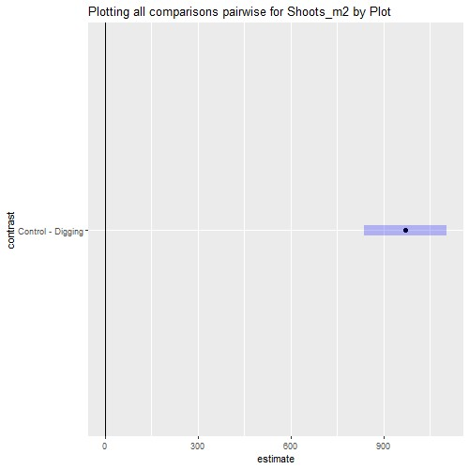

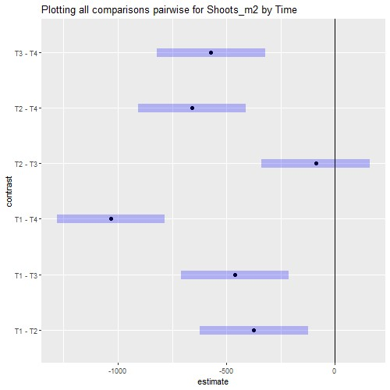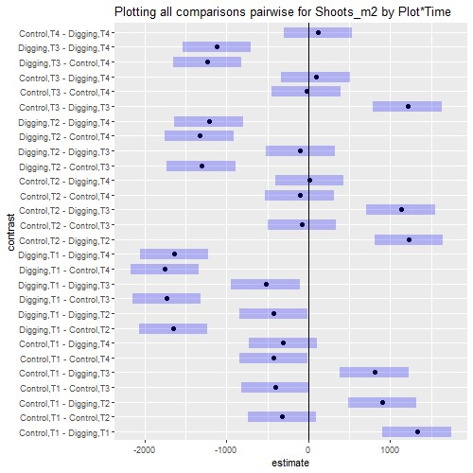

# Interaction plot with Confidence Intervals

