**BSkyOpenNewDataset( datasetName='Dataset1')**

**Open Dataset**

**Anova (1 Way and 2 Way)**

C:\Users\User\Documents\Marg I\Clean data D&R trials\Restoration plots.xlsx

`Summarise()` ungrouping output (override with `.groups` arment)

***Summaries for Sand___ by factor variable Tube_diameter***

|  |  |  |  |  |  |  |
| --- | --- | --- | --- | --- | --- | --- |
| **Tube_diame**  **Ter** | **n** | **mean** | **median** | **min** | **Max** | **Sd**  **variance** |
| 4.5cm | 48 | 86.4746 | 86.6 | 85.29 | 88.78 | 0.609 0.3708 |
| 7.5cm | 48 | 86.4775 | 86.68 | 85.28 | 86.98 | 0.5006 0.2505 |

# `summarise()` ungrouping output (override with `.groups` argument)

***Summaries for Sand___ by factor variable Time***

|  |  |  |  |  |  |  |
| --- | --- | --- | --- | --- | --- | --- |
| **Time** | **n** | **mean** | **median** | **min** | **max** | **sd** |
| T1 | 24 | 86.7037 | 86.665 | 85.29 | 88.78 | 0.5745 |
| T2 | 24 | 85.9 | 85.69 | 85.28 | 86.95 | 0.4919 |
| T3 | 24 | 86.8 | 86.845 | 86.23 | 86.92 | 0.1651 |
| T4 | 24 | 86.5004 | 86.55 | 85.79 | 86.99 | 0.4001 |

**variance**

0.33

0.242

0.0273

0.1601

# `summarise()` regrouping output by 'Tube_diameter' (override with `.groups` argument)

***Summaries for Sand___ by factor variables Tube_diameter*Time***

|  |  |  |  |  |  |  |
| --- | --- | --- | --- | --- | --- | --- |
| **Tube_diame**  **Ter** | **Time** | **n** | **mean** | **median** | **min** | **max** |
| 4.5cm | T1 | 12 | 86.7 | 86.615 | 85.29 | 88.78 |
| 4.5cm | T2 | 12 | 85.8967 | 85.755 | 85.5 | 86.85 |
| 4.5cm | T3 | 12 | 86.8008 | 86.85 | 86.23 | 86.92 |
| 4.5cm | T4 | 12 | 86.5008 | 86.57 | 85.85 | 86.99 |
| 7.5cm | T1 | 12 | 86.7075 | 86.825 | 86.3 | 86.9 |
| 7.5cm | T2 | 12 | 85.9033 | 85.675 | 85.28 | 86.95 |
| 7.5cm | T3 | 12 | 86.7992 | 86.835 | 86.35 | 86.9 |
| 7.5cm | T4 | 12 | 86.5 | 86.55 | 85.79 | 86.98 |

|  |  |
| --- | --- |
| **sd** | **variance** |
| 0.8022 | 0.6436 |
| 0.4502 | 0.2027 |
| 0.1868 | 0.0349 |
| 0.4082 | 0.1666 |
| 0.2156 | 0.0465 |
| 0.5507 | 0.3033 |
| 0.1486 | 0.0221 |
| 0.41 | 0.1681 |

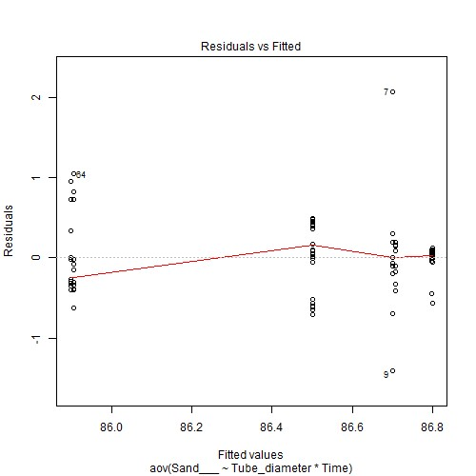

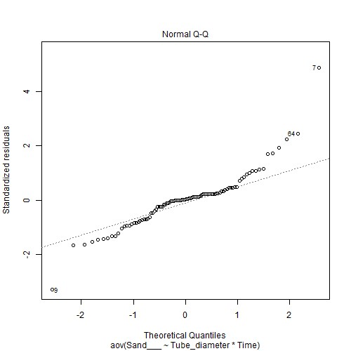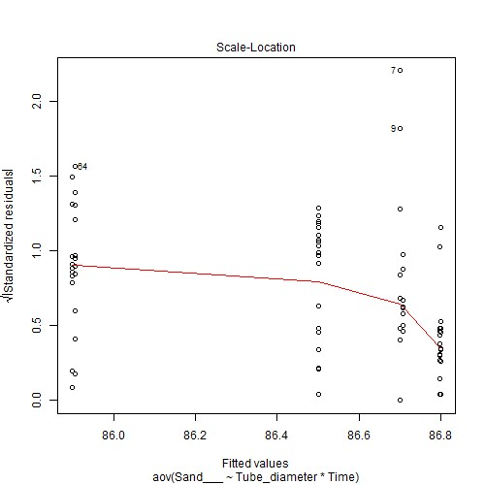

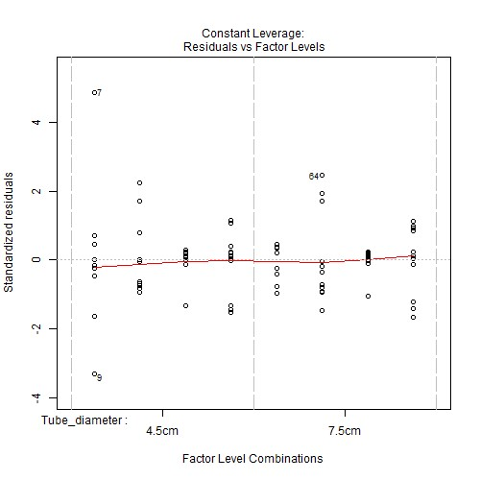

***Anova table with type III sum of squares for Sand___ by Tube_diameter*Time***

|  |  |  |  |  |  |
| --- | --- | --- | --- | --- | --- |
|  | **Df** | **Sum Sq** | **Mean Sq** | **F value** | **Pr(>F)** |
| **Tube_diame**  **Ter** | 1 | 0.0002 | 0.0002 | 0.001 | 0.9745 |
| **Time** | 3 | 11.7412 | 3.9137 | 19.7206 | <.001*** |
| **Tube_diame ter:Time** | 3 | 0.0004 | 0.0001 | 0.0007 | 1 |
| **Residuals** | 88 | 17.4644 | 0.1985 | NA | NA |

*Note.* Signif. codes: 0 '***' 0.001 '**' 0.01 '*' 0.05 '.' 0.1 ' ' 1

# NOTE: Results may be misleading due to involvement in interactions

***Estimated Marginal Means for Sand___ by Tube_diameter***

|  |  |  |  |  |  |
| --- | --- | --- | --- | --- | --- |
| **Tube_diame**  **ter** | **emmean** | **SE** | **df** | **lower.CL** | **upper.CL** |
| 4.5cm | 86.4746 | 0.0643 | 88 | 86.3468 | 86.6024 |
| 7.5cm | 86.4775 | 0.0643 | 88 | 86.3497 | 86.6053 |

# NOTE: Results may be misleading due to involvement in interactions

***Estimated Marginal Means for Sand___ by Time***

|  |  |  |  |  |  |
| --- | --- | --- | --- | --- | --- |
| **Time** | **emmean** | **SE** | **df** | **lower.CL** | **upper.CL** |
| T1 | 86.7037 | 0.0909 | 88 | 86.523 | 86.8845 |
| T2 | 85.9 | 0.0909 | 88 | 85.7193 | 86.0807 |
| T3 | 86.8 | 0.0909 | 88 | 86.6193 | 86.9807 |
| T4 | 86.5004 | 0.0909 | 88 | 86.3197 | 86.6811 |

***Estimated Marginal Means for Sand___ by Tube_diameter*Time***

|  |  |  |  |  |  |  |
| --- | --- | --- | --- | --- | --- | --- |
| **Tube_diame**  **ter** | **Time** | **emmean** | **SE** | **df** | **lower.CL** | **upper.CL** |
| 4.5cm | T1 | 86.7 | 0.1286 | 88 | 86.4444 | 86.9556 |
| 7.5cm | T1 | 86.7075 | 0.1286 | 88 | 86.4519 | 86.9631 |
| 4.5cm | T2 | 85.8967 | 0.1286 | 88 | 85.6411 | 86.1522 |
| 7.5cm | T2 | 85.9033 | 0.1286 | 88 | 85.6478 | 86.1589 |
| 4.5cm | T3 | 86.8008 | 0.1286 | 88 | 86.5453 | 87.0564 |
| 7.5cm | T3 | 86.7992 | 0.1286 | 88 | 86.5436 | 87.0547 |
| 4.5cm | T4 | 86.5008 | 0.1286 | 88 | 86.2453 | 86.7564 |
| 7.5cm | T4 | 86.5 | 0.1286 | 88 | 86.2444 | 86.7556 |

***Levene's test for homogenity of variances (center=mean) for Sand___ against Tube_diameter***

|  |  |  |  |
| --- | --- | --- | --- |
|  | **Df** | **F value** | **Pr(>F)** |
| **Group** | 1 | 0.4713 | 0.4941 |
|  | 94 | NA | NA |

*Note.* Signif. codes: 0 '***' 0.001 '**' 0.01 '*' 0.05 '.' 0.1 ' ' 1

***Levene's test for homogenity of variances (center=mean) for Sand___ against Time***

|  |  |  |  |
| --- | --- | --- | --- |
|  | **Df** | **F value** | **Pr(>F)** |
| **group** | 3 | 3.2156 | 0.0265 * |
|  | 92 | NA | NA |

*Note.* Signif. codes: 0 '***' 0.001 '**' 0.01 '*' 0.05 '.' 0.1 ' ' 1

# Results are averaged over the levels of: Time

***Post-hoc tests for Sand___ by Tube_diameter (using method = pairwise)***

|  |  |  |  |
| --- | --- | --- | --- |
| **contrast** | **estimate SE df t.ratio** | | **p.value** |
| 4.5cm -  7.5cm | -0.0029 0.0909 88 -0.0321 | | 0.9745 |
| *Note.* Signif. codes: 0 '***' 0.001 '**' 0.01 '*' 0.05 '.' 0.1 ' ' 1  Results are averaged over the levels of: Tube_diameter  P value adjustment: tukey method for comparing a family of 4 estimates  ***Post-hoc tests for Sand___ by Time (using method = pairwise)*** | | |  |
| **contrast estimate SE df** | | **t.ratio** | **p.value** |

T1 - T2 0.8038 0.1286 88 6.2499 <.001***

|  |  |  |  |  |  |  |  |  |  |  |  |  |  |  |
| --- | --- | --- | --- | --- | --- | --- | --- | --- | --- | --- | --- | --- | --- | --- |
| **contrast** | | | **estimate** | | **SE** | | **df** | | **t.ratio** | | | **p.value** | | |
| T1 - T3 | | | -0.0962 | | 0.1286 | | 88 | | -0.7484 | | | 0.8771 | | |
| T1 - T4 | | | 0.2033 | | 0.1286 | | 88 | | 1.5811 | | | 0.3946 | | |
| T2 - T3 | | | -0.9 | | 0.1286 | | 88 | | -6.9984 | | | <.001*** | | |
| T2 - T4 | | | -0.6004 | | 0.1286 | | 88 | | -4.6688 | | | <.001*** | | |
| T3 - T4 | | | 0.2996 | | 0.1286 | | 88 | | 2.3296 | | | 0.0991 . | | |
| *Note.* Signif. codes: 0 '***' 0.001 '**' 0.01 '*' 0.05 '.' 0.1 ' ' 1  P value adjustment: tukey method for comparing a fam ***Simple effects for Sand___ by Tube_diameter*Time (using*** | | | | | | | ily of 8 est ***method = pairwise)*** | | imates | | |  | | |
| **contrast estimate SE df t.ratio** | | | | | | | | | | | | **p.value** | | |
| 4.5cm,T1 -  7.5cm,T1 | -0.0075 | | 0.1819 | | 88 | | -0.0412 | | | 1 | | |
| 4.5cm,T1 -  4.5cm,T2 | 0.8033 | | 0.1819 | | 88 | | 4.4171 | | | <.001*** | | |
| 4.5cm,T1 -  7.5cm,T2 | 0.7967 | | 0.1819 | | 88 | | 4.3804 | | | <.001*** | | |
| 4.5cm,T1 -  4.5cm,T3 | -0.1008 | | 0.1819 | | 88 | | -0.5544 | | | 0.9993 | | |
| 4.5cm,T1 -  7.5cm,T3 | -0.0992 | | 0.1819 | | 88 | | -0.5453 | | | 0.9994 | | |
| 4.5cm,T1 -  4.5cm,T4 | 0.1992 | | 0.1819 | | 88 | | 1.0951 | | | 0.9562 | | |
| 4.5cm,T1 -  7.5cm,T4 | 0.2 | | 0.1819 | | 88 | | 1.0997 | | | 0.9553 | | |
| 7.5cm,T1 -  4.5cm,T2 | 0.8108 | | 0.1819 | | 88 | | 4.4583 | | | <.001*** | | |
| 7.5cm,T1 -  7.5cm,T2 | 0.8042 | | 0.1819 | | 88 | | 4.4217 | | | <.001*** | | |
| 7.5cm,T1 -  4.5cm,T3 | -0.0933 | | 0.1819 | | 88 | | -0.5132 | | | 0.9996 | | |
| 7.5cm,T1 -  7.5cm,T3 | -0.0917 | | 0.1819 | | 88 | | -0.504 | | | 0.9996 | | |
| 7.5cm,T1 -  4.5cm,T4 | 0.2067 | | 0.1819 | | 88 | | 1.1363 | | | 0.9469 | | |
| 7.5cm,T1 -  7.5cm,T4 | 0.2075 | | 0.1819 | | 88 | | 1.1409 | | | 0.9458 | | |
| 4.5cm,T2 -  7.5cm,T2 | -0.0067 | | 0.1819 | | 88 | | -0.0367 | | | 1 | | |
| 4.5cm,T2 -  4.5cm,T3 | -0.9042 | | 0.1819 | | 88 | | -4.9715 | | | <.001*** | | |
| 4.5cm,T2 -  7.5cm,T3 | -0.9025 | | 0.1819 | | 88 | | -4.9623 | | | <.001*** | | |
| 4.5cm,T2 -  4.5cm,T4 | -0.6042 | | 0.1819 | | 88 | | -3.322 | | | 0.0273 * | | |
| 4.5cm,T2 -  7.5cm,T4 | -0.6033 | | 0.1819 | | 88 | | -3.3174 | | | 0.0277 * | | |
| 7.5cm,T2 -  4.5cm,T3 | -0.8975 | | 0.1819 | | 88 | | -4.9349 | | | <.001*** | | |
| 7.5cm,T2 -  7.5cm,T3 | -0.8958 | | 0.1819 | | 88 | | -4.9257 | | | <.001*** | | |
| 7.5cm,T2 -  4.5cm,T4 | -0.5975 | | 0.1819 | | 88 | | -3.2853 | | | 0.0303 * | | |
| 7.5cm,T2 -  7.5cm,T4 | -0.5967 | | 0.1819 | | 88 | | -3.2807 | | | 0.0307 * | | |
| 4.5cm,T3 -  7.5cm,T3 | 0.0017 | | 0.1819 | | 88 | | 0.0092 | | | 1 | | |
| 4.5cm,T3 -  4.5cm,T4 | 0.3 | | 0.1819 | | 88 | | 1.6495 | | | 0.7190 | | |
| **contrast** | | | **estimate** | | **SE** | | **df** | | | **t.ratio** | | | **p.value** | |
| 4.5cm,T3 -  7.5cm,T4 | | | 0.3008 | | 0.1819 | | 88 | | | 1.6541 | | | 0.7162 | |
| 7.5cm,T3 -  4.5cm,T4 | | | 0.2983 | | 0.1819 | | 88 | | | 1.6404 | | | 0.7246 | |
| 7.5cm,T3 -  7.5cm,T4 | | | 0.2992 | | 0.1819 | | 88 | | | 1.645 | | | 0.7218 | |
| 4.5cm,T4 -  7.5cm,T4 | | | 0.0008 | | 0.1819 | | 88 | | | 0.0046 | | | 1 | |

*Note.* Signif. codes: 0 '***' 0.001 '**' 0.01 '*' 0.05 '.' 0.1 ' ' 1

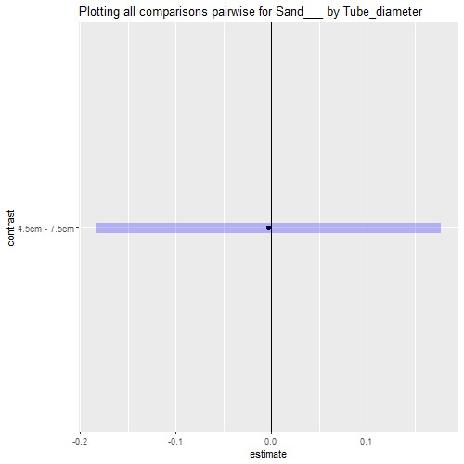

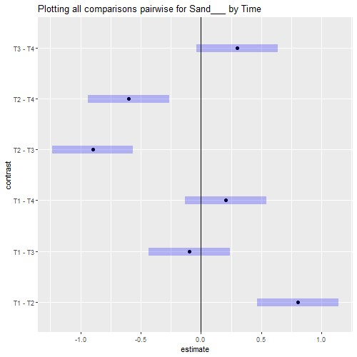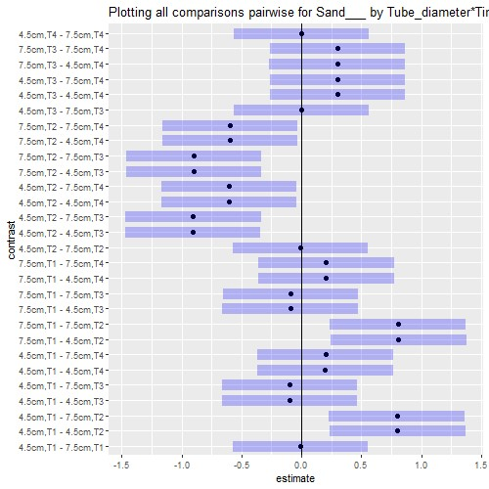

# Interaction plot with Confidence Intervals

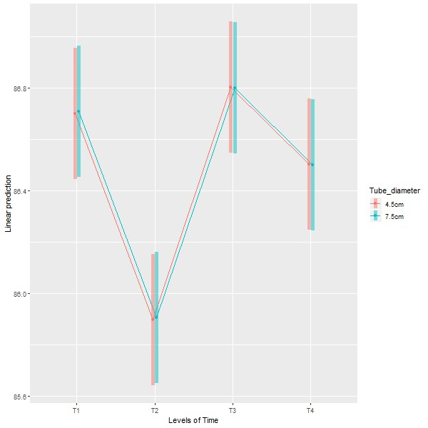

**Anova (1 Way and 2 Way)**

[Restoration.plots.xlsx.Sediment] - C:\Users\User\Documents\Marg I\Clean data D&R trials\Restoration plots.xlsx

`summarise()` ungrouping output (override with `.groups` argument)

***Summaries for Silt___ by factor variable Tube_diameter***

**Tube_diameter n mean median min max sd** **variance**

4.5cm 48 11.3304 11.475 9.2 13 0.6686 0.447

7.5cm 48 11.3212 11.485 10.11 12.08 0.5113 0.2614

## `summarise()` ungrouping output (override with `.groups` argument)

***Summaries for Silt___ by factor variable Time***

|  |  |  |  |  |  |  |
| --- | --- | --- | --- | --- | --- | --- |
| **Time** | **n** | **mean** | **median** | **min** | **max** | **sd** |
| T1 | 24 | 11.3987 | 11.5 | 9.2 | 13 | 0.6915 |
| T2 | 24 | 10.7004 | 10.6 | 10.1 | 11.6 | 0.4562 |
| T3 | 24 | 11.4 | 11.405 | 11 | 11.9 | 0.2658 |
| T4 | 24 | 11.8042 | 11.835 | 11.43 | 12.08 | 0.1803 |

**variance**

0.4782

0.2082

0.0706

0.0325

## `summarise()` regrouping output by 'Tube_diameter' (override with `.groups` argument)

***Summaries for Silt___ by factor variables Tube_diameter*Time***

|  |  |  |  |  |  |  |  |  |
| --- | --- | --- | --- | --- | --- | --- | --- | --- |
| **Tube_diame**  **Ter** | | **Time** | | **n** | **mean** | **median** | **min** | **max** |
| 4.5cm | | T1 | | 12 | 11.4083 | 11.6 | 9.2 | 13 |
| 4.5cm | | T2 | | 12 | 10.705 | 10.8 | 10.1 | 11.6 |
| 4.5cm | | T3 | | 12 | 11.4 | 11.405 | 11 | 11.9 |
| 4.5cm | | T4 | | 12 | 11.8083 | 11.88 | 11.43 | 12.08 |
| 7.5cm | | T1 | | 12 | 11.3892 | 11.45 | 10.53 | 12.01 |
| 7.5cm | | T2 | | 12 | 10.6958 | 10.6 | 10.11 | 11.47 |
| 7.5cm | | T3 | | 12 | 11.4 | 11.41 | 11.11 | 11.79 |
| 7.5cm | | T4 | | 12 | 11.8 | 11.8 | 11.63 | 12.08 |
| **Sd** | **variance** | |
| 0.9288 | 0.8627 | |
| 0.4702 | 0.2211 | |
| 0.3045 | 0.0927 | |
| 0.2136 | 0.0456 | |
| 0.3702 | 0.1371 | |
| 0.4627 | 0.2141 | |
| 0.2345 | 0.055 | |
| 0.1494 | 0.0223 | |

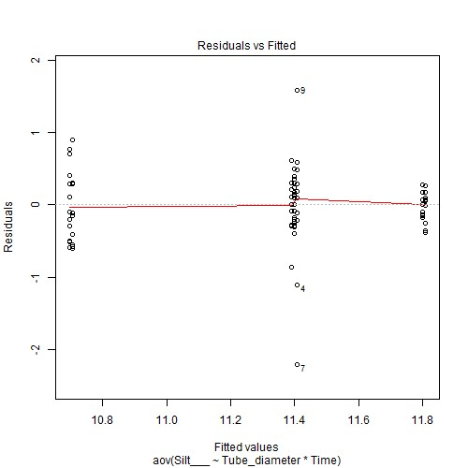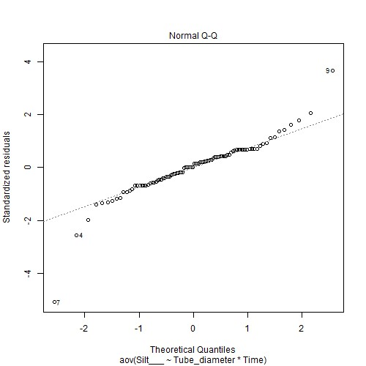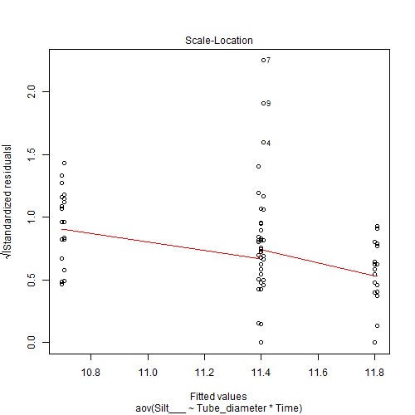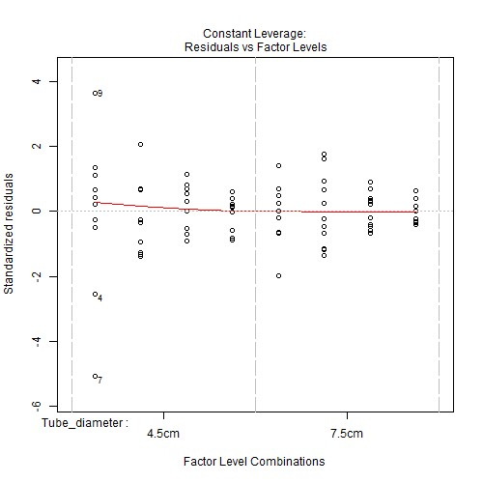

***Anova table with type III sum of squares for Silt___ by Tube_diameter*Time***

|  |  |  |  |  |  |
| --- | --- | --- | --- | --- | --- |
|  | **Df** | **Sum Sq** | **Mean Sq** | **F value** | **Pr(>F)** |
| **Tube_diame**  **ter** | 1 | 0.002 | 0.002 | 0.0098 | 0.9215 |
| **Time** | 3 | 15.1384 | 5.0461 | 24.4574 | <.001*** |
| **Tube_diame ter:Time** | 3 | 0.0011 | 0.0004 | 0.0018 | 0.9999 |
| **Residuals** | 88 | 18.1564 | 0.2063 | NA | NA |

*Note.* Signif. codes: 0 '***' 0.001 '**' 0.01 '*' 0.05 '.' 0.1 ' ' 1

## NOTE: Results may be misleading due to involvement in interactions

***Estimated Marginal Means for Silt___ by Tube_diameter***

|  |  |  |  |  |  |
| --- | --- | --- | --- | --- | --- |
| **Tube_diame**  **Ter** | **emmean** | **SE** | **Df** | **lower.CL** | **upper.CL** |
| 4.5cm | 11.3304 | 0.0656 | 88 | 11.2001 | 11.4607 |
| 7.5cm | 11.3212 | 0.0656 | 88 | 11.191 | 11.4515 |

NOTE: Results may be misleading due to involvement in interactions

***Estimated Marginal Means for Silt___ by Time***

|  |  |  |  |  |  |
| --- | --- | --- | --- | --- | --- |
| **Time** | **Emmean** | **SE** | **df** | **lower.CL** | **upper.CL** |
| T1 | 11.3987 | 0.0927 | 88 | 11.2145 | 11.583 |
| T2 | 10.7004 | 0.0927 | 88 | 10.5162 | 10.8847 |
| T3 | 11.4 | 0.0927 | 88 | 11.2157 | 11.5843 |
| T4 | 11.8042 | 0.0927 | 88 | 11.6199 | 11.9884 |

***Estimated Marginal Means for Silt___ by Tube_diameter*Time***

|  |  |  |  |  |  |  |
| --- | --- | --- | --- | --- | --- | --- |
| **Tube_diame**  **ter** | **Time** | **emmean** | **SE** | **Df** | **lower.CL** | **upper.CL** |
| 4.5cm | T1 | 11.4083 | 0.1311 | 88 | 11.1478 | 11.6689 |
| 7.5cm | T1 | 11.3892 | 0.1311 | 88 | 11.1286 | 11.6497 |
| 4.5cm | T2 | 10.705 | 0.1311 | 88 | 10.4444 | 10.9656 |
| 7.5cm | T2 | 10.6958 | 0.1311 | 88 | 10.4352 | 10.9564 |
| 4.5cm | T3 | 11.4 | 0.1311 | 88 | 11.1394 | 11.6606 |
| 7.5cm | T3 | 11.4 | 0.1311 | 88 | 11.1394 | 11.6606 |
| 4.5cm | T4 | 11.8083 | 0.1311 | 88 | 11.5478 | 12.0689 |
| 7.5cm | T4 | 11.8 | 0.1311 | 88 | 11.5394 | 12.0606 |

***Levene's test for homogenity of variances (center=mean) for Silt___ against Tube_diameter***

|  |  |  |  |
| --- | --- | --- | --- |
|  | **Df** | **F value** | **Pr(>F)** |
| **group** | 1 | 1.4624 | 0.2296 |
|  | 94 | NA | NA |

*Note.* Signif. codes: 0 '***' 0.001 '**' 0.01 '*' 0.05 '.' 0.1 ' ' 1

***Levene's test for homogenity of variances (center=mean) for Silt___ against Time***

|  |  |  |  |
| --- | --- | --- | --- |
|  | **Df** | **F value** | **Pr(>F)** |
| **group** | 3 | 3.97 | 0.0104 * |
|  | 92 | NA | NA |

*Note.* Signif. codes: 0 '***' 0.001 '**' 0.01 '*' 0.05 '.' 0.1 ' ' 1

## Results are averaged over the levels of: Time

***Post-hoc tests for Silt___ by Tube_diameter (using method = pairwise)***

|  |  |  |  |  |  |  |  |  |  |  |  |  |  |  |
| --- | --- | --- | --- | --- | --- | --- | --- | --- | --- | --- | --- | --- | --- | --- |
| **contrast** | | | **estimate SE** | | | | **df** | | | **t.ratio** | | | **p.value** | |
| 4.5cm -  7.5cm | | | 0.0092 0.0927 | | | | 88 | | | 0.0989 | | | 0.9215 | |
| *Note.* Signif. codes: 0 '***' 0.001 '**' 0.01 '*' 0.05 '.' 0.1 ' ' 1  Results are averaged over the levels of: Tube_diameter P value adjustment: tukey method for comparing a family of 4 estimate  ***Post-hoc tests for Silt___ by Time (using method = pairwise)*** | | | | | | |  | | |  | | |  | |
| **contrast** | | | **Estimate** | | **SE** | | **df** | | | **t.ratio** | | | **p.value** | |
| T1 - T2 | | | 0.6983 | | 0.1311 | | 88 | | | 5.3257 | | | <.001*** | |
| T1 - T3 | | | -0.0012 | | 0.1311 | | 88 | | | -0.0095 | | | 1.0000 | |
| T1 - T4 | | | -0.4054 | | 0.1311 | | 88 | | | -3.0919 | | | 0.0139 * | |
| T2 - T3 | | | -0.6996 | | 0.1311 | | 88 | | | -5.3353 | | | <.001*** | |
| T2 - T4 | | | -1.1038 | | 0.1311 | | 88 | | | -8.4176 | | | <.001*** | |
| T3 - T4 | | | -0.4042 | | 0.1311 | | 88 | | | -3.0823 | | | 0.0143 * | |
| *Note.* Signif. codes: 0 '***' 0.001 '**' 0.01 '*' 0.05 '.' 0.1 ' ' 1  P value adjustment: tukey method for comparing a family of 8 estimates  ***Simple effects for Silt___ by Tube_diameter*Time (using method = pairwise)*** | | | | | | |  | | |  | | |  | |
| **contrast estimate SE df t.ratio** | | | | | | | | | | | | | **p.value** | |
| 4.5cm,T1 -  7.5cm,T1 | 0.0192 | | 0.1854 | | 88 | | 0.1034 | | | 1 | | |
| 4.5cm,T1 -  4.5cm,T2 | 0.7033 | | 0.1854 | | 88 | | 3.7928 | | | 0.0064 ** | | |
| 4.5cm,T1 -  7.5cm,T2 | 0.7125 | | 0.1854 | | 88 | | 3.8423 | | | 0.0054 ** | | |
| 4.5cm,T1 -  4.5cm,T3 | 0.0083 | | 0.1854 | | 88 | | 0.0449 | | | 1 | | |
| 4.5cm,T1 -  7.5cm,T3 | 0.0083 | | 0.1854 | | 88 | | 0.0449 | | | 1 | | |
| 4.5cm,T1 -  4.5cm,T4 | -0.4000 | | 0.1854 | | 88 | | -2.1571 | | | 0.3877 | | |
| **contrast** | | | **Estimate** | | **SE** | | **df** | | **t.ratio** | | | **p.value** | | |
| 4.5cm,T1 -  7.5cm,T4 | | | -0.3917 | | 0.1854 | | 88 | | -2.1121 | | | 0.4155 | | |
| 7.5cm,T1 -  4.5cm,T2 | | | 0.6842 | | 0.1854 | | 88 | | 3.6895 | | | 0.0089 ** | | |
| 7.5cm,T1 -  7.5cm,T2 | | | 0.6933 | | 0.1854 | | 88 | | 3.7389 | | | 0.0076 ** | | |
| 7.5cm,T1 -  4.5cm,T3 | | | -0.0108 | | 0.1854 | | 88 | | -0.0584 | | | 1 | | |
| 7.5cm,T1 -  7.5cm,T3 | | | -0.0108 | | 0.1854 | | 88 | | -0.0584 | | | 1 | | |
| 7.5cm,T1 -  4.5cm,T4 | | | -0.4192 | | 0.1854 | | 88 | | -2.2604 | | | 0.3272 | | |
| 7.5cm,T1 -  7.5cm,T4 | | | -0.4108 | | 0.1854 | | 88 | | -2.2155 | | | 0.3529 | | |
| 4.5cm,T2 -  7.5cm,T2 | | | 0.0092 | | 0.1854 | | 88 | | 0.0494 | | | 1 | | |
| 4.5cm,T2 -  4.5cm,T3 | | | -0.6950 | | 0.1854 | | 88 | | -3.7479 | | | 0.0074 ** | | |
| 4.5cm,T2 -  7.5cm,T3 | | | -0.6950 | | 0.1854 | | 88 | | -3.7479 | | | 0.0074 ** | | |
| 4.5cm,T2 -  4.5cm,T4 | | | -1.1033 | | 0.1854 | | 88 | | -5.9499 | | | <.001*** | | |
| 4.5cm,T2 -  7.5cm,T4 | | | -1.095 | | 0.1854 | | 88 | | -5.9049 | | | <.001*** | | |
| 7.5cm,T2 -  4.5cm,T3 | | | -0.7042 | | 0.1854 | | 88 | | -3.7973 | | | 0.0063 ** | | |
| 7.5cm,T2 -  7.5cm,T3 | | | -0.7042 | | 0.1854 | | 88 | | -3.7973 | | | 0.0063 ** | | |
| 7.5cm,T2 -  4.5cm,T4 | | | -1.1125 | | 0.1854 | | 88 | | -5.9993 | | | <.001*** | | |
| 7.5cm,T2 -  7.5cm,T4 | | | -1.1042 | | 0.1854 | | 88 | | -5.9544 | | | <.001*** | | |
| 4.5cm,T3 -  7.5cm,T3 | | | -0.0000 | | 0.1854 | | 88 | | -0.0000 | | | 1 | | |
| 4.5cm,T3 -  4.5cm,T4 | | | -0.4083 | | 0.1854 | | 88 | | -2.202 | | | 0.3608 | | |
| 4.5cm,T3 -  7.5cm,T4 | | | -0.4000 | | 0.1854 | | 88 | | -2.1571 | | | 0.3877 | | |
| 7.5cm,T3 -  4.5cm,T4 | | | -0.4083 | | 0.1854 | | 88 | | -2.202 | | | 0.3608 | | |
| 7.5cm,T3 -  7.5cm,T4 | | | -0.4000 | | 0.1854 | | 88 | | -2.1571 | | | 0.3877 | | |
| 4.5cm,T4 -  7.5cm,T4 | | | 0.0083 | | 0.1854 | | 88 | | 0.0449 | | | 1 | | |

*Note.* Signif. codes: 0 '***' 0.001 '**' 0.01 '*' 0.05 '.' 0.1 ' ' 1

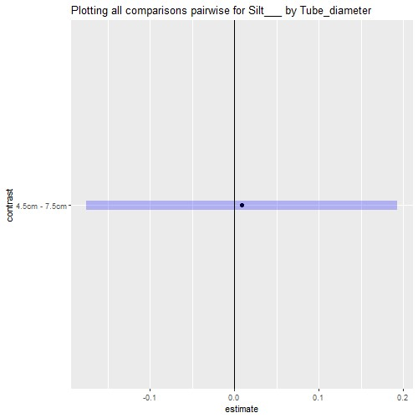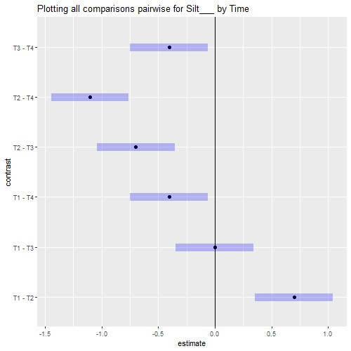

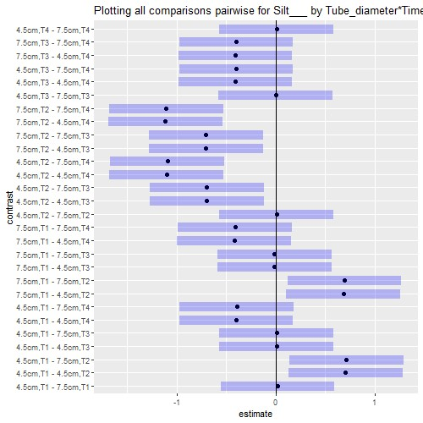

# Interaction plot with Confidence Intervals

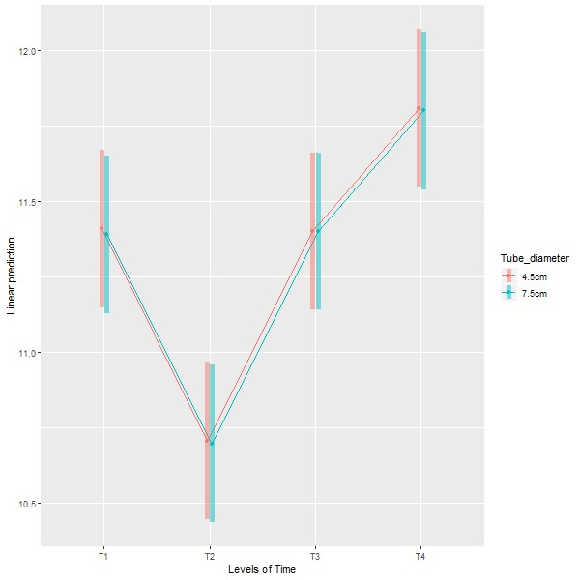

**Anova (1 Way and 2 Way)**

[Restoration.plots.xlsx.Sediment] - C:\Users\User\Documents\Marg I\Clean data D&R trials\Restoration plots.xlsx

## `summarise()` ungrouping output (override with `.groups` argument)

***Summaries for Clay___ by factor variable Tube_diameter***

|  |  |  |  |  |  |  |
| --- | --- | --- | --- | --- | --- | --- |
| **Tube_diame**  **ter** | **n** | **mean** | **median** | **min** | **max** | **sd** |
| 4.5cm | 48 | 2.1977 | 2.005 | 1.06 | 4.34 | 0.8576 |
| 7.5cm | 48 | 2.2012 | 1.96 | 1.05 | 4.33 | 0.8303 |

**variance**

0.7355

0.6893

## `summarise()` ungrouping output (override with `.groups` argument)

***Summaries for Clay___ by factor variable Time***

|  |  |  |  |  |  |  |
| --- | --- | --- | --- | --- | --- | --- |
| **Time** | **n** | **mean** | **median** | **min** | **max** | **sd** |
| T1 | 24 | 1.8975 | 1.81 | 1.3 | 2.8 | 0.3377 |
| T2 | 24 | 3.3996 | 3.28 | 2.17 | 4.34 | 0.6529 |
| T3 | 24 | 1.8 | 1.92 | 1.18 | 2.36 | 0.3054 |
| T4 | 24 | 1.7008 | 1.605 | 1.05 | 2.66 | 0.5039 |

**variance** 0.114

0.4263

0.0933

0.2539

## `summarise()` regrouping output by 'Tube_diameter' (override with `.groups` argument)

***Summaries for Clay___ by factor variables Tube_diameter*Time***

|  |  |  |  |  |  |  |  |  |
| --- | --- | --- | --- | --- | --- | --- | --- | --- |
| **Tube_diame**  **ter** | | **Time** | | **n** | **mean** | **median** | **min** | **max** |
| 4.5cm | | T1 | | 12 | 1.8917 | 1.8 | 1.3 | 2.8 |
| 4.5cm | | T2 | | 12 | 3.3983 | 3.245 | 2.17 | 4.34 |
| 4.5cm | | T3 | | 12 | 1.7992 | 1.9 | 1.18 | 2.36 |
| 4.5cm | | T4 | | 12 | 1.7017 | 1.55 | 1.06 | 2.66 |
| 7.5cm | | T1 | | 12 | 1.9033 | 1.83 | 1.5 | 2.62 |
| 7.5cm | | T2 | | 12 | 3.4008 | 3.28 | 2.55 | 4.33 |
| 7.5cm | | T3 | | 12 | 1.8008 | 1.92 | 1.31 | 2.1 |
| 7.5cm | | T4 | | 12 | 1.7 | 1.63 | 1.05 | 2.58 |
| **sd** | **variance** | |
| 0.3713 | 0.1379 | |
| 0.6948 | 0.4828 | |
| 0.3657 | 0.1337 | |
| 0.5211 | 0.2716 | |
| 0.3169 | 0.1004 | |
| 0.6392 | 0.4086 | |
| 0.2475 | 0.0612 | |
| 0.5093 | 0.2594 | |

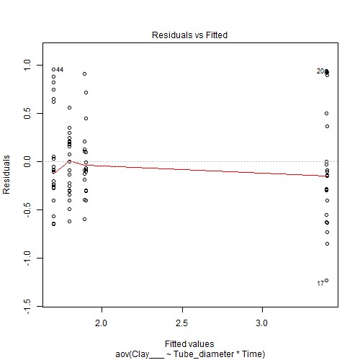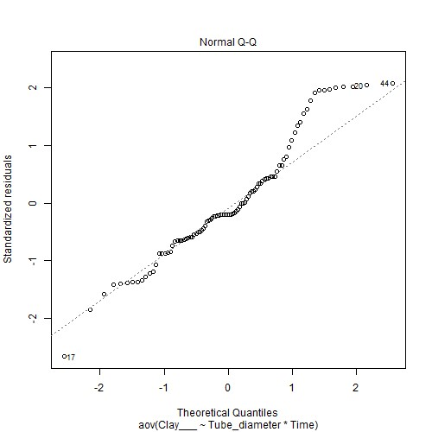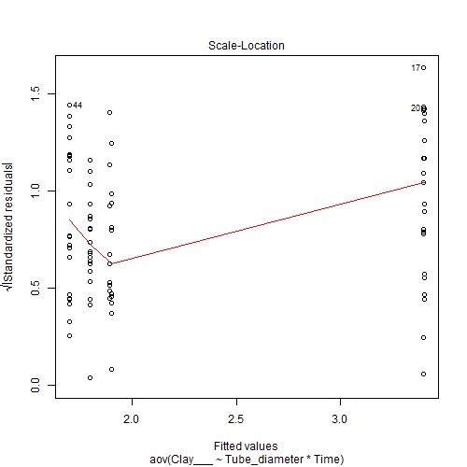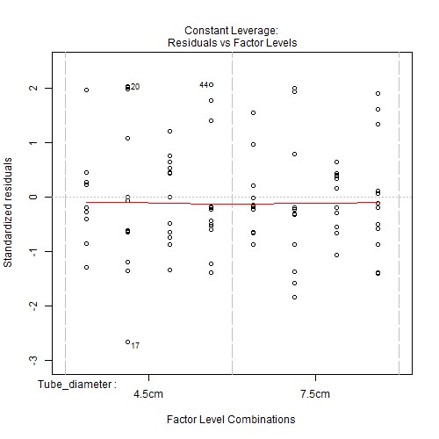

***Anova table with type III sum of squares for Clay___ by Tube_diameter*Time***

|  |  |  |  |  |  |
| --- | --- | --- | --- | --- | --- |
|  | **Df** | **Sum Sq** | **Mean Sq** | **F value** | **Pr(>F)** |
| **Tube_diame**  **ter** | 1 | 0.0003 | 0.0003 | 0.0013 | 0.9713 |
| **Time** | 3 | 46.5521 | 15.5174 | 66.8989 | <.001*** |
| **Tube_diame ter:Time** | 3 | 0.0006 | 0.0002 | 0.0008 | 1 |
| **Residuals** | 88 | 20.4118 | 0.232 | NA | NA |

*Note.* Signif. codes: 0 '***' 0.001 '**' 0.01 '*' 0.05 '.' 0.1 ' ' 1

## NOTE: Results may be misleading due to involvement in interactions

***Estimated Marginal Means for Clay___ by Tube_diameter***

|  |  |  |  |  |  |
| --- | --- | --- | --- | --- | --- |
| **Tube_diame**  **ter** | **emmean** | **SE** | **df** | **lower.CL** | **upper.CL** |
| 4.5cm | 2.1977 | 0.0695 | 88 | 2.0596 | 2.3359 |
| 7.5cm | 2.2012 | 0.0695 | 88 | 2.0631 | 2.3394 |

NOTE: Results may be misleading due to involvement in interactions

***Estimated Marginal Means for Clay___ by Time***

|  |  |  |  |  |  |
| --- | --- | --- | --- | --- | --- |
| **Time** | **emmean** | **SE** | **df** | **lower.CL** | **upper.CL** |
| T1 | 1.8975 | 0.0983 | 88 | 1.7021 | 2.0929 |
| T2 | 3.3996 | 0.0983 | 88 | 3.2042 | 3.595 |
| T3 | 1.8 | 0.0983 | 88 | 1.6046 | 1.9954 |
| T4 | 1.7008 | 0.0983 | 88 | 1.5055 | 1.8962 |

***Estimated Marginal Means for Clay___ by Tube_diameter*Time***

|  |  |  |  |  |  |  |
| --- | --- | --- | --- | --- | --- | --- |
| **Tube_diame**  **ter** | **Time** | **emmean** | **SE** | **df** | **lower.CL** | **upper.CL** |
| 4.5cm | T1 | 1.8917 | 0.139 | 88 | 1.6154 | 2.168 |
| 7.5cm | T1 | 1.9033 | 0.139 | 88 | 1.627 | 2.1796 |
| 4.5cm | T2 | 3.3983 | 0.139 | 88 | 3.122 | 3.6746 |
| 7.5cm | T2 | 3.4008 | 0.139 | 88 | 3.1245 | 3.6771 |
| 4.5cm | T3 | 1.7992 | 0.139 | 88 | 1.5229 | 2.0755 |
| 7.5cm | T3 | 1.8008 | 0.139 | 88 | 1.5245 | 2.0771 |
| 4.5cm | T4 | 1.7017 | 0.139 | 88 | 1.4254 | 1.978 |
| 7.5cm | T4 | 1.7 | 0.139 | 88 | 1.4237 | 1.9763 |

***Levene's test for homogenity of variances (center=mean) for Clay___ against Tube_diameter***

|  |  |  |  |
| --- | --- | --- | --- |
|  | **Df** | **F value** | **Pr(>F)** |
| **group** | 1 | 0.0957 | 0.7578 |
|  | 94 | NA | NA |

*Note.* Signif. codes: 0 '***' 0.001 '**' 0.01 '*' 0.05 '.' 0.1 ' ' 1

|  |  |  |  |
| --- | --- | --- | --- |
|  | **Df** | **F value** | **Pr(>F)** |
| **group** | 3 | 4.1067 | 0.0088 ** |
|  | 92 | NA | NA |

***Levene's test for homogenity of variances (center=mean) for Clay___ against Time***

*Note.* Signif. codes: 0 '***' 0.001 '**' 0.01 '*' 0.05 '.' 0.1 ' ' 1

## Results are averaged over the levels of: Time

***Post-hoc tests for Clay___ by Tube_diameter (using method = pairwise)***

|  |  |  |  |  |  |  |  |  |  |  |  |  |  |  |  |
| --- | --- | --- | --- | --- | --- | --- | --- | --- | --- | --- | --- | --- | --- | --- | --- |
| **contrast** | | | **estimate** | | | **SE** | | **df** | | | | **t.ratio** | | **p.value** | |
| 4.5cm -  7.5cm | | | -0.0035 | | | 0.0983 | | 88 | | | | -0.036 | | 0.9713 | |
| *Note.* Signif. codes: 0 '***' 0.001 '**' 0.01 | | | '*' 0.05 '.' 0.1 ' ' 1 | | |  | |  | | | |  | |  | |
| Results are averaged over the levels of: Tube_diameter  P value adjustment: tukey method for comparing a family of 4 estimates  ***Post-hoc tests for Clay___ by Time (using method = pairwise)*** | | | | | | | | | | | | | |  | |
| **contrast** | | | **estimate** | | | **SE** | | **df** | | **t.ratio** | | | | **p.value** | |
| T1 - T2 | | | -1.5021 | | | 0.139 | | 88 | | -10.804 | | | | <.001*** | |
| T1 - T3 | | | 0.0975 | | | 0.139 | | 88 | | 0.7013 | | | | 0.8963 | |
| T1 - T4 | | | 0.1967 | | | 0.139 | | 88 | | 1.4146 | | | | 0.4937 | |
| T2 - T3 | | | 1.5996 | | | 0.139 | | 88 | | 11.5053 | | | | <.001*** | |
| T2 - T4 | | | 1.6988 | | | 0.139 | | 88 | | 12.2186 | | | | <.001*** | |
| T3 - T4 | | | 0.0992 | | | 0.139 | | 88 | | 0.7133 | | | | 0.8916 | |
| *Note.* Signif. codes: 0 '***' 0.001 '**' 0.01 | | | '*' 0.05 '.' 0.1 ' ' 1 | | |  | |  | |  | | | |  | |
| P value adjustment: tukey method for comparing a family of 8 estimates  ***Simple effects for Clay___ by Tube_diameter*Time (using method = pairwise)*** | | | | | | | | | | | | | |  | |
| **contrast estimate SE df t.ratio** | | | | | | | | | | | | | | **p.value** | |
| 4.5cm,T1 -  7.5cm,T1 | -0.0117 | | 0.1966 | | | 88 | | -0.0593 | | | | 1 | |
| 4.5cm,T1 -  4.5cm,T2 | -1.5067 | | 0.1966 | | | 88 | | -7.6629 | | | | <.001*** | |
| 4.5cm,T1 -  7.5cm,T2 | -1.5092 | | 0.1966 | | | 88 | | -7.6756 | | | | <.001*** | |
| 4.5cm,T1 -  4.5cm,T3 | 0.0925 | | 0.1966 | | | 88 | | 0.4705 | | | | 0.9998 | |
| 4.5cm,T1 -  7.5cm,T3 | 0.0908 | | 0.1966 | | | 88 | | 0.462 | | | | 0.9998 | |
| 4.5cm,T1 -  4.5cm,T4 | 0.19 | | 0.1966 | | | 88 | | 0.9663 | | | | 0.9780 | |
| **contrast** | | | **estimate** | | **SE** | | | **df** | | | **t.ratio** | | | **p.value** | |
| 4.5cm,T1 -  7.5cm,T4 | | | 0.1917 | | 0.1966 | | | 88 | | | 0.9748 | | | 0.9768 | |
| 7.5cm,T1 -  4.5cm,T2 | | | -1.495 | | 0.1966 | | | 88 | | | -7.6036 | | | <.001*** | |
| 7.5cm,T1 -  7.5cm,T2 | | | -1.4975 | | 0.1966 | | | 88 | | | -7.6163 | | | <.001*** | |
| 7.5cm,T1 -  4.5cm,T3 | | | 0.1042 | | 0.1966 | | | 88 | | | 0.5298 | | | 0.9995 | |
| 7.5cm,T1 -  7.5cm,T3 | | | 0.1025 | | 0.1966 | | | 88 | | | 0.5213 | | | 0.9995 | |
| 7.5cm,T1 -  4.5cm,T4 | | | 0.2017 | | 0.1966 | | | 88 | | | 1.0257 | | | 0.9693 | |
| 7.5cm,T1 -  7.5cm,T4 | | | 0.2033 | | 0.1966 | | | 88 | | | 1.0342 | | | 0.9679 | |
| 4.5cm,T2 -  7.5cm,T2 | | | -0.0025 | | 0.1966 | | | 88 | | | -0.0127 | | | 1 | |
| 4.5cm,T2 -  4.5cm,T3 | | | 1.5992 | | 0.1966 | | | 88 | | | 8.1334 | | | <.001*** | |
| 4.5cm,T2 -  7.5cm,T3 | | | 1.5975 | | 0.1966 | | | 88 | | | 8.1249 | | | <.001*** | |
| 4.5cm,T2 -  4.5cm,T4 | | | 1.6967 | | 0.1966 | | | 88 | | | 8.6292 | | | <.001*** | |
| 4.5cm,T2 -  7.5cm,T4 | | | 1.6983 | | 0.1966 | | | 88 | | | 8.6377 | | | <.001*** | |
| 7.5cm,T2 -  4.5cm,T3 | | | 1.6017 | | 0.1966 | | | 88 | | | 8.1461 | | | <.001*** | |
| 7.5cm,T2 -  7.5cm,T3 | | | 1.6 | | 0.1966 | | | 88 | | | 8.1376 | | | <.001*** | |
| 7.5cm,T2 -  4.5cm,T4 | | | 1.6992 | | 0.1966 | | | 88 | | | 8.642 | | | <.001*** | |
| 7.5cm,T2 -  7.5cm,T4 | | | 1.7008 | | 0.1966 | | | 88 | | | 8.6504 | | | <.001*** | |
| 4.5cm,T3 -  7.5cm,T3 | | | -0.0017 | | 0.1966 | | | 88 | | | -0.0085 | | | 1 | |
| 4.5cm,T3 -  4.5cm,T4 | | | 0.0975 | | 0.1966 | | | 88 | | | 0.4959 | | | 0.9997 | |
| 4.5cm,T3 -  7.5cm,T4 | | | 0.0992 | | 0.1966 | | | 88 | | | 0.5044 | | | 0.9996 | |
| 7.5cm,T3 -  4.5cm,T4 | | | 0.0992 | | 0.1966 | | | 88 | | | 0.5044 | | | 0.9996 | |
| 7.5cm,T3 -  7.5cm,T4 | | | 0.1008 | | 0.1966 | | | 88 | | | 0.5128 | | | 0.9996 | |
| 4.5cm,T4 -  7.5cm,T4 | | | 0.0017 | | 0.1966 | | | 88 | | | 0.0085 | | | 1 | |

*Note.* Signif. codes: 0 '***' 0.001 '**' 0.01 '*' 0.05 '.' 0.1 ' ' 1

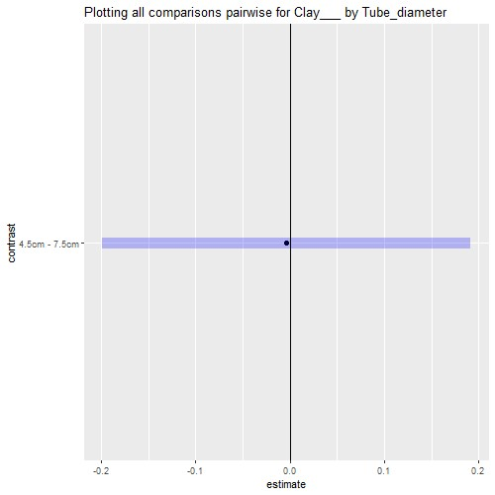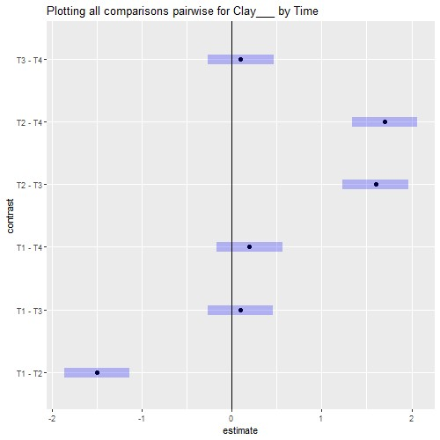

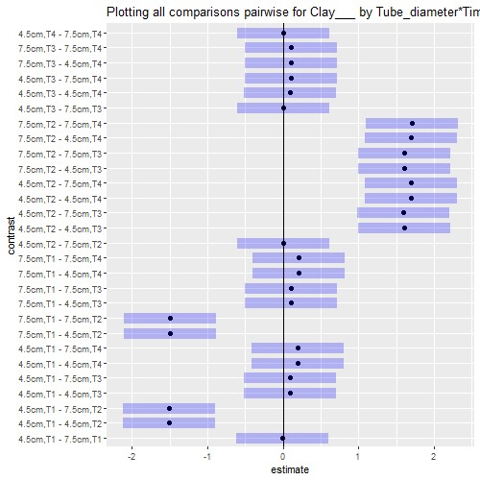

# Interaction plot with Confidence Intervals

