**Anova (1 Way and 2 Way)**

C:\Users\User\Documents\Marg I\Clean data D&R trials\Restoration plots.xlsx

# `summarise()` ungrouping output (override with `.groups` argument)

***Summaries for X_Epiphytes by factor variable PVC_Tube***

|  |  |  |  |  |  |  |
| --- | --- | --- | --- | --- | --- | --- |
| **PVC_Tube** | **n** | **mean** | **median** | **min** | **max** | **sd** |
| 4.5cm | 48 | 7.2083 | 0 | 0 | 35 | 10.2976 |
| 7.5cm | 48 | 5.0833 | 0 | 0 | 25 | 7.5761 |

**variance**

106.0408

57.3972

# `summarise()` ungrouping output (override with `.groups` argument)

***Summaries for X_Epiphytes by factor variable Time***

|  |  |  |  |  |  |  |
| --- | --- | --- | --- | --- | --- | --- |
| **Time** | **n** | **mean** | **median** | **min** | **max** | **sd** |
| T1 | 24 | 0 | 0 | 0 | 0 | 0 |
| T2 | 24 | 0 | 0 | 0 | 0 | 0 |
| T3 | 24 | 7.5833 | 8 | 0 | 15 | 4.1275 |
| T4 | 24 | 17 | 15 | 0 | 35 | 10.8508 |

**variance**

0

0

17.0362

117.7391

# `summarise()` regrouping output by 'PVC_Tube' (override with `.groups` argument)

***Summaries for X_Epiphytes by factor variables PVC_Tube*Time***

|  |  |  |  |  |  |  |  |  |
| --- | --- | --- | --- | --- | --- | --- | --- | --- |
| **PVC_Tube** | | **Time** | | **n** | **mean** | **median** | **min** | **max** |
| 4.5cm | | T1 | | 12 | 0 | 0 | 0 | 0 |
| 4.5cm | | T2 | | 12 | 0 | 0 | 0 | 0 |
| 4.5cm | | T3 | | 12 | 8.5833 | 8 | 0 | 15 |
| 4.5cm | | T4 | | 12 | 20.25 | 22.5 | 0 | 35 |
| 7.5cm | | T1 | | 12 | 0 | 0 | 0 | 0 |
| 7.5cm | | T2 | | 12 | 0 | 0 | 0 | 0 |
| 7.5cm | | T3 | | 12 | 6.5833 | 7.5 | 0 | 12 |
| 7.5cm | | T4 | | 12 | 13.75 | 15 | 0 | 25 |
| **sd** | **Variance** | |
| 0 | 0 | |
| 0 | 0 | |
| 3.3699 | 11.3561 | |
| 11.8638 | 140.75 | |
| 0 | 0 | |
| 0 | 0 | |
| 4.6993 | 22.0833 | |
| 9.0767 | 82.3864 | |

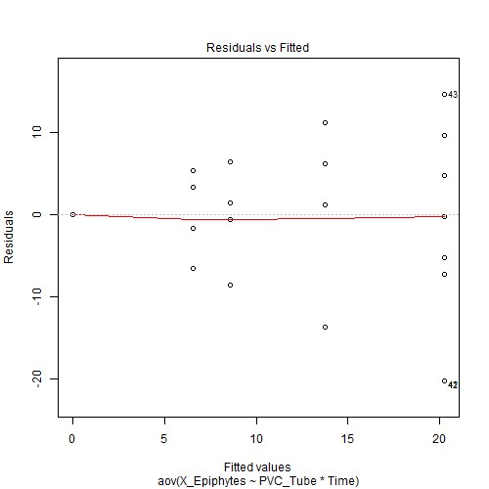

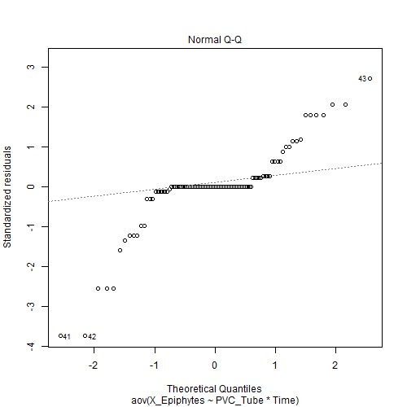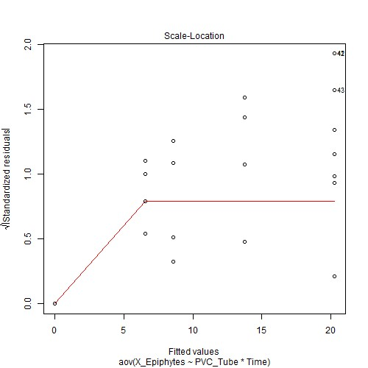

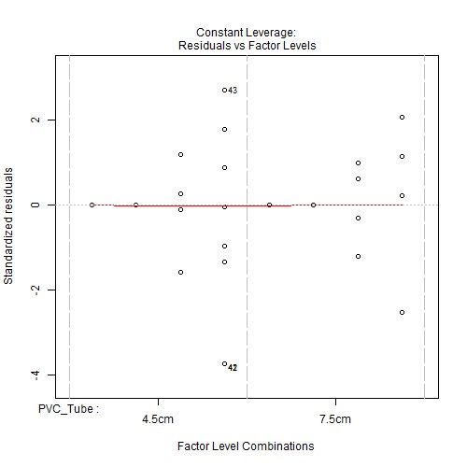

***Anova table with type III sum of squares for X_Epiphytes by PVC_Tube*Time***

|  |  |  |  |  |  |
| --- | --- | --- | --- | --- | --- |
|  | **Df** | **Sum Sq** | **Mean Sq** | **F value** | **Pr(>F)** |
| **PVC_Tube** | 1 | 108.375 | 108.375 | 3.3791 | 0.0694 . |
| **Time** | 3 | 4690.125 | 1563.375 | 48.7458 | <.001*** |
| **PVC_Tube:T ime** | 3 | 169.125 | 56.375 | 1.7578 | 0.1611 |
| **Residuals** | 88 | 2822.333 | 32.072 | NA | NA |

*Note.* Signif. codes: 0 '***' 0.001 '**' 0.01 '*' 0.05 '.' 0.1 ' ' 1

# NOTE: Results may be misleading due to involvement in interactions

***Estimated Marginal Means for X_Epiphytes by PVC_Tube***

|  |  |  |  |  |  |
| --- | --- | --- | --- | --- | --- |
| **PVC_Tube** | **emmean** | **SE** | **df** | **lower.CL** | **upper.CL** |
| 4.5cm | 7.2083 | 0.8174 | 88 | 5.5839 | 8.8328 |
| 7.5cm | 5.0833 | 0.8174 | 88 | 3.4589 | 6.7078 |

# NOTE: Results may be misleading due to involvement in interactions

***Estimated Marginal Means for X_Epiphytes by Time***

|  |  |  |  |  |  |
| --- | --- | --- | --- | --- | --- |
| **Time** | **emmean** | **SE** | **df** | **lower.CL** | **upper.CL** |
| T1 | -0.0000 | 1.156 | 88 | -2.2973 | 2.2973 |
| T2 | 0.0000 | 1.156 | 88 | -2.2973 | 2.2973 |
| T3 | 7.5833 | 1.156 | 88 | 5.286 | 9.8806 |
| T4 | 17 | 1.156 | 88 | 14.7027 | 19.2973 |

***Estimated Marginal Means for X_Epiphytes by PVC_Tube*Time***

|  |  |  |  |  |  |  |
| --- | --- | --- | --- | --- | --- | --- |
| **PVC_Tube** | **Time** | **emmean** | **SE** | **df** | **lower.CL** | **upper.CL** |
| 4.5cm | T1 | -0.0000 | 1.6348 | 88 | -3.2489 | 3.2489 |
| 7.5cm | T1 | -0.0000 | 1.6348 | 88 | -3.2489 | 3.2489 |
| 4.5cm | T2 | 0.0000 | 1.6348 | 88 | -3.2489 | 3.2489 |
| 7.5cm | T2 | 0.0000 | 1.6348 | 88 | -3.2489 | 3.2489 |
| 4.5cm | T3 | 8.5833 | 1.6348 | 88 | 5.3345 | 11.8322 |
| 7.5cm | T3 | 6.5833 | 1.6348 | 88 | 3.3345 | 9.8322 |
| 4.5cm | T4 | 20.25 | 1.6348 | 88 | 17.0011 | 23.4989 |
| 7.5cm | T4 | 13.75 | 1.6348 | 88 | 10.5011 | 16.9989 |

***Levene's test for homogenity of variances (center=mean) for X_Epiphytes against PVC_Tube***

|  |  |  |  |
| --- | --- | --- | --- |
|  | **Df** | **F value** | **Pr(>F)** |
| **group** | 1 | 1.3262 | 0.2524 |
|  | 94 | NA | NA |

*Note.* Signif. codes: 0 '***' 0.001 '**' 0.01 '*' 0.05 '.' 0.1 ' ' 1

***Levene's test for homogenity of variances (center=mean) for X_Epiphytes against Time***

|  |  |  |  |
| --- | --- | --- | --- |
|  | **Df** | **F value** | **Pr(>F)** |
| **group** | 3 | 27.0906 | <.001*** |
|  | 92 | NA | NA |

*Note.* Signif. codes: 0 '***' 0.001 '**' 0.01 '*' 0.05 '.' 0.1 ' ' 1

# Results are averaged over the levels of: Time

***Post-hoc tests for X_Epiphytes by PVC_Tube (using method = pairwise)***

|  |  |  |  |  |
| --- | --- | --- | --- | --- |
| **contrast** | **estimate SE** | **df** | **t.ratio** | **p.value** |
| 4.5cm -  7.5cm | 2.125 1.156 | 88 | 1.8382 | 0.0694 . |
| *Note.* Signif. codes: 0 '***' 0.001 '**' 0.01 '*' 0.05 '.' 0.1 ' ' 1  Results are averaged over the levels of: PVC_Tube  P value adjustment: tukey method for comparing a family of 4 estimates  ***Post-hoc tests for X_Epiphytes by Time (using method = pairwise)*** | | | |  |
| **contrast estimate SE df t.ratio** | | | | **p.value** |

T1 - T2 -0.0000 1.6348 88 -0.0000 1

T1 - T3 -7.5833 1.6348 88 -4.6386 <.001*** T1 - T4 -17 1.6348 88 -10.399 <.001***

|  |  |  |  |  |  |  |  |  |  |  |  |  |  |
| --- | --- | --- | --- | --- | --- | --- | --- | --- | --- | --- | --- | --- | --- |
| **contrast** | | | **estimate** | | **SE** | | | **df** | | **t.ratio** | | **p.value** | |
| T2 - T3 | | | -7.5833 | | 1.6348 | | | 88 | | -4.6386 | | <.001*** | |
| T2 - T4 | | | -17 | | 1.6348 | | | 88 | | -10.399 | | <.001*** | |
| T3 - T4 | | | -9.4167 | | 1.6348 | | | 88 | | -5.76 | | <.001*** | |
| *Note.* Signif. codes: 0 '***' 0.001 '**' 0.01 '*' 0.05 '.' 0.1 ' ' 1  P value adjustment: tukey method for comparing a fam ***Simple effects for X_Epiphytes by PVC_Tube*Time (using*** | | | | | | | | ily of 8 est ***method = pairwise)*** | | imates | |  | |
| **contrast estimate SE df t.ratio** | | | | | | | | | | | | **p.value** | |
| 4.5cm,T1 -  7.5cm,T1 | 0.0000 | | 2.312 | | | 88 | | 0.0000 | | 1 | |
| 4.5cm,T1 -  4.5cm,T2 | -0.0000 | | 2.312 | | | 88 | | -0.0000 | | 1 | |
| 4.5cm,T1 -  7.5cm,T2 | -0.0000 | | 2.312 | | | 88 | | -0.0000 | | 1 | |
| 4.5cm,T1 -  4.5cm,T3 | -8.5833 | | 2.312 | | | 88 | | -3.7125 | | 0.0083 ** | |
| 4.5cm,T1 -  7.5cm,T3 | -6.5833 | | 2.312 | | | 88 | | -2.8475 | | 0.0966 . | |
| 4.5cm,T1 -  4.5cm,T4 | -20.25 | | 2.312 | | | 88 | | -8.7587 | | <.001*** | |
| 4.5cm,T1 -  7.5cm,T4 | -13.75 | | 2.312 | | | 88 | | -5.9472 | | <.001*** | |
| 7.5cm,T1 -  4.5cm,T2 | -0.0000 | | 2.312 | | | 88 | | -0.0000 | | 1 | |
| 7.5cm,T1 -  7.5cm,T2 | -0.0000 | | 2.312 | | | 88 | | -0.0000 | | 1 | |
| 7.5cm,T1 -  4.5cm,T3 | -8.5833 | | 2.312 | | | 88 | | -3.7125 | | 0.0083 ** | |
| 7.5cm,T1 -  7.5cm,T3 | -6.5833 | | 2.312 | | | 88 | | -2.8475 | | 0.0966 . | |
| 7.5cm,T1 -  4.5cm,T4 | -20.25 | | 2.312 | | | 88 | | -8.7587 | | <.001*** | |
| 7.5cm,T1 -  7.5cm,T4 | -13.75 | | 2.312 | | | 88 | | -5.9472 | | <.001*** | |
| 4.5cm,T2 -  7.5cm,T2 | 0.0000 | | 2.312 | | | 88 | | 0.0000 | | 1 | |
| 4.5cm,T2 -  4.5cm,T3 | -8.5833 | | 2.312 | | | 88 | | -3.7125 | | 0.0083 ** | |
| 4.5cm,T2 -  7.5cm,T3 | -6.5833 | | 2.312 | | | 88 | | -2.8475 | | 0.0966 . | |
| 4.5cm,T2 -  4.5cm,T4 | -20.25 | | 2.312 | | | 88 | | -8.7587 | | <.001*** | |
| 4.5cm,T2 -  7.5cm,T4 | -13.75 | | 2.312 | | | 88 | | -5.9472 | | <.001*** | |
| 7.5cm,T2 -  4.5cm,T3 | -8.5833 | | 2.312 | | | 88 | | -3.7125 | | 0.0083 ** | |
| 7.5cm,T2 -  7.5cm,T3 | -6.5833 | | 2.312 | | | 88 | | -2.8475 | | 0.0966 . | |
| 7.5cm,T2 -  4.5cm,T4 | -20.25 | | 2.312 | | | 88 | | -8.7587 | | <.001*** | |
| 7.5cm,T2 -  7.5cm,T4 | -13.75 | | 2.312 | | | 88 | | -5.9472 | | <.001*** | |
| 4.5cm,T3 -  7.5cm,T3 | 2 | | 2.312 | | | 88 | | 0.8651 | | 0.9884 | |
| 4.5cm,T3 -  4.5cm,T4 | -11.667 | | 2.312 | | | 88 | | -5.0461 | | <.001*** | |
| 4.5cm,T3 -  7.5cm,T4 | -5.1667 | | 2.312 | | | 88 | | -2.2347 | | 0.3417 | |
| **contrast** | | | **estimate** | | | **SE** | | **df** | | **t.ratio** | | **p.value** | |
| 7.5cm,T3 -  4.5cm,T4 | | | -13.667 | | | 2.312 | | 88 | | -5.9112 | | <.001*** | |
| 7.5cm,T3 -  7.5cm,T4 | | | -7.1667 | | | 2.312 | | 88 | | -3.0998 | | 0.0507 . | |
| 4.5cm,T4 -  7.5cm,T4 | | | 6.5 | | | 2.312 | | 88 | | 2.8114 | | 0.1053 | |

*Note.* Signif. codes: 0 '***' 0.001 '**' 0.01 '*' 0.05 '.' 0.1 ' ' 1

***Comparing means compactly for X_Epiphytes by PVC_Tube using pairwise comparison (p values adjusted using tukey)***

|  |  |  |  |  |  |  |
| --- | --- | --- | --- | --- | --- | --- |
| **PVC_Tube** | **emmean** | **SE** | **df** | **lower.CL** | **upper.CL** | **.group** |
| 7.5cm | 5.0833 | 0.8174 | 88 | 5.0319 | 5.1347 | 1 |
| 4.5cm | 7.2083 | 0.8174 | 88 | 7.1569 | 7.2597 | 1 |

***Comparing means compactly for X_Epiphytes by Time using pairwise comparison (p values adjusted using tukey)***

|  |  |  |  |  |  |  |
| --- | --- | --- | --- | --- | --- | --- |
| **Time** | **emmean** | **SE** | **df** | **lower.CL** | **upper.CL** | **.group** |
| T1 | -0.0000 | 1.156 | 88 | -0.0727 | 0.0727 | 1 |
| T2 | 0.0000 | 1.156 | 88 | -0.0727 | 0.0727 | 1 |
| T3 | 7.5833 | 1.156 | 88 | 7.5106 | 7.656 | 2 |
| T4 | 17 | 1.156 | 88 | 16.9273 | 17.0727 | 3 |

***Comparing means compactly for X_Epiphytes by PVC_Tube*Time using pairwise comparison (p values adjusted using tukey)***

|  |  |  |  |  |  |  |
| --- | --- | --- | --- | --- | --- | --- |
| **PVC_Tube** | **Time** | **emmean** | **SE** | **df** | **lower.CL** | **upper.CL** |
| 7.5cm | T1 | -0.0000 | 1.6348 | 88 | -0.1028 | 0.1028 |
| 4.5cm | T1 | -0.0000 | 1.6348 | 88 | -0.1028 | 0.1028 |
| 7.5cm | T2 | 0.0000 | 1.6348 | 88 | -0.1028 | 0.1028 |
| 4.5cm | T2 | 0.0000 | 1.6348 | 88 | -0.1028 | 0.1028 |
| 7.5cm | T3 | 6.5833 | 1.6348 | 88 | 6.4805 | 6.6861 |
| 4.5cm | T3 | 8.5833 | 1.6348 | 88 | 8.4805 | 8.6861 |
| 7.5cm | T4 | 13.75 | 1.6348 | 88 | 13.6472 | 13.8528 |
| 4.5cm | T4 | 20.25 | 1.6348 | 88 | 20.1472 | 20.3528 |

**.group**

1

1

1

1

12

2

23

3

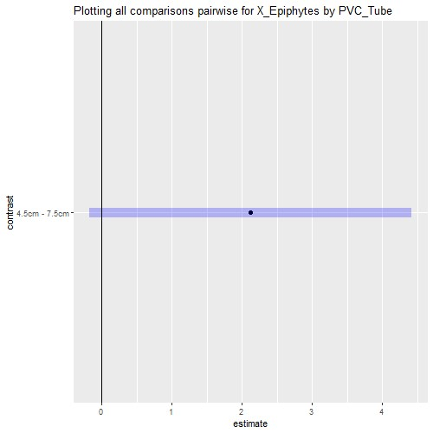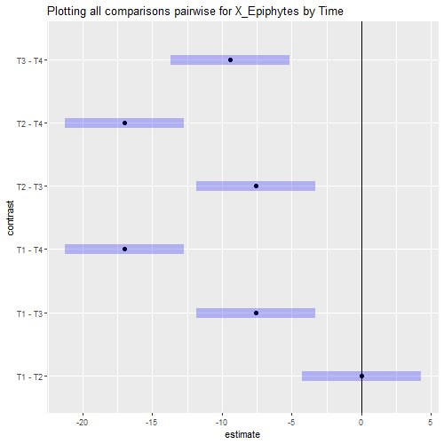

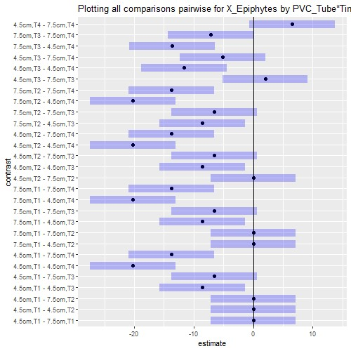

# Interaction plot with Confidence Intervals

