**Close Dataset**

**Open Dataset**

**Anova (1 Way and 2 Way)**

[Restoration.plots.xlsx.Surv.rate] - C:\Users\User\Documents\Marg I\Clean data D&R trials\Restoration plots.xlsx

|  |  |  |  |  |  |  |
| --- | --- | --- | --- | --- | --- | --- |
| **PVC** | **n** | **mean** | **median** | **min** | **max** | **sd**  **variance** |
| 4.5cm | 16 | 33.9062 | 27.5 | 0 | 88.75 | 30.8858 953.9323 |
| 7.5cm | 16 | 82.9688 | 83.125 | 66.25 | 96.25 | 8.9777 80.599 |

# `summarise()` ungrouping output (override with `.groups` argument)

***Summaries for Survival_rate____ by factor variable PVC***

# `

Summarise()` ungrouping output (override with `.groups` argument)

***Summaries for Survival_rate____ by factor variable Time***

|  |  |  |  |  |  |  |
| --- | --- | --- | --- | --- | --- | --- |
| **Time** | **n** | **mean** | **median** | **min** | **max** | **sd** |
| T1 | 8 | 85.3125 | 86.25 | 72.5 | 96.25 | 8.1216 |
| T2 | 8 | 57.9688 | 63.125 | 0 | 96.25 | 33.6801 |
| T3 | 8 | 49.0625 | 53.125 | 0 | 88.75 | 33.8177 |
| T4 | 8 | 41.4062 | 39.375 | 0 | 88.75 | 36.963 |

**variance** 65.9598

1134.347

1143.638

1366.267

# `summarise()` regrouping output by 'PVC' (override with `.groups` argument)

***Summaries for Survival_rate____ by factor variables PVC*Time***

|  |  |  |  |  |  |  |
| --- | --- | --- | --- | --- | --- | --- |
| **PVC** | **Time** | **n** | **mean** | **median** | **min** | **max** |
| 4.5cm | T1 | 4 | 80 | 79.375 | 72.5 | 88.75 |
| 4.5cm | T2 | 4 | 29.375 | 35.625 | 0 | 46.25 |
| 4.5cm | T3 | 4 | 18.75 | 21.875 | 0 | 31.25 |
| 4.5cm | T4 | 4 | 7.5 | 8.75 | 0 | 12.5 |
| 7.5cm | T1 | 4 | 90.625 | 91.25 | 83.75 | 96.25 |
| 7.5cm | T2 | 4 | 86.5625 | 85 | 80 | 96.25 |
| 7.5cm | T3 | 4 | 79.375 | 76.875 | 75 | 88.75 |
| 7.5cm | T4 | 4 | 75.3125 | 73.125 | 66.25 | 88.75 |

|  |  |
| --- | --- |
| **Sd** | **variance** |
| 7.1443 | 51.0417 |
| 20.3741 | 415.1042 |
| 13.3463 | 178.125 |
| 5.4006 | 29.1667 |
| 5.254 | 27.6042 |
| 7.1716 | 51.4323 |
| 6.3328 | 40.1042 |
| 9.6488 | 93.099 |

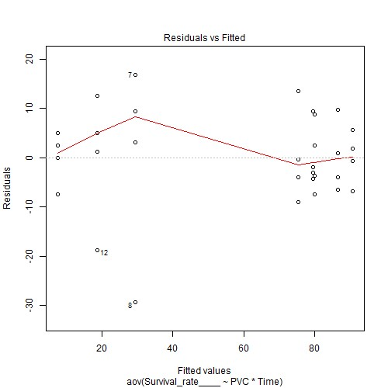

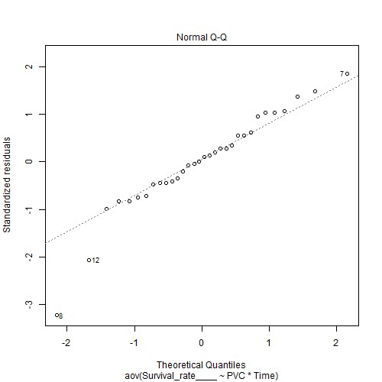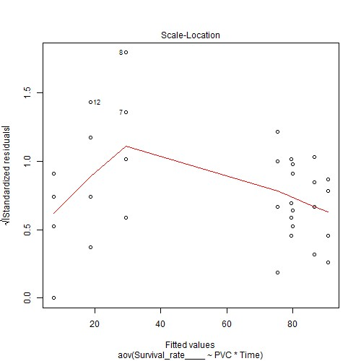

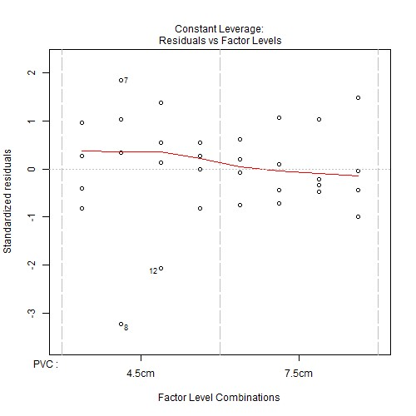

***Anova table with type III sum of squares for Survival_rate____ by PVC*Time***

|  |  |  |  |  |  |
| --- | --- | --- | --- | --- | --- |
|  | **Df** | **Sum Sq** | **Mean Sq** | **F value** | **Pr(>F)** |
| **PVC** | 1 | 19257.03 | 19257.03 | 173.9418 | <.001*** |
| **Time** | 3 | 8803.516 | 2934.505 | 26.5063 | <.001*** |
| **PVC:Time** | 3 | 4057.422 | 1352.474 | 12.2164 | <.001*** |
| **Residuals** | 24 | 2657.031 | 110.7096 | NA | NA |

*Note.* Signif. codes: 0 '***' 0.001 '**' 0.01 '*' 0.05 '.' 0.1 ' ' 1

# NOTE: Results may be misleading due to involvement in interactions

***Estimated Marginal Means for Survival_rate____ by PVC***

|  |  |  |  |  |  |
| --- | --- | --- | --- | --- | --- |
| **PVC** | **emmean** | **SE** | **df** | **lower.CL** | **upper.CL** |
| 4.5cm | 33.9062 | 2.6305 | 24 | 28.4772 | 39.3353 |
| 7.5cm | 82.9688 | 2.6305 | 24 | 77.5397 | 88.3978 |

# NOTE: Results may be misleading due to involvement in interactions

***Estimated Marginal Means for Survival_rate____ by Time***

|  |  |  |  |  |  |
| --- | --- | --- | --- | --- | --- |
| **Time** | **emmean** | **SE** | **df** | **lower.CL** | **upper.CL** |
| T1 | 85.3125 | 3.72 | 24 | 77.6347 | 92.9903 |
| T2 | 57.9688 | 3.72 | 24 | 50.291 | 65.6465 |
| T3 | 49.0625 | 3.72 | 24 | 41.3847 | 56.7403 |
| T4 | 41.4062 | 3.72 | 24 | 33.7285 | 49.084 |

***Estimated Marginal Means for Survival_rate____ by PVC*Time***

|  |  |  |  |  |  |  |
| --- | --- | --- | --- | --- | --- | --- |
| **PVC** | **Time** | **Emmean** | **SE** | **df** | **lower.CL** | **upper.CL** |
| 4.5cm | T1 | 80 | 5.2609 | 24 | 69.142 | 90.858 |
| 7.5cm | T1 | 90.625 | 5.2609 | 24 | 79.767 | 101.483 |
| 4.5cm | T2 | 29.375 | 5.2609 | 24 | 18.517 | 40.233 |
| 7.5cm | T2 | 86.5625 | 5.2609 | 24 | 75.7045 | 97.4205 |
| 4.5cm | T3 | 18.75 | 5.2609 | 24 | 7.892 | 29.608 |
| 7.5cm | T3 | 79.375 | 5.2609 | 24 | 68.517 | 90.233 |
| 4.5cm | T4 | 7.5 | 5.2609 | 24 | -3.358 | 18.358 |
| 7.5cm | T4 | 75.3125 | 5.2609 | 24 | 64.4545 | 86.1705 |

***Levene's test for homogenity of variances (center=mean) for Survival_rate____ against PVC***

|  |  |  |  |
| --- | --- | --- | --- |
|  | **Df** | **F value** | **Pr(>F)** |
| **group** | 1 | 12.8359 | 0.0012 ** |
|  | 30 | NA | NA |

*Note.* Signif. codes: 0 '***' 0.001 '**' 0.01 '*' 0.05 '.' 0.1 ' ' 1

***Levene's test for homogenity of variances (center=mean) for Survival_rate____ against Time***

|  |  |  |  |
| --- | --- | --- | --- |
|  | **Df** | **F value** | **Pr(>F)** |
| **group** | 3 | 11.758 | <.001*** |
|  | 28 | NA | NA |

*Note.* Signif. codes: 0 '***' 0.001 '**' 0.01 '*' 0.05 '.' 0.1 ' ' 1

# Results are averaged over the levels of: Time

***Post-hoc tests for Survival_rate____ by PVC (using method = pairwise)***

|  |  |  |  |
| --- | --- | --- | --- |
| **contrast** | **estimate SE** | **df t.ratio** | **p.value** |
| 4.5cm -  7.5cm | -49.0625 3.72 | 24 -13.1887 | <.001*** |
| *Note.* Signif. codes: 0 '***' 0.001 '**' 0.01 '*' 0.05 '.' 0.1 ' ' 1  Results are averaged over the levels of: PVC  P value adjustment: tukey method for comparing a fam ***Post-hoc tests for Survival_rate____ by Time (using method =*** | | ily of 4 estimates  ***pairwise)*** |  |
| **contrast estimate SE df t.ratio** | | | **p.value** |

## T1 - T2 27.3438 5.2609 24 5.1975 <.001***

T1 - T3 36.25 5.2609 24 6.8904 <.001*** T1 - T4 43.9062 5.2609 24 8.3457 <.001***

|  |  |  |  |  |  |  |  |  |  |  |  |  |  |  |
| --- | --- | --- | --- | --- | --- | --- | --- | --- | --- | --- | --- | --- | --- | --- |
| **contrast** | | | **estimate** | | **SE** | | **df** | | | **t.ratio** | | | **p.value** | |
| T2 - T3 | | | 8.9062 | | 5.2609 | | 24 | | | 1.6929 | | | 0.3491 | |
| T2 - T4 | | | 16.5625 | | 5.2609 | | 24 | | | 3.1482 | | | 0.0211 * | |
| T3 - T4 | | | 7.6562 | | 5.2609 | | 24 | | | 1.4553 | | | 0.4789 | |
| *Note.* Signif. codes: 0 '***' 0.001 '**' 0.01 '*' 0.05 '.' 0.1 ' ' 1  P value adjustment: tukey method for comparing a fam  ***Simple effects for Survival_rate____ by PVC*Time (using method*** | | | | | | | ily of 8 est  ***= pairwise)*** | | | imates | | |  | |
| **contrast estimate SE df t.ratio** | | | | | | | | | | | | | **p.value** | |
| 4.5cm,T1 -  7.5cm,T1 | -10.625 | | 7.4401 | | 24 | | -1.4281 | | | 0.8356 | | |
| 4.5cm,T1 -  4.5cm,T2 | 50.625 | | 7.4401 | | 24 | | 6.8044 | | | <.001*** | | |
| 4.5cm,T1 -  7.5cm,T2 | -6.5625 | | 7.4401 | | 24 | | -0.882 | | | 0.9850 | | |
| 4.5cm,T1 -  4.5cm,T3 | 61.25 | | 7.4401 | | 24 | | 8.2324 | | | <.001*** | | |
| 4.5cm,T1 -  7.5cm,T3 | 0.625 | | 7.4401 | | 24 | | 0.084 | | | 1 | | |
| 4.5cm,T1 -  4.5cm,T4 | 72.5 | | 7.4401 | | 24 | | 9.7445 | | | <.001*** | | |
| 4.5cm,T1 -  7.5cm,T4 | 4.6875 | | 7.4401 | | 24 | | 0.63 | | | 0.9980 | | |
| 7.5cm,T1 -  4.5cm,T2 | 61.25 | | 7.4401 | | 24 | | 8.2324 | | | <.001*** | | |
| 7.5cm,T1 -  7.5cm,T2 | 4.0625 | | 7.4401 | | 24 | | 0.546 | | | 0.9992 | | |
| 7.5cm,T1 -  4.5cm,T3 | 71.875 | | 7.4401 | | 24 | | 9.6605 | | | <.001*** | | |
| 7.5cm,T1 -  7.5cm,T3 | 11.25 | | 7.4401 | | 24 | | 1.5121 | | | 0.7938 | | |
| 7.5cm,T1 -  4.5cm,T4 | 83.125 | | 7.4401 | | 24 | | 11.1726 | | | <.001*** | | |
| 7.5cm,T1 -  7.5cm,T4 | 15.3125 | | 7.4401 | | 24 | | 2.0581 | | | 0.4672 | | |
| 4.5cm,T2 -  7.5cm,T2 | -57.1875 | | 7.4401 | | 24 | | -7.6864 | | | <.001*** | | |
| 4.5cm,T2 -  4.5cm,T3 | 10.625 | | 7.4401 | | 24 | | 1.4281 | | | 0.8356 | | |
| 4.5cm,T2 -  7.5cm,T3 | -50 | | 7.4401 | | 24 | | -6.7204 | | | <.001*** | | |
| 4.5cm,T2 -  4.5cm,T4 | 21.875 | | 7.4401 | | 24 | | 2.9402 | | | 0.1080 | | |
| 4.5cm,T2 -  7.5cm,T4 | -45.9375 | | 7.4401 | | 24 | | -6.1743 | | | <.001*** | | |
| 7.5cm,T2 -  4.5cm,T3 | 67.8125 | | 7.4401 | | 24 | | 9.1145 | | | <.001*** | | |
| 7.5cm,T2 -  7.5cm,T3 | 7.1875 | | 7.4401 | | 24 | | 0.9661 | | | 0.9751 | | |
| 7.5cm,T2 -  4.5cm,T4 | 79.0625 | | 7.4401 | | 24 | | 10.6266 | | | <.001*** | | |
| 7.5cm,T2 -  7.5cm,T4 | 11.25 | | 7.4401 | | 24 | | 1.5121 | | | 0.7938 | | |
| 4.5cm,T3 -  7.5cm,T3 | -60.625 | | 7.4401 | | 24 | | -8.1484 | | | <.001*** | | |
| 4.5cm,T3 -  4.5cm,T4 | 11.25 | | 7.4401 | | 24 | | 1.5121 | | | 0.7938 | | |
| 4.5cm,T3 -  7.5cm,T4 | -56.5625 | | 7.4401 | | 24 | | -7.6024 | | | <.001*** | | |
| **contrast** | | | **estimate** | | **SE** | | **df** | | **t.ratio** | | | **p.value** | | |
| 7.5cm,T3 -  4.5cm,T4 | | | 71.875 | | 7.4401 | | 24 | | 9.6605 | | | <.001*** | | |
| 7.5cm,T3 -  7.5cm,T4 | | | 4.0625 | | 7.4401 | | 24 | | 0.546 | | | 0.9992 | | |
| 4.5cm,T4 -  7.5cm,T4 | | | -67.8125 | | 7.4401 | | 24 | | -9.1145 | | | <.001*** | | |

*Note.* Signif. codes: 0 '***' 0.001 '**' 0.01 '*' 0.05 '.' 0.1 ' ' 1

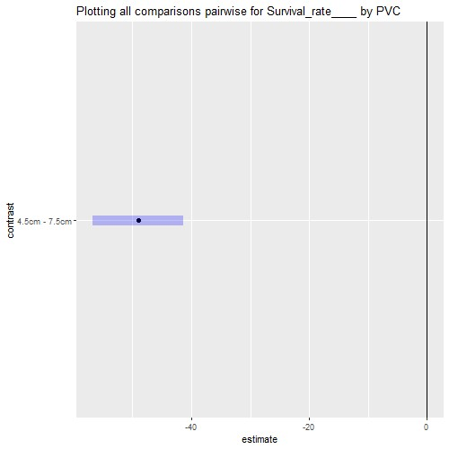

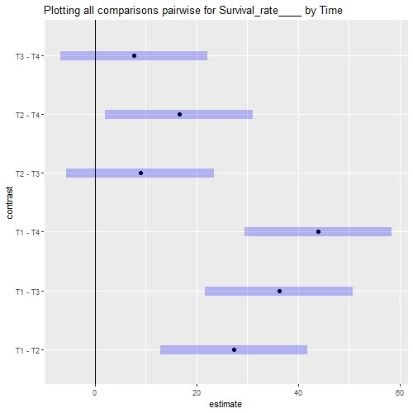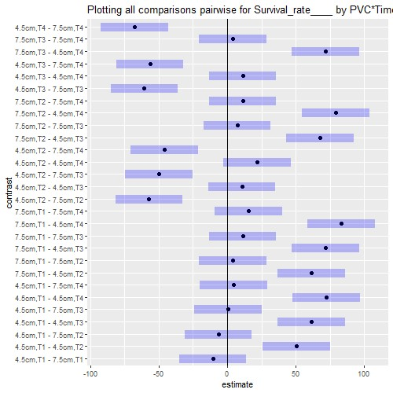

# Interaction plot with Confidence Intervals

