Matlab Simulation of Cameras Tracking Volume
Program to calculate the approximate tracking volume obtained by a tracking system camera setup. Current values are valid for Flex13 Optitrack tracking system (8 cameras).
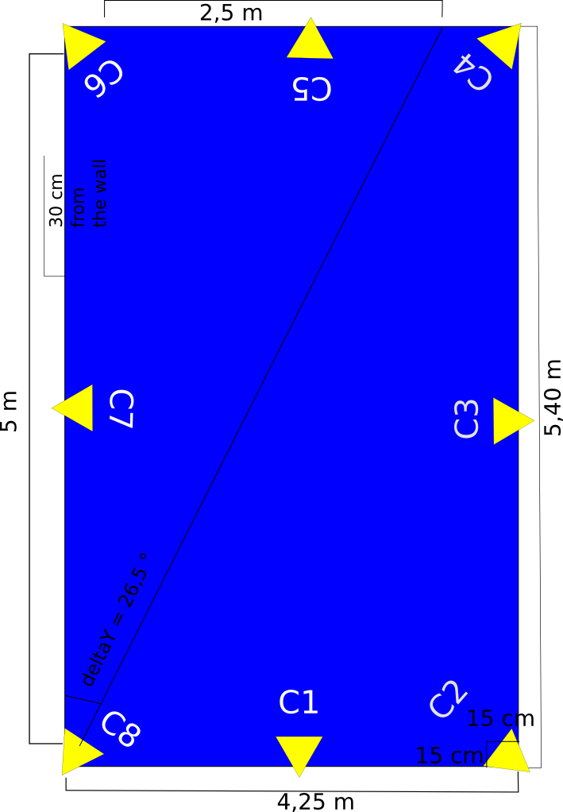

C1 to C8 are all the cameras present in the drone arena. Alfa is the pointing angle of the camera located in the corners. Distance from C2-C8 that we call in the software L1 is 4.25 m. While distance C2- C4, L2 = 5.40 m.
Any camera is defined with the following parameters:
- Field Of View - defined as an horizontal and vertical angle
- Camera Range - the maximum distance at the camera can track
- Pose - position of the center and orientation of the camera
Matrix for 8 cameras:

Tracking Volume is defined as the global origin and the size of the volume to be tarcked:

The basic idea behind this software is to check in the whole volume for every voxel in the space if it is visible for at least min_cameras_point = 3 cameras. Every voxel is a 3D point p_w = (xp,yp,zp). In the function camera_point_visible_bool( camera, p_w ) the point is transformed from world coordinates to camera coordinates. Then it checks if tangent in the horizontal and vertical axes is within the maximum accepted to be visible from the camera.
The size of the Voxel is set as voxel_size=2^(Vox_Size-1)*[1 1 1] .

