BB1
Technical Notes
J&K Ross
Automatic Print Documents - Workflow Action Script (Gap 9)
Author: Jared Espineli | Date: 22 September 2026
Status: Initial technical notes, first pass. Scope is the WorkflowActionScript component only (bb1_jkr_prnt_doc_wfa.js). The SuiteFlow workflows that call this action, and any custom records they depend on, are being built by another developer and are out of scope of this document - see Section 2.7 and Section 4.

1. Overview

1.1 Introduction
J&K Ross needs NetSuite to print warehouse documents - pick tickets, pick notes, labels - automatically, without a user manually opening and printing a PDF. Gap 9 of the functional design proposes a single, reusable NetSuite SuiteFlow Workflow Action Script that acts as a configurable print engine: NetSuite workflows decide when a document should print, and the action script renders and delivers it to a warehouse printer via the existing BB1 QZ Tray library. This document covers only the piece of that design actually assigned to and built by this developer - the action script itself, bb1_jkr_prnt_doc_wfa.js. The SuiteFlow workflows that will call it (one per triggering scenario in the functional design's conditions matrix, for example a Work Order/Build being saved with its finished goods committed to an open Sales Order) are being configured separately by another developer, and any custom records those workflows may need are theirs to build, not this script's.

1.2 BRS / Specification
Two PDF documents were provided directly by the user for this project, with no Confluence or Drive link supplied:
- Gap 9: Automatic Print Documents - business requirement and gap definition, including the August 2026 expansion notes on picking-slip and inventory commitment scenarios (file: P102821-Gap 9_ Automatic Print Documents-170926-100913.pdf).
- Functional Design: Gap 9 - architecture, action script parameters, the workflow triggers and conditions matrix, and the proposed Printer custom record (file: P102821-Functional Design_ Gap 9-180926-102113.pdf).

1.3 Development Environment
Production Account: 11643893

1.4 Business Requirements

1.4.1 Summary
Warehouse staff at J&K Ross currently rely on someone remembering to print a pick ticket, pick note or label at the right moment in the fulfilment or production process, which is repetitive and occasionally missed. The business wants NetSuite to do this automatically: the moment a qualifying event happens - an order being released, stock being committed, a build being completed - the correct document should print to the correct warehouse printer with no one clicking Print. This customisation delivers the reusable engine that renders a document and hands it to a printer once it is told to; deciding exactly when to fire, for which record, and at which printer remains the job of the NetSuite workflows built around it, so the same engine can support every scenario in the functional design without being rewritten for each one.

1.4.2 Print Execution Engine
The Workflow Action Script is the component that actually produces a printed document. When a NetSuite workflow calls it after a record is saved, the script identifies the record that triggered it, works out which printed form to render for that record, and hands the resulting document off to the existing BB1 QZ Tray library so it can be delivered to a physical warehouse printer without anyone opening the record or clicking Print. Because the script does not contain any logic about when to fire, it can sit behind any of the workflows in the functional design's trigger matrix without being customer- or scenario-specific.

1.4.3 Delivery via the Existing QZ Tray Library
Rather than talking to the warehouse printer directly, the action script queues the print request with BB1's existing QZ Tray library (already built and maintained separately) and redirects the user's browser back to the record. That library is responsible for picking the job up from its queue and delivering it to the physical printer through the QZ Tray application installed on the warehouse computer. This means the print engine did not need to reinvent the browser-to-printer bridge that the functional design's architecture called for - it reuses a mechanism that already exists.

1.4.4 Configurability - Current State
The functional design asks for the engine to be configurable by document type, printer and quantity so it can be reused across every scenario in the trigger matrix, not just one. In its current, first-pass form the script only supports choosing which printed form to render, via a single script parameter set once on the deployment; it does not yet accept a separate document type, a specific target printer, or a print quantity per trigger. This is flagged as an open item in Section 4 rather than treated as finished, since closing that gap is what will let one script instance serve more than one of the workflows being built around it.

2. Components

2.1 Custom Records
None created as part of this deliverable. The Functional Design specifies a Printer custom record (fields _bb1_prn_name, _bb1_prn_ip_address) to hold warehouse printer details; it is not present in this SDF project and is not yet referenced by the script. See Section 2.7 for how it fits the wider design and Section 4, item 2, for its open ownership question.

2.2 Custom Fields
None created as part of this deliverable.

2.3 Custom Lists
None created as part of this deliverable.

2.4 Scripts
File cabinet path: src/FileCabinet/SuiteScripts/[JKR] Print Document/
File Name | Type | Function | Deployed To
bb1_​jkr_​prnt_​doc_​wfa.​js | wfa | Reads the triggering record's type and id from the workflow context, resolves a redirect URL back to that record, reads the configured print form number from a script parameter, builds a print job payload, and queues it with the existing BB1 QZ Tray library before redirecting the browser back to the record so the library can complete delivery. | SuiteFlow Workflow Action step - workflow(s) configured separately by another developer (see Section 2.7).

bb1_jkr_prnt_doc_wfa.js - Script Parameters
Field Name | Field Internal ID | Type | Description
Print Form Number | custscript_​bb1_​jkr_​auto_​print_​cust_​form | Integer/List | Internal ID / number of the custom transaction form the script renders as the printed PDF. Currently a single value per script deployment - not yet a per-trigger Document Type, Printer or Quantity parameter as called for by the Functional Design (see Section 4, item 1).

2.5 Other Files / External Dependencies
File Name | Function
/SuiteApps/com.​bluebridgeonecouk.​qztray/bb1_​qz_​lib_​public | Existing BB1 QZ Tray integration library (built and maintained separately by Wayne Wundram), loaded as a module dependency. Exposes AddJobToQueue() to queue a print job and InitiateProcessJobQueue() to process the queue and redirect the browser back to the source record, which is how the browser-to-QZ-Tray handoff described in the Functional Design's Open Points is actually resolved today. Its internals sit outside this SDF project.

2.6 Dependency Diagram
This component has no data model of its own - it is a single script and its dependencies. The diagram below shows the triggering record handing off to the action script, the script handing a print job to the existing BB1 QZ Tray library, and the Printer custom record from the Functional Design shown dashed, since it is specified but not yet built or referenced by this script.
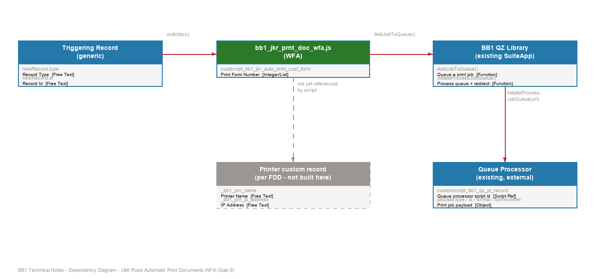

2.7 Additional Components (Dependencies, Not Built Here)

SuiteFlow Workflows - built separately
Per the Functional Design's trigger matrix, the following NetSuite workflows are expected to call this action script once built. None of them are part of this deliverable; they are listed here so the script's parameters and behaviour can be reviewed against every scenario it needs to serve, not just the first one.
Transaction & Trigger | Trigger Type | Condition Summary | Output
Sales Order / Released | After Submit | Order status is an open fulfilment state and at least one line has Quantity Committed > 0. | Sales Order Pick Ticket
Work Order-Build / Build saved | After Submit | Build is saved and the finished goods commit to an open Sales Order. | Sales Order Pick Note
Project Order / Created | After Submit | New Project Order created; a saved search prints the picking list for all its Work Orders. | Picking Ticket
Project Order / Event | Custom Button | Triggered per Gap 2 rules (creation or release of the Project Order). | Manufacturing Picking Ticket / Manufacturing Document
Item Fulfillment / Packed | After Submit | Fulfilment status changes to Picked and delivery method requires internal fleet labels. | Address Labels (qty = Number of Boxes field)

Printer Custom Record - per Functional Design
The Functional Design specifies a custom record to hold each warehouse printer's name and IP address (fields _bb1_prn_name, _bb1_prn_ip_address). It is not present in this SDF project, and the current script does not read from it - the printer a job is delivered to is resolved entirely inside the existing BB1 QZ Tray library. Ownership of this record should be confirmed with whoever is building the workflows (see Section 4, item 2).

2.8 Process Flow
The flow below traces what bb1_jkr_prnt_doc_wfa.js actually does today, from the point a (separately built) workflow calls it through to the existing QZ Tray library delivering the document to a printer.
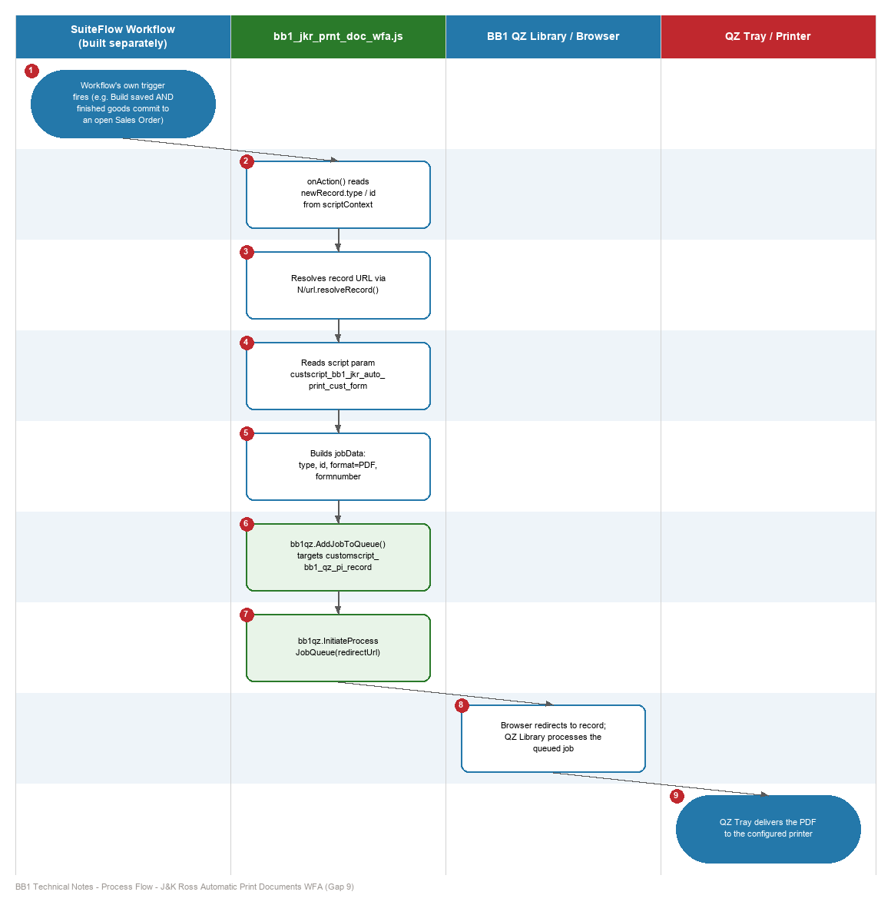

3. Testing & Setup

3.1 Steps to Test / Replicate
Since the production trigger workflows are being built separately and were not available at the time of writing, testing this script in isolation requires a temporary test workflow - see step 2.
- Confirm the BB1 QZ Tray SuiteApp (com.bluebridgeonecouk.qztray) is installed in the target account, and that QZ Tray is installed and running on the test machine with a printer registered and the browser's QZ Tray certificate/connection approved.
- Build a temporary SuiteFlow workflow on a test record type with an After Submit action calling bb1_jkr_prnt_doc_wfa.js, purely to exercise the script until the real trigger workflow(s) are delivered.
- Set the custscript_bb1_jkr_auto_print_cust_form parameter to a valid custom transaction form internal ID that exists on the target record type.
- Save/trigger the test record and confirm, from the script's existing log.debug statements, that Record Type, Record Id, Redirect Url and Form Number are all captured correctly.
- Confirm the browser redirects back to the record and the queued job - customscript_bb1_qz_pi_record, per the payload the script builds - is picked up by the BB1 QZ Tray library and the document reaches the configured printer.
- Repeat with an invalid or blank form number parameter and confirm the resulting behaviour; the script currently has no validation for this case (see Section 4, item 3).
- Remove the temporary test workflow once the real trigger workflow(s) are delivered, to avoid the same event printing twice.

3.2 Custom Record Setup
Not applicable to this deliverable - no custom records were created. If the Printer custom record from the Functional Design (Section 2.7) is required, its setup steps belong to whoever builds it.

4. Open Items / Gaps vs Functional Design
This is an initial pass at the technical notes, written against the script as it stands today rather than the full end state described in the Functional Design. The items below are the known gaps and open questions, so they are visible before the dependent workflows are built on top of this script.
# | Item | Category | Notes
1 | Document Type, Printer and Quantity are not yet separate parameters | Gap vs Design | The Functional Design calls for the engine to be configured by Document Type, Printer and Quantity per trigger. Today there is only one script parameter (print form number), fixed per deployment, so one script instance cannot yet serve more than one document type/printer/quantity combination.
2 | Printer custom record ownership is unconfirmed | Decision Needed | Specified in the Functional Design (_​bb1_​prn_​name, _​bb1_​prn_​ip_​address) but not present in this SDF project and not referenced by the script. Confirm with the developer building the workflows whether it is needed and who owns it.
3 | No validation on the form number parameter | Gap vs Design | onAction() reads custscript_​bb1_​jkr_​auto_​print_​cust_​form and uses it directly with no check for missing or invalid values before queuing the print job.
4 | Script does not branch by document type | Gap vs Design | newRecord.​type/id are read generically, but the script does not vary its behaviour by which of the five trigger-matrix scenarios called it, so every trigger currently renders the same hardcoded form.
5 | Quantity (e.g. Number of Boxes for Address Labels) is not implemented | Gap vs Design | jobData has no explicit quantity field; the Address Labels scenario in the trigger matrix needs one copy per box.
6 | BB1 QZ Library internals are outside this project | Dependency | AddJobToQueue()/InitiateProcessJobQueue() are assumed to resolve the Functional Design's Open Point #1 (server-to-client handoff), but the library's source is not in this SDF project - confirm its exact behaviour with Wayne Wundram before relying on it for every trigger scenario.
7 | Script has not been exercised against all five trigger-matrix rows | Test Coverage | Only tested (per Section 3.1) via a temporary workflow; needs to be re-verified once the real workflows - including the Work Order/Build scenario - are built and wired up.

