The objective is to create permutations of 10, 100 or 1000 colours. Similar colours being kept as close as possible. To do so, we will calculate the Euclidean distance of adjacent colours (using RGB values) and sum it. Our goal will be to minimise this sum.
We tried 4 heuristic algorithms to find the best solution:
- Random search: There is no move operator required for random search as we are not making any improvements, just generating random solution every time, and keeping track of the minimum solution found till the end.
- Hill climber using a inverting move: The inverting move operator gets us close to the local optima in a very short period of time. This operator also minimises the number of iterations and computation time.
- Iterated local search using 2 two-inverting: For my algorithm we performed two two-inverting move which is even more powerful. It increases a great number of chances for escaping the local optima and moving closer to Global optima.
- Evolutionary algorithm: The move operators that I chose in the algorithm are one-point crossover for generating two children where we copy the first parts into both the children and the rest we inherit from the parents in each of the child skipping the values they already inherit. This move creates a necessary diversity in the children which gives novelty to every child. I chose to use inverting move for the mutation of the children.

What was done:
- Write functions to read the file and calculate the sum of the Euclidean distance
- Write the algorithms as well as the perturbation functions (Inverting move, perturbation, and Two-inverting)
- Run each algorithm 20 times and report the mean, standard deviation and best fitness found + plot boxplots
- Plot line plots of the best fitness found depending on the number of iterations
- Visualize the sets of colours
- We can then make conclusions about the best algorithm depending on the requirements (processing time for example)

Visualizations
RANDOM SEARCH COLOUR PLOT FOR PROBLEM SIZE 10 WITH AVERAGE AND STANDARD DEVIATION FOR 20 BEST VALUES: -
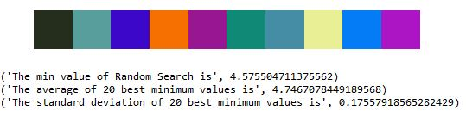

RANDOM SEARCH COLOUR PLOT FOR PROBLEM SIZE 100 WITH AVERAGE AND STANDARD DEVIATION FOR 20 BEST VALUES: -
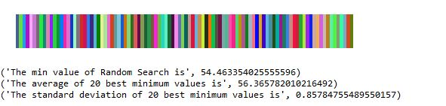

RANDOM SEARCH COLOUR PLOT FOR PROBLEM SIZE 1000 WITH TEN THOUSAND ITERATIONS AND WITH AVERAGE AND STANDARD DEVIATION FOR 20 BEST VALUES: -
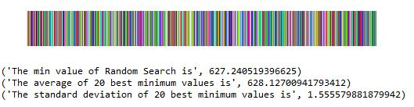

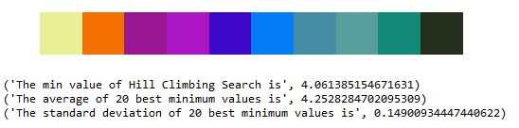
HILL CLIMBING COLOUR PLOT FOR PROBLEM SIZE 10 WITH AVERAGE AND STANDARD DEVIATION FOR 20 BEST VALUES: -

HILL CLIMBING COLOUR PLOT FOR PROBLEM SIZE 100 WITH AVERAGE AND STANDARD DEVIATION FOR 20 BEST VALUES: -
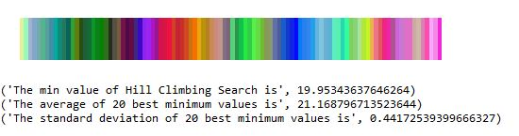

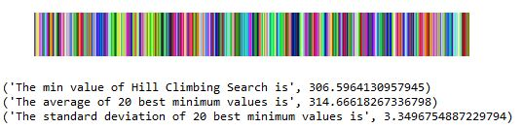
HILL CLIMBING COLOUR PLOT FOR PROBLEM SIZE 1000 WITH TEN THOUSAND ITERATIONS AND WITH AVERAGE AND STANDARD DEVIATION FOR 20 BEST VALUES: -

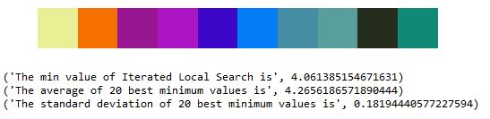
ITERATED LOCAL SEARCH COLOUR PLOT FOR PROBLEM SIZE 10 WITH AVERAGE AND STANDARD DEVIATION FOR 20 BEST VALUES: -

ITERATED LOCAL SEARCH COLOUR PLOT FOR PROBLEM SIZE 100 WITH AVERAGE AND STANDARD DEVIATION FOR 20 BEST VALUES: -
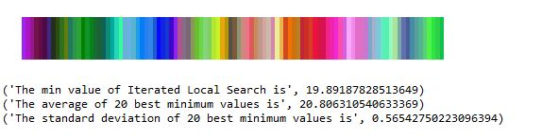

ITERATED LOCAL SEARCH COLOUR PLOT FOR PROBLEM SIZE 1000 WITH TEN THOUSAND ITERATIONS AND WITH AVERAGE AND STANDARD DEVIATION FOR 20 BEST VALUES: -
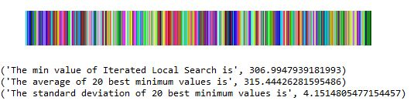

EVOLUTIONARY/GENETIC ALGORITHM COLOUR PLOT FOR PROBLEM SIZE 10 WITH AVERAGE AND STANDARD DEVIATION FOR 20 BEST VALUES: -
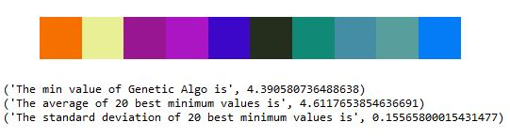

EVOLUTIONARY/GENETIC ALGORITHM COLOUR PLOT FOR PROBLEM SIZE 100 WITH AVERAGE AND STANDARD DEVIATION FOR 20 BEST VALUES: -
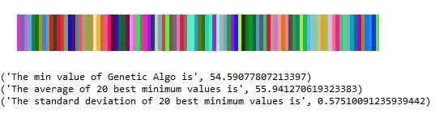

EVOLUTIONARY/GENETIC ALGORITHM COLOUR PLOT FOR PROBLEM SIZE 1000 WITH TEN THOUSAND ITERATIONS AND WITH AVERAGE AND STANDARD DEVIATION FOR 20 BEST VALUES: -
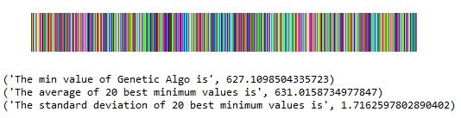

BOXPLOT FOR 100 COLOURS ACCROSS ALL THE ALGORITHMS: -

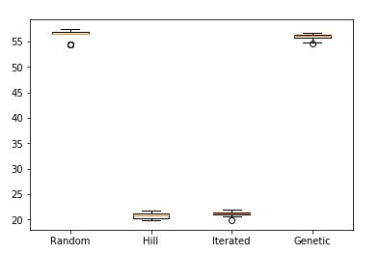

BOXPLOT FOR 1000 COLOURS WITH TEN THOUSAND ITERATIONS ACCROSS ALL THE ALGORITHMS: -
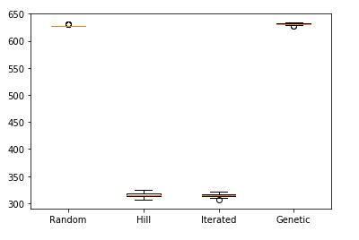

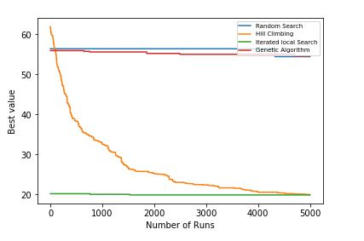
LINE PLOT FOR 100 COLOURS ACROSS ALL THE ALGORITHMS: -

LINE PLOT FOR 1000 COLOURS WITH TEN THOUSAND ITERATIONS ACCROSS ALL THE ALGORITHMS: -
