ML-HEALTH KIT

TEAM NAME: HACK O’ HOLICS

COLLEGE: KLN COLLEGE OF ENGINEERING

TEAM MEMBERS:

* R P SRIVATSAN
* R C SURAJ KUMAR
* R RANJITH KUMAR

**ABSTRACT**

  Most people are concern about what they eat every day. This is because "we are what we eat". People tend to search information about the things that they eat or what related to their diet. Nowadays, there are systems which help people to manage their diet. However, the systems are not specifically focusing on the user's own needs. Different people will require different dietary needs or nutrition for their body. This is due to variety of weight, daily activity level and so on. So they need something that will help them with their own personal body needs. The system that has been developed is an Diet Planning System using Machine Learning. This web-based or mobile application system will help user to get information about their dietary intake using their height and weight. There will be dietary recommendations for the user based on what they need. It is more focusing on the user with his or her own needs rather than just giving the general recommendations to all users. Moreover, this system is focuses on users in INDIA.

**NEED/PROBLEMS**

* People nowadays are very concern about their health. They care about what they eat. However, most of them lack knowledge about how to choose and what kind of food servings that is suitable for their body. This is because, different people will have different needs of dietary .due to variety of age, weight, height, gender, and lifestyle.
* Male needs different types of food compared to female, a sedentary activity level person need different types of food compared to a heavy activity level person, and this go so on and so far.
* India is popular for their country food. Some of these foods are cannot be found outside of India. Many of the online diet system available on the Internet are based on the Western country.
* The system is designed and built to be used by Western people. So, Indian foods are normally not included or cannot be easy found in most of the common diet planning systems. Indian people cannot really refer to those systems as they are not so 'Indian user' friendly.

**ARCHITECTURE DIAGRAM**

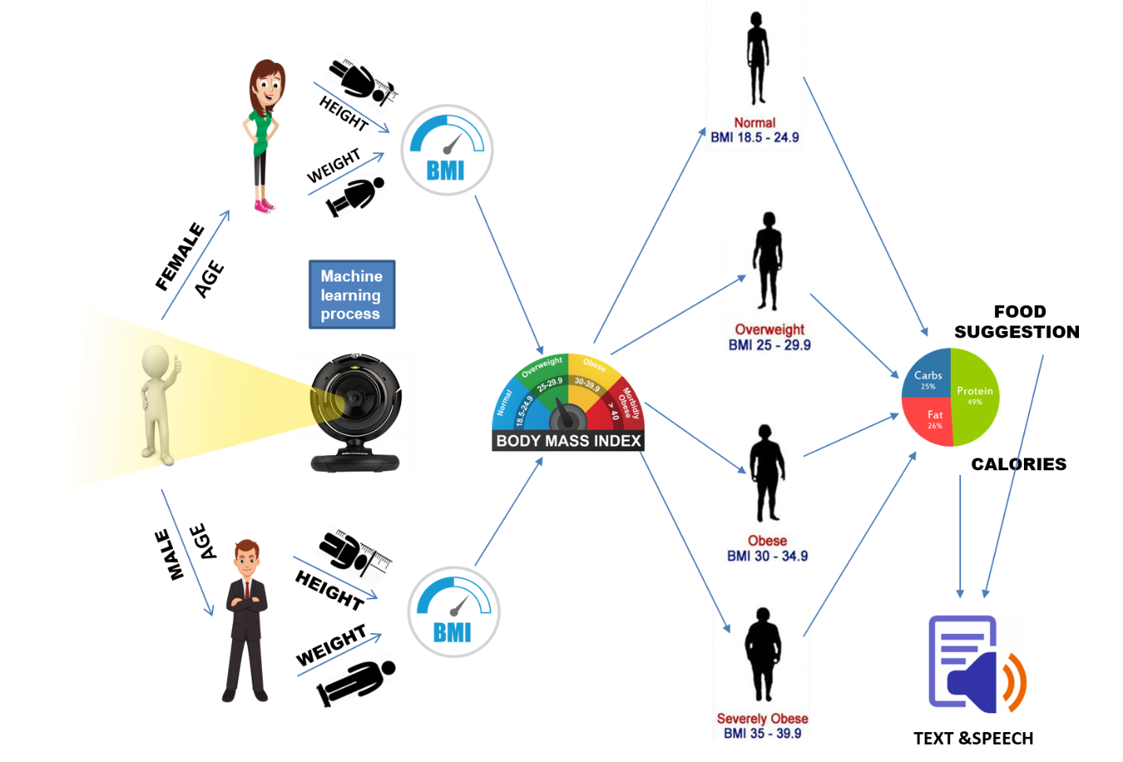

**MACHINE LEARNING CONTRIBUTION:**

* **Viola Jones algorithm** used to recognize facial measurement .
* Based on the facial measurement **Back propagation algorithm(**Neural Network**)** used to classify gender and age of a specific person.
* **Height** is measured by using object detection and **weight** is detected based on trained dataset with height.
* **Calories** suggestioncalculationis done based on the **BMI** that is calculated by height and weight

**GOALS/OBJECTIVES**

1. To find out Gender classification and age using camera (Machine Learning).
2. To find out the Height, weight using camera (machine learning) and blood pressure, etc.
3. To find out BMI of a person and suggest food and calories using machine learning. Gives output using Text and voice.

**PLATFORMS**

* Anaconda 3
* Pychrm
* Tensorflow
* Keras

**DEPENDENCIES**

* Python3.7
* numpy 1.13.3+mkl
* Keras 2.0.8
* TensorFlow 1.4.0
* opencv 1.0.1
* opencv-python 3.3.0+contrib

**PROCEDURES/SCOPE OF WORK**

* This system will be used by people who want to know what type of food serving that are suitable for them and want to manage their diet better. It can also be used by people who works relate to the diet field. This will include the public, the expert dietitian/nutritionist, medical/health staff, individuals who is involved in campaign or talk to promote health and diet and so on.
* This system will provide different types of foods to be chosen by the user. Food is widely range from all the food that is normally eaten by all races in India.
* Recommendation and advice will be given to the user based on automation( Machine Learning).
* System is easy to use and user friendly with the icon-based user interfaces. This will allow the user to navigate easily and feel like they are controlling the system.

**CURRENT OUTPUT**

* Classification of gender using camera is completed using  **Viola Jones algorithm**  and   **Back Propagation Algorithm**(Neural Network).
* For BMI(**BODY MASS INDEX)** calculation algorthim is coded.

**FUTURE OUTPUT**

* To find Height ,weight using camera by machine learning.
* Body temperature and Heartbeat is analysed **(Data Analysis)** from Arduino.
* BMI Is calculated suggest food and calories level to be consumed using machine learning.

**PROS**

* Instant health condition of a person.
* It gives food suggestion and calories to be consumed to specific person.
* This results will be of text and voice.
* The people affected by the disease due to calories will be reduced.

**Cons**

* Less accuracy in calculation of weight
* Requires sample photo from user with matching requirements (To be appear full size in camera).

REFERENCES

<https://www.ncbi.nlm.nih.gov/books/NBK235013/>

<https://www.medicalnewstoday.com/articles/263028.php>

<https://www.smartnutrition.ca/nutrition-2/6-dangers-calorie-counting/>