Unit testing documents of the hero tutorial 1st project in withCenter INC.

This files are already build and just for testing just follow and install it on the folders all of these are important

1st step is environment set up

Typings.json

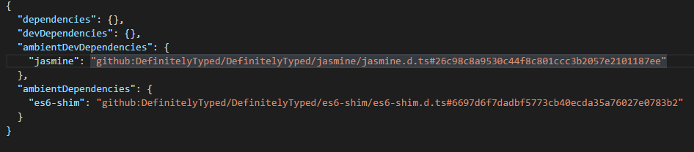

Tsconfig.json

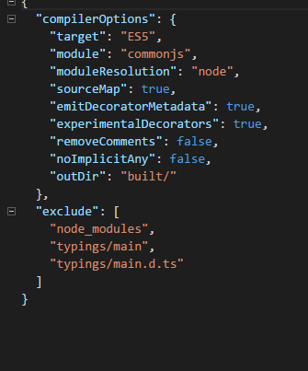

Package.json

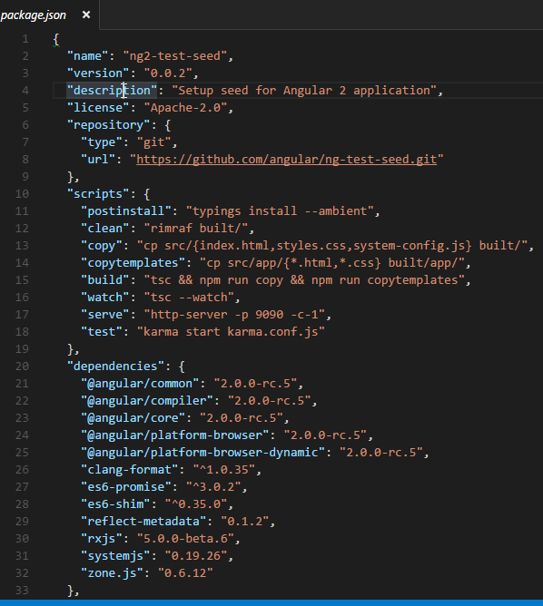

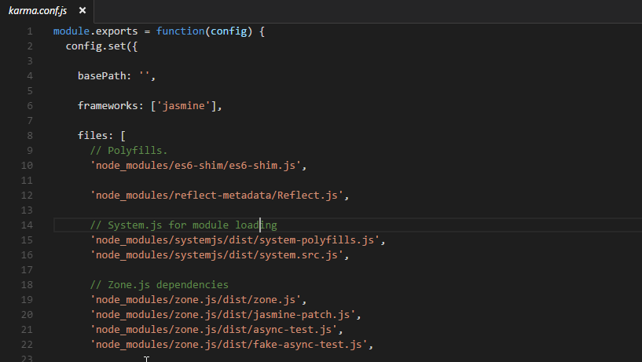

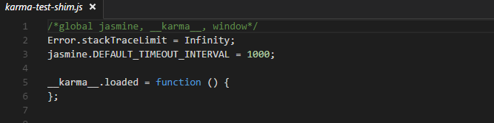

These are all neede to load the testing framework karma.

Next is

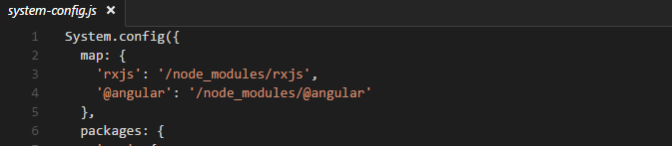

That is located on the src folder

And the last one is the index.html

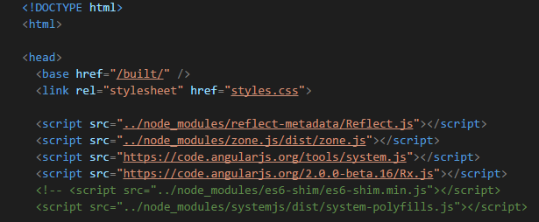

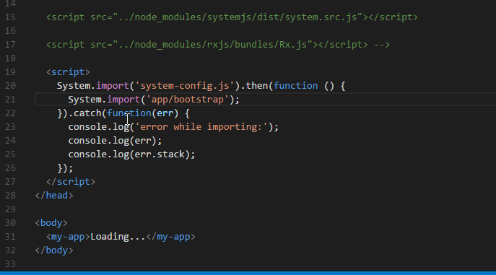

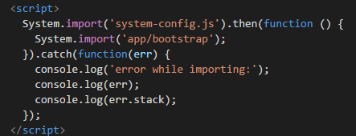this is important to load the testing by importing system-config.js file to load the testing application

The last one is separate the working files and the test files.



And now install the karma and jasmin modules.



And



How to test the out-put? Just type npm test

There are components of the testing procedure when you test it using npm it will show watchers

Watchers show what files that doesn’t match in the testing.

When you run a test it will show you this if there is an error or no error’s



But watchers that will show on the yellow lines have some issue it doesn’t work with typescript.

And there is no support yet.



But it will show if there is an error.



