**Raft Website Guide:**

1. **Logo**

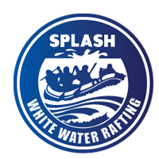

1. **Color Code**

* Primary-color (#505033)
* Secondary-color (#264969)
* Accent1-color (#cfcfb4)
* Accent2-color (#b4cde4)

1. **Typography**

* Heading-font (“Lora”, serif)
* Text-font (Georgia, serif)

1. **coolors.co url**

https://coolors.co/4e5340-697268-95a3a4-b7d1da-e2e8dd