# NEU 501a Problem Set 1

Due: Saturday September, 26th 2020 @ 12:00 pm

Written by Jess Breda & Max Argon

1. The answers to this problem set are to be submitted by canvas. Please copy this google doc, enter your answers and **submit as a pdf.**
2. If there are papers pertinent to the question, we linked to them in the question.
3. If you are using any literature to guide your hypotheses, please cite it (name, year & link)
4. Some of these questions are open ended - we will be evaluating how you support your claim. Please keep answers as succinct as possible.
5. You may work with your classmates on the problem set, but your answers must represent your own understanding of the solutions.
6. Problem sets that are turned in late will receive a 10 point deduction per late day.

**1.** In Drosophila asymmetric segregation of Numb in the sensory organ precursor diversifies cell fates.

* 1. What cells would you expect the terminal cell division to produce if Numb was expressed in both intermediate precursors IIa and IIb?
  2. What manipulation of IIa and IIb would produce only socket cells?
  3. Does Numb provide an intrinsic or extrinsic bias to the cells producing Notch and Delta?

**2.** In your research, you've found proteins Alpha and Beta that are related to cell fate in motor neurons located in the mouse spinal cord. Alpha is a transcription factor and transmembrane protein. Alpha on one cell can bind to Beta on a neighboring cell - this causes intramembrane proteolytic cleavage of Alpha, which then translocates to the nucleus, turning on genes, up-regulating Alpha expression, and down-regulating Beta expression.

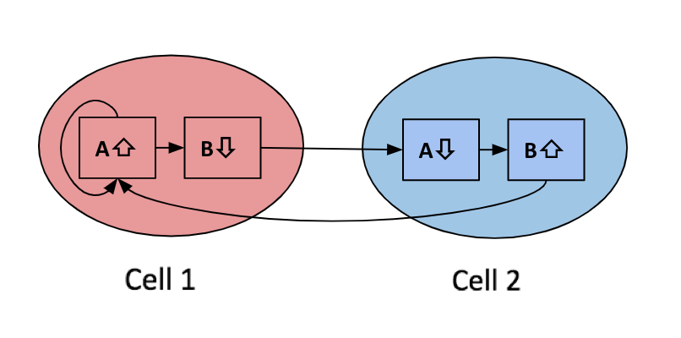

* 1. You ectopically express (over-express) Beta in cells that have high Alpha expression (cell 1 above). What happens to Alpha expression in these cells and in neighboring cells that were high in Beta expression (like cell 2 above)?
  2. You discover a mutation in the Alpha gene that prevents the protein from being cleaved. You generate mice with this mutation. What would the expression of Alpha and Beta be in cells like 1 and 2 above?
  3. A protein called Gamma is released from the dorsal surface of the spinal cord, resulting in a dorsal-ventral gradient of Gamma, where the highest concentration of Gamma is dorsal and lowest concentration is ventral. You hypothesize that Gamma inhibits expression of Beta. Consider two neighboring motor neurons (one is more ventral than the other) that are born with equal amounts of Alpha and Beta. If your hypothesis is correct, how would Gamma influence their fate? Describe one experiment to test this hypothesis that involves a loss-of-function mutation in Gamma.
  4. Cell 1 will eventually send an axonal projection into the ventral part of the limb, while cell 2 will project to the dorsal part of the limb. Alpha and Beta promote the expression of BPTh and BPTm (respectively) which are receptors of a protein Dim1. BPTh-expressing axons are repelled by Dim1, while BPTm-expressing axons are attracted to Dim1. Sketch where Dim1 is expressed in order for cells 1 and 2 to target properly. What would happen to these projection patterns in the mouse mutant described in part b above?

**3.** You conduct an experiment in which you flip the Shh gradient - instead of being produced in the floor plate and diffusing dorsally, Shh is now made at the dorsal end of the developing spinal cord.

1. Sketch how the transcription factors Pax6, Irx3, Dbx2, Nkx6.1, and Nkx2.2 will now distribute.
2. Given the distribution of the transcription factors in (a), where will motor neurons develop within the spinal cord?

You then go on to study cortical development using a mouse mutant for Satb2.

1. What changes in cortical layers 5 and 6 (in terms of transcription factor expression, cell fate, or axonal projection patterns) do you observe in the homozygous mutant mouse?

**4. Journey to the center of the brain**

It’s time to take your 501a quiz, and you begin excitedly typing your answer on Canvas using your computer’s keyboard. As you type, a neuron innervating your fingertips generates ___, or electrical signals. These signals travel along a neuronal process called a/an ___, passing the ____ root ganglion before entering the ___ level of the spinal cord. This sensory neuron is called a ___ bipolar cell, since it has a single process with two branches: one extending from your finger tip, one extending into the spinal cord. The process extending into the spinal cord enters the cord through a structure called the ___ root. This root is made of ___ matter. From here, this process [does / does not] synapse onto secondary neurons. On its way up to the brain, sensory information travels through a ___ matter fiber bundle called the ___ column.

We are now leaving the spinal cord and entering the brain. The touch information generated at your fingertip reaches the ___, the brain’s first sensory relay. Within this relay, spinal cord fibers synapse onto neurons within the ___ nucleus. Secondary neurons then ___, or cross the midline and travel up a fiber bundle called the ____. Next, neurons in this bundle synapse in the ____ nucleus of the ____, a major sensory integration center of the brain. Finally, neurons in this nucleus project to ___, a region of cortex that contains a somatotopic map.

**5.** You perform quantitative MRI scanning (QMRI) in several adults and children with the goal of assessing neural development. For the questions below, you can assume sample sizes are matched. Given that T1 can be used to measure tissue growth & development, for each group below, hypothesize if relaxation times would be similar or different. Further, explain *why* you have each hypothesis.

1. Adults vs. children in the fusiform face area (FFA)
2. Adults vs. children in the parahippocampal place area (PPA)
3. Adults vs. children in the visual word form area (VWMA)
4. Illiterate vs. literate adults in the VWMA
5. Congenitally blind adults vs. seeing adults in primary auditory cortex (A1)
6. Congenitally blind adults vs. seeing adults in primary somatosensory cortex (S1)
7. Right handed children vs. left handed children in the right primary motor cortex (M1)

[**6.**](https://www.ncbi.nlm.nih.gov/pmc/articles/PMC6095461/) You are interested in studying the genetic mechanisms of congenital microcephaly. Your colleague suggests that you design an experiment in ferrets as opposed to mice to answer your question(s). You are feeling unsure of their judgement so you design an experiment that has both ferrets and mice. You are interested in studying the gene *abnormal spindle-like microcephaly-associated (ASPM)* as it has been shown to have implications in human microcephaly ([Bond et al., 2002](https://pubmed.ncbi.nlm.nih.gov/12355089/#:~:text=Abstract,mild%20to%20moderate%20mental%20retardation.)). You create genetic knockout (KO) lines for both species that have two mutant gene copies which leads to a significant reduction in *Aspm* protein (KO: Aspm -/-, Control: Aspm +/-, +/+). Visually, you observe the KO ferrets have reduced brain size (Left). When you perform MRI on the brains, you notice that although the cortex is smaller, the structure appears roughly normal (Center). And this is verified by the outer surface area of the KO ferrets being significantly smaller than the controls (Right). Interestingly, when you look in mice, you do not see these effects (Right).

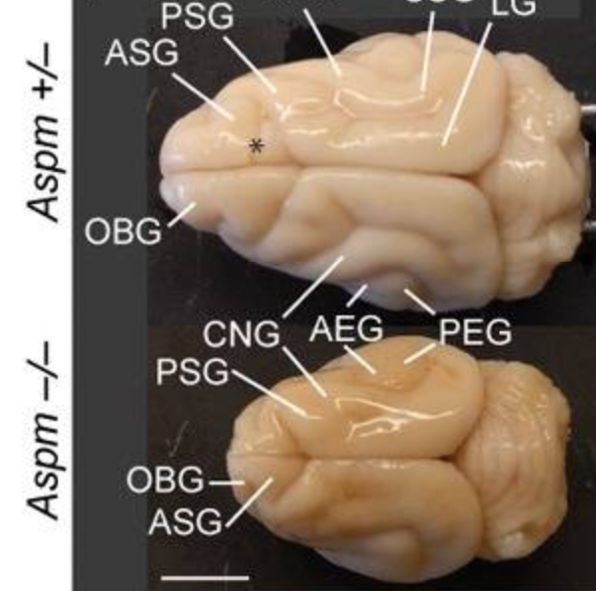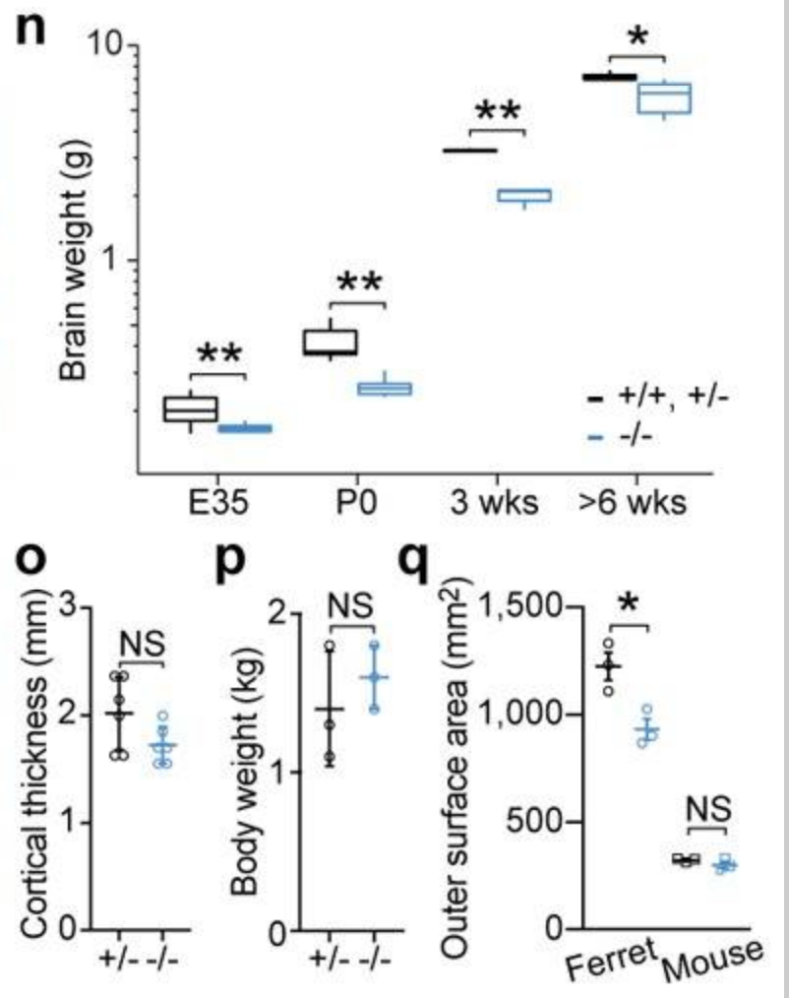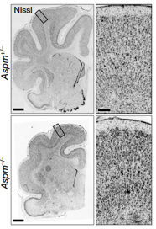

1. Why did your colleague suggest ferrets? Please be explicit in explaining the differences in cortical organization and cell types between the two species.
2. Given the plot on the right and your answer to question a, which cortical layers and cell types would you begin to look for for abnormal development in ferrets?
3. What phenotype do you hypothesize you would observe if you *overexpressed* ASPM in ferrets and why?

[**7.**](https://drive.google.com/file/d/1v9Ytmo-Z--TkuscozWXWzoPTSDUCjCRl/view)You are studying object representations in monkey posterior inferotemporal cortex (PIT). You train monkeys to discriminate symbols from different categories. Training is performed in the monkeys home cages, meaning that their head position is not controlled while they learn the task. After many months of training, BOLD responses to these stimuli are recorded in an fMRI scanner.

1. Your first cohort of monkeys is trained with cartoon face images. Based on published findings, would you expect this image category representation in PIT to be similar to or different from other face stimuli at the beginning of training? How about after training? Describe any possible spatial or functional (i.e. BOLD amplitude) changes in PIT. Indicate any spatial changes with respect to positioning along the dorsal/ventral axis. Are there broader feature gradients across visual cortex (i.e. rectilinearity tuning, receptive field size) that support your expectations?
2. Suppose another cohort of monkeys has been trained with two classes of stimuli, A and B. Images in class B have more straight edges than images in class A. The monkeys’ response patches to class A stimuli and class B stimuli after training are represented by the magenta and green circles, respectively. The underlying colormap indicates the BOLD signal corresponding to stimuli presented in the monkey’s peripheral visual field relative to the BOLD signal corresponding to stimuli presented in the center of the monkey’s visual field. Is the correlation between patch location and periphery/center selectivity sufficient evidence that PIT representations are organized according to an eccentricity principle? Explain why or why not. Indicate how you might modify your training protocol to better support your claim.

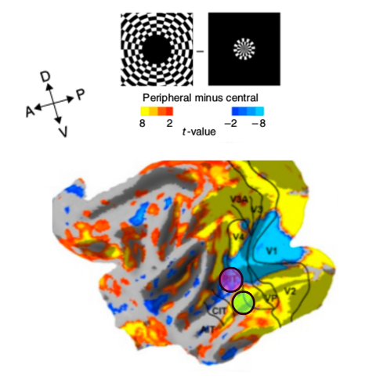

1. You divide your last cohort of monkeys into two groups. One group is first trained with stimulus class A. After one year, the group is trained with stimulus class B in addition to stimulus class A. The second group is similar, but with the order of training reversed. Do you expect that the BOLD responses to these stimulus classes will differ between these groups? Provide a piece of evidence from primary literature that supports your claim. You may ignore any differences in the total amount of training between the two classes.