# NEU 501a Problem Set 4

Due: Thursday, November 12th @ 11:59 pm

Written by Jess Breda & Max Argon

1. The answers to this problem set are to be submitted by canvas. Please copy this google doc, enter your answers and **submit as a pdf.**
2. **Please do not add your name to document or file name so we can grade anonymously**
3. Put your text in a different color
4. If there are papers pertinent to the question, we linked to them in the question.
5. If you are using any literature to guide your hypotheses, please cite it (name, year & link)
6. Some of these questions are open ended - we will be evaluating how you support your claim. **Please keep answers as succinct as possible.**
7. You may work with your classmates on the problem set, but your answers must represent your own understanding of the solutions.
8. Problem sets that are turned in late will receive a 10 point deduction per late day.

**NEU 501a Problem Set 4**

Question 1- Quantal Release [15] 2

Question 2- Calcium Currents & Neurotransmitter Release [10] 5

Question 3- Dendrites [10] 7

Question 4- Whitlock et al. 2006 [10] 10

Question 5- Facilitation & Potentiation [10] 12

Question 6- Synaptic Mechanisms of LTP [10] 14

## Question 1- Quantal Release [15]

**Part I**The following histogram represents the amplitude of the end-plate-potentials (EPPs) in response to 400 trials of presynaptic stimulation measured in low calcium extracellular solution from a neuromuscular junction. The inset shows the spontaneous mini-EPPs that occur without any presynaptic stimulation.

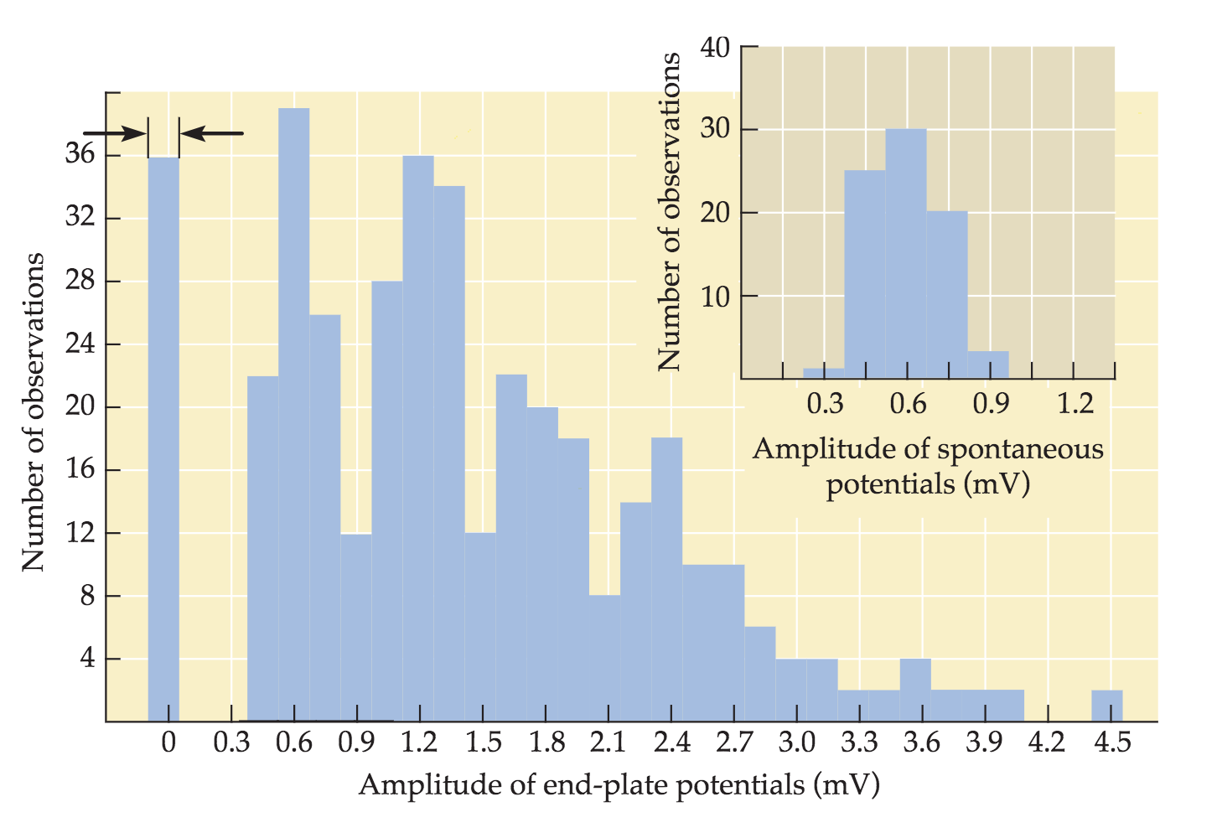

1. Draw the recording set-up for the experiment. [1]
2. Specifically, what do the events at 0mV represent in the above histogram? [1]
3. Using what you know from part (a) compute the mean number of quanta released per trial. [2]
4. How are the amplitudes at the peaks of the distribution related to the mini-EPP? [2]
5. What is the quantal size at this NMJ? [1]
6. The mean EPP from the above histogram is 1.4mV. Using the mean EPP, estimate the mean number of quanta released per trial. [1]

**Part II**

You now perform the following manipulations to the NMJ.Briefly, describe how (and why) the EPP and spontaneous potential histograms (mEPP) change in response to the items below. Note: answers should not need to exceed 3-5 sentences.

1. Performing these recordings from a synaptotagmin knockout mouse [1.75]
2. Inserting more AChR to the post-synaptic membrane [1.75]
3. Decreasing the readily releasable pool of vesicles [1.75]
4. Adding BAPTA to the preparation (you may need to look this up). [1.75]

## 

## Question 2- Calcium Currents & Neurotransmitter Release [10]

This figure (3-5 in your book) is from an experiment in the squid giant synapse that helped show that neurotransmitter release is triggered by presynaptic Ca2+. Note: answers should not need to exceed 3-5 sentences.

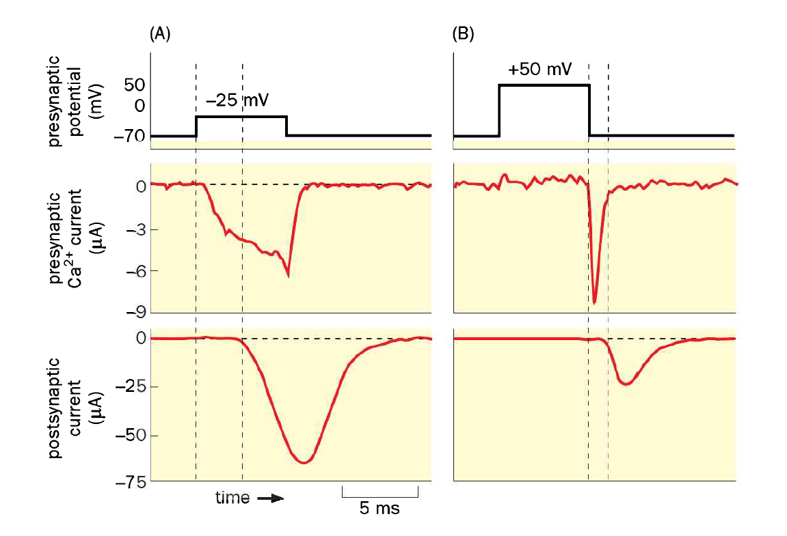

1. Draw the recording set-up for this experiment for the presynaptic neuron. [1]
2. In panel A, the presynaptic membrane potential was clamped at –25mV. (1) How does panel A demonstrate that Ca2+ entered the presynaptic neuron? (2) And what does it show happened to the postsynaptic neuron? [1.5]

1. In panel B, the presynaptic membrane potential was clamped at +50mV. Why was there no net current during the presynaptic depolarization? [3]
2. Why was there a current after the presynaptic potential was returned to –70mV? [3]

1. What happened to the delay in postsynaptic current with the +50mV presynaptic depolarization? [1.5]

## 

## 

## Question 3- Dendrites [10]

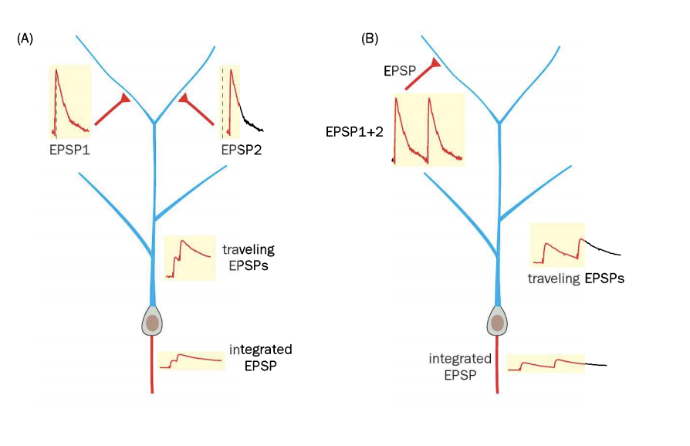

1. Postsynaptic neurons integrate presynaptic inputs in two principal ways. Briefly, describe the two integration types, as represented in (A) and (B) in the figure above. [3.5]

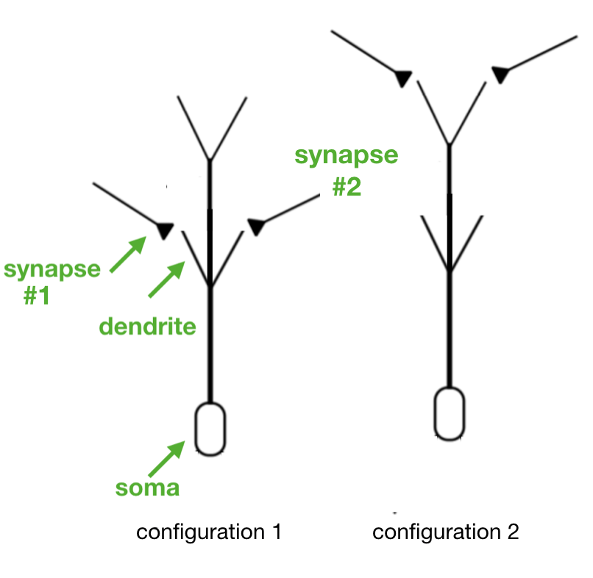

1. The figure above shows a neuron with synaptic connections at either proximal (left) or distal (right) dendrites. In each configuration, the two synapses are equidistant from the soma and produce inputs that are separated by a time Δt (e.g. synapse 1 fires at t1 and synapse 2 fires at t2).

(1) Which configuration (left/right) would you expect to produce a larger integrated EPSP at the soma as Δt increases? (2) Which configuration (left/right) would you expect to produce a larger integrated EPSP at the soma as Δt decreases towards 0? For both, in ~1 sentence explain why. [3.5]

1. In this figure , a 5-ms depolarizing current pulse was injected into the soma, which produced a single action potential that was recorded in the cell body. Right after that, the distant dendrites of the neuron were activated, which generated a dendritic spike, which propagated to the cell body and resulted in two additional somatic action potentials. Briefly, what would happen to (A) the first and (B) the second two action potentials if you blocked the dendritic action potentials (and why)? [3.5]

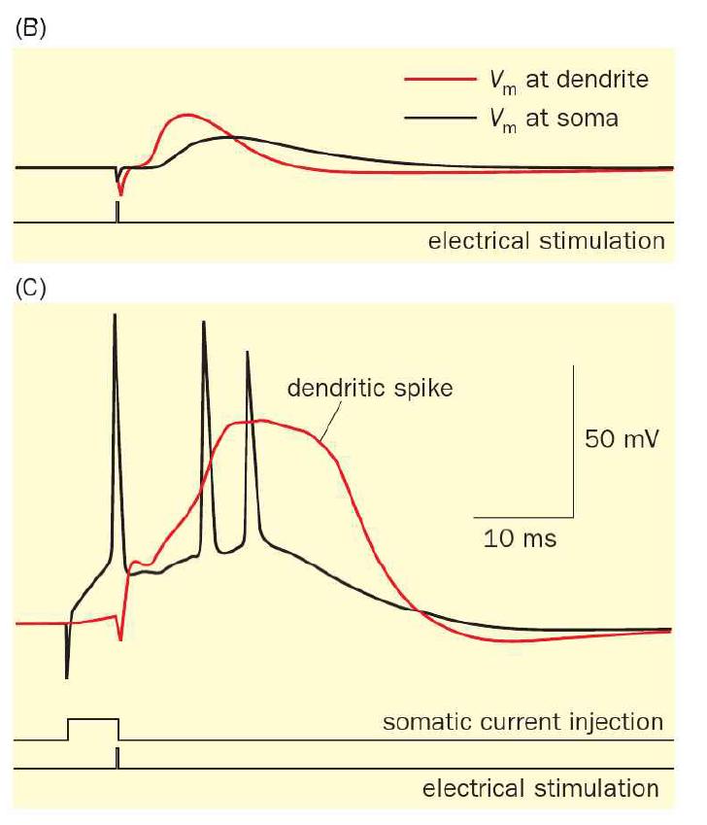

## Question 4- [Whitlock et al. 2006](https://drive.google.com/file/d/1TmxuTCmzbO_YGuXTYQQuKO1SSKvhHYe_/view) [10]

1. Briefly, explain which three behavioral controls were used and why these particular controls were chosen. [1]
2. Following training the authors dissected the hippocampus of experimental rats and assayed for 5 types of molecular markers.Briefly (~ 1 sentence each), explain what these markers were and how they were changed post-training. [2.5]
3. You develop a GFP-tagged protein that binds to phosphorylated Ser831 and a second GFP-tagged protein that binds to phosphorylated Ser845. The proteins are specific for the AMPA receptor and are also very sensitive. In ~3 sentences,how would you use these instead of the immunoblots of Fig. 1? [2.5]
4. List one way this method can more precisely quantify the effects of training, compared to the results shown in figure 1A-C. [2]
5. From the textbook & class, we know high-frequency stimulation (HFS) can induce LTP through specific measurable changes. Whitlock et al. argue that learning via their paradigm results in similar changes. List one molecular marker and an electrophysiological property of the change resulting from their learning paradigm that is similar to what you'd expect from HFS-induced LTP.) [3]

## 

## 

## Question 5- Facilitation & Potentiation [10]

The following figure shows field synaptic responses in CA1 neurons in response to stimulation of CA3 axons (similar to Whitlock et al., but there is only one recording electrode here). Note answers to the below questions should not need to exceed ~3-5 sentences.

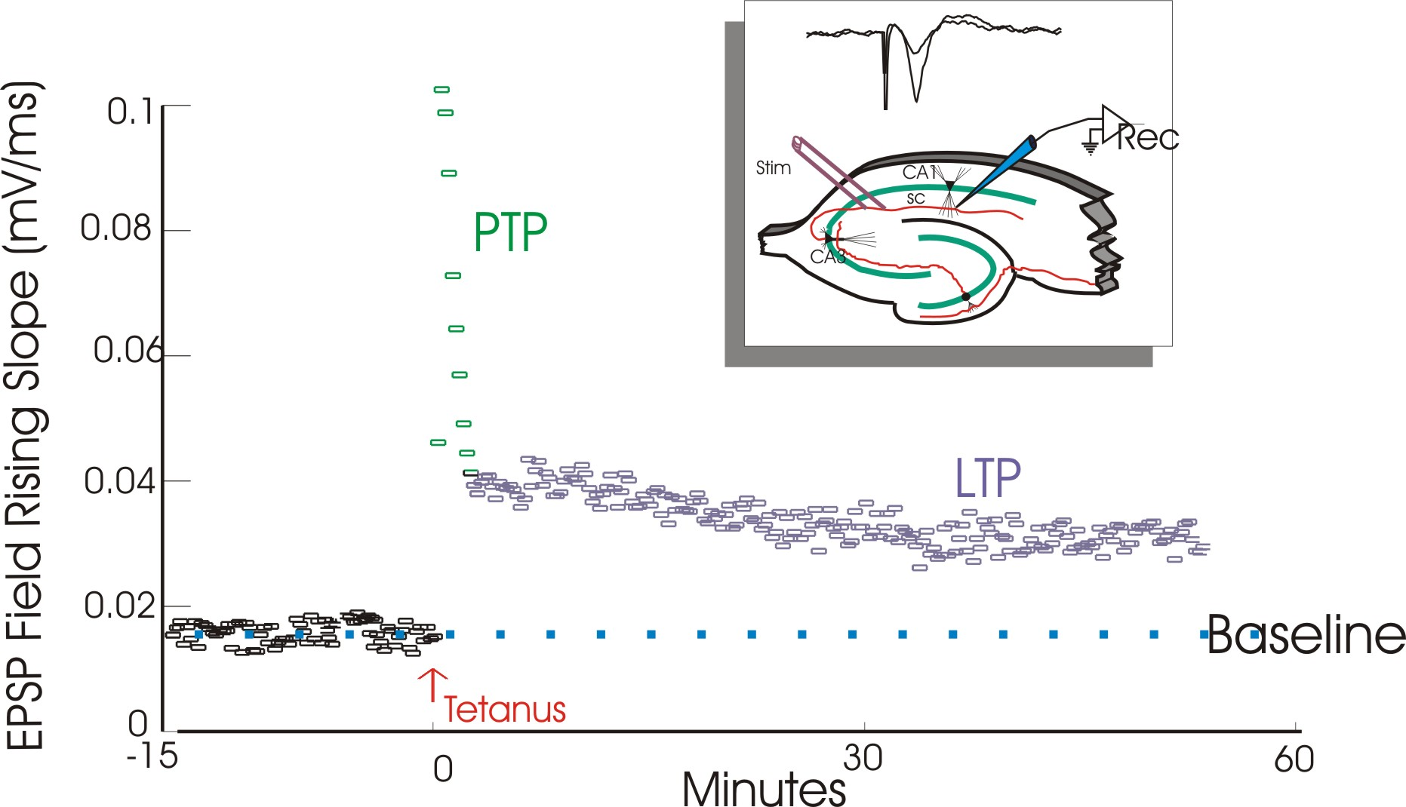

1. How would the synaptic responses of the CA1 neurons (PTP and LTP) change in the experiment if 3-(2-Carboxypiperazin-4-yl)propyl-1-phosphonic acid (CPP; you may need to look this up) was added before the tetanus? Briefly explain why. [2]
2. How would LTP change if 3-(2-Carboxypiperazin-4-yl)propyl-1-phosphonic acid (CPP) was added at 30 minutes? Briefly explain why. [2]
3. How would LTP change if z-pseudosubstrate inhibitory peptide (ZIP) was added at 30 minutes? Briefly explain why. [2]
4. How would the synaptic responses change in a mouse mutant for GluR1? Briefly explain why. [2]
5. You apply a drug (starting before the tetanus and continuing through T=60min) that hyperpolarizes all CA1 neurons to -80mV. How does this drug application affect your results? Briefly explain why. [2]

## 

## Question 6- Synaptic Mechanisms of LTP [10]

Building on the recording set up from Question 5, you select a single CA3 axon to stimulate, while recording from a single CA1 neuron that the axon projects to. Your experimental results are in Panel A below. In each case, you stimulate the presynaptic neuron to produce an action potential (lower traces), and record from the postsynaptic neuron in voltage clamp mode (upper traces). The postsynaptic neuron is clamped at the voltages indicated. Between panels A2 and A3 you give a tetanus to the presynaptic neuron (100Hz for 15 seconds) while clamping the postsynaptic neuron at +30mV. Note: answers to these questions should not need to exceed 3-5 sentences.

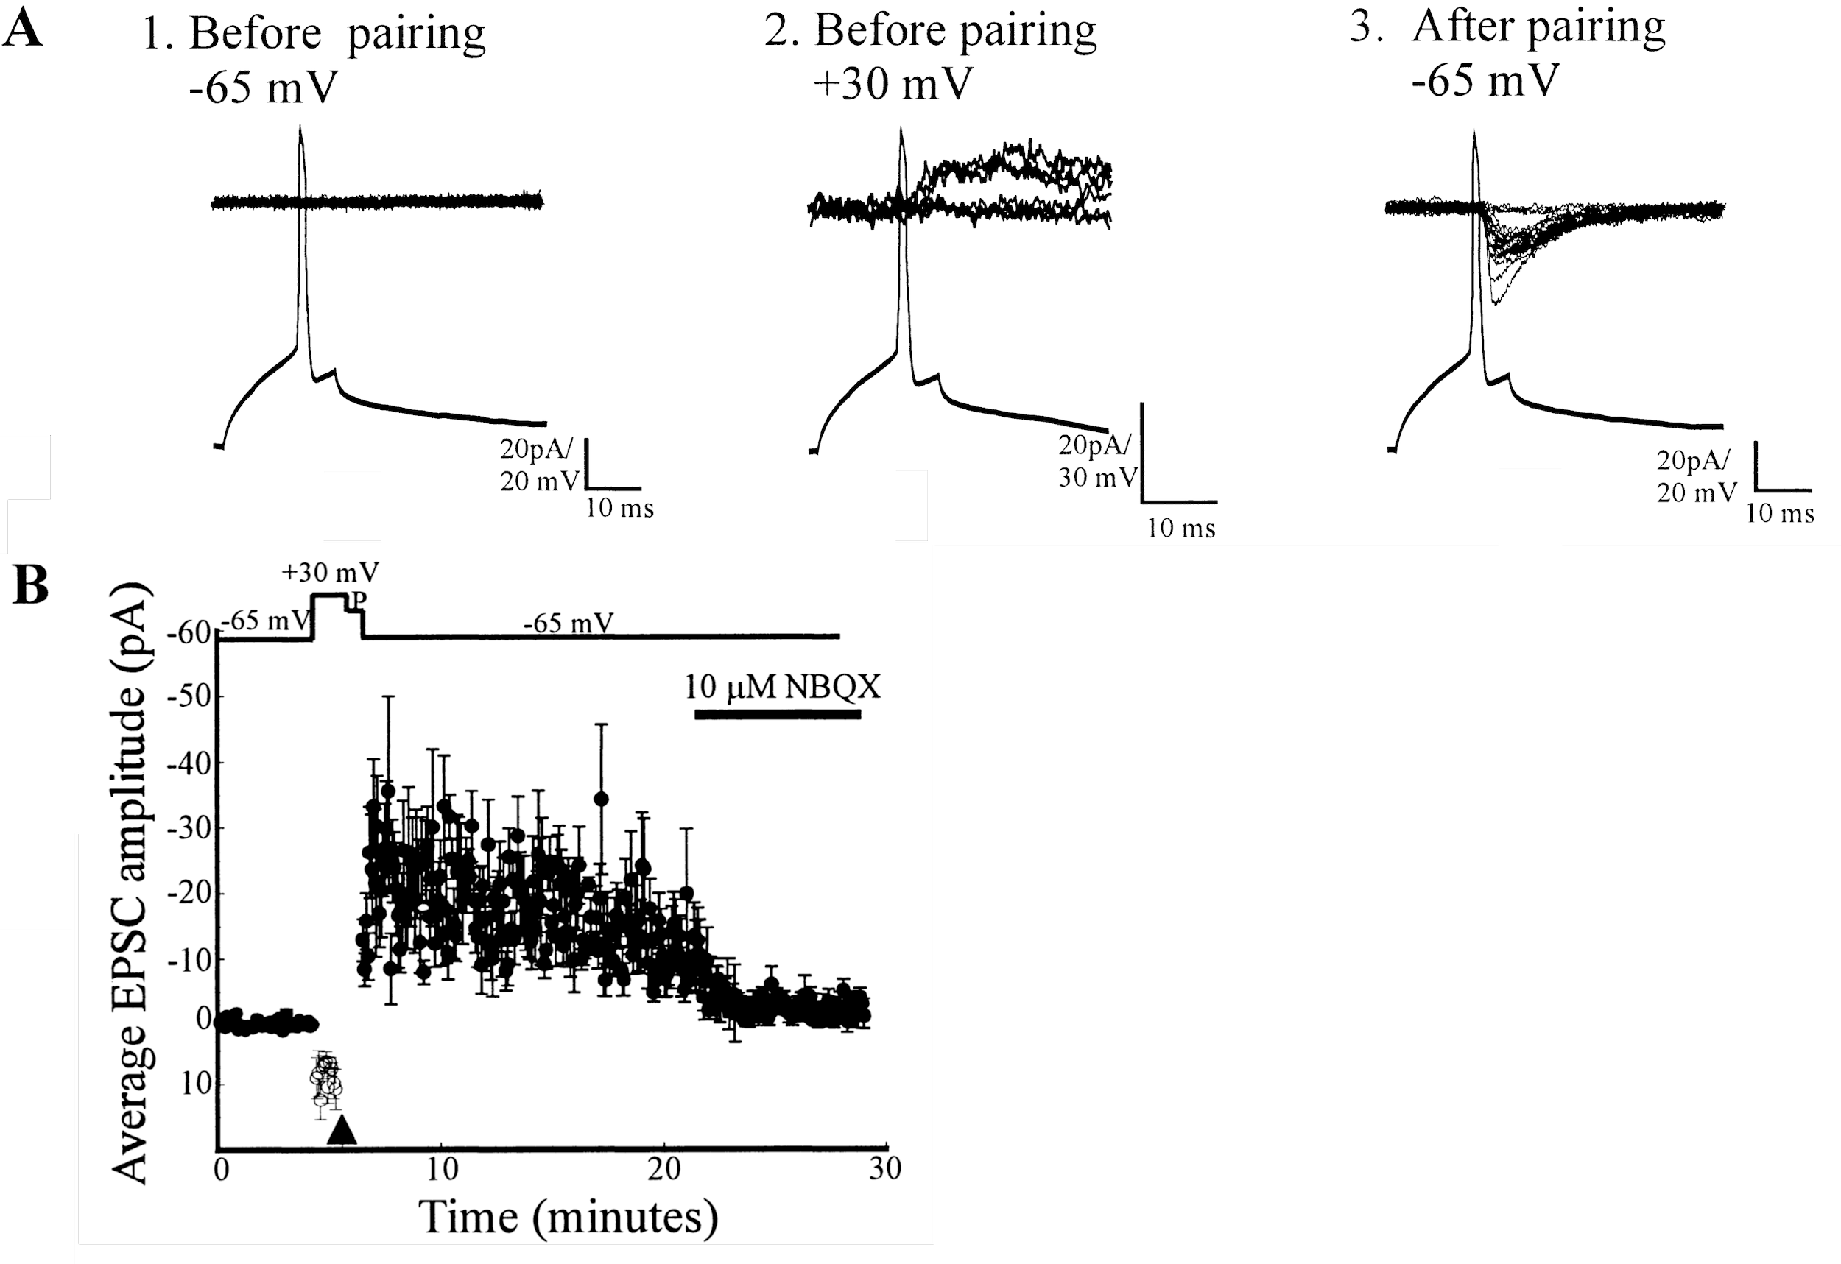

1. In panel A1, there was a presynaptic action potential, but no current was observed when voltage clamping the postsynaptic cell to -65, why is this? [2]
2. Given your answer to a, why is the current in panel A2 positive? [2]
3. Given your answers to a and b, why is the current negative in panel A3? [2]
4. What changes occurred at the synapse after the tetanus? List two parts of the experimental design that are necessary for producing this change. [2]
5. Now, you repeat the experiment in a new pair of neurons and observe the same results as in panels A1 and A2. Describe how panel A3 would change if you instead gave a tetanus to the presynaptic neuron while clamping the postsynaptic neuron at -65mV. [2]

## 

## 

## 