## NEU 501a Problem Set 6

Due: Thursday, December 14th @ 11:59 pm

Written by Jess Breda & Max Argon

1. The answers to this problem set are to be submitted by canvas. Please copy this google doc, enter your answers and **submit as a pdf.**
2. **Please do not add your name to document or file name so we can grade anonymously**
3. Put your text in a different color
4. If there are papers pertinent to the question, we linked to them in the question.
5. If you are using any literature to guide your hypotheses, please cite it (name, year & link)
6. Some of these questions are open ended - we will be evaluating how you support your claim. **Please keep answers as succinct as possible.**
7. You may work with your classmates on the problem set, but your answers must represent your own understanding of the solutions.
8. NO LATE EXTENSION for final pset

### 

### 

**NEU 501a Problem Set 6**1

Question 1-Olfactory Response [5] 2

Question 2 - Olfactory Coding & Organization [10] 3

Question 3- Olsen & Wilson [15] 4

Question 4 - Auditory Tuning [10] 5

Question 5- Auditory Physiology [10] 7

Question 6- Auditory Signaling [5] 8

### 

### Question 1-Olfactory Response [5]

You are studying a mouse that is a homozygous mutant for the CNG channel - you record from individual olfactory receptor neurons in this mouse and puff onto the olfactory epithelium 15 different odors, along with a mineral oil control (see figure 6-5 for more information if needed).

1. What response do you observe to each of the 15 odors? Why? [1.5]

Next you study a mouse that is homozygous mutant for Calmodulin (CaM) in all olfactory receptor neurons. You run the same experiment as above (see figure 6-4 for more information if needed).

1. What response do you observe now to each of the 15 odors? [1]
2. Explain what three intracellular mechanisms Calmodulin affects in olfactory receptor neurons and how these mechanisms will be altered in the CaM mutant. [2.5]

.

### 

### Question 2 - Olfactory Coding & Organization [10]

**Part I**

In less than a paragraph, explain the principle of combinatorial coding across the olfactory receptor neuron population (see figure 6-8 for more information if needed). [4]

**Part II**

The picture below illustrates three possible ways in which olfactory receptor neurons could wire up with postsynaptic mitral cells in the brain. In each panel, red ORNs express the ‘red” olfactory receptor, blue ORNs express the “blue” olfactory receptor, etc.

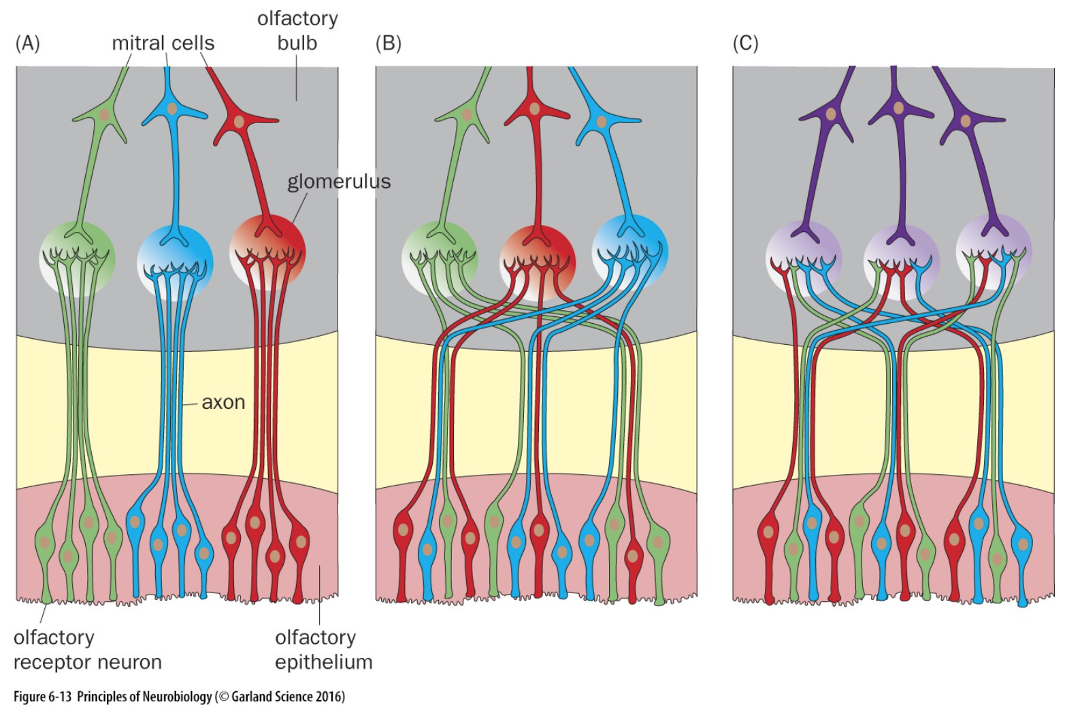

* 1. Do the red ORNs in (A) and (B) and (C) respond to odors differently? why? [1.5]
  2. Do the red mitrals cells in (A) and (B) and (C) respond to odors differently? Why? [1.5]
  3. Panel (B) is correct - briefly, why is this arrangement of ORNs and mitral cells preferable to (A) and (C)? [3]

### 

### [Question 3- Olsen & Wilson [15]](https://drive.google.com/file/d/1ruIjHxflC3upjzvcTEEWiJfdhTuC4Hqp/view)

You are studying the olfactory system of the fly and are interested in determining how antennal lobe PNs respond to odor and what effect inhibition has on the responses. You know that 90% of the ORNs reside in the antenna and the remaining 10% are found in the maxillary palp. All ORNs that express the same OR project to the same glomerulus. Each PN receives direct input from the ORNs in a single glomerulus.

1. You want to test the hypothesis that lateral input from neighboring glomeruli inhibits projection neurons responses. Describe an experimental strategy that would allow you to uncover the nature of the lateral input to the PNs. [2]

For the following scenarios, sketch what you would expect to see and briefly state why:

1. The LNs are excitatory [2]
2. The LNs are inhibitory [2]

You record from a PN that receives direct input from an ORN that resides in the maxillary palp. You observe spontaneous spike-driven EPSPs in the PN.

1. How will the EPSPs in the PN be affected by removal of the maxillary palp? Briefly explain why [2]
2. How will the EPSPs change when the maxillary palp is shielded? Briefly explain why. [2]
3. You now excite antennal ORNs with odor. How will inhibitory lateral input to the change the EPSPs in the PN? Assume the maxillary palps are attached and shielded. [2]
4. You express a toxin that blocks GABAreceptors in the PNs. You do the experiment above where you cover the palp and apply odors while recording from a PN. You see a small decrease in the amount of inhibition induced by the odor stimulation. You then express the toxin that blocks GABAreceptors in the ORNs and you see a big effect – you no longer see any inhibition from the odor stimulation. In no more than 3-5 sentences, what can you conclude about the site of inhibition? Why? [3]

### 

### Question 4 - Auditory Tuning [10]

**Part I**

Explain how the tuning of the basilar membrane would change in the following cases. Your answer to each of the cases below should include a plot (like below) of distance from the apex (x axis) and vibration magnitude (y axis). The plot below is for a wild type Guinea pig basilar membrane. For each part, also explain how the tuning of the corresponding auditory neurons change.



1. If the basilar membrane had higher stiffness throughout [2]
2. If the basilar membrane was the same at the base but three times as long so the apex was three times higher mass with lower stiffness [2]
3. If the inner hair cells responding to 500Hz were focally ablated [3]

**Part II**

The following figure shows the role outer hair cells play in modulating the auditory tuning of inner hair cells (spike trace on the right).:

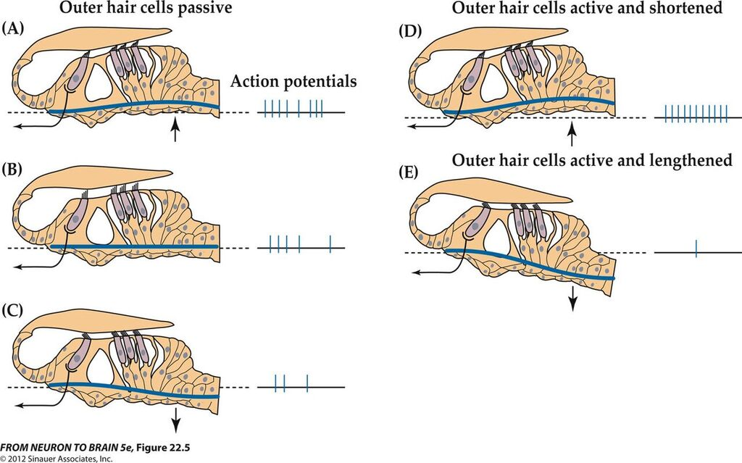

*During sound-evoked fluid waves, the cochlear partition (basilar membrane and organ of Corti) moves up and down. (A) During the rarefaction phase of a sound wave, the basilar membrane and tectorial membrane move upward, resulting in a shearing motion toward the longest stereocilia of the hair bundle—depolarizing the hair cells relative to the resting condition (B). (C) Downward motion during the compressive phase of a sound produces the opposite displacement of the hair bundles, and hair cells are hyperpolarized relative to rest. (D) Active contraction of outer hair cells during depolarization accentuates the upward motion of the basilar membrane. (E) Hyperpolarization of outer hair cells causes them to elongate. The net effect is that motion of the basilar membrane is greater because of the so-called electromotility of the outer hair cells, and this is reflected in the activity pattern of afferent fibers contacting the inner hair cells. The extent of motion is greatly exaggerated here for the purpose of illustration.*

1. Compare and sketch the tuning curve for an auditory neuron with a characteristic frequency of 1kHz in a prestin mutant and a WT mouse. Label the x-axis, y-axis, units, and ensure realistic values for the x- and y-ticks. [3]

### Question 5- Auditory Physiology [10]

For the following questions, in no more than 3 sentences, state how & why the response of an auditory receptor neuron tuned to 500Hz would change in the following conditions:

* 1. If Tmc1 and Tmc2 channels were knocked-out (removed). [1.5]
  2. If BAPTA was present in all inner hair cells. [1.5]
  3. If BAPTA was present in all outer hair cells. [2]
  4. If the K+ concentration in the hair cell endolymph decreased. [2]
  5. If the genes that encode proteins that make up the synaptic ribbon were knocked-out (removed). [1]
  6. If the bushy cells were ablated. [2]

### 

### Question 6- Auditory Signaling [5]

Order the following events (if any of the events listed below **ARE NOT** part of the transduction/transmission of sound signals in the cochlea, please indicate that as well).

1) Auditory receptor neurons transmit the signal to glomeruli in the auditory bulb of the brain

2) The 100Hz sound causes vibration at a particular location within the basilar membrane

3) Inner and outer hair cell stereocilia are displaced

4) Inner and outer hair cell membrane potential changes

5) Glutamate is released at the ribbon synapse

6) Voltage-gated Ca++ channels open and relax the gating spring

7) G-protein coupled receptors are activated

8) Tip links pull on ion channels located at the bottom of the tip link

9) A 100Hz sound is played at 30 degrees to the right of the front of the head