A meta-regression was performed comparing the beta’s of different pilots with each other. The pilots are separated by:

* Percentage of people with high social anxiety: the pilots are divided into two categories of higher or lower than 40% participants with a high social anxiety score. The threshold of social anxiety was calculated according to mini-SPIN score of higher than 6.
* Modality (text vs video): answers written in text format or shared verbally in audio and video format.
* Size of PE: according to the size of social prediction errors

The title in the x-axis specifies the model. It seems that for mood, the size of the PE's plays a bigger role (compared to the anxiety ones), as well as text vs video.

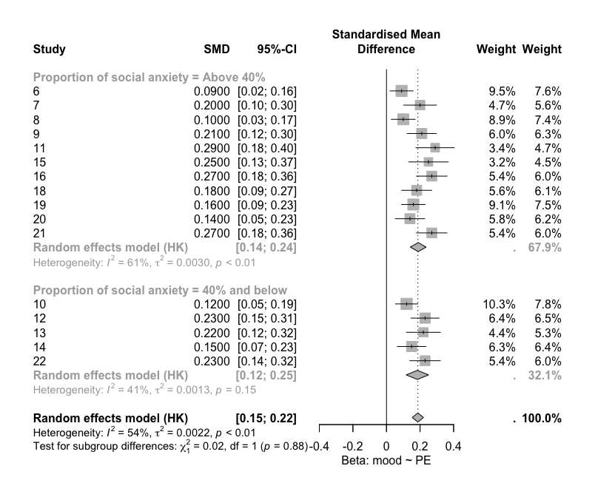

**Figure.1** shows the forest plot comparing pilots across categories of proportion of social anxiety: above and below 40%. The beta was calculated using the model mood ~ subj_PE + mini_SPIN + (subj_PE | ID)

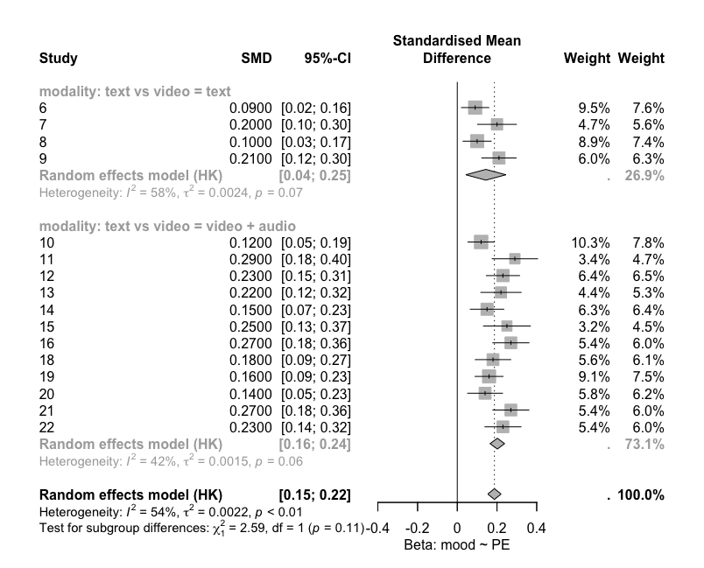

**Figure.2** shows the forest plot comparing pilots across modalities of text versus audio/video. The beta was calculated using the model mood ~ subj_PE + mini_SPIN + (subj_PE | ID)

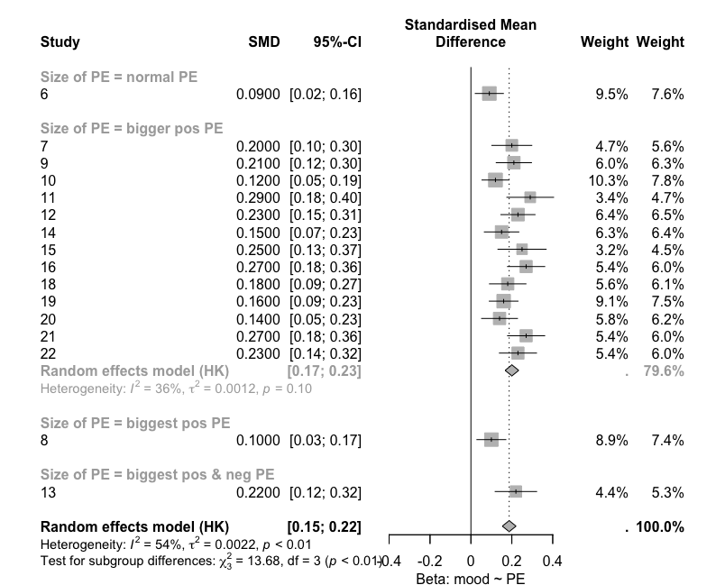

**Figure.3** shows the forest plot comparing pilots with different sizes of prediction errors (PE). The beta was calculated using the model mood ~ subj_PE + mini_SPIN + (subj_PE | ID)

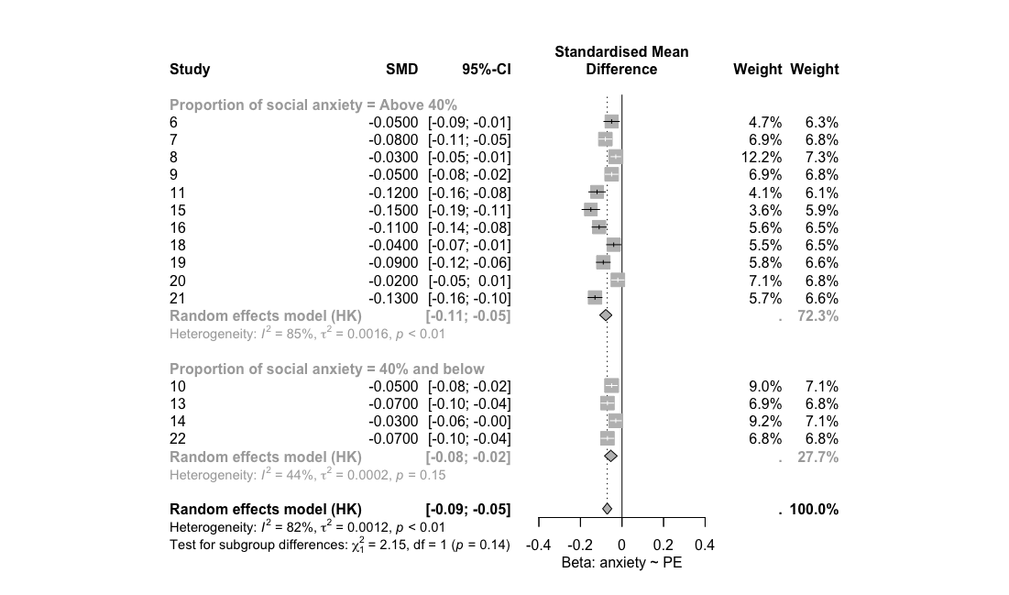

**Figure.4** shows the forest plot comparing pilots across categories of proportion of social anxiety: above and below 40%. The beta was calculated using the model anxiety ~ subj_PE + mini_SPIN + (subj_PE | ID)

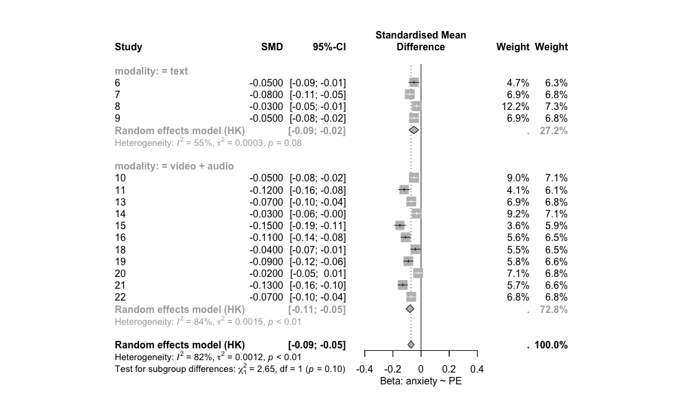

**Figure.5** shows the forest plot comparing pilots across modalities of text versus audio/video. The beta was calculated using the model anxiety ~ subj_PE + mini_SPIN + (subj_PE | ID)

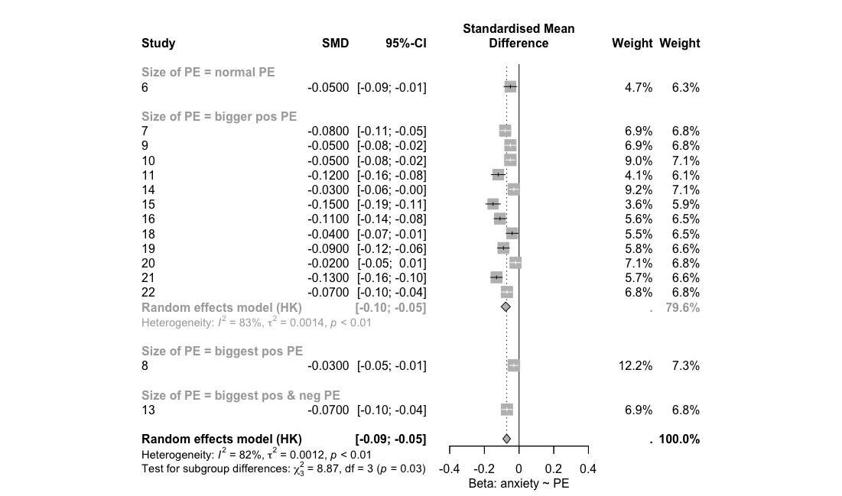

**Figure.6** shows the forest plot comparing pilots with different sizes of prediction errors (PE). The beta was calculated using the model anxiety ~ subj_PE + mini_SPIN + (subj_PE | ID)