计算机组成原理实验报告
2021 年 4 月 9 日 成绩：
姓名 | 应宇杰 | 学号 | 19151633 | 班级 | 19052321
专业 | 计算机科学与技术 |  | 课程名称 | 计算机组成原理课程设计
任课老师 | 程雨夏 | 指导老师 | 程雨夏 | 机位号 | 8
实验序号 | 1 | 实验名称 | 实验一平台使用和HDU-XL-01实验板卡测试实验
实验时间 | 2021/4/9 | 实验地点 | 1教225 | 实验设备号 | 8
一、实验目的和实验要求
1、掌握运用Verilog HDL语言进行结构描述与建模的技巧和方法，理解实验源文件代码。理解工程文件中管脚约束语句，掌握管脚约束的方法:
2、学习Xilinx Vivado Design Suite工具软件的使用方法，掌握Vivado工具软件上打开一个工程、编译、仿真、综合生成.bit文件的方法。掌握下载 bit文件和在HDU-XL-0l实验板卡上调试的方法;
3、在后续14个FPGA实验中,若遇到疑似板卡故障,懂得使用本实验生成的 bit文件，进行板卡检测。
二、实验程序源代码
`timescale 1ns / 1ps
//本实验是通过将32位LED灯分割为8*4的段，来控制8个数码管，使用10位count来对时钟型号进行分频，使用8位seg来控制数码管的亮灭，
分频倍数是2048倍，原clk是200MHZ
// 通过数据输入输出测试开关、LED、数码管；通过数码管使能测试按钮
module Board(sw, swb, led, clk, which, seg, enable);
input [1:32] sw;
output [1:32] led;
assign led = sw; // 开关输入数据，直接输出到 LED

input clk; // 数码管相关
output [2:0] which;
output [7:0] seg;
output reg enable = 1; // 默认开启数码管使能
Display Display_Instance(.clk(clk), .data(sw),
.which(which), .seg(seg));

input [1:6] swb;
assign toggle = |swb; // 按下任意按钮切换数码管使能
always @(posedge toggle) enable <= ~enable;

endmodule // Board
`timescale 1ns / 1ps
// 数码管扫描显示模块仿真测试
module Display_Test();
reg clk = 0;
reg [32:1] data; // input
wire [2:0] which;
wire [7:0] seg; // output
wire [10:0] count;
wire [3:0] digit; // output for debug

// Instantiate a display module
Display Display_Instance(.clk(clk), .data(data),
.which(which), .seg(seg),
.count(count), .digit(digit));

always #0.01 clk = ~clk; // 0.01ns == 10ps
initial begin
data = 32'hfedc_ba98; #500;
data = 32'h7654_3210; #500;
end

endmodule // Display_Test

`timescale 1ns / 1ps
// 通过数据输入输出测试开关、LED、数码管；通过数码管使能测试按钮
module Board(sw, swb, led, clk, which, seg, enable);
input [1:32] sw;
output [1:32] led;
assign led = sw; // 开关输入数据，直接输出到 LED

input clk; // 数码管相关
output [2:0] which;
output [7:0] seg;
output reg enable = 1; // 默认开启数码管使能
Display Display_Instance(.clk(clk), .data(sw),
.which(which), .seg(seg));

input [1:6] swb;
assign toggle = |swb; // 按下任意按钮切换数码管使能
always @(posedge toggle) enable <= ~enable;

endmodule // Board

三、仿真文件和波形图（有就填，没有就不填）
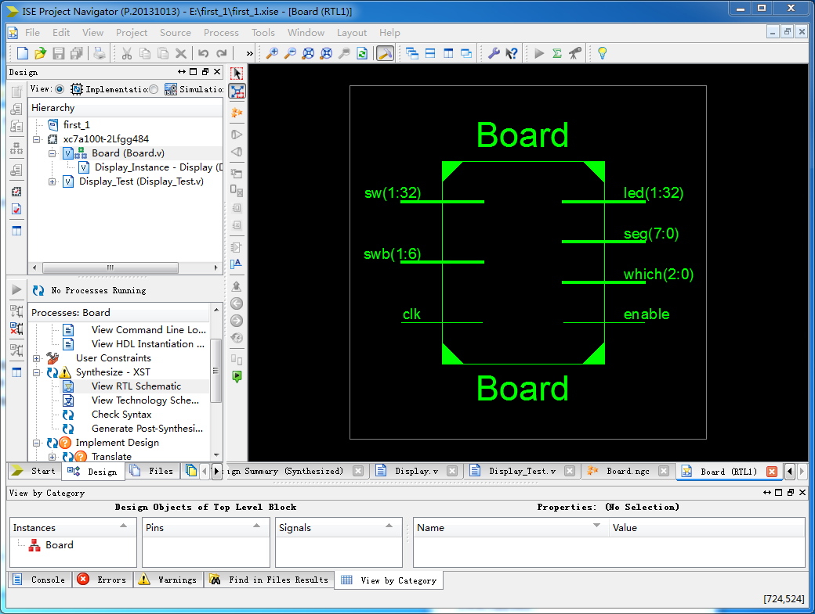
四、电路图（有就填，没有就不填）
五、引脚配置（约束文件，有就填，没有就不填））
// 开启比特流压缩，优化 .bit 文件大小
set_property BITSTREAM.GENERAL.COMPRESS TRUE [current_design]
//以下实现对 32 个开关管脚约束
set_property PULLDOWN true [get_ports sw]
set_property IOSTANDARD LVCMOS18 [get_ports sw]
set_property PACKAGE_PIN T3 [get_ports {sw[1]}]
set_property PACKAGE_PIN U3 [get_ports {sw[2]}]
set_property PACKAGE_PIN T4 [get_ports {sw[3]}]
set_property PACKAGE_PIN V3 [get_ports {sw[4]}]
set_property PACKAGE_PIN V4 [get_ports {sw[5]}]
set_property PACKAGE_PIN W4 [get_ports {sw[6]}]
set_property PACKAGE_PIN Y4 [get_ports {sw[7]}]
set_property PACKAGE_PIN Y6 [get_ports {sw[8]}]
set_property PACKAGE_PIN W7 [get_ports {sw[9]}]
set_property PACKAGE_PIN Y8 [get_ports {sw[10]}]
set_property PACKAGE_PIN Y7 [get_ports {sw[11]}]
set_property PACKAGE_PIN T1 [get_ports {sw[12]}]
set_property PACKAGE_PIN U1 [get_ports {sw[13]}]
set_property PACKAGE_PIN U2 [get_ports {sw[14]}]
set_property PACKAGE_PIN W1 [get_ports {sw[15]}]set_property PACKAGE_PIN W2 [get_ports {sw[16]}]
set_property PACKAGE_PIN Y1 [get_ports {sw[17]}]
set_property PACKAGE_PIN AA1 [get_ports {sw[18]}]
set_property PACKAGE_PIN V2 [get_ports {sw[19]}]
set_property PACKAGE_PIN Y2 [get_ports {sw[20]}]
set_property PACKAGE_PIN AB1 [get_ports {sw[21]}]
set_property PACKAGE_PIN AB2 [get_ports {sw[22]}]
set_property PACKAGE_PIN AB3 [get_ports {sw[23]}]
set_property PACKAGE_PIN AB5 [get_ports {sw[24]}]
set_property PACKAGE_PIN AA6 [get_ports {sw[25]}]
set_property PACKAGE_PIN R2 [get_ports {sw[26]}]
set_property PACKAGE_PIN R3 [get_ports {sw[27]}]
set_property PACKAGE_PIN T6 [get_ports {sw[28]}]
set_property PACKAGE_PIN R6 [get_ports {sw[29]}]
set_property PACKAGE_PIN U7 [get_ports {sw[30]}]
set_property PACKAGE_PIN AB7 [get_ports {sw[31]}]
set_property PACKAGE_PIN AB8 [get_ports {sw[32]}]
//以下实现对 8 个按键管脚约束
set_property IOSTANDARD LVCMOS18 [get_ports swb]
set_property PACKAGE_PIN R4 [get_ports {swb[1]}]
set_property PACKAGE_PIN AA4 [get_ports {swb[2]}]
set_property PACKAGE_PIN AB6 [get_ports {swb[3]}]
set_property PACKAGE_PIN T5 [get_ports {swb[4]}]
set_property PACKAGE_PIN V8 [get_ports {swb[5]}]
set_property PACKAGE_PIN AA8 [get_ports {swb[6]}]
set_property PACKAGE_PIN V9 [get_ports {swb[7]}] //注意：远程板卡上只有 6 个按键，
本程序用于远程实验时需删除本条语句
set_property PACKAGE_PIN Y9 [get_ports {swb[8]}] //注意：远程板卡上只有 6 个按键，
本程序用于远程实验时需删除本条语句
6//以下实现对 32 个 LED 灯管脚约束
set_property IOSTANDARD LVCMOS18 [get_ports led]
set_property PACKAGE_PIN R1 [get_ports {led[1]}]
set_property PACKAGE_PIN P2 [get_ports {led[2]}]
set_property PACKAGE_PIN P1 [get_ports {led[3]}]
set_property PACKAGE_PIN N2 [get_ports {led[4]}]
set_property PACKAGE_PIN M1 [get_ports {led[5]}]
set_property PACKAGE_PIN M2 [get_ports {led[6]}]
set_property PACKAGE_PIN L1 [get_ports {led[7]}]
set_property PACKAGE_PIN J2 [get_ports {led[8]}]
set_property PACKAGE_PIN G1 [get_ports {led[9]}]
set_property PACKAGE_PIN E1 [get_ports {led[10]}]
set_property PACKAGE_PIN D2 [get_ports {led[11]}]
set_property PACKAGE_PIN A1 [get_ports {led[12]}]
set_property PACKAGE_PIN L3 [get_ports {led[13]}]
set_property PACKAGE_PIN G3 [get_ports {led[14]}]
set_property PACKAGE_PIN K4 [get_ports {led[15]}]
set_property PACKAGE_PIN G4 [get_ports {led[16]}]
set_property PACKAGE_PIN K1 [get_ports {led[17]}]
set_property PACKAGE_PIN J1 [get_ports {led[18]}]
set_property PACKAGE_PIN H2 [get_ports {led[19]}]
set_property PACKAGE_PIN G2 [get_ports {led[20]}]
set_property PACKAGE_PIN F1 [get_ports {led[21]}]
set_property PACKAGE_PIN E2 [get_ports {led[22]}]
set_property PACKAGE_PIN D1 [get_ports {led[23]}]
set_property PACKAGE_PIN B1 [get_ports {led[24]}]
set_property PACKAGE_PIN B2 [get_ports {led[25]}]
set_property PACKAGE_PIN N3 [get_ports {led[26]}]
set_property PACKAGE_PIN M3 [get_ports {led[27]}]
7set_property PACKAGE_PIN K3 [get_ports {led[28]}]
set_property PACKAGE_PIN H3 [get_ports {led[29]}]
set_property PACKAGE_PIN N4 [get_ports {led[30]}]
set_property PACKAGE_PIN L4 [get_ports {led[31]}]
set_property PACKAGE_PIN J4 [get_ports {led[32]}]
// 以下实现对数码管管脚约束
set_property IOSTANDARD LVCMOS18 [get_ports seg]
set_property PACKAGE_PIN H19 [get_ports {seg[7]}]
set_property PACKAGE_PIN G20 [get_ports {seg[6]}]
set_property PACKAGE_PIN J22 [get_ports {seg[5]}]
set_property PACKAGE_PIN K22 [get_ports {seg[4]}]
set_property PACKAGE_PIN K21 [get_ports {seg[3]}]
set_property PACKAGE_PIN H20 [get_ports {seg[2]}]
set_property PACKAGE_PIN H22 [get_ports {seg[1]}]
set_property PACKAGE_PIN J21 [get_ports {seg[0]}]
set_property IOSTANDARD LVCMOS18 [get_ports which]
set_property PACKAGE_PIN N22 [get_ports {which[0]}]
set_property PACKAGE_PIN M21 [get_ports {which[1]}]
set_property PACKAGE_PIN M22 [get_ports {which[2]}]
set_property -dict {IOSTANDARD LVCMOS18 PACKAGE_PIN L21} [get_ports enable]
set_property -dict {IOSTANDARD LVCMOS18 PACKAGE_PIN H4} [get_ports clk]
// [Place 30-574] Poor placement for routing between an IO pin and BUFG.If this
// sub optimal condition is acceptable for this design, you may use the
// CLOCK_DEDICATED_ROUTE constraint in the .xdc file to demote this message to a
// WARNING. However, the use of this override is highly discouraged.
set_property CLOCK_DEDICATED_ROUTE FALSE [get_nets clk_IBUF]
set_property CLOCK_DEDICATED_ROUTE FALSE [get_nets swb_IBUF[1]]
set_property CLOCK_DEDICATED_ROUTE FALSE [get_nets swb_IBUF[2]]
89
set_property CLOCK_DEDICATED_ROUTE FALSE [get_nets swb_IBUF[3]]
set_property CLOCK_DEDICATED_ROUTE FALSE [get_nets swb_IBUF[4]]
set_property CLOCK_DEDICATED_ROUTE FALSE [get_nets swb_IBUF[5]]
set_property CLOCK_DEDICATED_ROUTE FALSE [get_nets swb_IBUF[6]]
//注意：远程板卡上只有 6 个按键，本程序用于远程实验时需删除最后 2 条语句
set_property CLOCK_DEDICATED_ROUTE FALSE [get_nets swb_IBUF[7]]
set_property CLOCK_DEDICATED_ROUTE FALSE [get_nets swb_IBUF[8]]
六、实验分工（需写清楚每个人负责的工作，以及个人贡献在小组总工作量中的占比）
实验由应宇杰和于龙轩合作完成，于龙轩完成完成配置环境，代码编写，语言编译和硬件烧录
应宇杰完成功能测试环节，报告编写任务。
七、实验收获（心得体会等，请以个人为单位分别写）
成功完成通过实验1，我学会了如何使用Xlinx Vadio，花费了大量时间来配置环境，安装IDE，
根据已有的学习资料掌握了Verilog语法，并成功了运行给出的代码，
在运行的代码过程中，遇到了管角约束错误的问题，经过探讨我们发现原来IDE语言结构异构，所导致语言Translate失败，根据报错以及语法提示，我将其成功更改正确，并顺利运行。

