***Dear Fellow ECoG Researcher,***

These are some of the cue-based movement, imagery, and feedback data described in the Proceedings of the National Academy (PNAS) 2010 Manuscript titled: “**Cortical activity during motor execution, motor imagery, and imagery-based online feedback**”. The patients are a subset of the patients from that study.

Miller, Kai J., Gerwin Schalk, Eberhard E. Fetz, Marcel Den Nijs, Jeffrey G. Ojemann, and Rajesh PN Rao. "Cortical activity during motor execution, motor imagery, and imagery-based online feedback." *Proceedings of the National Academy of Sciences* (2010): 200913697.

Please keep in mind that these anonymized data are from real patients who donated time in a difficult period of their lives to advance our understanding of the brain. Any publication involving these data **MUST** include the following in the methods section of the manuscript, without modification:

**Ethics statement:** All patients participated in a purely voluntary manner, after providing informed written consent, under experimental protocols approved by the Institutional Review Board of the University of Washington (#12193). All patient data was anonymized according to IRB protocol, in accordance with HIPAA mandate. It was made available through the library described in “A Library of Human Electrocorticographic Data and Analyses” by Kai Miller [Reference], freely available at <https://searchworks.stanford.edu/view/zk881ps0522>. These data originally appeared in the manuscript *“Cortical activity during motor execution, motor imagery, and imagery-based online feedback”* published in PNAS in 2010 [Reference].

**The patient code names corresponding to the subject numbers in the manuscript are:**

* AL-S6 (control channel is 36)
* FP-S2 (control channel is 24 for hand, and 22 for tongue)
* HH-S8 (control channel is 11)
* JC-S1 (control channel is 13)

NOTE: ALL SUBJECTS are displayed together in supplemental Fig. S6.

Clipped table from paper:

|  |  |  |  |  |  |
| --- | --- | --- | --- | --- | --- |
| **Patient** | **Age** | **Sex** | **Hand** | **Grid Location** | **Seizure Focus** |
| 1 | 18 | F | R | L Frontal | L Frontal |
| 2 | 23 | M | R | L Frontotemporal | L Temporal |
| 6 | 31 | F | R | R Frontotemporal | R Insula |
| 8 | 32 | M | R | R Frontotemporal | L Temporal |

**“Cue-based movement task”** *The basic datafiles (in MATLAB format) are named “##_mot_XX.mat” in the folder data/##, where ## denotes the 2 letter patient code (this is not the patient’s initials), and XX notes the types of task(s)****:***

* XX=’_h’: Patients performed simple, repetitive, hand movement (synchronous flexion and extension of all fingers, i.e., clenching and releasing a fist), contralateral to the side of cortical grid placement.
* XX=’_t’: Patients performed simple, repetitive, tongue extension (opening of mouth with protrusion and retraction of the tongue, i.e., sticking the tongue in and out).
* XX=’_ih’: Patients performed simple, repetitive, hand movement (synchronous flexion and extension of all fingers, i.e., clenching and releasing a fist), *ipsilateral* to the side of cortical grid placement.
* XX=’_shrug’: Patients performed simple, repetitive, shrugging (raising of the contralateral shoulder toward the head).
* XX=’_mov’: Patients audibly repeated the word “move”.
* XX=’_l’: Patients performed simple, repetitive, adduction and abduction at the hip, contralateral to the side of cortical grid placement.

These movements were performed in an interval-based manner while cued to do so, alternating between movement and rest, and movements were self-paced, generally at ~1-2Hz. There were between 30 and 75 cue presentations for each movement modality. Cues for motor movement were delivered visually in a 10 x 10 cm presentation window at a distance of 75–100 cm from patient. Visual cues were presented using the BCI 2000 program with a written word indicating the specific body part to be moved (typically, multiple movement types were interleaved in each experimental run). Stimuli were presented for 2 s or 3 s cue blocks, followed by rest intervals (indicated by a blank screen) of the same length. The patients were instructed to perform repetitive, self-paced motor movement, alternating with rest intervals of the same length (indicated by the absence of the cuing target). Repetitive motion, rather than tonic contraction, was intended to accentuate the spectral shift during each interval.

**“Cue-based imagery task”** *The basic datafiles (in MATLAB format) are named “##_im_XX.mat” in the folder data/##, where ## denotes the 2 letter patient code. This code is not the patient’s initials****.*** *XX notes the types of task(s), as defined above.* Following the overt movement experiment, each subject performed an imagery task, imagining making identical movement rather than executing the movement. The imagery was kinesthetic rather than visual (“imagine yourself performing the actions like you just did”; i.e., “don’t imagine what it looked like, but imagine making the motions”).

**“Imagery-Based Cursor Feedback task”** *The feedback datafiles (in MATLAB format) are named “##_fb_XX.mat” in the folder data/##, where ## denotes the 2 letter patient code. This code is not the patient’s initials****.*** *XX notes the types imagery the patient was instructed to perform during feedback. The file used is the final trial run – the patient will already have had a few minutes of training (e.g. Run 4 from figure 3 in the manuscript is the datafile for ‘JC’ – “jc_fb_mov.mat”, corresponding to the 4th trial run, imagining saying the word “move”).* Following the overt and imagery experiment, each subject participated in an imagery-based learning task. Experimenters then visually selected a feedback feature from the imagery task, a particular electrode and frequency combination, to be used for online cursor control. That frequency-range power from a particular electrode was coupled to the speed of a computer cursor using a simple linear relation. Targets were presented in random order, in one of two locations on the periphery of the screen (e.g., up/down or left/right). The subject was instructed to imagine (again, via kinesthetic imagery) a particular movement to move a cursor toward one target (the “active” direction), and to rest (or “idle”) to move the cursor to the other target (the “passive” direction). The active and passive targets were presented in a block-randomized fashion, and in approximately equal numbers. The coupling was meant to be intuitive (i.e. for hand imagery – increased power in high frequencies would pull cursor toward direction of hand in a left/right cursor task). A trial was terminated when the cursor hit any target or when movement time exceeded a fixed duration (7.2 s). A trial was followed by a 1-s “reward” period during which the target turned yellow if the correct target was hit. The reward period was followed by a 1-s rest (ITI) period during which the screen was blank before the next trial began. A trial was considered a “miss” if the wrong target was hit or the timeout length was reached.

Each movement (*“##_mot_XX.mat”*) or imagery (*“##_im_XX.mat”*) datafile has 2 variables:

* "StimulusCode" (time x 1): This is what was stimulus was on the screen at each point in time.

0: blank screen

11: tongue movement or imagery

12: hand movement or imagery

15: actually or imagining saying the word ‘move’

19: shoulder shrug or imagery

* "data" (time x number of channels): These are the data. I have attempted to remove the contaminated channels. Data were recorded with respect to a scalp reference.
* sampled at 1000Hz
* scale factor: 1 amplifier unit = .0298 microvolts
* built-in band pass 0.15 to 200 Hz,

- but a 1 pole band pass, so there is no sharp corner at 200Hz.

-The amplitude roll-off function is in the file “ns_1k_1_300_filt.mat”

Each feedback datafile (*“##_fb_XX.mat”*) has the following variables:

* "TargetCode" (time x 1): This is what was target was on the screen at each point in time.

0: No target

1: Target “A”

2: Target “B”

* "Result" (time x 1): This is what was target was “hit” on the screen at each point in time.

0: No target hit (i.e. active control or ISI)

1: Target “A” – if correct (e.g. Result==TargetCode), then cursor and target turn from red to yellow, as shown in figure 3A of manuscript.

2: Target “B” – if correct (e.g. Result==TargetCode), then cursor and target turn from red to yellow, as shown in figure 3A of manuscript.

* "ITI" (time x 1): Blank-screen inter-trial interval periods prior to onset of each control period.

0: Active control or Target Hit periods

1: Blank screen ITI

* "Cursor" (time x 1): Position of cursor (in arbitrary units) on the screen at each point in time. Note that Cursor position not relevant when “Result” is nonzero and not displayed when “ITI” is nonzero.
* "data" (time x number of channels): These are the data. I have attempted to remove the contaminated channels. Data were recorded with respect to a scalp reference.
* sampled at 1000Hz
* scale factor: 1 amplifier unit = .0298 microvolts
* built-in band pass 0.15 to 200 Hz,

- but a 1 pole band pass, so there is no sharp corner at 200Hz.

-The amplitude roll-off function is in the file “ns_1k_1_300_filt.mat”

For all patients, there is a file titled “##_electrodes.mat” in the folder electrodes/##,

Each file contains a single variable:

* "electrodes" (number of channels x 3): Electrode locations, in Taliarach coordinates, for plotting on the standardized brain. These were obtained using the LOC package, and can be plotted with it as well (code in “loc” folder). From “*Cortical electrode localization from X-rays and simple mapping for electrocorticographic research: The “Location on Cortex” (LOC) package for MATLAB*” in J Neurosci Meth, 2007.

In order to reproduce the analyses from the manuscript (shown in full in Supplemental figure S6, reproduced below), open and examine the file “MIF_master.m” from the Mot_Im_FB project folder. Each step of analysis is shown clearly in the functions called from these files. The subjects are cycled through from “call_MIF_master.m”

Some considerations for these data and analyses:

- Note that electrode montages may be different from same task in same patient elsewhere in this library (when electrodes were artifactual for a different task within the same experiment, those electrodes would be deleted across to the board, to ensure consistent montage across all tasks for the experiment).

- I have rewritten new code to analyze these data to compensate for MATLAB software updates, and I have not rejected all bad channels from these data. There may be small differences with the manuscript because of this.

Best Wishes!

Kai Miller, Stanford University, 2015 (revised 2018)

[kai.miller@stanford.edu](mailto:kai.miller@stanford.edu), miller.kai@mayo.edu

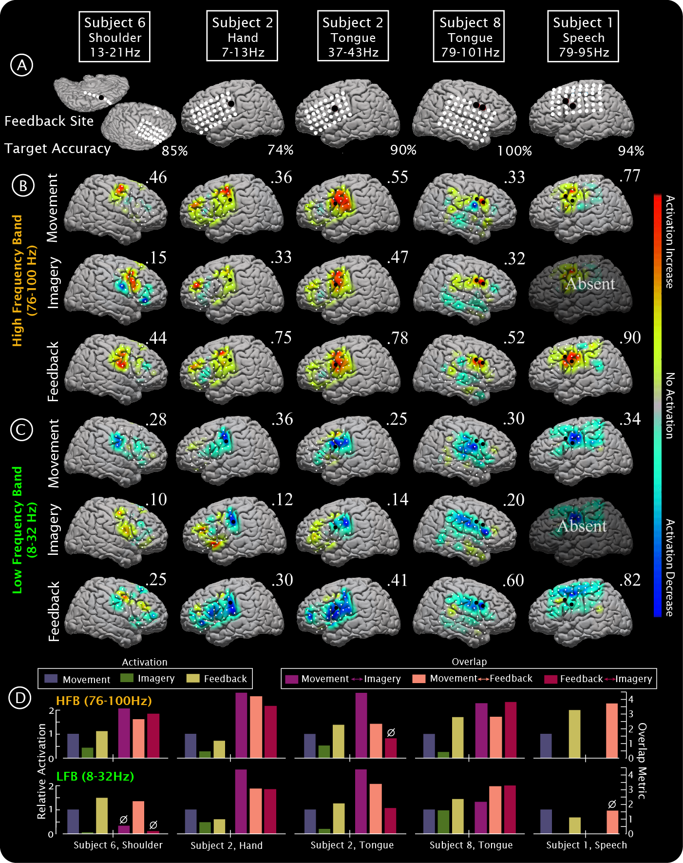**Figure S6:** **Augmentation of cortical activity during learning.** **(A)** Site of feedback is shown with a black dot, and electrode positions for subjects 6, 2, 8, and 1. The box above each template brain indicates the subject, the paired motor/imagery/feedback modality, and the frequency range used for feedback. The feedback accuracy is the percentage of time the subject was able to hit the correct target using this feedback feature. ‘Speech’ for subject 1 was repetition of the word “move”. **(B)** HFB (76-100Hz) ECoG-based brain activation maps for actual movement, imagined movement, and feedback-based BCI cursor control. Activation in each map is scaled to the maximum activation (absolute-value, noted by the number above each template brain). Subject 1 did not perform a speech (word repetition) imagery task. **(C)** As in B, for the LFB (8-32Hz). **(D)** The relative activation (also shown in figure 5 of the main text) during each of the three conditions is shown for the HFB (upper) and LFB (lower) on the left side of each set of axes, for each subject. The overlap between each of the conditions is shown with the purple/pink/magenta bars, for the HFB (upper) and LFB (lower) on the right side of each set of axes, for each subject.