Cue Weighting in L2 Stress Perception

|  |
| --- |
| Jessyca Campos1 |
| 1 Rutgers University |
| NULL NULL |
|  |

# Author note

Correspondence concerning this article should be addressed to Jessyca Campos, . E-mail: [jac706@rutgers.edu](mailto:jac706@rutgers.edu)

Abstract

*Keywords:*

Word count:

Cue Weighting in L2 Stress Perception

# Introduction

The goal of this study is to analyze the influence of syllable weight on the perception of stress by late L2 learners of Spanish. How do late L2 learners of Spanish decide where to place lexical stress in the absence of acoustic cues? The hypothesis being tested is that late learners will rely on the weight of the syllable to aid them in perceiving stressed syllables. As proficiency increases in the L2, the perception of stressed syllables becomes more and more native-like, therefore, we expect a positive correlation between a learner’s proficiency and their ability to perceive the correct stressed syllable. The overarching question driving this study is: to what extent does the phonological structure of language influence speech perception? (adopted from Hume & Johnson (1999)). We expect the late learner to become more attuned to the unmarked Spanish stress patterns as they become more proficient in the language. To test the effects of syllable weight on stress perception an experiment was designed in which disyllabic nonce words were created and synthesized. Three nonce word used in the study, *fafa*, *fufu*, and *fafal*. The data of interest in this experiment were those in which acoustic correlates were neutral in regard to stress in *fafa* and *fafal*. We will be comparing the proportion of oxytone responses provided by participants for each of the two conditions (*fafa*, *fafal*) based on the participants proficiency in Spanish.

# Methods

## Participants

68 subjects took part in this study. The subjects that took part in the study were second language learners of Spanish of varying proficiencies from Middleberry College. Participants did not know the purpose of the study before beginning the experiment but were informed afterwards if they were interested. None of the participants had any language or hearing impairments.

## Stimuli

The stimuli in this study were modified natural recordings of the words *fafa*, *fufu*, and *fafal* produced by a female speaker then manipulated in Praat (Boersma & Weenink, 2016). The nonce words were chosen for this study because they do not violate any phonological constraints in either Spanish or English. Combinations of different measures of duration and intensity were created for each of the words which produced stressed syllables that were either clear paroxytone, paroxytone, neutral, oxytone, or clear oxytone (see Llebraria & Prieto (2016) for a detailed explanation of how the stimuli were manipulated). There were a total of 25 different combinations of duration and intensity for each word. In all, the participants heard 300 words during the course of the experiment (25 variations x 3 words x 4 repetitions = 300 total). Although other stimuli were presented to the participants during the experiment, this study focuses on the data where the intensity and duration were 0. It is also important to note that the words were said in isolation to ensure that the experiment was solely analyzing lexical stress and not influenced by pitch accents.

## Procedure

Upon completing a proficiency test, the participants completed a two-alternative forced choice task on a computer implemented through the PyschoPy II software (Pierce 2009), in which they were asked to identify the location of stress (first or second syllable) in disyllabic nonce words *fafa*, *fufu*, and *fafal* by clicking the ‘1’ or ‘0’ keys on the keyboard. The participants were instructed to wear headphones and select ‘1’ if they perceived the stress to fall on the first syllable of the word and ‘0’ if they thought stress fell on the second syllable. The participants heard the audio stimuli while the words were displayed on the screen with the first or second syllable capitalized (denoting the stressed syllable) on the right-hand or left-hand side. The order in which the words were presented to the participants was randomly assigned. The participant needed to complete the cycle of the randomly assigned word (25 variations x 1 word x 4 repetitions) before moving forward to the other words. They were offered a break at the end of each cycle. The average time to complete the experiment was 20 minutes. The results of the proficiency test and perception experiment were recorded by the computer and collected at the end of the experiment.

# Results

The results of the experiment were compiled and analyzed in R. We used R (Version 3.4.3; R Core Team, 2017) and the R-package *papaja* (Version 0.1.0.9709; Aust & Barth, 2018) for all our analyses. The packages *Tidyverse()* (Wickham 2016) and *rsq()* (Zhang 2017) were also used. The data was analyzed using a general linear model to see if the proportion of oxytone responses differed as a function of condition ( *fafa* / *fafal* ) and proficiency. The model included proportion of oxytone responses as the dependent variable, and condition ( *fafa* / *fafal* ) and proficiency as the independent variables. A *fafal* response was coded as “1” and a *fafa* response was coded as “0.” The data was centered by proficiency. Significance of main effects and interactions were assessed using hierarchical partitioning of the variance via nested model comparisons. A visual inspection of Q-Q plots indicate that the residuals are normally distributed. Other model diagnostics concluded that the mean of residuals is zero and were homoscedastic, there were no autocorrelation of residuals. Experiment-wise alpha was set at 0.05.

The plot shows the proportion of Oxytone responses as a function of proficiency (centered) and condition ( *fafa* , *fafal* ).

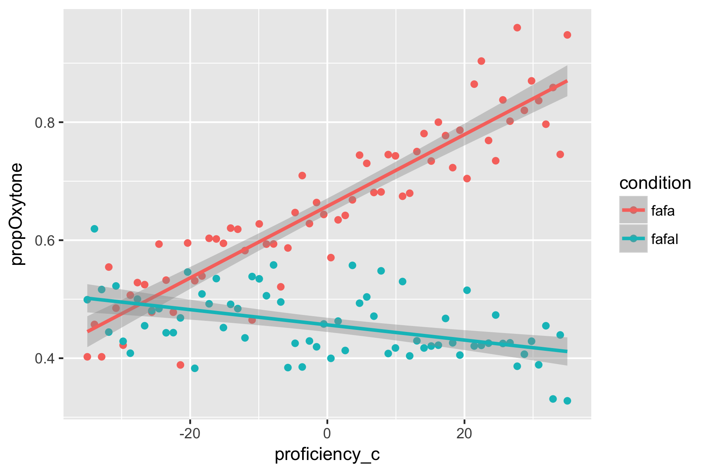

The model revealed a main effect of *proficiency* [$χ$ ^2(1)= 0.3277; p< 0.01] and of *condition* [$χ$ ^2(1)= 1.3752; p< 0.01]. There was a *proficiency x condition* interaction [$χ$ ^2(1)= 0.7756; p< 0.01] which makes interpreting the main effects challenging. Visual inspection of the plot suggests that the *fafal* condition had higher values than the *fafa* condition. The best model was the model with the *condition x proficiency* interaction, 87.24% of the variance in the predictors in this model were accounted for by the response variable [R^2 = 0.8724]. Due to an error in coding the propOxytone responses, the values for the *fafa* condition correspond to those of the *fafal* condition and vice versa. There was a negative correlation between the *fafa* condition and proficiency; as proficiency increased, participants were less likely to perceive the word as being stressed on the first syllable (paroxytone) [ $β$ = -0.2011; CI = -0.2187, -0.1835; SE = 0.0089; p < 0.001]. On the contrary, there was a positive relationship between the *fafal* condition and the proportion of oxytone responses; as proficiency increased participants were more likely to perceive stress on the final syllable [ $β$ = 0.6576; CI = 0.6452, 0.6701; SE = 0.0064; p < 0.001]. The model revealed that when confronted with disyllabic nonce words in Spanish, late learners complied with the unmarked stress patterns and perceived stress on the first syllable if the syllable was light and stress on the final syllable if the final syllable was heavy. Results of this analysis indicate that syllable weight is a determiner in the perception of stress by late learners of Spanish.

# Discussion

Findings support the hypothesis that late learners of Spanish use the weight of the syllable in the absence of acoustic cues to aid in the perception of stress. This was shown to be in true for both conditions ( *fafa* , *fafal* ). As proficiency increased the proportion of oxytone responses increased when the final syllable was heavy, in other words, learners perceived the final syllable to be stressed when the final syllable was heavy. We also saw that as proficiency increased the proportion of oxytone responses decreased in disyllabic words with light syllables.

When presented with an unfamiliar word, late learners will use analogies, words in their L1 or L2 that share similar phonological or morphological features to the unfamiliar word, to guide them in emphasizing the correct syllable. Novice leaners tend to revert to their L1 when looking for analogies while more experienced learners use their L2 since their lexicon is more developed. The errors novice learners make in finding analogies in their L1 is due to the fact that their predictions of stress placement in the target language are based on rules and constraints of their native language. Novice English-speaking learners of Spanish have been shown to revert to their L1 stress system which lead them to predict antepenultimate stress since the default stress pattern in English is to stress the antepenultimate syllable (Bullock and Lord 2003). As proficiency increases the learner becomes more attuned to the unmarked stressed patterns of their L2, which, in Spanish, is to stress the penultimate syllable in words that have light final syllables and the final syllable in words that have a heavy final syllable.

The second half of this discussion is more theoretically driven. The overarching question driving this study was: to what extent does the phonological structure of language influence speech perception? Syllable weight influencing the perception of stress by late learners of Spanish shows that phonological structure of language influences speech perception to an extent. Further, the acquisition of Spanish Stress rules by non-native speakers can be analyzed in terms of Optimality Theory. In terms of OT, the faithfulness constraints that the language is bound to follow and violate are the suprasegmental features such as fundamental frequency (F0), duration, intensity, and vowel spectra. Syllable weight is argued to be another constraint in a language that is dominated by the acoustic correlates of stress. The unmarked structure will emerge when the other acoustic correlates are neutralized leaving the candidates to either remain faithful or violate the syllable weight constraint. It is important to note that the acoustic correlates of stress need to be absent in order to study the effect syllable weight has on perception. If syllable weight were a constraint the language needed to be faithful to, the ranking of the constraint would be dominated by the acoustic correlates that have been proven to indicate stress. This would mean that the unmarked rules in Spanish emerge through the role of syllable weight in stress perception.

# Conclusion

The present study examined the influence of syllable weight on the perception of stress by late learners of Spanish. Findings support the hypothesis that late learners of Spanish use the weight of the syllable in the absence of acoustic cues. This suggests that as a learner’s proficiency increases they are becoming more attuned to the unmarked stress patterns in Spanish. This is important because it supports the claim that phonological structure of language influences speech perception.

# References

Aske, J. (1990). Disembodied rules versus patterns in the lexicon: Testing the psychological reality of Spanish stress rules. In K. Hall, J. P. Koenig, M. Meacham, S. Reinman, & L. A. Sutton (Eds.), Proceedings of the Sixteenth Annual Meeting of the Berkeley Linguistics Society (pp. 30-45).

Aust, F., & Barth, M. (2018). papaja: Create APA manuscripts with R Markdown. Retrieved from <https://github.com/crsh/papaja>

Bullock, B., & Lord, G. (2003). Analogy as a learning tool in second language acquisition: The case of Spanish stress. Amsterdam studies in the theory and history of linguistic science, 281-297.

Chrabaszcz, A., Winn, M., Lin, C. Y., & Idsardi, W. J. (2014). Acoustic cues to perception of word stress by English, Mandarin, and Russian speakers. Journal of Speech, Language, and Hearing Research, 57(4), 1468-1479.

Face, T. L. (2000). The role of syllable weight in the perception of Spanish stress. In H. Campos, E.Herburger, A. Morales-Front, & T. J. Walsh (Eds.), Hispanic linguistics at the turn of the millennium (pp. 1-13). Somerville, MA: Cascadilla Proceedings Project.

Face, T. L. (2005). Syllable weight and the perception of Spanish stress placement by second language learners. Journal of Language and Learning, 3(1), 90-103.

Peirce, JW (2009) Generating stimuli for neuroscience using PsychoPy. Front. Neuroinform. 2:10. <doi:10.3389/neuro.11.010.2008>

R Core Team. (2017). R: A language and environment for statistical computing. Vienna, Austria: R Foundation for Statistical Computing. Retrieved from <https://www.R-project.org/>

Aust, F., & Barth, M. (2018). *papaja: Create APA manuscripts with R Markdown*. Retrieved from <https://github.com/crsh/papaja>

R Core Team. (2017). *R: A language and environment for statistical computing*. Vienna, Austria: R Foundation for Statistical Computing. Retrieved from <https://www.R-project.org/>