Movie Recommendation System

Daniel Agbay
danielagbay@gmail.com
Jessica Clappison
Clappis2@msu.edu

ABSTRACT

For this project, a movie recommendation system was created using movieLens and imDB data. This was accomplished by processing this provided data and running it through and efficient algorithm via python, then tying that algorithm to a user interface. Our worked resulted in a site that recommends what it found to be the five movies the user would most likely enjoy viewing.

INTRODUCTION

The project’s goal was to create an accurate movie recommendation site. Previous in class exercises, such as the pyspark exercise assisted us in accomplishing this task. Additionally, we referenced lectures 16, 25 and 26 from the CSE 482 site. Challenges that needed to be addressed were how to effectively cut down the data in addition to finding the most accurate algorithm to run that data on. We found that the algorithm we created has an average accuracy RMSE accuracy of 0.843833 and an MAE accuracy of 0.6778 when tested with multiple users.

PRELIMINARIES

Permission to make digital or hard copies of all or part of this work for personal or classroom use is granted without fee provided that copies are not made or distributed for profit or commercial advantage and that copies bear this notice and the full citation on the first page. To copy otherwise, or republish, to post on servers or to redistribute to lists, requires prior specific permission and/or a fee.
Conference’04, Month 1–2, 2004, City, State, Country.
Copyright 2004 ACM 1-58113-000-0/00/0004…$5.00.

The data that was collected from the imDB were two tab separated files. One contained columns consisting of the alphanumeric unique identifier of the title, the type/format of the title, the more popular, the original title, if it was an adult title, the release year of a title, the TV Series end year, the primary runtime of the title and the genres. While the other contained the alphanumeric unique identifier of the title, the weighted average of all the individual user ratings and number of votes the title has received. These two files were combined by the alphanumeric identifiers and condensed down to having the identifiers, movie titles, ratings and genres. We did not use this parsed data in our final analysis. The data we did use was from movieLens. We took two files from the site to get our final dataset. The first file contained movieIDs, titles and genres as its columns and the second consisted of userID, movieID, rating and timestamp as it columns. These files were combined by their movieID via pyspark and reduced down to just containing the userID, title and rating. This data was then further reduced by removing users who have not rated more than 250 movies as well as to only contain movies that have been rated at least 500 times. Our final dataset contains 9739525 rows of information. Once that data was reduced, it was loaded into python where several surprise algorithms were ran on it until we had determined which one was most accurate. We ran NMF, knnBasics and SVD on the data and found that the NMF algorithm resulted in the most accurate analysis. The NMF algorithm, or non-negative matrix factorization, is a collaborative filtering technique used to predict how well a user will like on item based on previous judgments by finding non negative matrix factors from a given matrix.

METHODOLOGY
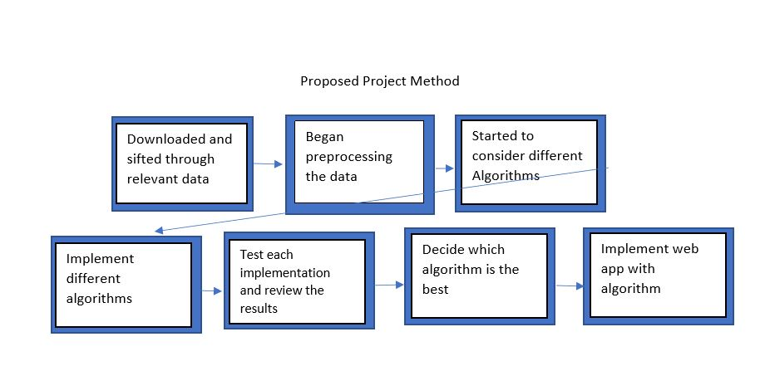
The first module involved just downloading the datasets from the imDB and movielens site. Once downloaded, the information was looked over and we determined what columns we would need in the processing stage.
The second column is when we finally started processing the data. The data was processed by combining two relevant files form each site into one dataset that only contained relevant columns (title, rating, userID). The data was then further processed by cutting out underrated movies and users who did not provide a lot of ratings.
The third module is when we thought about what algorithms to apply to our dataset. Our dataset followed the formatting that is needed to use the python extension surprise, so we decided that was our best option.
The fourth module was when we ran multiple surprise algorithms on our datasets. We used kNNbasics, NMF and SVD.
The fourth and fifth module is when we ran multiple test sets on those algorithms to see which was the most accurate. The tests resulted in us choosing NMF.
The final module involved use connecting our python code into the user interface.
Early on we ran into troubles with processing our data. The files were so large that it was impossible to process on python alone. Once we learned about how to use Hadoop, it became easier to process the data. We did not fully complete processing our data until we learned about pyspark. After we processed the data, finding an algorithm was relatively easy with the help of the python extension surprise, and we did not run into and further major issues.
We found in modules 4 and 5 that the best method to find a user’s movie recommendation was the NMF surprise algorithm.

EXPERIMENTAL EVALUATION

Experimental Setup
Before the dataset we used was preprocessed, the two movieLens tables movies.csv and ratings.csv were processed they consisted of the columns movieID, title, genres and userID, movieID, rating, timestamp. The movies.csv file had 27.278 columns while the ratings one had 20000263 columns. After processing we ended up with a tab separated file containing the columns userID, title and ratings which had 9739525 rows.
To validate the results, several test cases where run on the multiple surprise algorithms and the algorithm with the highest accuracy was chosen.
The East N. Viginia Hadoop cluster was used. One which contained pyspark and another that had Pig. Additionally, a digital lotion droplet was used to host our user interface.
For our final project we used pyspark to process the data, html and php to create our user interface and python to process our dataset.
We first trying to process the data we had used Pig, but the datasets from Pig were not used in the final project.
2/9/18 – Both started project proposal.
2/11/19 – Completed and turned in project proposal.
3/15/18-3/17/18 - Began preprocessing data
Jessica: Downloaded movies.csv and ratings.csv, loaded them into data frames. Removed unwanted fields.
Daniels: Downloaded title.basics.tsv.gz and title.ratings.tsv.gz, loaded them into data frames. Removed unwanted fields
4/11/18 – Learned about Hadoop and larger data processing methods so re-processed out data.
Jessica: Downloaded movies.csv and ratings.csv into Pig. Combined and reduced it to containing movieID, title, genres, userID and rating.
Daniels: Downloaded title.basics.tsv.gz and title.ratings.tsv.gz in Pig. Combined and reduced it.
4/23/18 – Jessica & Daniel: Found pyspark to be a more effective tool so both worked together to re-reduce movieLens data.
4/28/18- Jessica: Loaded in movieLens data and ran multiple algorithms on data and test sets until found one with most accurate results.
Daniel: Completed user interface capable of logging in, adding user, and making movie ratings.
4/29/18- Jessica: Typed out report
Daniel: combined user interface and python code.

Experimental Results
URL: https://github.com/jessclappis/cse482project
Using the movieLens data, a test was run on the three algorithms to determine which was the most accurate. The ratings were pulled from multiple users and then run in the three algorithms to see what was predicted versus what the actual ratings was. This was done in the project-tests.ipynb script. We found that the NMF algorithm had an average RMSE of 0.843833 and MAE of 0.6778. We also found the SV algorithm had an average RMSE of 0.7472 and MAE of 0.5896 and the kNNbasic to have an average RMSE of 0.7472 and MAE of 0.5896.

Discussion
The results found that the knnBasic and SV algorithm resulted in the same predictions, but that both were less accurate than the NVM algorithm.

CONCLUSIONS
Unfraternally our data had encoding issues and could not work on the final site. We ran all of our work on the test user Daniel under the file projectscrpt.ipyb. We completed the site by using the build in surprise dataset for movieLens. For future work we could find a way to encode our datasets to be capable of working on the web browser.

