A Web-Based Point of Sale and Inventory System for Auto Repair Garages

189730
190527

ICS 3 Group: C

Supervisor: Emmanuel Olang

An Informatics and Computer Science Project Proposal Submitted to the School of Computing and Engineering Sciences (SCES) in partial fulfilment of the requirements for the award of a Bachelor of Science Degree in Informatics and Computer Sciences

School of Computing and Engineering
Science Strathmore University
Nairobi, Kenya

19 May 2026

Declaration and Approval
We declare that this work has not been previously submitted and approved for the award of a degree by this or any other University. To the best of our knowledge and belief, the research proposal contains no material previously published or written by another person except where due reference is made in the research proposal itself.

Student Name: Kamwaro Jesse Kariuki
Number: 189730
Student Signature: _________________________ Date: ________________________

Student Name: Getahun Tsedenya Wondwessen
Admission Number: 190527
Student Signature: ________________________ Date: ________________________

Supervisor Name: Emmanuel Olang
Supervisor Signature: _________________________ Date: _______________________

Abstract
Auto repair garages need to have effective systems to handle service billing and spare parts inventory to sustain profitability and to maintain smooth operations. Nevertheless, a significant number of garages still have to use disjointed digital tools or archaic manual record-keeping procedures. The result of these methods tends to give inaccurate stock records of fast-moving components of vehicles and untracked credit transactions. Consequently, owners of garages cannot have real-time access to inventory and financial data, which prevents them from making effective decisions and causes delays in service delivery and operational inefficiencies.
This project suggests the creation of a web-based Point of Sale and Inventory System that is specifically geared towards auto repair garages. The system will centralize and automate the major operational processes such as inventory management of spare parts, recording of service and sales transactions, and monitoring of customer and supplier credit. It also introduces automated low-stock notifications and simple reporting features to enhance inventory visibility and facilitate timely decision-making.
OOAD will be used to develop the system. It will be implemented as a full-stack web application using React for the frontend and Spring Boot for the backend. Postman will be used to test API functionality to ensure reliability and security.
Functional testing will be carried out to evaluate the system and ensure accuracy in inventory management and service billing. The anticipated result is an efficient and scalable system that replaces manual processes with a computerized solution, improving accuracy, transparency, and overall operational efficiency in auto repair garages

Acknowledgement
First and foremost, we thank God for the strength, guidance, and good health throughout this work. We sincerely appreciate our project supervisor, Mr. Emmanuel Olang, for his invaluable guidance, constructive feedback, and continuous support during the development of this project proposal. His insights have greatly shaped the direction of this work. We also extend our gratitude to Mr. Daniel Machanje, the Computer Science project lecturer, for his academic guidance and support throughout this study. Special thanks go to the School of Computing and Engineering Sciences for providing a conducive learning environment and the necessary resources that supported this work. Finally, we appreciate our families and friends for their encouragement, patience, and moral support throughout this journey. We also acknowledge all authors and researchers whose work contributed to the foundation of this study.

Table of Contents
Declaration and Approval ii
Abstract iii
Acknowledgement iv
Table of Contents v
List of Figures viii
List of Tables ix
Abbreviations x
Chapter 1: Introduction 1
1.1 Background Information 1
1.2 Problem Statement 2
1.3 Objectives 3
1.3.1 General Objective 3
1.3.2 Specific Objectives 3
1.3.3 Research Questions 3
1.4 Justification 4
1.5 Scope 4
1.6 Limitations 4
1.7 Delimitations 5
Chapter 2: Literature Review 6
2.1 Introduction 6
2.2 Overview of POS System 6
2.3 Inventory Management Systems in the Automotive Industry 6
2.4 Credit Management in Auto Repair Garages 7
2.5 Web-Based Information Systems in Small and Medium Enterprises 8
2.6 Technologies Related to the Study 8
2.6.1 RepairShopr 9
2.6.2 Workshop Software 10
2.6.3 Odoo (Inventory and POS Modules) 11
2.6.4 Garage Management System (GMS) by AutoLeap 11
2.6.5 Custom Web-Based POS Systems in Academic Literature 12
2.7 Comparative Analysis of Related Systems 12
2.8 Gaps in Related Works 13
2.9 Conceptual Framework 13
Chapter 3: Methodology 16
3.1 Introduction 16
3.2 Incremental Development Method 16
3.2.1 Requirement Analysis 16
3.2.2 Design 17
3.2.3 Implementation 17
3.2.4 Testing 17
3.2.5 Deployment 17
3.3 System Analysis 17
3.3.1 Use Case Diagram 17
3.3.2 System Sequence Diagram 18
3.3.3 Entity-Relationship Diagram 18
3.3.4 Activity Diagram 18
3.4 System Design 18
3.4.1 Class Diagram 18
3.4.2 Sequence Diagram 18
3.4.3 Database Schema 19
3.4.4 Wireframes 19
3.5 System Development Tools and Techniques 19
3.5.1 React.js 19
3.5.2 Java Spring Boot 19
3.5.3 MariaDB 19
3.5.4 VS Code and IntelliJ IDEA 20
3.5.5 GitHub 20
3.5.6 Postman 20
3.6 Deliverables 20
3.6.1 System Documentation 20
3.6.2 Authentication Module 20
3.6.3 Inventory Management Module 21
3.6.4 POS Module 21
3.6.5 Admin Dashboard Module 21
3.6.6 Financial Reporting Module 21
References 22
Appendix 25
Appendix 1: Gantt Chart 25
Appendix 2: Similarity Report 26

List of Figures
Figure ‎2.1: RepairShopr Dashboard 9
Figure ‎2.2: Workshop Software Dashboard 10
Figure ‎2.3: Odoo Inventory Dashboard 11
Figure ‎2.4:Conceptual Framework 15
Figure ‎3.1: Steps in the Incremental Development Model. (Sommerville, 2021) 16

List of Tables
Table 2. 1: Comparative Analysis of Related Systems 10

Abbreviations
KNBS - Kenya National Bureau of Statistics
OOAD - Object-Oriented Analysis and Design
POS - Point of Sale
POSIS - Point of Sale and Inventory System
SMEs - Small and medium-sized enterprises

Introduction

Background Information
The auto repair industry is a complex and ever-changing business that relies on the synchronisation of services and spare parts. Maintaining an efficient and profitable garage involves organization of services provided, parts utilized and customer transactions. These operations are often executed under time constraints, particularly when tackling multiple vehicles and critical repairs. Good coordination of service and inventory is essential for service efficiency and customer satisfaction (Krajewski, Malhotra, & Ritzman, 2022).
However, many auto repair shops, particularly SMEs, continue to use manual documentation or a combination of disjointed tools like notebooks, spreadsheets, or simple software (Laudon & Laudon, 2020). In Kenya, SMEs make up a significant portion of businesses and jobs and many of these ventures have limited digital systems in place (KNBS, 2022). In small businesses, manual processes can suffice, but as the company expands, it becomes challenging to keep records up to date, locate stock details, and minimize mistakes. According to Davenport & Redman (2020), businesses that are expanding can suffer adverse consequences from poor record management, such as performance issues and decision-making.
In recent years, many SMEs have started to develop digital systems for operation efficiency and for facilitating decision making. Mwangi, Njiraini and Waweru (2023) found that greater adoption of digital transformation was positively correlated with increased revenue growth, better operational efficiency and customer satisfaction among Kenyan SMEs, though digital skills gaps and funding constraints remain issues limiting the adoption. The shift to digital tools is however not uniform. According to Safaricom Business (2021), the overall ICT penetration rate of Kenyan SMEs is 54/100 with businesses in the wholesale and retail sector, which includes vehicle repair, rated at the bottom of the list. For auto repair shops, a successful digitalisation is a system that can handle spare parts tracking, service transactions and financial records in one integrated system.
Many garages still don't have systems in place or integrated, creating particular and recurring operational issues. The Kenya Bankers Association (KBA) and the Japan International Cooperation Agency (JICA) conducted a survey of MSMEs in Kenya in 2021, which revealed that although most MSMEs kept financial records, there was a high percentage maintaining records informally or in a fragmented manner, mirroring the broader issue of financial record keeping for small businesses (KBA & JICA, 2021). The auto repair industry suffers from three interconnected issues: inaccurate inventory for fast moving spares, gaps in managing customer and supplier credit balances, and inefficiencies in service billing with parts and labour not managed as part of a single process. Poor tracking of spare parts is often causing stock-outs, delays in repairs, and loss of revenue in repair workshops, while the lack of a structured billing workflow introduces gaps and inconsistencies into the workshop's accounting system (Autorox, 2026; Identifix, 2025). These operational shortcomings have real financial and service quality impacts such as loss of stock, loss of time around vehicles, incorrect invoicing, and all of these can lead to impacts on the viability and competitiveness of small garages.
These challenges highlight the need for a more structured and reliable approach to managing garage operations. A centralized, system-based solution that brings together service processing, inventory tracking, and financial management can help reduce these inefficiencies and improve overall performance in auto repair garages.

Problem Statement
Auto repair SMEs in Kenya face significant operational challenges in managing service invoicing and stock control. Many garages still rely on manual paper records or disconnected digital tools, leading to frequent errors in tracking fast-moving spare parts, delayed inventory updates, and inconsistent service reporting. These traditional methods are often inefficient and can negatively affect daily business operations, including inventory accuracy, transaction recording, and overall workflow management (Erameha & Odoh, 2021; Ufua et al., 2022).
In addition, fragmented systems make it difficult to track customer and supplier credit, especially in busy workshops where many transactions happen daily. Many SMEs in Kenya still struggle to consolidate financial records across different payment channels, which affects their ability to maintain clear financial visibility (FSD Kenya, 2023). Since inventory and sales are not properly linked, fast-moving parts often run out unexpectedly and are only noticed when urgently needed, causing delays in vehicle repairs.
Overall, these challenges reduce the availability of accurate, real-time information needed for decision-making. The lack of integration between service billing, inventory management, and payment tracking creates gaps that affect stock planning and financial control. Studies also show that SMEs with poor system integration tend to experience lower efficiency and limited business growth due to poor visibility of operations (Pesapal, 2024; The Kenyan Wallstreet, 2025). In auto repair garages, this results in slower service delivery, reduced customer satisfaction, and restricted growth.

Objectives

General Objective
To develop a web-based Point of Sale and Inventory System to improve service processing, inventory control, and financial tracking in auto repair garages.

Specific Objectives
- To analyse the existing manual procedures and operational challenges in managing service invoicing, spare parts inventory, and supplier credit in auto repair garages.
- To define the system specifications and design constraints required to address the identified challenges and guide the development of a centralized digital platform.
- To design a decoupled system architecture capable of managing service transactions, spare parts inventory, and automated low-stock alerts.
- To develop a web-based Point of Sale and Inventory System that supports real-time data management and tracks transactions through common payment methods such as M-Pesa, bank transfers, and cash.
- To evaluate the developed system through functional testing to ensure the accuracy of inventory records, reliability of service billing, and effectiveness of reporting features.

Research Questions
- What are the current manual procedures and operational challenges in managing service invoicing, spare parts inventory, and supplier credit in auto repair garages?
- What system specifications and design constraints are required to address the identified challenges and guide the development of a centralized digital platform?
- How can a decoupled system architecture be designed to manage service transactions, spare parts inventory, and automated low-stock alerts?
- How can a web-based Point of Sale and Inventory System be developed to support real-time data management and track transactions through payment methods such as M-Pesa, bank transfers, and cash?
- How can the developed system be evaluated to ensure accuracy in inventory records, reliability in service billing, and effectiveness of reporting features?

Justification
The proposed web-based POSIS is intended to alleviate the practical difficulties of a manual system in an automobile repair shop. Automation of service billing and inventory management minimizes any routine mistakes and eases the workflow process in the workshop every day. Real-time inventory management and automated alerts for low stock for mechanics and operational personnel help them to replace rapidly moving spare parts in time. This eliminates stock-outs and service delays, resulting in a smoother and more effective repair service experience for the customer.
Further, the system enhances financial management and credit management of garage owners. Having a unified digital platform creates clear transparency on tracking customers and suppliers' credit, which is difficult to track on paper ledgers. The system allows for tracking payments in the local area, which results in precise financial reports that support management decisions on stock and revenue scheduling. In conclusion, POSIS offers a streamlined and scalable solution that can help optimize and enhance the overall performance of the garage.

Scope
The study focuses on the analysis, design, implementation and evaluation of a centralized Point of Sale and Inventory System for the small to medium sized auto repair shops in Nairobi metropolitan area in Kenya. The study is targeted towards simplifying the processes within the internal workshop for the garage administration, inventory and sales staff. The project is concerned with the digitization of spare parts inventory tracking, service and parts sales, credit control of suppliers and customers, as well as the creation of internal operational reports. The research does not include integration with external third parties (such as national banking networks, insurance company databases, external logistics and supply chain systems) and only focuses on the internal processes of the garage.

Limitations
There are two main constraints that could affect the implementation and implementation of this project. The first is that because the system is web-based, it needs a constant Internet connection to sync data. This could be serious in areas with poor network connections, as cashiers may not be able to accept payments if the network drops out or inventory is not being synced in real-time, resulting in discrepancies. Secondly, there is an expected learning curve and some resistance from the garage staff members that are used to the old paper based bookkeeping systems. This resistance could moderately hinder the implementation of projects, because if people have difficulties adopting the new technology, it will likely lead to manual data entry with low speed or accuracy, thus reducing the efficiency benefits of the system.

Delimitations
Project boundaries have been set to ensure successful project delivery within the constraints. The system's architecture is limited in scope to use a lightweight front end suitable for low bandwidth environments, with some fundamental data-caching to avoid data loss if the network goes down for a brief period. In addition, the user interface of the system is limited to a minimalistic approach, with a visual layout similar to the traditional manual approach of ledgers to simplify the learning curve.

Literature Review

Introduction
This chapter presents a review of relevant literature related to the development of web-based Point of Sale and Inventory Management Systems, with particular emphasis on their application in the auto repair industry. It examines theoretical frameworks that underpin such systems, surveys related works deployed in similar operational contexts, evaluates the strengths and shortcomings of existing systems, and identifies gaps that the proposed system seeks to address. The review draws from academic literature, industry reports, and documented case studies to establish a strong conceptual and technical foundation for the proposed system.

Overview of POS System
A POS system is a combo computing system that enables you to execute and record a sale or settlement for a service at the moment a customer purchases it. Today's point-of-sale systems are more than just a cash register, they are a unified system that integrates sales, inventory, customer and financial data.
Traditionally, POS systems were hardware-based; that is, they had to be physically placed on the premises. With the advent of web technology, however, there comes the option of cloud-based and web-enabled POS systems that can work within a standard web browser and have a reduced dependence on hardware, allowing remote access to real-time business data (LAWAL, 2022). They rely on client-server architectures, RESTful APIs, and relational databases to provide scalable, responsive, and reliable functions.
Current POS technology has significantly evolved from its original sales transaction features. Today, businesses increasingly opt for all-in-one POS software solutions that integrate various services like accounting, customer relationship management, payroll, and operations into a single system. (Hitesh Asrani et al, 2024).

Inventory Management Systems in the Automotive Industry
An inventory management system (or inventory system) is how you can monitor your products from purchase to production to end sale. It determines the way one manages stocks in a business. For auto repair garages, essential inventory includes spare parts, lubricants, filters, and other fluids that are vital to the process, and as their competitive edge relies on timely service, having the right parts and materials at the right time is crucial.
Three main problems associated with automotive inventory are: vehicle repairs are unpredictable, resulting in a variable demand; the variety of stock-keeping units (SKUs) needed to service the wide range of vehicle make and model types; and the danger of carrying slow moving or obsolete parts. Demand forecasting in the automotive spare parts industry is especially challenging due to the irregular and intermittent nature of demand patterns, the diversity of SKUs(Tharinda, Nipun & Kosgoda, Dilina & Tibbotuwawa, Amila & Nielsen, Izabela, 2025), and the economic impact of inventory mismanagement, problems that are particularly pronounced in automotive sectors in developing countries. These challenges can be overcome with effective inventory management systems, which incorporate features like real-time monitoring, automated reordering, and detailed reporting.
In the automotive service industry, the implementation of an integrated inventory management system has been associated with an increase in service throughput, decrease in parts wastage, and improved supplier relationship management. In particular, alerts to low stock levels in the automated system prevent unnecessary emergency buying, and cost premiums are avoided, while central stock databases eliminate inconsistencies when stock is tracked in multiple spreadsheets or ledgers.
However, a significant percentage of small and medium sized auto repair shops in developing economies are still using manual or semi-automated inventory systems. This continuity of traditional practices is due to cost considerations, technical limitations, and inadequate knowledge of cost-effective web-based options.

Credit Management in Auto Repair Garages
Credit management is a critical operational function in auto repair businesses, many of which extend credit to regular customers and maintain running accounts with suppliers. Survey data from manufacturing SMEs demonstrates that well-structured credit and collection policies including consistently communicated collection procedures, positively impact cash flow and notably reduce bad debt and outstanding receivables. (Mbarushimana E., & Kengere A., O. 2023). In garages that lack integrated systems, credit transactions are commonly recorded manually in ledgers or tracked informally, making reconciliation difficult and increasing the risk of financial discrepancies.
The integration of credit management into a POS system provides garage owners with a consolidated view of financial exposure at any given time. Features such as real-time outstanding balance tracking, customer credit limits, and automated overdue notifications support timely collections and reduce bad debt. Furthermore, supplier credit management facilitates the negotiation of favourable payment terms and ensures that accounts payable are honoured within agreed periods.
Effective credit management tools must be tightly integrated with both the sales and inventory modules of a POS system to ensure that credit transactions arising from service billing and parts purchases are reflected accurately in financial reports. This integration is particularly important in high-volume repair environments where multiple credit transactions may occur simultaneously.

Web-Based Information Systems in Small and Medium Enterprises
The proliferation of web technologies has made sophisticated information systems increasingly accessible to SMEs. Web-based systems offer several advantages over traditional desktop-installed software: they require no local installation, support multi-user concurrent access, enable centralised data management, and facilitate remote monitoring of business operations (Laudon & Laudon, 2020).
Modern web application frameworks enable the development of decoupled, full-stack systems where a frontend application communicates with a backend server through well-defined API endpoints. This architectural pattern, commonly referred to as a single-page application (SPA) backed by a RESTful API, offers modularity, scalability, and ease of maintenance. React combined with Spring Boot provides a robust full-stack development approach in which React simplifies frontend development through a component-based architecture enabling code reusability, while Spring Boot offers a powerful and scalable backend for building APIs and microservices with extensive support for various data sources (Refelctoring.io, 2023)
For SMEs operating in resource-constrained environments, web-based systems reduce total cost of ownership by eliminating the need for expensive hardware, proprietary software licences, and on-site IT support. The use of open-source frameworks further reduces development costs while delivering enterprise-grade functionality (O'Brien & Marakas, 2011). These factors make web-based systems particularly suitable for the auto repair garage context.

Technologies Related to the Study
Several POS and inventory management systems have been developed and deployed in contexts relevant to the proposed system. This section reviews the most pertinent of these, evaluating their features, strengths, and limitations in relation to the requirements of auto repair garages.

RepairShopr
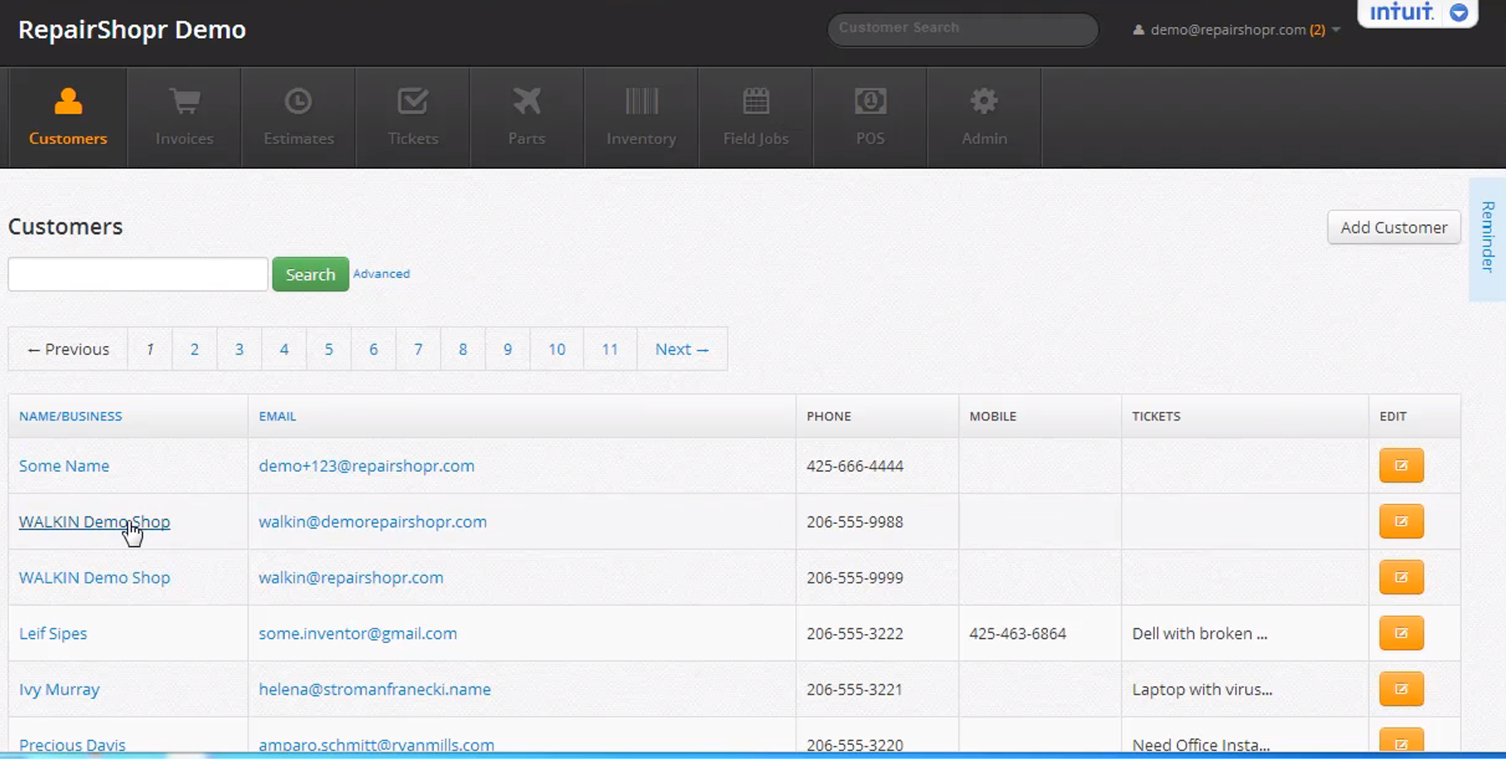
Figure ‎2.1: RepairShopr Dashboard (RepairShopr 2020)
RepairShopr is a cloud-based management platform designed specifically for repair businesses, including auto repair shops. It integrates POS functionality, inventory tracking, customer relationship management (CRM), invoicing, and reporting into a single web-accessible platform (RepairShopr, 2024). The system supports the creation of itemised invoices that incorporate both parts costs and labour charges, enabling accurate service billing. RepairShopr also includes a customer portal that allows clients to view the status of their repairs and access past invoices.
One notable strength of RepairShopr is its breadth of integrations with third-party payment processors and accounting platforms such as QuickBooks. However, its pricing model, based on monthly subscription tiers, may be prohibitive for small garages in developing economies. Furthermore, the system is primarily designed for the North American and European markets, meaning that certain localisation features, such as currency configurations and tax frameworks relevant to the Kenyan context, may require additional customisation (RepairShopr, 2024).

Workshop Software
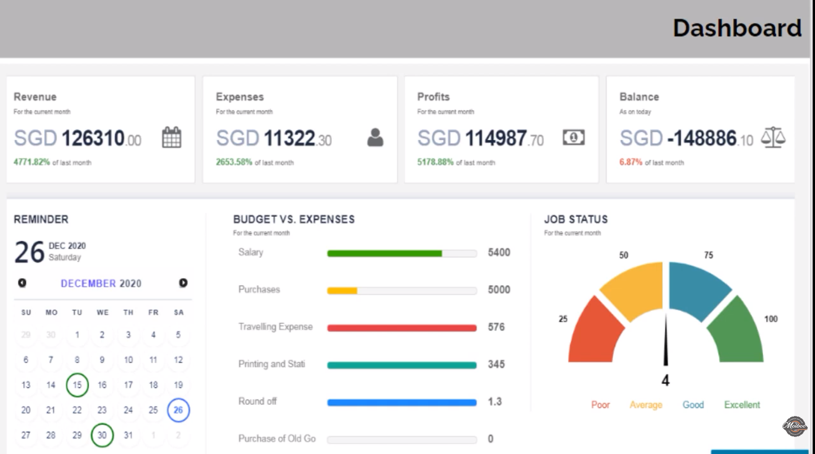
Figure ‎2.2: Workshop Software Dashboard (Workshop Software, 2023)
Workshop Software is a cloud-based automotive workshop management system used by garages and service centres, primarily in Australia and the United Kingdom. It provides modules for job card management, parts inventory, service invoicing, supplier ordering, and basic reporting (Workshop Software, 2023). The platform includes automated low-stock alerts and supports the management of recurring customer accounts.
While Workshop Software offers robust features for automotive service management, it is a subscription-based SaaS product that requires continuous internet connectivity and monthly payments, which may not align with the operational context of garages in Sub-Saharan Africa. Additionally, the system does not provide developer-accessible APIs, limiting opportunities for customisation or integration with locally deployed university or institutional systems (Workshop Software, 2023).

Odoo (Inventory and POS Modules)
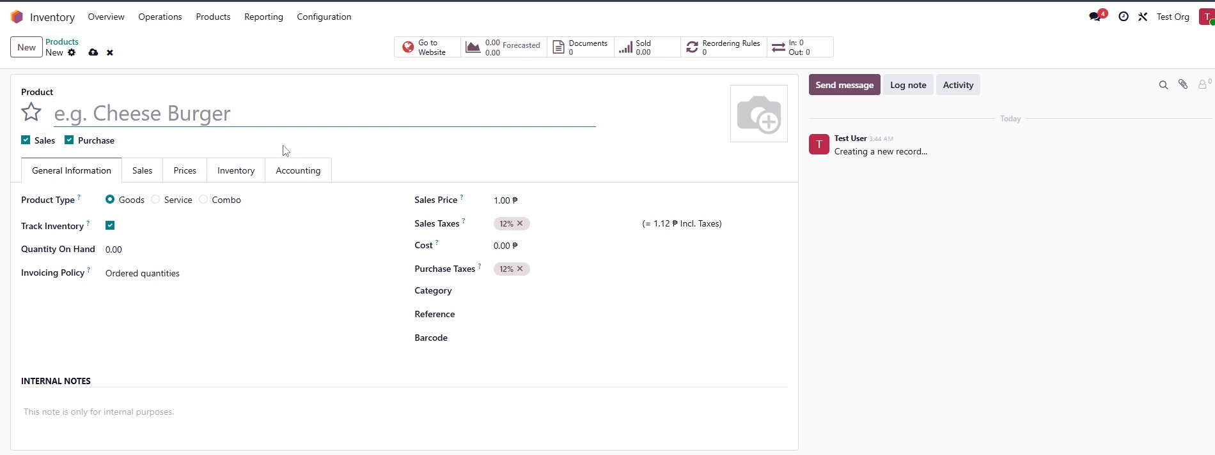
Figure ‎2.3: Odoo Inventory Dashboard (Odoo Inventory, 2024)
Odoo is an open-source enterprise resource planning (ERP) platform that includes dedicated modules for Point of Sale, Inventory Management, Accounting, and CRM. Its modular architecture allows businesses to activate only the features they require, making it flexible for deployment in various operational contexts (Odoo, 2024). The inventory module supports real-time stock tracking, automated reorder rules, and multi-warehouse management, while the POS module handles transaction processing, product catalogues, and payment recording.
Odoo's open-source community edition is available at no licensing cost, making it financially accessible. However, its full feature set demands significant technical expertise to configure and maintain, and its interface, designed for general business use, is not optimised for the fast-paced, service-centric workflows of auto repair garages (Odoo, 2024). Customisation to meet garage-specific requirements such as job card integration, mechanic assignment, and credit tracking per customer requires substantial development effort.

Garage Management System (GMS) by AutoLeap
AutoLeap is a garage management platform that combines POS, inventory, customer communication, and digital vehicle inspection capabilities (AutoLeap, 2024). It provides detailed job costing features that allow garage owners to track the profitability of individual repair jobs, incorporating both parts costs and labour rates. The system also offers a customer-facing mobile application for appointment scheduling and repair status updates.
AutoLeap's sophisticated feature set represents a comprehensive solution for larger, well-resourced garages. However, for smaller auto repair businesses, many of its advanced features add unnecessary complexity and cost. The system is also a proprietary, closed-source SaaS product, which limits adaptability and long-term control over the system (AutoLeap, 2024). Like RepairShopr, its primary market is North America, and localisation for the Kenyan operational context, particularly around M-Pesa payment integration and local tax structures, is not natively supported.

Custom Web-Based POS Systems in Academic Literature
Several academic studies have documented the development of custom web-based POS and inventory systems for SMEs. Mukherjee and Bhattacharya (2019) developed a web-based inventory management system for a retail business using PHP and MySQL, demonstrating that custom-built systems could deliver core inventory functionality at low cost. The study identified real-time stock updating and low-stock notification as the features with the greatest operational impact.
Similarly, Atieno and Mwangi (2021) documented the development of a web-based POS system for a small hardware store in Kenya, using React for the frontend and Node.js for the backend. Their findings confirmed that a decoupled architecture facilitated ease of maintenance and future feature additions. The study also highlighted the importance of designing systems around local payment methods, particularly M-Pesa, to ensure practical adoption. However, neither study addressed the specific requirements of the auto repair sector, particularly the management of customer and supplier credit accounts alongside service invoicing.

Comparative Analysis of Related Systems
Table 2.1 below provides a comparative summary of the related systems reviewed in Section 2.6, evaluated against key functional requirements identified for the proposed system.
System | POS & Billing | Inventory Mgmt | Credit Tracking | Local Context
RepairShopr | Yes | Yes | Limited | No (US/EU)
Workshop Software | Yes | Yes | No | No (AU/UK)
Odoo | Yes | Yes | Yes (complex) | Partial
AutoLeap | Yes | Yes | No | No (US)
Proposed System | Yes | Yes | Yes | Yes (Kenya)
Table 2. 1: Comparative Analysis of Related Systems

Gaps in Related Works
The review of related systems reveals several significant gaps that the proposed system seeks to address. First, none of the commercial systems reviewed RepairShopr, Workshop Software, and AutoLeap provide native support for the Kenyan operational context. This includes the absence of M-Pesa integration for localised payment tracking, currency and tax configurations aligned with Kenyan regulatory requirements, and pricing models accessible to small garage businesses operating in a developing economy.
Second, while Odoo provides a theoretically comprehensive suite of features, its configuration complexity and generalised design make it poorly suited to the specific workflows of auto repair garages. The system requires significant customisation effort to implement garage-specific requirements such as job card management, mechanic assignment, and the integration of service-based and parts-based billing into a single invoice. This level of technical investment is beyond the capacity of most small garages.
Third, all commercial systems reviewed are proprietary SaaS products, meaning that garages are subject to ongoing subscription costs and have no control over the system's source code or hosting infrastructure. For garages in Kenya, where operating margins may be slim and internet connectivity may be inconsistent, a locally deployable, open or custom-built system represents a more sustainable long-term solution.
Fourth, the academic systems documented by Mukherjee and Bhattacharya (2019) and Atieno and Mwangi (2021) demonstrate the viability of custom web-based solutions but do not address the multi-dimensional requirements of auto repair garages, particularly the concurrent management of spare parts inventory, service invoicing, and customer and supplier credit accounts. There is therefore a clear gap in the literature for a purpose-built, web-based system that integrates all three functions within a single, cohesive platform designed for the Kenyan automotive service context.

Conceptual Framework
The proposed system is based on the principles of designing integrated information systems, which consists of three main functional areas: Point of Sale and Service Billing, Inventory Management, and Credit Management. The domains communicate with each other using a common relational database, so that information entered in one domain is instantly shared among all other domains.
The presentation layer includes a role-based dashboard and workflows which are accessed by the employees and administrators of the garage running a web interface using react. A RESTful API is used to communicate between the frontend and backend, which is implemented using Spring Boot, and acts as a single point of entry for all web services, enforcing business logic, handling authentication and authorisation, and coordinating data access. The back end is connected to a relational database, which stores all transactional, inventory and financial data.
The POS module can be used to generate and maintain service invoices including parts cost pulled from the inventory module and parts labour charges (which can be set). When finalised, inventory is automatically adjusted for parts used and, if applicable, the sale will be posted to the appropriate customer credit account. The Inventory Management module provides an up-to-the-minute list of spares, monitors stock movements and automatically alerts the user when stock levels are at a low level (as defined by the user). The Credit Management module keeps ledger accounts for customers and suppliers, records credit transactions, monitors outstanding balances and allows for the generation of financial summary reports.
These three modules work together in one system to break away from the data siloes and manual reconciliation currently seen in many auto repair garages. The conceptual framework of the proposed system is based on the principles of integrated information system design with 3 major functional domains which are Point of Sale and Service Billing, Inventory Management and Credit Management. These domains communicate with each other via the shared relational database so that data entered into any one domain is instantaneously reflected in all other domains as well.
The garage administrators and employees are presented with a web interface through React at the presentation layer of the system, which offers role-specific dashboards and workflows. A RESTful API is used to pass data between the frontend and backend, providing business logic, authentication and authorisation and managing data access. The back end communicates with a relational database where all transactional, inventory and financial information is stored.
The Point of Sale module lets you create and manage service invoices, including parts costs pulled from the inventory module, and includes a Pricer, which allows users to set up labour costs that can be applied to the invoice. The system will automatically update parts used and, if applicable, post the sale to the customer credit account after finalisation of a sale. The Inventory Management module is used to keep a live catalog of all spare parts, records all inventory movements and automatically sends low stock alerts whenever inventory gets below a defined limit. The Credit Management module tracks customer and supplier ledger accounts, records credit transactions, and provides balance and financial summary reports.
These 3 modules work together in the same system to break down data silos and manual reconciliation in many auto repair garages as they deal with fragmented processes. The conceptual framework is illustrated in Figure 2.1 below.
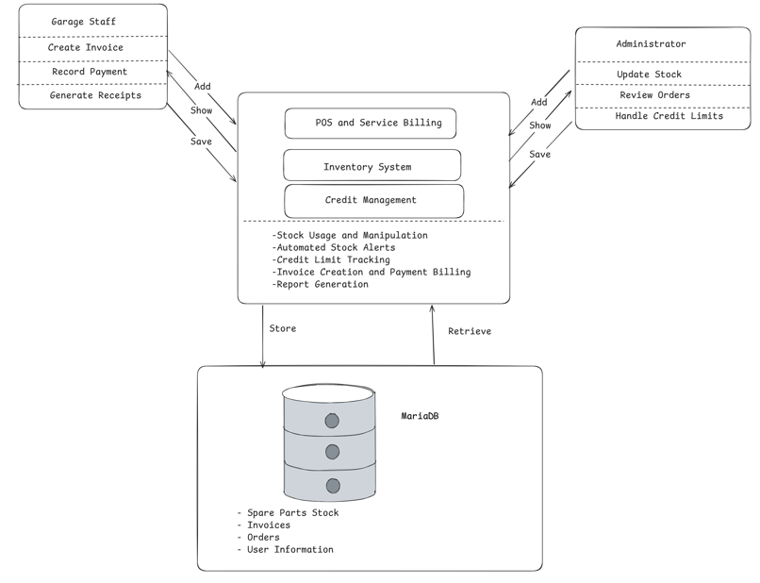
Figure ‎2.4:Conceptual Framework

Methodology

Introduction
This chapter outlines the design methodology and paradigm applied to the proposed POSIS. Additionally, system analysis, development tools, and project deliverables will be covered.

Incremental Development Method
The applied development approach for this project is the Incremental Development Model. In this model, the system is designed, developed, and tested in small parts. Each new increment builds upon the previous one. This allows for partial implementation of the system, meaning basic features like inventory tracking can be delivered early. It also makes it easy to incorporate user feedback from garage staff throughout the process.
To support this step-by-step building process, the project utilizes OOAD. OOAD is ideal because the POSIS system is highly modular. It is made up of independent components, such as user authentication, inventory control, and financial dashboards. Using OOAD makes the system easier to maintain and allows the code to be reused across different modules.
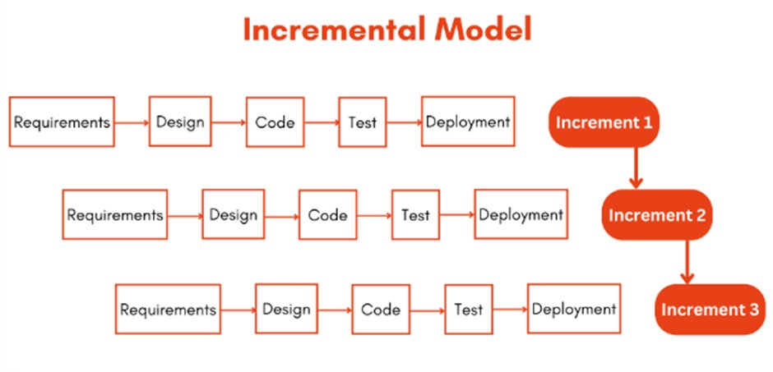
Figure ‎3.1: Steps in the Incremental Development Model. (Sommerville, 2021)

Requirement Analysis
This step identifies what the system must do. For the proposed system, the specific functional needs of the Garage Administrator and the Cashier are defined. This step also identifies the unique modules to be developed, such as billing and stock alerts, in their order of priority.

Design
This step involves drafting the blueprints of the system. Using OOAD techniques, the design is mapped out to meet the requirements identified in the previous phase. Diagrams are created to define user access levels and structure the database.

Implementation
In this phase, the proposed system is coded. The constraints defined in the design phase are strictly followed. Each specific module is built one at a time. The application will be coded using React for the user interface and Java Spring Boot for the backend logic.

Testing
This step checks the performance of all system functions. Each module of the POSIS is tested individually to ensure it works correctly. After each new increment is finished, testing is done again on the whole system to ensure the new code works seamlessly with the older parts.

Deployment
Once the increment is completed, it is delivered to users or stakeholders. Feedback is collected during this phase, helping the team refine requirements and make improvements for future increments.

System Analysis
The following section analyzes the system requirements. This section also goes through different techniques and modelling tools, such as the use case diagram, system sequence diagram, and activity diagram. These models are meant to illustrate the requirements of the POSIS and how garage staff will interact with it.

Use Case Diagram
A use case diagram shows the functionalities of the system along with its environment. Crucially, it shows how system properties are seen by users from an outside perspective (Rutkowska, 2025). The use case diagram will be used to show how users, specifically the Garage Administrator and the Cashier, will interact with the system to process sales and manage spare parts.

System Sequence Diagram
A system sequence diagram illustrates the high-level flow of information between external actors and the system. It will be used to show the exact chronological steps of a Cashier ringing up a vehicle service, displaying the input events and the system's immediate responses without detailing the internal code logic.

Entity-Relationship Diagram
An entity-relationship diagram is a visual tool used in database design to map out entities within a system and how they relate to one another (Xmind, 2024). The ERD provides a visual representation of the database structure. For example, a one-to-many relationship will be used to represent a single customer being linked to multiple service invoices.

Activity Diagram
An activity diagram shows how a system should behave upon a series of actions. It can illustrate parallel activities, decisions, and conditions that provide a clear description of activity flows (Ang, 2025). The activity diagram will be used to show the step-by-step workflow of critical garage operations, such as the automated process that triggers a low-stock alert when a fast-moving part runs out.

System Design
The following section transitions from system requirements to the actual technical blueprints. It details the design models that will guide the programming and database creation phases.

Class Diagram
A class diagram provides a static view of an object-oriented system, showcasing classes, methods, attributes, and relationships among objects (Singh, 2024). Class diagrams will help in identifying the different code entities needed for the Java Spring Boot backend, such as Users, Spare parts, and Invoices, and how they are interconnected.

Sequence Diagram
A sequence diagram illustrates how different parts of a system interact with each other to carry out a particular function in a particular order (Athuraliya, 2022). This diagram will show how the React frontend, Spring Boot backend, and MariaDB database work in sequence to get something done, like securely saving an M-Pesa payment and automatically deducting physical stock.

Database Schema
A database schema is the structural foundation used to organize stored information. It sets the rules for how data is saved into tables and prevents duplicate or broken records (Lucid Software Inc., 2021). For this project, the schema will map out exactly how the system safely stores the list of physical spare parts, the daily sales invoices, and the registered staff accounts.

Wireframes
These are basic visual sketches of the software's user interface. They help developers plan exactly where buttons, menus, and text will be placed before any actual programming begins. In this project, wireframes will be created to plan the layout of the Cashier's checkout screen and the Administrator's profit dashboard, ensuring the final system is easy for the garage staff to navigate.

System Development Tools and Techniques
This section discusses the specific software tools, frameworks, and environments used to build the POSIS.

React.js
React.js is a popular front-end JavaScript library created by Meta (Dubey, 2025). It is used to build interactive user interfaces using reusable components. Because the POSIS requires a dynamic and fast interface where a Cashier can search for spare parts and process M-Pesa payments in real-time, React.js is well-suited for this frontend functionality.

Java Spring Boot
Spring Boot is a robust backend framework based on the Java programming language. It provides a highly secure and structured environment for building REST APIs. It is an ideal tool for this project because it perfectly handles object-oriented data and securely manages the distinct access roles.

MariaDB
MariaDB is a stable, open-source relational database management system. It will be used to store structured data related to physical spare parts, daily sales, and administrator accounts. Because garage operations require strict financial accuracy, MariaDB is well-suited to handle the relational links between a customer's specific vehicle service and the exact parts used from inventory.

VS Code and IntelliJ IDEA
Visual Studio Code and IntelliJ IDEA are powerful code editors that will serve as the development environments. Visual Studio Code will be utilized for its lightweight front-end capabilities to write the React.js code. For the backend, IntelliJ IDEA will be used because it provides excellent, built-in support for compiling and debugging complex Java Spring Boot applications.

GitHub
GitHub is a cloud-based platform that allows developers to store, share, and track changes to their source code (About GitHub and Git, 2025). GitHub will be used for version control, ensuring the system's code repositories are securely backed up online and allowing different features to be tested safely in isolated branches.

Postman
Postman is a tool used to manually test API endpoints and simulate user requests. This will be used during the development phase to simulate actions, like a Cashier processing a sale, to ensure the Java backend correctly deducts the inventory data before the React frontend is fully attached.

Deliverables
The successful completion of this project will result in a number of tangible deliverables spanning documentation and functional software modules.

System Documentation
This documentation provides a complete overview of the POSIS. It includes the system proposal, functional requirements, and the technical blueprints that guided the development process.

Authentication Module
Authentication ensures secure access to the system. Staff must log in using their credentials. This module uses Spring Security to verify the user's role, ensuring that a Cashier and a Garage Administrator are securely routed to their correct, restricted dashboards.

Inventory Management Module
This module allows the garage to digitally track all physical spare parts. It handles logging new shipments, automatically deducting items during a sale, and triggering automated dashboard alerts when fast-moving parts fall below minimum stock levels.

POS Module
This is the core billing interface used by the Cashier. It allows staff to combine spare parts and mechanic labour fees into a single invoice. It also processes and records specific payment methods, including M-Pesa, cash, and bank transfers.

Admin Dashboard Module
This module gives the Garage Administrator comprehensive control over the system. It allows the garage owner to manage staff accounts, manually adjust inventory counts, manage supplier debt, and oversee overall business operations securely.

Financial Reporting Module
The report module generates summaries of the garage's financial data. It helps the administrator track daily profits, view unpaid customer credit ledgers, and make informed business decisions based on real-time revenue tracking.

References
Athuraliya, A. (2022). Sequence diagram tutorial: Complete guide with examples. Creately. https://creately.com/guides/sequence-diagram-tutorial
AutoLeap. (2024). Garage management platform documentation. AutoLeap. https://www.autoleap.com
Autorox. (2026). Spare parts inventory management for garages and auto repair workshops. https://www.autorox.ai/post/spares-inventory-management-system
Davenport, T. H., & Redman, T. C. (2020). Data driven: Creating a data culture. Harvard Business Review Press.
GitHub. (2025). About GitHub and Git. GitHub. https://docs.github.com/en/get-started/using-git/about-git
Identifix. (2025). Auto parts inventory management: The best options for your shop. https://www.identifix.com/blogs/auto-parts-inventory-management-the-best-options-for-your-shop
Kenya Bankers Association & Japan International Cooperation Agency. (2021). Micro, small and medium enterprises (MSME) survey report. KBA Centre for Research on Financial Markets and Policy. https://www.kba.co.ke/wp-content/uploads/2022/05/MSMEs-Survey-Report.pdf
Kenya National Bureau of Statistics. (2022). Economic survey 2022. KNBS.
Krajewski, L. J., Malhotra, M. K., & Ritzman, L. P. (2022). Operations management: Processes and supply chains (13th ed.). Pearson.
Laudon, K. C., & Laudon, J. P. (2020). Management information systems: Managing the digital firm (16th ed.). Pearson.
LAWAL, A. (2022). Web-based point of sale systems and cloud integration.
Lucid Software Inc. (2021). What is a Database Schema? Lucidchart. https://www.lucidchart.com/pages/database-diagram/database-schema
Mbarushimana, E., & Kengere, A. O. (2023). Credit management practices among manufacturing SMEs.
Mwangi, N. K., Njiraini, R. N., & Waweru, M. K. (2023). The impact of digital transformation on small and medium-sized enterprises (SMEs) in Kenya. International Journal of Entrepreneurship, Innovation, and Business Strategies, 2(1), 1–8. https://doi.org/10.58425/ijeib.v2i1.156
O'Brien, J. A., & Marakas, G. M. (2011). Management information systems (10th ed.). McGraw-Hill Education.
Odoo. (2024). Odoo inventory and POS modules documentation. Odoo S.A. https://www.odoo.com/documentation
RepairShopr. (2024). RepairShopr platform documentation. RepairShopr. https://www.repairshopr.com
Safaricom Business. (2021, November 9). Ready Business Index shows SMEs in Kenya stand to gain from adopting customised ICT solutions. Safaricom. https://www.safaricom.co.ke/media-center-landing/press-releases/ready-business-index-shows-smes-in-kenya-stand-to-gain-from-adopting-customised-ict-solutions
Singh, R. (2024). Understanding UML class diagrams.
Sommerville, I. (2021). Software engineering (10th ed.).
Tharinda, Nipun & Kosgoda, Dilina & Tibbotuwawa, Amila & Nielsen, Izabela. (2025). Spare Parts Categorization and Machine Learning Approaches for Demand Forecasting in Automotive Spare Parts Sector of Developing Economies.
Workshop Software. (2023). Workshop Software product documentation. Workshop Software. https://www.workshopsoftware.com
Xmind. (2024). Entity relationship diagram guide. Xmind. Everything about an Entity Relationship Diagram (ERD)

Appendix

Appendix 1: Gantt Chart
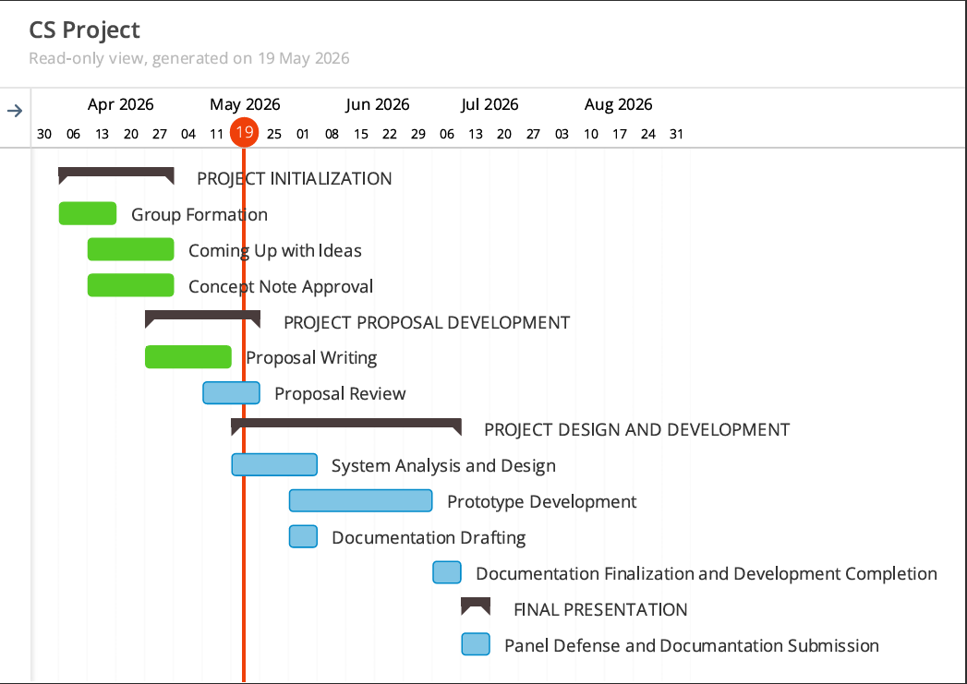

Appendix 2: Similarity Report

Include the proposal marking template (uploaded on E-learning) at the very end of the proposal (not as an appendix).

