# Database Management Systems

Removed year/month. This is not needed as it can be obtained from the referral date.

Giving unique identifiers to the following:

1. Referral. This is needed in case someone has more than one referral on a given day.
2. Surgeon: Needed as doctor name can not be guaranteed to be unique.
3. Department: Needed for ease, expediency, and to avoid spelling errors when people are entering data.

Patient is not being given a unique identifier as they will have the NHI number which is unique. This is a number that is used on all referrals, paperwork, patient tag (bracelet they are given in hospital) etc, so it is a suitable key to use.

# Version 0.1:

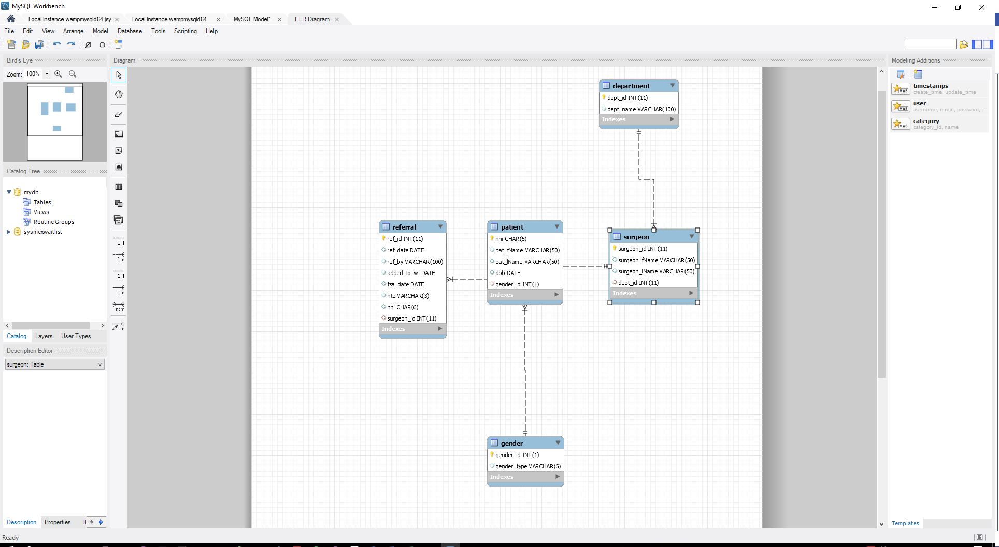

## Problems:

Version one does not match the planned schema. Unfortunately Surgeon is connecting to Patient instead of Referral. This is because I forgot to list NHI on the referral table as a Foreign Key.

# Version 0.2:

Changes made:

1. Changed Referral.nhi to forgein key of Patient

