An Analysis of Holiday Flight Performance in the United States between 1987 and 2014

Jesse Green

INTRODUCTION

This documents looks at passenger airline travel and flight performance statistics provided by the Bureau of Transportation Statistics [1] between October 1987 and January 2014 in the United States. The focus of the paper will be a quantitative analysis of flight performance near key federal holidays in the United States, as an attempt to improve upon the qualitative notion that exists for expecting delays and avoiding flights during holiday travel.

Before stepping into a detailed look at flight delays around holidays, it is worthwhile to examine flight volume and performance as it has changed over the years, and consider a few ways to define delays in a meaningful way. Figure 1 shows the total flight volume and percentage of delayed flights for all available BTS data. The figure shows monthly values overlaid with the 7-month moving average to better illustrate the overall trend. In this plot a flight is considered delayed if its actual arrival time is greater than its scheduled arrival time by any amount. It is easy to see that the overall volume of flights has increased over the time period, while the number of delays has decreased. A linear regression performed on delay percentage over the time period results in an expected decrease in delays of 0.7 percentage points annually. The decrease in delays may be explained by an increase in airports (there are 82 new airports in 2013 versus 1988, but this only accounts for 12.5% of increased outbound flight traffic); or perhaps delays only appear to decrease because there has been an increase in the reservation times allocated by airlines for itineraries (see Figure 2) as reported in the CRS (Computer Reservation System). The typical CRS elapsed time for a flight between the 20 busiest airports in the US increased by an average of 10.7 minutes between 1988 and 2013. Although the cause behind this overall trend in flight delays is a topic worth further investigation, here it will be used only as a point of reference and introduction. The following sections will look at the methods taken to quantify delays with statistics and understand how these statistics are affected during holiday travel.

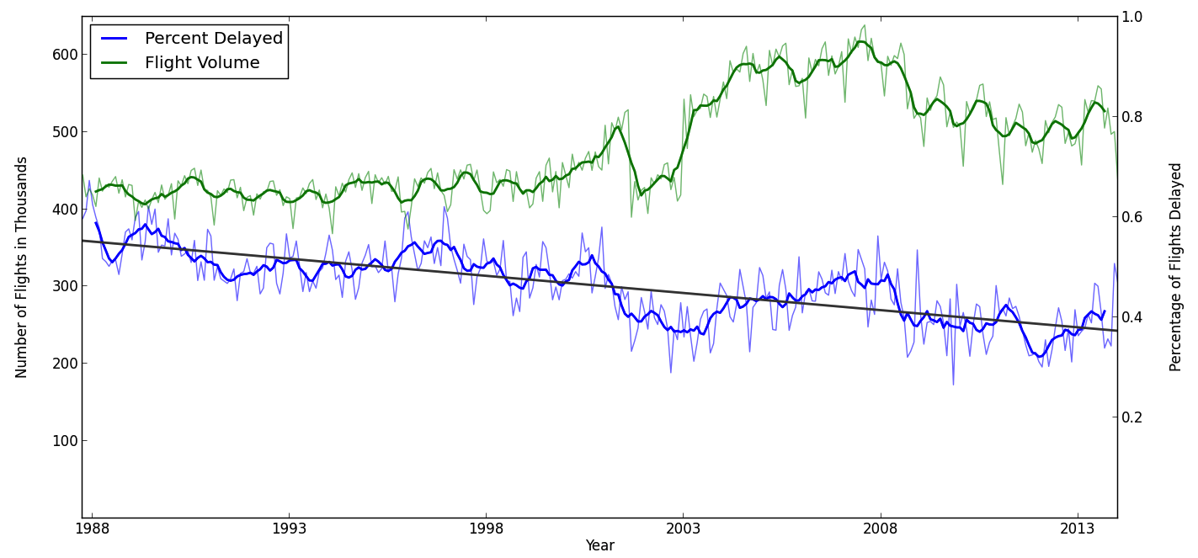**Figure 1 – Monthly flight volume and percentage of flights delayed in the United States.**

METHODS

Data Collection and Storage

There are over 150 million flights adding up to over 20GB of flight performance data available for download through the BTS website application. Given the quantity of data and the desire to query across the entire timeframe and various dimensions, it was most convenient to import the dataset into a database where it could be efficiently queried. Using a script the data was downloaded, imported into MySQL, indexed and then used for the analysis.

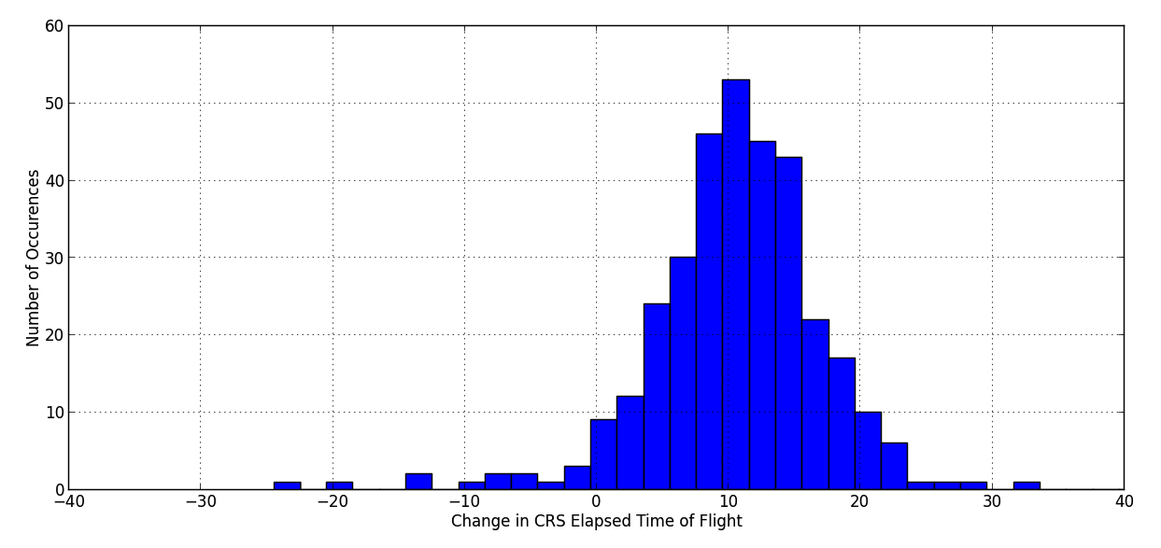

Figure 2 – This histogram shows changes in CRS Elapsed Flight Times for flight routes between the 20 busiest domestic US airports by departure volume[1]. Between 1998 and 2013, the typical CRS elapsed time increased by an average of 10.7 minutes.

Delay Statistics

An important step in this analysis was to determine the statistics by which to measure delayed flights. The usefulness of a statistic may vary depending on the audience, and this analysis will assume the audience to be a typical airline passenger interested in traveling for the holidays. Assuming a delay can also be negative for flights arriving early, using the mean and median to summarize delays provides little insight. For example, consider all flights on Mondays in 2013 scheduled to depart between 4 p.m. and 5 p.m. are on average delayed 11.5 minutes. The median delay for this subset is -1 minute. These two statistics reveal something commonly seen in the dataset - this subset has a positively skewed probability distribution – but has little practical value for an everyday airline passenger looking for some travel insight.

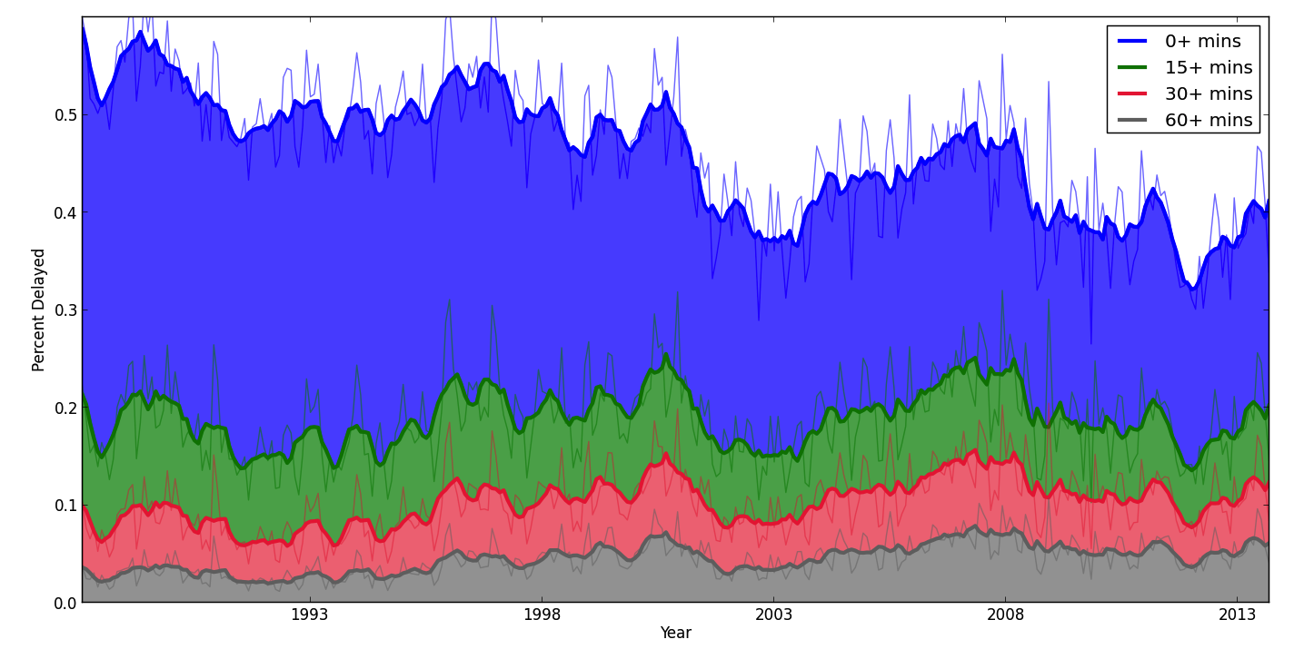

Figure 3 – Delay percentages by year and delay severity, where a flight is considered delayed if it arrives later than *n* minutes. The severest delays (*n*=30,60) slightly increase over time, while delays for *n*=0 decrease over time.

What passengers are really looking to know is whether or not there is a good chance their travel plans will be interrupted by a significant amount of time spent in an airport or on the tarmac. Instead of considering the number of flights that were delayed overall, let us consider only the delays occurring for more than a significant amount of time. Figure 3 shows the percentage of flights delayed more than *n* minutes over the dataset time period. The number of overall delays is decreasing (i.e. decreasing median delay), but the average delay stayed about the same. This means recent flight delays are for longer amounts of time, as seen by the slightly upward trend in the 30+ and 60+ minute delays.

Additional Datasets

Two additional datasets were used in this analysis. The website timeanddate.com provided the dates for actual and observed holidays in the United States during the period of interest. For the interactive website discussed later, airport GPS data is provided by openflights.org.

results

This section will analyze domestic flights for the past 10 years (2004 – 2013) and will use the percentage of delays lasting at least 60 minutes as the delay statistic. This allows the reader to interpret the results in a meaningful way, and avoids reported delays as a result of variations in scheduled flight times as seen in Figure 2. However, these analyses still represent an aggregate performance independent of airport size, flight volume, weather, etc. For a much more focused investigation, an interactive application will then be presented that allows a user to review performance of specific route and holiday combinations.

A Typical Week of Flight Delays

The likelihood of delays in a given week look as one might expect, with almost no chance of long delays on early flights, and the frequency of delays increasing throughout the day and peaking in the evening. The heat-map in Figure 4 visualizes the frequency of delays for the average week over the last 10 years. It is clear that Tuesday and Saturday are the best days to fly for avoiding a long delay. There is also an unexpected peak easily visible on the left side of the chart: although flights between 3 a.m. and 4 a.m. are rare, they have extended delays similar in frequency to the afternoon time block. Figure 5 shows the same information as Figure 4, but time is organized linearly to reveal how delays stack up and drop off as the day progresses. The horizontal lines mark the peak flight delay in the afternoon and will be used as a reference in the next few figures. Figure 5 also contains flight volume, visualized beneath the delay stems as the average number of flights each weekday.

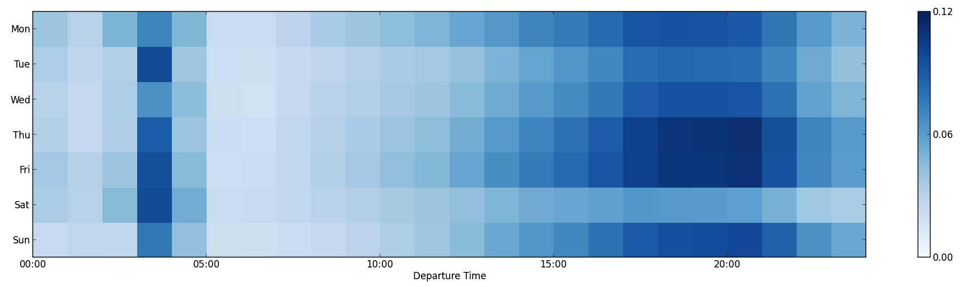

Figure 4 – Heatmap showing a week of average flight delay percentages of 60+ minutes from 2004-2013.

Thanksgiving and Memorial Day

Thanksgiving week is well-known as one of the worst times to travel. But aside from busy airports, the number of delays longer than 1 hour on the Tuesday and Wednesday before Thanksgiving only slightly increase (Figure 6). The largest average increase happens following Thanksgiving, as people board their return flights on Sunday. The number of flights on Tuesday, Wednesday and Sunday increase by a few percent, but there is a drastic reduction in flight volume on Thursday and Friday. The reductions seem suitable, as the number of long delays on these days fall close to zero.

Although flight delays are rare on Thanksgiving day, the Thursday before Memorial Day has been the worst day to travel out of the two holiday weeks examined. The percentage of delays jumps above 17%, meaning 1 in 6 people trying to catch the after-work flight on Thursday will be delayed *at* *least* an hour. The only significant change in flight volume occurs the Sunday right before Memorial Day.

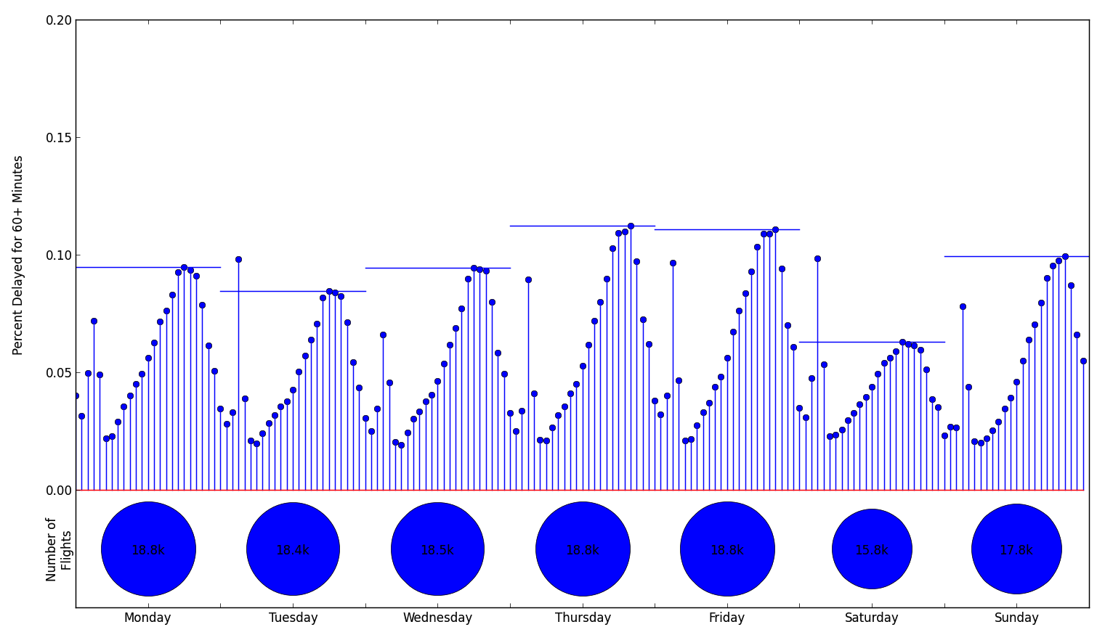

Figure 5 – Percentage of flights delayed 60+ minutes for the average week over the last 10 years. Delay percentages are displayed ever hour. Included below is the average number of flights for each day.

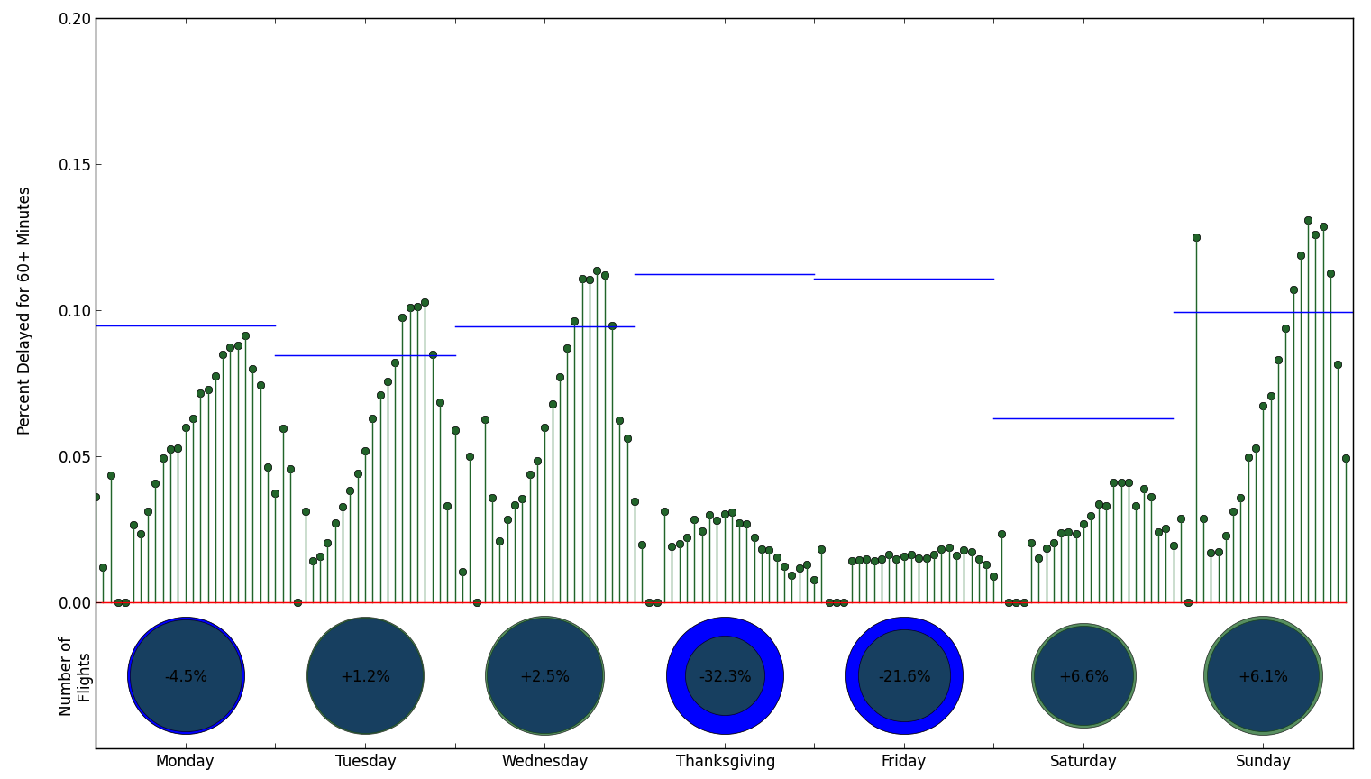

Figure 6 - Percentage of flights delayed 60+ minutes for the average Thanksgiving week over the last 10 years. Delay percentages are displayed ever hour. Included below is the average number of flights for each day of Thanksgiving week, compared to the average number of flights for that day over the period.

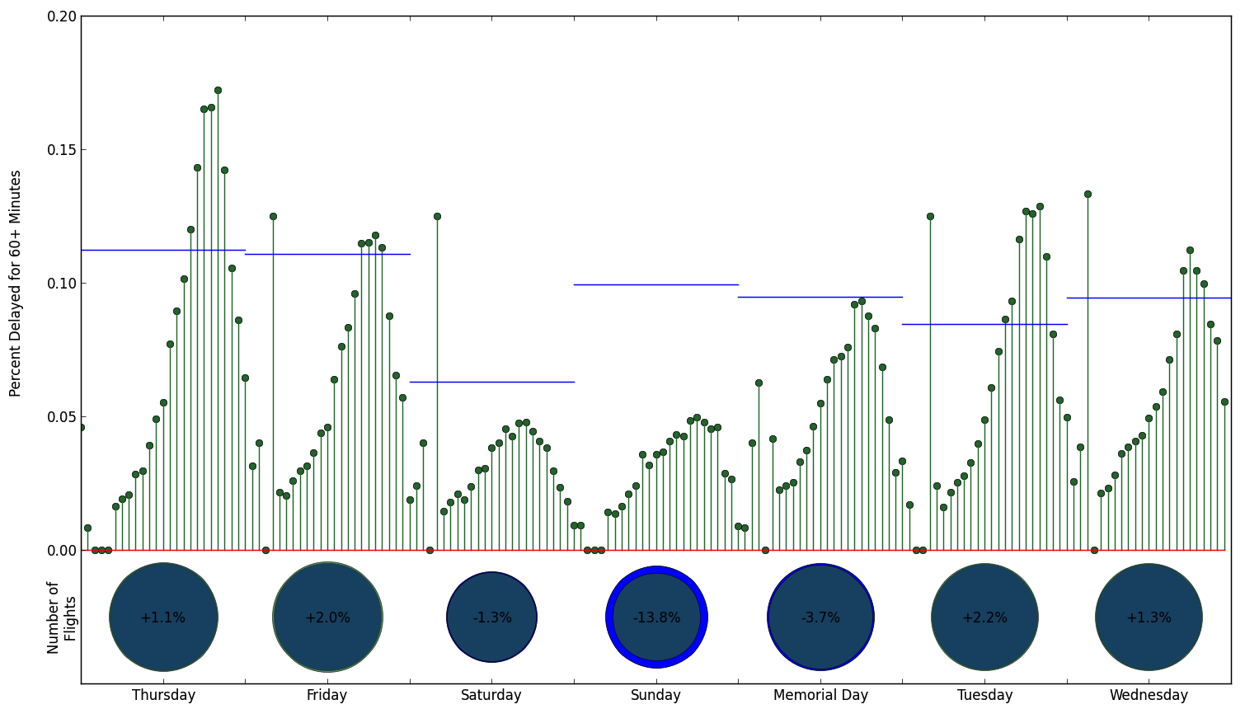

Figure 7 - Percentage of flights delayed 60+ minutes for the average week prior to Memorial Day over the last 10 years. Delay percentages are displayed ever hour. Included below is the average number of flights for each day of the Memorial Day week, compared to the average number of flights for that day over the period.

DISCUSSION

This paper has provided a brief look at general flight performance for two holidays, barely scratching the surface of what can be said about flight performance overall. Additional analysis could consider how performance changes by airport, distance and many other factors. One way to visualize performance by route is provided in the following application: http://thanksgiving-flights.appspot.com/. Here a user can select an airport and a day leading up to Thanksgiving to see the average performance of the route. In this visualization, the delay is represented as a distance, corresponding to the equivalent distance the airplane would travel if the delay was added to the average flighttime for that route. For example, destinations that have longer average delays will be positioned further away from the origin city, and cities with historical flights arriving early will be positioned closer to the origin origin. The size of the circle is proportional to the number of flights between the cities. From this, historical averages can be observed between many different cities (again the top 20, but only 1 in the NY area) on different days.

REFERENCES

[1] BTS: http://www.transtats.bts.gov/DL_SelectFields.asp?Table_ID=236&DB_Short_Name=On-Time

[2] Timanddate.com: http://www.timeanddate.com/holidays/us/

[3] Openflights.org: http://openflights.org/data.html

1. 20 busiest airports calculated by number of US departures in 2013: ATL, ORD, DFW, DEN, LAX, IAH, PHX, SFO, DTW, CLT, MSP, LAS, EWR, MCO, SLC, BOS, JFK, LGA, SEA, BWI