Cross country ski manual

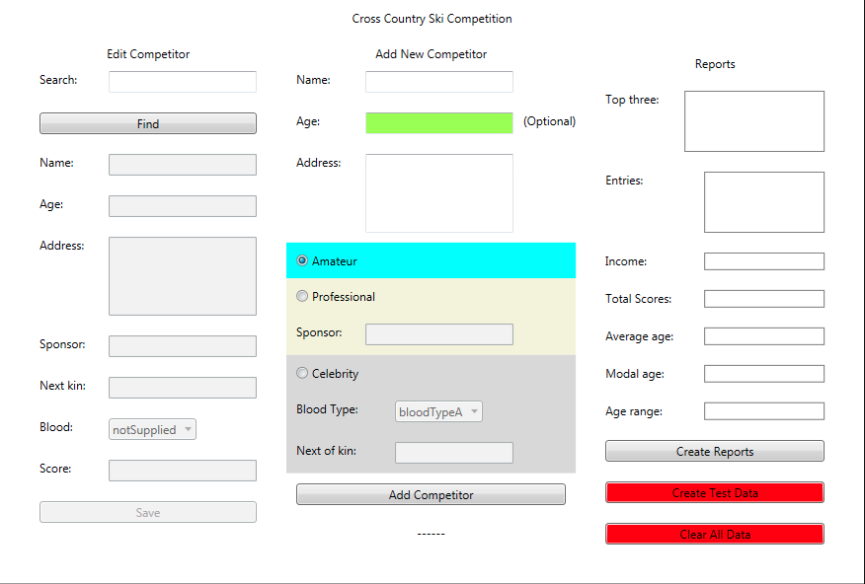Jesse Serrao

**1**

**2**

**3**

**4**

**5**

**6**

**7**

**8**

**9**

**10**

**12**

**13**

**14**

**15**

**15**

**16**

**15**

**17**

**18**

**19**

**20**

**21**

**22**

**23**

**24**

**25**

**26**

**27**

**28**

**29**

**30**

The cross country ski account managing application (pictured above) allows the lodger to easily manage accounts. The application can handle three types of accounts, amateur, professional and celebrity; each account having its own specific pre-defined entry cost and associated fields. All accounts contain the basic fields “name”, “age” and “address” while more advanced accounts contain additional fields. The professional account contains a “sponsor” field (for the company sponsoring them), while the “celebrity” account type enables the use of both the “blood type” and “next of kin” fields, each containing their respective information.

Creating an account.

All account creation takes place in the central column of the application. In order to create an account, you must enter a name (12), address (14) and any other fields that are tied to the account type that you wish to create. It is up to the user whether they disclose their age into the program. When a field has been filled in correctly, it will light up green to help guide you along with account creation (see (13)). There are three choices of account type (15), simply tick the checkbox of the desired account type and the relevant fields will become available to you. If you select a professional account, you must enter a sponsor for said professional (16). Celebrity accounts require that you select their blood type from the drop down menu (17) and enter the name of their next of kin (18). Once all information has been entered, press the “add competitor” button (19). If you have made any entries outside of the given specification, you will be informed as to what needs changing. If all information is valid, the account will be created and the ID will be displayed (20) at the bottom. The account will then have its properties displayed on the left for editting.

Finding an account.

In the provided diagram above, the “search” (1) and “find” (2) items allow you to search through your records for a person via their ski-ID or name. In order to use the search feature, enter the ID (using numbers 0-9) or the name of the person into the “search” (1) box. Once you have entered the desired ID or age, press the “find” (2) button to search for them. If searching by name a new box will appear with a list of matching contestants (if contestants are found). Here is an image of the page:

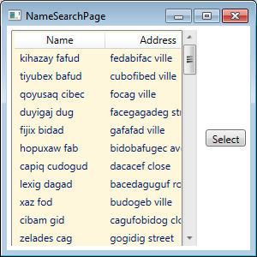

To use the searching page, simply highlight the account you wish to load by left clicking on their name/address and then press the “select” button located on the right. The box will close and the account will be ready to edit in the main application.

Editing an account.

In order to edit an account you must first select it using the previously mentioned search methods. Editing is incredibly simple. Once the account has been loaded, all fields relevant to it will be enabled in the editing area (3 – 9). To change information about the selected account, simply edit the corresponding field; once all changed are ready to be committed, press the “save” (10) button. The account will be saved. You do not need to worry about saving/loading accounts to your hard disk, this is done automatically on startup/closing.

Creating reports

To create reports, simply press the “create reports” button (28). If there are accounts in the system statistics will be generated based on all of the accounts; these statistics are displayed on the right (21 – 27).

Delete all accounts.

To delete all stored account information, press the “Clear all data” button (30). THIS ACTION CAN NOT BE UNDONE.

Account generation feature.

A button has been provided called “create test data” (29). This button will create 120 randomly generated accounts, each with a random name/address/age/accounttype/score/etc… This button is generally for testing purposes to create vast amounts of data quickly.