Catering App Increment #6 Documentation

Jesse Rossetti

2020

Table of Contents

HOME PAGE 1

Logging in 1

CUSTOMERS 3

General Information 3

Adding a customer 3

Removing a Customer 4

Editing a Customer 4

ORDERS 5

General Information 5

Placing a New Order 5

Removing an Order 6

Editing an Existing Order 6

EMPLOYEES 7

General Information 7

Hiring a New Employee 7

Removing an Employee 8

Editing an Employee 8

DETAIL VIEW 9

General Information 9

Completing an Order 9

SYSTEM ADMINISTRATION AND BACKUP 10

Required Software and Hardware 10

Creating Backups 10

REVISIONS 11

Increment 6 11

# HOME PAGE

## Logging in

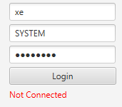

To log-in and access the application, you must enter the database name (default is “xe”), username and password (SYSTEM/password) you created for the database at the beginning during the installation. After logging in successfully, the status of the application will change to connected.

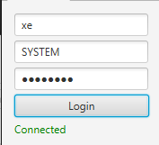

# CUSTOMERS

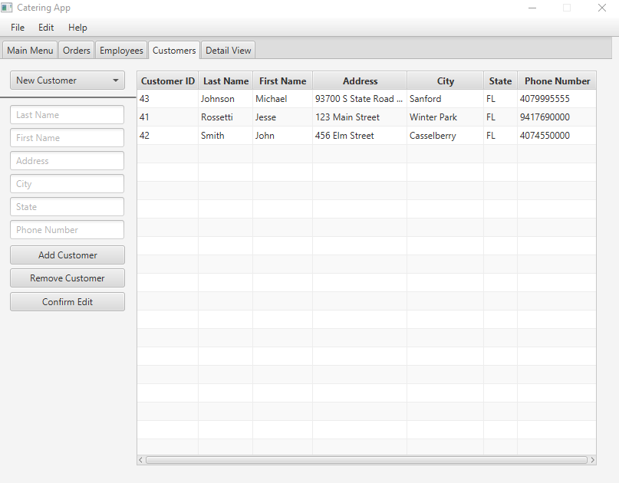

## General Information

Under the customers tab you can see a list of all existing customers. You can add, remove, and edit customers under this page. Information such as their id number, first and last name, address and phone number will be available.

## Adding a customer

To add a customer, fill out the customer’s information on the left side of the application. Make sure that the selection box at the top displays “New Customer”, if it does not, you must complete your previous edit or removal first. Look at the example below to see how the form should look before completion.

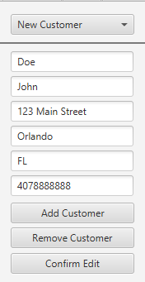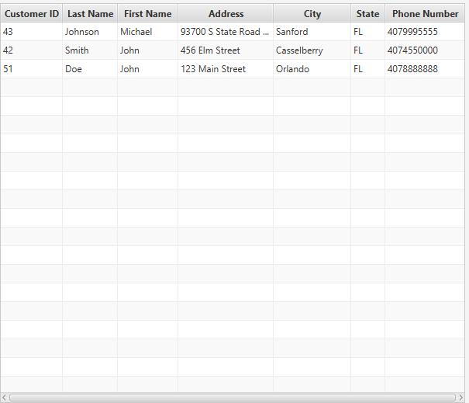

When you have all your information entered, you can press the “Add Customer” button to submit your addition and it will be listed in the table on the right.

## Removing a Customer

To remove a customer, select the customer you wish to remove by ID from the combo box and hit the “Remove Customer” Button.

**Required:** None, but should have a way of identifying customer.

**NOTE:** You should be careful removing customers entirely, as removing a customer with an order in place could be problematic.

## Editing a Customer

To edit a customer, select a customer from the combo box. The information about the customer will populate the text fields. You can then edit the information that needs to be changed and submit the changes for storage. If you accidentally select a customer from the combo box with no intention to edit, simply press confirm edit to free the text fields.

# ORDERS

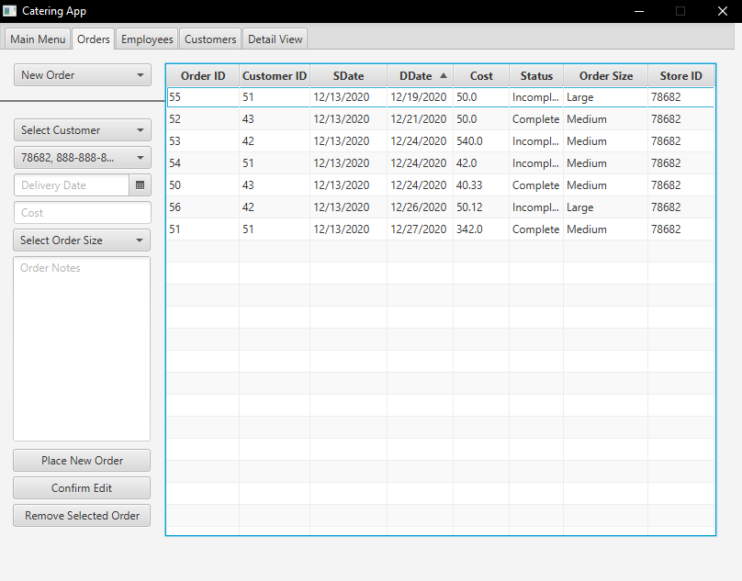

General Information

Under the orders tab you can view, create, edit, and remove orders. Information such as the responsible customer, submission and delivery date, cost, status, size, and store are listed in the table.

## Placing a New Order

To create a new order, make sure “New Order” is selected in the combo box or confirm your existing deletion or edit. Fill out all required information about the order and click the “Place New Order” button to submit the order and it will appear in the table. If there are no employees available, that task will be left empty. It is recommended that before entering any orders, you enter in the data for employees. You should always immediately check the detailed view of the new order to make sure all tasks are accounted for.

**Required:** Customer ID, Store, Delivery Date

When submitting a new order, all labor delegation will be done automatically. Depending on specific needs necessary from the client, the process of this can be changed. The default setting is that three (3) employees are assigned the necessary tasks to carry out an order, one for each task.

## Removing an Order

To remove an order, simply select your order from the combo box and hit the “Remove Selected Order” button. Removing an order will delete ALL employee assignments. It is highly recommended that you make sure that the order is complete before deleting it.

## Editing an Existing Order

To edit an order, select the order from the combo box, update the fields and then confirm your edit with the “Confirm Edit” button.

**NOTE**: Selecting an order will not update the customer or the store for which the order was for, check the information from the table and re-enter it to store submit the order for the right customer and store. Also, if you encounter an error you may have to select the date again. This issue is inconsistent among multiple machines.

# EMPLOYEES

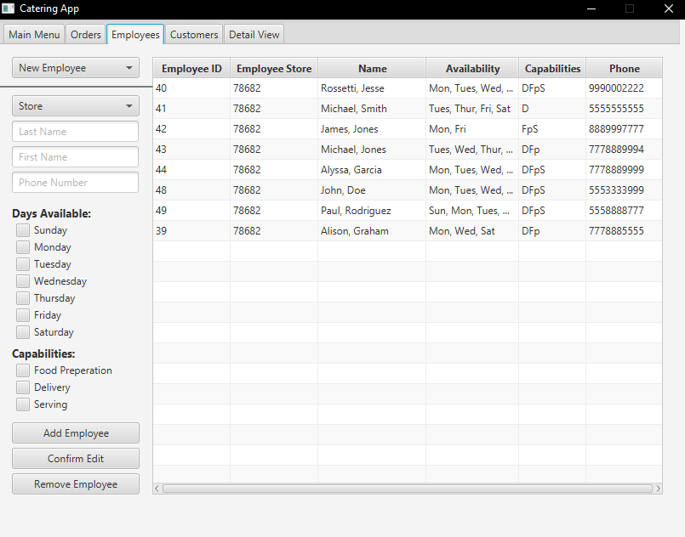

## General Information

Under the “Employees” tab you can manage all your employees. Here you can see, alter, add, and delete employees. Information such as their employer/store, name, phone number, availability and capabilities are listed.

## Hiring a New Employee

To add a new employee, fill out the relevant information and press the “Add Employee” button. All information can be changed later if the employee needs to change availability or is trained in another area.

**Required:** Only the store field is required, however it is probably a good idea to have a way of identifying an employee.

## Removing an Employee

To remove an employee, select the employee from the combo box and press the “Remove Employee” button.

## Editing an Employee

To edit an employee, select the employee from the combo box and edit the relevant information. Press the “Confirm Edit” button to confirm your changes.

**NOTE:** Editing an employee will not carry over the store they work for, you must look up that information and select the correct store!

# DETAIL VIEW

## General Information

Under the detailed view tab, you can select an order and view the notes about the order and who is/was responsible for completing a specific task. You can also complete the order here once it is finished.

## Completing an Order

To complete an order, simply select your order from the combo box and click complete order. You will not notice any immediate changes, however in the order table you will see that it is marked complete.

# SYSTEM ADMINISTRATION AND BACKUP

It is recommended that an IT or Systems Administrator handle backups and maintenance.

## Required Software and Hardware

This software and related software require the installation of JRE and JDK. It is recommended that you also use SQL Developer for ease of use.

For the most part, most computers operating on Windows 2007 or newer can run this software.

This application was developed using Java 1.8. You can see the Java specific requirements here:

<https://docs.oracle.com/javase/8/docs/technotes/guides/install/windows_system_requirements.html>

And the SQL Developer specific requirements here:

<https://docs.oracle.com/cd/E12151_01/doc.150/e12153/install.htm#RPTIG100>

## Creating Backups

To create backups for the database, please follow the guides provided by Oracle using SQL Developer.

<https://docs.oracle.com/cd/E17781_01/server.112/e18804/impexp.htm#BABJIFDA>

# REVISIONS

## Increment 6

* Update explaining required fields when there are some.
* Orders
  + Creating an order
* Detail view
  + General information
  + Completing an order
* System Administration and Backup
  + Required Software and Hardware
  + Creating backups