Pets…

**By: Georgios, Jesse**

# http://

## Requirements

### BUsiness Requirements

Pets… is an online social media platform for pets. Pet owners create a profile for their pets and have access to other pet profiles as well as the larger pet community. All pet information can be stored either publicly or privately, such as name, type, age, birthday, likes, dislikes, colour, medical history, breeding info, food info, exercise info, etc. The platform aims to encourage education as well as interaction with other pet/pet owners

### Competitors

We understand that there are many competitors to our service in the online marketplace. Some of our competitors include:

* <http://www.whiskeymilitia.com>
* <http://www.groupon.com>
* <http://www.retailmenot.ca>

### COMPetitive advantage

We feel that our service is unique in the marketplace. We offer our potential supplier companies a strategic marketing and promotion option to reach a large volume of their target market, aka, customers looking for a deal. By defining a time slot for getting our promotions, we can create a more precise demand for the supplier’s items as well as promote their brand as well in a quantifiable time frame.

## Functional Requirements - *Essential*

|  |  |  |  |
| --- | --- | --- | --- |
| **System** | **Administrator** | **GD_users** | **Companies** |
| 1. Deal Management  * Automates deal closure if the quantity available is exhausted. | 1. Manage Active Deals  * View details of active deal: * quantity remaining * price before and after * Update/edit active deal’s optional descriptions and alerts  1. Manage Deal Inventory  * View list of deals in inventory * Update/delete deal details, including optional descriptions and alerts * Ability to remove deal  1. Manage User/Company accounts  * View/Edit/Delete user and company accounts.  1. Once a user has claimed a coupon, one coupon is subtracted from the amount of coupon left. 2. Create coupon codes. | 1. Create an account. 2. Update account profile. Edit email and password. 3. Click redeem button and have the coupon added in the user‘s coupon list. 4. Users can navigate to their coupons panel and view their active coupons. 5. Users bring their device to store and show cashier their coupon to claim it. | 1. Create/Login company account 2. Post a new deal.  * Pick up a time slot to publicize deal. * Pay for a time slot thru Paypal. * Fill in the required deal information. * The business receives confirmation email after payment is processed with a list of coupon codes.  1. View submitted deals. 2. Coupons are sold once it is scanned by the company. Coupon marked as claimed from the user’s list of coupons, and marked as sold in Database. |

## Functional Requirements - *Important*

|  |  |  |  |
| --- | --- | --- | --- |
| **System** | **Administrator** | **GD_users** | **Companies** |
|  | 1. Schedule a deal 2. Switch deal every period of time. 3. If the interval is not done, and the coupons are gone, the item will be displayed with “Sold out, come back later!” 4. Monitor coupon code update when claimed or scanned by companies. | 1. Reset one’s password in situation where password was forgotten. | * + 1. Reset business password if forgotten.     2. View purchased deal(s) that hasn’t ran yet. |

## Functional Requirements – *Nice to Have*

|  |  |  |  |
| --- | --- | --- | --- |
| **System** | **Administrator** | **GD_users** | **Companies** |
|  | 1. Coupon codes printability. 2. Automate scheduling of deals. 3. Send email notification when coupon is about to expire. 4. Generate reports on items based on popularity, and other parameters. | 1. Users can post to social links, send email to friends. 2. Users can rate/review/comment on the items. 3. Users can see a history of past deals. | 1. Businesses can receive push notifications, like email, when their deal is posted. 2. Companies can pick specific time slots and priced accordingly. 3. Update company profile. |

## Non-functional Requirements

Platform: ASP.NET MVC 5 with SQL Server

## Use Case Diagram

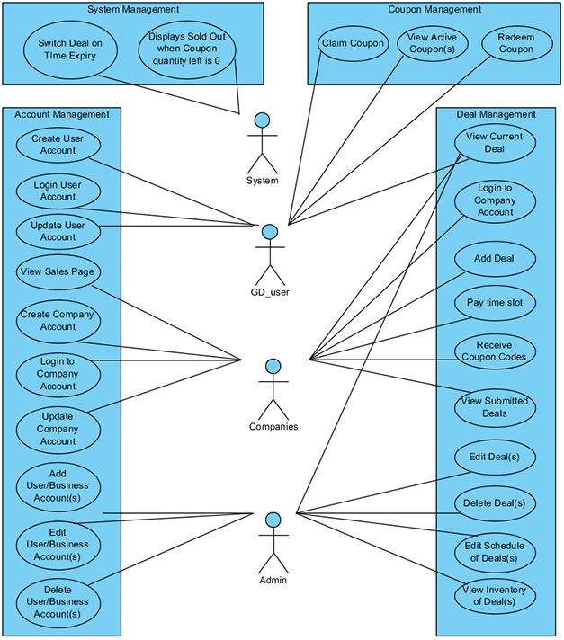

## SQL

|  |
| --- |
| --------------CREATE TABLE DATA BEGIN--------------  IF OBJECT_ID('Customer_Coupon', 'U')  IS NOT NULL DROP TABLE Customer_Coupon;  GO  IF OBJECT_ID('Coupon', 'U')  IS NOT NULL DROP TABLE Coupon;  GO  IF OBJECT_ID('Deal', 'U')  IS NOT NULL DROP TABLE Deal;  GO  IF OBJECT_ID('GD_user', 'U')  IS NOT NULL DROP TABLE GD_user;  GO  IF OBJECT_ID('Company', 'U')  IS NOT NULL DROP TABLE Company;  GO  IF OBJECT_ID('AdminInfo', 'U')  IS NOT NULL DROP TABLE AdminInfo;  GO  CREATE TABLE AdminInfo  (  ID INT IDENTITY(1,1) NOT NULL PRIMARY KEY,  account VARCHAR(20) NOT NULL,  pass VARCHAR(50) NOT NULL  )  INSERT INTO AdminInfo VALUES('admin', 'secure');  GO  --IF (OBJECT_ID('CompanyID', 'F') IS NOT NULL)  --BEGIN  -- ALTER TABLE Company DROP CONSTRAINT CompanyID  --END  CREATE TABLE Company  (  ID INT IDENTITY(5000,1) NOT NULL PRIMARY KEY,  name VARCHAR(50) NOT NULL,  email VARCHAR(50) NOT NULL,  pass VARCHAR(50) NOT NULL  );  GO  CREATE TABLE GD_user  (  ID INT IDENTITY(1000,1) NOT NULL PRIMARY KEY,  email VARCHAR(50) NOT NULL,  pass VARCHAR(50) NOT NULL,  firstname VARCHAR(30) NOT NULL  );  GO  INSERT INTO Company VALUES ('Tim Hortons', 'tim@timhortons.ca', 'abcde');  INSERT INTO Company VALUES ('BestBuy', 'john@bestbuy.com', 'dff#$');  INSERT INTO Company VALUES ('A and W', 'michael.smith@aw.ca', 'pass1234');  INSERT INTO Company VALUES ('McDonalds', 'sales@mcdonalds.com', 'Pass5678');  INSERT INTO Company VALUES ('FreshSlice', 'sales@freshslice.ca', 'myPassword');  INSERT INTO Company VALUES ('Red Robin', 'anthony.bourdin@redrobin.ca', 'gosecure');  GO  INSERT INTO GD_user VALUES('junior@email.com', 'Junior###', 'junior');  INSERT INTO GD_user VALUES ('marychou@email.com', 'Mary_Chou', 'mary');  INSERT INTO GD_user VALUES ('amirs@email.com', '_Amir_Seif', 'amir');  GO  CREATE TABLE Deal  (  ID INT IDENTITY(10000,1) NOT NULL PRIMARY KEY,  companyID INT,  productName VARCHAR(255),  picture VARCHAR(255),  shortDescription VARCHAR(255),  discount FLOAT,  msrp MONEY,  quantityLeft INT,  quantity INT,  dealStart DATETIME,  dealExpiry DATETIME,  alert VARCHAR(255),  FOREIGN KEY (companyID) REFERENCES Company(ID)  );  GO  INSERT INTO Deal VALUES(5000, 'Dark Roast Coffee', 'Content\images\deals\timhortons01.png', 'Try our new dark roast coffee', 0.8, 2.50, 50, 100, '2014-12-15 16:00:00','2014-12-15 17:00:00', '');  INSERT INTO Deal VALUES (5003, 'Double Cheese Burger', 'Content\images\deals\mcdonald01.png', 'value deal', 0.85, 2.38, 20, 100, '2014-12-01 12:30:00','2015-02-11 17:30:00', '');  INSERT INTO Deal VALUES (5001, 'Beats Headphone', 'Content\images\deals\bestbuy01.png', 'holiday sale', 0.75, 249.99, 120, 500, '2014-12-11 12:00:00', '2014-12-31 20:00:00', '');  INSERT INTO Deal VALUES(5001, 'Big Mac', 'Content\images\deals\mcdonald02.png', 'value deal', 0.85, 4.50, 10, 50, '2014-12-09 12:30:00', '2015-02-01 12:30:00', '');  INSERT INTO Deal VALUES (5004, 'Pasta', 'Content\images\deals\freshslice01.png', 'birthday deal', 0.8, 6.15, 80, 100, '2014-12-06 11:00:00','2015-01-12 11:00:00', '');  INSERT INTO Deal VALUES (5002, 'Tean Burger', 'Content\images\deals\aandw01.png', 'today only', 0.75, 3.50, 10, 300, '2014-12-21 12:00:00','2015-03-12 23:00:00', '');  GO  CREATE TABLE Coupon  (  ID INT IDENTITY(9000,1) NOT NULL PRIMARY KEY,  expiry DATE,  code VARCHAR(255),  claimed BIT,  redeemed BIT,  dealID INT,  FOREIGN KEY (dealID) REFERENCES Deal(ID)  );  GO  INSERT INTO Coupon VALUES('2015-05-24','dfs43534$%#', 0, 1, 10003);  INSERT INTO Coupon VALUES ('2015-02-05','@$dddffs43544', 0, 1, 10002);  INSERT INTO Coupon VALUES ('2015-03-15','gd44%^fffd@', 1, 0, 10005);  INSERT INTO Coupon VALUES('2015-01-31','FDS345fgd6$', 1, 0, 10001);  INSERT INTO Coupon VALUES ('2015-03-15','3554fh+df', 1, 0, 10005);  INSERT INTO Coupon VALUES ('2015-02-05','gd546%%33gdb', 1, 0, 10002);  GO  CREATE TABLE Customer_Coupon  (  couponID INT,  userID INT,  FOREIGN KEY (couponID) REFERENCES Coupon(ID),  FOREIGN KEY (userID) REFERENCES GD_user(ID),  PRIMARY KEY (couponID, userID)  );  GO  INSERT INTO Customer_Coupon VALUES (9000, 1001);  INSERT INTO Customer_Coupon VALUES (9003, 1002);  INSERT INTO Customer_Coupon VALUES (9003, 1000);  INSERT INTO Customer_Coupon VALUES (9004, 1000);  INSERT INTO Customer_Coupon VALUES (9001, 1001);  INSERT INTO Customer_Coupon VALUES (9002, 1001);  GO  SELECT * FROM Deal  SELECT * FROM Company  SELECT * FROM AdminInfo  SELECT * FROM GD_user  SELECT * FROM Coupon  SELECT * FROM Customer_Coupon  GO |

## ERD

