CDC Data ETL

Jesse DeBolt & Isaac Johnson

2023-07-13

# Primary Document for all code

## Setup

### Load libraries and knit setup

### Files located in the GitHub repository data folder

# File names list  
filenames <- c("SEED-UR-Urban-Rural.csv",  
 "SEED-SE-Unemployment\_Rate.csv",  
# "SEED-SE-Severe\_Housing\_Cost\_Burden.csv", #REMOVE, not relevant.  
 "SEED-SE-Poverty.csv",  
 "SEED-SE-Median\_Household\_Income.csv",  
 "SEED-SE-Median\_Home\_Value.csv",  
# "SEED-SE-Income\_Inequality.csv", #REMOVE, SEED-SE-Poverty.csv acts as proxy.  
 "SEED-SE-Food\_Stamp\_SNAP\_recipients.csv",  
# "SEED-SE-Education-LessThanHighSchool.csv", #REMOVE, SEED-SE-Education-LessThanCollege.csv acts as proxy.  
 "SEED-SE-Education-LessThanCollege.csv",  
# "SEED-SE-Computer.csv", #REMOVE, SEED-SE-Broadband.csv acts as proxy.  
 "SEED-SE-Broadband.csv",  
 "SEED-PE-Park\_Access.csv", #REMOVE?  
 "SEED-PE-Air\_Quality.csv", #REMOVE?  
 "RF-Smoking.csv",  
 "RF-Physical\_Inactivity.csv",  
 "RF-Obesity.csv",  
 "RF-High\_Cholesterol.csv",  
 "RF-Diagnosed\_Diabetes.csv",  
 "Prev-Stroke.csv",  
 "Prev-High\_Blood\_Pressure.csv",  
 "Prev-Coronary\_Heart\_Disease.csv",  
 "HCDI-PS-PCP.csv",  
# "HCDI-PS-Neurosurgeons.csv", #REMOVE, not relevant.  
# "HCDI-PS-Neurologists.csv", #REMOVE, not relevant.  
 "HCDI-PS-CDP.csv",  
 "HCDI-Insurance-Health\_Insurance\_Status.csv",   
 "HCDI-HP-Pharmacies\_and\_Drug\_Stores.csv",  
# "HCDI-HP-Hospitals-Services-NS.csv", #REMOVE, not relevant.  
 "HCDI-HP-Hospitals-Services-ED.csv",  
 "HCDI-HP-Hospitals-Services-CIC.csv",  
 "HCDI-HP-Hospitals-Services-CR.csv",  
 "HCDI-HP-Hospitals.csv",  
 "HCDI-CRU-Participation\_Among\_Eligible.csv",  
 "HCDI-CRU-Eligibility\_Rate.csv",  
 "HCDI-CLM-Nonadherence.csv",  
 "HCDI-Cholesterol\_Screening.csv",  
 "HCDI-BPM-Medication\_Use.csv",  
 "Demo-Total\_Population.csv",  
 "Demo-Age65Plus.csv"  
 )

### Create a function to generate the URL for a given filename

generate\_url <- function(filename) {  
 return(paste0("https://raw.githubusercontent.com/jessedebolt/MSDS-Capstone/main/data\_raw/", filename))  
}

### Generate urls for each filename

urls <- sapply(filenames, generate\_url)

### Read the CSV files into a list of data frames

# Read the CSV files into a list of data frames  
df\_list <- lapply(urls, read\_csv)  
  
# Create names for the list items (remove the .csv from the filenames)  
names(df\_list) <- sapply(filenames, function(filename) gsub(".csv", "", filename))  
  
# Create individual data frames  
list2env(df\_list, .GlobalEnv)

## <environment: R\_GlobalEnv>

### Merge all sets together into one data frame

# Get all the data frame names in the global environment  
df\_names <- ls(.GlobalEnv)  
  
# Initialize an empty data frame for the final result  
cdc <- data.frame()  
  
# Loop through each data frame  
for (df\_name in df\_names) {  
   
 # Get the data frame  
 df <- get(df\_name, envir = .GlobalEnv)  
   
 # Check if 'cnty\_fips' and 'display\_name' exist in the data frame  
 if(all(c("cnty\_fips", "display\_name") %in% colnames(df))){  
   
 # Convert 'cnty\_fips' column to character type  
 df$cnty\_fips <- as.character(df$cnty\_fips)  
   
 # Select all columns excluding those with "theme\_range" in their name  
 df <- df %>%  
 select(-contains("theme\_range"))  
  
 # Rename each variable, except 'cnty\_fips' and 'display\_name', to include the data frame name  
 df <- df %>%  
 rename\_with(.cols = -c(cnty\_fips, display\_name),  
 .fn = ~ paste(df\_name, ., sep = "\_"))  
   
 # Join the data frame with the final data frame  
 if (nrow(cdc) == 0){  
 cdc <- df  
 }   
 else {  
 cdc <- full\_join(cdc, df, by = c("cnty\_fips", "display\_name"))  
   
 # Remove the ".x" from the column names  
 names(cdc) <- gsub("\\.x$", "", names(cdc))  
   
 # Remove the "\_Value" from the column names  
 names(cdc) <- gsub("\\\_Value$", "", names(cdc))  
 }  
 }  
}

### Renaming variables

# Mapping of original names to new names  
name\_mapping <- c("cnty\_fips" = "fips",  
 "display\_name" = "display\_name",  
 "SEED-UR-Urban-Rural" = "UrbanRural",  
 "SEED-SE-Unemployment\_Rate" = "Unemploy",  
# "SEED-SE-Severe\_Housing\_Cost\_Burden"= "HouseCostBurd",  
 "SEED-SE-Poverty" = "Poverty",  
 "SEED-SE-Median\_Household\_Income" = "MedHouseIncome",  
 "SEED-SE-Median\_Home" = "MedHomeValue",  
# "SEED-SE-Income\_Inequality" = "IncomeInequality",  
 "SEED-SE-Food\_Stamp\_SNAP\_recipients" = "SNAPrecipients",  
# "SEED-SE-Education-LessThanHighSchool" = "EdLessHigh",  
 "SEED-SE-Education-LessThanCollege" = "EdLessColl",  
# "SEED-SE-Computer" = "Computer",  
 "SEED-SE-Broadband" = "Broadband",  
 "SEED-PE-Park\_Access" = "Parks",  
 "SEED-PE-Air\_Quality" = "AirQuality",  
 "RF-Smoking" = "Smoker",  
 "RF-Physical\_Inactivity" = "PhysInactivity",  
 "RF-Obesity" = "Obesity",  
 "RF-High\_Cholesterol" = "HighChol",  
 "RF-Diagnosed\_Diabetes" = "Diabetes",  
 "Prev-Stroke" = "Stroke",  
 "Prev-High\_Blood\_Pressure" = "HighBP",  
 "Prev-Coronary\_Heart\_Disease" = "CHD",  
 "HCDI-PS-PCP" = "PrimaryCarePhys",  
# "HCDI-PS-Neurosurgeons" = "NeuroSurgeons",  
# "HCDI-PS-Neurologists" = "Neurologists",  
 "HCDI-PS-CDP" = "CardioPhys",  
 "HCDI-Insurance-Health\_Insurance\_Status" = "HealthIns",  
 "HCDI-HP-Pharmacies\_and\_Drug\_Stores" = "Pharmacies",  
# "HCDI-HP-Hospitals-Services-NS" = "HospNeuro",  
 "HCDI-HP-Hospitals-Services-ED" = "HospED",  
 "HCDI-HP-Hospitals-Services-CIC" = "HospCIC",  
 "HCDI-HP-Hospitals-Services-CR" = "HospCR",  
 "HCDI-HP-Hospitals" = "Hospitals",  
 "HCDI-CRU-Participation\_Among\_Eligible" = "cruParticipate",  
 "HCDI-CRU-Eligibility\_Rate" = "CholMedElegible",  
 "HCDI-CLM-Nonadherence" = "CholMedNonAdhear",  
 "HCDI-Cholesterol\_Screening" = "CholScreen",  
 "HCDI-BPM-Medication\_Use" = "bpmUse",  
 "Demo-Total\_Population" = "pop",  
 "Demo-Age65Plus" = "Age65Plus"  
 )  
  
# Get the column names of the data frame  
original\_names <- colnames(cdc)  
  
# Find the corresponding new names using the mapping  
new\_names <- name\_mapping[match(original\_names, names(name\_mapping))]  
  
# Rename the variables in the data frame  
colnames(cdc) <- new\_names  
  
# Clean up global environment  
keep(cdc, sure = TRUE)

### Make backup and display first few rows

cdc\_copy <- cdc  
  
head(cdc)

## # A tibble: 6 × 35  
## fips display\_name Age65Plus pop bpmUse CholScreen CholMedNonAdhear  
## <chr> <chr> <dbl> <dbl> <dbl> <dbl> <dbl>  
## 1 02013 "\"Aleutians East, … 11.2 3389 67 79.4 -1   
## 2 02016 "\"Aleutians West, … 7.5 5708 63.2 80.2 -1   
## 3 02020 "\"Anchorage, (AK)\… 11.1 292090 64 80.4 15.3  
## 4 02050 "\"Bethel, (AK)\"" 7.4 18263 64.1 74.2 27.8  
## 5 02060 "\"Bristol Bay, (AK… 11.6 739 68.6 82.1 -1   
## 6 02068 "\"Denali, (AK)\"" 10.5 2502 66.6 81.2 -1   
## # ℹ 28 more variables: CholMedElegible <dbl>, cruParticipate <dbl>,  
## # Hospitals <dbl>, HospCIC <dbl>, HospCR <dbl>, HospED <dbl>,  
## # Pharmacies <dbl>, HealthIns <dbl>, CardioPhys <dbl>, PrimaryCarePhys <dbl>,  
## # CHD <dbl>, HighBP <dbl>, Stroke <dbl>, Diabetes <dbl>, HighChol <dbl>,  
## # Obesity <dbl>, PhysInactivity <dbl>, Smoker <dbl>, AirQuality <dbl>,  
## # Parks <dbl>, Broadband <dbl>, EdLessColl <dbl>, SNAPrecipients <dbl>,  
## # MedHomeValue <dbl>, MedHouseIncome <dbl>, Poverty <dbl>, Unemploy <dbl>, …

#cdc <- cdc\_copy

### Read in data for table descriptions

TableDesc <- read\_csv("data\_support/Table\_Descriptions.csv")

\*\*\*\*\*\*\*\*\*\*\*\*\*\*\*\*\*\*\*\*\*\*\*\*\*\*\*\*\*\*\*\*\*\*\*\*\*\*\*\*\*\*\*\*\*\*\*\*\*\*\*\*\*\*\*\*\*\*\*\*\*\*\*\*\*\*\*\*\*\*\*\*\*\*\*\*\*\*\*\*\*\*\*\*\*\*\*\*\*\*\*

End setup section

\*\*\*\*\*\*\*\*\*\*\*\*\*\*\*\*\*\*\*\*\*\*\*\*\*\*\*\*\*\*\*\*\*\*\*\*\*\*\*\*\*\*\*\*\*\*\*\*\*\*\*\*\*\*\*\*\*\*\*\*\*\*\*\*\*\*\*\*\*\*\*\*\*\*\*\*\*\*\*\*\*\*\*\*\*\*\*\*\*\*\*

## Data cleansing

### Removing US territories

#Use if needed to back up changes  
#cdc <- cdc\_copy  
  
#Remove territories  
cdc <- cdc %>%  
 filter(!grepl("\\(AS\\)|\\(GU\\)|\\(MP\\)|\\(PR\\)|\\(County Equivalent\\)", as.character(display\_name)))

### Separated County and State

# Separate the 'display\_name' column  
cdc <- cdc %>% separate(display\_name, into = c("county", "state"), sep = ", \\(|\\)", remove = TRUE, convert = TRUE)  
  
# Remove the closing parenthesis from the state column  
cdc$state <- gsub("\\)", "", cdc$state)  
  
# Remove the quotation marks from the 'county' column  
cdc$county <- gsub("\"", "", cdc$county)  
  
print(cdc)

## # A tibble: 3,142 × 36  
## fips county state Age65Plus pop bpmUse CholScreen CholMedNonAdhear  
## <chr> <chr> <chr> <dbl> <dbl> <dbl> <dbl> <dbl>  
## 1 02013 Aleutians Ea… AK 11.2 3389 67 79.4 -1   
## 2 02016 Aleutians We… AK 7.5 5708 63.2 80.2 -1   
## 3 02020 Anchorage AK 11.1 292090 64 80.4 15.3  
## 4 02050 Bethel AK 7.4 18263 64.1 74.2 27.8  
## 5 02060 Bristol Bay AK 11.6 739 68.6 82.1 -1   
## 6 02068 Denali AK 10.5 2502 66.6 81.2 -1   
## 7 02070 Dillingham AK 11.3 4934 66.2 78 -1   
## 8 02090 Fairbanks No… AK 10.4 98455 62.2 78.8 15.7  
## 9 02100 Haines AK 23 2547 73.8 85.3 16.2  
## 10 02105 Hoonah-Angoon AK 22.6 2135 74.4 85 -1   
## # ℹ 3,132 more rows  
## # ℹ 28 more variables: CholMedElegible <dbl>, cruParticipate <dbl>,  
## # Hospitals <dbl>, HospCIC <dbl>, HospCR <dbl>, HospED <dbl>,  
## # Pharmacies <dbl>, HealthIns <dbl>, CardioPhys <dbl>, PrimaryCarePhys <dbl>,  
## # CHD <dbl>, HighBP <dbl>, Stroke <dbl>, Diabetes <dbl>, HighChol <dbl>,  
## # Obesity <dbl>, PhysInactivity <dbl>, Smoker <dbl>, AirQuality <dbl>,  
## # Parks <dbl>, Broadband <dbl>, EdLessColl <dbl>, SNAPrecipients <dbl>, …

### Relabeling Urban/Rural codes

#change rural/urban  
# 1 = Large central metro -> Large\_Urban  
# 2 = Large fringe metro -> LargeFringe\_Urban  
# 3 = Medium/small metro -> MediumSmall\_Urban  
# 4 = Nonmetro -> Rural  
  
cdc$"UrbanRural" <-  
 ifelse(cdc$"UrbanRural" == 1,  
 "Large\_Urban",  
 ifelse(cdc$"UrbanRural" == 2,  
 "LargeFringe\_Urban",  
 ifelse(cdc$"UrbanRural" == 3,  
 "MediumSmall\_Urban",  
 ifelse(cdc$"UrbanRural" == 4,  
 "Rural",  
 cdc$"UrbanRural"))))  
  
### Replacing '-1' with 'NA' under assumption that these are truly missing elements  
cdc[cdc == -1] <- NA

### Review header names, check for missing rural/urban values

names(cdc)

## [1] "fips" "county" "state" "Age65Plus"   
## [5] "pop" "bpmUse" "CholScreen" "CholMedNonAdhear"  
## [9] "CholMedElegible" "cruParticipate" "Hospitals" "HospCIC"   
## [13] "HospCR" "HospED" "Pharmacies" "HealthIns"   
## [17] "CardioPhys" "PrimaryCarePhys" "CHD" "HighBP"   
## [21] "Stroke" "Diabetes" "HighChol" "Obesity"   
## [25] "PhysInactivity" "Smoker" "AirQuality" "Parks"   
## [29] "Broadband" "EdLessColl" "SNAPrecipients" "MedHomeValue"   
## [33] "MedHouseIncome" "Poverty" "Unemploy" "UrbanRural"

unique(cdc$'UrbanRural')

## [1] "Rural" "MediumSmall\_Urban" NA   
## [4] "Large\_Urban" "LargeFringe\_Urban"

rural\_query <- filter(cdc, `UrbanRural` %in% c(NA, "", "NA"))  
  
head(rural\_query, n=20)

## # A tibble: 1 × 36  
## fips county state Age65Plus pop bpmUse CholScreen CholMedNonAdhear  
## <chr> <chr> <chr> <dbl> <dbl> <dbl> <dbl> <dbl>  
## 1 02158 Kusilvak AK 5.8 8298 61.9 70.1 NA  
## # ℹ 28 more variables: CholMedElegible <dbl>, cruParticipate <dbl>,  
## # Hospitals <dbl>, HospCIC <dbl>, HospCR <dbl>, HospED <dbl>,  
## # Pharmacies <dbl>, HealthIns <dbl>, CardioPhys <dbl>, PrimaryCarePhys <dbl>,  
## # CHD <dbl>, HighBP <dbl>, Stroke <dbl>, Diabetes <dbl>, HighChol <dbl>,  
## # Obesity <dbl>, PhysInactivity <dbl>, Smoker <dbl>, AirQuality <dbl>,  
## # Parks <dbl>, Broadband <dbl>, EdLessColl <dbl>, SNAPrecipients <dbl>,  
## # MedHomeValue <dbl>, MedHouseIncome <dbl>, Poverty <dbl>, Unemploy <dbl>, …

### Inserting Rural/Urban for missing value

# Find and insert where county is 'Kusilvak' based on Wikipedia data.  
cdc$"UrbanRural"[grepl("Kusilvak", cdc$county)] <- "Rural"  
  
unique(cdc$'UrbanRural')

## [1] "Rural" "MediumSmall\_Urban" "Large\_Urban"   
## [4] "LargeFringe\_Urban"

# Double check for any NAs in Rural/Urban  
rural\_query <- filter(cdc, `UrbanRural` %in% c(NA, "", "NA"))  
head(rural\_query, n=20)

## # A tibble: 0 × 36  
## # ℹ 36 variables: fips <chr>, county <chr>, state <chr>, Age65Plus <dbl>,  
## # pop <dbl>, bpmUse <dbl>, CholScreen <dbl>, CholMedNonAdhear <dbl>,  
## # CholMedElegible <dbl>, cruParticipate <dbl>, Hospitals <dbl>,  
## # HospCIC <dbl>, HospCR <dbl>, HospED <dbl>, Pharmacies <dbl>,  
## # HealthIns <dbl>, CardioPhys <dbl>, PrimaryCarePhys <dbl>, CHD <dbl>,  
## # HighBP <dbl>, Stroke <dbl>, Diabetes <dbl>, HighChol <dbl>, Obesity <dbl>,  
## # PhysInactivity <dbl>, Smoker <dbl>, AirQuality <dbl>, Parks <dbl>, …

### Inserting Parks missing value

# Find and insert where county is 'Kusilvak' based on average for all AK counties.  
cdc$"Parks"[grepl("Kusilvak", cdc$county)] <- 66

### Checking for missing values

#total number of missing values in dataset  
sum(is.na(cdc))

## [1] 3316

#total number of missing values in each column  
colSums(is.na(cdc))

## fips county state Age65Plus   
## 0 0 0 1   
## pop bpmUse CholScreen CholMedNonAdhear   
## 1 22 22 81   
## CholMedElegible cruParticipate Hospitals HospCIC   
## 111 744 0 0   
## HospCR HospED Pharmacies HealthIns   
## 0 0 1 1   
## CardioPhys PrimaryCarePhys CHD HighBP   
## 1966 220 1 22   
## Stroke Diabetes HighChol Obesity   
## 1 21 22 21   
## PhysInactivity Smoker AirQuality Parks   
## 21 1 26 0   
## Broadband EdLessColl SNAPrecipients MedHomeValue   
## 1 1 1 1   
## MedHouseIncome Poverty Unemploy UrbanRural   
## 2 2 2 0

#total number of missing values in each column  
count\_na\_func <- function(x) sum(is.na(x))   
cdc <- cdc %>%  
 mutate(count\_na = apply(., 1, count\_na\_func)) %>%   
 arrange(desc(count\_na))

### Remove counties with minimal data

# Remove those that have more than 8 NAs in that row  
cdc <- cdc[cdc$count\_na <= 8, ]  
  
# Remove count\_na column  
cdc$count\_na <- NULL

## Populating missing values

## Single value entry

### Inserting value for missing values in bpmUse for NJ

# Find NAs and replace where state is 'NJ'  
cdc$"bpmUse"[grepl("NJ", cdc$state)] <- 71.71

Source: Average of NJ Cities from 500\_Cities: Taking medicine for high blood pressure control among adults aged >=18 Years with high blood pressure File: 500\_Cities\_\_Taking\_medicine\_for\_high\_blood\_pressure\_control\_among\_adults\_aged\_\_\_18\_years\_with\_high\_blood\_pressure.csv Source: <https://chronicdata.cdc.gov/500-Cities-Places/500-Cities-Taking-medicine-for-high-blood-pressure/4peq-qp55>

### Inserting value for missing values in CholScreen for NJ

# Find NAs and replace where state is 'NJ'  
cdc$"CholScreen"[grepl("NJ", cdc$state)] <- 79.43

Source: Average of NJ Cities from 500 Cities: Cholesterol screening among adults aged >=18 years FIle: 500\_Cities\_\_Cholesterol\_screening\_among\_adults\_aged\_\_\_18\_years.csv Source: <https://chronicdata.cdc.gov/500-Cities-Places/500-Cities-Cholesterol-screening-among-adults-aged/myk4-ptre>

### Inserting value for missing values in HighBP for NJ

# Find NAs and replace where state is 'NJ'  
cdc$"HighBP"[grepl("NJ", cdc$state)] <- 33.7

Source: Average of NJ Cities from 500 Cities: High blood pressure among adults aged >=18 years File: 500\_Cities\_\_High\_blood\_pressure\_among\_adults\_aged\_\_\_18\_years.csv Source: <https://chronicdata.cdc.gov/500-Cities-Places/500-Cities-High-blood-pressure-among-adults-aged-1/ebxs-yc6e>

### Inserting value for missing values in Diabetes for NJ

# Find NAs and replace where state is 'NJ'  
cdc$"Diabetes"[grepl("NJ", cdc$state)] <- 17.4

Source: Average of NJ Cities from 500 Cities: Diagnosed diabetes among adults aged >=18 years File: 500\_Cities\_\_Diagnosed\_diabetes\_among\_adults\_aged\_\_\_18\_years.csv Source: <https://chronicdata.cdc.gov/500-Cities-Places/500-Cities-Diagnosed-diabetes-among-adults-aged-18/cn78-b9bj>

### Inserting value for missing values in HighChol for NJ

# Find NAs and replace where state is 'NJ'  
cdc$"HighChol"[grepl("NJ", cdc$state)] <- 32.41

Source: Average of NJ Cities from 500 Cities: High cholesterol among adults aged >=18 years who have been screened in the past 5 years <File:500_Cities__High_cholesterol_among_adults_aged___18_years_who_have_been_screened_in_the_past_5_years.csv> Source: <https://chronicdata.cdc.gov/500-Cities-Places/500-Cities-High-cholesterol-among-adults-aged-18-y/mc6z-sjie>

### Inserting value for missing values in Obesity for NJ

# Find NAs and replace where state is 'NJ'  
cdc$"Obesity"[grepl("NJ", cdc$state)] <- 33.59

Source: Average of NJ Cities from 500 Cities: Obesity among adults aged >=18 years File: 500\_Cities\_\_Obesity\_among\_adults\_aged\_\_\_18\_years.csv Source: <https://chronicdata.cdc.gov/500-Cities-Places/500-Cities-Obesity-among-adults-aged-18-years/bjvu-3y7d>

### Inserting values for missing values in Median Home Value

cdc$"MedHomeValue"[grepl("48261", cdc$fips)] <- 42550  
cdc$"MedHomeValue"[grepl("48301", cdc$fips)] <- 38143  
cdc$"MedHomeValue"[grepl("46017", cdc$fips)] <- 101393  
cdc$"MedHomeValue"[grepl("46095", cdc$fips)] <- 60537

Reference: Kenedy TX (fips 48261): Median Home Value = $42,550 <https://www.city-data.com/county/Kenedy_County-TX.html> Loving TX (fips 48301): Median Home Value = $38,143 <http://www.city-data.com/county/Loving_County-TX.html> Buffalo SD (fips 46017): Median Home Value = $101,393 <http://www.city-data.com/county/Buffalo_County-SD.html> Mellette SD (fips 46095): Median Home Value = $60,537 <http://www.city-data.com/county/Mellette_County-SD.html>

## Multiple value entry

### Read in additional data

pcp\_cardio\_count <- read\_csv("data\_support/pcp\_cardio\_count.csv")  
  
pcp\_cardio\_count$COUNTY = as.character(pcp\_cardio\_count$COUNTY)

### Populating missing items for PCPs and Cardio Phys

# Joining count data frame to the cdc data frame  
cdc <- left\_join(cdc, pcp\_cardio\_count, by = c("fips" = "COUNTY"))  
  
# Use coalesce to replace NAs in PCP and CardioPhys  
cdc <- cdc %>%   
 mutate(  
 pcp = coalesce(pcp, PrimaryCarePhys),  
 CardioPhys = coalesce(CardioPhys, cardio)  
 )  
  
# Remove the temporary columns  
cdc <- cdc %>% select(-PrimaryCarePhys, -cardio)

\*\*\*\*\*\*\*\*\*\*\*\*\*\*\*\*\*\*\*\*\*\*\*\*\*\*\*\*\*\*\*\*\*\*\*\*\*\*\*\*\*\*\*\*\*\*\*\*\*\*\*\*\*\*\*\*\*\*\*\*\*\*\*\*\*\*\*\*\*\*\*\*\*\*\*\*\*\*\*\*\*\*\*\*\*\*\*\*\*\*\*

## Imputations should happen after split…

\*\*\*\*\*\*\*\*\*\*\*\*\*\*\*\*\*\*\*\*\*\*\*\*\*\*\*\*\*\*\*\*\*\*\*\*\*\*\*\*\*\*\*\*\*\*\*\*\*\*\*\*\*\*\*\*\*\*\*\*\*\*\*\*\*\*\*\*\*\*\*\*\*\*\*\*\*\*\*\*\*\*\*\*\*\*\*\*\*\*\*

## Imputations

### Impute remaining missing Cardiologists and Primary Care Physicians based on median of urban/rural for each state

# Calculate medians and impute NAs  
cdc <- cdc %>%  
 group\_by(state) %>%  
 group\_by(UrbanRural) %>%   
 mutate(  
 CardioPhys = replace\_na(CardioPhys, median(CardioPhys, na.rm = TRUE)),  
 pcp = replace\_na(pcp, median(pcp, na.rm = TRUE))  
 )

### Imputing missing values in CholMedNonAdhear based on median of urban/rural for each state

cdc = cdc %>%  
 group\_by(state) %>%  
 group\_by(UrbanRural) %>%   
 mutate(CholMedNonAdhear = replace\_na(CholMedNonAdhear, median(CholMedNonAdhear, na.rm=TRUE)))

### Imputing missing values in CholMedElegible based on median of urban/rural for each state

cdc = cdc %>%   
 group\_by(state) %>%  
 group\_by(UrbanRural) %>%   
 mutate(CholMedElegible = replace\_na(CholMedElegible, median(CholMedElegible, na.rm=TRUE)))

### Imputing missing values in cruParticipate based on median of urban/rural for each state

cdc = cdc %>%   
 group\_by(state) %>%  
 group\_by(UrbanRural) %>%   
 mutate(cruParticipate = replace\_na(cruParticipate, median(cruParticipate, na.rm=TRUE)))

### Imputing missing values in PhysInactivity based on median of urban/rural for each state

cdc = cdc %>%   
 group\_by(state) %>%  
 group\_by(UrbanRural) %>%   
 mutate(PhysInactivity = replace\_na(PhysInactivity, median(PhysInactivity, na.rm=TRUE)))

### Imputing missing values in AirQuality based on median of urban/rural for each state

cdc = cdc %>%   
 group\_by(state) %>%  
 group\_by(UrbanRural) %>%   
 mutate(AirQuality = replace\_na(AirQuality, median(AirQuality, na.rm=TRUE)))

### Checking for missing values

#total number of missing values in dataset  
sum(is.na(cdc))

## [1] 0

#total number of missing values in each column  
colSums(is.na(cdc))

## fips county state Age65Plus   
## 0 0 0 0   
## pop bpmUse CholScreen CholMedNonAdhear   
## 0 0 0 0   
## CholMedElegible cruParticipate Hospitals HospCIC   
## 0 0 0 0   
## HospCR HospED Pharmacies HealthIns   
## 0 0 0 0   
## CardioPhys CHD HighBP Stroke   
## 0 0 0 0   
## Diabetes HighChol Obesity PhysInactivity   
## 0 0 0 0   
## Smoker AirQuality Parks Broadband   
## 0 0 0 0   
## EdLessColl SNAPrecipients MedHomeValue MedHouseIncome   
## 0 0 0 0   
## Poverty Unemploy UrbanRural pcp   
## 0 0 0 0

\*\*\*\*\*\*\*\*\*\*\*\*\*\*\*\*\*\*\*\*\*\*\*\*\*\*\*\*\*\*\*\*\*\*\*\*\*\*\*\*\*\*\*\*\*\*\*\*\*\*\*\*\*\*\*\*\*\*\*\*\*\*\*\*\*\*\*\*\*\*\*\*\*\*\*\*\*\*\*\*\*\*\*\*\*\*\*\*\*\*\*

## Remove one hot for states? …

\*\*\*\*\*\*\*\*\*\*\*\*\*\*\*\*\*\*\*\*\*\*\*\*\*\*\*\*\*\*\*\*\*\*\*\*\*\*\*\*\*\*\*\*\*\*\*\*\*\*\*\*\*\*\*\*\*\*\*\*\*\*\*\*\*\*\*\*\*\*\*\*\*\*\*\*\*\*\*\*\*\*\*\*\*\*\*\*\*\*\*

## Additional feature engineering

### One-hot encoding for the ‘state’ and ‘UrbanRural’ columns

# Convert urban/rural variables to factors  
cdc$UrbanRural <- as.factor(cdc$UrbanRural)  
  
# Use fastDummies for the 'state' column  
cdc <- fastDummies::dummy\_cols(cdc, select\_columns = 'state')  
  
# Use fastDummies for the 'UrbanRural' column  
cdc <- fastDummies::dummy\_cols(cdc, select\_columns = 'UrbanRural')

\*\*\*\*\*\*\*\*\*\*\*\*\*\*\*\*\*\*\*\*\*\*\*\*\*\*\*\*\*\*\*\*\*\*\*\*\*\*\*\*\*\*\*\*\*\*\*\*\*\*\*\*\*\*\*\*\*\*\*\*\*\*\*\*\*\*\*\*\*\*\*\*\*\*\*\*\*\*\*\*\*\*\*\*\*\*\*\*\*\*\*

## Adding additional columns should come before split (move above Add feature…

\*\*\*\*\*\*\*\*\*\*\*\*\*\*\*\*\*\*\*\*\*\*\*\*\*\*\*\*\*\*\*\*\*\*\*\*\*\*\*\*\*\*\*\*\*\*\*\*\*\*\*\*\*\*\*\*\*\*\*\*\*\*\*\*\*\*\*\*\*\*\*\*\*\*\*\*\*\*\*\*\*\*\*\*\*\*\*\*\*\*\*

### Convert provider demographics

#### Convert number of hospitals per county to number of hospitals per 100k residents

# Create column for number of hospitals per 100k residents  
cdc$Hosp100k <- (cdc$Hospitals / cdc$pop) \* 100000

#### Convert number of pharmacies per population to number of pharmacies per 100k residents

# Create column for number of hospitals per 100k residents  
cdc$Pharm100k <- (cdc$Pharmacies / cdc$pop) \* 100000

#### Convert population per physicians to physician per 1k residents

# Calculate the number of physicians  
cdc$TotalPCP <- cdc$pop / cdc$pcp  
# Create columns for number of physicians per 1k residents  
cdc$PSP1k <- (cdc$TotalPCP / cdc$pop) \* 1000

#### Convert population per cardiovascular physicians to cardiovascular physician per 100k residents

# Calculate the number of physicians  
cdc$TotalCardio <- cdc$pop / cdc$CardioPhys  
# Create columns for number of physicians per 1k residents  
cdc$Cardio100k <- (cdc$CardioPhys / cdc$pop) \* 100000

## Export cleaned data to csv

# Write data to local in csv format  
write\_csv(cdc, "data/CDC\_all.csv")

\*\*\*\*\*\*\*\*\*\*\*\*\*\*\*\*\*\*\*\*\*\*\*\*\*\*\*\*\*\*\*\*\*\*\*\*\*\*\*\*\*\*\*\*\*\*\*\*\*\*\*\*\*\*\*\*\*\*\*\*\*\*\*\*\*\*\*\*\*\*\*\*\*\*\*\*\*\*\*\*\*\*\*\*\*\*\*\*\*\*\*

End cleaning section

\*\*\*\*\*\*\*\*\*\*\*\*\*\*\*\*\*\*\*\*\*\*\*\*\*\*\*\*\*\*\*\*\*\*\*\*\*\*\*\*\*\*\*\*\*\*\*\*\*\*\*\*\*\*\*\*\*\*\*\*\*\*\*\*\*\*\*\*\*\*\*\*\*\*\*\*\*\*\*\*\*\*\*\*\*\*\*\*\*\*\*

## EDA

### Show basic details and information

head(cdc)

## # A tibble: 6 × 97  
## fips county state Age65Plus pop bpmUse CholScreen CholMedNonAdhear  
## <chr> <chr> <chr> <dbl> <dbl> <dbl> <dbl> <dbl>  
## 1 34001 Atlantic NJ 18.1 264650 71.7 79.4 16.4  
## 2 34003 Bergen NJ 17.3 931275 71.7 79.4 15.9  
## 3 34005 Burlington NJ 17 446301 71.7 79.4 13.8  
## 4 34007 Camden NJ 15.7 506721 71.7 79.4 15   
## 5 34009 Cape May NJ 26.6 92701 71.7 79.4 13.7  
## 6 34011 Cumberland NJ 15.2 150085 71.7 79.4 15.6  
## # ℹ 89 more variables: CholMedElegible <dbl>, cruParticipate <dbl>,  
## # Hospitals <dbl>, HospCIC <dbl>, HospCR <dbl>, HospED <dbl>,  
## # Pharmacies <dbl>, HealthIns <dbl>, CardioPhys <dbl>, CHD <dbl>,  
## # HighBP <dbl>, Stroke <dbl>, Diabetes <dbl>, HighChol <dbl>, Obesity <dbl>,  
## # PhysInactivity <dbl>, Smoker <dbl>, AirQuality <dbl>, Parks <dbl>,  
## # Broadband <dbl>, EdLessColl <dbl>, SNAPrecipients <dbl>,  
## # MedHomeValue <dbl>, MedHouseIncome <dbl>, Poverty <dbl>, Unemploy <dbl>, …

str(cdc)

## tibble [3,140 × 97] (S3: tbl\_df/tbl/data.frame)  
## $ fips : chr [1:3140] "34001" "34003" "34005" "34007" ...  
## $ county : chr [1:3140] "Atlantic" "Bergen" "Burlington" "Camden" ...  
## $ state : chr [1:3140] "NJ" "NJ" "NJ" "NJ" ...  
## $ Age65Plus : num [1:3140] 18.1 17.3 17 15.7 26.6 15.2 13.7 15.9 18.6 15.3 ...  
## $ pop : num [1:3140] 264650 931275 446301 506721 92701 ...  
## $ bpmUse : num [1:3140] 71.7 71.7 71.7 71.7 71.7 ...  
## $ CholScreen : num [1:3140] 79.4 79.4 79.4 79.4 79.4 ...  
## $ CholMedNonAdhear : num [1:3140] 16.4 15.9 13.8 15 13.7 15.6 20.5 13.9 12.7 15.8 ...  
## $ CholMedElegible : num [1:3140] 20.6 15.5 14.8 16 19 16.9 15.1 14.9 15 14.5 ...  
## $ cruParticipate : num [1:3140] 22.5 27.4 19 16.5 35.2 22 22.3 18.7 37.8 20.8 ...  
## $ Hospitals : num [1:3140] 2 5 3 4 1 1 8 1 1 4 ...  
## $ HospCIC : num [1:3140] 1 3 1 2 0 1 5 0 1 1 ...  
## $ HospCR : num [1:3140] 1 5 1 2 1 1 5 1 1 2 ...  
## $ HospED : num [1:3140] 1 5 3 4 1 1 6 1 1 4 ...  
## $ Pharmacies : num [1:3140] 15 17.9 14.5 19.5 22.1 13.6 19.7 12.6 14.7 18.1 ...  
## $ HealthIns : num [1:3140] 10.7 8.4 6 8.2 9.2 12.1 12 5.7 5.2 9.6 ...  
## $ CardioPhys : num [1:3140] 12 5.5 10.6 8 9.2 24.9 8.5 22.4 10.4 8.4 ...  
## $ CHD : num [1:3140] 7.6 5.5 6.2 6.2 8.6 7.5 6.1 6 6.2 5.8 ...  
## $ HighBP : num [1:3140] 33.7 33.7 33.7 33.7 33.7 33.7 33.7 33.7 33.7 33.7 ...  
## $ Stroke : num [1:3140] 3.5 2.5 2.8 3.1 3.6 3.8 3.3 2.7 2.6 2.8 ...  
## $ Diabetes : num [1:3140] 17.4 17.4 17.4 17.4 17.4 17.4 17.4 17.4 17.4 17.4 ...  
## $ HighChol : num [1:3140] 32.4 32.4 32.4 32.4 32.4 ...  
## $ Obesity : num [1:3140] 33.6 33.6 33.6 33.6 33.6 ...  
## $ PhysInactivity : num [1:3140] 22.8 21.9 21.9 21.9 22.8 22.8 21.1 21.9 21.9 22.8 ...  
## $ Smoker : num [1:3140] 15.9 10.2 12.4 14.9 13.4 18.8 14.3 13.1 9.8 11.8 ...  
## $ AirQuality : num [1:3140] 7.3 9.9 9.9 10.1 7.8 7.8 8.9 7.4 8.5 8.6 ...  
## $ Parks : num [1:3140] 55 50 33 56 85 38 73 31 32 53 ...  
## $ Broadband : num [1:3140] 14.6 8.8 9.2 13.5 13 17.9 17.5 10.2 8.1 15.1 ...  
## $ EdLessColl : num [1:3140] 71.2 49.3 61.5 67.7 66.4 83.4 63.7 66.2 46 56.5 ...  
## $ SNAPrecipients : num [1:3140] 13.3 3.4 4.6 12.2 7.5 16.5 13.3 5.9 1.9 7.4 ...  
## $ MedHomeValue : num [1:3140] 217000 477000 260000 200000 306000 166000 396000 224000 419000 290000 ...  
## $ MedHouseIncome : num [1:3140] 61000 107000 92000 72000 76000 60000 66000 87000 114000 88000 ...  
## $ Poverty : num [1:3140] 13.8 6.4 6 12.4 9.6 13.1 14.3 7 4.1 9.5 ...  
## $ Unemploy : num [1:3140] 9.5 6 5.3 6.8 8.9 7.7 8 6 4.6 5.2 ...  
## $ UrbanRural : Factor w/ 4 levels "Large\_Urban",..: 3 2 2 2 3 3 1 2 2 3 ...  
## $ pcp : num [1:3140] 1.2 0.8 1.2 1 1.7 2.3 1.2 1.8 0.8 1 ...  
## $ state\_AK : int [1:3140] 0 0 0 0 0 0 0 0 0 0 ...  
## $ state\_AL : int [1:3140] 0 0 0 0 0 0 0 0 0 0 ...  
## $ state\_AR : int [1:3140] 0 0 0 0 0 0 0 0 0 0 ...  
## $ state\_AZ : int [1:3140] 0 0 0 0 0 0 0 0 0 0 ...  
## $ state\_CA : int [1:3140] 0 0 0 0 0 0 0 0 0 0 ...  
## $ state\_CO : int [1:3140] 0 0 0 0 0 0 0 0 0 0 ...  
## $ state\_CT : int [1:3140] 0 0 0 0 0 0 0 0 0 0 ...  
## $ state\_DC : int [1:3140] 0 0 0 0 0 0 0 0 0 0 ...  
## $ state\_DE : int [1:3140] 0 0 0 0 0 0 0 0 0 0 ...  
## $ state\_FL : int [1:3140] 0 0 0 0 0 0 0 0 0 0 ...  
## $ state\_GA : int [1:3140] 0 0 0 0 0 0 0 0 0 0 ...  
## $ state\_HI : int [1:3140] 0 0 0 0 0 0 0 0 0 0 ...  
## $ state\_IA : int [1:3140] 0 0 0 0 0 0 0 0 0 0 ...  
## $ state\_ID : int [1:3140] 0 0 0 0 0 0 0 0 0 0 ...  
## $ state\_IL : int [1:3140] 0 0 0 0 0 0 0 0 0 0 ...  
## $ state\_IN : int [1:3140] 0 0 0 0 0 0 0 0 0 0 ...  
## $ state\_KS : int [1:3140] 0 0 0 0 0 0 0 0 0 0 ...  
## $ state\_KY : int [1:3140] 0 0 0 0 0 0 0 0 0 0 ...  
## $ state\_LA : int [1:3140] 0 0 0 0 0 0 0 0 0 0 ...  
## $ state\_MA : int [1:3140] 0 0 0 0 0 0 0 0 0 0 ...  
## $ state\_MD : int [1:3140] 0 0 0 0 0 0 0 0 0 0 ...  
## $ state\_ME : int [1:3140] 0 0 0 0 0 0 0 0 0 0 ...  
## $ state\_MI : int [1:3140] 0 0 0 0 0 0 0 0 0 0 ...  
## $ state\_MN : int [1:3140] 0 0 0 0 0 0 0 0 0 0 ...  
## $ state\_MO : int [1:3140] 0 0 0 0 0 0 0 0 0 0 ...  
## $ state\_MS : int [1:3140] 0 0 0 0 0 0 0 0 0 0 ...  
## $ state\_MT : int [1:3140] 0 0 0 0 0 0 0 0 0 0 ...  
## $ state\_NC : int [1:3140] 0 0 0 0 0 0 0 0 0 0 ...  
## $ state\_ND : int [1:3140] 0 0 0 0 0 0 0 0 0 0 ...  
## $ state\_NE : int [1:3140] 0 0 0 0 0 0 0 0 0 0 ...  
## $ state\_NH : int [1:3140] 0 0 0 0 0 0 0 0 0 0 ...  
## $ state\_NJ : int [1:3140] 1 1 1 1 1 1 1 1 1 1 ...  
## $ state\_NM : int [1:3140] 0 0 0 0 0 0 0 0 0 0 ...  
## $ state\_NV : int [1:3140] 0 0 0 0 0 0 0 0 0 0 ...  
## $ state\_NY : int [1:3140] 0 0 0 0 0 0 0 0 0 0 ...  
## $ state\_OH : int [1:3140] 0 0 0 0 0 0 0 0 0 0 ...  
## $ state\_OK : int [1:3140] 0 0 0 0 0 0 0 0 0 0 ...  
## $ state\_OR : int [1:3140] 0 0 0 0 0 0 0 0 0 0 ...  
## $ state\_PA : int [1:3140] 0 0 0 0 0 0 0 0 0 0 ...  
## $ state\_RI : int [1:3140] 0 0 0 0 0 0 0 0 0 0 ...  
## $ state\_SC : int [1:3140] 0 0 0 0 0 0 0 0 0 0 ...  
## $ state\_SD : int [1:3140] 0 0 0 0 0 0 0 0 0 0 ...  
## $ state\_TN : int [1:3140] 0 0 0 0 0 0 0 0 0 0 ...  
## $ state\_TX : int [1:3140] 0 0 0 0 0 0 0 0 0 0 ...  
## $ state\_UT : int [1:3140] 0 0 0 0 0 0 0 0 0 0 ...  
## $ state\_VA : int [1:3140] 0 0 0 0 0 0 0 0 0 0 ...  
## $ state\_VT : int [1:3140] 0 0 0 0 0 0 0 0 0 0 ...  
## $ state\_WA : int [1:3140] 0 0 0 0 0 0 0 0 0 0 ...  
## $ state\_WI : int [1:3140] 0 0 0 0 0 0 0 0 0 0 ...  
## $ state\_WV : int [1:3140] 0 0 0 0 0 0 0 0 0 0 ...  
## $ state\_WY : int [1:3140] 0 0 0 0 0 0 0 0 0 0 ...  
## $ UrbanRural\_Large\_Urban : int [1:3140] 0 0 0 0 0 0 1 0 0 0 ...  
## $ UrbanRural\_LargeFringe\_Urban: int [1:3140] 0 1 1 1 0 0 0 1 1 0 ...  
## $ UrbanRural\_MediumSmall\_Urban: int [1:3140] 1 0 0 0 1 1 0 0 0 1 ...  
## $ UrbanRural\_Rural : int [1:3140] 0 0 0 0 0 0 0 0 0 0 ...  
## $ Hosp100k : num [1:3140] 0.756 0.537 0.672 0.789 1.079 ...  
## $ Pharm100k : num [1:3140] 5.67 1.92 3.25 3.85 23.84 ...  
## $ TotalPCP : num [1:3140] 220542 1164094 371918 506721 54530 ...  
## $ PSP1k : num [1:3140] 833 1250 833 1000 588 ...  
## $ TotalCardio : num [1:3140] 22054 169323 42104 63340 10076 ...  
## $ Cardio100k : num [1:3140] 4.534 0.591 2.375 1.579 9.924 ...  
## - attr(\*, "groups")= tibble [4 × 2] (S3: tbl\_df/tbl/data.frame)  
## ..$ UrbanRural: Factor w/ 4 levels "Large\_Urban",..: 1 2 3 4  
## ..$ .rows : list<int> [1:4]   
## .. ..$ : int [1:68] 7 19 21 2032 2047 2048 2053 2077 2088 2101 ...  
## .. ..$ : int [1:368] 2 3 4 8 9 11 12 13 14 15 ...  
## .. ..$ : int [1:729] 1 5 6 10 20 81 85 86 99 104 ...  
## .. ..$ : int [1:1975] 22 23 24 25 26 27 28 29 30 31 ...  
## .. ..@ ptype: int(0)   
## ..- attr(\*, ".drop")= logi TRUE  
## - attr(\*, ".internal.selfref")=<externalptr>

dim(cdc)

## [1] 3140 97

summary(cdc)

## fips county state Age65Plus   
## Length:3140 Length:3140 Length:3140 Min. : 3.00   
## Class :character Class :character Class :character 1st Qu.:16.20   
## Mode :character Mode :character Mode :character Median :18.90   
## Mean :19.24   
## 3rd Qu.:21.70   
## Max. :57.80   
## pop bpmUse CholScreen CholMedNonAdhear  
## Min. : 117 Min. :56.1 Min. :70.10 Min. : 7.70   
## 1st Qu.: 10954 1st Qu.:75.5 1st Qu.:84.00 1st Qu.:12.90   
## Median : 25778 Median :78.0 Median :85.70 Median :14.60   
## Mean : 104000 Mean :77.3 Mean :85.44 Mean :14.93   
## 3rd Qu.: 68136 3rd Qu.:79.9 3rd Qu.:87.20 3rd Qu.:16.50   
## Max. :10040682 Max. :85.8 Max. :93.20 Max. :42.80   
## CholMedElegible cruParticipate Hospitals HospCIC   
## Min. : 6.20 Min. : 2.20 Min. : 0.000 Min. : 0.0000   
## 1st Qu.:15.00 1st Qu.:26.50 1st Qu.: 1.000 1st Qu.: 0.0000   
## Median :17.90 Median :35.70 Median : 1.000 Median : 0.0000   
## Mean :18.55 Mean :35.01 Mean : 1.426 Mean : 0.3086   
## 3rd Qu.:21.30 3rd Qu.:40.90 3rd Qu.: 2.000 3rd Qu.: 0.0000   
## Max. :51.60 Max. :87.90 Max. :77.000 Max. :27.0000   
## HospCR HospED Pharmacies HealthIns   
## Min. : 0.0000 Min. : 0.000 Min. : 0.00 Min. : 2.40   
## 1st Qu.: 0.0000 1st Qu.: 0.000 1st Qu.: 0.00 1st Qu.: 8.00   
## Median : 0.0000 Median : 1.000 Median : 10.30 Median :11.00   
## Mean : 0.7143 Mean : 1.053 Mean : 10.88 Mean :11.94   
## 3rd Qu.: 1.0000 3rd Qu.: 1.000 3rd Qu.: 16.60 3rd Qu.:15.00   
## Max. :24.0000 Max. :47.000 Max. :124.40 Max. :35.80   
## CardioPhys CHD HighBP Stroke   
## Min. : 1.00 Min. : 3.500 Min. :19.90 Min. :1.700   
## 1st Qu.: 12.75 1st Qu.: 7.100 1st Qu.:33.40 1st Qu.:3.300   
## Median : 12.75 Median : 8.300 Median :36.80 Median :3.800   
## Mean : 17.74 Mean : 8.204 Mean :37.13 Mean :3.871   
## 3rd Qu.: 18.00 3rd Qu.: 9.300 3rd Qu.:40.80 3rd Qu.:4.400   
## Max. :187.20 Max. :14.100 Max. :58.70 Max. :8.000   
## Diabetes HighChol Obesity PhysInactivity Smoker   
## Min. : 4.1 Min. :20.6 Min. :13.90 Min. :10.20 Min. : 5.20   
## 1st Qu.: 7.5 1st Qu.:32.9 1st Qu.:24.50 1st Qu.:20.10 1st Qu.:16.30   
## Median : 8.4 Median :35.4 Median :28.30 Median :22.50 Median :18.65   
## Mean : 8.8 Mean :35.2 Mean :28.56 Mean :23.03 Mean :18.93   
## 3rd Qu.: 9.6 3rd Qu.:37.7 3rd Qu.:32.10 3rd Qu.:25.40 3rd Qu.:21.40   
## Max. :17.6 Max. :45.3 Max. :45.40 Max. :38.00 Max. :41.10   
## AirQuality Parks Broadband EdLessColl   
## Min. : 1.500 Min. : 0.0 Min. : 3.20 Min. : 20.90   
## 1st Qu.: 6.475 1st Qu.: 7.0 1st Qu.:15.90 1st Qu.: 73.28   
## Median : 7.900 Median : 18.0 Median :20.40 Median : 79.80   
## Mean : 7.639 Mean : 25.9 Mean :21.46 Mean : 77.39   
## 3rd Qu.: 8.800 3rd Qu.: 38.0 3rd Qu.:25.90 3rd Qu.: 84.10   
## Max. :16.000 Max. :100.0 Max. :66.70 Max. :100.00   
## SNAPrecipients MedHomeValue MedHouseIncome Poverty   
## Min. : 0.30 Min. : 23000 Min. : 23000 Min. : 3.00   
## 1st Qu.: 7.50 1st Qu.: 101848 1st Qu.: 48000 1st Qu.: 9.90   
## Median :11.40 Median : 134000 Median : 55000 Median :12.80   
## Mean :12.41 Mean : 161015 Mean : 57464 Mean :13.74   
## 3rd Qu.:15.82 3rd Qu.: 185000 3rd Qu.: 64000 3rd Qu.:16.60   
## Max. :51.60 Max. :1163000 Max. :160000 Max. :43.90   
## Unemploy UrbanRural pcp state\_AK   
## Min. : 0.900 Large\_Urban : 68 Min. : 0.4 Min. :0.000000   
## 1st Qu.: 3.500 LargeFringe\_Urban: 368 1st Qu.: 9.0 1st Qu.:0.000000   
## Median : 4.400 MediumSmall\_Urban: 729 Median : 33.0 Median :0.000000   
## Mean : 4.659 Rural :1975 Mean : 120.1 Mean :0.008917   
## 3rd Qu.: 5.500 3rd Qu.: 103.0 3rd Qu.:0.000000   
## Max. :19.900 Max. :5587.0 Max. :1.000000   
## state\_AL state\_AR state\_AZ state\_CA   
## Min. :0.00000 Min. :0.00000 Min. :0.000000 Min. :0.00000   
## 1st Qu.:0.00000 1st Qu.:0.00000 1st Qu.:0.000000 1st Qu.:0.00000   
## Median :0.00000 Median :0.00000 Median :0.000000 Median :0.00000   
## Mean :0.02134 Mean :0.02389 Mean :0.004777 Mean :0.01847   
## 3rd Qu.:0.00000 3rd Qu.:0.00000 3rd Qu.:0.000000 3rd Qu.:0.00000   
## Max. :1.00000 Max. :1.00000 Max. :1.000000 Max. :1.00000   
## state\_CO state\_CT state\_DC state\_DE   
## Min. :0.00000 Min. :0.000000 Min. :0.0000000 Min. :0.0000000   
## 1st Qu.:0.00000 1st Qu.:0.000000 1st Qu.:0.0000000 1st Qu.:0.0000000   
## Median :0.00000 Median :0.000000 Median :0.0000000 Median :0.0000000   
## Mean :0.02038 Mean :0.002548 Mean :0.0003185 Mean :0.0009554   
## 3rd Qu.:0.00000 3rd Qu.:0.000000 3rd Qu.:0.0000000 3rd Qu.:0.0000000   
## Max. :1.00000 Max. :1.000000 Max. :1.0000000 Max. :1.0000000   
## state\_FL state\_GA state\_HI state\_IA   
## Min. :0.00000 Min. :0.00000 Min. :0.000000 Min. :0.00000   
## 1st Qu.:0.00000 1st Qu.:0.00000 1st Qu.:0.000000 1st Qu.:0.00000   
## Median :0.00000 Median :0.00000 Median :0.000000 Median :0.00000   
## Mean :0.02134 Mean :0.05064 Mean :0.001274 Mean :0.03153   
## 3rd Qu.:0.00000 3rd Qu.:0.00000 3rd Qu.:0.000000 3rd Qu.:0.00000   
## Max. :1.00000 Max. :1.00000 Max. :1.000000 Max. :1.00000   
## state\_ID state\_IL state\_IN state\_KS   
## Min. :0.00000 Min. :0.00000 Min. :0.0000 Min. :0.00000   
## 1st Qu.:0.00000 1st Qu.:0.00000 1st Qu.:0.0000 1st Qu.:0.00000   
## Median :0.00000 Median :0.00000 Median :0.0000 Median :0.00000   
## Mean :0.01401 Mean :0.03248 Mean :0.0293 Mean :0.03344   
## 3rd Qu.:0.00000 3rd Qu.:0.00000 3rd Qu.:0.0000 3rd Qu.:0.00000   
## Max. :1.00000 Max. :1.00000 Max. :1.0000 Max. :1.00000   
## state\_KY state\_LA state\_MA state\_MD   
## Min. :0.00000 Min. :0.00000 Min. :0.000000 Min. :0.000000   
## 1st Qu.:0.00000 1st Qu.:0.00000 1st Qu.:0.000000 1st Qu.:0.000000   
## Median :0.00000 Median :0.00000 Median :0.000000 Median :0.000000   
## Mean :0.03822 Mean :0.02038 Mean :0.004459 Mean :0.007643   
## 3rd Qu.:0.00000 3rd Qu.:0.00000 3rd Qu.:0.000000 3rd Qu.:0.000000   
## Max. :1.00000 Max. :1.00000 Max. :1.000000 Max. :1.000000   
## state\_ME state\_MI state\_MN state\_MO   
## Min. :0.000000 Min. :0.00000 Min. :0.00000 Min. :0.00000   
## 1st Qu.:0.000000 1st Qu.:0.00000 1st Qu.:0.00000 1st Qu.:0.00000   
## Median :0.000000 Median :0.00000 Median :0.00000 Median :0.00000   
## Mean :0.005096 Mean :0.02643 Mean :0.02771 Mean :0.03662   
## 3rd Qu.:0.000000 3rd Qu.:0.00000 3rd Qu.:0.00000 3rd Qu.:0.00000   
## Max. :1.000000 Max. :1.00000 Max. :1.00000 Max. :1.00000   
## state\_MS state\_MT state\_NC state\_ND   
## Min. :0.00000 Min. :0.00000 Min. :0.00000 Min. :0.00000   
## 1st Qu.:0.00000 1st Qu.:0.00000 1st Qu.:0.00000 1st Qu.:0.00000   
## Median :0.00000 Median :0.00000 Median :0.00000 Median :0.00000   
## Mean :0.02611 Mean :0.01783 Mean :0.03185 Mean :0.01688   
## 3rd Qu.:0.00000 3rd Qu.:0.00000 3rd Qu.:0.00000 3rd Qu.:0.00000   
## Max. :1.00000 Max. :1.00000 Max. :1.00000 Max. :1.00000   
## state\_NE state\_NH state\_NJ state\_NM   
## Min. :0.00000 Min. :0.000000 Min. :0.000000 Min. :0.00000   
## 1st Qu.:0.00000 1st Qu.:0.000000 1st Qu.:0.000000 1st Qu.:0.00000   
## Median :0.00000 Median :0.000000 Median :0.000000 Median :0.00000   
## Mean :0.02962 Mean :0.003185 Mean :0.006688 Mean :0.01051   
## 3rd Qu.:0.00000 3rd Qu.:0.000000 3rd Qu.:0.000000 3rd Qu.:0.00000   
## Max. :1.00000 Max. :1.000000 Max. :1.000000 Max. :1.00000   
## state\_NV state\_NY state\_OH state\_OK   
## Min. :0.000000 Min. :0.00000 Min. :0.00000 Min. :0.00000   
## 1st Qu.:0.000000 1st Qu.:0.00000 1st Qu.:0.00000 1st Qu.:0.00000   
## Median :0.000000 Median :0.00000 Median :0.00000 Median :0.00000   
## Mean :0.005414 Mean :0.01975 Mean :0.02803 Mean :0.02452   
## 3rd Qu.:0.000000 3rd Qu.:0.00000 3rd Qu.:0.00000 3rd Qu.:0.00000   
## Max. :1.000000 Max. :1.00000 Max. :1.00000 Max. :1.00000   
## state\_OR state\_PA state\_RI state\_SC   
## Min. :0.00000 Min. :0.00000 Min. :0.000000 Min. :0.00000   
## 1st Qu.:0.00000 1st Qu.:0.00000 1st Qu.:0.000000 1st Qu.:0.00000   
## Median :0.00000 Median :0.00000 Median :0.000000 Median :0.00000   
## Mean :0.01146 Mean :0.02134 Mean :0.001592 Mean :0.01465   
## 3rd Qu.:0.00000 3rd Qu.:0.00000 3rd Qu.:0.000000 3rd Qu.:0.00000   
## Max. :1.00000 Max. :1.00000 Max. :1.000000 Max. :1.00000   
## state\_SD state\_TN state\_TX state\_UT   
## Min. :0.00000 Min. :0.00000 Min. :0.00000 Min. :0.000000   
## 1st Qu.:0.00000 1st Qu.:0.00000 1st Qu.:0.00000 1st Qu.:0.000000   
## Median :0.00000 Median :0.00000 Median :0.00000 Median :0.000000   
## Mean :0.02102 Mean :0.03025 Mean :0.08089 Mean :0.009236   
## 3rd Qu.:0.00000 3rd Qu.:0.00000 3rd Qu.:0.00000 3rd Qu.:0.000000   
## Max. :1.00000 Max. :1.00000 Max. :1.00000 Max. :1.000000   
## state\_VA state\_VT state\_WA state\_WI   
## Min. :0.00000 Min. :0.000000 Min. :0.00000 Min. :0.00000   
## 1st Qu.:0.00000 1st Qu.:0.000000 1st Qu.:0.00000 1st Qu.:0.00000   
## Median :0.00000 Median :0.000000 Median :0.00000 Median :0.00000   
## Mean :0.04236 Mean :0.004459 Mean :0.01242 Mean :0.02293   
## 3rd Qu.:0.00000 3rd Qu.:0.000000 3rd Qu.:0.00000 3rd Qu.:0.00000   
## Max. :1.00000 Max. :1.000000 Max. :1.00000 Max. :1.00000   
## state\_WV state\_WY UrbanRural\_Large\_Urban  
## Min. :0.00000 Min. :0.000000 Min. :0.00000   
## 1st Qu.:0.00000 1st Qu.:0.000000 1st Qu.:0.00000   
## Median :0.00000 Median :0.000000 Median :0.00000   
## Mean :0.01752 Mean :0.007325 Mean :0.02166   
## 3rd Qu.:0.00000 3rd Qu.:0.000000 3rd Qu.:0.00000   
## Max. :1.00000 Max. :1.000000 Max. :1.00000   
## UrbanRural\_LargeFringe\_Urban UrbanRural\_MediumSmall\_Urban UrbanRural\_Rural  
## Min. :0.0000 Min. :0.0000 Min. :0.000   
## 1st Qu.:0.0000 1st Qu.:0.0000 1st Qu.:0.000   
## Median :0.0000 Median :0.0000 Median :1.000   
## Mean :0.1172 Mean :0.2322 Mean :0.629   
## 3rd Qu.:0.0000 3rd Qu.:0.0000 3rd Qu.:1.000   
## Max. :1.0000 Max. :1.0000 Max. :1.000   
## Hosp100k Pharm100k TotalPCP PSP1k   
## Min. : 0.0000 Min. : 0.000 Min. : 5 Min. : 0.179   
## 1st Qu.: 0.5618 1st Qu.: 0.000 1st Qu.: 435 1st Qu.: 9.709   
## Median : 2.2458 Median : 6.964 Median : 723 Median : 30.303   
## Mean : 5.1179 Mean : 45.223 Mean : 22964 Mean : 143.333   
## 3rd Qu.: 5.6162 3rd Qu.: 38.658 3rd Qu.: 1277 3rd Qu.: 111.111   
## Max. :95.1475 Max. :2817.029 Max. :7171916 Max. :2500.000   
## TotalCardio Cardio100k   
## Min. : 9.2 Min. : 0.15   
## 1st Qu.: 917.2 1st Qu.: 18.00   
## Median : 1823.0 Median : 54.85   
## Mean : 9455.6 Mean : 124.10   
## 3rd Qu.: 5556.7 3rd Qu.: 109.02   
## Max. :664945.8 Max. :10897.44

### Additional details

skim(cdc)

Data summary

|  |  |
| --- | --- |
| Name | cdc |
| Number of rows | 3140 |
| Number of columns | 97 |
| \_\_\_\_\_\_\_\_\_\_\_\_\_\_\_\_\_\_\_\_\_\_\_ |  |
| Column type frequency: |  |
| character | 3 |
| factor | 1 |
| numeric | 93 |
| \_\_\_\_\_\_\_\_\_\_\_\_\_\_\_\_\_\_\_\_\_\_\_\_ |  |
| Group variables | None |

**Variable type: character**

| skim\_variable | n\_missing | complete\_rate | min | max | empty | n\_unique | whitespace |
| --- | --- | --- | --- | --- | --- | --- | --- |
| fips | 0 | 1 | 5 | 5 | 0 | 3140 | 0 |
| county | 0 | 1 | 3 | 21 | 0 | 1841 | 0 |
| state | 0 | 1 | 2 | 2 | 0 | 51 | 0 |

**Variable type: factor**

| skim\_variable | n\_missing | complete\_rate | ordered | n\_unique | top\_counts |
| --- | --- | --- | --- | --- | --- |
| UrbanRural | 0 | 1 | FALSE | 4 | Rur: 1975, Med: 729, Lar: 368, Lar: 68 |

**Variable type: numeric**

| skim\_variable | n\_missing | complete\_rate | mean | sd | p0 | p25 | p50 | p75 | p100 | hist |
| --- | --- | --- | --- | --- | --- | --- | --- | --- | --- | --- |
| Age65Plus | 0 | 1 | 19.24 | 4.80 | 3.00 | 16.20 | 18.90 | 21.70 | 57.80 | ▁▇▁▁▁ |
| pop | 0 | 1 | 103999.84 | 332241.34 | 117.00 | 10953.50 | 25778.00 | 68136.25 | 10040682.00 | ▇▁▁▁▁ |
| bpmUse | 0 | 1 | 77.30 | 3.74 | 56.10 | 75.50 | 78.00 | 79.90 | 85.80 | ▁▁▂▇▃ |
| CholScreen | 0 | 1 | 85.44 | 2.72 | 70.10 | 84.00 | 85.70 | 87.20 | 93.20 | ▁▁▃▇▂ |
| CholMedNonAdhear | 0 | 1 | 14.93 | 2.91 | 7.70 | 12.90 | 14.60 | 16.50 | 42.80 | ▇▆▁▁▁ |
| CholMedElegible | 0 | 1 | 18.55 | 5.22 | 6.20 | 15.00 | 17.90 | 21.30 | 51.60 | ▃▇▂▁▁ |
| cruParticipate | 0 | 1 | 35.01 | 13.69 | 2.20 | 26.50 | 35.70 | 40.90 | 87.90 | ▂▇▃▁▁ |
| Hospitals | 0 | 1 | 1.43 | 2.48 | 0.00 | 1.00 | 1.00 | 2.00 | 77.00 | ▇▁▁▁▁ |
| HospCIC | 0 | 1 | 0.31 | 1.02 | 0.00 | 0.00 | 0.00 | 0.00 | 27.00 | ▇▁▁▁▁ |
| HospCR | 0 | 1 | 0.71 | 1.27 | 0.00 | 0.00 | 0.00 | 1.00 | 24.00 | ▇▁▁▁▁ |
| HospED | 0 | 1 | 1.05 | 1.84 | 0.00 | 0.00 | 1.00 | 1.00 | 47.00 | ▇▁▁▁▁ |
| Pharmacies | 0 | 1 | 10.88 | 11.48 | 0.00 | 0.00 | 10.30 | 16.60 | 124.40 | ▇▁▁▁▁ |
| HealthIns | 0 | 1 | 11.94 | 5.12 | 2.40 | 8.00 | 11.00 | 15.00 | 35.80 | ▆▇▃▁▁ |
| CardioPhys | 0 | 1 | 17.74 | 16.32 | 1.00 | 12.75 | 12.75 | 18.00 | 187.20 | ▇▁▁▁▁ |
| CHD | 0 | 1 | 8.20 | 1.58 | 3.50 | 7.10 | 8.30 | 9.30 | 14.10 | ▁▅▇▂▁ |
| HighBP | 0 | 1 | 37.13 | 5.73 | 19.90 | 33.40 | 36.80 | 40.80 | 58.70 | ▁▆▇▂▁ |
| Stroke | 0 | 1 | 3.87 | 0.86 | 1.70 | 3.30 | 3.80 | 4.40 | 8.00 | ▂▇▃▁▁ |
| Diabetes | 0 | 1 | 8.80 | 1.76 | 4.10 | 7.50 | 8.40 | 9.60 | 17.60 | ▁▇▂▁▁ |
| HighChol | 0 | 1 | 35.20 | 3.46 | 20.60 | 32.90 | 35.40 | 37.70 | 45.30 | ▁▂▇▇▁ |
| Obesity | 0 | 1 | 28.56 | 4.83 | 13.90 | 24.50 | 28.30 | 32.10 | 45.40 | ▁▇▇▃▁ |
| PhysInactivity | 0 | 1 | 23.03 | 3.92 | 10.20 | 20.10 | 22.50 | 25.40 | 38.00 | ▁▆▇▃▁ |
| Smoker | 0 | 1 | 18.93 | 3.97 | 5.20 | 16.30 | 18.65 | 21.40 | 41.10 | ▁▇▆▁▁ |
| AirQuality | 0 | 1 | 7.64 | 1.68 | 1.50 | 6.47 | 7.90 | 8.80 | 16.00 | ▁▅▇▁▁ |
| Parks | 0 | 1 | 25.90 | 23.74 | 0.00 | 7.00 | 18.00 | 38.00 | 100.00 | ▇▃▂▁▁ |
| Broadband | 0 | 1 | 21.46 | 8.25 | 3.20 | 15.90 | 20.40 | 25.90 | 66.70 | ▃▇▂▁▁ |
| EdLessColl | 0 | 1 | 77.39 | 9.71 | 20.90 | 73.27 | 79.80 | 84.10 | 100.00 | ▁▁▂▇▃ |
| SNAPrecipients | 0 | 1 | 12.41 | 6.68 | 0.30 | 7.50 | 11.40 | 15.83 | 51.60 | ▇▇▂▁▁ |
| MedHomeValue | 0 | 1 | 161014.53 | 100728.72 | 23000.00 | 101848.25 | 134000.00 | 185000.00 | 1163000.00 | ▇▁▁▁▁ |
| MedHouseIncome | 0 | 1 | 57464.33 | 14582.71 | 23000.00 | 48000.00 | 55000.00 | 64000.00 | 160000.00 | ▅▇▁▁▁ |
| Poverty | 0 | 1 | 13.74 | 5.42 | 3.00 | 9.90 | 12.80 | 16.60 | 43.90 | ▆▇▂▁▁ |
| Unemploy | 0 | 1 | 4.66 | 1.76 | 0.90 | 3.50 | 4.40 | 5.50 | 19.90 | ▇▅▁▁▁ |
| pcp | 0 | 1 | 120.11 | 288.28 | 0.40 | 9.00 | 33.00 | 103.00 | 5587.00 | ▇▁▁▁▁ |
| state\_AK | 0 | 1 | 0.01 | 0.09 | 0.00 | 0.00 | 0.00 | 0.00 | 1.00 | ▇▁▁▁▁ |
| state\_AL | 0 | 1 | 0.02 | 0.14 | 0.00 | 0.00 | 0.00 | 0.00 | 1.00 | ▇▁▁▁▁ |
| state\_AR | 0 | 1 | 0.02 | 0.15 | 0.00 | 0.00 | 0.00 | 0.00 | 1.00 | ▇▁▁▁▁ |
| state\_AZ | 0 | 1 | 0.00 | 0.07 | 0.00 | 0.00 | 0.00 | 0.00 | 1.00 | ▇▁▁▁▁ |
| state\_CA | 0 | 1 | 0.02 | 0.13 | 0.00 | 0.00 | 0.00 | 0.00 | 1.00 | ▇▁▁▁▁ |
| state\_CO | 0 | 1 | 0.02 | 0.14 | 0.00 | 0.00 | 0.00 | 0.00 | 1.00 | ▇▁▁▁▁ |
| state\_CT | 0 | 1 | 0.00 | 0.05 | 0.00 | 0.00 | 0.00 | 0.00 | 1.00 | ▇▁▁▁▁ |
| state\_DC | 0 | 1 | 0.00 | 0.02 | 0.00 | 0.00 | 0.00 | 0.00 | 1.00 | ▇▁▁▁▁ |
| state\_DE | 0 | 1 | 0.00 | 0.03 | 0.00 | 0.00 | 0.00 | 0.00 | 1.00 | ▇▁▁▁▁ |
| state\_FL | 0 | 1 | 0.02 | 0.14 | 0.00 | 0.00 | 0.00 | 0.00 | 1.00 | ▇▁▁▁▁ |
| state\_GA | 0 | 1 | 0.05 | 0.22 | 0.00 | 0.00 | 0.00 | 0.00 | 1.00 | ▇▁▁▁▁ |
| state\_HI | 0 | 1 | 0.00 | 0.04 | 0.00 | 0.00 | 0.00 | 0.00 | 1.00 | ▇▁▁▁▁ |
| state\_IA | 0 | 1 | 0.03 | 0.17 | 0.00 | 0.00 | 0.00 | 0.00 | 1.00 | ▇▁▁▁▁ |
| state\_ID | 0 | 1 | 0.01 | 0.12 | 0.00 | 0.00 | 0.00 | 0.00 | 1.00 | ▇▁▁▁▁ |
| state\_IL | 0 | 1 | 0.03 | 0.18 | 0.00 | 0.00 | 0.00 | 0.00 | 1.00 | ▇▁▁▁▁ |
| state\_IN | 0 | 1 | 0.03 | 0.17 | 0.00 | 0.00 | 0.00 | 0.00 | 1.00 | ▇▁▁▁▁ |
| state\_KS | 0 | 1 | 0.03 | 0.18 | 0.00 | 0.00 | 0.00 | 0.00 | 1.00 | ▇▁▁▁▁ |
| state\_KY | 0 | 1 | 0.04 | 0.19 | 0.00 | 0.00 | 0.00 | 0.00 | 1.00 | ▇▁▁▁▁ |
| state\_LA | 0 | 1 | 0.02 | 0.14 | 0.00 | 0.00 | 0.00 | 0.00 | 1.00 | ▇▁▁▁▁ |
| state\_MA | 0 | 1 | 0.00 | 0.07 | 0.00 | 0.00 | 0.00 | 0.00 | 1.00 | ▇▁▁▁▁ |
| state\_MD | 0 | 1 | 0.01 | 0.09 | 0.00 | 0.00 | 0.00 | 0.00 | 1.00 | ▇▁▁▁▁ |
| state\_ME | 0 | 1 | 0.01 | 0.07 | 0.00 | 0.00 | 0.00 | 0.00 | 1.00 | ▇▁▁▁▁ |
| state\_MI | 0 | 1 | 0.03 | 0.16 | 0.00 | 0.00 | 0.00 | 0.00 | 1.00 | ▇▁▁▁▁ |
| state\_MN | 0 | 1 | 0.03 | 0.16 | 0.00 | 0.00 | 0.00 | 0.00 | 1.00 | ▇▁▁▁▁ |
| state\_MO | 0 | 1 | 0.04 | 0.19 | 0.00 | 0.00 | 0.00 | 0.00 | 1.00 | ▇▁▁▁▁ |
| state\_MS | 0 | 1 | 0.03 | 0.16 | 0.00 | 0.00 | 0.00 | 0.00 | 1.00 | ▇▁▁▁▁ |
| state\_MT | 0 | 1 | 0.02 | 0.13 | 0.00 | 0.00 | 0.00 | 0.00 | 1.00 | ▇▁▁▁▁ |
| state\_NC | 0 | 1 | 0.03 | 0.18 | 0.00 | 0.00 | 0.00 | 0.00 | 1.00 | ▇▁▁▁▁ |
| state\_ND | 0 | 1 | 0.02 | 0.13 | 0.00 | 0.00 | 0.00 | 0.00 | 1.00 | ▇▁▁▁▁ |
| state\_NE | 0 | 1 | 0.03 | 0.17 | 0.00 | 0.00 | 0.00 | 0.00 | 1.00 | ▇▁▁▁▁ |
| state\_NH | 0 | 1 | 0.00 | 0.06 | 0.00 | 0.00 | 0.00 | 0.00 | 1.00 | ▇▁▁▁▁ |
| state\_NJ | 0 | 1 | 0.01 | 0.08 | 0.00 | 0.00 | 0.00 | 0.00 | 1.00 | ▇▁▁▁▁ |
| state\_NM | 0 | 1 | 0.01 | 0.10 | 0.00 | 0.00 | 0.00 | 0.00 | 1.00 | ▇▁▁▁▁ |
| state\_NV | 0 | 1 | 0.01 | 0.07 | 0.00 | 0.00 | 0.00 | 0.00 | 1.00 | ▇▁▁▁▁ |
| state\_NY | 0 | 1 | 0.02 | 0.14 | 0.00 | 0.00 | 0.00 | 0.00 | 1.00 | ▇▁▁▁▁ |
| state\_OH | 0 | 1 | 0.03 | 0.17 | 0.00 | 0.00 | 0.00 | 0.00 | 1.00 | ▇▁▁▁▁ |
| state\_OK | 0 | 1 | 0.02 | 0.15 | 0.00 | 0.00 | 0.00 | 0.00 | 1.00 | ▇▁▁▁▁ |
| state\_OR | 0 | 1 | 0.01 | 0.11 | 0.00 | 0.00 | 0.00 | 0.00 | 1.00 | ▇▁▁▁▁ |
| state\_PA | 0 | 1 | 0.02 | 0.14 | 0.00 | 0.00 | 0.00 | 0.00 | 1.00 | ▇▁▁▁▁ |
| state\_RI | 0 | 1 | 0.00 | 0.04 | 0.00 | 0.00 | 0.00 | 0.00 | 1.00 | ▇▁▁▁▁ |
| state\_SC | 0 | 1 | 0.01 | 0.12 | 0.00 | 0.00 | 0.00 | 0.00 | 1.00 | ▇▁▁▁▁ |
| state\_SD | 0 | 1 | 0.02 | 0.14 | 0.00 | 0.00 | 0.00 | 0.00 | 1.00 | ▇▁▁▁▁ |
| state\_TN | 0 | 1 | 0.03 | 0.17 | 0.00 | 0.00 | 0.00 | 0.00 | 1.00 | ▇▁▁▁▁ |
| state\_TX | 0 | 1 | 0.08 | 0.27 | 0.00 | 0.00 | 0.00 | 0.00 | 1.00 | ▇▁▁▁▁ |
| state\_UT | 0 | 1 | 0.01 | 0.10 | 0.00 | 0.00 | 0.00 | 0.00 | 1.00 | ▇▁▁▁▁ |
| state\_VA | 0 | 1 | 0.04 | 0.20 | 0.00 | 0.00 | 0.00 | 0.00 | 1.00 | ▇▁▁▁▁ |
| state\_VT | 0 | 1 | 0.00 | 0.07 | 0.00 | 0.00 | 0.00 | 0.00 | 1.00 | ▇▁▁▁▁ |
| state\_WA | 0 | 1 | 0.01 | 0.11 | 0.00 | 0.00 | 0.00 | 0.00 | 1.00 | ▇▁▁▁▁ |
| state\_WI | 0 | 1 | 0.02 | 0.15 | 0.00 | 0.00 | 0.00 | 0.00 | 1.00 | ▇▁▁▁▁ |
| state\_WV | 0 | 1 | 0.02 | 0.13 | 0.00 | 0.00 | 0.00 | 0.00 | 1.00 | ▇▁▁▁▁ |
| state\_WY | 0 | 1 | 0.01 | 0.09 | 0.00 | 0.00 | 0.00 | 0.00 | 1.00 | ▇▁▁▁▁ |
| UrbanRural\_Large\_Urban | 0 | 1 | 0.02 | 0.15 | 0.00 | 0.00 | 0.00 | 0.00 | 1.00 | ▇▁▁▁▁ |
| UrbanRural\_LargeFringe\_Urban | 0 | 1 | 0.12 | 0.32 | 0.00 | 0.00 | 0.00 | 0.00 | 1.00 | ▇▁▁▁▁ |
| UrbanRural\_MediumSmall\_Urban | 0 | 1 | 0.23 | 0.42 | 0.00 | 0.00 | 0.00 | 0.00 | 1.00 | ▇▁▁▁▂ |
| UrbanRural\_Rural | 0 | 1 | 0.63 | 0.48 | 0.00 | 0.00 | 1.00 | 1.00 | 1.00 | ▅▁▁▁▇ |
| Hosp100k | 0 | 1 | 5.12 | 8.81 | 0.00 | 0.56 | 2.25 | 5.62 | 95.15 | ▇▁▁▁▁ |
| Pharm100k | 0 | 1 | 45.22 | 128.58 | 0.00 | 0.00 | 6.96 | 38.66 | 2817.03 | ▇▁▁▁▁ |
| TotalPCP | 0 | 1 | 22963.64 | 193595.61 | 5.32 | 435.32 | 723.22 | 1277.48 | 7171915.71 | ▇▁▁▁▁ |
| PSP1k | 0 | 1 | 143.33 | 278.87 | 0.18 | 9.71 | 30.30 | 111.11 | 2500.00 | ▇▁▁▁▁ |
| TotalCardio | 0 | 1 | 9455.62 | 29531.24 | 9.18 | 917.23 | 1822.98 | 5556.67 | 664945.83 | ▇▁▁▁▁ |
| Cardio100k | 0 | 1 | 124.10 | 314.57 | 0.15 | 18.00 | 54.86 | 109.02 | 10897.44 | ▇▁▁▁▁ |

\*\*\*\*\*\*\*\*\*\*\*\*\*\*\*\*\*\*\*\*\*\*\*\*\*\*\*\*\*\*\*\*\*\*\*\*\*\*\*\*\*\*\*\*\*\*\*\*\*\*\*\*\*\*\*\*\*\*\*\*\*\*\*\*\*\*\*\*\*\*\*\*\*\*\*\*\*\*\*\*\*\*\*\*\*\*\*\*\*\*\*

End basic eda

\*\*\*\*\*\*\*\*\*\*\*\*\*\*\*\*\*\*\*\*\*\*\*\*\*\*\*\*\*\*\*\*\*\*\*\*\*\*\*\*\*\*\*\*\*\*\*\*\*\*\*\*\*\*\*\*\*\*\*\*\*\*\*\*\*\*\*\*\*\*\*\*\*\*\*\*\*\*\*\*\*\*\*\*\*\*\*\*\*\*\*

### Reviewing CHD prevalence

hist(cdc$"CHD")

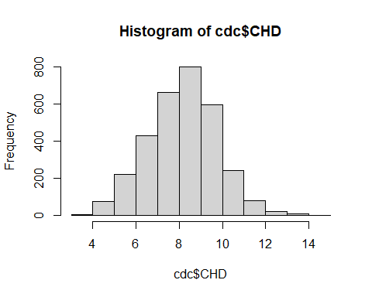

#looked at Urban Rural vs CHD (Keep here? or below at line 619)  
ggplot(data = cdc, aes(x = `UrbanRural`, y = `CHD`, fill = `UrbanRural`)) +  
 geom\_bar(stat = "identity", position = "dodge") +  
 labs(x = "UrbanRural", y = "Prevalence of CHD", fill = "UrbanRural") +  
 theme(axis.text.x = element\_text(angle = 45, hjust = 1))

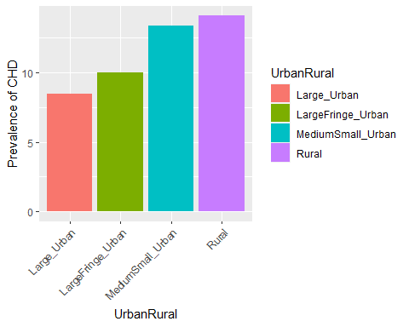

### Top 10 Counties with highest CHD prevalence

highest\_10 <- cdc %>%  
 arrange(desc(CHD)) %>%  
 head(10)  
highest\_10

## # A tibble: 10 × 97  
## fips county state Age65Plus pop bpmUse CholScreen CholMedNonAdhear  
## <chr> <chr> <chr> <dbl> <dbl> <dbl> <dbl> <dbl>  
## 1 04012 La Paz AZ 39.8 21035 80.5 86.2 16.8  
## 2 35003 Catron NM 41.6 3547 83.8 87.8 14.6  
## 3 29153 Ozark MO 28 9138 84.9 85.3 14.3  
## 4 54047 McDowell WV 21.5 18083 82.8 85.3 17.7  
## 5 32009 Esmeralda NV 25.4 1030 80.2 87.2 14.6  
## 6 48377 Presidio TX 24 6808 80.7 82.5 26.7  
## 7 12119 Sumter FL 57.8 129938 85.8 93.2 13.6  
## 8 21237 Wolfe KY 19.3 7188 81.7 88.5 17.3  
## 9 22107 Tensas LA 24.6 4435 84.5 88.2 23.2  
## 10 54101 Webster WV 23.3 8289 82.7 86.8 13   
## # ℹ 89 more variables: CholMedElegible <dbl>, cruParticipate <dbl>,  
## # Hospitals <dbl>, HospCIC <dbl>, HospCR <dbl>, HospED <dbl>,  
## # Pharmacies <dbl>, HealthIns <dbl>, CardioPhys <dbl>, CHD <dbl>,  
## # HighBP <dbl>, Stroke <dbl>, Diabetes <dbl>, HighChol <dbl>, Obesity <dbl>,  
## # PhysInactivity <dbl>, Smoker <dbl>, AirQuality <dbl>, Parks <dbl>,  
## # Broadband <dbl>, EdLessColl <dbl>, SNAPrecipients <dbl>,  
## # MedHomeValue <dbl>, MedHouseIncome <dbl>, Poverty <dbl>, Unemploy <dbl>, …

### Bottom 10 Counties with lowest CHD prevalence

lowest\_10 <- cdc %>%  
# filter("CHD" != -1) %>%  
 arrange(CHD) %>%  
 head(10)  
lowest\_10

## # A tibble: 10 × 97  
## fips county state Age65Plus pop bpmUse CholScreen CholMedNonAdhear  
## <chr> <chr> <chr> <dbl> <dbl> <dbl> <dbl> <dbl>  
## 1 13053 Chattahoochee GA 3 10470 56.1 76.9 18.5  
## 2 51013 Arlington VA 10.8 236434 71 88.3 14.7  
## 3 11001 District of … DC 12.2 701974 69.3 89.1 18.4  
## 4 49049 Utah UT 7.7 621506 59.1 76.4 15.5  
## 5 08031 Denver CO 11.8 715878 63.8 83.7 14.6  
## 6 51107 Loudoun VA 9.4 405312 72.4 90.1 13.8  
## 7 16065 Madison ID 6.7 39725 59.9 71 16.5  
## 8 51610 Falls Church VA 13.2 14309 75 90.7 13.4  
## 9 08035 Douglas CO 12 344280 65.8 88.4 12.7  
## 10 20161 Riley KS 9.2 74059 65.2 77.2 12.3  
## # ℹ 89 more variables: CholMedElegible <dbl>, cruParticipate <dbl>,  
## # Hospitals <dbl>, HospCIC <dbl>, HospCR <dbl>, HospED <dbl>,  
## # Pharmacies <dbl>, HealthIns <dbl>, CardioPhys <dbl>, CHD <dbl>,  
## # HighBP <dbl>, Stroke <dbl>, Diabetes <dbl>, HighChol <dbl>, Obesity <dbl>,  
## # PhysInactivity <dbl>, Smoker <dbl>, AirQuality <dbl>, Parks <dbl>,  
## # Broadband <dbl>, EdLessColl <dbl>, SNAPrecipients <dbl>,  
## # MedHomeValue <dbl>, MedHouseIncome <dbl>, Poverty <dbl>, Unemploy <dbl>, …

### 

\*\*\*\*\*\*\*\*\*\*\*\*\*\*\*\*\*\*\*\*\*\*\*\*\*\*\*\*\*\*\*\*\*\*\*\*\*\*\*\*\*\*\*\*\*\*\*\*\*\*\*\*\*\*\*\*\*\*\*\*\*\*\*\*\*\*\*\*\*\*\*\*\*\*\*\*\*\*\*\*\*\*\*\*\*\*\*\*\*\*\*

BELOW: move general coor to basic eda section

\*\*\*\*\*\*\*\*\*\*\*\*\*\*\*\*\*\*\*\*\*\*\*\*\*\*\*\*\*\*\*\*\*\*\*\*\*\*\*\*\*\*\*\*\*\*\*\*\*\*\*\*\*\*\*\*\*\*\*\*\*\*\*\*\*\*\*\*\*\*\*\*\*\*\*\*\*\*\*\*\*\*\*\*\*\*\*\*\*\*\*

### Correlations

plot\_correlation(cdc)

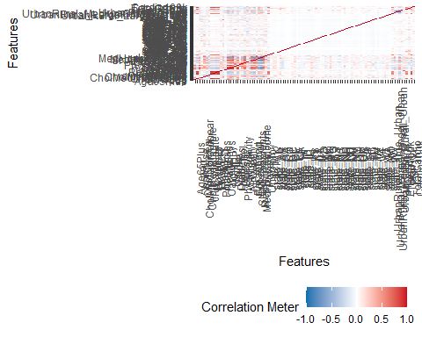

#tried this but needed to remove non numerical first  
correlation\_matrix <- cdc %>% select(-c(fips, county, state, "UrbanRural")) %>% cor()  
  
#install.packages("reshape2")  
library(reshape2)  
  
melted\_cor <- melt(correlation\_matrix)  
  
ggplot(data = melted\_cor, aes(x = Var1, y = Var2, fill = value)) +  
 geom\_tile() +  
 scale\_fill\_gradient(low = "blue", high = "red") +  
 theme(axis.text.x = element\_text(angle = 45, hjust = 1)) +  
 labs(title = "Correlation Heatmap")

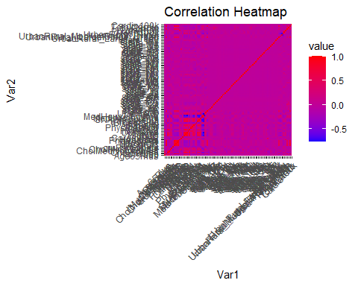

#focused on looking at high correlations only  
high\_correlations <- subset(melt(correlation\_matrix), value > 0.75 & value < 1)  
  
ggplot(data = high\_correlations, aes(x = Var1, y = Var2, fill = value)) +  
 geom\_tile() +  
 scale\_fill\_gradient(low = "blue", high = "red") +  
 theme(axis.text.x = element\_text(angle = 45, hjust = 1)) +  
 labs(title = "High Correlation Heatmap (Correlation > 0.75)")

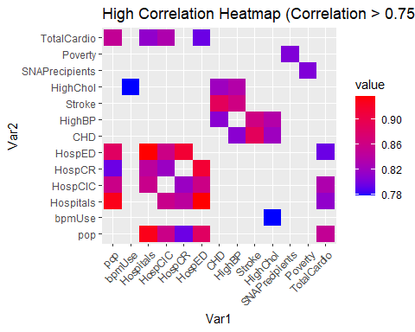

#focused on medium high correlations  
mid\_correlations <- subset(melt(correlation\_matrix), value > 0.50 & value < 0.75)  
  
ggplot(data = mid\_correlations, aes(x = Var1, y = Var2, fill = value)) +  
 geom\_tile() +  
 scale\_fill\_gradient(low = "blue", high = "red") +  
 theme(axis.text.x = element\_text(angle = 45, hjust = 1)) +  
 labs(title = "Mid Correlation Heatmap (0.50 < Correlation < 0.75)")

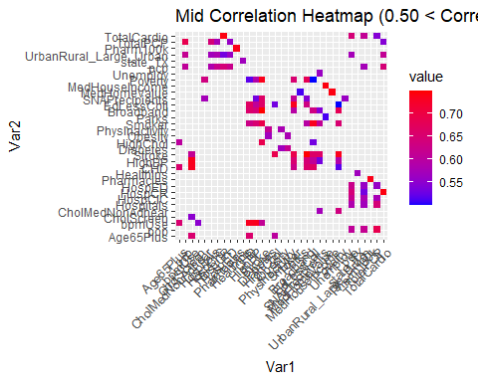

#looked at Urban Rural vs CHD  
ggplot(data = cdc, aes(x = `UrbanRural`, y = `CHD`, fill = `UrbanRural`)) +  
 geom\_bar(stat = "identity", position = "dodge") +  
 labs(x = "UrbanRural", y = "Prevalence of CHD", fill = "UrbanRural") +  
 theme(axis.text.x = element\_text(angle = 45, hjust = 1))



#### Negative Correlations

# focused on looking at negative high correlations only  
neg\_high\_correlations <- subset(melt(correlation\_matrix), value < -0.75 & value > -1)  
  
ggplot(data = neg\_high\_correlations, aes(x = Var1, y = Var2, fill = value)) +  
 geom\_tile() +  
 scale\_fill\_gradient(low = "blue", high = "red") +  
 theme(axis.text.x = element\_text(angle = 45, hjust = 1)) +  
 labs(title = "High Correlation Heatmap (Correlation < -0.75)")

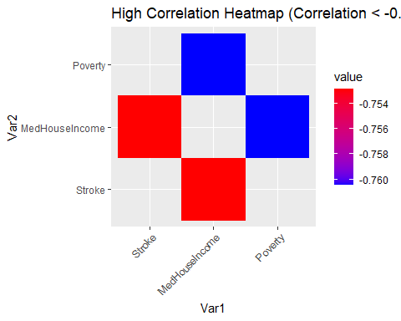

# focused on negative medium high correlations  
neg\_mid\_correlations <- subset(melt(correlation\_matrix), value < -0.50 & value > -0.75)  
  
ggplot(data = neg\_mid\_correlations, aes(x = Var1, y = Var2, fill = value)) +  
 geom\_tile() +  
 scale\_fill\_gradient(low = "blue", high = "red") +  
 theme(axis.text.x = element\_text(angle = 45, hjust = 1)) +  
 labs(title = "Mid Correlation Heatmap (-0.75 < Correlation < -0.50)")

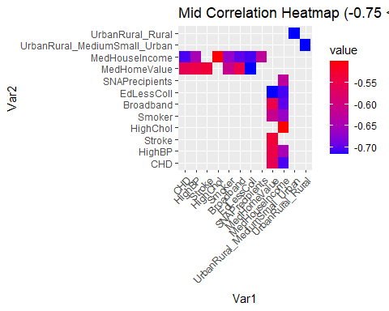

### Auto EDA report (from DataExplorer)

# cdc %>%  
# select(c(4:34, 36, 92:97)) %>%  
# create\_report(  
# output\_file = paste ("Auto EDA Report"),  
# report\_title = "EDA Report - CHD Dataset",  
# y = "CHD"  
# )

## EDA GGally

## Correlation plots: CHD and Urban/Rural vs various factors

### Prevalence of other heart conditions factors

cdc %>%  
 select("CHD",  
 "HighBP",  
 "Stroke",  
 "UrbanRural") %>%  
 ggpairs(mapping = aes(color = cdc$"UrbanRural", alpha = 0.5))

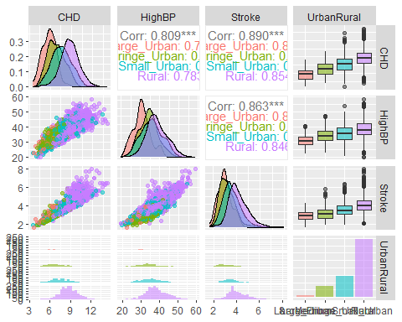

### Hospitals and pharmacy access factors

cdc %>%  
 select("CHD",  
 "Hospitals",  
 "Pharmacies",  
 "UrbanRural") %>%  
 ggpairs(mapping = aes(color = cdc$"UrbanRural", alpha = 0.5))

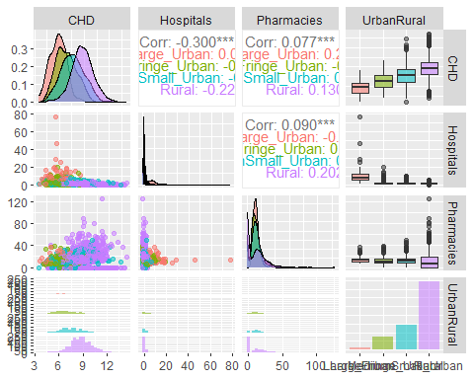

### Hospital services factors

cdc %>%  
 select("CHD",  
 "HospCR",  
 "HospCIC",  
 "HospED",  
# "HospNeuro",  
 "UrbanRural") %>%  
 ggpairs(mapping = aes(color = cdc$"UrbanRural", alpha = 0.5))

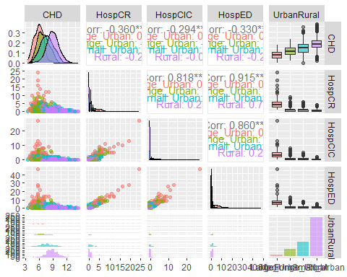

### Physician and specialist access factors

cdc %>%  
 select("CHD",  
 "CardioPhys",  
# "Neurologists",  
# "NeuroSurgeons",  
 "pcp",  
 "UrbanRural") %>%  
 ggpairs(mapping = aes(color = cdc$"UrbanRural", alpha = 0.5))

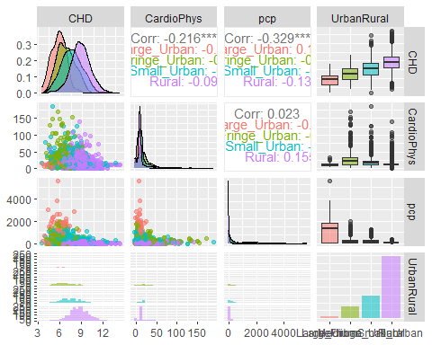

### Various health care delivery and insurance factors

cdc %>%  
 select("CHD",  
 "bpmUse",  
 "CholScreen",  
 "CholMedNonAdhear",  
 "CholMedElegible",  
 "cruParticipate",  
# "HealthIns",  
 "UrbanRural") %>%  
 ggpairs(mapping = aes(color = cdc$"UrbanRural", alpha = 0.5))

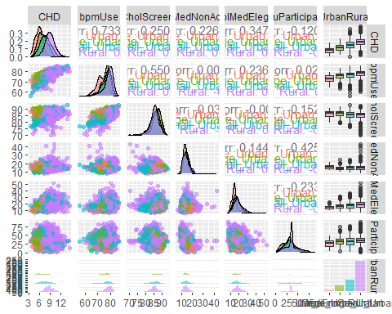

### Various (physical activity/smoking) risk factors

cdc %>%  
 select("CHD",  
 "PhysInactivity",  
 "Smoker",  
 "UrbanRural") %>%  
 ggpairs(mapping = aes(color = cdc$"UrbanRural", alpha = 0.5))

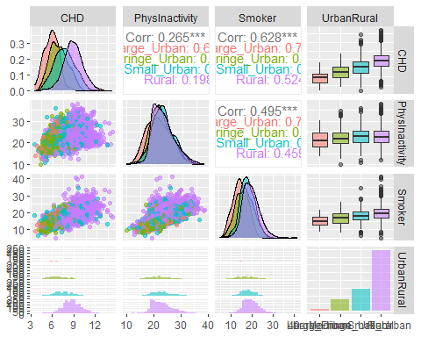

### Various (other diagnosed)risk factors

cdc %>%  
 select("CHD",  
 "Diabetes",  
 "HighChol",  
 "Obesity",  
 "UrbanRural") %>%  
 ggpairs(mapping = aes(color = cdc$"UrbanRural", alpha = 0.5))

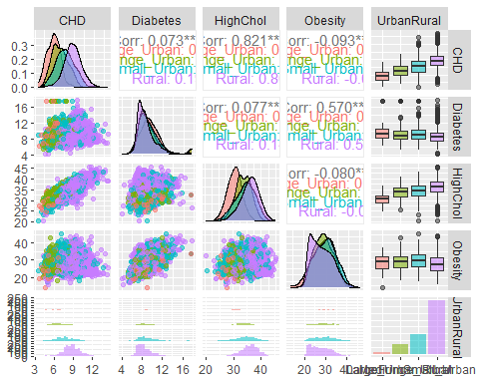

### Various physical environment factors

cdc %>%  
 select("CHD",  
 "AirQuality",  
 "Parks",  
 "UrbanRural") %>%  
 ggpairs(mapping = aes(color = cdc$"UrbanRural", alpha = 0.5))

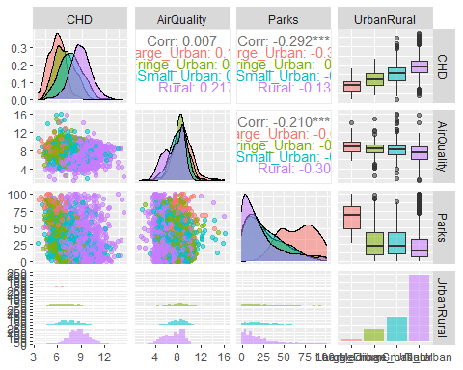

### Various (income) social environmental factors

cdc %>%  
 select("CHD",  
 "SNAPrecipients",  
# "IncomeInequality",  
 "Poverty",  
 "Unemploy",  
 "UrbanRural") %>%  
 ggpairs(mapping = aes(color = cdc$"UrbanRural", alpha = 0.5))

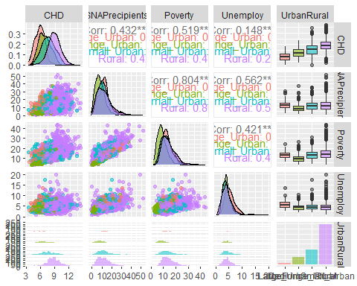

### Various (housing) social environmental factors

cdc %>%  
 select("CHD",  
 "MedHomeValue",  
 "MedHouseIncome",  
 "Poverty",  
 "UrbanRural") %>%  
 ggpairs(mapping = aes(color = cdc$"UrbanRural", alpha = 0.5))

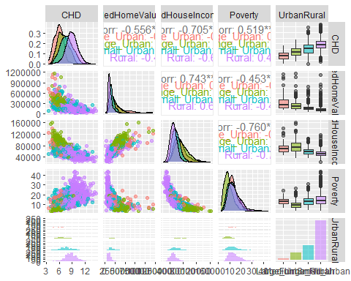

### Various (Education) social environmental factors

cdc %>%  
 select("CHD",  
 "Broadband",  
# "Computer",  
 "EdLessColl",  
# "EdLessHigh",  
 "UrbanRural") %>%  
 ggpairs(mapping = aes(color = cdc$"UrbanRural", alpha = 0.5))

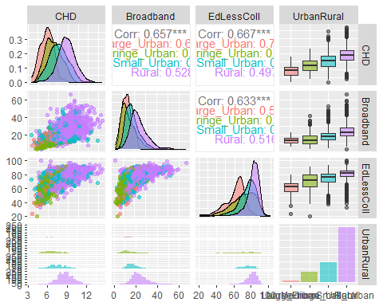

#### Density plot for EdLessCol by itself

ggplot(cdc, aes(x = Broadband, fill = UrbanRural)) +  
 geom\_density(alpha = 0.5) +  
 labs(x = "EdLessColl", y = "Density") +  
 theme\_minimal() +  
 scale\_fill\_brewer(palette = "Dark2")

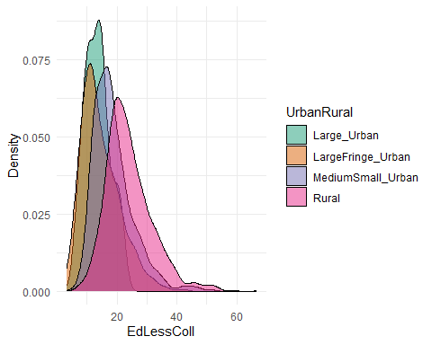

library(corrplot)  
  
correlation\_matrix <- cor(cdc[, c("EdLessColl", "CHD")])  
corrplot(correlation\_matrix, method = "number")

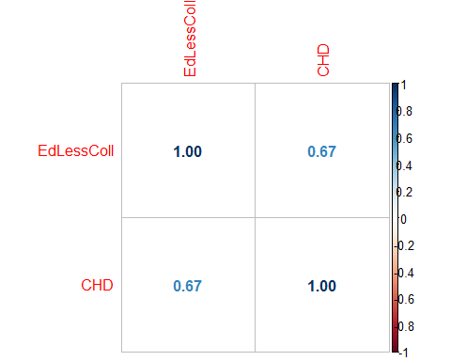

# Create a plot for each UrbanRural category  
for(category in unique(cdc$UrbanRural)) {  
 data\_subset <- subset(cdc, UrbanRural == category)  
  
 # Calculate correlation  
 correlation <- round(cor(data\_subset$EdLessColl, data\_subset$CHD, use = "pairwise.complete.obs"), 2)  
  
 # Create the plot  
 p <- ggplot(data\_subset, aes(x = EdLessColl, y = CHD)) +  
 geom\_point(alpha = 0.5) +  
 geom\_smooth(method = "lm", se = FALSE, color = "red", linetype = "dashed") +  
 geom\_text(aes(label = paste("Correlation = ", correlation), x = Inf, y = Inf), hjust = "right", vjust = "top") +  
 labs(title = paste("UrbanRural category:", category), x = "EdLessColl", y = "CHD") +  
 theme\_minimal()  
   
 print(p)  
}

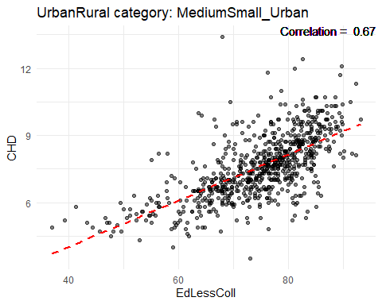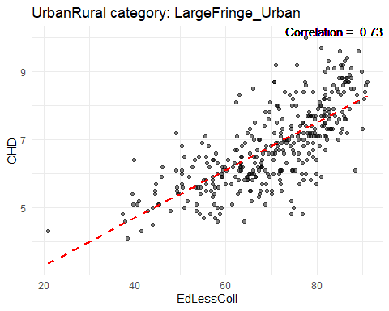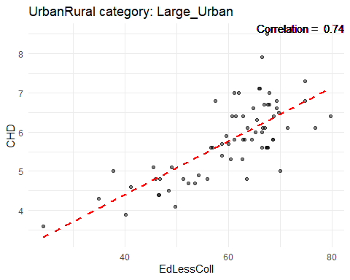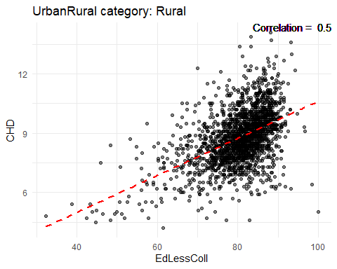

##PCA ### Prepare data for principle component analysis

# Remove non-numeric variables  
cdc\_comp <- cdc %>%   
 select(-c("fips", "county", "state", "UrbanRural"))  
  
# Remove NAs  
cdc\_comp[is.na(cdc\_comp)] <- 0  
  
# Double check to see if all entries are finite  
all(sapply(cdc\_comp, is.finite))

## [1] TRUE

#### Run PCA on the dataset

pr\_cdc <- prcomp(x = cdc\_comp, scale = T, center = T)  
  
summary(pr\_cdc)

#### Run PCA on the dataset without hot coded states

#Drop non numeric variables (note, rural/urban has been hot coded)  
cdc\_comp2 <- cdc %>%  
 select(c(4:34, 36, 92:97))  
  
pr\_cdc2 <- prcomp(x = cdc\_comp2, scale = T, center = T)  
  
summary(pr\_cdc2)

## Importance of components:  
## PC1 PC2 PC3 PC4 PC5 PC6 PC7  
## Standard deviation 3.233 2.3863 1.78163 1.57849 1.38962 1.24992 1.18391  
## Proportion of Variance 0.275 0.1499 0.08353 0.06557 0.05082 0.04111 0.03689  
## Cumulative Proportion 0.275 0.4248 0.50836 0.57393 0.62475 0.66586 0.70274  
## PC8 PC9 PC10 PC11 PC12 PC13 PC14  
## Standard deviation 1.13132 1.0260 0.97227 0.94008 0.87044 0.82594 0.76482  
## Proportion of Variance 0.03368 0.0277 0.02488 0.02326 0.01994 0.01795 0.01539  
## Cumulative Proportion 0.73643 0.7641 0.78900 0.81226 0.83220 0.85015 0.86554  
## PC15 PC16 PC17 PC18 PC19 PC20 PC21  
## Standard deviation 0.71800 0.70924 0.68949 0.63353 0.59095 0.57999 0.55347  
## Proportion of Variance 0.01357 0.01324 0.01251 0.01056 0.00919 0.00885 0.00806  
## Cumulative Proportion 0.87911 0.89235 0.90486 0.91542 0.92461 0.93346 0.94152  
## PC22 PC23 PC24 PC25 PC26 PC27 PC28  
## Standard deviation 0.53294 0.48511 0.45995 0.44101 0.4136 0.40717 0.39566  
## Proportion of Variance 0.00747 0.00619 0.00557 0.00512 0.0045 0.00436 0.00412  
## Cumulative Proportion 0.94900 0.95519 0.96076 0.96588 0.9704 0.97474 0.97886  
## PC29 PC30 PC31 PC32 PC33 PC34 PC35  
## Standard deviation 0.37769 0.35801 0.3376 0.31139 0.29041 0.2759 0.24375  
## Proportion of Variance 0.00375 0.00337 0.0030 0.00255 0.00222 0.0020 0.00156  
## Cumulative Proportion 0.98261 0.98599 0.9890 0.99154 0.99376 0.9958 0.99732  
## PC36 PC37 PC38  
## Standard deviation 0.20110 0.19288 0.15500  
## Proportion of Variance 0.00106 0.00098 0.00063  
## Cumulative Proportion 0.99839 0.99937 1.00000

### Boxplot to compare coronary heart disease prevalence in rural and urban areas

ggplot(cdc, aes(x=UrbanRural, y=CHD)) + geom\_boxplot()

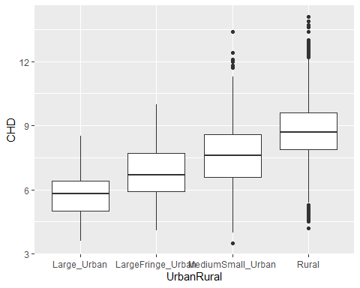

### Histogram to understand distribution of cardiovascular providers in rural and urban areas

ggplot(cdc, aes(x=CardioPhys)) + geom\_histogram(binwidth=10) + facet\_grid(~ UrbanRural)

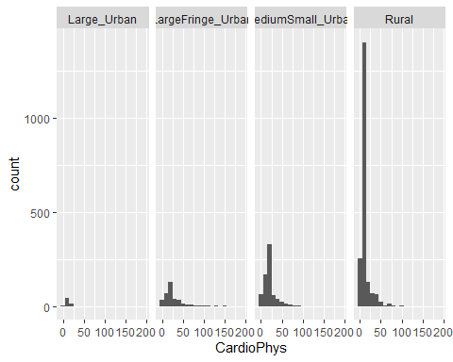

### Histogram to understand distribution of primary care providers in rural and urban areas

ggplot(cdc, aes(x=pcp)) + geom\_histogram(binwidth=10) + facet\_grid(~ UrbanRural)

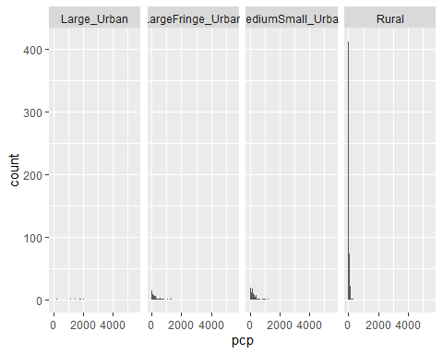

### Histogram to understand distribution of hospitals in rural and urban areas

ggplot(cdc, aes(x=Hospitals)) + geom\_histogram(binwidth=10) + facet\_grid(~ UrbanRural)

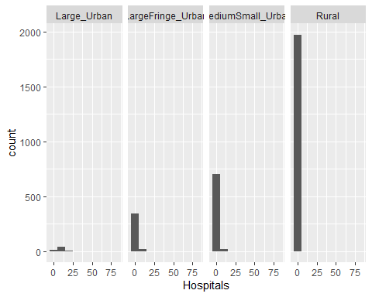

### Histogram to understand distribution of hospitals with cardiac intensive care centers in rural and urban areas

ggplot(cdc, aes(x=HospCIC)) + geom\_histogram(binwidth=10) + facet\_grid(~ UrbanRural)

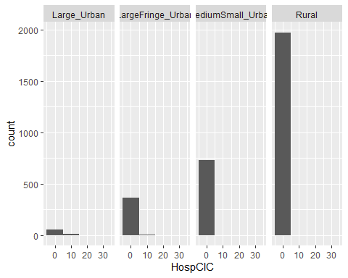

### Histogram to understand distribution of hospitals with cardiac rehabilitation centers in rural and urban areas

ggplot(cdc, aes(x=HospCR)) + geom\_histogram(binwidth=10) + facet\_grid(~ UrbanRural)

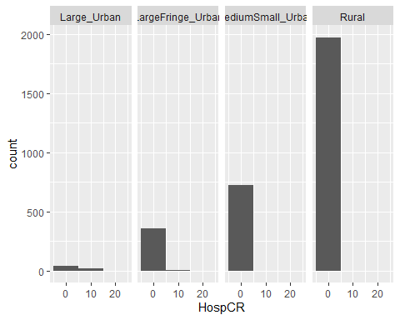

### Histogram to understand distribution of pharmacies in rural and urban areas

ggplot(cdc, aes(x=Pharmacies)) + geom\_histogram(binwidth=10) + facet\_grid(~ UrbanRural)

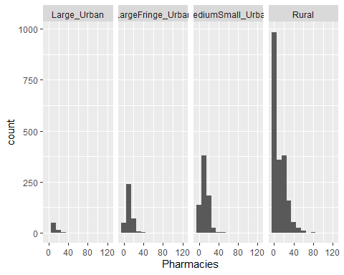

# Statistical Analysis

## Correlation Analysis

### Correlation analysis between cardiovascular providers and coronary heart disease prevalence

cor.test(cdc$CardioPhys, cdc$CHD)

##   
## Pearson's product-moment correlation  
##   
## data: cdc$CardioPhys and cdc$CHD  
## t = -12.386, df = 3138, p-value < 2.2e-16  
## alternative hypothesis: true correlation is not equal to 0  
## 95 percent confidence interval:  
## -0.2489961 -0.1822942  
## sample estimates:  
## cor   
## -0.215897

#### CHD/cardiovascular physicians correlation analysis visualization

cdc %>%  
 filter(UrbanRural %in% c(unique(UrbanRural))) %>%  
ggplot(aes(log(CardioPhys), CHD, color=UrbanRural)) +  
geom\_point(alpha=0.3)+  
facet\_wrap(~UrbanRural)+  
geom\_smooth(method = lm)

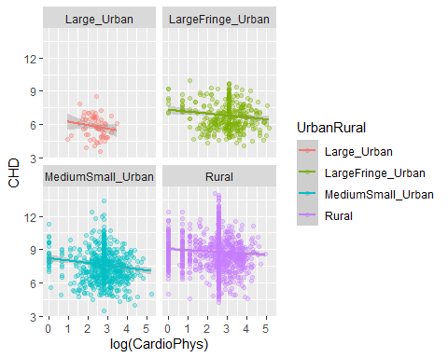

### Correlation analysis between primary care providers and coronary heart disease prevalence

cor.test(cdc$pcp, cdc$CHD)

##   
## Pearson's product-moment correlation  
##   
## data: cdc$pcp and cdc$CHD  
## t = -19.489, df = 3138, p-value < 2.2e-16  
## alternative hypothesis: true correlation is not equal to 0  
## 95 percent confidence interval:  
## -0.3594356 -0.2970218  
## sample estimates:  
## cor   
## -0.3285874

#### CHD/primary care physicians correlation analysis visualization

cdc %>%  
 filter(UrbanRural %in% c(unique(UrbanRural))) %>%  
ggplot(aes(log(pcp), CHD, color=UrbanRural)) +  
geom\_point(alpha=0.3)+  
facet\_wrap(~UrbanRural)+  
geom\_smooth(method = lm)

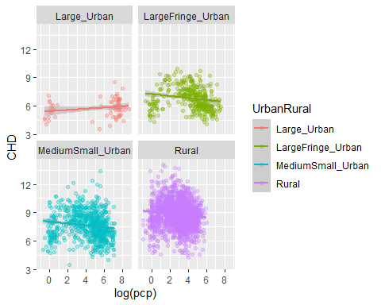

### Correlation analysis between hospitals and coronary heart disease prevalence

cor.test(cdc$Hospitals, cdc$CHD)

##   
## Pearson's product-moment correlation  
##   
## data: cdc$Hospitals and cdc$CHD  
## t = -17.626, df = 3138, p-value < 2.2e-16  
## alternative hypothesis: true correlation is not equal to 0  
## 95 percent confidence interval:  
## -0.3316449 -0.2679814  
## sample estimates:  
## cor   
## -0.3001474

#### CHD/hospitals correlation analysis visualization

cdc %>%  
 filter(UrbanRural %in% c(unique(UrbanRural))) %>%  
ggplot(aes(log(Hospitals), CHD, color=UrbanRural)) +  
geom\_point(alpha=0.3)+  
facet\_wrap(~UrbanRural)+  
geom\_smooth(method = lm)

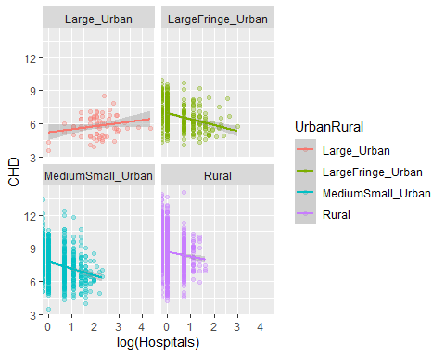

### Correlation analysis between hospitals with cardiac intensive care centers and coronary heart disease prevalence

cor.test(cdc$HospCIC, cdc$CHD)

##   
## Pearson's product-moment correlation  
##   
## data: cdc$HospCIC and cdc$CHD  
## t = -17.232, df = 3138, p-value < 2.2e-16  
## alternative hypothesis: true correlation is not equal to 0  
## 95 percent confidence interval:  
## -0.3256434 -0.2617252  
## sample estimates:  
## cor   
## -0.294013

#### CHD/cardiac intensive care centers correlation analysis visualization

cdc %>%  
 filter(UrbanRural %in% c(unique(UrbanRural))) %>%  
ggplot(aes(log(HospCIC), CHD, color=UrbanRural)) +  
geom\_point(alpha=0.3)+  
facet\_wrap(~UrbanRural)+  
geom\_smooth(method = lm)

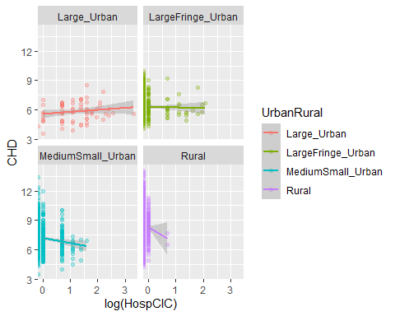

### Correlation analysis between hospitals with cardiac rehabilitation centers and coronary heart disease prevalence

cor.test(cdc$HospCR, cdc$CHD)

##   
## Pearson's product-moment correlation  
##   
## data: cdc$HospCR and cdc$CHD  
## t = -21.622, df = 3138, p-value < 2.2e-16  
## alternative hypothesis: true correlation is not equal to 0  
## 95 percent confidence interval:  
## -0.3901568 -0.3292595  
## sample estimates:  
## cor   
## -0.3600917

#### CHD/hospitals with cardiac rehabilitation centers correlation analysis visualization

cdc %>%  
 filter(UrbanRural %in% c(unique(UrbanRural))) %>%  
ggplot(aes(log(HospCR), CHD, color=UrbanRural)) +  
geom\_point(alpha=0.3)+  
facet\_wrap(~UrbanRural)+  
geom\_smooth(method = lm)

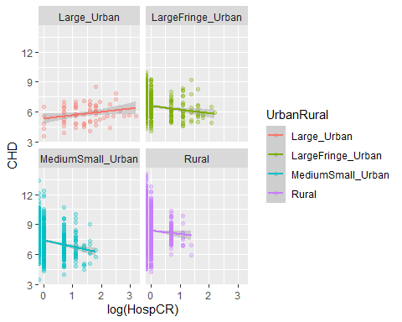

### Correlation analysis between pharmacies and coronary heart disease prevalence

cor.test(cdc$Pharmacies, cdc$CHD)

##   
## Pearson's product-moment correlation  
##   
## data: cdc$Pharmacies and cdc$CHD  
## t = 4.333, df = 3138, p-value = 1.517e-05  
## alternative hypothesis: true correlation is not equal to 0  
## 95 percent confidence interval:  
## 0.04225411 0.11179754  
## sample estimates:  
## cor   
## 0.07711962

#### CHD/pharmacies correlation analysis visualization

cdc %>%  
 filter(UrbanRural %in% c(unique(UrbanRural))) %>%  
ggplot(aes(log(Pharmacies), CHD, color=UrbanRural)) +  
geom\_point(alpha=0.3)+  
facet\_wrap(~UrbanRural)+  
geom\_smooth(method = lm)

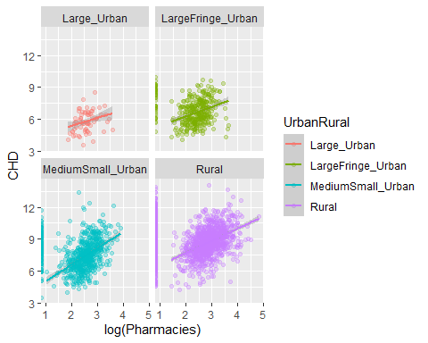

## Regreassion analysis

### Regression analysis for potential confounders.

model <- lm(CHD ~ CardioPhys + Broadband + Smoker + UrbanRural, data = cdc)  
summary(model)

##   
## Call:  
## lm(formula = CHD ~ CardioPhys + Broadband + Smoker + UrbanRural,   
## data = cdc)  
##   
## Residuals:  
## Min 1Q Median 3Q Max   
## -4.1947 -0.6105 -0.0589 0.5536 6.8327   
##   
## Coefficients:  
## Estimate Std. Error t value Pr(>|t|)   
## (Intercept) 2.934072 0.145203 20.207 < 2e-16 \*\*\*  
## CardioPhys -0.005596 0.001187 -4.714 2.53e-06 \*\*\*  
## Broadband 0.063216 0.002972 21.273 < 2e-16 \*\*\*  
## Smoker 0.139684 0.005792 24.116 < 2e-16 \*\*\*  
## UrbanRuralLargeFringe\_Urban 0.756765 0.137509 5.503 4.03e-08 \*\*\*  
## UrbanRuralMediumSmall\_Urban 1.068177 0.132009 8.092 8.33e-16 \*\*\*  
## UrbanRuralRural 1.640674 0.130151 12.606 < 2e-16 \*\*\*  
## ---  
## Signif. codes: 0 '\*\*\*' 0.001 '\*\*' 0.01 '\*' 0.05 '.' 0.1 ' ' 1  
##   
## Residual standard error: 1.029 on 3133 degrees of freedom  
## Multiple R-squared: 0.5756, Adjusted R-squared: 0.5748   
## F-statistic: 708.3 on 6 and 3133 DF, p-value: < 2.2e-16

#### Linear Model with CHD vs various features Explanation:

**Residuals:** The “Residuals” section provides information about the errors or residuals of the model. Residuals are the differences between the actual observed values and the predicted values from the regression model. This section displays summary statistics of the residuals, including the minimum, first quartile (1Q), median, third quartile (3Q), and maximum values. In your model, the minimum residual is -4.1947, the first quartile is -0.6105, the median is -0.0589, the third quartile is 0.5536, and the maximum residual is 6.8327.

**Coefficients:** The “Coefficients” section provides the estimated coefficients of the independent variables in the linear regression model. Each coefficient represents the expected change in the dependent variable (CHD) associated with a one-unit change in the corresponding independent variable, while holding other variables constant. For example, the estimated coefficient for “CardioPhys” is -0.005596, indicating that, on average, for each unit increase in the “CardioPhys” variable, the dependent variable “CHD” is expected to decrease by approximately 0.005596 units, assuming all other variables are held constant.

The “Estimate” column shows the estimated coefficient values, the “Std. Error” column provides the standard errors of the estimates, and the “t value” column gives the t-statistic for testing whether the coefficient is significantly different from zero. The “Pr(>|t|)” column represents the p-value associated with the t-statistic, indicating the statistical significance of the coefficient. Lower p-values indicate greater significance.

In your model, all the coefficients have p-values less than 0.05, denoted by three asterisks (\*\*\*), indicating that all the variables are statistically significant in explaining the variation in the dependent variable.

**Residual standard error:** The “Residual standard error” is an estimate of the standard deviation of the residuals. It represents the average amount by which the observed values deviate from the predicted values. In your model, the residual standard error is 1.029.

**Multiple R-squared and Adjusted R-squared:** The “Multiple R-squared” is a measure of how well the linear regression model fits the data. It indicates the proportion of the variance in the dependent variable that is explained by the independent variables. In your model, the multiple R-squared value is 0.5756, meaning that approximately 57.56% of the variance in the dependent variable “CHD” is explained by the independent variables in the model.

The “Adjusted R-squared” adjusts the multiple R-squared value for the number of independent variables and the sample size. It penalizes the addition of irrelevant variables that do not contribute much to the model’s explanatory power. The adjusted R-squared value in your model is 0.5748.

**F-statistic:** The F-statistic is a measure of overall significance in the linear regression model. It tests the null hypothesis that all the coefficients in the model are equal to zero, indicating that none of the independent variables have a significant relationship with the dependent variable. A low p-value (typically below 0.05) suggests that the model as a whole is statistically significant. In your model, the F-statistic is 708.3, and the associated p-value is < 2.2e-16, which is essentially zero. This extremely low p-value indicates that the overall model is statistically significant, and at least one of the independent variables has a significant relationship with the dependent variable.

In summary, the linear regression model explains approximately 57.56% of the variance in the dependent variable “CHD.” The coefficients of the independent variables are statistically significant, indicating that they have a significant relationship with “CHD” when controlling for other variables in the model. The model as a whole is statistically significant, suggesting that it provides valuable information in predicting the dependent variable.

# Predictive Modeling

### Split the data into training and test sets

set.seed(2112)  
train\_index <- sample(1:nrow(cdc), 0.7 \* nrow(cdc))  
train\_set <- cdc[train\_index, ]  
test\_set <- cdc[-train\_index, ]  
  
table(cdc$UrbanRural)

##   
## Large\_Urban LargeFringe\_Urban MediumSmall\_Urban Rural   
## 68 368 729 1975

### Build a random forest model

library(randomForest)  
  
set.seed(2112)  
  
model <- randomForest(CHD ~ Hospitals + Broadband + UrbanRural, data=train\_set, ntree=100)  
  
print(model)

##   
## Call:  
## randomForest(formula = CHD ~ Hospitals + Broadband + UrbanRural, data = train\_set, ntree = 100)   
## Type of random forest: regression  
## Number of trees: 100  
## No. of variables tried at each split: 1  
##   
## Mean of squared residuals: 1.235738  
## % Var explained: 50.98

### Predict on the test set

predictions <- predict(model, test\_set)

## Predictions

### Policy intervention to increases the number of cardiovascular providers providers by 20% in rural areas

data\_simulation <- cdc  
data\_simulation[data\_simulation$UrbanRural == 'Rural', 'CardioPhys'] <- data\_simulation[data\_simulation$UrbanRural == 'Rural', 'CardioPhys'] \* 1.20

### Use the model to predict outcomes with the simulated data

predictions\_simulation <- predict(model, data\_simulation)

### Compare the original predictions and the simulated predictions

summary(predictions)

## Min. 1st Qu. Median Mean 3rd Qu. Max.   
## 5.075 7.664 8.314 8.230 9.056 9.797

summary(predictions\_simulation)

## Min. 1st Qu. Median Mean 3rd Qu. Max.   
## 4.935 7.559 8.302 8.210 9.060 9.797

## more EDA

#Histograms for numerical variables  
for (col in c(4:34, 36, 92:97)) {  
 if (is.numeric(cdc[[col]])) {  
 hist(cdc[[col]], main = names(cdc)[col])  
 } else {  
 message(paste("Skipping column", names(cdc)[col], "as it is not numeric."))  
 }  
}

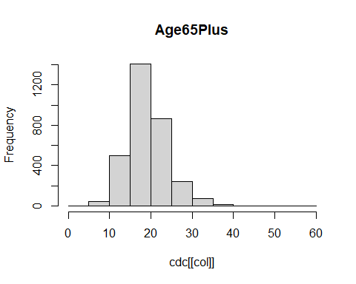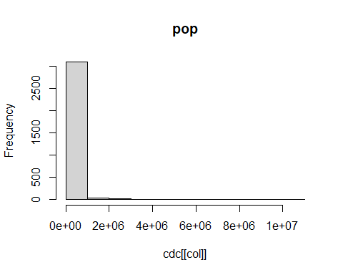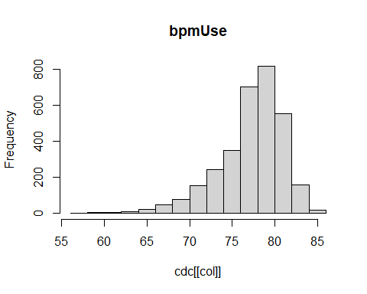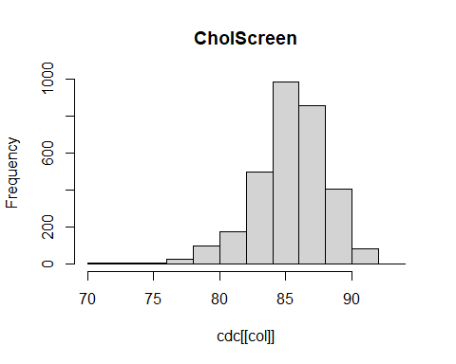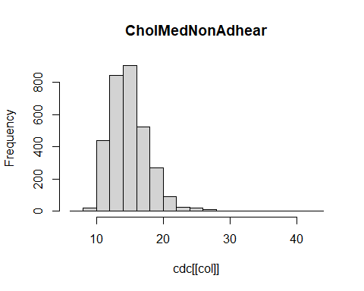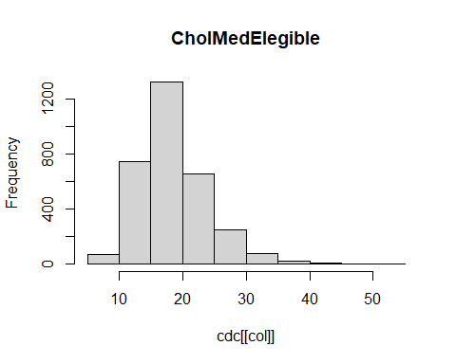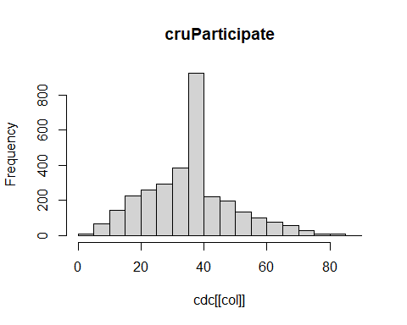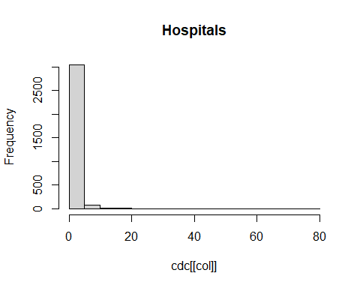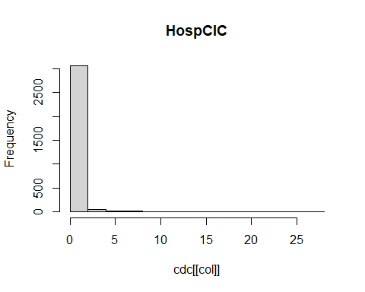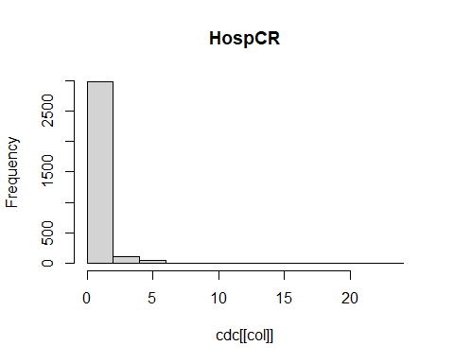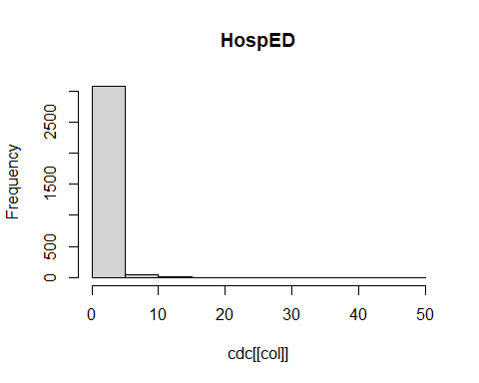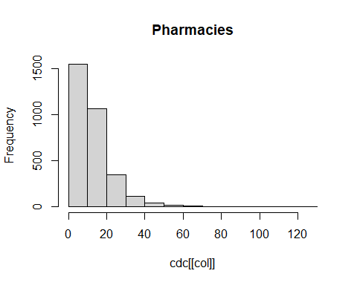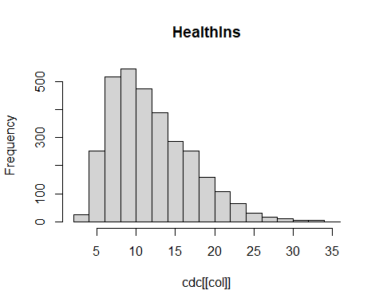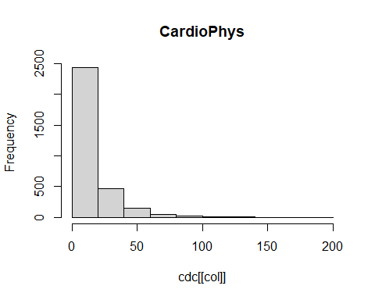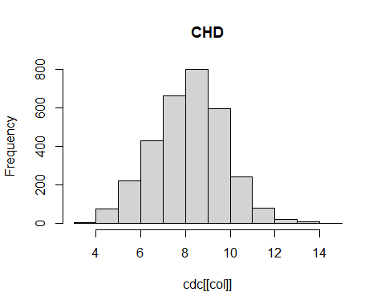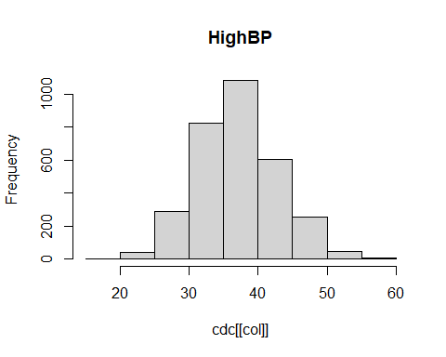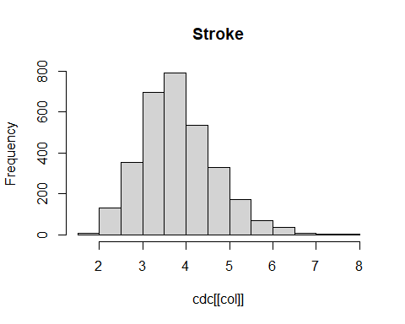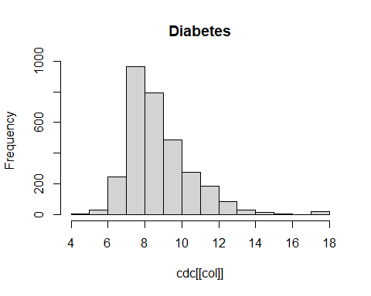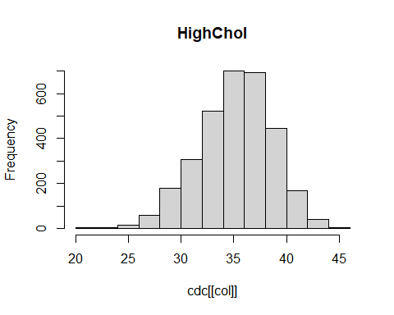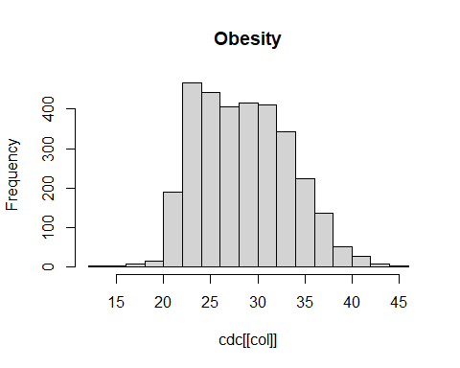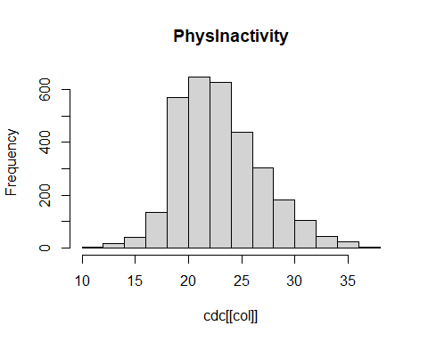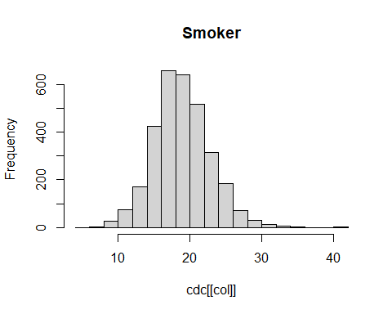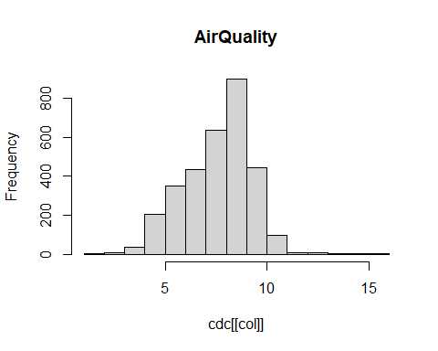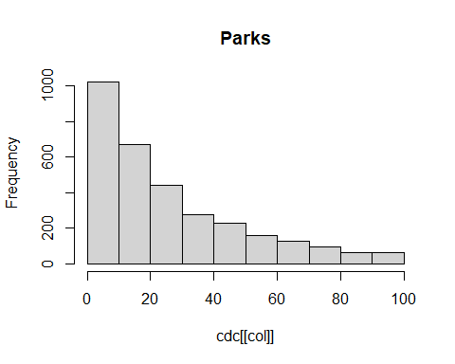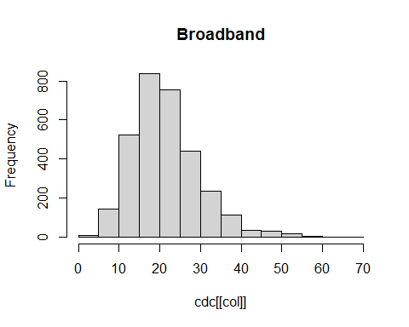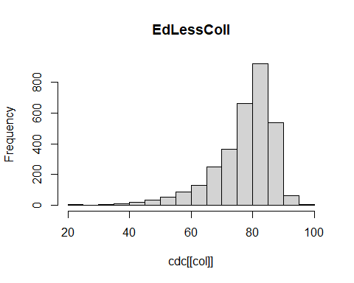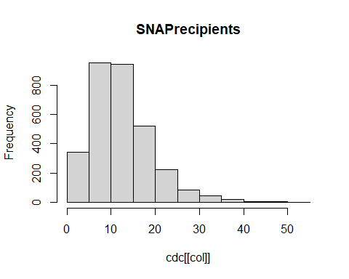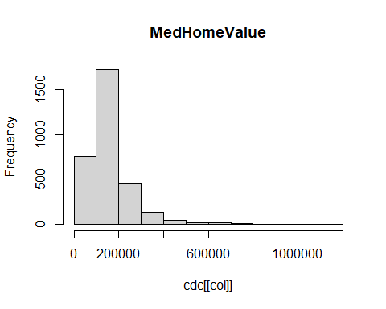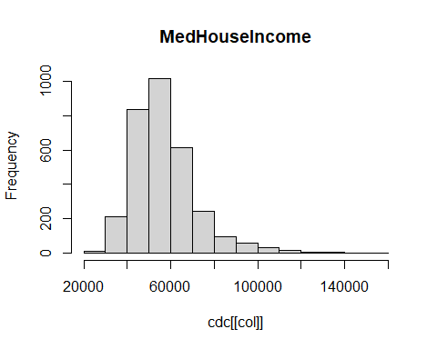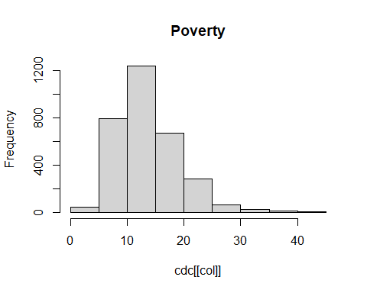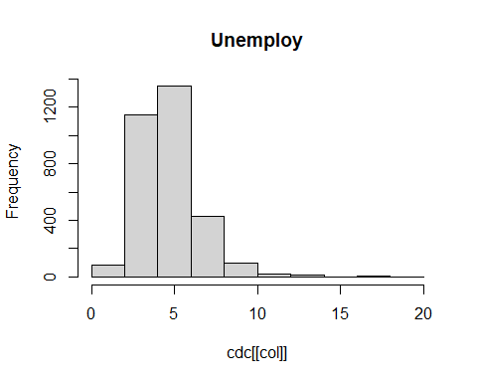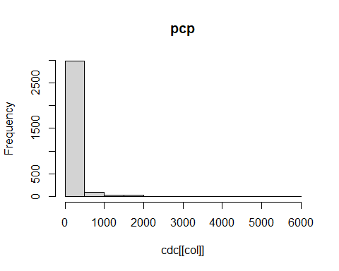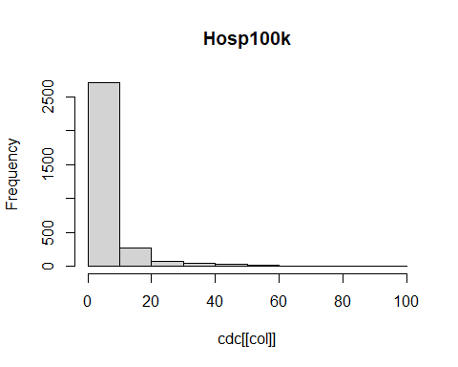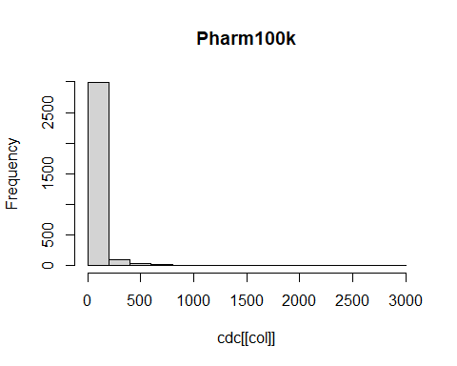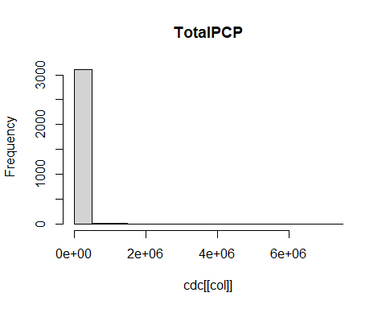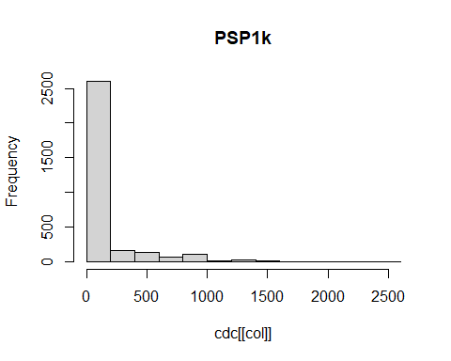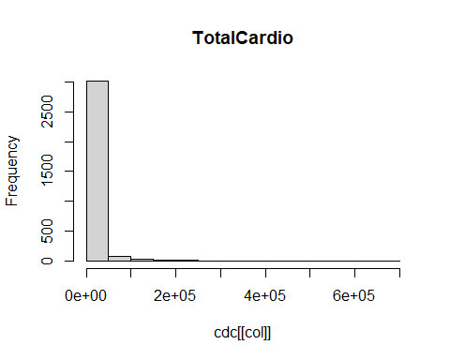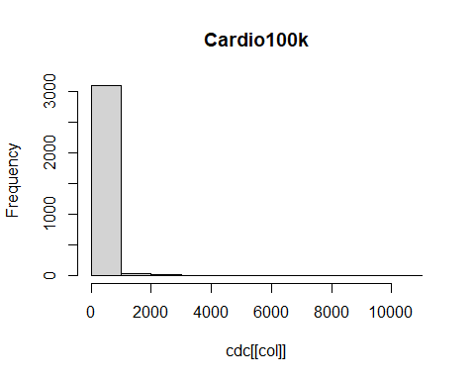

#### Wanted to zoom in hospitals

hospital\_counts <- cdc$Hospitals # Assuming "Hospitals" is the column name in the dataset "cdc"  
  
# Filter out hospitals greater than 10 (optional, if needed)  
hospital\_counts <- hospital\_counts[hospital\_counts <= 10]  
  
# Create a table of counts for each hospital count  
count\_table <- table(hospital\_counts)  
  
# Create a bar plot to visualize the breakdown  
barplot(count\_table, main = "Number of Hospitals per County", xlab = "Number of Hospitals", ylab = "Count")

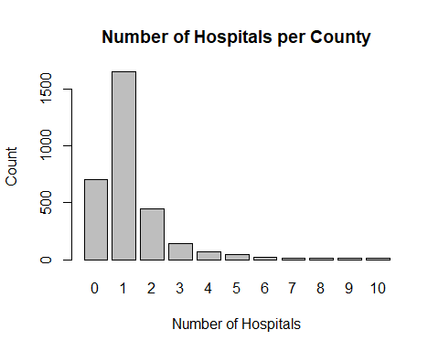

#### Same as above but improved visual

#Most counties have 1 hospital  
hospital\_counts <- cdc$Hospitals # Assuming "Hospitals" is the column name in the dataset "cdc"  
  
# Filter out hospitals greater than 10 (optional, if needed)  
hospital\_counts <- hospital\_counts[hospital\_counts <= 10]  
  
# Create a data frame with counts for each hospital count  
count\_df <- data.frame(Hospitals = as.factor(hospital\_counts))  
count\_summary <- summary(count\_df$Hospitals)  
  
# Create a bar plot using ggplot2  
ggplot(count\_df, aes(x = Hospitals)) +  
 geom\_bar(fill = "steelblue") +  
 labs(title = "Number of Hospitals per County", x = "Number of Hospitals", y = "Count") +  
 scale\_x\_discrete(limits = as.character(0:10)) +  
 theme\_minimal()

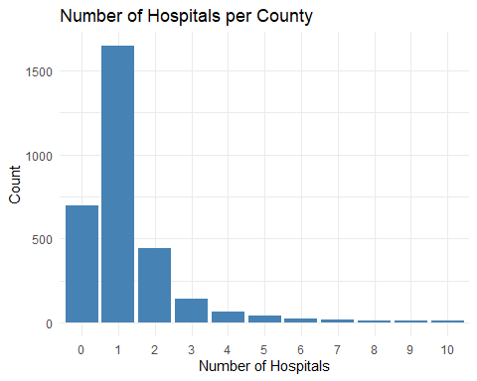

#### How many counties have no hospitals

# Check the count for zero hospitals  
count\_zero <- count\_table[as.character(0)]  
  
# Print the number of counties with zero hospitals  
print(paste("Number of counties with zero hospitals:", count\_zero))

## [1] "Number of counties with zero hospitals: 700"

#### list of counties with 0 hospitals

no\_hospital <- cdc %>%  
 filter(Hospitals == 0) %>%  
 select(county, state, Hospitals) %>%  
 arrange(state, county)  
  
print(no\_hospital)

## # A tibble: 700 × 3  
## county state Hospitals  
## <chr> <chr> <dbl>  
## 1 Aleutians East AK 0  
## 2 Aleutians West AK 0  
## 3 Bristol Bay AK 0  
## 4 Denali AK 0  
## 5 Dillingham AK 0  
## 6 Haines AK 0  
## 7 Hoonah-Angoon AK 0  
## 8 Kusilvak AK 0  
## 9 Lake and Peninsula AK 0  
## 10 Northwest Arctic AK 0  
## # ℹ 690 more rows

no\_hospital\_counts <- no\_hospital %>%  
 group\_by(state) %>%  
 summarize(count = n(), .groups = "drop") %>%  
 arrange(desc(count))  
  
print(no\_hospital\_counts)

## # A tibble: 44 × 2  
## state count  
## <chr> <int>  
## 1 TX 74  
## 2 VA 67  
## 3 GA 55  
## 4 MO 46  
## 5 KY 43  
## 6 NE 26  
## 7 IL 25  
## 8 TN 24  
## 9 AR 23  
## 10 SD 22  
## # ℹ 34 more rows

#### How many counties per state

county\_counts <- cdc %>%  
 group\_by(state) %>%  
 summarise(counties = n())  
  
print(county\_counts)

## # A tibble: 51 × 2  
## state counties  
## <chr> <int>  
## 1 AK 28  
## 2 AL 67  
## 3 AR 75  
## 4 AZ 15  
## 5 CA 58  
## 6 CO 64  
## 7 CT 8  
## 8 DC 1  
## 9 DE 3  
## 10 FL 67  
## # ℹ 41 more rows

#### Average prevalence of CHD

# Average prevalence for the US  
us\_average <- mean(cdc$CHD, na.rm = TRUE)  
us\_average <- sprintf("%.1f%%", us\_average)  
  
# Average prevalence for each state  
state\_average <- cdc %>%  
 group\_by(state) %>%  
 summarise(average\_CHD = mean(CHD, na.rm = TRUE)) %>%  
 mutate(average\_CHD = sprintf("%.1f%%", average\_CHD))  
  
print(us\_average)

## [1] "8.2%"

print(state\_average)

## # A tibble: 51 × 2  
## state average\_CHD  
## <chr> <chr>   
## 1 AK 7.1%   
## 2 AL 9.0%   
## 3 AR 9.5%   
## 4 AZ 8.5%   
## 5 CA 7.0%   
## 6 CO 6.9%   
## 7 CT 6.4%   
## 8 DC 3.9%   
## 9 DE 7.7%   
## 10 FL 8.9%   
## # ℹ 41 more rows

#### states with highest and lowest prevalence

# Top 10 states with highest prevalence  
highest\_prevalence <- cdc %>%  
 group\_by(state) %>%  
 summarise(average\_CHD = mean(CHD, na.rm = TRUE)) %>%  
 arrange(desc(average\_CHD)) %>%  
 slice(1:10) %>%  
 mutate(average\_CHD\_text = sprintf("%.1f%%", average\_CHD))  
  
# Top 10 states with lowest prevalence  
lowest\_prevalence <- cdc %>%  
 group\_by(state) %>%  
 summarise(average\_CHD = mean(CHD, na.rm = TRUE)) %>%  
 arrange(average\_CHD) %>%  
 slice(1:10) %>%  
 mutate(average\_CHD\_text = sprintf("%.1f%%", average\_CHD))  
  
print(highest\_prevalence)

## # A tibble: 10 × 3  
## state average\_CHD average\_CHD\_text  
## <chr> <dbl> <chr>   
## 1 WV 10.3 10.3%   
## 2 AR 9.46 9.5%   
## 3 KY 9.14 9.1%   
## 4 MO 8.99 9.0%   
## 5 AL 8.95 9.0%   
## 6 TN 8.90 8.9%   
## 7 FL 8.89 8.9%   
## 8 OK 8.89 8.9%   
## 9 NV 8.73 8.7%   
## 10 MS 8.72 8.7%

print(lowest\_prevalence)

## # A tibble: 10 × 3  
## state average\_CHD average\_CHD\_text  
## <chr> <dbl> <chr>   
## 1 DC 3.9 3.9%   
## 2 HI 6.12 6.1%   
## 3 MA 6.26 6.3%   
## 4 CT 6.38 6.4%   
## 5 NJ 6.41 6.4%   
## 6 UT 6.56 6.6%   
## 7 RI 6.66 6.7%   
## 8 MD 6.72 6.7%   
## 9 CO 6.92 6.9%   
## 10 CA 6.96 7.0%

#### states with highest and lowest prevalence visual

# Bar plot for highest prevalence  
ggplot(highest\_prevalence, aes(x = reorder(state, average\_CHD), y = average\_CHD)) +  
 geom\_bar(stat = "identity", fill = "steelblue") +  
 coord\_flip() +  
 labs(x = "State", y = "Average CHD Prevalence", title = "Top 10 States with Highest CHD Prevalence") +  
 theme\_minimal()

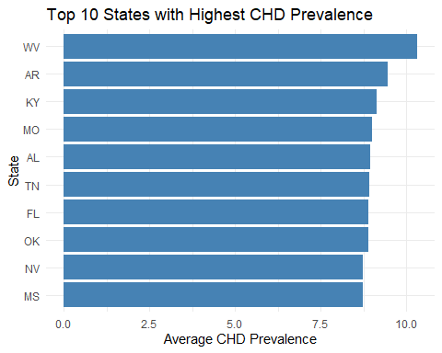

# Bar plot for lowest prevalence  
ggplot(lowest\_prevalence, aes(x = reorder(state, -average\_CHD), y = average\_CHD)) +  
 geom\_bar(stat = "identity", fill = "steelblue") +  
 coord\_flip() +  
 labs(x = "State", y = "Average CHD Prevalence", title = "Top 10 States with Lowest CHD Prevalence") +  
 theme\_minimal()

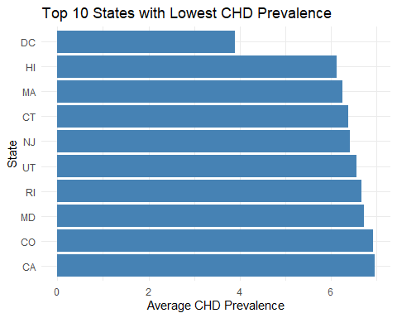

#### Heatmap for CHD Prevalence

# Calculate the average CHD prevalence by state and UrbanRural level  
chd\_prevalence\_by\_state\_and\_urbanrural <- cdc %>%  
 group\_by(state, UrbanRural) %>%  
 summarise(average\_CHD = mean(CHD, na.rm = TRUE))  
  
# Pivot the data to have a column for each UrbanRural level  
chd\_prevalence\_pivot <- chd\_prevalence\_by\_state\_and\_urbanrural %>%  
 pivot\_wider(names\_from = UrbanRural, values\_from = average\_CHD)  
  
chd\_prevalence\_pivot

## # A tibble: 51 × 5  
## # Groups: state [51]  
## state MediumSmall\_Urban Rural Large\_Urban LargeFringe\_Urban  
## <chr> <dbl> <dbl> <dbl> <dbl>  
## 1 AK 5.17 7.31 NA NA   
## 2 AL 8.19 9.56 7.1 8.22  
## 3 AR 8.17 9.94 NA 7.9   
## 4 AZ 8.08 9.3 6.1 7.7   
## 5 CA 6.47 8.51 5.25 5.85  
## 6 CO 5.84 7.44 4.1 5.4   
## 7 CT 6.38 7.1 6.4 6   
## 8 DC NA NA 3.9 NA   
## 9 DE 8.45 NA NA 6.2   
## 10 FL 9.16 9.64 6.8 7.62  
## # ℹ 41 more rows

# Reshape data to a longer format suitable for plotting  
chd\_prevalence\_long <- chd\_prevalence\_pivot %>%  
 pivot\_longer(cols = c(Large\_Urban, LargeFringe\_Urban, MediumSmall\_Urban, Rural),  
 names\_to = "UrbanRural",  
 values\_to = "average\_CHD")  
  
# Generate a heatmap  
ggplot(chd\_prevalence\_long, aes(x = state, y = UrbanRural, fill = average\_CHD)) +  
 geom\_tile() +  
 scale\_fill\_gradient(low = "white", high = "red") +  
 labs(x = "State", y = "Urban/Rural Level", fill = "Average CHD Prevalence",   
 title = "Heatmap of CHD Prevalence by State and Urban/Rural Level") +  
 theme(axis.text.x = element\_text(angle = 90))

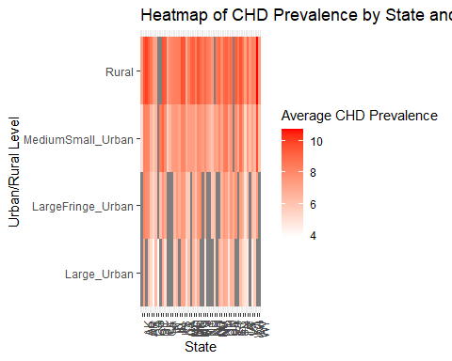

#### What is distribution of Urban Rural for Each State

#We should maybe bucket these? but not sure if we need to keep as is for model?  
urbanrural\_counts <- cdc %>%  
 group\_by(state, UrbanRural) %>%  
 summarise(count = n()) %>%  
 ungroup() %>%  
 arrange(state, desc(UrbanRural)) %>%  
 pivot\_wider(names\_from = UrbanRural, values\_from = count, values\_fill = 0)  
  
# Define the desired column order  
column\_order <- c("Large\_Urban", "LargeFringe\_Urban", "MediumSmall\_Urban", "Rural")  
  
# Reorder the columns  
urbanrural\_counts <- urbanrural\_counts %>%  
 select(state, all\_of(column\_order))  
  
print(urbanrural\_counts)

## # A tibble: 51 × 5  
## state Large\_Urban LargeFringe\_Urban MediumSmall\_Urban Rural  
## <chr> <int> <int> <int> <int>  
## 1 AK 0 0 3 25  
## 2 AL 1 6 22 38  
## 3 AR 0 1 19 55  
## 4 AZ 1 1 6 7  
## 5 CA 8 8 21 21  
## 6 CO 1 9 7 47  
## 7 CT 1 2 4 1  
## 8 DC 1 0 0 0  
## 9 DE 0 1 2 0  
## 10 FL 5 11 28 23  
## # ℹ 41 more rows

#### Visualization - Stacked Bar

urbanrural\_counts <- cdc %>%  
 group\_by(state, UrbanRural) %>%  
 summarise(count = n()) %>%  
 ungroup()  
  
ggplot(urbanrural\_counts, aes(x = state, y = count, fill = UrbanRural)) +  
 geom\_bar(stat = "identity") +  
 labs(title = "Distribution of UrbanRural Variable by State",  
 x = "State", y = "Count") +  
 scale\_fill\_discrete(name = "UrbanRural") +  
 theme\_minimal() +  
 theme(axis.text.x = element\_text(angle = 90, hjust = 1))

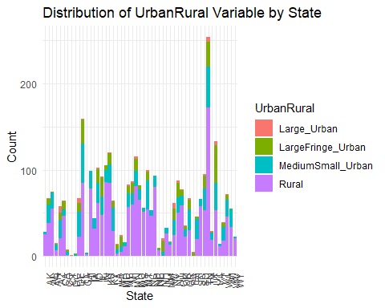

#### Visualization Bar

urbanrural\_counts <- cdc %>%  
 group\_by(state, UrbanRural) %>%  
 summarise(count = n()) %>%  
 ungroup()  
  
ggplot(urbanrural\_counts, aes(x = state, y = count, fill = UrbanRural)) +  
 geom\_bar(stat = "identity", position = "dodge") +  
 labs(title = "Distribution of UrbanRural Variable by State",  
 x = "State", y = "Count") +  
 scale\_fill\_discrete(name = "UrbanRural") +  
 theme\_minimal() +  
 theme(axis.text.x = element\_text(angle = 90, hjust = 1))

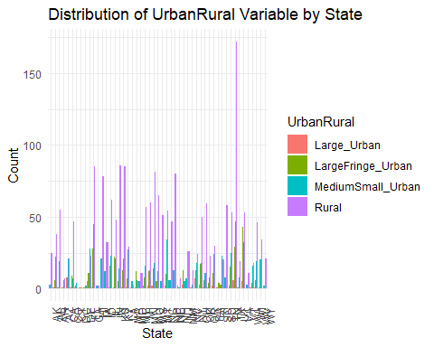

#### Top 5 states with most Urban

top\_large\_urban <- cdc %>%  
 filter(UrbanRural == "Large\_Urban") %>%  
 group\_by(state) %>%  
 summarise(count = n()) %>%  
 arrange(count) %>%  
 slice\_tail(n = 5) %>%  
 mutate(state = factor(state, levels = rev(state)))  
  
ggplot(top\_large\_urban, aes(x = state, y = count, fill = state)) +  
 geom\_bar(stat = "identity") +  
 geom\_text(aes(label = count), vjust = -0.5) +  
 labs(title = "Top 5 States with the Most Large Urban Areas",  
 x = "State", y = "Count") +  
 scale\_fill\_brewer(palette = "Dark2") +  
 theme\_minimal() +  
 theme(axis.text.x = element\_text(angle = 90, hjust = 1))

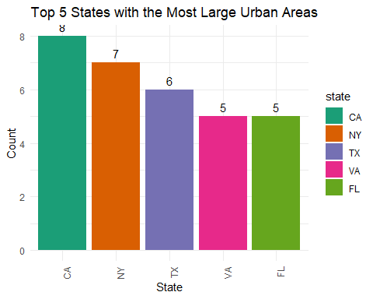

#### Top 10 states with most Rural

top\_rural <- cdc %>%  
 filter(UrbanRural == "Rural") %>%  
 group\_by(state) %>%  
 summarise(count = n()) %>%  
 arrange(count) %>%  
 slice\_tail(n = 10) %>%  
 mutate(state = factor(state, levels = rev(state)))  
  
custom\_colors <- c("#FF5733", "#FFC300", "#C70039", "#900C3F", "#581845", "#FF7F50", "#FFA500", "#FFD700", "#ADFF2F", "#00FF00")  
  
ggplot(top\_rural, aes(x = state, y = count, fill = state)) +  
 geom\_bar(stat = "identity") +  
 geom\_text(aes(label = count), vjust = -0.5) +  
 labs(title = "Top 10 States with the Most Rural Areas",  
 x = "State", y = "Count") +  
 scale\_fill\_manual(values = custom\_colors) +  
 theme\_minimal() +  
 theme(axis.text.x = element\_text(angle = 90, hjust = 1))

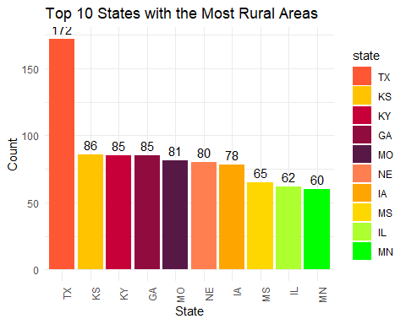

#### I like this one better I think

# Reverse the color palette  
color\_func <- colorRampPalette(c("lightblue", "darkblue"))  
custom\_colors <- rev(color\_func(10))  
  
top\_rural <- cdc %>%  
 filter(UrbanRural == "Rural") %>%  
 group\_by(state) %>%  
 summarise(count = n()) %>%  
 arrange(count) %>%  
 slice\_tail(n = 10) %>%  
 mutate(state = factor(state, levels = rev(state)))  
  
ggplot(top\_rural, aes(x = state, y = count, fill = state)) +  
 geom\_bar(stat = "identity") +  
 geom\_text(aes(label = count), vjust = -0.5) +  
 labs(title = "Top 10 States with the Most Rural Areas",  
 x = "State", y = "Count") +  
 scale\_fill\_manual(values = custom\_colors) +  
 theme\_minimal() +  
 theme(axis.text.x = element\_text(angle = 90, hjust = 1))

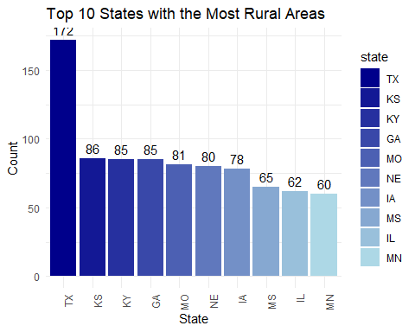

#### Top 10 states with most Large Fringe Urban

# Create the color palette  
color\_func <- colorRampPalette(c("lightblue", "darkblue"))  
custom\_colors <- rev(color\_func(10)) # Reverse to get dark colors for higher values  
  
top\_large\_fringe\_urban <- cdc %>%  
 filter(UrbanRural == "LargeFringe\_Urban") %>%  
 group\_by(state) %>%  
 summarise(count = n()) %>%  
 arrange(count) %>%  
 slice\_tail(n = 10) %>%  
 mutate(state = factor(state, levels = rev(state)))  
  
ggplot(top\_large\_fringe\_urban, aes(x = state, y = count, fill = state)) +  
 geom\_bar(stat = "identity") +  
 geom\_text(aes(label = count), vjust = -0.5) +  
 labs(title = "Top 10 States with the Most Large Fringe Urban Areas",  
 x = "State", y = "Count") +  
 scale\_fill\_manual(values = custom\_colors) + # Use the custom color palette  
 theme\_minimal() +  
 theme(axis.text.x = element\_text(angle = 90, hjust = 1))

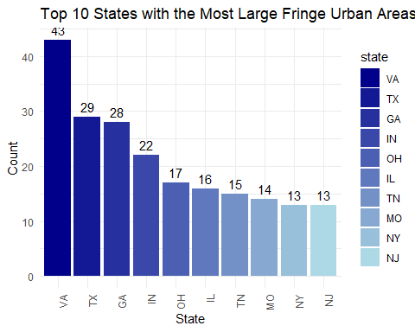

#### Medium Small Urban Areas

# Create the color palette  
color\_func <- colorRampPalette(c("lightblue", "darkblue"))  
custom\_colors <- rev(color\_func(10)) # Reverse to get dark colors for higher values  
  
top\_large\_fringe\_urban <- cdc %>%  
 filter(UrbanRural == "MediumSmall\_Urban") %>%  
 group\_by(state) %>%  
 summarise(count = n()) %>%  
 arrange(count) %>%  
 slice\_tail(n = 10) %>%  
 mutate(state = factor(state, levels = rev(state)))  
  
ggplot(top\_large\_fringe\_urban, aes(x = state, y = count, fill = state)) +  
 geom\_bar(stat = "identity") +  
 geom\_text(aes(label = count), vjust = -0.5) +  
 labs(title = "Top 10 States with the Most Medium Small Urban Areas",  
 x = "State", y = "Count") +  
 scale\_fill\_manual(values = custom\_colors) + # Use the custom color palette  
 theme\_minimal() +  
 theme(axis.text.x = element\_text(angle = 90, hjust = 1))

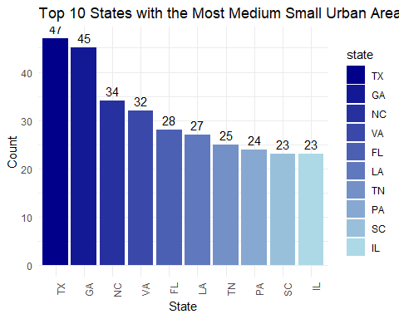

#### Boxplots for each variable

# Create the subset  
cdc\_subset <- cdc %>%  
 select(c(4:34, 36, 92:97))  
  
# Box plots for each variable in the subset  
for (i in 1:ncol(cdc\_subset)) {  
 par(mar = c(5, 4, 2, 1))  
 boxplot(cdc\_subset[, i], main = names(cdc\_subset)[i])  
}

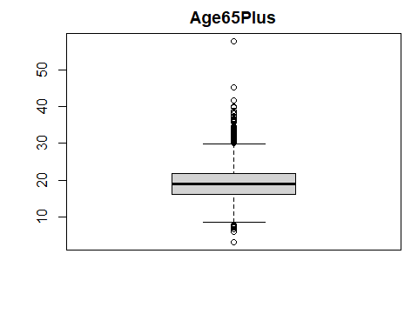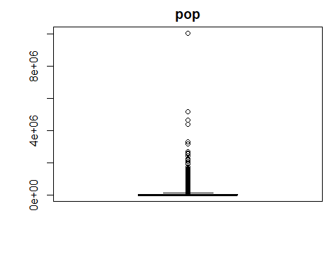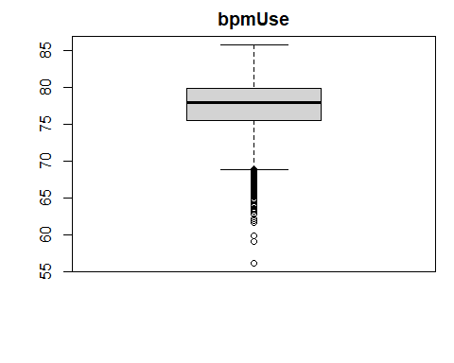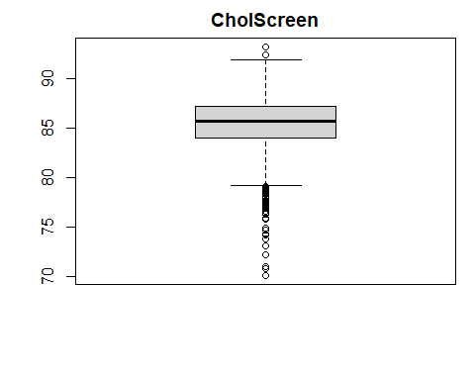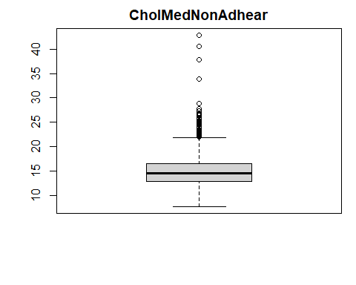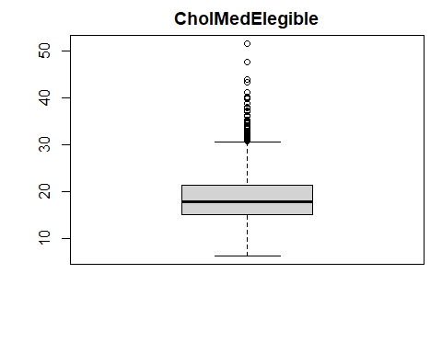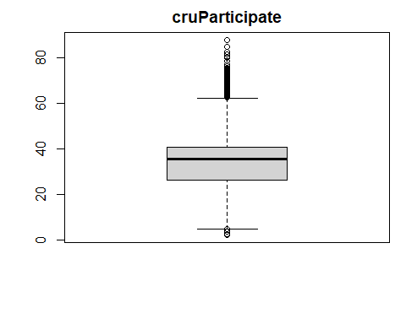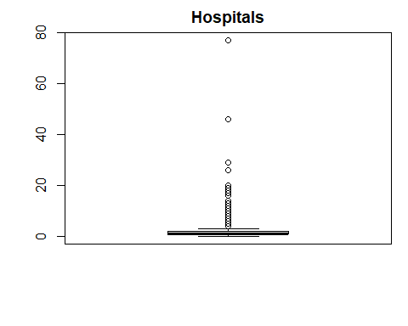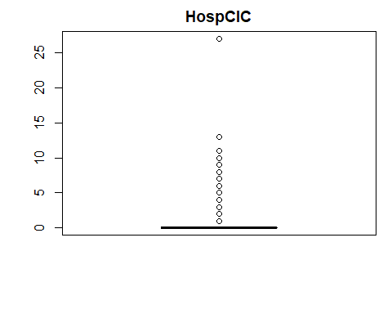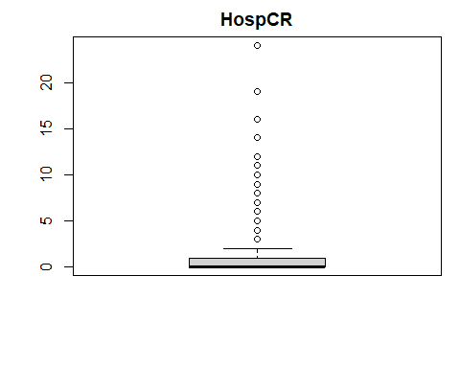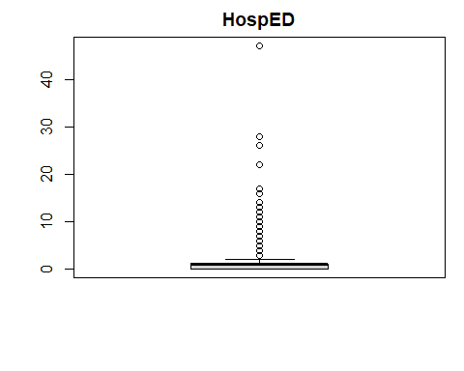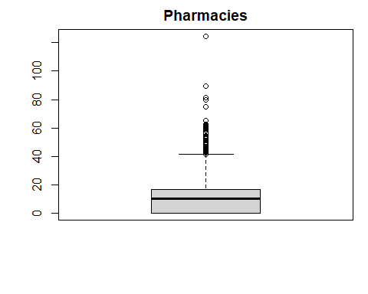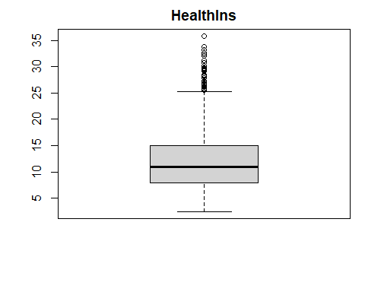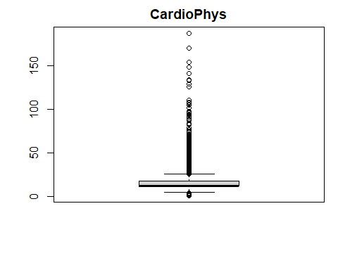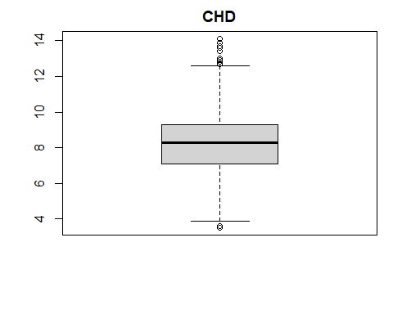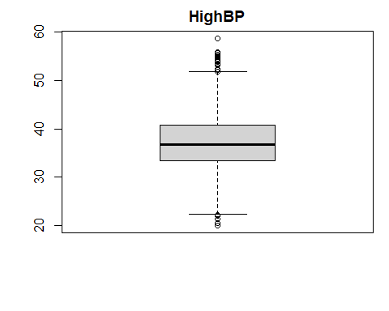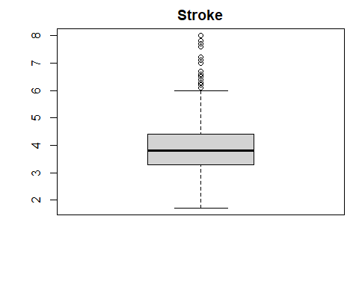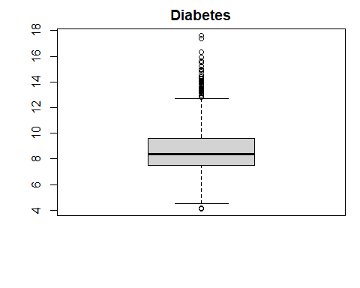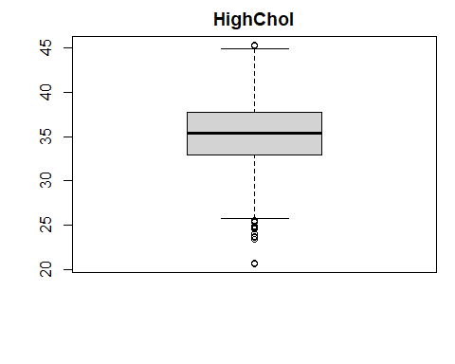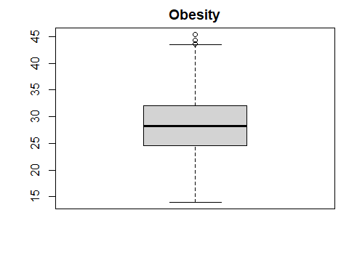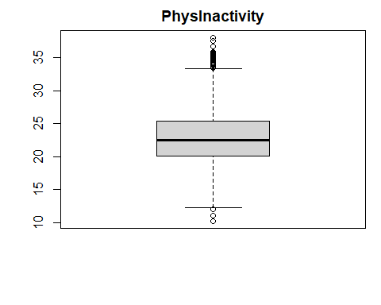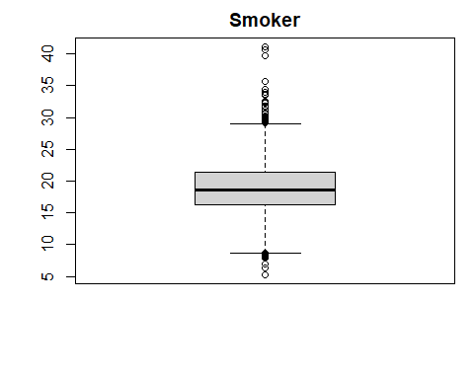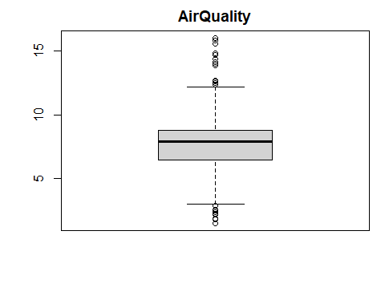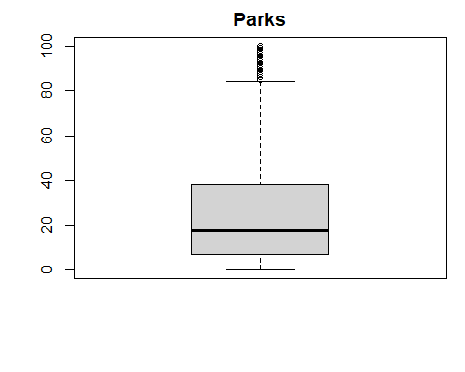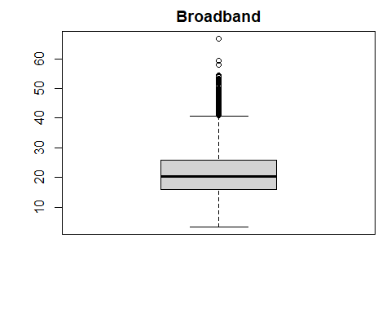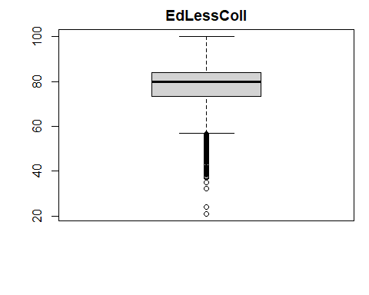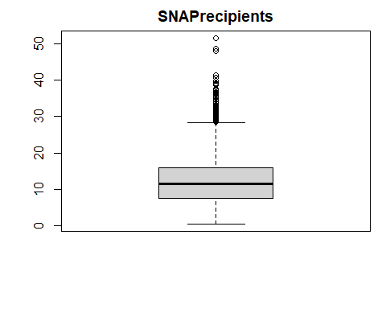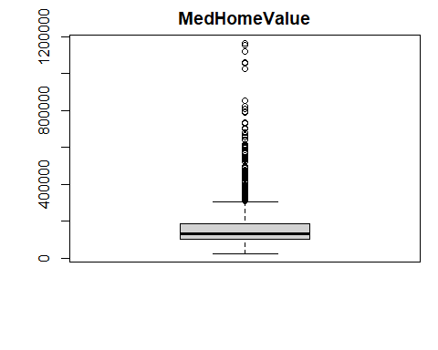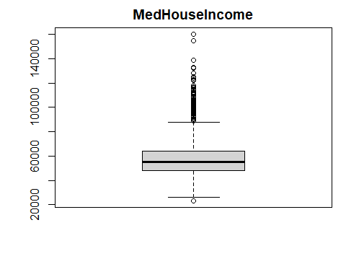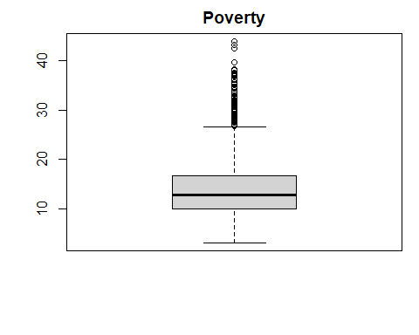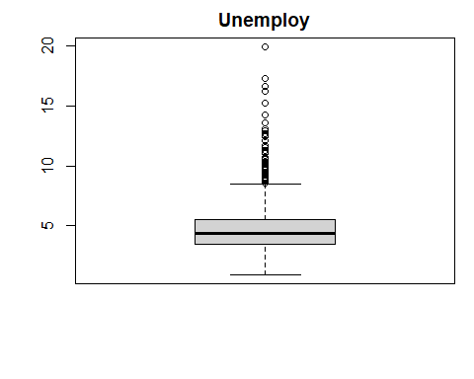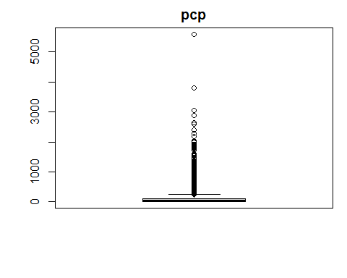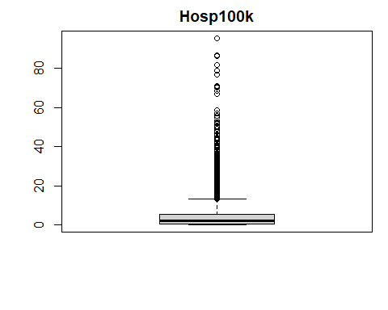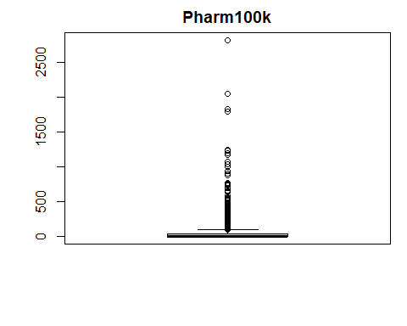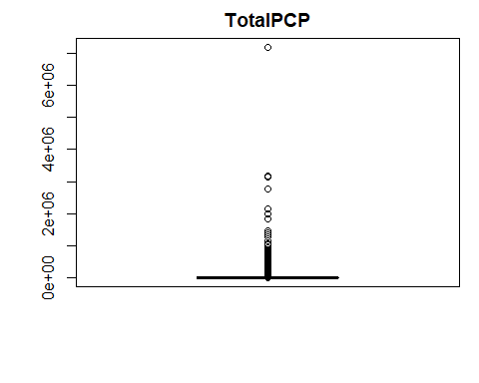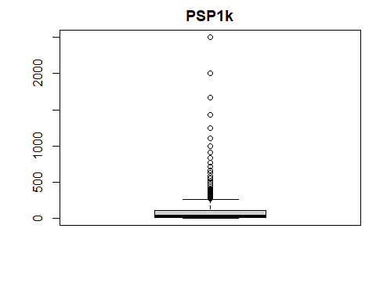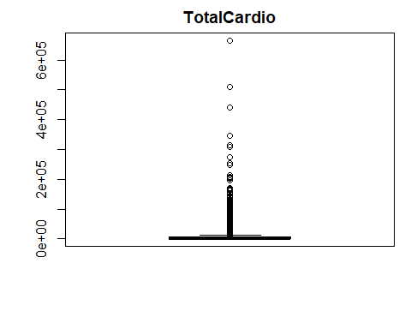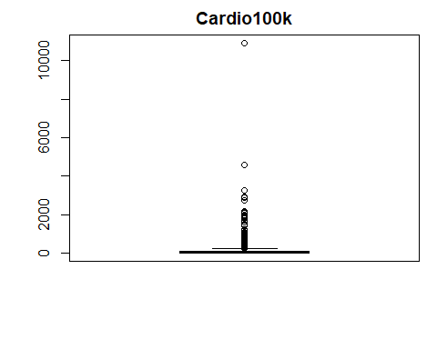

#### Outliers

# Outlier detection  
for (column in colnames(cdc\_comp)){  
 IQR = IQR(cdc\_comp[[column]], na.rm = TRUE)  
 lower\_bound = quantile(cdc\_comp[[column]], 0.25, na.rm = TRUE) - 1.5 \* IQR  
 upper\_bound = quantile(cdc\_comp[[column]], 0.75, na.rm = TRUE) + 1.5 \* IQR  
 outliers = length(which(cdc\_comp[[column]] < lower\_bound | cdc\_comp[[column]] > upper\_bound))  
 print(paste("Number of outliers in", column, ":", outliers))  
}

## [1] "Number of outliers in Age65Plus : 104"  
## [1] "Number of outliers in pop : 431"  
## [1] "Number of outliers in bpmUse : 106"  
## [1] "Number of outliers in CholScreen : 73"  
## [1] "Number of outliers in CholMedNonAdhear : 56"  
## [1] "Number of outliers in CholMedElegible : 80"  
## [1] "Number of outliers in cruParticipate : 148"  
## [1] "Number of outliers in Hospitals : 205"  
## [1] "Number of outliers in HospCIC : 557"  
## [1] "Number of outliers in HospCR : 156"  
## [1] "Number of outliers in HospED : 243"  
## [1] "Number of outliers in Pharmacies : 60"  
## [1] "Number of outliers in HealthIns : 47"  
## [1] "Number of outliers in CardioPhys : 793"  
## [1] "Number of outliers in CHD : 14"  
## [1] "Number of outliers in HighBP : 25"  
## [1] "Number of outliers in Stroke : 52"  
## [1] "Number of outliers in Diabetes : 88"  
## [1] "Number of outliers in HighChol : 20"  
## [1] "Number of outliers in Obesity : 3"  
## [1] "Number of outliers in PhysInactivity : 39"  
## [1] "Number of outliers in Smoker : 49"  
## [1] "Number of outliers in AirQuality : 24"  
## [1] "Number of outliers in Parks : 101"  
## [1] "Number of outliers in Broadband : 77"  
## [1] "Number of outliers in EdLessColl : 150"  
## [1] "Number of outliers in SNAPrecipients : 86"  
## [1] "Number of outliers in MedHomeValue : 198"  
## [1] "Number of outliers in MedHouseIncome : 124"  
## [1] "Number of outliers in Poverty : 82"  
## [1] "Number of outliers in Unemploy : 93"  
## [1] "Number of outliers in pcp : 367"  
## [1] "Number of outliers in state\_AK : 28"  
## [1] "Number of outliers in state\_AL : 67"  
## [1] "Number of outliers in state\_AR : 75"  
## [1] "Number of outliers in state\_AZ : 15"  
## [1] "Number of outliers in state\_CA : 58"  
## [1] "Number of outliers in state\_CO : 64"  
## [1] "Number of outliers in state\_CT : 8"  
## [1] "Number of outliers in state\_DC : 1"  
## [1] "Number of outliers in state\_DE : 3"  
## [1] "Number of outliers in state\_FL : 67"  
## [1] "Number of outliers in state\_GA : 159"  
## [1] "Number of outliers in state\_HI : 4"  
## [1] "Number of outliers in state\_IA : 99"  
## [1] "Number of outliers in state\_ID : 44"  
## [1] "Number of outliers in state\_IL : 102"  
## [1] "Number of outliers in state\_IN : 92"  
## [1] "Number of outliers in state\_KS : 105"  
## [1] "Number of outliers in state\_KY : 120"  
## [1] "Number of outliers in state\_LA : 64"  
## [1] "Number of outliers in state\_MA : 14"  
## [1] "Number of outliers in state\_MD : 24"  
## [1] "Number of outliers in state\_ME : 16"  
## [1] "Number of outliers in state\_MI : 83"  
## [1] "Number of outliers in state\_MN : 87"  
## [1] "Number of outliers in state\_MO : 115"  
## [1] "Number of outliers in state\_MS : 82"  
## [1] "Number of outliers in state\_MT : 56"  
## [1] "Number of outliers in state\_NC : 100"  
## [1] "Number of outliers in state\_ND : 53"  
## [1] "Number of outliers in state\_NE : 93"  
## [1] "Number of outliers in state\_NH : 10"  
## [1] "Number of outliers in state\_NJ : 21"  
## [1] "Number of outliers in state\_NM : 33"  
## [1] "Number of outliers in state\_NV : 17"  
## [1] "Number of outliers in state\_NY : 62"  
## [1] "Number of outliers in state\_OH : 88"  
## [1] "Number of outliers in state\_OK : 77"  
## [1] "Number of outliers in state\_OR : 36"  
## [1] "Number of outliers in state\_PA : 67"  
## [1] "Number of outliers in state\_RI : 5"  
## [1] "Number of outliers in state\_SC : 46"  
## [1] "Number of outliers in state\_SD : 66"  
## [1] "Number of outliers in state\_TN : 95"  
## [1] "Number of outliers in state\_TX : 254"  
## [1] "Number of outliers in state\_UT : 29"  
## [1] "Number of outliers in state\_VA : 133"  
## [1] "Number of outliers in state\_VT : 14"  
## [1] "Number of outliers in state\_WA : 39"  
## [1] "Number of outliers in state\_WI : 72"  
## [1] "Number of outliers in state\_WV : 55"  
## [1] "Number of outliers in state\_WY : 23"  
## [1] "Number of outliers in UrbanRural\_Large\_Urban : 68"  
## [1] "Number of outliers in UrbanRural\_LargeFringe\_Urban : 368"  
## [1] "Number of outliers in UrbanRural\_MediumSmall\_Urban : 729"  
## [1] "Number of outliers in UrbanRural\_Rural : 0"  
## [1] "Number of outliers in Hosp100k : 292"  
## [1] "Number of outliers in Pharm100k : 383"  
## [1] "Number of outliers in TotalPCP : 433"  
## [1] "Number of outliers in PSP1k : 462"  
## [1] "Number of outliers in TotalCardio : 483"  
## [1] "Number of outliers in Cardio100k : 326"

#### Just checking where missing values are

# Checking for missing values  
missing\_value\_cols <- c()  
for (i in 1:ncol(cdc\_comp)) {  
 if (any(is.na(cdc\_comp[, i]))) {  
 missing\_value\_cols <- c(missing\_value\_cols, names(cdc\_comp)[i])  
 }  
}  
cat("Columns with missing values:\n")

## Columns with missing values:

print(missing\_value\_cols)

## NULL

cat("Number of NA values in each column:\n")

## Number of NA values in each column:

print(colSums(is.na(cdc\_comp)))

## Age65Plus pop   
## 0 0   
## bpmUse CholScreen   
## 0 0   
## CholMedNonAdhear CholMedElegible   
## 0 0   
## cruParticipate Hospitals   
## 0 0   
## HospCIC HospCR   
## 0 0   
## HospED Pharmacies   
## 0 0   
## HealthIns CardioPhys   
## 0 0   
## CHD HighBP   
## 0 0   
## Stroke Diabetes   
## 0 0   
## HighChol Obesity   
## 0 0   
## PhysInactivity Smoker   
## 0 0   
## AirQuality Parks   
## 0 0   
## Broadband EdLessColl   
## 0 0   
## SNAPrecipients MedHomeValue   
## 0 0   
## MedHouseIncome Poverty   
## 0 0   
## Unemploy pcp   
## 0 0   
## state\_AK state\_AL   
## 0 0   
## state\_AR state\_AZ   
## 0 0   
## state\_CA state\_CO   
## 0 0   
## state\_CT state\_DC   
## 0 0   
## state\_DE state\_FL   
## 0 0   
## state\_GA state\_HI   
## 0 0   
## state\_IA state\_ID   
## 0 0   
## state\_IL state\_IN   
## 0 0   
## state\_KS state\_KY   
## 0 0   
## state\_LA state\_MA   
## 0 0   
## state\_MD state\_ME   
## 0 0   
## state\_MI state\_MN   
## 0 0   
## state\_MO state\_MS   
## 0 0   
## state\_MT state\_NC   
## 0 0   
## state\_ND state\_NE   
## 0 0   
## state\_NH state\_NJ   
## 0 0   
## state\_NM state\_NV   
## 0 0   
## state\_NY state\_OH   
## 0 0   
## state\_OK state\_OR   
## 0 0   
## state\_PA state\_RI   
## 0 0   
## state\_SC state\_SD   
## 0 0   
## state\_TN state\_TX   
## 0 0   
## state\_UT state\_VA   
## 0 0   
## state\_VT state\_WA   
## 0 0   
## state\_WI state\_WV   
## 0 0   
## state\_WY UrbanRural\_Large\_Urban   
## 0 0   
## UrbanRural\_LargeFringe\_Urban UrbanRural\_MediumSmall\_Urban   
## 0 0   
## UrbanRural\_Rural Hosp100k   
## 0 0   
## Pharm100k TotalPCP   
## 0 0   
## PSP1k TotalCardio   
## 0 0   
## Cardio100k   
## 0

####Test imputing data that is still missing

# Handling missing values (assuming you want to impute them)  
library(mice)  
imputed\_data <- mice(cdc, m = 5) # Impute missing values (replace 'data' with your dataset)

##   
## iter imp variable  
## 1 1  
## 1 2  
## 1 3  
## 1 4  
## 1 5  
## 2 1  
## 2 2  
## 2 3  
## 2 4  
## 2 5  
## 3 1  
## 3 2  
## 3 3  
## 3 4  
## 3 5  
## 4 1  
## 4 2  
## 4 3  
## 4 4  
## 4 5  
## 5 1  
## 5 2  
## 5 3  
## 5 4  
## 5 5

# Encoding categorical variables (assuming 'urban\_rural' is a categorical variable)  
#imputed\_data$UrbanRural <- as.factor(imputed\_data$UrbanRural)

### Linear Model with CHD vs Urban Rural

# Fit models to each imputed dataset  
models <- with(imputed\_data, exp = lm(CHD ~ UrbanRural))  
  
# Pool results  
pooled\_results <- pool(models)  
  
# Print summary of pooled results  
summary(pooled\_results)

## term estimate std.error statistic df  
## 1 (Intercept) 5.792647 0.1647367 35.163061 3133.664  
## 2 UrbanRuralLargeFringe\_Urban 1.009527 0.1793122 5.629997 3133.664  
## 3 UrbanRuralMediumSmall\_Urban 1.803786 0.1722486 10.471992 3133.664  
## 4 UrbanRuralRural 2.979505 0.1675487 17.782920 3133.664  
## p.value  
## 1 1.304286e-228  
## 2 1.961196e-08  
## 3 3.018089e-25  
## 4 1.780474e-67

#### Linear Model with CHD vs Urban Rural Explanation:

**Intercept (Large\_Urban)**: In this model, “Large\_Urban” is the reference category because it is represented by the intercept. The intercept’s value of approximately 5.79 is the average CHD prevalence in “Large\_Urban” areas (given that the CHD data and coefficients are in a format where this interpretation makes sense).

**LargeFringe\_Urban**: The coefficient of approximately 1.01 suggests that, on average, the CHD prevalence in “LargeFringe\_Urban” areas is estimated to be about 1.01 units higher than in “Large\_Urban” areas.

**MediumSmall\_Urban**: Similarly, the CHD prevalence in “MediumSmall\_Urban” areas is estimated to be about 1.80 units higher than in “Large\_Urban” areas.

**Rural**: Lastly, the CHD prevalence in “Rural” areas is estimated to be about 2.98 units higher than in “Large\_Urban” areas.

For all categories of “UrbanRural”, the p-values are less than 0.05, which suggests that the differences in CHD prevalence between “Large\_Urban” areas and the other types of areas are statistically significant.

In other words, your model suggests that there is a significant association between the type of area and CHD prevalence. Specifically, all other types of areas have higher estimated CHD prevalence than “Large\_Urban” areas.

### Linear Model CHD vs Urban Rural + HighBP

# Fit models to each imputed dataset  
models <- with(imputed\_data, exp = lm(CHD ~ UrbanRural + HighBP))  
  
# Pool results  
pooled\_results <- pool(models)  
  
# Print summary of pooled results  
summary(pooled\_results)

## term estimate std.error statistic df  
## 1 (Intercept) -0.2876621 0.130539462 -2.203641 3132.664  
## 2 UrbanRuralLargeFringe\_Urban 0.2928782 0.109712450 2.669508 3132.664  
## 3 UrbanRuralMediumSmall\_Urban 0.7978104 0.105870294 7.535735 3132.664  
## 4 UrbanRuralRural 1.4393493 0.104266985 13.804459 3132.664  
## 5 HighBP 0.1983978 0.002722696 72.868147 3132.664  
## p.value  
## 1 2.762211e-02  
## 2 7.635461e-03  
## 3 6.317965e-14  
## 4 3.999368e-42  
## 5 0.000000e+00

#### Linear Model CHD vs Urban Rural + HighBP Explanation:

In your output, each row corresponds to a term in the model, and each column corresponds to an aspect of the term.

* **term**: This is the name of the variable in the model. “(Intercept)” refers to the model’s intercept, or baseline outcome when all the predictors are 0. In your case, “UrbanRuralLargeFringe\_Urban”, “UrbanRuralMediumSmall\_Urban”, and “UrbanRuralRural” are dummy variables derived from the categorical variable “UrbanRural”, and “HighBP” is a variable representing high blood pressure.
* **estimate**: This is the estimated coefficient for the term in the model. For example, the estimate for “HighBP” is 0.1983978. In the context of this model, it means that for each unit increase in “HighBP”, we would expect an increase of 0.1983978 units in “CHD”, holding all other variables constant.
* **std.error**: This is the standard error of the estimated coefficient. It measures the variability in the estimate. A smaller standard error means the estimate is more precise.
* **statistic**: This is the t-statistic for the term. It is the ratio of the estimate to the standard error. The t-statistic follows a t-distribution under the null hypothesis that the true coefficient is zero. A larger absolute value of the t-statistic means it is further from zero, which provides stronger evidence against the null hypothesis.
* **df**: This is the degrees of freedom for the t-statistic.
* **p.value**: This is the p-value for the hypothesis test of whether the coefficient is zero. A smaller p-value means there is stronger evidence against the null hypothesis, i.e., stronger evidence that the coefficient is not zero.

In your output, all the p-values are very small, which suggests that each term in the model is significantly related to “CHD”. Specifically:

* For a county that’s “UrbanRuralLargeFringe\_Urban” versus “Large\_Urban”, the expected “CHD” increases by 0.2928782 units, holding all other variables constant.
* For a county that’s “UrbanRuralMediumSmall\_Urban” versus “Large\_Urban”, the expected “CHD” increases by 0.7978104 units, holding all other variables constant.
* For a county that’s “UrbanRuralRural” versus “Large\_Urban”, the expected “CHD” increases by 1.4393493 units, holding all other variables constant.
* For each unit increase in “HighBP”, the expected “CHD” increases by 0.1983978 units, holding all other variables constant.

Therefore, your model suggests that “HighBP” and “UrbanRural” are both significant predictors of “CHD”, with “HighBP” being a particularly strong predictor given its large t-statistic. This matches with what you might expect given that high blood pressure is known to be a risk factor for coronary heart disease.

### Linear Model with various variables

# Fit models to each imputed dataset  
models <- with(imputed\_data, exp = lm(CHD ~ UrbanRural + HighBP + Broadband + Smoker + EdLessColl + MedHouseIncome + Poverty))   
  
# Pool results  
pooled\_results <- pool(models)  
  
# Print summary of pooled results  
summary(pooled\_results)

## term estimate std.error statistic df  
## 1 (Intercept) 2.450299e+00 2.906028e-01 8.431780 3127.665  
## 2 UrbanRuralLargeFringe\_Urban 1.992106e-01 1.052145e-01 1.893375 3127.665  
## 3 UrbanRuralMediumSmall\_Urban 3.713941e-01 1.012705e-01 3.667346 3127.665  
## 4 UrbanRuralRural 8.349018e-01 1.019060e-01 8.192858 3127.665  
## 5 HighBP 1.554063e-01 3.606174e-03 43.094503 3127.665  
## 6 Broadband 1.916928e-02 2.729911e-03 7.021943 3127.665  
## 7 Smoker 2.840665e-02 6.045674e-03 4.698674 3127.665  
## 8 EdLessColl 8.625805e-03 2.552777e-03 3.378990 3127.665  
## 9 MedHouseIncome -2.641664e-05 1.986370e-06 -13.298952 3127.665  
## 10 Poverty -5.460001e-02 4.615795e-03 -11.828951 3127.665  
## p.value  
## 1 5.125619e-17  
## 2 5.840023e-02  
## 3 2.491615e-04  
## 4 3.676903e-16  
## 5 6.391233e-319  
## 6 2.672660e-12  
## 7 2.731532e-06  
## 8 7.364365e-04  
## 9 2.685810e-39  
## 10 1.292198e-31

#### Linear Model with various variables Explanation:

1. **(Intercept)**: The expected value of CHD when all predictor variables are zero. In practice, this might not be meaningful if zero is outside the range of your predictor variables.
2. **UrbanRuralLargeFringe\_Urban**: This is the change in CHD expected with a change from Large Urban (the reference category) to Large Fringe Urban, keeping all other variables constant. The p-value is slightly more than 0.05, so this effect may not be statistically significant at the usual levels.
3. **UrbanRuralMediumSmall\_Urban**: This is the change in CHD expected with a change from Large Urban to Medium or Small Urban. The positive coefficient and small p-value suggest this is associated with an increase in CHD, and this effect is statistically significant.
4. **UrbanRuralRural**: The expected change in CHD with a change from Large Urban to Rural. This is significantly associated with an increase in CHD.
5. **HighBP (High Blood Pressure)**: The expected change in CHD with a unit increase in HighBP. The positive coefficient and very small p-value suggest that higher blood pressure is significantly associated with higher CHD.
6. **Broadband**: I’m not sure what this variable represents, but its positive coefficient and small p-value suggest that an increase in Broadband is associated with an increase in CHD, assuming all other variables are held constant.
7. **Smoker**: This might represent whether the individual is a smoker or the proportion of smokers. The positive coefficient and small p-value suggest that smoking is significantly associated with higher CHD.
8. **EdLessColl (Education Less than College)**: This might represent individuals with less than college education. The positive coefficient and small p-value suggest that having less than college education is significantly associated with higher CHD.
9. **MedHouseIncome (Median Household Income)**: This might represent the median household income in an area. The negative coefficient and very small p-value suggest that higher median household income is significantly associated with lower CHD, assuming all other variables are held constant.
10. **Poverty**: This might represent the proportion of individuals in poverty in an area. The negative coefficient and small p-value suggest that higher poverty is significantly associated with lower CHD, which seems counterintuitive. It might be due to confounding variables or other complex relationships in your data.

Remember, these interpretations are conditional on the other variables in the model. This means, for example, the effect of HighBP on CHD is estimated assuming all other variables (UrbanRural, Broadband, Smoker, EdLessColl, MedHouseIncome, Poverty) are held constant.

Also, all these interpretations are about associations, not causal relationships. Determining whether a relationship is causal is more complex and requires more than just statistical analysis.

### Linear Model with Poverty

# Fit models to each imputed dataset  
models <- with(imputed\_data, exp = lm(CHD ~ UrbanRural + Poverty))  
  
# Pool results  
pooled\_results <- pool(models)  
  
# Print summary of pooled results  
summary(pooled\_results)

## term estimate std.error statistic df  
## 1 (Intercept) 4.196543 0.155820394 26.931924 3132.664  
## 2 UrbanRuralLargeFringe\_Urban 1.441820 0.159586118 9.034745 3132.664  
## 3 UrbanRuralMediumSmall\_Urban 1.802180 0.152642974 11.806503 3132.664  
## 4 UrbanRuralRural 2.766099 0.148656543 18.607315 3132.664  
## 5 Poverty 0.122293 0.004174238 29.297091 3132.664  
## p.value  
## 1 7.004028e-144  
## 2 2.808080e-19  
## 3 1.664810e-31  
## 4 2.199503e-73  
## 5 5.782284e-167

#### Linear Model with Poverty Explanation:

* **(Intercept)**: The expected value of CHD when all predictor variables are zero. In the context of your model, this would mean when UrbanRural is at its reference level (which I’m assuming is “Large\_Urban”) and Poverty is 0. It’s unlikely that the zero value of Poverty has a practical interpretation in your context. So, the intercept here is more of a technical aspect of the model, rather than something you would interpret directly.
* **UrbanRuralLargeFringe\_Urban**: This represents the expected change in CHD when the UrbanRural variable changes from “Large\_Urban” to “LargeFringe\_Urban”, keeping the Poverty constant. The estimate of 1.441820 suggests that, on average, CHD is 1.441820 units higher in “LargeFringe\_Urban” areas than in “Large\_Urban” areas, when Poverty is the same in both areas. The p-value of 2.808080e-19 (very close to 0) suggests that this effect is statistically significant.
* **UrbanRuralMediumSmall\_Urban**: This represents the expected change in CHD when UrbanRural changes from “Large\_Urban” to “MediumSmall\_Urban”, with Poverty kept constant. The estimate suggests that, on average, CHD is 1.802180 units higher in “MediumSmall\_Urban” areas than in “Large\_Urban” areas when Poverty is the same. The p-value (1.664810e-31) indicates that this effect is statistically significant.
* **UrbanRuralRural**: This represents the expected change in CHD when UrbanRural changes from “Large\_Urban” to “Rural”, keeping Poverty constant. The estimate of 2.766099 suggests that CHD is, on average, 2.766099 units higher in “Rural” areas than in “Large\_Urban” areas when Poverty is the same. The p-value (2.199503e-73) indicates this effect is statistically significant.
* **Poverty**: This represents the expected change in CHD for a one-unit increase in Poverty, keeping UrbanRural constant. The positive estimate of 0.122293 suggests that for each unit increase in Poverty, CHD increases, on average, by 0.122293 units. The p-value (5.782284e-167) indicates this effect is statistically significant.

Please note that these interpretations are based on associations, not causal relationships. The estimates give us the expected change in the outcome variable (CHD) for a unit change in the predictor variables, assuming all other predictors are held constant. However, they do not tell us whether changing the predictor variable would cause a change in the outcome. Also, be aware that other factors not included in the model could be confounding the relationships.

### Linear Model with interactions

# Fit models to each imputed dataset  
models <- with(imputed\_data, exp = lm(CHD ~ UrbanRural \* HighBP + Smoker \* MedHouseIncome + Broadband + EdLessColl + Poverty))  
  
# Pool results  
pooled\_results <- pool(models)  
  
# Print summary of pooled results  
summary(pooled\_results)

## term estimate std.error statistic  
## 1 (Intercept) 2.885515e+00 7.827139e-01 3.6865515  
## 2 UrbanRuralLargeFringe\_Urban -3.678558e-01 7.078630e-01 -0.5196709  
## 3 UrbanRuralMediumSmall\_Urban -1.810311e+00 6.851842e-01 -2.6420793  
## 4 UrbanRuralRural -1.074777e+00 6.804544e-01 -1.5794992  
## 5 HighBP 9.160947e-02 2.157208e-02 4.2466687  
## 6 Smoker 1.533452e-01 1.373856e-02 11.1616583  
## 7 MedHouseIncome 2.732502e-06 3.842155e-06 0.7111899  
## 8 Broadband 1.644542e-02 2.672308e-03 6.1540138  
## 9 EdLessColl 1.711770e-02 2.607027e-03 6.5659855  
## 10 Poverty -8.284974e-02 5.108394e-03 -16.2183525  
## 11 UrbanRuralLargeFringe\_Urban:HighBP 2.213500e-02 2.252995e-02 0.9824697  
## 12 UrbanRuralMediumSmall\_Urban:HighBP 6.817760e-02 2.187294e-02 3.1169830  
## 13 UrbanRuralRural:HighBP 5.869291e-02 2.170823e-02 2.7037165  
## 14 Smoker:MedHouseIncome -2.492507e-06 2.458332e-07 -10.1390143  
## df p.value  
## 1 3123.665 2.311787e-04  
## 2 3123.665 6.033298e-01  
## 3 3123.665 8.280977e-03  
## 4 3123.665 1.143228e-01  
## 5 3123.665 2.233017e-05  
## 6 3123.665 2.147988e-28  
## 7 3123.665 4.770197e-01  
## 8 3123.665 8.516366e-10  
## 9 3123.665 6.030705e-11  
## 10 3123.665 7.384720e-57  
## 11 3123.665 3.259446e-01  
## 12 3123.665 1.843731e-03  
## 13 3123.665 6.894025e-03  
## 14 3123.665 8.622200e-24

#### Linear Model with interactions explanation:

1. **Intercept:** The intercept of the model is approximately 2.89. In the context of this model, the intercept represents the expected value of CHD when all the predictor variables are 0. However, since some of your variables are categorical (UrbanRural), the interpretation of the intercept becomes less straightforward.
2. **UrbanRural:** The coefficients for UrbanRural indicate the change in the expected value of CHD for a given level of UrbanRural compared to the reference level (which in this case is “Large\_Urban”), while all other predictors remain constant. For example, for “MediumSmall\_Urban”, the expected CHD decreases by about 1.81 units compared to “Large\_Urban”, assuming all other variables stay constant. Keep in mind that this coefficient is not statistically significant as the p-value is larger than 0.05.
3. **HighBP:** HighBP is positively associated with CHD, with a one-unit increase in HighBP leading to a ~0.092 increase in the expected value of CHD, assuming all other variables stay constant.
4. **Smoker:** Being a smoker increases the expected value of CHD by about 0.15, assuming all other variables stay constant.
5. **MedHouseIncome:** The coefficient for MedHouseIncome is close to 0 and its p-value is greater than 0.05, suggesting that there is no significant linear relationship between MedHouseIncome and CHD when other variables are controlled.
6. **Broadband, EdLessColl, and Poverty:** Similar to HighBP and Smoker, Broadband and EdLessColl are positively associated with CHD while Poverty is negatively associated. The more detailed interpretation would be similar to what we’ve gone over for HighBP and Smoker.
7. **Interaction Terms:** The coefficients for the interaction terms represent how much the relationship between HighBP and CHD changes for different levels of UrbanRural and how much the relationship between Smoker and CHD changes for different levels of MedHouseIncome. For instance, the interaction term UrbanRuralMediumSmall\_Urban:HighBP suggests that the effect of HighBP on CHD is 0.068 units higher in MediumSmall\_Urban areas compared to Large\_Urban areas.

* The interpretation of interaction terms can be complex, especially when the variables involved are not continuous. The main point here is that the relationship between CHD and HighBP and between CHD and Smoker varies depending on the level of UrbanRural and MedHouseIncome, respectively.

Overall, this model provides a nuanced view of the factors influencing CHD. However, it’s essential to remember that this is a statistical model that captures associations, not necessarily causal relationships. For instance, while Broadband is positively associated with CHD, we wouldn’t conclude that increasing broadband availability causes an increase in coronary heart disease prevalence. The associations we observe could be influenced by a variety of other factors not included in the model.

#### Saved the data (can delete this)

#write.csv(cdc, "/Users/isaacjohnson/Documents/Scanner Output/School/Willamette/Capstone/Capstone Project/Backup/cdc.csv", row.names = FALSE)

#### Proportion for each level of Urban Rural

# proportion of each level 'UrbanRural'  
urban\_rural\_proportions <- cdc %>%  
 group\_by(UrbanRural) %>%  
 summarise(n = n()) %>%  
 mutate(prop = n / sum(n))  
  
# Print the proportions  
print(urban\_rural\_proportions)

## # A tibble: 4 × 3  
## UrbanRural n prop  
## <fct> <int> <dbl>  
## 1 Large\_Urban 68 0.0217  
## 2 LargeFringe\_Urban 368 0.117   
## 3 MediumSmall\_Urban 729 0.232   
## 4 Rural 1975 0.629

#### Mean Prevalence for CHD by each level of Urban/Rural

# Compute mean CHD prevalence for each category of UrbanRural  
mean\_chd <- cdc %>%   
 group\_by(UrbanRural) %>%   
 summarise(mean\_chd = mean(CHD))  
  
# Print mean CHD prevalence  
print(mean\_chd)

## # A tibble: 4 × 2  
## UrbanRural mean\_chd  
## <fct> <dbl>  
## 1 Large\_Urban 5.79  
## 2 LargeFringe\_Urban 6.80  
## 3 MediumSmall\_Urban 7.60  
## 4 Rural 8.77

#### Look at extremes for Urban Rural

# Find urban areas (Large\_Urban, LargeFringe\_Urban, MediumSmall\_Urban) with high CHD  
urban\_high\_chd <- cdc %>%   
 filter(UrbanRural %in% c('Large\_Urban', 'LargeFringe\_Urban', 'MediumSmall\_Urban'),   
 CHD > quantile(CHD, 0.95))  
  
# Find rural areas with low CHD  
rural\_low\_chd <- cdc %>%   
 filter(UrbanRural == 'Rural', CHD < quantile(CHD, 0.05))  
  
# Print the top 5 urban areas with high CHD  
print(head(urban\_high\_chd, 5))

## # A tibble: 5 × 97  
## fips county state Age65Plus pop bpmUse CholScreen CholMedNonAdhear  
## <chr> <chr> <chr> <dbl> <dbl> <dbl> <dbl> <dbl>  
## 1 13007 Baker GA 29.8 3090 81.8 88.4 19.8  
## 2 54043 Lincoln WV 19.2 20617 81.3 86.4 14.6  
## 3 54015 Clay WV 20.5 8599 81.9 86 13.9  
## 4 54105 Wirt WV 20 5764 81.2 87 13.7  
## 5 12015 Charlotte FL 40.1 185926 83 90.7 14.8  
## # ℹ 89 more variables: CholMedElegible <dbl>, cruParticipate <dbl>,  
## # Hospitals <dbl>, HospCIC <dbl>, HospCR <dbl>, HospED <dbl>,  
## # Pharmacies <dbl>, HealthIns <dbl>, CardioPhys <dbl>, CHD <dbl>,  
## # HighBP <dbl>, Stroke <dbl>, Diabetes <dbl>, HighChol <dbl>, Obesity <dbl>,  
## # PhysInactivity <dbl>, Smoker <dbl>, AirQuality <dbl>, Parks <dbl>,  
## # Broadband <dbl>, EdLessColl <dbl>, SNAPrecipients <dbl>,  
## # MedHomeValue <dbl>, MedHouseIncome <dbl>, Poverty <dbl>, Unemploy <dbl>, …

# Print the top 5 rural areas with low CHD  
print(head(rural\_low\_chd, 5))

## # A tibble: 5 × 97  
## fips county state Age65Plus pop bpmUse CholScreen CholMedNonAdhear  
## <chr> <chr> <chr> <dbl> <dbl> <dbl> <dbl> <dbl>  
## 1 02016 Aleutians West AK 7.5 5708 63.2 80.2 14.6  
## 2 48301 Loving TX 45.3 117 72.3 82.2 14.6  
## 3 02150 Kodiak Island AK 10.5 13383 65.4 79.8 14.4  
## 4 08051 Gunnison CO 13.8 17119 66.9 83.1 15   
## 5 08113 San Miguel CO 14.4 8110 67.8 86.9 18.7  
## # ℹ 89 more variables: CholMedElegible <dbl>, cruParticipate <dbl>,  
## # Hospitals <dbl>, HospCIC <dbl>, HospCR <dbl>, HospED <dbl>,  
## # Pharmacies <dbl>, HealthIns <dbl>, CardioPhys <dbl>, CHD <dbl>,  
## # HighBP <dbl>, Stroke <dbl>, Diabetes <dbl>, HighChol <dbl>, Obesity <dbl>,  
## # PhysInactivity <dbl>, Smoker <dbl>, AirQuality <dbl>, Parks <dbl>,  
## # Broadband <dbl>, EdLessColl <dbl>, SNAPrecipients <dbl>,  
## # MedHomeValue <dbl>, MedHouseIncome <dbl>, Poverty <dbl>, Unemploy <dbl>, …

#### Side by side of what’s different between the two extremes

# Get the names of numeric columns  
numeric\_columns <- names(cdc)[sapply(cdc, is.numeric)]  
  
# Select the first 32 numeric columns  
numeric\_columns <- numeric\_columns[1:32]  
  
# Compute descriptive statistics for urban areas with high CHD  
urban\_high\_chd\_stats <- urban\_high\_chd %>%  
 select(numeric\_columns) %>%  
 summarise\_all(list(mean = mean, sd = sd), na.rm = TRUE)  
  
# Compute descriptive statistics for rural areas with low CHD  
rural\_low\_chd\_stats <- rural\_low\_chd %>%  
 select(numeric\_columns) %>%  
 summarise\_all(list(mean = mean, sd = sd), na.rm = TRUE)  
  
# Add a group indicator  
urban\_high\_chd\_stats$group <- "urban\_high\_chd"  
rural\_low\_chd\_stats$group <- "rural\_low\_chd"  
  
# Bind the rows  
combined\_stats <- bind\_rows(urban\_high\_chd\_stats, rural\_low\_chd\_stats)  
  
# Reshape from wide to long format  
long\_stats <- pivot\_longer(combined\_stats, -group, names\_to = c(".value", "statistic"), names\_pattern = "(.+)\_(.+)")  
  
# Print the long format stats  
print(long\_stats)

## # A tibble: 4 × 34  
## group statistic Age65Plus pop bpmUse CholScreen CholMedNonAdhear  
## <chr> <chr> <dbl> <dbl> <dbl> <dbl> <dbl>  
## 1 urban\_high\_chd mean 32.4 75806. 82.6 88.7 15.2   
## 2 urban\_high\_chd sd 13.1 74492. 1.48 2.41 2.06  
## 3 rural\_low\_chd mean 13.6 31980. 67.8 80.8 14.4   
## 4 rural\_low\_chd sd 7.19 24171. 3.33 4.46 2.25  
## # ℹ 27 more variables: CholMedElegible <dbl>, cruParticipate <dbl>,  
## # Hospitals <dbl>, HospCIC <dbl>, HospCR <dbl>, HospED <dbl>,  
## # Pharmacies <dbl>, HealthIns <dbl>, CardioPhys <dbl>, CHD <dbl>,  
## # HighBP <dbl>, Stroke <dbl>, Diabetes <dbl>, HighChol <dbl>, Obesity <dbl>,  
## # PhysInactivity <dbl>, Smoker <dbl>, AirQuality <dbl>, Parks <dbl>,  
## # Broadband <dbl>, EdLessColl <dbl>, SNAPrecipients <dbl>,  
## # MedHomeValue <dbl>, MedHouseIncome <dbl>, Poverty <dbl>, Unemploy <dbl>, …

# Separate the mean and standard deviation rows  
mean\_stats <- long\_stats %>% filter(statistic == "mean")  
sd\_stats <- long\_stats %>% filter(statistic == "sd")  
  
# Merge the data frames by group and variable names  
merged\_stats <- merge(mean\_stats, sd\_stats, by = c("group"), suffixes = c("\_mean", "\_sd"))  
  
# Plot mean and sd for CHD  
ggplot(merged\_stats, aes(x = group, y = CHD\_mean, fill = group)) +  
 geom\_bar(stat = "identity", position = position\_dodge()) +  
 geom\_errorbar(aes(ymin = CHD\_mean - CHD\_sd, ymax = CHD\_mean + CHD\_sd), width = 0.2, position = position\_dodge(0.9)) +  
 labs(title = "Mean and Standard Deviation of CHD", x = "Group", y = "Mean CHD")

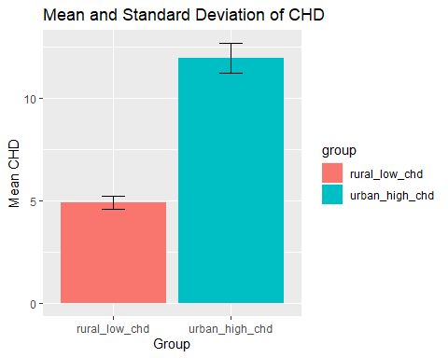

#### 

# Convert data from wide to long format  
long\_data <- gather(merged\_stats, variable, value, -group)  
  
# Select variables  
# selected\_vars <- c("bpmUse", "CholScreen", "Obesity", "CholMedNonAdhear", "CholMedElegible", "cruParticipate", "Hospitals")  
  
# selected\_vars <- c("bpmUse", "CholScreen", "CholMedNonAdhear", "CholMedElegible", "cruParticipate", "Hospitals", "HospCIC",   
# "HospCR", "HospED", "Pharmacies", "CardioPhys", "PrimaryCarePhys", "CHD", "HighBP", "Stroke", "Diabetes", "HighChol", "Obesity",  
# "PhysInactivity", "Smoker", "AirQuality", "Parks", "Broadband", "EdLessColl", "SNAPrecipients", "MedHomeValue", "MedHouseIncome",   
# "Poverty", "Unemploy")  
  
selected\_vars <- cdc\_subset %>% names()  
  
# Loop over selected variables  
for (var in selected\_vars) {  
 # Filter data for this variable (mean only)  
 var\_data <- filter(long\_data, variable == paste0(var, "\_mean"))  
   
 # Create bar plot  
 p <- ggplot(var\_data, aes(x = group, y = value, fill = group)) +  
 geom\_bar(stat = "identity", position = position\_dodge()) +  
 labs(title = paste("Comparison of", var, "between Groups"),  
 x = "Group",  
 y = "Value")   
   
 # Print plot  
 print(p)  
}

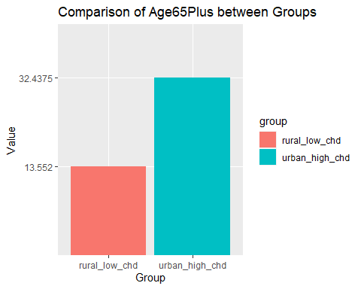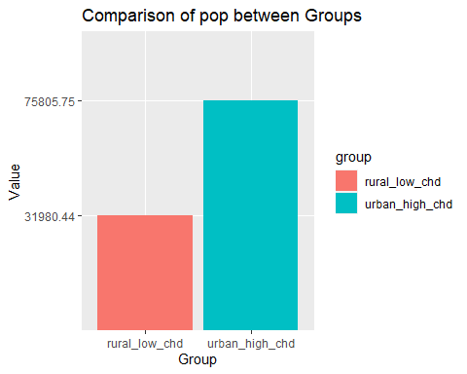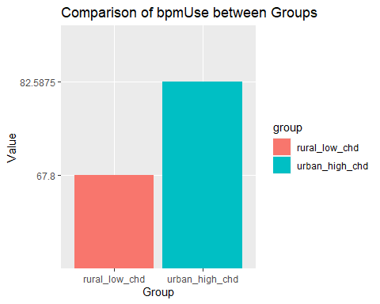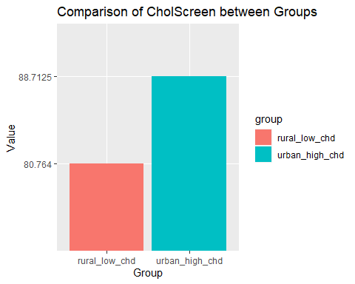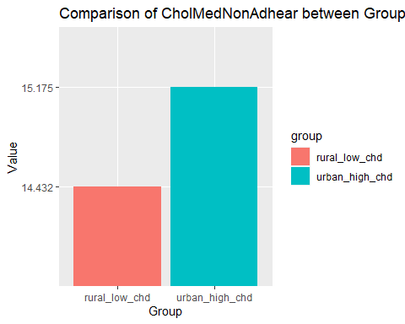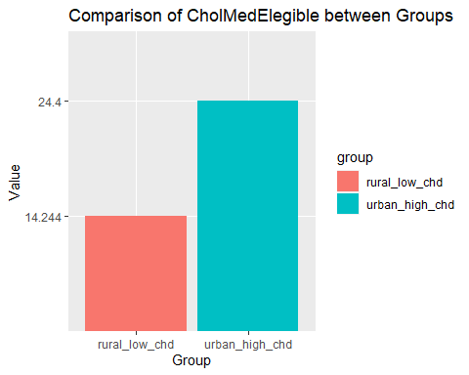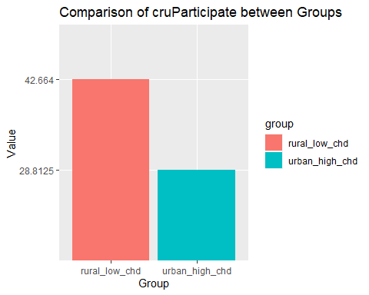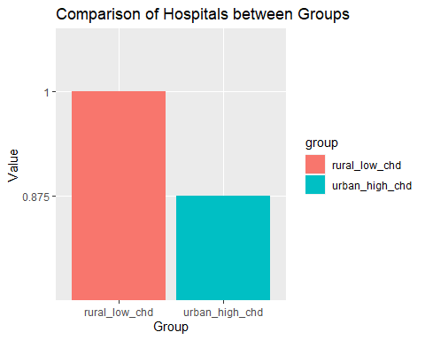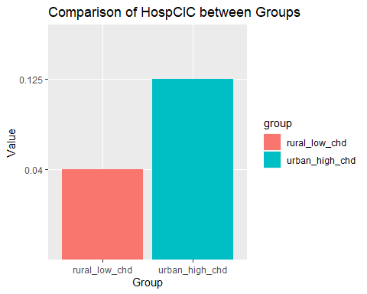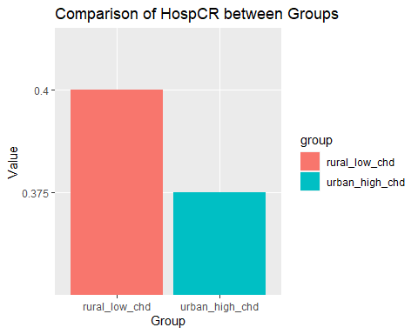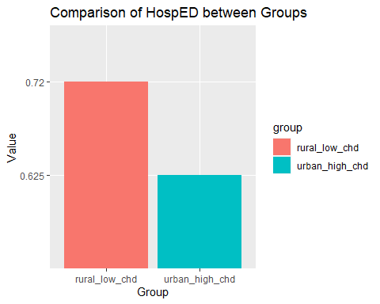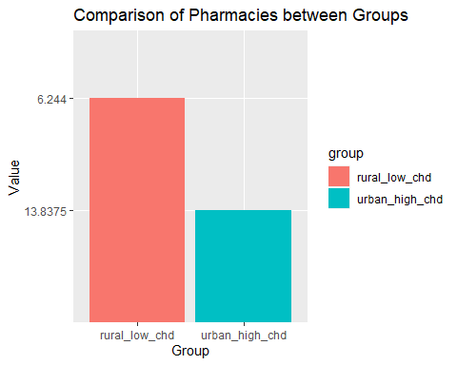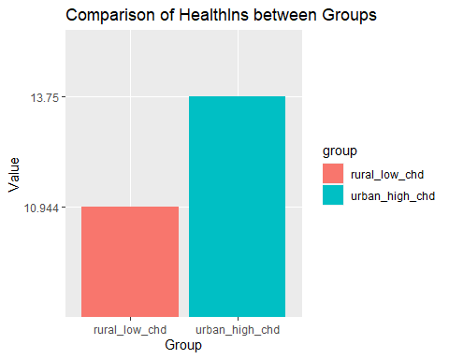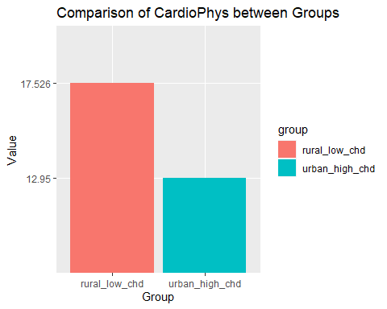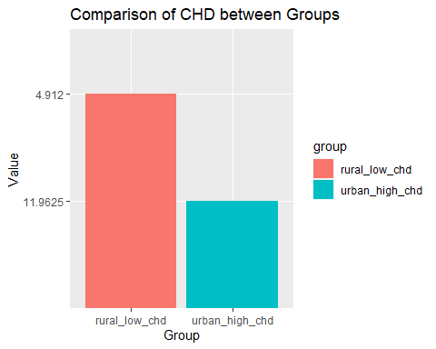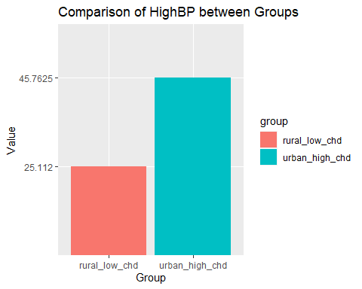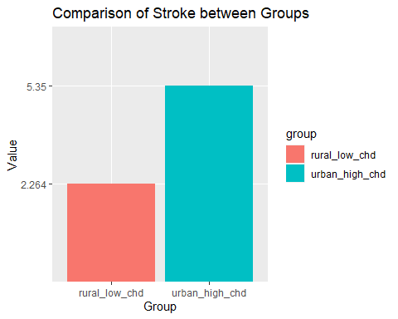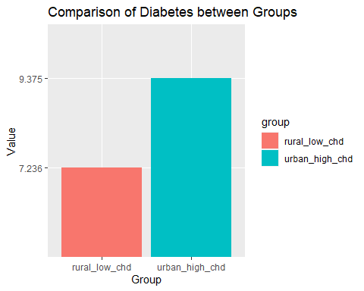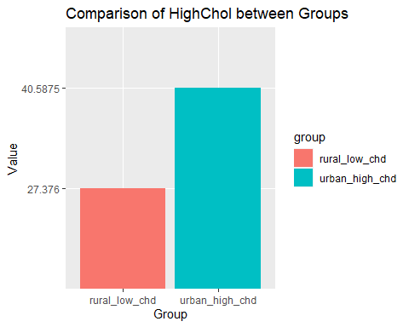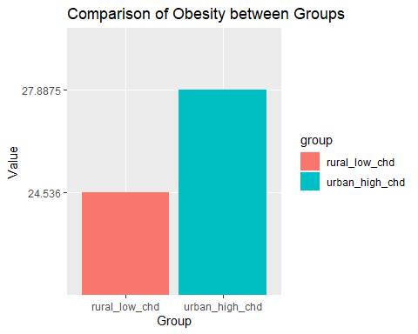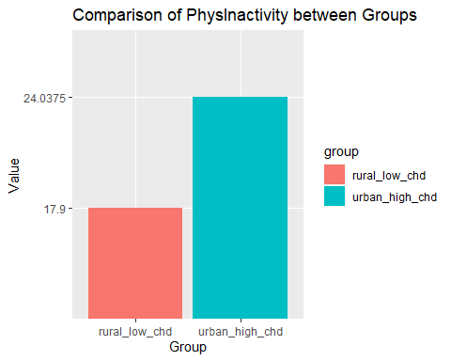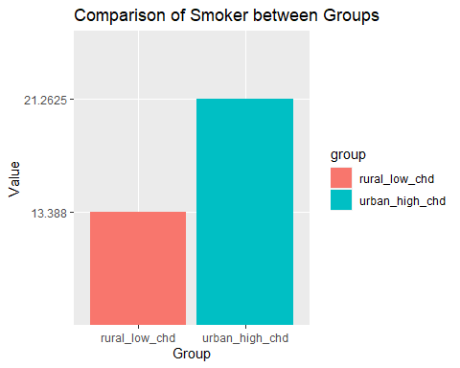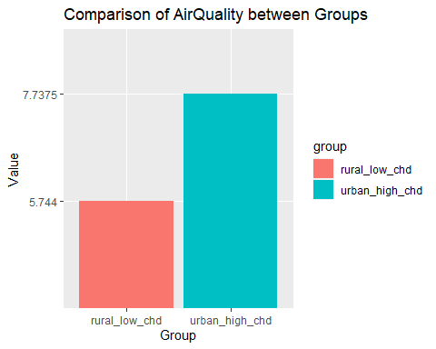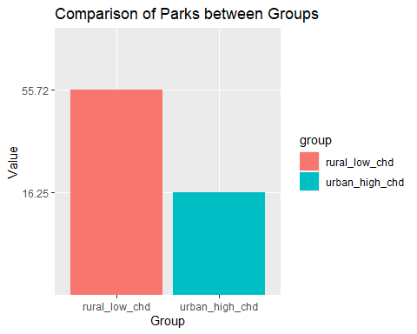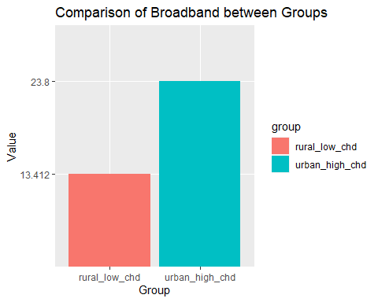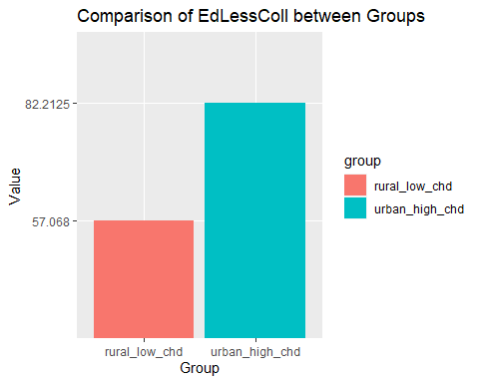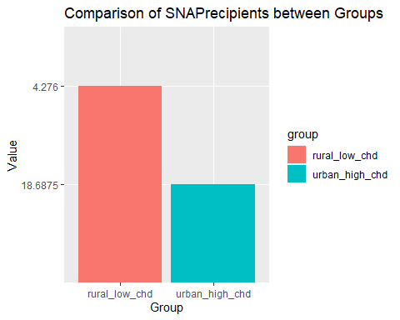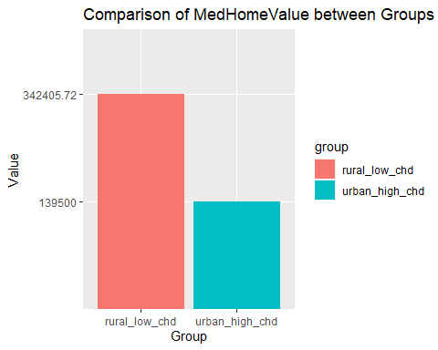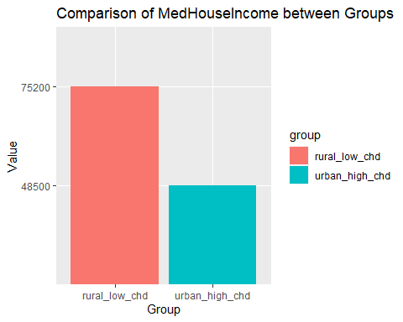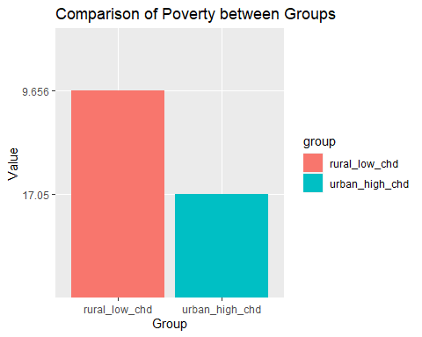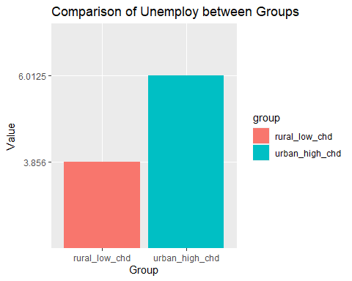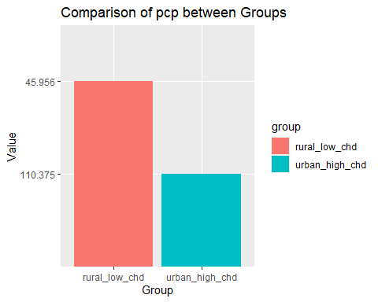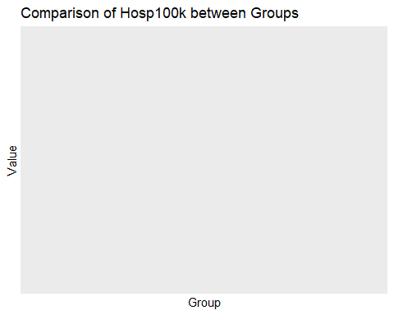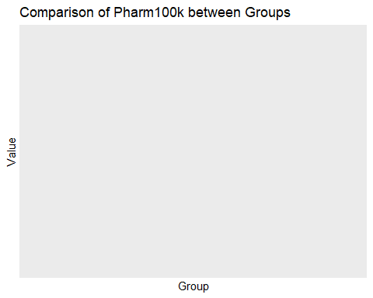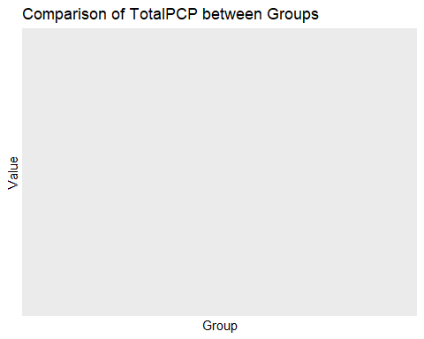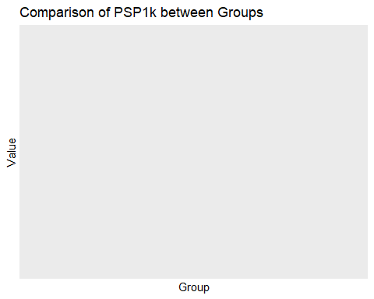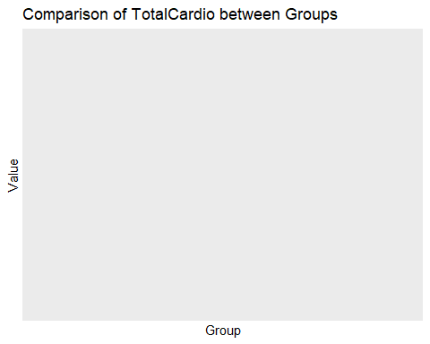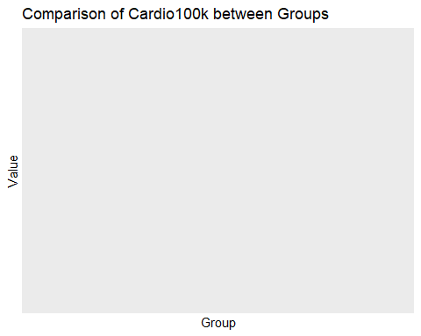

####Saving for possible use later

# Splitting the data into training and testing sets  
#library(caret)  
#set.seed(123) # For reproducibility  
#train\_indices <- createDataPartition(cdc$target\_variable, p = 0.7, list = FALSE)  
#train\_data <- data[train\_indices, ]  
#test\_data <- data[-train\_indices, ]

# Example of building a linear regression model using caret  
#library(caret)  
#set.seed(123) # For reproducibility  
#model <- train(target\_variable ~ ., data = train\_data, method = "lm") # Replace 'target\_variable' with #your target variable/column name  
  
# Model evaluation  
#predictions <- predict(model, newdata = test\_data)

cdc\_lm <- cdc\_copy %>% select (3:35,)  
  
model <- lm(CHD ~ ., data = cdc\_lm)  
  
model

##   
## Call:  
## lm(formula = CHD ~ ., data = cdc\_lm)  
##   
## Coefficients:  
## (Intercept) Age65Plus pop bpmUse   
## 2.188e-01 8.735e-02 2.068e-07 1.759e-02   
## CholScreen CholMedNonAdhear CholMedElegible cruParticipate   
## -3.554e-02 -2.090e-02 1.202e-02 -3.673e-03   
## Hospitals HospCIC HospCR HospED   
## 1.662e-03 -3.204e-02 -2.520e-02 -5.988e-03   
## Pharmacies HealthIns CardioPhys PrimaryCarePhys   
## -9.749e-04 6.006e-03 6.177e-05 -8.058e-03   
## HighBP Stroke Diabetes HighChol   
## -5.228e-02 1.243e+00 -6.859e-02 1.186e-01   
## Obesity PhysInactivity Smoker AirQuality   
## 1.106e-02 5.857e-03 9.337e-02 2.056e-02   
## Parks Broadband EdLessColl SNAPrecipients   
## 1.268e-03 -9.408e-03 -4.579e-03 -7.666e-03   
## MedHomeValue MedHouseIncome Poverty Unemploy   
## 7.112e-08 -2.856e-06 -1.461e-02 -1.388e-02   
## UrbanRural   
## 1.023e-01

summary(model)

##   
## Call:  
## lm(formula = CHD ~ ., data = cdc\_lm)  
##   
## Residuals:  
## Min 1Q Median 3Q Max   
## -3.13497 -0.19994 -0.01033 0.18873 2.32282   
##   
## Coefficients:  
## Estimate Std. Error t value Pr(>|t|)   
## (Intercept) 2.188e-01 1.027e-01 2.131 0.033205 \*   
## Age65Plus 8.735e-02 2.249e-03 38.843 < 2e-16 \*\*\*  
## pop 2.068e-07 5.658e-08 3.655 0.000262 \*\*\*  
## bpmUse 1.759e-02 3.543e-03 4.966 7.20e-07 \*\*\*  
## CholScreen -3.554e-02 2.942e-03 -12.081 < 2e-16 \*\*\*  
## CholMedNonAdhear -2.090e-02 1.992e-03 -10.490 < 2e-16 \*\*\*  
## CholMedElegible 1.202e-02 1.086e-03 11.071 < 2e-16 \*\*\*  
## cruParticipate -3.673e-03 3.902e-04 -9.414 < 2e-16 \*\*\*  
## Hospitals 1.662e-03 8.831e-03 0.188 0.850734   
## HospCIC -3.204e-02 1.356e-02 -2.362 0.018238 \*   
## HospCR -2.520e-02 1.352e-02 -1.863 0.062534 .   
## HospED -5.988e-03 1.306e-02 -0.459 0.646527   
## Pharmacies -9.749e-04 5.848e-04 -1.667 0.095598 .   
## HealthIns 6.006e-03 1.544e-03 3.890 0.000102 \*\*\*  
## CardioPhys 6.177e-05 3.526e-04 0.175 0.860961   
## PrimaryCarePhys -8.058e-03 2.705e-03 -2.978 0.002919 \*\*   
## HighBP -5.228e-02 3.453e-03 -15.141 < 2e-16 \*\*\*  
## Stroke 1.243e+00 2.100e-02 59.199 < 2e-16 \*\*\*  
## Diabetes -6.859e-02 6.455e-03 -10.625 < 2e-16 \*\*\*  
## HighChol 1.186e-01 4.427e-03 26.787 < 2e-16 \*\*\*  
## Obesity 1.106e-02 1.910e-03 5.792 7.64e-09 \*\*\*  
## PhysInactivity 5.857e-03 2.568e-03 2.281 0.022620 \*   
## Smoker 9.337e-02 3.202e-03 29.163 < 2e-16 \*\*\*  
## AirQuality 2.056e-02 4.031e-03 5.101 3.57e-07 \*\*\*  
## Parks 1.268e-03 3.362e-04 3.772 0.000165 \*\*\*  
## Broadband -9.408e-03 1.144e-03 -8.224 2.82e-16 \*\*\*  
## EdLessColl -4.579e-03 1.085e-03 -4.219 2.52e-05 \*\*\*  
## SNAPrecipients -7.666e-03 1.915e-03 -4.003 6.41e-05 \*\*\*  
## MedHomeValue 7.112e-08 2.315e-08 3.072 0.002145 \*\*   
## MedHouseIncome -2.856e-06 7.398e-07 -3.861 0.000115 \*\*\*  
## Poverty -1.461e-02 2.706e-03 -5.399 7.18e-08 \*\*\*  
## Unemploy -1.388e-02 4.579e-03 -3.030 0.002465 \*\*   
## UrbanRural 1.023e-01 1.024e-02 9.992 < 2e-16 \*\*\*  
## ---  
## Signif. codes: 0 '\*\*\*' 0.001 '\*\*' 0.01 '\*' 0.05 '.' 0.1 ' ' 1  
##   
## Residual standard error: 0.3422 on 3193 degrees of freedom  
## Multiple R-squared: 0.9748, Adjusted R-squared: 0.9745   
## F-statistic: 3856 on 32 and 3193 DF, p-value: < 2.2e-16

library(rpart)  
  
cdc\_test <- cdc\_copy %>% select (8:35, )  
  
cdc\_test <- cdc\_test %>% select(-c(Stroke, HighChol))  
  
tree\_model <- rpart(CHD ~ ., data=cdc\_test)  
  
library(rpart.plot)  
rpart.plot(tree\_model)

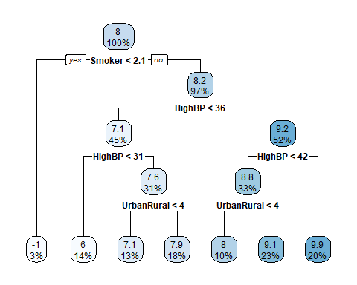

library(rpart)  
  
cdc\_test <- cdc\_copy %>% select (8:35, )  
  
cdc\_test <- cdc\_test %>% select(-c(Stroke, HighChol, Smoker, HighBP))  
  
tree\_model <- rpart(CHD ~ ., data=cdc\_test)  
  
library(rpart.plot)  
rpart.plot(tree\_model)

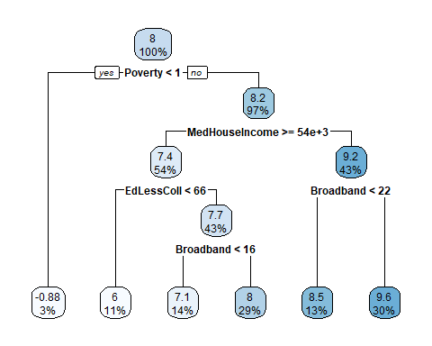 # **Isaac new work** ## **Additional eda** Diabetes Obesity Physical Inactivity Health Insurance Non Adherence all med types Med Home Value/med house income/Income Inequality/poverty ## Diabetes

summary(cdc$Diabetes)

## Min. 1st Qu. Median Mean 3rd Qu. Max.   
## 4.1 7.5 8.4 8.8 9.6 17.6

hist(cdc$"Diabetes")

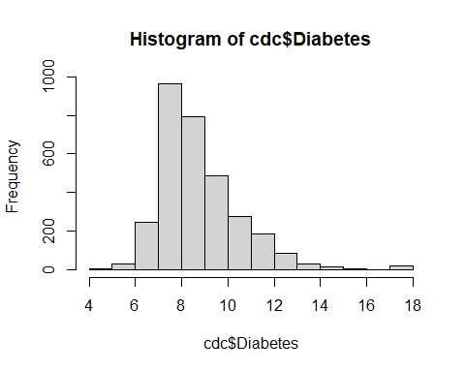

# Calculate the average prevalence of Diabetes for each UrbanRural status  
avg\_diabetes\_urbanrural <- cdc %>%  
 group\_by(UrbanRural) %>%  
 summarise(avg\_diabetes = mean(Diabetes, na.rm = TRUE))  
  
# Print the result  
print(avg\_diabetes\_urbanrural)

## # A tibble: 4 × 2  
## UrbanRural avg\_diabetes  
## <fct> <dbl>  
## 1 Large\_Urban 9.55  
## 2 LargeFringe\_Urban 9.08  
## 3 MediumSmall\_Urban 9.10  
## 4 Rural 8.61

# Plot a bar graph  
ggplot(avg\_diabetes\_urbanrural, aes(x=UrbanRural, y=avg\_diabetes)) +  
 geom\_bar(stat='identity', fill='skyblue') +  
 labs(x='UrbanRural Status', y='Average Diabetes %', title='Average Prevalence of Diabetes for Each UrbanRural Status')

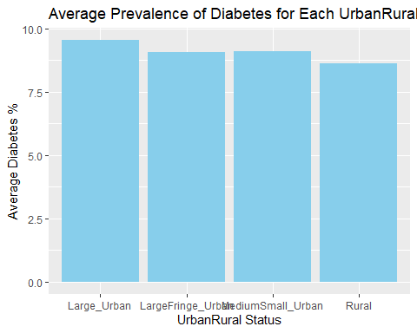

#looked at CHD vs Diabetes  
ggplot(data = cdc, aes(x = `CHD`, y = `Diabetes`, fill = `CHD`)) +  
 geom\_bar(stat = "identity", position = "dodge") +  
 labs(x = "CHD", y = "Prevalence of Diabetes", fill = "CHD") +  
 theme(axis.text.x = element\_text(angle = 45, hjust = 1))

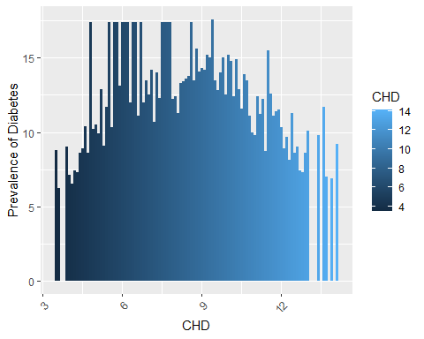 ### Top 10 Counties with highest Diabetes prevalence

highest\_10 <- cdc %>%  
 arrange(desc(Diabetes)) %>%  
 head(10)  
highest\_10

## # A tibble: 10 × 97  
## fips county state Age65Plus pop bpmUse CholScreen CholMedNonAdhear  
## <chr> <chr> <chr> <dbl> <dbl> <dbl> <dbl> <dbl>  
## 1 46102 Oglala Lakota SD 7.1 14277 69.9 72.2 33.8  
## 2 34001 Atlantic NJ 18.1 264650 71.7 79.4 16.4  
## 3 34003 Bergen NJ 17.3 931275 71.7 79.4 15.9  
## 4 34005 Burlington NJ 17 446301 71.7 79.4 13.8  
## 5 34007 Camden NJ 15.7 506721 71.7 79.4 15   
## 6 34009 Cape May NJ 26.6 92701 71.7 79.4 13.7  
## 7 34011 Cumberland NJ 15.2 150085 71.7 79.4 15.6  
## 8 34013 Essex NJ 13.7 798698 71.7 79.4 20.5  
## 9 34015 Gloucester NJ 15.9 291745 71.7 79.4 13.9  
## 10 34019 Hunterdon NJ 18.6 125063 71.7 79.4 12.7  
## # ℹ 89 more variables: CholMedElegible <dbl>, cruParticipate <dbl>,  
## # Hospitals <dbl>, HospCIC <dbl>, HospCR <dbl>, HospED <dbl>,  
## # Pharmacies <dbl>, HealthIns <dbl>, CardioPhys <dbl>, CHD <dbl>,  
## # HighBP <dbl>, Stroke <dbl>, Diabetes <dbl>, HighChol <dbl>, Obesity <dbl>,  
## # PhysInactivity <dbl>, Smoker <dbl>, AirQuality <dbl>, Parks <dbl>,  
## # Broadband <dbl>, EdLessColl <dbl>, SNAPrecipients <dbl>,  
## # MedHomeValue <dbl>, MedHouseIncome <dbl>, Poverty <dbl>, Unemploy <dbl>, …

### Bottom 10 Counties with lowest Diabetes prevalence

lowest\_10 <- cdc %>%  
 arrange(Diabetes) %>%  
 head(10)  
lowest\_10

## # A tibble: 10 × 97  
## fips county state Age65Plus pop bpmUse CholScreen CholMedNonAdhear  
## <chr> <chr> <chr> <dbl> <dbl> <dbl> <dbl> <dbl>  
## 1 30031 Gallatin MT 12.5 111401 68.3 80 11.6  
## 2 56039 Teton WY 14.9 23356 70.4 85.4 17.6  
## 3 53055 San Juan WA 33.5 16953 76.9 88.6 13.1  
## 4 49043 Summit UT 12.5 41680 68.6 83.7 14.7  
## 5 08059 Jefferson CO 16.5 578795 67.4 86.8 11.9  
## 6 08069 Larimer CO 15.6 350523 69.3 84.4 12.1  
## 7 08035 Douglas CO 12 344280 65.8 88.4 12.7  
## 8 16085 Valley ID 27.8 11085 76.3 85.7 12.9  
## 9 08013 Boulder CO 14.4 324682 66.8 84.9 12.3  
## 10 30063 Missoula MT 15.5 119062 69.2 80.5 12.2  
## # ℹ 89 more variables: CholMedElegible <dbl>, cruParticipate <dbl>,  
## # Hospitals <dbl>, HospCIC <dbl>, HospCR <dbl>, HospED <dbl>,  
## # Pharmacies <dbl>, HealthIns <dbl>, CardioPhys <dbl>, CHD <dbl>,  
## # HighBP <dbl>, Stroke <dbl>, Diabetes <dbl>, HighChol <dbl>, Obesity <dbl>,  
## # PhysInactivity <dbl>, Smoker <dbl>, AirQuality <dbl>, Parks <dbl>,  
## # Broadband <dbl>, EdLessColl <dbl>, SNAPrecipients <dbl>,  
## # MedHomeValue <dbl>, MedHouseIncome <dbl>, Poverty <dbl>, Unemploy <dbl>, …

### Correlation plots

cdc %>%  
 select("CHD",  
 "UrbanRural",  
 "Diabetes",  
 "Obesity",  
 "PhysInactivity") %>%  
 ggpairs(mapping = aes(color = cdc$"UrbanRural", alpha = 0.5))

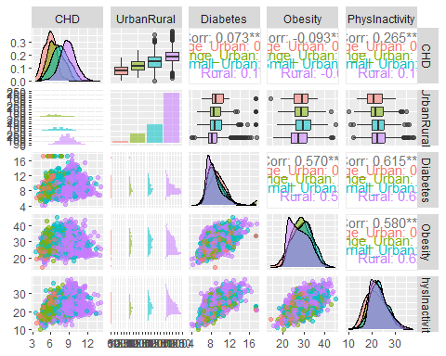 #### Density plot for Diabetes UrbanRural

ggplot(cdc, aes(x = Diabetes, fill = UrbanRural)) +  
 geom\_density(alpha = 0.5) +  
 labs(x = "Diabetes", y = "Density") +  
 theme\_minimal() +  
 scale\_fill\_brewer(palette = "Dark2")

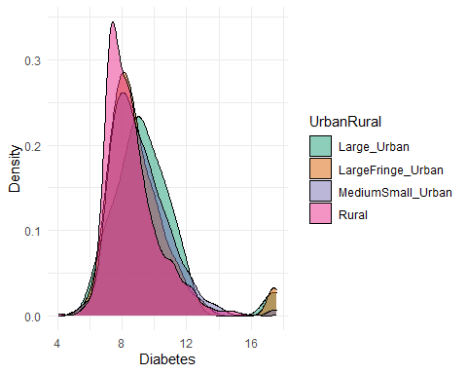

library(corrplot)  
  
correlation\_matrix <- cor(cdc[, c("Diabetes", "CHD")])  
corrplot(correlation\_matrix, method = "number")

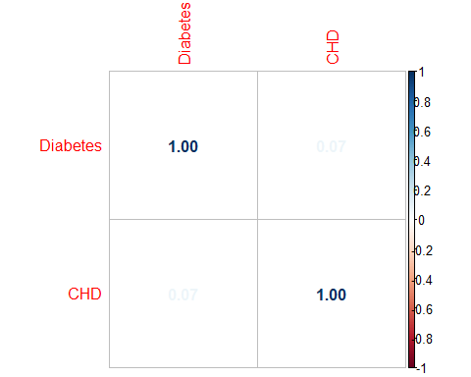

# Create a plot for each UrbanRural category  
for(category in unique(cdc$UrbanRural)) {  
 data\_subset <- subset(cdc, UrbanRural == category)  
  
 # Calculate correlation  
 correlation <- round(cor(data\_subset$Diabetes, data\_subset$CHD, use = "pairwise.complete.obs"), 2)  
  
 # Create the plot  
 p <- ggplot(data\_subset, aes(x = Diabetes, y = CHD)) +  
 geom\_point(alpha = 0.5) +  
 geom\_smooth(method = "lm", se = FALSE, color = "red", linetype = "dashed") +  
 geom\_text(aes(label = paste("Correlation = ", correlation), x = Inf, y = Inf), hjust = "right", vjust = "top") +  
 labs(title = paste("UrbanRural category:", category), x = "Diabetes", y = "CHD") +  
 theme\_minimal()  
   
 print(p)  
}

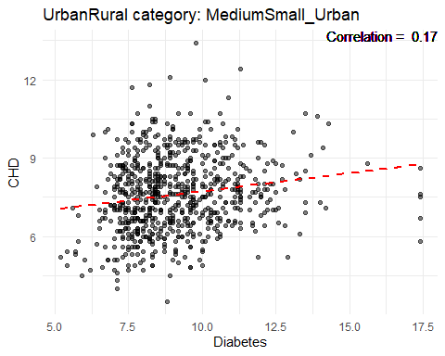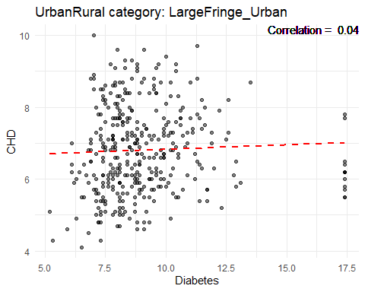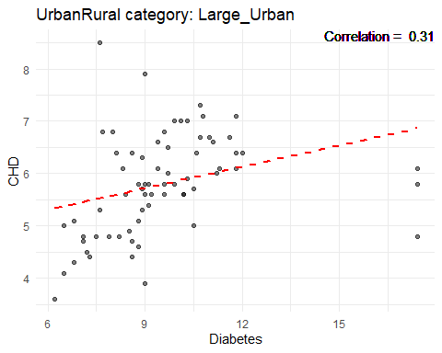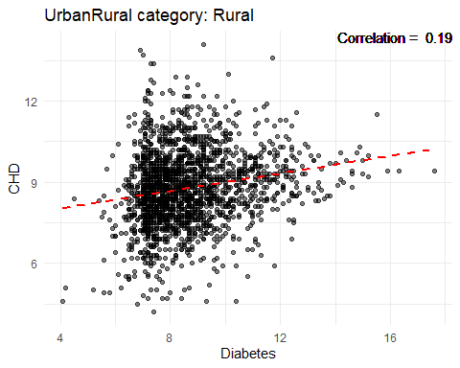 ### Diabetes Boxplot

ggplot(cdc, aes(x=UrbanRural, y=Diabetes)) + geom\_boxplot()

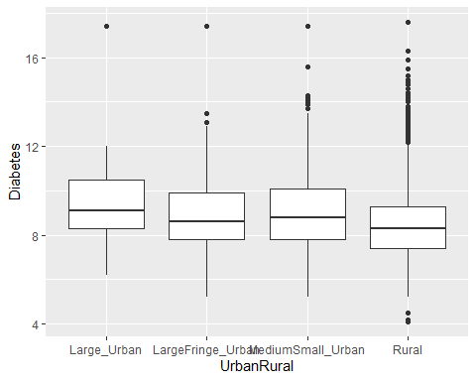

### Correlation analysis between Diabetes, Obesity, and physical inactivity

cor.test(cdc$Diabetes, cdc$Obesity)

##   
## Pearson's product-moment correlation  
##   
## data: cdc$Diabetes and cdc$Obesity  
## t = 38.854, df = 3138, p-value < 2.2e-16  
## alternative hypothesis: true correlation is not equal to 0  
## 95 percent confidence interval:  
## 0.5458317 0.5930854  
## sample estimates:  
## cor   
## 0.5699296

cor.test(cdc$Diabetes, cdc$PhysInactivity)

##   
## Pearson's product-moment correlation  
##   
## data: cdc$Diabetes and cdc$PhysInactivity  
## t = 43.738, df = 3138, p-value < 2.2e-16  
## alternative hypothesis: true correlation is not equal to 0  
## 95 percent confidence interval:  
## 0.5932060 0.6366891  
## sample estimates:  
## cor   
## 0.6154156

#### Highest and Lowest States Diabetes Prevalence

# Top 10 states with highest prevalence  
cdc %>%  
 group\_by(state) %>%  
 summarise(avg\_diabetes = mean(Diabetes, na.rm=TRUE)) %>%  
 arrange(desc(avg\_diabetes)) %>%  
 head(10) %>%  
 ggplot(aes(x=reorder(state, avg\_diabetes), y=avg\_diabetes)) +  
 geom\_bar(stat='identity', fill='skyblue') +  
 coord\_flip() +  
 labs(x='State', y='Average Diabetes %', title='Top 10 States with Highest Prevalence of Diabetes')

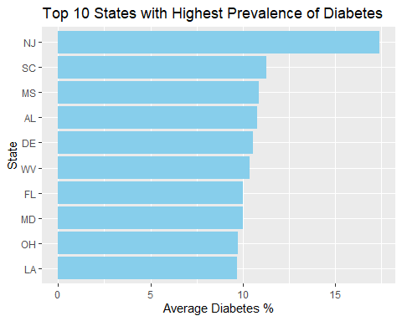

# Bottom 10 states with lowest prevalence  
cdc %>%  
 group\_by(state) %>%  
 summarise(avg\_diabetes = mean(Diabetes, na.rm=TRUE)) %>%  
 arrange(avg\_diabetes) %>%  
 head(10) %>%  
 ggplot(aes(x=reorder(state, avg\_diabetes), y=avg\_diabetes)) +  
 geom\_bar(stat='identity', fill='skyblue') +  
 coord\_flip() +  
 labs(x='State', y='Average Diabetes %', title='Top 10 States with Lowest Prevalence of Diabetes')

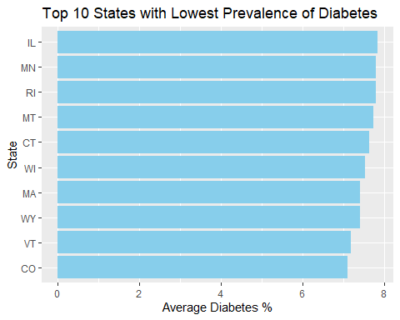

## Obesity

summary(cdc$Obesity)

## Min. 1st Qu. Median Mean 3rd Qu. Max.   
## 13.90 24.50 28.30 28.56 32.10 45.40

hist(cdc$"Obesity")

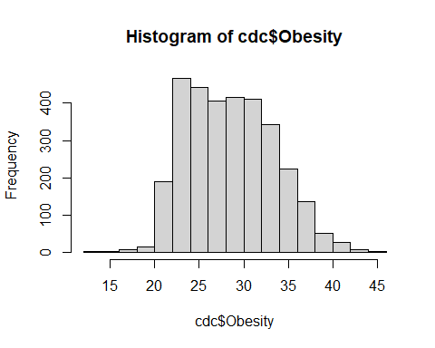

# Calculate the average prevalence of Obesity for each UrbanRural status  
avg\_obesity\_urbanrural <- cdc %>%  
 group\_by(UrbanRural) %>%  
 summarise(avg\_obesity = mean(Obesity, na.rm = TRUE))  
  
# Print the result  
print(avg\_obesity\_urbanrural)

## # A tibble: 4 × 2  
## UrbanRural avg\_obesity  
## <fct> <dbl>  
## 1 Large\_Urban 28.5  
## 2 LargeFringe\_Urban 29.0  
## 3 MediumSmall\_Urban 29.8  
## 4 Rural 28.0

# Plot a bar graph  
ggplot(avg\_obesity\_urbanrural, aes(x=UrbanRural, y=avg\_obesity)) +  
 geom\_bar(stat='identity', fill='skyblue') +  
 labs(x='UrbanRural Status', y='Average Obesity %', title='Average Obesity for Each UrbanRural Status')

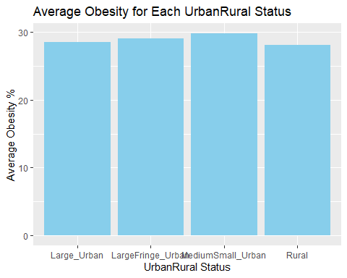

#looked at CHD vs Obesity  
ggplot(data = cdc, aes(x = `CHD`, y = `Obesity`, fill = `CHD`)) +  
 geom\_bar(stat = "identity", position = "dodge") +  
 labs(x = "CHD", y = "Obesity Rates", fill = "CHD") +  
 theme(axis.text.x = element\_text(angle = 45, hjust = 1))

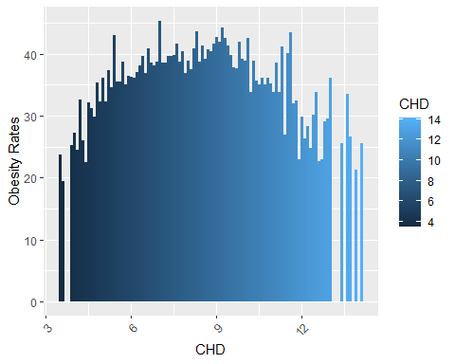 ### Top 10 Counties with highest Obesity prevalence

highest\_10 <- cdc %>%  
 arrange(desc(Obesity)) %>%  
 head(10)  
highest\_10

## # A tibble: 10 × 97  
## fips county state Age65Plus pop bpmUse CholScreen CholMedNonAdhear  
## <chr> <chr> <chr> <dbl> <dbl> <dbl> <dbl> <dbl>  
## 1 48215 Hidalgo TX 11.1 861137 74.2 80 17.8  
## 2 38079 Rolette ND 11.8 14437 76 81.5 16   
## 3 28133 Sunflower MS 13.5 25759 79.2 84.9 26.8  
## 4 54059 Mingo WV 18.9 23808 80.5 85.9 17.4  
## 5 24017 Charles MD 12.5 161448 76.7 90.2 16.1  
## 6 28113 Pike MS 16.8 39365 81.8 86 19   
## 7 12059 Holmes FL 19.8 19530 75.9 84.6 16   
## 8 28151 Washington MS 16.4 45072 83.5 87.1 25.4  
## 9 19197 Wright IA 22.2 12644 80.6 85.9 11.8  
## 10 01047 Dallas AL 18 38184 81.6 89.5 19   
## # ℹ 89 more variables: CholMedElegible <dbl>, cruParticipate <dbl>,  
## # Hospitals <dbl>, HospCIC <dbl>, HospCR <dbl>, HospED <dbl>,  
## # Pharmacies <dbl>, HealthIns <dbl>, CardioPhys <dbl>, CHD <dbl>,  
## # HighBP <dbl>, Stroke <dbl>, Diabetes <dbl>, HighChol <dbl>, Obesity <dbl>,  
## # PhysInactivity <dbl>, Smoker <dbl>, AirQuality <dbl>, Parks <dbl>,  
## # Broadband <dbl>, EdLessColl <dbl>, SNAPrecipients <dbl>,  
## # MedHomeValue <dbl>, MedHouseIncome <dbl>, Poverty <dbl>, Unemploy <dbl>, …

### Bottom 10 Counties with lowest Obesity prevalence

lowest\_10 <- cdc %>%  
 arrange(Obesity) %>%  
 head(10)  
lowest\_10

## # A tibble: 10 × 97  
## fips county state Age65Plus pop bpmUse CholScreen CholMedNonAdhear  
## <chr> <chr> <chr> <dbl> <dbl> <dbl> <dbl> <dbl>  
## 1 06075 San Francisco CA 15.8 874784 69.7 86.8 13   
## 2 56039 Teton WY 14.9 23356 70.4 85.4 17.6  
## 3 08117 Summit CO 13.6 30735 65.8 85.2 13.9  
## 4 16085 Valley ID 27.8 11085 76.3 85.7 12.9  
## 5 08013 Boulder CO 14.4 324682 66.8 84.9 12.3  
## 6 49043 Summit UT 12.5 41680 68.6 83.7 14.7  
## 7 08037 Eagle CO 11.4 54960 65.6 85.4 17.3  
## 8 06041 Marin CA 22.3 259441 75 90.2 11.8  
## 9 12085 Martin FL 31.2 160420 81.2 89.9 15.8  
## 10 16081 Teton ID 11.6 11776 66.8 82.4 16.6  
## # ℹ 89 more variables: CholMedElegible <dbl>, cruParticipate <dbl>,  
## # Hospitals <dbl>, HospCIC <dbl>, HospCR <dbl>, HospED <dbl>,  
## # Pharmacies <dbl>, HealthIns <dbl>, CardioPhys <dbl>, CHD <dbl>,  
## # HighBP <dbl>, Stroke <dbl>, Diabetes <dbl>, HighChol <dbl>, Obesity <dbl>,  
## # PhysInactivity <dbl>, Smoker <dbl>, AirQuality <dbl>, Parks <dbl>,  
## # Broadband <dbl>, EdLessColl <dbl>, SNAPrecipients <dbl>,  
## # MedHomeValue <dbl>, MedHouseIncome <dbl>, Poverty <dbl>, Unemploy <dbl>, …

#### Density plot for Obesity UrbanRural

ggplot(cdc, aes(x = Obesity, fill = UrbanRural)) +  
 geom\_density(alpha = 0.5) +  
 labs(x = "Obesity", y = "Density") +  
 theme\_minimal() +  
 scale\_fill\_brewer(palette = "Dark2")

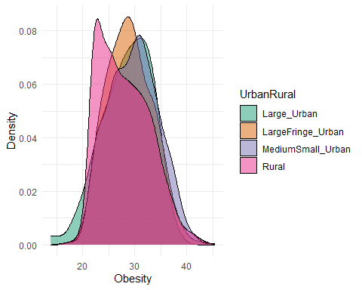

library(corrplot)  
  
correlation\_matrix <- cor(cdc[, c("Obesity", "CHD")])  
corrplot(correlation\_matrix, method = "number")

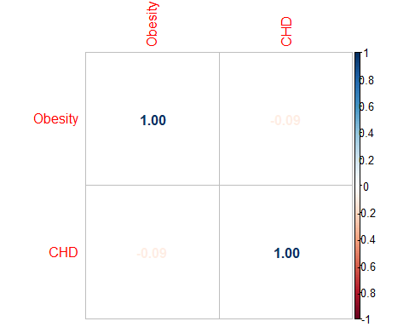

# Create a plot for each UrbanRural category  
for(category in unique(cdc$UrbanRural)) {  
 data\_subset <- subset(cdc, UrbanRural == category)  
  
 # Calculate correlation  
 correlation <- round(cor(data\_subset$Obesity, data\_subset$CHD, use = "pairwise.complete.obs"), 2)  
  
 # Create the plot  
 p <- ggplot(data\_subset, aes(x = Obesity, y = CHD)) +  
 geom\_point(alpha = 0.5) +  
 geom\_smooth(method = "lm", se = FALSE, color = "red", linetype = "dashed") +  
 geom\_text(aes(label = paste("Correlation = ", correlation), x = Inf, y = Inf), hjust = "right", vjust = "top") +  
 labs(title = paste("UrbanRural category:", category), x = "Obesity", y = "CHD") +  
 theme\_minimal()  
   
 print(p)  
}

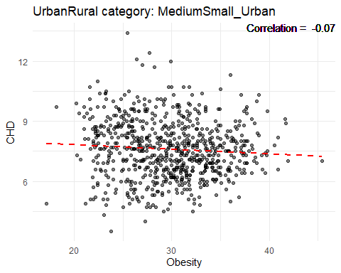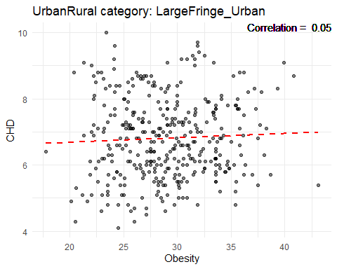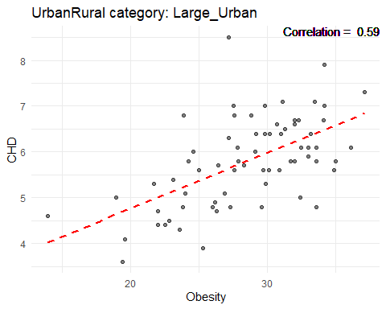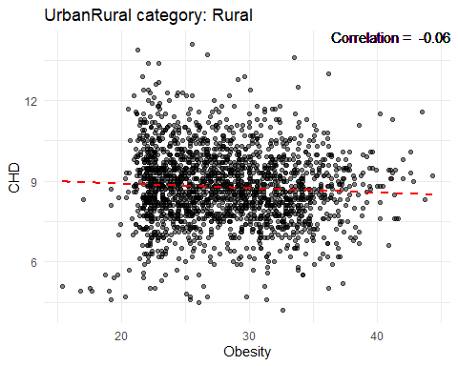 ### Obesity Boxplot

ggplot(cdc, aes(x=UrbanRural, y=Obesity)) + geom\_boxplot()

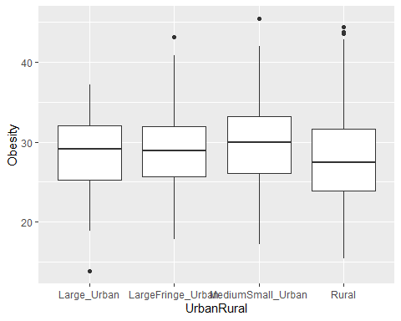

#### Highest and Lowest States rates of Obesity

# Top 10 states with highest rates  
cdc %>%  
 group\_by(state) %>%  
 summarise(avg\_obesity = mean(Obesity, na.rm=TRUE)) %>%  
 arrange(desc(avg\_obesity)) %>%  
 head(10) %>%  
 ggplot(aes(x=reorder(state, avg\_obesity), y=avg\_obesity)) +  
 geom\_bar(stat='identity', fill='skyblue') +  
 coord\_flip() +  
 labs(x='State', y='Average Obesity %', title='Top 10 States with Highest Rates of Obesity')

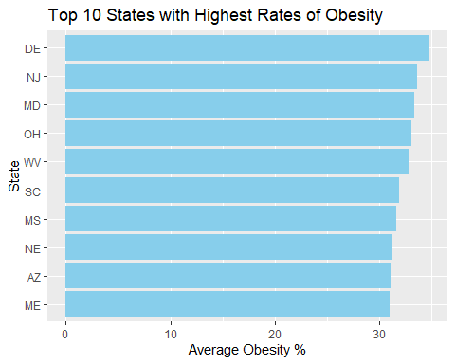

# Bottom 10 states with lowest rates  
cdc %>%  
 group\_by(state) %>%  
 summarise(avg\_obesity = mean(Obesity, na.rm=TRUE)) %>%  
 arrange(avg\_obesity) %>%  
 head(10) %>%  
 ggplot(aes(x=reorder(state, avg\_obesity), y=avg\_obesity)) +  
 geom\_bar(stat='identity', fill='skyblue') +  
 coord\_flip() +  
 labs(x='State', y='Average Obesity %', title='Top 10 States with Rates of Obesity')

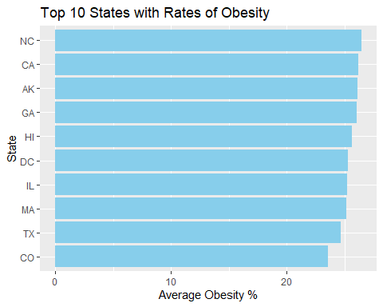

## Physical Inactivity

summary(cdc$PhysInactivity)

## Min. 1st Qu. Median Mean 3rd Qu. Max.   
## 10.20 20.10 22.50 23.03 25.40 38.00

hist(cdc$"PhysInactivity")

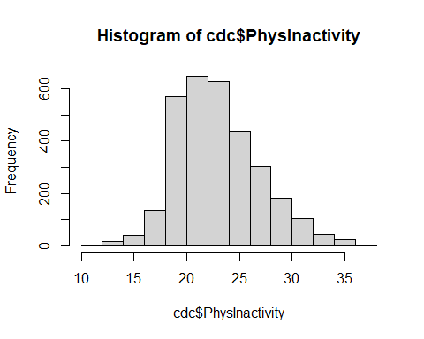

# Calculate the average % Physical Inactivity for each UrbanRural status  
avg\_inactivity\_urbanrural <- cdc %>%  
 group\_by(UrbanRural) %>%  
 summarise(avg\_inactivity = mean(PhysInactivity, na.rm = TRUE))  
  
# Print the result  
print(avg\_inactivity\_urbanrural)

## # A tibble: 4 × 2  
## UrbanRural avg\_inactivity  
## <fct> <dbl>  
## 1 Large\_Urban 21.5  
## 2 LargeFringe\_Urban 22.3  
## 3 MediumSmall\_Urban 23.1  
## 4 Rural 23.2

# Plot a bar graph  
ggplot(avg\_inactivity\_urbanrural, aes(x=UrbanRural, y=avg\_inactivity)) +  
 geom\_bar(stat='identity', fill='skyblue') +  
 labs(x='UrbanRural Status', y='Average Physical Inactivity %', title='Average Physical Inactivity for Each UrbanRural Status')

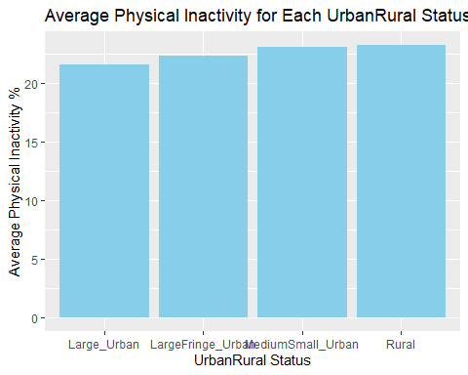

#looked at CHD vs Physical Inactivity  
ggplot(data = cdc, aes(x = `CHD`, y = `PhysInactivity`, fill = `CHD`)) +  
 geom\_bar(stat = "identity", position = "dodge") +  
 labs(x = "CHD", y = "Rate of Physical Inactivity", fill = "CHD") +  
 theme(axis.text.x = element\_text(angle = 45, hjust = 1))

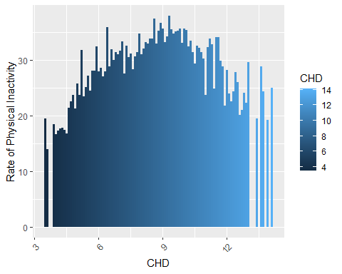 ### Top 10 Counties with highest % of Physical Inactivity

highest\_10 <- cdc %>%  
 arrange(desc(PhysInactivity)) %>%  
 head(10)  
highest\_10

## # A tibble: 10 × 97  
## fips county state Age65Plus pop bpmUse CholScreen CholMedNonAdhear  
## <chr> <chr> <chr> <dbl> <dbl> <dbl> <dbl> <dbl>  
## 1 28151 Washington MS 16.4 45072 83.5 87.1 25.4  
## 2 28083 Leflore MS 14.2 28764 81.4 86 25.2  
## 3 29201 Scott MO 18.2 38538 80.6 83.8 14.8  
## 4 31043 Dakota NE 13.7 20124 74.8 79.9 12.4  
## 5 01047 Dallas AL 18 38184 81.6 89.5 19   
## 6 28113 Pike MS 16.8 39365 81.8 86 19   
## 7 29133 Mississippi MO 18.4 13328 79.5 82 15.4  
## 8 28027 Coahoma MS 15.1 22685 82.3 86.7 26.4  
## 9 12059 Holmes FL 19.8 19530 75.9 84.6 16   
## 10 28051 Holmes MS 15.2 17414 82.3 85.5 27.4  
## # ℹ 89 more variables: CholMedElegible <dbl>, cruParticipate <dbl>,  
## # Hospitals <dbl>, HospCIC <dbl>, HospCR <dbl>, HospED <dbl>,  
## # Pharmacies <dbl>, HealthIns <dbl>, CardioPhys <dbl>, CHD <dbl>,  
## # HighBP <dbl>, Stroke <dbl>, Diabetes <dbl>, HighChol <dbl>, Obesity <dbl>,  
## # PhysInactivity <dbl>, Smoker <dbl>, AirQuality <dbl>, Parks <dbl>,  
## # Broadband <dbl>, EdLessColl <dbl>, SNAPrecipients <dbl>,  
## # MedHomeValue <dbl>, MedHouseIncome <dbl>, Poverty <dbl>, Unemploy <dbl>, …

### Bottom 10 Counties with lowest % of Physical Inactivity

lowest\_10 <- cdc %>%  
 arrange(PhysInactivity) %>%  
 head(10)  
lowest\_10

## # A tibble: 10 × 97  
## fips county state Age65Plus pop bpmUse CholScreen CholMedNonAdhear  
## <chr> <chr> <chr> <dbl> <dbl> <dbl> <dbl> <dbl>  
## 1 08035 Douglas CO 12 344280 65.8 88.4 12.7  
## 2 08013 Boulder CO 14.4 324682 66.8 84.9 12.3  
## 3 56039 Teton WY 14.9 23356 70.4 85.4 17.6  
## 4 08069 Larimer CO 15.6 350523 69.3 84.4 12.1  
## 5 08117 Summit CO 13.6 30735 65.8 85.2 13.9  
## 6 53031 Jefferson WA 36.4 31825 78.9 88.6 14.7  
## 7 08014 Broomfield CO 13.8 69444 68 86.7 11.9  
## 8 53055 San Juan WA 33.5 16953 76.9 88.6 13.1  
## 9 35028 Los Alamos NM 17.6 18976 72.8 87.1 16.1  
## 10 49043 Summit UT 12.5 41680 68.6 83.7 14.7  
## # ℹ 89 more variables: CholMedElegible <dbl>, cruParticipate <dbl>,  
## # Hospitals <dbl>, HospCIC <dbl>, HospCR <dbl>, HospED <dbl>,  
## # Pharmacies <dbl>, HealthIns <dbl>, CardioPhys <dbl>, CHD <dbl>,  
## # HighBP <dbl>, Stroke <dbl>, Diabetes <dbl>, HighChol <dbl>, Obesity <dbl>,  
## # PhysInactivity <dbl>, Smoker <dbl>, AirQuality <dbl>, Parks <dbl>,  
## # Broadband <dbl>, EdLessColl <dbl>, SNAPrecipients <dbl>,  
## # MedHomeValue <dbl>, MedHouseIncome <dbl>, Poverty <dbl>, Unemploy <dbl>, …

#### Density plot for Physical Inactivity UrbanRural

ggplot(cdc, aes(x = PhysInactivity, fill = UrbanRural)) +  
 geom\_density(alpha = 0.5) +  
 labs(x = "PhysInactivity", y = "Density") +  
 theme\_minimal() +  
 scale\_fill\_brewer(palette = "Dark2")

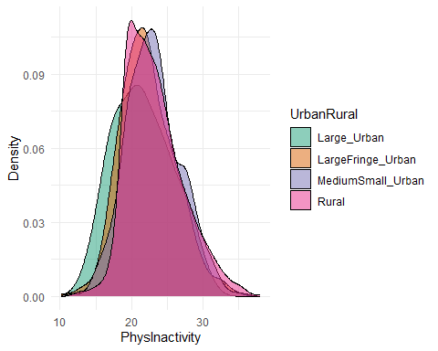

library(corrplot)  
  
correlation\_matrix <- cor(cdc[, c("PhysInactivity", "CHD")])  
corrplot(correlation\_matrix, method = "number")

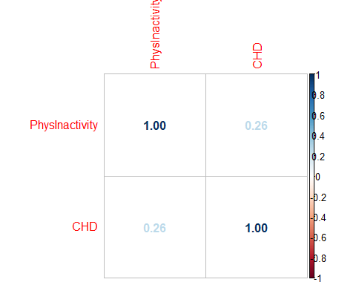

# Create a plot for each UrbanRural category  
for(category in unique(cdc$UrbanRural)) {  
 data\_subset <- subset(cdc, UrbanRural == category)  
  
 # Calculate correlation  
 correlation <- round(cor(data\_subset$PhysInactivity, data\_subset$CHD, use = "pairwise.complete.obs"), 2)  
  
 # Create the plot  
 p <- ggplot(data\_subset, aes(x = PhysInactivity, y = CHD)) +  
 geom\_point(alpha = 0.5) +  
 geom\_smooth(method = "lm", se = FALSE, color = "red", linetype = "dashed") +  
 geom\_text(aes(label = paste("Correlation = ", correlation), x = Inf, y = Inf), hjust = "right", vjust = "top") +  
 labs(title = paste("UrbanRural category:", category), x = "PhysInactivity", y = "CHD") +  
 theme\_minimal()  
   
 print(p)  
}

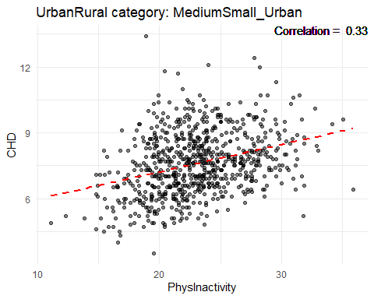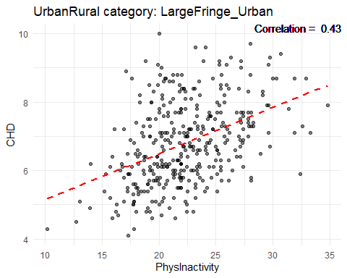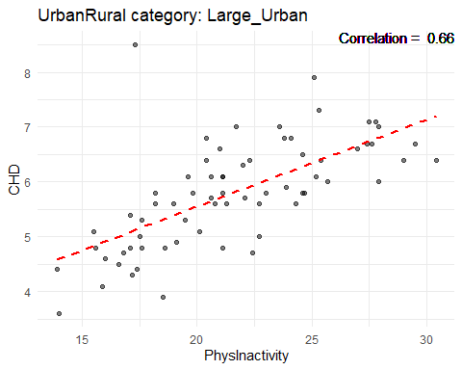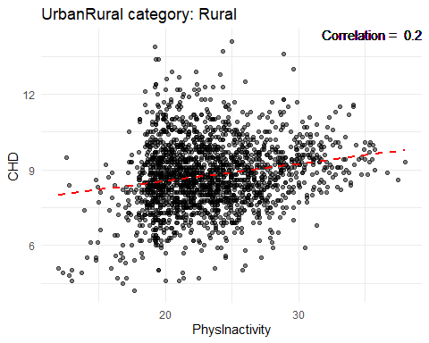 ### PhysInactivity Boxplot

ggplot(cdc, aes(x=UrbanRural, y=PhysInactivity)) + geom\_boxplot()

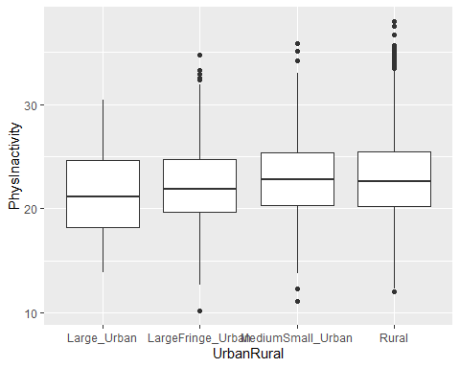

#### Highest and Lowest States Rates of Physical Inactivity

# Top 10 states with highest activity  
cdc %>%  
 group\_by(state) %>%  
 summarise(avg\_inactivity = mean(PhysInactivity, na.rm=TRUE)) %>%  
 arrange(desc(avg\_inactivity)) %>%  
 head(10) %>%  
 ggplot(aes(x=reorder(state, avg\_inactivity), y=avg\_inactivity)) +  
 geom\_bar(stat='identity', fill='skyblue') +  
 coord\_flip() +  
 labs(x='State', y='Average PhysInactivity %', title='Top 10 States with Highest Rates of Physical Inactivity')

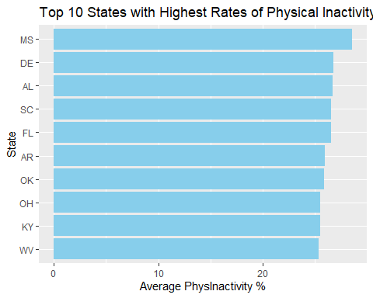

# Bottom 10 states with lowest activity  
cdc %>%  
 group\_by(state) %>%  
 summarise(avg\_inactivity = mean(PhysInactivity, na.rm=TRUE)) %>%  
 arrange(avg\_inactivity) %>%  
 head(10) %>%  
 ggplot(aes(x=reorder(state, avg\_inactivity), y=avg\_inactivity)) +  
 geom\_bar(stat='identity', fill='skyblue') +  
 coord\_flip() +  
 labs(x='State', y='Average PhysInactivity %', title='Top 10 States with Lowest Rates of Physical Inactivity')

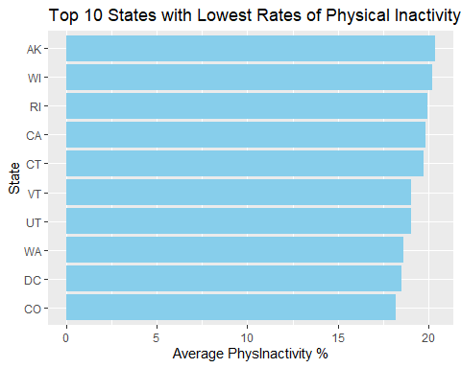

## Medication Non Adherence

summary(cdc$CholMedNonAdhear)

## Min. 1st Qu. Median Mean 3rd Qu. Max.   
## 7.70 12.90 14.60 14.93 16.50 42.80

hist(cdc$"CholMedNonAdhear")

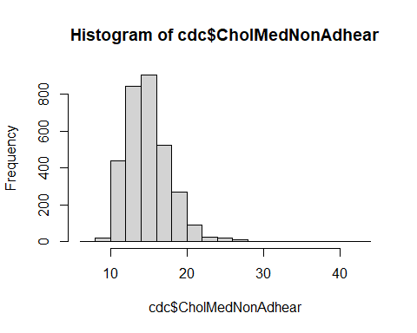

# Calculate the average rate of CholMedNonAdhear for each UrbanRural status  
avg\_nonadhear\_urbanrural <- cdc %>%  
 group\_by(UrbanRural) %>%  
 summarise(avg\_nonadhear = mean(CholMedNonAdhear, na.rm = TRUE))  
  
# Print the result  
print(avg\_nonadhear\_urbanrural)

## # A tibble: 4 × 2  
## UrbanRural avg\_nonadhear  
## <fct> <dbl>  
## 1 Large\_Urban 15.9  
## 2 LargeFringe\_Urban 14.4  
## 3 MediumSmall\_Urban 14.7  
## 4 Rural 15.1

# Plot a bar graph  
ggplot(avg\_nonadhear\_urbanrural, aes(x=UrbanRural, y=avg\_nonadhear)) +  
 geom\_bar(stat='identity', fill='skyblue') +  
 labs(x='UrbanRural Status', y='Average CholMedNonAdhear %', title='Average CholMedNonAdhear for Each UrbanRural Status')

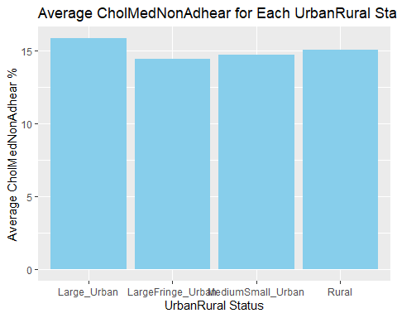

#looked at CHD vs CholMedNonAdhear  
ggplot(data = cdc, aes(x = `CHD`, y = `CholMedNonAdhear`, fill = `CHD`)) +  
 geom\_bar(stat = "identity", position = "dodge") +  
 labs(x = "CHD", y = "Rate of CholMedNonAdhear", fill = "CHD") +  
 theme(axis.text.x = element\_text(angle = 45, hjust = 1))

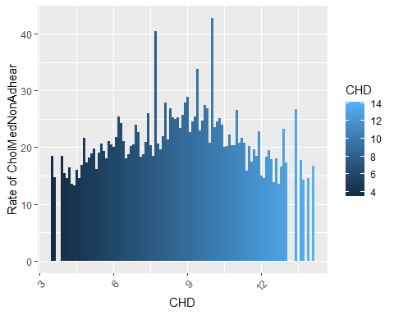 ### Top 10 Counties with highest CholMedNonAdhear

highest\_10 <- cdc %>%  
 arrange(desc(CholMedNonAdhear)) %>%  
 head(10)  
highest\_10

## # A tibble: 10 × 97  
## fips county state Age65Plus pop bpmUse CholScreen CholMedNonAdhear  
## <chr> <chr> <chr> <dbl> <dbl> <dbl> <dbl> <dbl>  
## 1 46121 Todd SD 7.4 10308 71.6 70.8 42.8  
## 2 02188 Northwest Arc… AK 7.7 7709 63.6 74.7 40.5  
## 3 04001 Apache AZ 15.5 71714 72.3 81.4 37.8  
## 4 46102 Oglala Lakota SD 7.1 14277 69.9 72.2 33.8  
## 5 35031 McKinley NM 12.3 71956 72.6 78.4 28.9  
## 6 02050 Bethel AK 7.4 18263 64.1 74.2 27.8  
## 7 48247 Jim Hogg TX 13.9 5187 77.3 82.3 27.8  
## 8 28051 Holmes MS 15.2 17414 82.3 85.5 27.4  
## 9 02290 Yukon-Koyukuk AK 14.9 5305 70.6 79.3 26.8  
## 10 28133 Sunflower MS 13.5 25759 79.2 84.9 26.8  
## # ℹ 89 more variables: CholMedElegible <dbl>, cruParticipate <dbl>,  
## # Hospitals <dbl>, HospCIC <dbl>, HospCR <dbl>, HospED <dbl>,  
## # Pharmacies <dbl>, HealthIns <dbl>, CardioPhys <dbl>, CHD <dbl>,  
## # HighBP <dbl>, Stroke <dbl>, Diabetes <dbl>, HighChol <dbl>, Obesity <dbl>,  
## # PhysInactivity <dbl>, Smoker <dbl>, AirQuality <dbl>, Parks <dbl>,  
## # Broadband <dbl>, EdLessColl <dbl>, SNAPrecipients <dbl>,  
## # MedHomeValue <dbl>, MedHouseIncome <dbl>, Poverty <dbl>, Unemploy <dbl>, …

### Bottom 10 Counties with lowest CholMedNonAdhear

lowest\_10 <- cdc %>%  
 arrange(CholMedNonAdhear) %>%  
 head(10)  
lowest\_10

## # A tibble: 10 × 97  
## fips county state Age65Plus pop bpmUse CholScreen CholMedNonAdhear  
## <chr> <chr> <chr> <dbl> <dbl> <dbl> <dbl> <dbl>  
## 1 46135 Yankton SD 19 22746 76.6 81.2 7.7  
## 2 27161 Waseca MN 17.8 18658 75.9 84.3 9.1  
## 3 55063 La Crosse WI 16.3 118168 73.6 79.8 9.4  
## 4 55123 Vernon WI 19.5 30759 77.9 82.6 9.4  
## 5 19169 Story IA 12.2 97355 71.1 79.8 9.5  
## 6 27015 Brown MN 21.2 25076 78.1 85 9.7  
## 7 31045 Dawes NE 18.3 8685 77 80.6 9.7  
## 8 46015 Brule SD 18.3 5233 78.5 82.6 9.7  
## 9 55023 Crawford WI 23.4 16155 78.4 83.2 9.7  
## 10 27049 Goodhue MN 19.6 46330 76.8 86.1 9.7  
## # ℹ 89 more variables: CholMedElegible <dbl>, cruParticipate <dbl>,  
## # Hospitals <dbl>, HospCIC <dbl>, HospCR <dbl>, HospED <dbl>,  
## # Pharmacies <dbl>, HealthIns <dbl>, CardioPhys <dbl>, CHD <dbl>,  
## # HighBP <dbl>, Stroke <dbl>, Diabetes <dbl>, HighChol <dbl>, Obesity <dbl>,  
## # PhysInactivity <dbl>, Smoker <dbl>, AirQuality <dbl>, Parks <dbl>,  
## # Broadband <dbl>, EdLessColl <dbl>, SNAPrecipients <dbl>,  
## # MedHomeValue <dbl>, MedHouseIncome <dbl>, Poverty <dbl>, Unemploy <dbl>, …

#### Density plot for CholMedNonAdhear UrbanRural

ggplot(cdc, aes(x = CholMedNonAdhear, fill = UrbanRural)) +  
 geom\_density(alpha = 0.5) +  
 labs(x = "CholMedNonAdhear", y = "Density") +  
 theme\_minimal() +  
 scale\_fill\_brewer(palette = "Dark2")

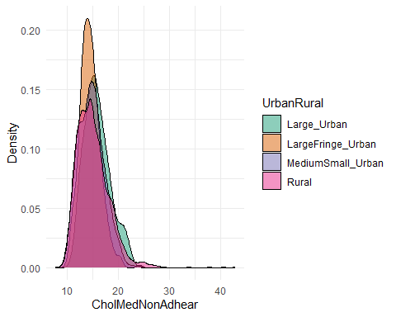

library(corrplot)  
  
correlation\_matrix <- cor(cdc[, c("CholMedNonAdhear", "CHD")])  
corrplot(correlation\_matrix, method = "number")

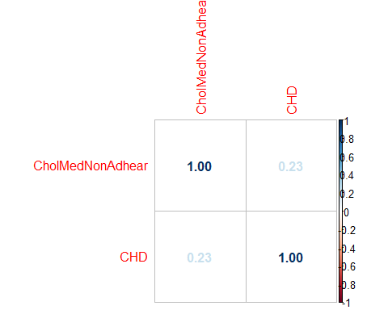

# Create a plot for each UrbanRural category  
for(category in unique(cdc$UrbanRural)) {  
 data\_subset <- subset(cdc, UrbanRural == category)  
  
 # Calculate correlation  
 correlation <- round(cor(data\_subset$CholMedNonAdhear, data\_subset$CHD, use = "pairwise.complete.obs"), 2)  
  
 # Create the plot  
 p <- ggplot(data\_subset, aes(x = CholMedNonAdhear, y = CHD)) +  
 geom\_point(alpha = 0.5) +  
 geom\_smooth(method = "lm", se = FALSE, color = "red", linetype = "dashed") +  
 geom\_text(aes(label = paste("Correlation = ", correlation), x = Inf, y = Inf), hjust = "right", vjust = "top") +  
 labs(title = paste("UrbanRural category:", category), x = "CholMedNonAdhear", y = "CHD") +  
 theme\_minimal()  
   
 print(p)  
}

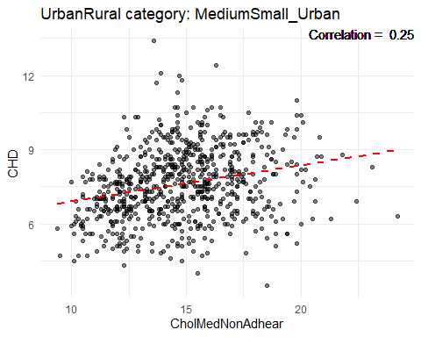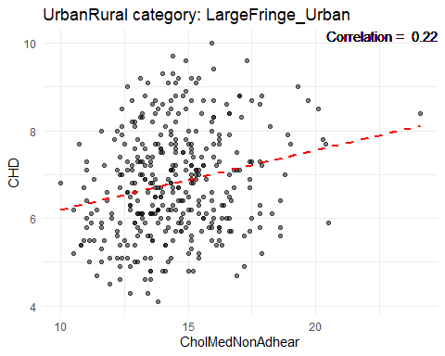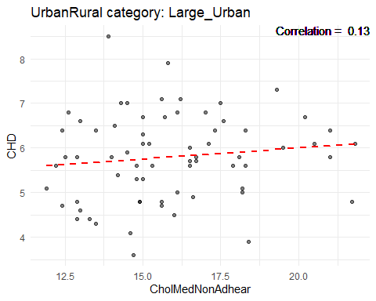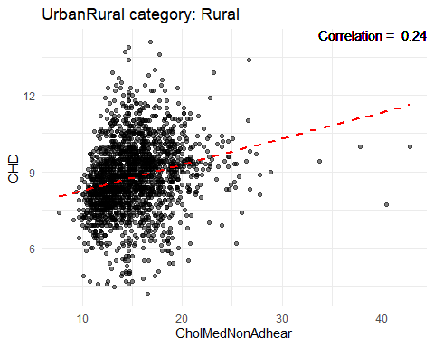 ### Medication Nonadherence Boxplot

ggplot(cdc, aes(x=UrbanRural, y=CholMedNonAdhear)) + geom\_boxplot()

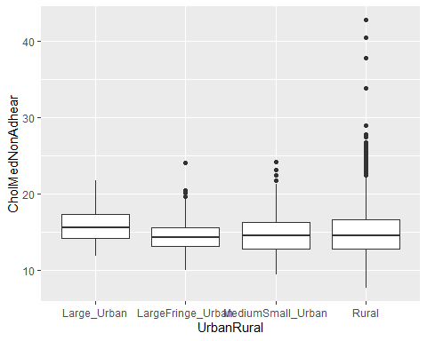

#### Highest and Lowest States Rates of CholMedNonAdhear

# Top 10 states with highest CholMedNonAdhear  
cdc %>%  
 group\_by(state) %>%  
 summarise(avg\_nonadhear = mean(CholMedNonAdhear, na.rm=TRUE)) %>%  
 arrange(desc(avg\_nonadhear)) %>%  
 head(10) %>%  
 ggplot(aes(x=reorder(state, avg\_nonadhear), y=avg\_nonadhear)) +  
 geom\_bar(stat='identity', fill='skyblue') +  
 coord\_flip() +  
 labs(x='State', y='Average CholMedNonAdhear %', title='Top 10 States with Highest Rates of CholMedNonAdhear')

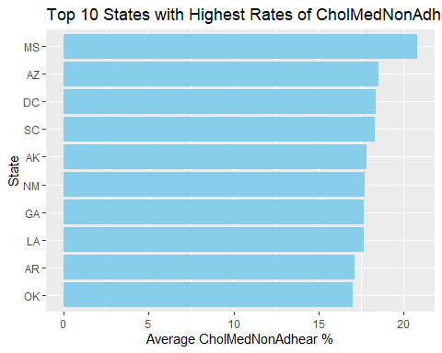

# Bottom 10 states with lowest CholMedNonAdhear  
cdc %>%  
 group\_by(state) %>%  
 summarise(avg\_nonadhear = mean(CholMedNonAdhear, na.rm=TRUE)) %>%  
 arrange(avg\_nonadhear) %>%  
 head(10) %>%  
 ggplot(aes(x=reorder(state, avg\_nonadhear), y=avg\_nonadhear)) +  
 geom\_bar(stat='identity', fill='skyblue') +  
 coord\_flip() +  
 labs(x='State', y='Average CholMedNonAdhear %', title='Top 10 States with Lowest Rates of CholMedNonAdhear')

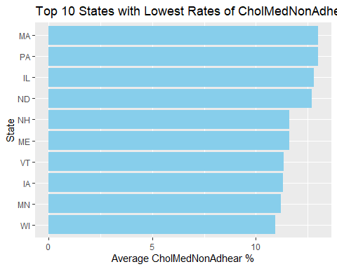

## Health Insurance (no Health Insurance %)

summary(cdc$HealthIns)

## Min. 1st Qu. Median Mean 3rd Qu. Max.   
## 2.40 8.00 11.00 11.94 15.00 35.80

hist(cdc$"HealthIns")

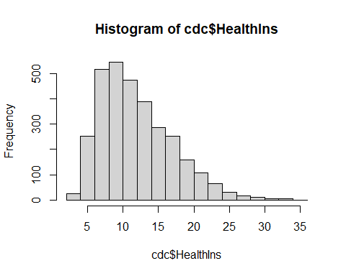

# Calculate the average % amount of No Health Insurance for each UrbanRural status  
avg\_NoHealthIns <- cdc %>%  
 group\_by(UrbanRural) %>%  
 summarise(avg\_NoHealthIns = mean(HealthIns, na.rm = TRUE))  
  
# Print the result  
print(avg\_NoHealthIns)

## # A tibble: 4 × 2  
## UrbanRural avg\_NoHealthIns  
## <fct> <dbl>  
## 1 Large\_Urban 10.4   
## 2 LargeFringe\_Urban 9.79  
## 3 MediumSmall\_Urban 11.1   
## 4 Rural 12.7

# Plot a bar graph  
ggplot(avg\_NoHealthIns, aes(x=UrbanRural, y=avg\_NoHealthIns)) +  
 geom\_bar(stat='identity', fill='skyblue') +  
 labs(x='UrbanRural Status', y='Average W/O Health Insurance %', title='Average % W/O Health Insurance for Each UrbanRural Status')

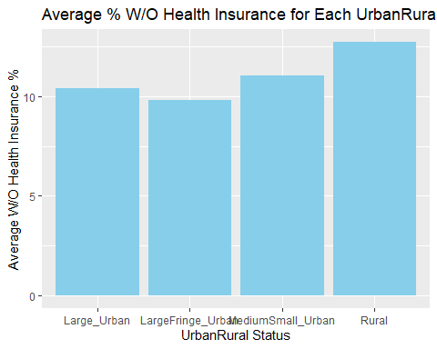

#looked at CHD vs No Health Insurance  
ggplot(data = cdc, aes(x = `CHD`, y = `HealthIns`, fill = `CHD`)) +  
 geom\_bar(stat = "identity", position = "dodge") +  
 labs(x = "CHD", y = "% Rate of No Health Insurance", fill = "CHD") +  
 theme(axis.text.x = element\_text(angle = 45, hjust = 1))

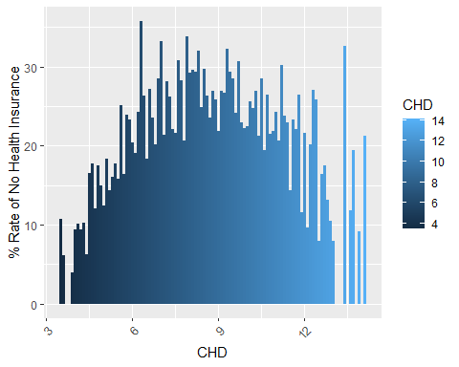 ### Top 10 Counties with highest rates % of No Health Insurance

highest\_10 <- cdc %>%  
 arrange(desc(HealthIns)) %>%  
 head(10)  
highest\_10

## # A tibble: 10 × 97  
## fips county state Age65Plus pop bpmUse CholScreen CholMedNonAdhear  
## <chr> <chr> <chr> <dbl> <dbl> <dbl> <dbl> <dbl>  
## 1 48165 Gaines TX 9 21077 70.5 79.8 18.5  
## 2 48111 Dallam TX 11.4 7272 71.9 81.6 18.3  
## 3 48215 Hidalgo TX 11.1 861137 74.2 80 17.8  
## 4 48377 Presidio TX 24 6808 80.7 82.5 26.7  
## 5 48087 Collingsworth TX 17.9 2939 75.9 82.9 16.6  
## 6 48229 Hudspeth TX 13.8 4687 72.8 78.6 23.1  
## 7 48427 Starr TX 11.3 64032 73.3 78 16.1  
## 8 48061 Cameron TX 13.5 422135 75.9 82.2 17.6  
## 9 48411 San Saba TX 23.4 6004 76.6 82.4 14.8  
## 10 48191 Hall TX 22 3025 80.1 83.9 17.4  
## # ℹ 89 more variables: CholMedElegible <dbl>, cruParticipate <dbl>,  
## # Hospitals <dbl>, HospCIC <dbl>, HospCR <dbl>, HospED <dbl>,  
## # Pharmacies <dbl>, HealthIns <dbl>, CardioPhys <dbl>, CHD <dbl>,  
## # HighBP <dbl>, Stroke <dbl>, Diabetes <dbl>, HighChol <dbl>, Obesity <dbl>,  
## # PhysInactivity <dbl>, Smoker <dbl>, AirQuality <dbl>, Parks <dbl>,  
## # Broadband <dbl>, EdLessColl <dbl>, SNAPrecipients <dbl>,  
## # MedHomeValue <dbl>, MedHouseIncome <dbl>, Poverty <dbl>, Unemploy <dbl>, …

### Bottom 10 Counties with lowest rates % of No Health Insurance

lowest\_10 <- cdc %>%  
 arrange(HealthIns) %>%  
 head(10)  
lowest\_10

## # A tibble: 10 × 97  
## fips county state Age65Plus pop bpmUse CholScreen CholMedNonAdhear  
## <chr> <chr> <chr> <dbl> <dbl> <dbl> <dbl> <dbl>  
## 1 25021 Norfolk MA 16.8 703740 74.9 89.7 12.6  
## 2 35028 Los Alamos NM 17.6 18976 72.8 87.1 16.1  
## 3 25023 Plymouth MA 18.1 518597 76.5 89.3 12.7  
## 4 25017 Middlesex MA 15.3 1605899 74.3 89.3 12.3  
## 5 25015 Hampshire MA 17.3 161361 73.5 86.2 12.1  
## 6 25011 Franklin MA 22 70529 77 89.2 11.7  
## 7 27019 Carver MN 12.1 103561 72.8 86.2 11.6  
## 8 44001 Bristol RI 19.9 48645 77.7 90 12.7  
## 9 25027 Worcester MA 15.7 826655 75.5 88.4 12.2  
## 10 44009 Washington RI 20.7 126139 78.4 89.2 13.7  
## # ℹ 89 more variables: CholMedElegible <dbl>, cruParticipate <dbl>,  
## # Hospitals <dbl>, HospCIC <dbl>, HospCR <dbl>, HospED <dbl>,  
## # Pharmacies <dbl>, HealthIns <dbl>, CardioPhys <dbl>, CHD <dbl>,  
## # HighBP <dbl>, Stroke <dbl>, Diabetes <dbl>, HighChol <dbl>, Obesity <dbl>,  
## # PhysInactivity <dbl>, Smoker <dbl>, AirQuality <dbl>, Parks <dbl>,  
## # Broadband <dbl>, EdLessColl <dbl>, SNAPrecipients <dbl>,  
## # MedHomeValue <dbl>, MedHouseIncome <dbl>, Poverty <dbl>, Unemploy <dbl>, …

#### Density plot for No HealthIns UrbanRural

ggplot(cdc, aes(x = HealthIns, fill = UrbanRural)) +  
 geom\_density(alpha = 0.5) +  
 labs(x = "PhysInactivity", y = "Density") +  
 theme\_minimal() +  
 scale\_fill\_brewer(palette = "Dark2")

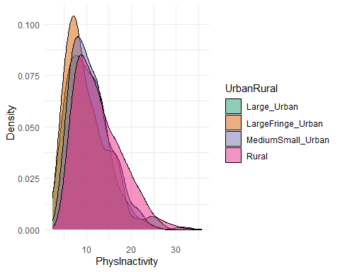

library(corrplot)  
  
correlation\_matrix <- cor(cdc[, c("HealthIns", "CHD")])  
corrplot(correlation\_matrix, method = "number")

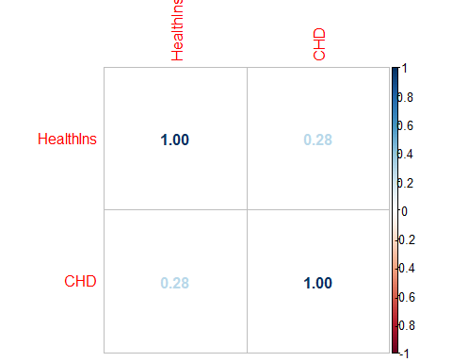

# Create a plot for each UrbanRural category  
for(category in unique(cdc$UrbanRural)) {  
 data\_subset <- subset(cdc, UrbanRural == category)  
  
 # Calculate correlation  
 correlation <- round(cor(data\_subset$HealthIns, data\_subset$CHD, use = "pairwise.complete.obs"), 2)  
  
 # Create the plot  
 p <- ggplot(data\_subset, aes(x = HealthIns, y = CHD)) +  
 geom\_point(alpha = 0.5) +  
 geom\_smooth(method = "lm", se = FALSE, color = "red", linetype = "dashed") +  
 geom\_text(aes(label = paste("Correlation = ", correlation), x = Inf, y = Inf), hjust = "right", vjust = "top") +  
 labs(title = paste("UrbanRural category:", category), x = "HealthIns", y = "CHD") +  
 theme\_minimal()  
   
 print(p)  
}

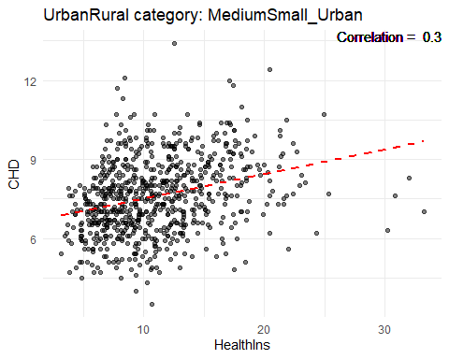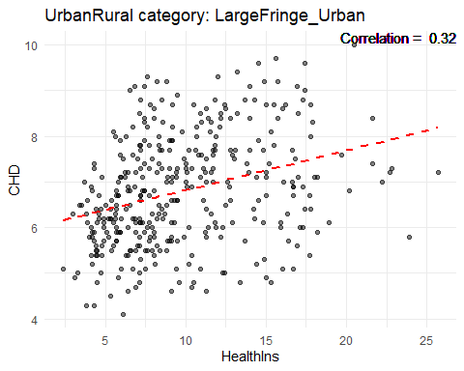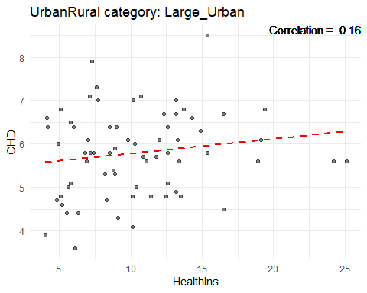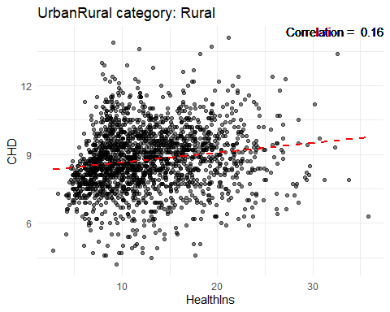 ### HealthIns Boxplot

ggplot(cdc, aes(x=UrbanRural, y=HealthIns)) + geom\_boxplot()

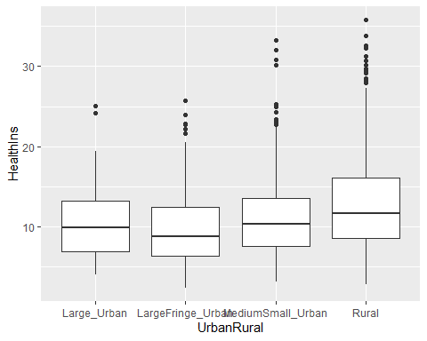

#### Highest and Lowest States Rates of No Health Insurance

# Top 10 states with highest % No Health Insurance  
cdc %>%  
 group\_by(state) %>%  
 summarise(avg\_NoHealthIns = mean(HealthIns, na.rm=TRUE)) %>%  
 arrange(desc(avg\_NoHealthIns)) %>%  
 head(10) %>%  
 ggplot(aes(x=reorder(state, avg\_NoHealthIns), y=avg\_NoHealthIns)) +  
 geom\_bar(stat='identity', fill='skyblue') +  
 coord\_flip() +  
 labs(x='State', y='Average % No Health Insurance', title='Top 10 States with Highest Rates of No Health Insurance')

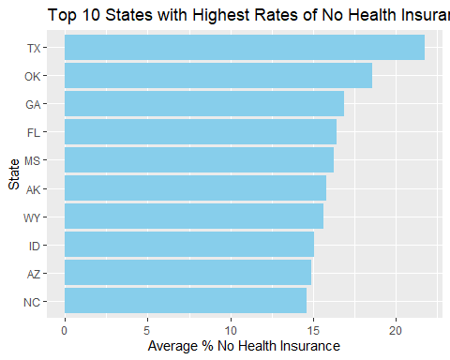

# Bottom 10 states with lowest rates % of No Health Insurance  
cdc %>%  
 group\_by(state) %>%  
 summarise(avg\_NoHealthIns = mean(HealthIns, na.rm=TRUE)) %>%  
 arrange(avg\_NoHealthIns) %>%  
 head(10) %>%  
 ggplot(aes(x=reorder(state, avg\_NoHealthIns), y=avg\_NoHealthIns)) +  
 geom\_bar(stat='identity', fill='skyblue') +  
 coord\_flip() +  
 labs(x='State', y='Average % No Health Insurance', title='Top 10 States with Lowest Rates % of No Health Insurance')

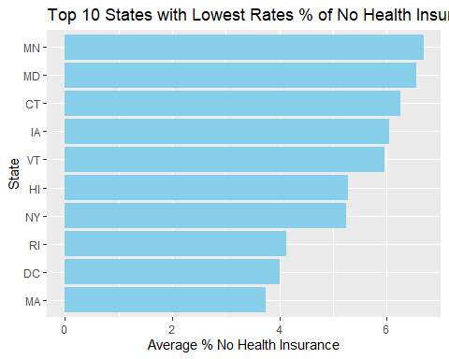

## Median Home Value

#need to fix this - 2 counties in SD and 2 in TX -66670000  
cdc %>% select(c(state, MedHomeValue)) %>% arrange(MedHomeValue)

## # A tibble: 3,140 × 2  
## state MedHomeValue  
## <chr> <dbl>  
## 1 TX 23000  
## 2 SD 27000  
## 3 SD 35000  
## 4 TX 38000  
## 5 TX 38143  
## 6 WV 40000  
## 7 TX 42550  
## 8 TX 43000  
## 9 TX 44000  
## 10 GA 44000  
## # ℹ 3,130 more rows

summary(cdc$MedHomeValue)

## Min. 1st Qu. Median Mean 3rd Qu. Max.   
## 23000 101848 134000 161015 185000 1163000

hist(cdc$"MedHomeValue")

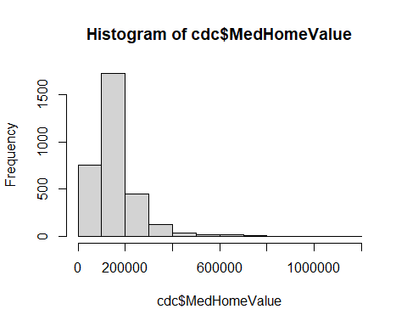

# Calculate the median home value for each UrbanRural status  
avg\_MedHomeValue\_urbanrural <- cdc %>%  
 group\_by(UrbanRural) %>%  
 summarise(avg\_MedHomeValue = mean(MedHomeValue, na.rm = TRUE))  
  
# Print the result  
print(avg\_MedHomeValue\_urbanrural)

## # A tibble: 4 × 2  
## UrbanRural avg\_MedHomeValue  
## <fct> <dbl>  
## 1 Large\_Urban 352471.  
## 2 LargeFringe\_Urban 245622.  
## 3 MediumSmall\_Urban 177738.  
## 4 Rural 132485.

# Plot a bar graph  
ggplot(avg\_MedHomeValue\_urbanrural, aes(x=UrbanRural, y=avg\_MedHomeValue)) +  
 geom\_bar(stat='identity', fill='skyblue') +  
 labs(x='UrbanRural Status', y='MedHomeValue %', title='MedHomeValue for Each UrbanRural Status')

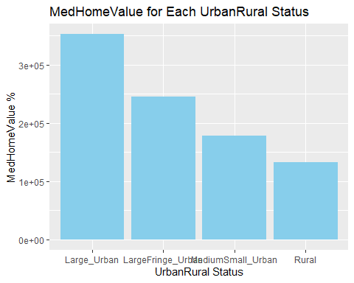

#looked at CHD vs MedHomeValue  
ggplot(data = cdc, aes(x = `CHD`, y = `MedHomeValue`, fill = `CHD`)) +  
 geom\_bar(stat = "identity", position = "dodge") +  
 labs(x = "CHD", y = "MedHomeValue", fill = "CHD") +  
 theme(axis.text.x = element\_text(angle = 45, hjust = 1))

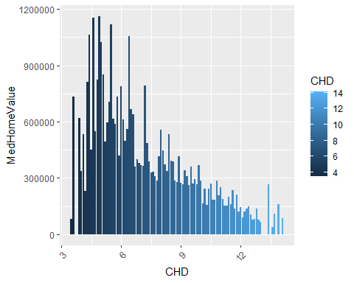 ### Top 10 Counties with highest MedHomeValue

highest\_10 <- cdc %>%  
 arrange(desc(MedHomeValue)) %>%  
 head(10)  
highest\_10

## # A tibble: 10 × 97  
## fips county state Age65Plus pop bpmUse CholScreen CholMedNonAdhear  
## <chr> <chr> <chr> <dbl> <dbl> <dbl> <dbl> <dbl>  
## 1 06081 San Mateo CA 16.2 7.66e5 69.5 88 12.7  
## 2 06075 San Francisco CA 15.8 8.75e5 69.7 86.8 13   
## 3 25019 Nantucket MA 16.1 1.12e4 73.1 89.4 13.4  
## 4 06085 Santa Clara CA 13.5 1.92e6 68.5 86.6 13.3  
## 5 06041 Marin CA 22.3 2.59e5 75 90.2 11.8  
## 6 36061 New York NY 16.6 1.63e6 73.9 88.5 18.2  
## 7 56039 Teton WY 14.9 2.34e4 70.4 85.4 17.6  
## 8 06001 Alameda CA 13.9 1.66e6 70.2 87.8 12.9  
## 9 51610 Falls Church VA 13.2 1.43e4 75 90.7 13.4  
## 10 25007 Dukes MA 24.5 1.74e4 78.9 90.7 13.4  
## # ℹ 89 more variables: CholMedElegible <dbl>, cruParticipate <dbl>,  
## # Hospitals <dbl>, HospCIC <dbl>, HospCR <dbl>, HospED <dbl>,  
## # Pharmacies <dbl>, HealthIns <dbl>, CardioPhys <dbl>, CHD <dbl>,  
## # HighBP <dbl>, Stroke <dbl>, Diabetes <dbl>, HighChol <dbl>, Obesity <dbl>,  
## # PhysInactivity <dbl>, Smoker <dbl>, AirQuality <dbl>, Parks <dbl>,  
## # Broadband <dbl>, EdLessColl <dbl>, SNAPrecipients <dbl>,  
## # MedHomeValue <dbl>, MedHouseIncome <dbl>, Poverty <dbl>, Unemploy <dbl>, …

### Bottom 10 Counties with lowest MedHomeValue

lowest\_10 <- cdc %>%  
 arrange(MedHomeValue) %>%  
 head(10)  
lowest\_10

## # A tibble: 10 × 97  
## fips county state Age65Plus pop bpmUse CholScreen CholMedNonAdhear  
## <chr> <chr> <chr> <dbl> <dbl> <dbl> <dbl> <dbl>  
## 1 48269 King TX 11.1 279 77.7 84.8 14.6  
## 2 46121 Todd SD 7.4 10308 71.6 70.8 42.8  
## 3 46102 Oglala Lakota SD 7.1 14277 69.9 72.2 33.8  
## 4 48079 Cochran TX 16.1 2860 75.8 81.1 19   
## 5 48301 Loving TX 45.3 117 72.3 82.2 14.6  
## 6 54047 McDowell WV 21.5 18083 82.8 85.3 17.7  
## 7 48261 Kenedy TX 28.1 391 76.5 78.3 14.6  
## 8 48275 Knox TX 18.5 3679 77.9 84 14.7  
## 9 48101 Cottle TX 21.4 1624 80.6 84.6 14.6  
## 10 13259 Stewart GA 14.6 6446 68.3 77.9 18.3  
## # ℹ 89 more variables: CholMedElegible <dbl>, cruParticipate <dbl>,  
## # Hospitals <dbl>, HospCIC <dbl>, HospCR <dbl>, HospED <dbl>,  
## # Pharmacies <dbl>, HealthIns <dbl>, CardioPhys <dbl>, CHD <dbl>,  
## # HighBP <dbl>, Stroke <dbl>, Diabetes <dbl>, HighChol <dbl>, Obesity <dbl>,  
## # PhysInactivity <dbl>, Smoker <dbl>, AirQuality <dbl>, Parks <dbl>,  
## # Broadband <dbl>, EdLessColl <dbl>, SNAPrecipients <dbl>,  
## # MedHomeValue <dbl>, MedHouseIncome <dbl>, Poverty <dbl>, Unemploy <dbl>, …

#### Density plot for MedHomeValue UrbanRural

ggplot(cdc, aes(x = MedHomeValue, fill = UrbanRural)) +  
 geom\_density(alpha = 0.5) +  
 labs(x = "MedHomeValue", y = "Density") +  
 theme\_minimal() +  
 scale\_fill\_brewer(palette = "Dark2")

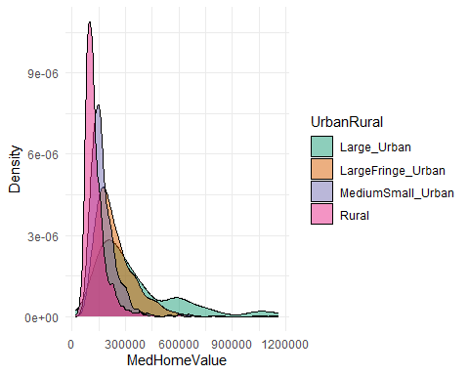

library(corrplot)  
  
correlation\_matrix <- cor(cdc[, c("MedHomeValue", "CHD")])  
corrplot(correlation\_matrix, method = "number")

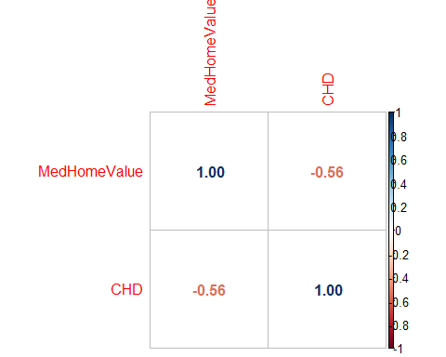

# Create a plot for each UrbanRural category  
for(category in unique(cdc$UrbanRural)) {  
 data\_subset <- subset(cdc, UrbanRural == category)  
  
 # Calculate correlation  
 correlation <- round(cor(data\_subset$MedHomeValue, data\_subset$CHD, use = "pairwise.complete.obs"), 2)  
  
 # Create the plot  
 p <- ggplot(data\_subset, aes(x = MedHomeValue, y = CHD)) +  
 geom\_point(alpha = 0.5) +  
 geom\_smooth(method = "lm", se = FALSE, color = "red", linetype = "dashed") +  
 geom\_text(aes(label = paste("Correlation = ", correlation), x = Inf, y = Inf), hjust = "right", vjust = "top") +  
 labs(title = paste("UrbanRural category:", category), x = "MedHomeValue", y = "CHD") +  
 theme\_minimal()  
   
 print(p)  
}

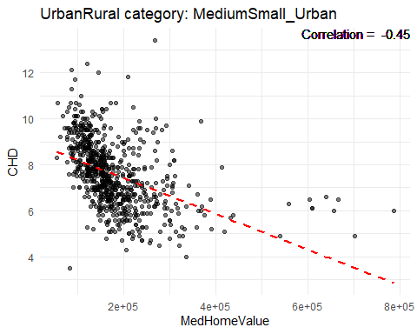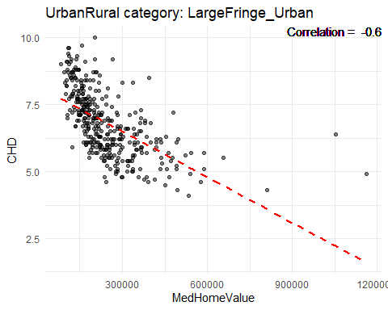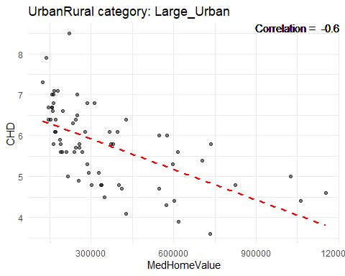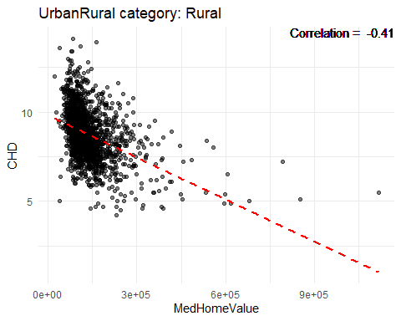 ### MedHomeValue Boxplot

ggplot(cdc, aes(x=UrbanRural, y=MedHomeValue)) + geom\_boxplot()

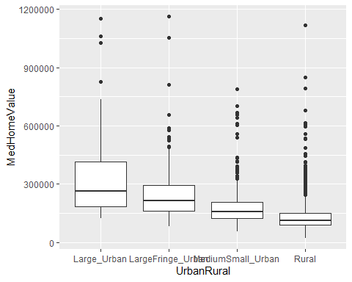

#### Highest and Lowest States of MedHomeValue

# Top 10 states with highest MedHomeValue  
cdc %>%  
 group\_by(state) %>%  
 summarise(avg\_MedHomeValue = mean(MedHomeValue, na.rm=TRUE)) %>%  
 arrange(desc(avg\_MedHomeValue)) %>%  
 head(10) %>%  
 ggplot(aes(x=reorder(state, avg\_MedHomeValue), y=avg\_MedHomeValue)) +  
 geom\_bar(stat='identity', fill='skyblue') +  
 coord\_flip() +  
 labs(x='State', y='MedHomeValue %', title='Top 10 States with Highest Rates of MedHomeValue')

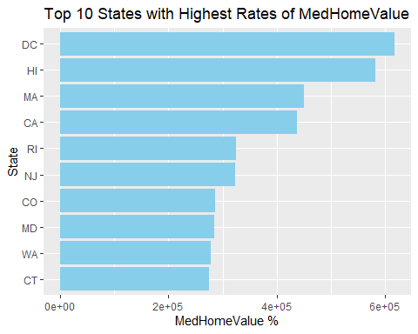

# Bottom 10 states with lowest MedHomeValue  
cdc %>%  
 group\_by(state) %>%  
 summarise(avg\_MedHomeValue = mean(MedHomeValue, na.rm=TRUE)) %>%  
 arrange(avg\_MedHomeValue) %>%  
 head(10) %>%  
 ggplot(aes(x=reorder(state, avg\_MedHomeValue), y=avg\_MedHomeValue)) +  
 geom\_bar(stat='identity', fill='skyblue') +  
 coord\_flip() +  
 labs(x='State', y='Average MedHomeValue %', title='Top 10 States with Lowest MedHomeValue')

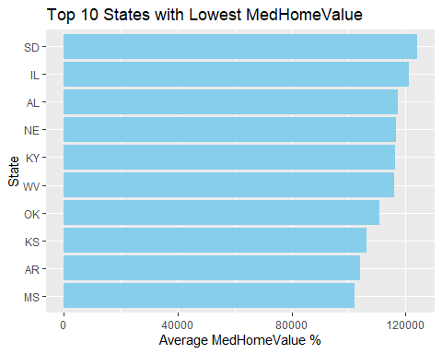

## Median Household Income

summary(cdc$MedHouseIncome)

## Min. 1st Qu. Median Mean 3rd Qu. Max.   
## 23000 48000 55000 57464 64000 160000

hist(cdc$"MedHouseIncome")

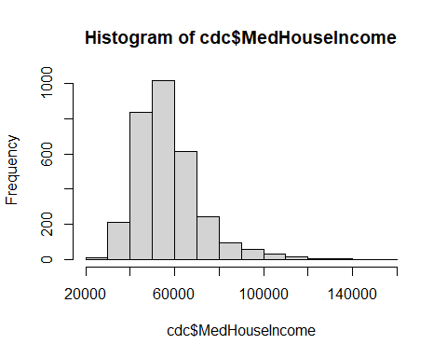

# Calculate the median household income for each UrbanRural status  
avg\_MedHouseIncome\_urbanrural <- cdc %>%  
 group\_by(UrbanRural) %>%  
 summarise(avg\_MedHouseIncome = mean(MedHouseIncome, na.rm = TRUE))  
  
# Print the result  
print(avg\_MedHouseIncome\_urbanrural)

## # A tibble: 4 × 2  
## UrbanRural avg\_MedHouseIncome  
## <fct> <dbl>  
## 1 Large\_Urban 72265.  
## 2 LargeFringe\_Urban 76166.  
## 3 MediumSmall\_Urban 59776.  
## 4 Rural 52617.

# Plot a bar graph  
ggplot(avg\_MedHouseIncome\_urbanrural, aes(x=UrbanRural, y=avg\_MedHouseIncome)) +  
 geom\_bar(stat='identity', fill='skyblue') +  
 labs(x='UrbanRural Status', y='MedHouseIncome %', title='MedHouseIncome for Each UrbanRural Status')

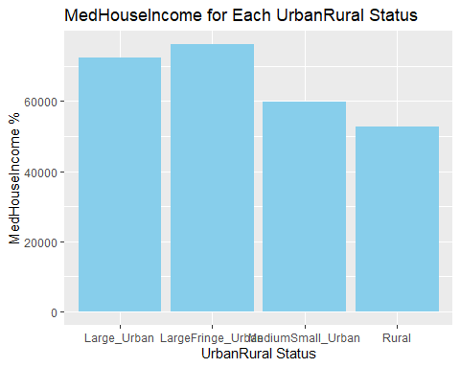

#looked at CHD vs MedHouseIncome  
ggplot(data = cdc, aes(x = `CHD`, y = `MedHouseIncome`, fill = `CHD`)) +  
 geom\_bar(stat = "identity", position = "dodge") +  
 labs(x = "CHD", y = "MedHouseIncome", fill = "CHD") +  
 theme(axis.text.x = element\_text(angle = 45, hjust = 1))

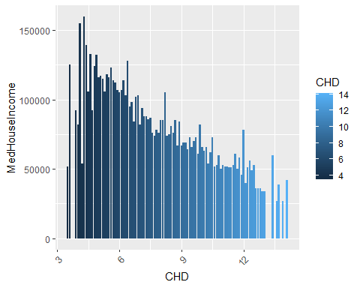 ### Top 10 Counties with highest MedHouseIncome

highest\_10 <- cdc %>%  
 arrange(desc(MedHouseIncome)) %>%  
 head(10)  
highest\_10

## # A tibble: 10 × 97  
## fips county state Age65Plus pop bpmUse CholScreen CholMedNonAdhear  
## <chr> <chr> <chr> <dbl> <dbl> <dbl> <dbl> <dbl>  
## 1 51610 Falls Church VA 13.2 1.43e4 75 90.7 13.4  
## 2 51107 Loudoun VA 9.4 4.05e5 72.4 90.1 13.8  
## 3 06085 Santa Clara CA 13.5 1.92e6 68.5 86.6 13.3  
## 4 51059 Fairfax Coun… VA 13.5 1.15e6 74.7 88.9 13.3  
## 5 06081 San Mateo CA 16.2 7.66e5 69.5 88 12.7  
## 6 06041 Marin CA 22.3 2.59e5 75 90.2 11.8  
## 7 51013 Arlington VA 10.8 2.36e5 71 88.3 14.7  
## 8 24027 Howard MD 13.8 3.22e5 77.6 90.9 14   
## 9 36059 Nassau NY 17.8 1.36e6 77.9 90.3 17.2  
## 10 06075 San Francisco CA 15.8 8.75e5 69.7 86.8 13   
## # ℹ 89 more variables: CholMedElegible <dbl>, cruParticipate <dbl>,  
## # Hospitals <dbl>, HospCIC <dbl>, HospCR <dbl>, HospED <dbl>,  
## # Pharmacies <dbl>, HealthIns <dbl>, CardioPhys <dbl>, CHD <dbl>,  
## # HighBP <dbl>, Stroke <dbl>, Diabetes <dbl>, HighChol <dbl>, Obesity <dbl>,  
## # PhysInactivity <dbl>, Smoker <dbl>, AirQuality <dbl>, Parks <dbl>,  
## # Broadband <dbl>, EdLessColl <dbl>, SNAPrecipients <dbl>,  
## # MedHomeValue <dbl>, MedHouseIncome <dbl>, Poverty <dbl>, Unemploy <dbl>, …

### Bottom 10 Counties with lowest MedHouseIncome

lowest\_10 <- cdc %>%  
 arrange(MedHouseIncome) %>%  
 head(10)  
lowest\_10

## # A tibble: 10 × 97  
## fips county state Age65Plus pop bpmUse CholScreen CholMedNonAdhear  
## <chr> <chr> <chr> <dbl> <dbl> <dbl> <dbl> <dbl>  
## 1 46017 Buffalo SD 7.7 2005 71.9 73.1 14.6  
## 2 21189 Owsley KY 20.9 4416 80.4 88.9 18.3  
## 3 35003 Catron NM 41.6 3547 83.8 87.8 14.6  
## 4 54047 McDowell WV 21.5 18083 82.8 85.3 17.7  
## 5 21051 Clay KY 15.5 20110 78.1 86.6 18.2  
## 6 13265 Taliaferro GA 29.4 1596 83.1 89.2 17.1  
## 7 46031 Corson SD 11.1 4106 76.1 75.9 19.3  
## 8 28051 Holmes MS 15.2 17414 82.3 85.5 27.4  
## 9 28053 Humphreys MS 16.9 8198 83.3 86.2 26.6  
## 10 21013 Bell KY 18.6 26426 80.9 87.7 20.8  
## # ℹ 89 more variables: CholMedElegible <dbl>, cruParticipate <dbl>,  
## # Hospitals <dbl>, HospCIC <dbl>, HospCR <dbl>, HospED <dbl>,  
## # Pharmacies <dbl>, HealthIns <dbl>, CardioPhys <dbl>, CHD <dbl>,  
## # HighBP <dbl>, Stroke <dbl>, Diabetes <dbl>, HighChol <dbl>, Obesity <dbl>,  
## # PhysInactivity <dbl>, Smoker <dbl>, AirQuality <dbl>, Parks <dbl>,  
## # Broadband <dbl>, EdLessColl <dbl>, SNAPrecipients <dbl>,  
## # MedHomeValue <dbl>, MedHouseIncome <dbl>, Poverty <dbl>, Unemploy <dbl>, …

#### Density plot for MedHouseIncome UrbanRural

ggplot(cdc, aes(x = MedHouseIncome, fill = UrbanRural)) +  
 geom\_density(alpha = 0.5) +  
 labs(x = "MedHouseIncome", y = "Density") +  
 theme\_minimal() +  
 scale\_fill\_brewer(palette = "Dark2")

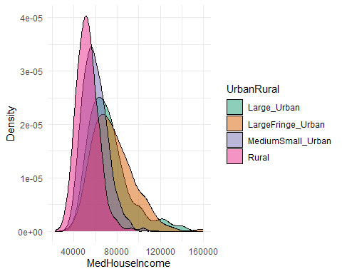

library(corrplot)  
  
correlation\_matrix <- cor(cdc[, c("MedHouseIncome", "CHD")])  
corrplot(correlation\_matrix, method = "number")

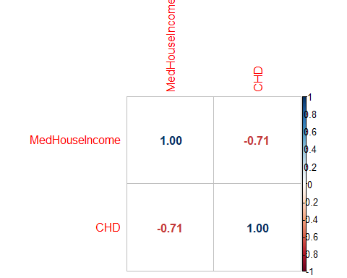

# Create a plot for each UrbanRural category  
for(category in unique(cdc$UrbanRural)) {  
 data\_subset <- subset(cdc, UrbanRural == category)  
  
 # Calculate correlation  
 correlation <- round(cor(data\_subset$MedHouseIncome, data\_subset$CHD, use = "pairwise.complete.obs"), 2)  
  
 # Create the plot  
 p <- ggplot(data\_subset, aes(x = MedHouseIncome, y = CHD)) +  
 geom\_point(alpha = 0.5) +  
 geom\_smooth(method = "lm", se = FALSE, color = "red", linetype = "dashed") +  
 geom\_text(aes(label = paste("Correlation = ", correlation), x = Inf, y = Inf), hjust = "right", vjust = "top") +  
 labs(title = paste("UrbanRural category:", category), x = "MedHouseIncome", y = "CHD") +  
 theme\_minimal()  
   
 print(p)  
}

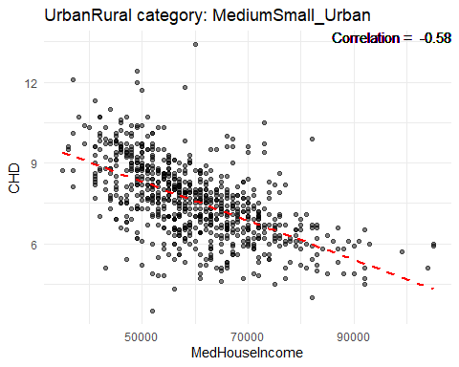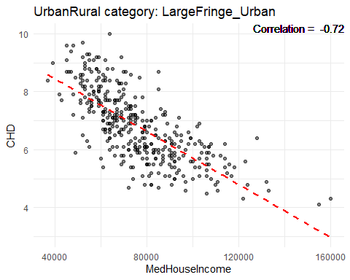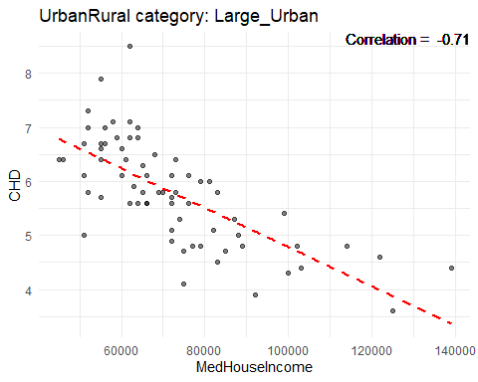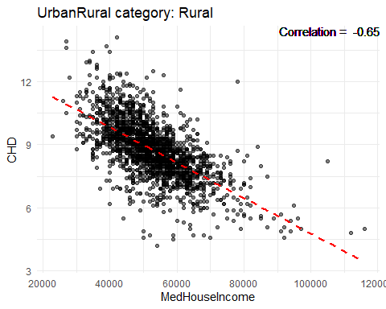 ### MedHouseIncome Boxplot

ggplot(cdc, aes(x=UrbanRural, y=MedHouseIncome)) + geom\_boxplot()

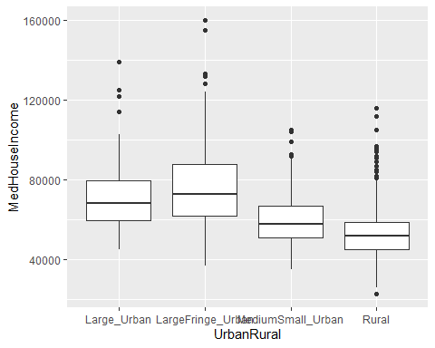

#### Highest and Lowest States of MedHouseIncome

# Top 10 states with highest MedHouseIncome  
cdc %>%  
 group\_by(state) %>%  
 summarise(avg\_MedHouseIncome = mean(MedHouseIncome, na.rm=TRUE)) %>%  
 arrange(desc(avg\_MedHouseIncome)) %>%  
 head(10) %>%  
 ggplot(aes(x=reorder(state, avg\_MedHouseIncome), y=avg\_MedHouseIncome)) +  
 geom\_bar(stat='identity', fill='skyblue') +  
 coord\_flip() +  
 labs(x='State', y='MedHouseIncome %', title='Top 10 States with Highest Rates of MedHouseIncome')

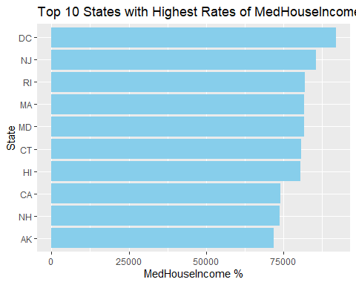

# Bottom 10 states with lowest MedHouseIncome  
cdc %>%  
 group\_by(state) %>%  
 summarise(avg\_MedHouseIncome = mean(MedHouseIncome, na.rm=TRUE)) %>%  
 arrange(avg\_MedHouseIncome) %>%  
 head(10) %>%  
 ggplot(aes(x=reorder(state, avg\_MedHouseIncome), y=avg\_MedHouseIncome)) +  
 geom\_bar(stat='identity', fill='skyblue') +  
 coord\_flip() +  
 labs(x='State', y='Average MedHouseIncome %', title='Top 10 States with Lowest MedHouseIncome')

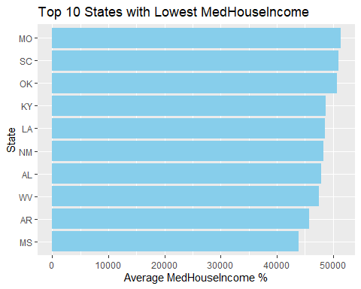

## Poverty

summary(cdc$Poverty)

## Min. 1st Qu. Median Mean 3rd Qu. Max.   
## 3.00 9.90 12.80 13.74 16.60 43.90

hist(cdc$"Poverty")

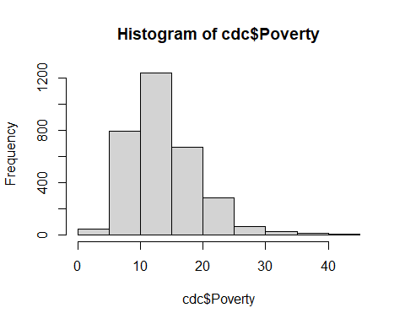

# Calculate the % Poverty level for each UrbanRural status  
avg\_Poverty\_urbanrural <- cdc %>%  
 group\_by(UrbanRural) %>%  
 summarise(avg\_Poverty = mean(Poverty, na.rm = TRUE))  
  
# Print the result  
print(avg\_Poverty\_urbanrural)

## # A tibble: 4 × 2  
## UrbanRural avg\_Poverty  
## <fct> <dbl>  
## 1 Large\_Urban 13.1   
## 2 LargeFringe\_Urban 9.52  
## 3 MediumSmall\_Urban 13.1   
## 4 Rural 14.8

# Plot a bar graph  
ggplot(avg\_Poverty\_urbanrural, aes(x=UrbanRural, y=avg\_Poverty)) +  
 geom\_bar(stat='identity', fill='skyblue') +  
 labs(x='UrbanRural Status', y='Poverty %', title='Poverty for Each UrbanRural Status')

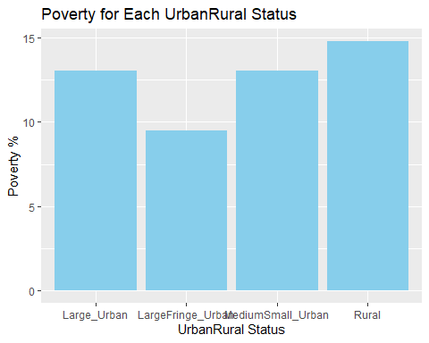

#looked at CHD vs Poverty  
ggplot(data = cdc, aes(x = `CHD`, y = `Poverty`, fill = `CHD`)) +  
 geom\_bar(stat = "identity", position = "dodge") +  
 labs(x = "CHD", y = "Poverty", fill = "CHD") +  
 theme(axis.text.x = element\_text(angle = 45, hjust = 1))

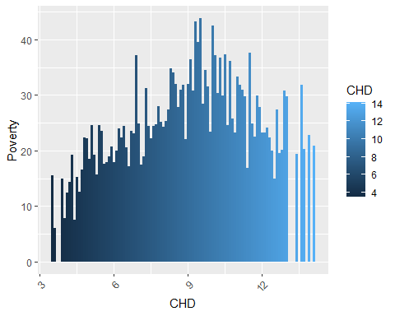 ### Top 10 Counties with highest % Poverty

highest\_10 <- cdc %>%  
 arrange(desc(Poverty)) %>%  
 head(10)  
highest\_10

## # A tibble: 10 × 97  
## fips county state Age65Plus pop bpmUse CholScreen CholMedNonAdhear  
## <chr> <chr> <chr> <dbl> <dbl> <dbl> <dbl> <dbl>  
## 1 46137 Ziebach SD 10.1 2767 73.9 73.8 14.6  
## 2 28055 Issaquena MS 22.6 1223 78.8 82.5 14.6  
## 3 46121 Todd SD 7.4 10308 71.6 70.8 42.8  
## 4 28027 Coahoma MS 15.1 22685 82.3 86.7 26.4  
## 5 13205 Mitchell GA 16.9 22072 77.9 86 17.9  
## 6 46102 Oglala Lakota SD 7.1 14277 69.9 72.2 33.8  
## 7 22035 East Carroll LA 13.3 6947 78.4 84.2 20.2  
## 8 21051 Clay KY 15.5 20110 78.1 86.6 18.2  
## 9 08025 Crowley CO 14.6 5733 64.1 78.8 14.4  
## 10 46031 Corson SD 11.1 4106 76.1 75.9 19.3  
## # ℹ 89 more variables: CholMedElegible <dbl>, cruParticipate <dbl>,  
## # Hospitals <dbl>, HospCIC <dbl>, HospCR <dbl>, HospED <dbl>,  
## # Pharmacies <dbl>, HealthIns <dbl>, CardioPhys <dbl>, CHD <dbl>,  
## # HighBP <dbl>, Stroke <dbl>, Diabetes <dbl>, HighChol <dbl>, Obesity <dbl>,  
## # PhysInactivity <dbl>, Smoker <dbl>, AirQuality <dbl>, Parks <dbl>,  
## # Broadband <dbl>, EdLessColl <dbl>, SNAPrecipients <dbl>,  
## # MedHomeValue <dbl>, MedHouseIncome <dbl>, Poverty <dbl>, Unemploy <dbl>, …

### Bottom 10 Counties with lowest % Poverty

lowest\_10 <- cdc %>%  
 arrange(Poverty) %>%  
 head(10)  
lowest\_10

## # A tibble: 10 × 97  
## fips county state Age65Plus pop bpmUse CholScreen CholMedNonAdhear  
## <chr> <chr> <chr> <dbl> <dbl> <dbl> <dbl> <dbl>  
## 1 08035 Douglas CO 12 344280 65.8 88.4 12.7  
## 2 51107 Loudoun VA 9.4 405312 72.4 90.1 13.8  
## 3 51610 Falls Church VA 13.2 14309 75 90.7 13.4  
## 4 35028 Los Alamos NM 17.6 18976 72.8 87.1 16.1  
## 5 27019 Carver MN 12.1 103561 72.8 86.2 11.6  
## 6 49029 Morgan UT 11.9 11950 67.2 82.6 14.8  
## 7 39041 Delaware OH 13.7 205454 75.8 87.6 12.3  
## 8 02230 Skagway AK 12.9 1300 67 82.3 14.6  
## 9 48301 Loving TX 45.3 117 72.3 82.2 14.6  
## 10 17093 Kendall IL 10.4 127583 69.8 86.6 12.3  
## # ℹ 89 more variables: CholMedElegible <dbl>, cruParticipate <dbl>,  
## # Hospitals <dbl>, HospCIC <dbl>, HospCR <dbl>, HospED <dbl>,  
## # Pharmacies <dbl>, HealthIns <dbl>, CardioPhys <dbl>, CHD <dbl>,  
## # HighBP <dbl>, Stroke <dbl>, Diabetes <dbl>, HighChol <dbl>, Obesity <dbl>,  
## # PhysInactivity <dbl>, Smoker <dbl>, AirQuality <dbl>, Parks <dbl>,  
## # Broadband <dbl>, EdLessColl <dbl>, SNAPrecipients <dbl>,  
## # MedHomeValue <dbl>, MedHouseIncome <dbl>, Poverty <dbl>, Unemploy <dbl>, …

#### Density plot for Poverty UrbanRural

ggplot(cdc, aes(x = Poverty, fill = UrbanRural)) +  
 geom\_density(alpha = 0.5) +  
 labs(x = "Poverty", y = "Density") +  
 theme\_minimal() +  
 scale\_fill\_brewer(palette = "Dark2")

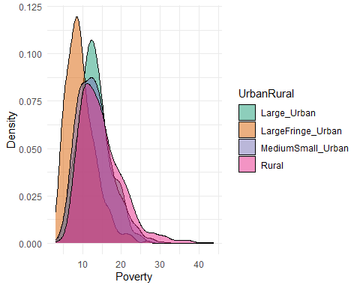

library(corrplot)  
  
correlation\_matrix <- cor(cdc[, c("Poverty", "CHD")])  
corrplot(correlation\_matrix, method = "number")

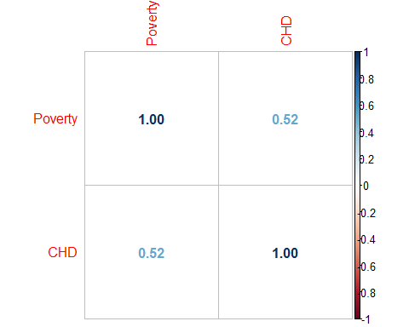

# Create a plot for each UrbanRural category  
for(category in unique(cdc$UrbanRural)) {  
 data\_subset <- subset(cdc, UrbanRural == category)  
  
 # Calculate correlation  
 correlation <- round(cor(data\_subset$Poverty, data\_subset$CHD, use = "pairwise.complete.obs"), 2)  
  
 # Create the plot  
 p <- ggplot(data\_subset, aes(x = Poverty, y = CHD)) +  
 geom\_point(alpha = 0.5) +  
 geom\_smooth(method = "lm", se = FALSE, color = "red", linetype = "dashed") +  
 geom\_text(aes(label = paste("Correlation = ", correlation), x = Inf, y = Inf), hjust = "right", vjust = "top") +  
 labs(title = paste("UrbanRural category:", category), x = "Poverty", y = "CHD") +  
 theme\_minimal()  
   
 print(p)  
}

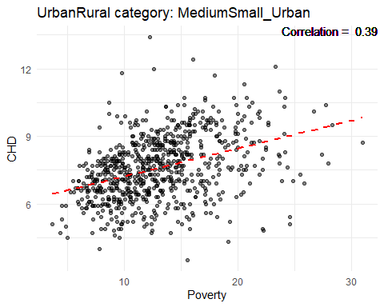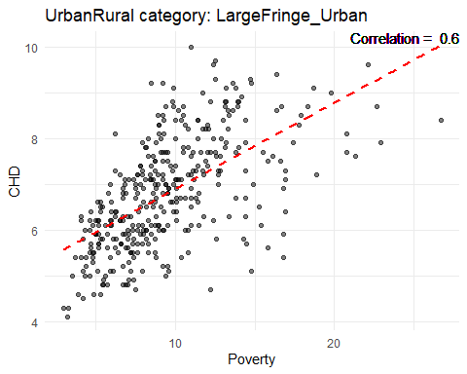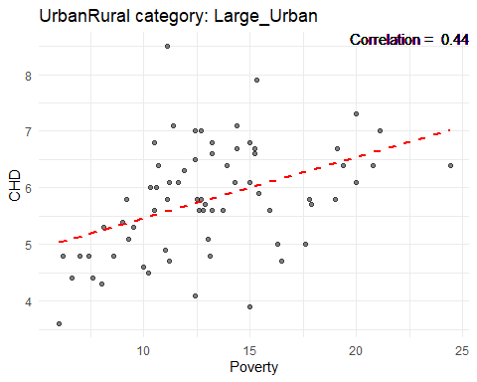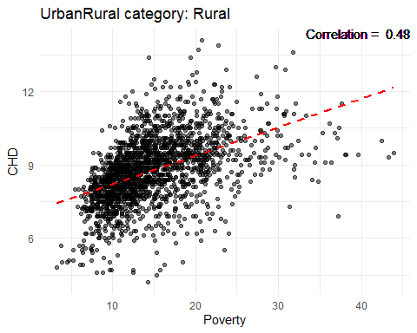 ### Poverty Boxplot

ggplot(cdc, aes(x=UrbanRural, y=Poverty)) + geom\_boxplot()

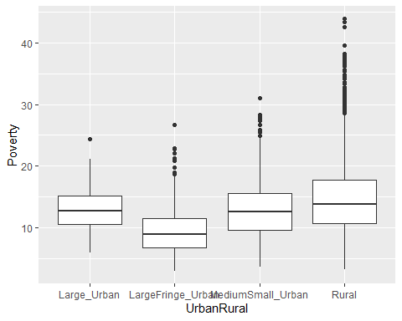

#### Highest and Lowest States % of Poverty

# Top 10 states with highest % Poverty  
cdc %>%  
 group\_by(state) %>%  
 summarise(avg\_Poverty = mean(Poverty, na.rm=TRUE)) %>%  
 arrange(desc(avg\_Poverty)) %>%  
 head(10) %>%  
 ggplot(aes(x=reorder(state, avg\_Poverty), y=avg\_Poverty)) +  
 geom\_bar(stat='identity', fill='skyblue') +  
 coord\_flip() +  
 labs(x='State', y='Poverty %', title='Top 10 States with Highest % of Poverty')

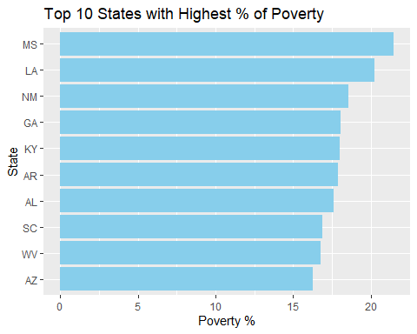

# Bottom 10 states with lowest % of Poverty  
cdc %>%  
 group\_by(state) %>%  
 summarise(avg\_Poverty = mean(Poverty, na.rm=TRUE)) %>%  
 arrange(avg\_Poverty) %>%  
 head(10) %>%  
 ggplot(aes(x=reorder(state, avg\_Poverty), y=avg\_Poverty)) +  
 geom\_bar(stat='identity', fill='skyblue') +  
 coord\_flip() +  
 labs(x='State', y='Average Poverty %', title='Top 10 States with Lowest % Poverty')

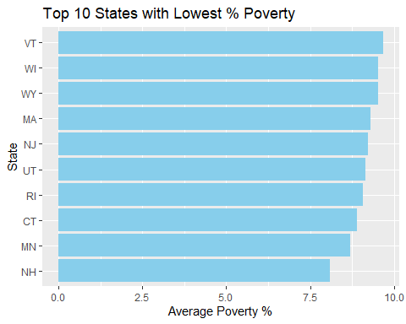

correlation\_matrix <- cor(cdc[, c("MedHomeValue", "MedHouseIncome", "Poverty", "CHD")])  
corrplot(correlation\_matrix, method = "number")

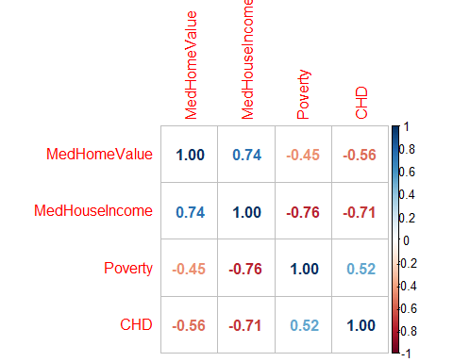

# Jesse new work

## Additional eda

Population = “pop” Air Quality = “AirQuality” Parks = “Parks” Broadband = “Broadband” Education = “EdLessColl” % over 65 = “”

## General correlations

### Various (other) factors

cdc %>%  
 select("CHD",  
 "pop",  
 "AirQuality",  
 "Parks",  
 "Broadband",  
 "EdLessColl",  
 "UrbanRural") %>%  
 ggpairs(mapping = aes(color = cdc$"UrbanRural", alpha = 0.5))

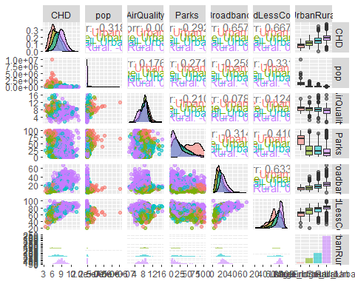

## Density and Correlations for individual features and CHD

#### Population

ggplot(cdc, aes(x = pop, fill = UrbanRural)) +  
 geom\_density(alpha = 0.5) +  
 labs(x = "Population", y = "Density") +  
 theme\_minimal() +  
 scale\_fill\_brewer(palette = "Dark2")

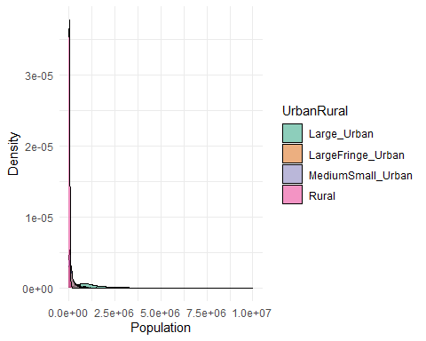

library(corrplot)  
  
correlation\_matrix <- cor(cdc[, c("pop", "CHD")])  
corrplot(correlation\_matrix, method = "number")

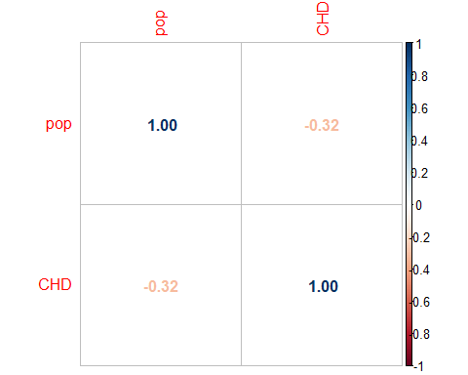

# Create a plot for each UrbanRural category  
for(category in unique(cdc$UrbanRural)) {  
 data\_subset <- subset(cdc, UrbanRural == category)  
  
 # Calculate correlation  
 correlation <- round(cor(data\_subset$pop, data\_subset$CHD, use = "pairwise.complete.obs"), 2)  
  
 # Create the plot  
 p <- ggplot(data\_subset, aes(x = pop, y = CHD)) +  
 geom\_point(alpha = 0.5) +  
 geom\_smooth(method = "lm", se = FALSE, color = "red", linetype = "dashed") +  
 geom\_text(aes(label = paste("Correlation = ", correlation), x = Inf, y = Inf), hjust = "right", vjust = "top") +  
 labs(title = paste("UrbanRural category:", category), x = "pop", y = "CHD") +  
 theme\_minimal()  
   
 print(p)  
}

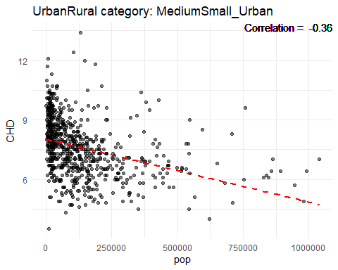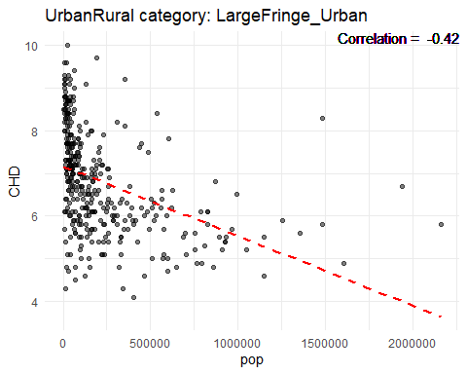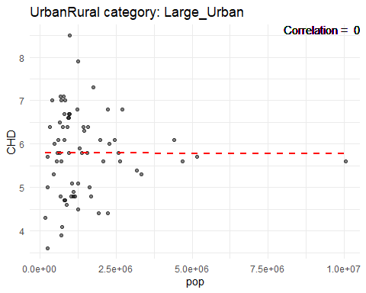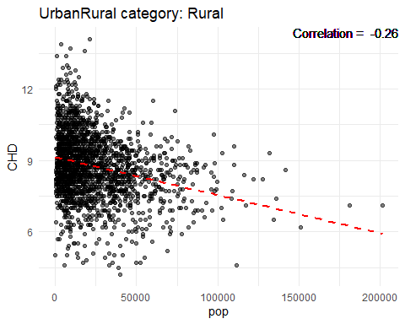

#### Air Quality

ggplot(cdc, aes(x = AirQuality, fill = UrbanRural)) +  
 geom\_density(alpha = 0.5) +  
 labs(x = "Air Quality", y = "Density") +  
 theme\_minimal() +  
 scale\_fill\_brewer(palette = "Dark2")

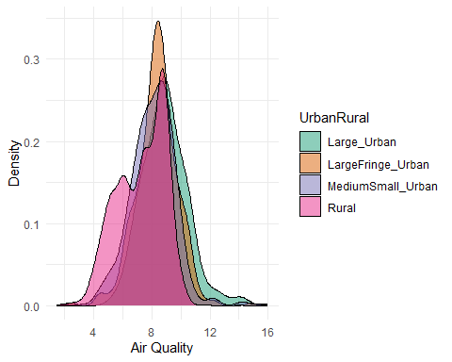

library(corrplot)  
  
correlation\_matrix <- cor(cdc[, c("AirQuality", "CHD")])  
corrplot(correlation\_matrix, method = "number")

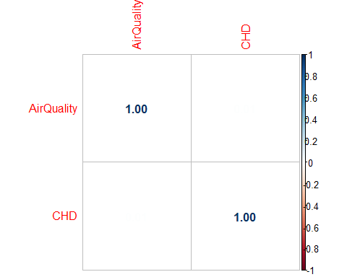

# Create a plot for each UrbanRural category  
for(category in unique(cdc$UrbanRural)) {  
 data\_subset <- subset(cdc, UrbanRural == category)  
  
 # Calculate correlation  
 correlation <- round(cor(data\_subset$AirQuality, data\_subset$CHD, use = "pairwise.complete.obs"), 2)  
  
 # Create the plot  
 p <- ggplot(data\_subset, aes(x = AirQuality, y = CHD)) +  
 geom\_point(alpha = 0.5) +  
 geom\_smooth(method = "lm", se = FALSE, color = "red", linetype = "dashed") +  
 geom\_text(aes(label = paste("Correlation = ", correlation), x = Inf, y = Inf), hjust = "right", vjust = "top") +  
 labs(title = paste("UrbanRural category:", category), x = "AirQuality", y = "CHD") +  
 theme\_minimal()  
   
 print(p)  
}

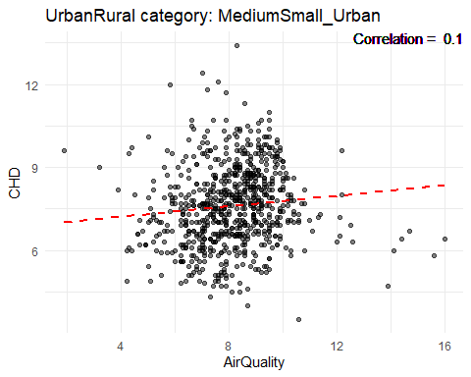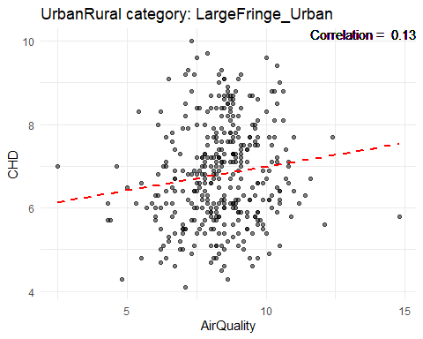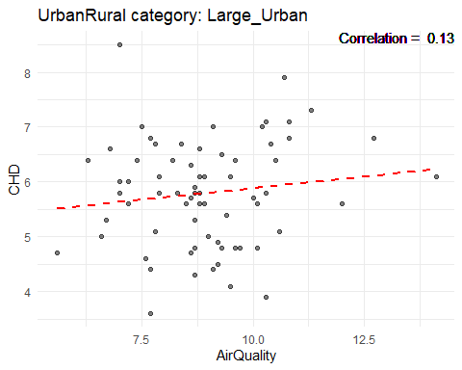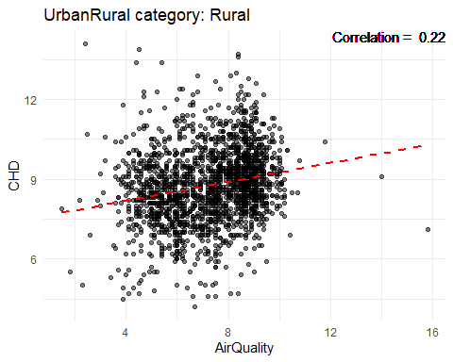

#### Parks

ggplot(cdc, aes(x = Parks, fill = UrbanRural)) +  
 geom\_density(alpha = 0.5) +  
 labs(x = "Parks", y = "Density") +  
 theme\_minimal() +  
 scale\_fill\_brewer(palette = "Dark2")

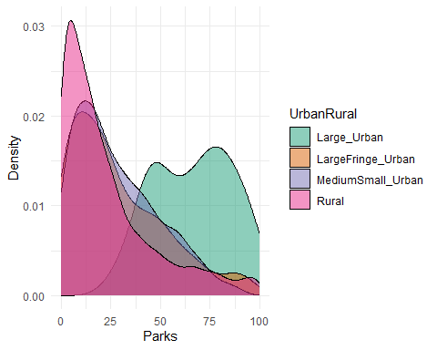

library(corrplot)  
  
correlation\_matrix <- cor(cdc[, c("Parks", "CHD")])  
corrplot(correlation\_matrix, method = "number")

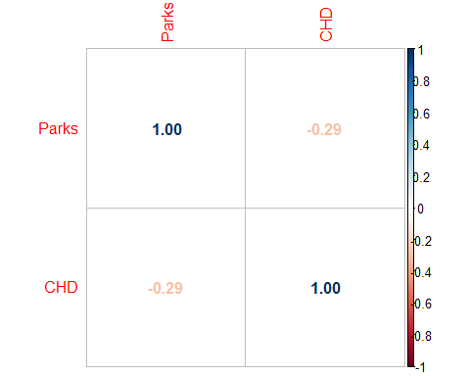

# Create a plot for each UrbanRural category  
for(category in unique(cdc$UrbanRural)) {  
 data\_subset <- subset(cdc, UrbanRural == category)  
  
 # Calculate correlation  
 correlation <- round(cor(data\_subset$Parks, data\_subset$CHD, use = "pairwise.complete.obs"), 2)  
  
 # Create the plot  
 p <- ggplot(data\_subset, aes(x = Parks, y = CHD)) +  
 geom\_point(alpha = 0.5) +  
 geom\_smooth(method = "lm", se = FALSE, color = "red", linetype = "dashed") +  
 geom\_text(aes(label = paste("Correlation = ", correlation), x = Inf, y = Inf), hjust = "right", vjust = "top") +  
 labs(title = paste("UrbanRural category:", category), x = "Parks", y = "CHD") +  
 theme\_minimal()  
   
 print(p)  
}

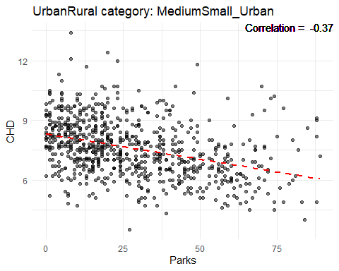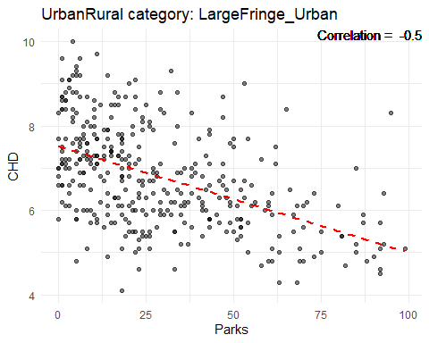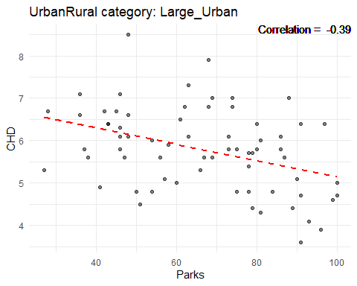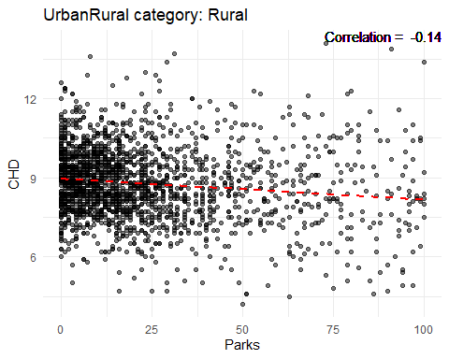

#### Broadband Access

ggplot(cdc, aes(x = Broadband, fill = UrbanRural)) +  
 geom\_density(alpha = 0.5) +  
 labs(x = "Broadband", y = "Density") +  
 theme\_minimal() +  
 scale\_fill\_brewer(palette = "Dark2")

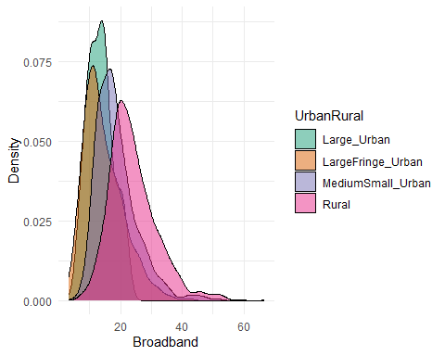

library(corrplot)  
  
correlation\_matrix <- cor(cdc[, c("Broadband", "CHD")])  
corrplot(correlation\_matrix, method = "number")

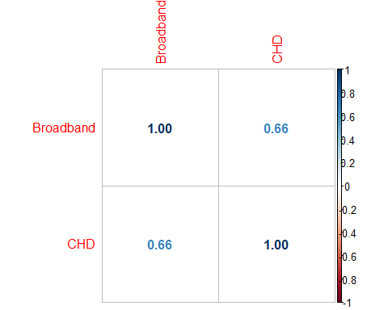

# Create a plot for each UrbanRural category  
for(category in unique(cdc$UrbanRural)) {  
 data\_subset <- subset(cdc, UrbanRural == category)  
  
 # Calculate correlation  
 correlation <- round(cor(data\_subset$Broadband, data\_subset$CHD, use = "pairwise.complete.obs"), 2)  
  
 # Create the plot  
 p <- ggplot(data\_subset, aes(x = Broadband, y = CHD)) +  
 geom\_point(alpha = 0.5) +  
 geom\_smooth(method = "lm", se = FALSE, color = "red", linetype = "dashed") +  
 geom\_text(aes(label = paste("Correlation = ", correlation), x = Inf, y = Inf), hjust = "right", vjust = "top") +  
 labs(title = paste("UrbanRural category:", category), x = "Broadband", y = "CHD") +  
 theme\_minimal()  
   
 print(p)  
}

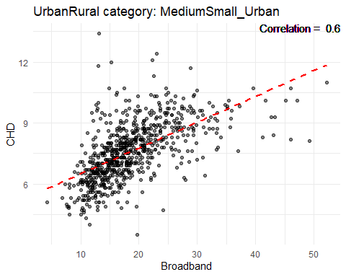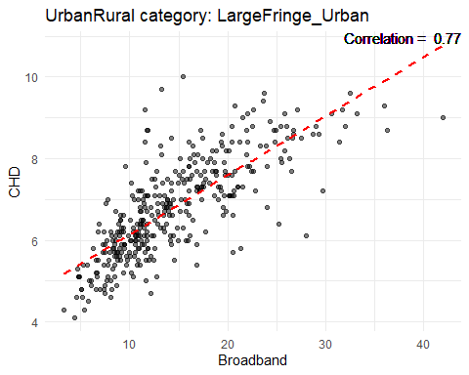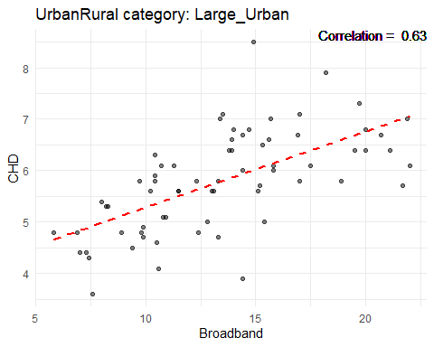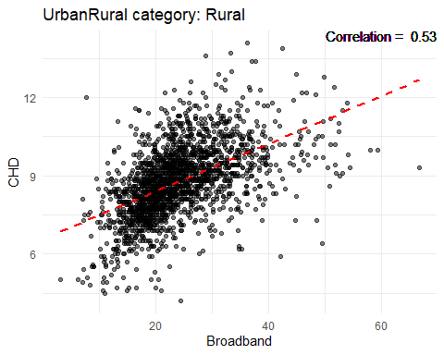

#### Education Less Than College

ggplot(cdc, aes(x = EdLessColl, fill = UrbanRural)) +  
 geom\_density(alpha = 0.5) +  
 labs(x = "EdLessColl", y = "Density") +  
 theme\_minimal() +  
 scale\_fill\_brewer(palette = "Dark2")

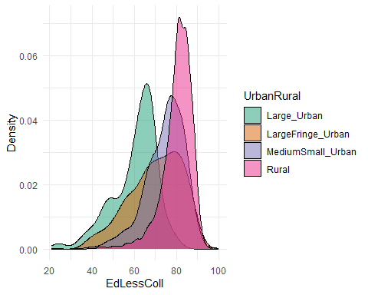

library(corrplot)  
  
correlation\_matrix <- cor(cdc[, c("EdLessColl", "CHD")])  
corrplot(correlation\_matrix, method = "number")



# Create a plot for each UrbanRural category  
for(category in unique(cdc$UrbanRural)) {  
 data\_subset <- subset(cdc, UrbanRural == category)  
  
 # Calculate correlation  
 correlation <- round(cor(data\_subset$EdLessColl, data\_subset$CHD, use = "pairwise.complete.obs"), 2)  
  
 # Create the plot  
 p <- ggplot(data\_subset, aes(x = EdLessColl, y = CHD)) +  
 geom\_point(alpha = 0.5) +  
 geom\_smooth(method = "lm", se = FALSE, color = "red", linetype = "dashed") +  
 geom\_text(aes(label = paste("Correlation = ", correlation), x = Inf, y = Inf), hjust = "right", vjust = "top") +  
 labs(title = paste("UrbanRural category:", category), x = "EdLessColl", y = "CHD") +  
 theme\_minimal()  
   
 print(p)  
}



#### Greater than 65 years old

ggplot(cdc, aes(x = Age65Plus, fill = UrbanRural)) +  
 geom\_density(alpha = 0.5) +  
 labs(x = "Age65Plus", y = "Density") +  
 theme\_minimal() +  
 scale\_fill\_brewer(palette = "Dark2")

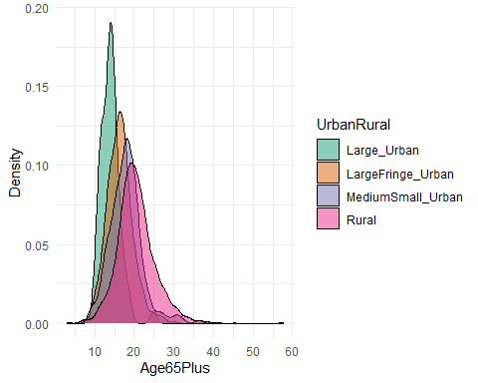

library(corrplot)  
  
correlation\_matrix <- cor(cdc[, c("Age65Plus", "CHD")])  
corrplot(correlation\_matrix, method = "number")

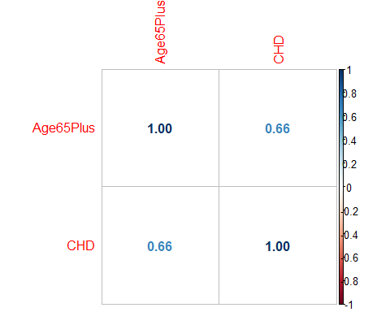

# Create a plot for each UrbanRural category  
for(category in unique(cdc$UrbanRural)) {  
 data\_subset <- subset(cdc, UrbanRural == category)  
  
 # Calculate correlation  
 correlation <- round(cor(data\_subset$Age65Plus, data\_subset$CHD, use = "pairwise.complete.obs"), 2)  
  
 # Create the plot  
 p <- ggplot(data\_subset, aes(x = Age65Plus, y = CHD)) +  
 geom\_point(alpha = 0.5) +  
 geom\_smooth(method = "lm", se = FALSE, color = "red", linetype = "dashed") +  
 geom\_text(aes(label = paste("Correlation = ", correlation), x = Inf, y = Inf), hjust = "right", vjust = "top") +  
 labs(title = paste("UrbanRural category:", category), x = "Age65Plus", y = "CHD") +  
 theme\_minimal()  
  
 print(p)  
}

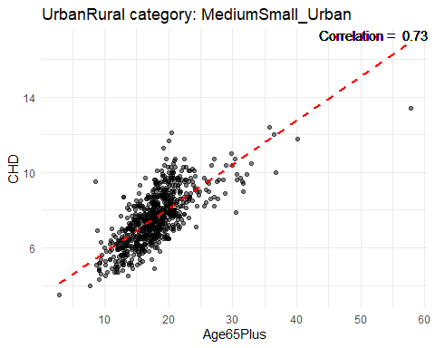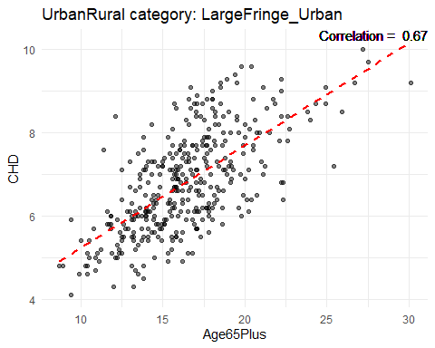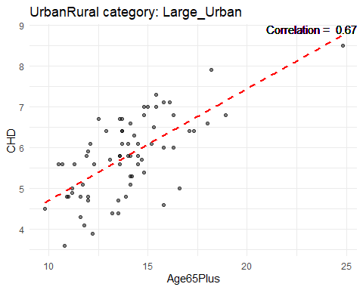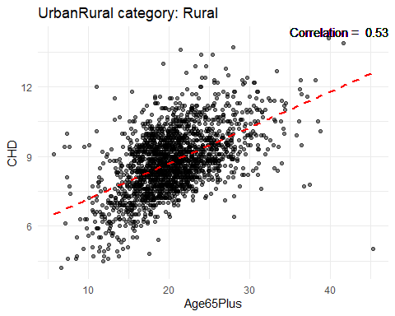

## Histograms to understand distribution of factors in rural and urban areas

### Population

ggplot(cdc, aes(x=log(pop))) + geom\_histogram(binwidth=1) + facet\_grid(~ UrbanRural)

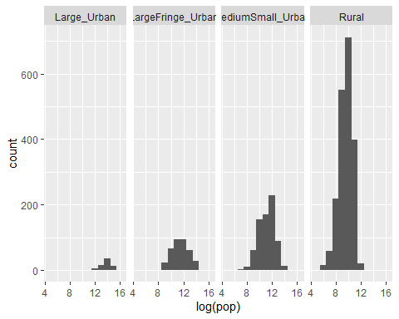

### Air Quality

ggplot(cdc, aes(x=AirQuality)) + geom\_histogram(binwidth=1) + facet\_grid(~ UrbanRural)

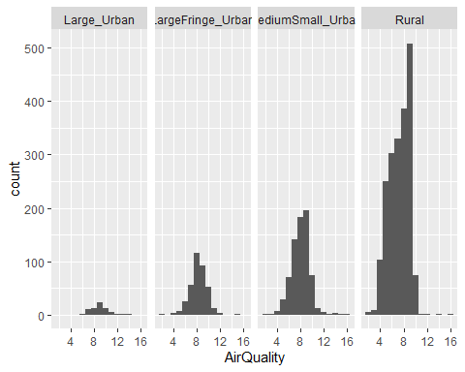

### Parks

ggplot(cdc, aes(x=Parks)) + geom\_histogram(binwidth=10) + facet\_grid(~ UrbanRural)

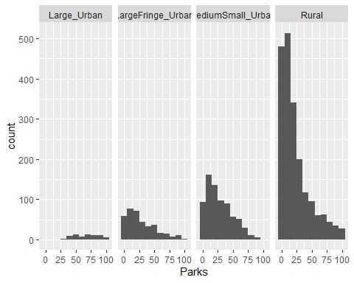

### Broadband Access

ggplot(cdc, aes(x=Broadband)) + geom\_histogram(binwidth=10) + facet\_grid(~ UrbanRural)

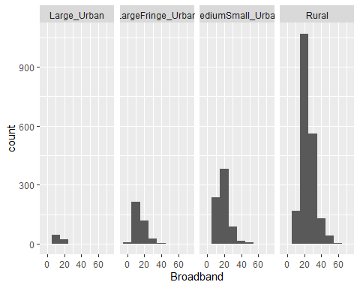

### Education Less Than College

ggplot(cdc, aes(x=EdLessColl)) + geom\_histogram(binwidth=10) + facet\_grid(~ UrbanRural)

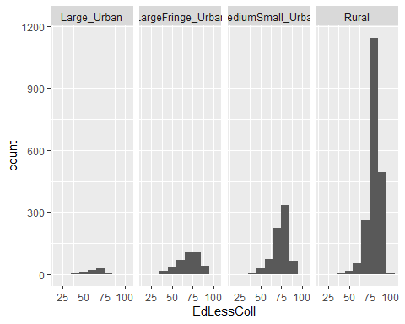

### Greater than 65 years old

ggplot(cdc, aes(x=Age65Plus)) + geom\_histogram(binwidth=10) + facet\_grid(~ UrbanRural)

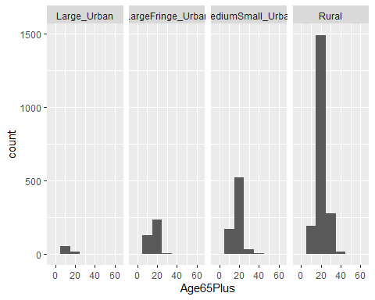

## Correlation analysis between CHD and various factors

### Population

cor.test(cdc$pop, cdc$CHD)

##   
## Pearson's product-moment correlation  
##   
## data: cdc$pop and cdc$CHD  
## t = -18.759, df = 3138, p-value < 2.2e-16  
## alternative hypothesis: true correlation is not equal to 0  
## 95 percent confidence interval:  
## -0.3486468 -0.2857341  
## sample estimates:  
## cor   
## -0.3175398

### Air Quality

cor.test(cdc$AirQuality, cdc$CHD)

##   
## Pearson's product-moment correlation  
##   
## data: cdc$AirQuality and cdc$CHD  
## t = 0.3941, df = 3138, p-value = 0.6935  
## alternative hypothesis: true correlation is not equal to 0  
## 95 percent confidence interval:  
## -0.02795134 0.04200420  
## sample estimates:  
## cor   
## 0.007035038

### Parks

cor.test(cdc$Parks, cdc$CHD)

##   
## Pearson's product-moment correlation  
##   
## data: cdc$Parks and cdc$CHD  
## t = -17.113, df = 3138, p-value < 2.2e-16  
## alternative hypothesis: true correlation is not equal to 0  
## 95 percent confidence interval:  
## -0.3238391 -0.2598453  
## sample estimates:  
## cor   
## -0.2921692

### Broadband

cor.test(cdc$Broadband, cdc$CHD)

##   
## Pearson's product-moment correlation  
##   
## data: cdc$Broadband and cdc$CHD  
## t = 48.883, df = 3138, p-value < 2.2e-16  
## alternative hypothesis: true correlation is not equal to 0  
## 95 percent confidence interval:  
## 0.6371680 0.6769049  
## sample estimates:  
## cor   
## 0.6574934

### Education Less Than College

cor.test(cdc$EdLessColl, cdc$CHD)

##   
## Pearson's product-moment correlation  
##   
## data: cdc$EdLessColl and cdc$CHD  
## t = 50.161, df = 3138, p-value < 2.2e-16  
## alternative hypothesis: true correlation is not equal to 0  
## 95 percent confidence interval:  
## 0.6472082 0.6860564  
## sample estimates:  
## cor   
## 0.6670856

### Age over 65 years old

cor.test(cdc$Age65Plus, cdc$CHD)

##   
## Pearson's product-moment correlation  
##   
## data: cdc$Age65Plus and cdc$CHD  
## t = 48.739, df = 3138, p-value < 2.2e-16  
## alternative hypothesis: true correlation is not equal to 0  
## 95 percent confidence interval:  
## 0.6360179 0.6758558  
## sample estimates:  
## cor   
## 0.6563942

## Correlation Visualizations between CHD and various factors

### Population

cdc %>%  
 filter(UrbanRural %in% c(unique(UrbanRural))) %>%  
ggplot(aes(log(pop), CHD, color=UrbanRural)) +  
geom\_point(alpha=0.3)+  
facet\_wrap(~UrbanRural)+  
geom\_smooth(method = lm)

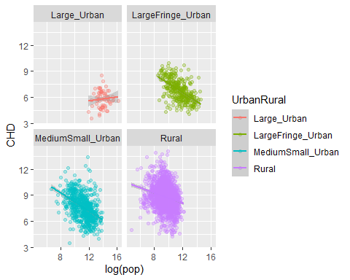

### Air Quality

cdc %>%  
 filter(UrbanRural %in% c(unique(UrbanRural))) %>%  
ggplot(aes(log(AirQuality), CHD, color=UrbanRural)) +  
geom\_point(alpha=0.3)+  
facet\_wrap(~UrbanRural)+  
geom\_smooth(method = lm)

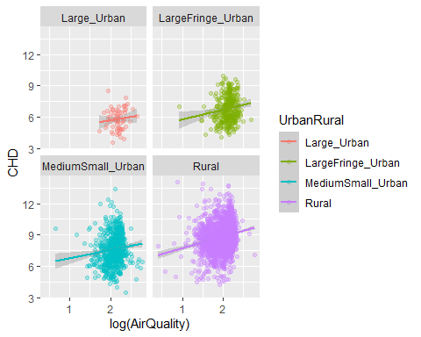

### Parks

cdc %>%  
 filter(UrbanRural %in% c(unique(UrbanRural))) %>%  
ggplot(aes(log(Parks), CHD, color=UrbanRural)) +  
geom\_point(alpha=0.3)+  
facet\_wrap(~UrbanRural)+  
geom\_smooth(method = lm)

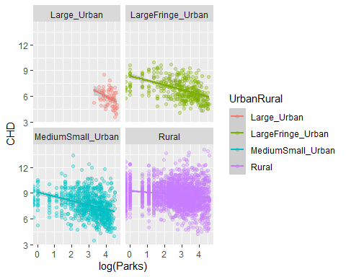

### Broadband

cdc %>%  
 filter(UrbanRural %in% c(unique(UrbanRural))) %>%  
ggplot(aes(log(Broadband), CHD, color=UrbanRural)) +  
geom\_point(alpha=0.3)+  
facet\_wrap(~UrbanRural)+  
geom\_smooth(method = lm)

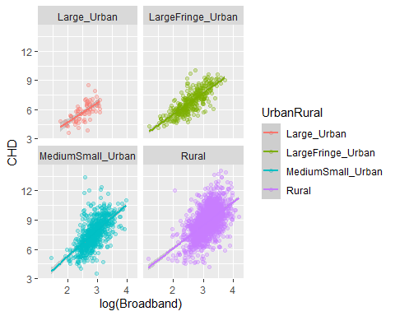

### Education Less Than College

cdc %>%  
 filter(UrbanRural %in% c(unique(UrbanRural))) %>%  
ggplot(aes(log(EdLessColl), CHD, color=UrbanRural)) +  
geom\_point(alpha=0.3)+  
facet\_wrap(~UrbanRural)+  
geom\_smooth(method = lm)

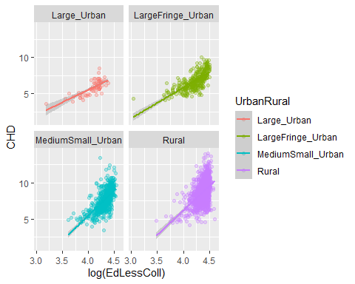

### Age Over 65 years old

cdc %>%  
 filter(UrbanRural %in% c(unique(UrbanRural))) %>%  
ggplot(aes(log(Age65Plus), CHD, color=UrbanRural)) +  
geom\_point(alpha=0.3)+  
facet\_wrap(~UrbanRural)+  
geom\_smooth(method = lm)

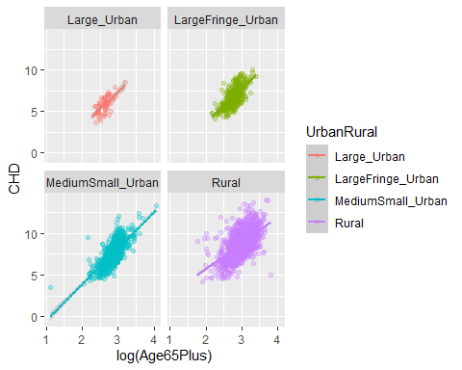

## Linear Model with various variables

### CHD, Population, Air Quality, Parks, Broadband Access, Education Less Than College, and Age greater than 65.

# Fit models to each imputed dataset  
models <- with(imputed\_data, exp = lm(CHD ~ UrbanRural + pop + Broadband + AirQuality + EdLessColl + Parks + Age65Plus))  
  
# Pool results  
pooled\_results <- pool(models)  
  
# Print summary of pooled results  
summary(pooled\_results)

## term estimate std.error statistic df  
## 1 (Intercept) -1.526024e+00 1.790871e-01 -8.5211320 3127.665  
## 2 UrbanRuralLargeFringe\_Urban -9.749606e-02 1.124079e-01 -0.8673420 3127.665  
## 3 UrbanRuralMediumSmall\_Urban -4.450950e-02 1.122241e-01 -0.3966128 3127.665  
## 4 UrbanRuralRural 1.267308e-01 1.158349e-01 1.0940644 3127.665  
## 5 pop -6.808235e-08 5.057885e-08 -1.3460638 3127.665  
## 6 Broadband 5.158378e-02 2.037722e-03 25.3144321 3127.665  
## 7 AirQuality 8.867193e-02 8.496331e-03 10.4364962 3127.665  
## 8 EdLessColl 5.846136e-02 1.819662e-03 32.1276003 3127.665  
## 9 Parks -8.750766e-04 6.023381e-04 -1.4527996 3127.665  
## 10 Age65Plus 1.763613e-01 2.846659e-03 61.9537732 3127.665  
## p.value  
## 1 2.420173e-17  
## 2 3.858212e-01  
## 3 6.916801e-01  
## 4 2.740110e-01  
## 5 1.783795e-01  
## 6 8.941061e-129  
## 7 4.341376e-25  
## 8 5.815991e-196  
## 9 1.463797e-01  
## 10 0.000000e+00

### CHD, Population, Age greater than 65.

# Fit models to each imputed dataset  
models <- with(imputed\_data, exp = lm(CHD ~ pop + Age65Plus))  
  
# Pool results  
pooled\_results <- pool(models)  
  
# Print summary of pooled results  
summary(pooled\_results)

## term estimate std.error statistic df p.value  
## 1 (Intercept) 4.391907e+00 8.858797e-02 49.57679 3134.664 0.000000e+00  
## 2 pop -8.951166e-07 6.342183e-08 -14.11370 3134.664 6.718768e-44  
## 3 Age65Plus 2.029882e-01 4.394442e-03 46.19202 3134.664 0.000000e+00

### CHD, Broadband, Parks, Age greater than 65.

# Fit models to each imputed dataset  
models <- with(imputed\_data, exp = lm(CHD ~ UrbanRural + Broadband + Parks + Age65Plus))  
  
# Pool results  
pooled\_results <- pool(models)  
  
# Print summary of pooled results  
summary(pooled\_results)

## term estimate std.error statistic df  
## 1 (Intercept) 2.740577731 0.1230425993 22.273406 3130.664  
## 2 UrbanRuralLargeFringe\_Urban 0.230056273 0.1124529204 2.045801 3130.664  
## 3 UrbanRuralMediumSmall\_Urban 0.396238944 0.1087903349 3.642226 3130.664  
## 4 UrbanRuralRural 0.633859834 0.1088645709 5.822462 3130.664  
## 5 Broadband 0.088399447 0.0020833770 42.430846 3130.664  
## 6 Parks -0.007336753 0.0006745321 -10.876804 3130.664  
## 7 Age65Plus 0.168335090 0.0033163461 50.759205 3130.664  
## p.value  
## 1 3.859029e-102  
## 2 4.085937e-02  
## 3 2.746721e-04  
## 4 6.385775e-09  
## 5 3.382940e-311  
## 6 4.505988e-27  
## 7 0.000000e+00

### CHD, Parks, Age greater than 65.

# Fit models to each imputed dataset  
models <- with(imputed\_data, exp = lm(CHD ~ UrbanRural + Parks + Age65Plus))  
  
# Pool results  
pooled\_results <- pool(models)  
  
# Print summary of pooled results  
summary(pooled\_results)

## term estimate std.error statistic df  
## 1 (Intercept) 4.26074753 0.1476862731 28.84999022 3131.664  
## 2 UrbanRuralLargeFringe\_Urban -0.01046657 0.1409097045 -0.07427859 3131.664  
## 3 UrbanRuralMediumSmall\_Urban 0.49327418 0.1364636491 3.61469284 3131.664  
## 4 UrbanRuralRural 1.13211705 0.1357900230 8.33726238 3131.664  
## 5 Parks -0.01535160 0.0008124413 -18.89563550 3131.664  
## 6 Age65Plus 0.18273379 0.0041390138 44.14911410 3131.664  
## p.value  
## 1 1.654388e-162  
## 2 9.407935e-01  
## 3 3.054390e-04  
## 4 1.124074e-16  
## 5 1.684843e-75  
## 6 0.000000e+00

### CHD, Air Quality, Age greater than 65.

# Fit models to each imputed dataset  
models <- with(imputed\_data, exp = lm(CHD ~ UrbanRural + AirQuality + Age65Plus))  
  
# Pool results  
pooled\_results <- pool(models)  
  
# Print summary of pooled results  
summary(pooled\_results)

## term estimate std.error statistic df  
## 1 (Intercept) 0.8645224 0.177063101 4.882567 3131.664  
## 2 UrbanRuralLargeFringe\_Urban 0.6793639 0.135464751 5.015060 3131.664  
## 3 UrbanRuralMediumSmall\_Urban 1.2375826 0.130863640 9.457040 3131.664  
## 4 UrbanRuralRural 2.1216021 0.129674533 16.360978 3131.664  
## 5 AirQuality 0.2476419 0.011506375 21.522152 3131.664  
## 6 Age65Plus 0.1947359 0.004137452 47.066633 3131.664  
## p.value  
## 1 1.099584e-06  
## 2 5.596788e-07  
## 3 6.011601e-21  
## 4 8.494054e-58  
## 5 6.204364e-96  
## 6 0.000000e+00

## Linear Model with interactions

### CHD, Population, Air Quality, Parks, Broadband Access, Education Less Than College, and Age greater than 65.

# Fit models to each imputed dataset  
models <- with(imputed\_data, exp = lm(CHD ~ UrbanRural + pop + EdLessColl \* Broadband + AirQuality \* Parks + Age65Plus))  
  
# Pool results  
pooled\_results <- pool(models)  
  
# Print summary of pooled results  
summary(pooled\_results)

## term estimate std.error statistic df  
## 1 (Intercept) 3.431609e-01 2.817230e-01 1.2180790 3125.665  
## 2 UrbanRuralLargeFringe\_Urban -2.412544e-01 1.122249e-01 -2.1497415 3125.665  
## 3 UrbanRuralMediumSmall\_Urban -9.610704e-02 1.114922e-01 -0.8620065 3125.665  
## 4 UrbanRuralRural 5.445270e-02 1.149682e-01 0.4736328 3125.665  
## 5 pop -7.390144e-08 5.031289e-08 -1.4688369 3125.665  
## 6 EdLessColl 3.477193e-02 3.058669e-03 11.3683210 3125.665  
## 7 Broadband -9.174260e-02 1.532437e-02 -5.9867136 3125.665  
## 8 AirQuality 1.059763e-01 1.246275e-02 8.5034440 3125.665  
## 9 Parks 4.388997e-03 2.154798e-03 2.0368481 3125.665  
## 10 Age65Plus 1.820821e-01 2.861246e-03 63.6373425 3125.665  
## 11 EdLessColl:Broadband 1.692682e-03 1.798223e-04 9.4130800 3125.665  
## 12 AirQuality:Parks -8.478715e-04 3.003907e-04 -2.8225625 3125.665  
## p.value  
## 1 2.232859e-01  
## 2 3.165219e-02  
## 3 3.887501e-01  
## 4 6.357948e-01  
## 5 1.419777e-01  
## 6 2.251916e-29  
## 7 2.384481e-09  
## 8 2.810154e-17  
## 9 4.174936e-02  
## 10 0.000000e+00  
## 11 9.048564e-21  
## 12 4.794277e-03

### CHD, Population, Age greater than 65.

# Fit models to each imputed dataset  
models <- with(imputed\_data, exp = lm(CHD ~ pop \* Age65Plus))  
  
# Pool results  
pooled\_results <- pool(models)  
  
# Print summary of pooled results  
summary(pooled\_results)

## term estimate std.error statistic df p.value  
## 1 (Intercept) 4.304889e+00 9.005646e-02 47.802108 3133.664 0.000000e+00  
## 2 pop 8.211808e-07 3.578075e-07 2.295035 3133.664 2.179690e-02  
## 3 Age65Plus 2.086850e-01 4.531956e-03 46.047450 3133.664 0.000000e+00  
## 4 pop:Age65Plus -1.205718e-07 2.474124e-08 -4.873312 3133.664 1.151951e-06

### CHD, Broadband, Parks, Age greater than 65.

# Fit models to each imputed dataset  
models <- with(imputed\_data, exp = lm(CHD ~ UrbanRural + Broadband \* Parks \* Age65Plus))  
  
# Pool results  
pooled\_results <- pool(models)  
  
# Print summary of pooled results  
summary(pooled\_results)

## term estimate std.error statistic df  
## 1 (Intercept) 3.195146e+00 2.641293e-01 12.0969015 3126.665  
## 2 UrbanRuralLargeFringe\_Urban 5.385891e-02 1.142804e-01 0.4712873 3126.665  
## 3 UrbanRuralMediumSmall\_Urban 1.969576e-01 1.109889e-01 1.7745704 3126.665  
## 4 UrbanRuralRural 4.305764e-01 1.110982e-01 3.8756368 3126.665  
## 5 Broadband 9.470893e-02 9.691293e-03 9.7725793 3126.665  
## 6 Parks -2.820520e-02 5.280791e-03 -5.3410938 3126.665  
## 7 Age65Plus 1.641101e-01 1.223249e-02 13.4159202 3126.665  
## 8 Broadband:Parks 5.122722e-04 2.419656e-04 2.1171280 3126.665  
## 9 Broadband:Age65Plus -7.198557e-04 4.902128e-04 -1.4684556 3126.665  
## 10 Parks:Age65Plus 7.854403e-04 2.765532e-04 2.8401055 3126.665  
## 11 Broadband:Parks:Age65Plus -1.138167e-05 1.171581e-05 -0.9714800 3126.665  
## p.value  
## 1 5.904507e-33  
## 2 6.374684e-01  
## 3 7.606613e-02  
## 4 1.085300e-04  
## 5 3.062928e-22  
## 6 9.900266e-08  
## 7 6.080465e-40  
## 8 3.432774e-02  
## 9 1.420811e-01  
## 10 4.539015e-03  
## 11 3.313844e-01

### CHD, Parks, Age greater than 65.

# Fit models to each imputed dataset  
models <- with(imputed\_data, exp = lm(CHD ~ UrbanRural + Parks \* Age65Plus))  
  
# Pool results  
pooled\_results <- pool(models)  
  
# Print summary of pooled results  
summary(pooled\_results)

## term estimate std.error statistic df  
## 1 (Intercept) 5.250100341 0.1890392848 27.772536 3130.664  
## 2 UrbanRuralLargeFringe\_Urban -0.248145450 0.1423713196 -1.742945 3130.664  
## 3 UrbanRuralMediumSmall\_Urban 0.259045397 0.1379793064 1.877422 3130.664  
## 4 UrbanRuralRural 0.890237348 0.1375218338 6.473426 3130.664  
## 5 Parks -0.038462657 0.0029144376 -13.197283 3130.664  
## 6 Age65Plus 0.144670085 0.0061692855 23.450055 3130.664  
## 7 Parks:Age65Plus 0.001163756 0.0001410632 8.249893 3130.664  
## p.value  
## 1 6.083591e-152  
## 2 8.144131e-02  
## 3 6.055317e-02  
## 4 1.108185e-10  
## 5 9.663303e-39  
## 6 3.605001e-112  
## 7 2.307420e-16

### CHD, Air Quality, Age greater than 65.

# Fit models to each imputed dataset  
models <- with(imputed\_data, exp = lm(CHD ~ UrbanRural + AirQuality \* Age65Plus))  
  
# Pool results  
pooled\_results <- pool(models)  
  
# Print summary of pooled results  
summary(pooled\_results)

## term estimate std.error statistic df  
## 1 (Intercept) 3.44739113 0.345496134 9.978089 3130.664  
## 2 UrbanRuralLargeFringe\_Urban 0.57091562 0.134472523 4.245593 3130.664  
## 3 UrbanRuralMediumSmall\_Urban 1.09538217 0.130377608 8.401613 3130.664  
## 4 UrbanRuralRural 1.94637906 0.129750185 15.000973 3130.664  
## 5 AirQuality -0.09802698 0.041457974 -2.364490 3130.664  
## 6 Age65Plus 0.06998847 0.014957574 4.679132 3130.664  
## 7 AirQuality:Age65Plus 0.01803825 0.002080437 8.670415 3130.664  
## p.value  
## 1 4.191699e-23  
## 2 2.243551e-05  
## 3 6.590067e-17  
## 4 3.554542e-49  
## 5 1.811559e-02  
## 6 3.003071e-06  
## 7 6.792914e-18

# 

cor\_matrix <- cor(cdc\_comp)  
  
cor\_matrix

## Age65Plus pop bpmUse  
## Age65Plus 1.000000e+00 -2.091319e-01 0.6531687217  
## pop -2.091319e-01 1.000000e+00 -0.2666443071  
## bpmUse 6.531687e-01 -2.666443e-01 1.0000000000  
## CholScreen 4.201509e-01 5.077146e-02 0.5495425624  
## CholMedNonAdhear -1.902739e-01 2.192065e-02 0.0008328635  
## CholMedElegible 4.659394e-02 -1.435762e-01 0.2361225764  
## cruParticipate 1.209040e-01 -1.316597e-01 0.0276063240  
## Hospitals -1.967072e-01 9.293519e-01 -0.2653346459  
## HospCIC -1.879001e-01 8.587897e-01 -0.2097154766  
## HospCR -1.858539e-01 7.957264e-01 -0.2346025913  
## HospED -2.029680e-01 8.855253e-01 -0.2677439155  
## Pharmacies -8.439659e-02 5.732455e-02 0.1451429662  
## HealthIns -2.739861e-02 -6.892664e-02 -0.0286120324  
## CardioPhys -1.782908e-01 4.389818e-02 -0.1882647805  
## CHD 6.563942e-01 -3.175398e-01 0.7329191462  
## HighBP 4.116709e-01 -2.641133e-01 0.7359536140  
## Stroke 4.255785e-01 -2.463373e-01 0.6125416468  
## Diabetes -2.281253e-01 7.691660e-02 0.0430490311  
## HighChol 6.021705e-01 -2.632134e-01 0.7786730399  
## Obesity -2.267398e-01 4.135751e-02 0.0078623560  
## PhysInactivity -1.079015e-01 -8.190881e-02 0.2742681242  
## Smoker -3.928960e-02 -2.576717e-01 0.3631474047  
## AirQuality -2.570910e-01 1.756819e-01 0.0790347814  
## Parks -3.016069e-02 2.705525e-01 -0.4082883035  
## Broadband 2.254712e-01 -2.584505e-01 0.4174505192  
## EdLessColl 1.711550e-01 -3.307782e-01 0.3757454375  
## SNAPrecipients -7.285176e-02 -3.242993e-02 0.1580820983  
## MedHomeValue -1.596358e-01 3.917941e-01 -0.4521820907  
## MedHouseIncome -2.642018e-01 2.829724e-01 -0.4359829114  
## Poverty -2.240632e-02 -1.009551e-01 0.1996571711  
## Unemploy -5.832492e-02 1.359702e-01 -0.1022231543  
## pcp -2.248971e-01 6.081624e-01 -0.1850388308  
## state\_AK -1.161309e-01 -2.227654e-02 -0.2457636180  
## state\_AL -1.880545e-02 -1.376492e-02 0.1067298946  
## state\_AR 1.513570e-02 -3.006313e-02 0.1006017031  
## state\_AZ 2.865001e-02 7.805890e-02 -0.0632584137  
## state\_CA -3.555643e-02 2.371987e-01 -0.2299917439  
## state\_CO 3.480234e-03 -6.588400e-03 -0.2258573706  
## state\_CT -1.462624e-02 5.208112e-02 -0.0093353997  
## state\_DC -2.619994e-02 3.212937e-02 -0.0381712897  
## state\_DE 6.208778e-03 2.034648e-02 0.0021721365  
## state\_FL 8.531355e-02 9.453208e-02 -0.0209366901  
## state\_GA -8.330333e-02 -2.632018e-02 0.0153292271  
## state\_HI -9.276188e-05 2.697583e-02 -0.0274719223  
## state\_IA 3.128337e-02 -3.920587e-02 0.0814836278  
## state\_ID -7.260821e-03 -2.301379e-02 -0.1395539953  
## state\_IL 9.397489e-03 1.140064e-02 -0.0346018194  
## state\_IN -5.602965e-02 -1.632154e-02 0.0719292701  
## state\_KS 3.420307e-02 -4.270031e-02 0.0036454509  
## state\_KY -6.097965e-02 -4.009489e-02 0.1201274622  
## state\_LA -8.428886e-02 -1.351092e-02 0.0197872155  
## state\_MA -6.804278e-03 7.795002e-02 -0.0262515841  
## state\_MD -2.844930e-02 3.898649e-02 0.0145673276  
## state\_ME 4.692881e-02 -4.351452e-03 -0.0373611014  
## state\_MI 8.707938e-02 8.019653e-03 0.0208921305  
## state\_MN 1.782465e-02 -2.013896e-02 -0.0011561565  
## state\_MO 1.502748e-02 -2.978557e-02 0.1465834602  
## state\_MS -7.034125e-02 -3.334123e-02 0.1532423277  
## state\_MT 8.146198e-02 -3.449687e-02 -0.0451439246  
## state\_NC 2.846936e-02 -7.510827e-05 0.0231263271  
## state\_ND 5.234854e-02 -3.536298e-02 0.0404933382  
## state\_NE 9.373347e-02 -4.381636e-02 0.1253100006  
## state\_NH 1.229148e-02 5.364045e-03 -0.0083639597  
## state\_NJ -3.837598e-02 7.882520e-02 -0.1226436296  
## state\_NM 3.652057e-02 -1.255049e-02 -0.0651928573  
## state\_NV 2.377494e-02 1.649157e-02 -0.0573613874  
## state\_NY -1.801132e-02 9.004437e-02 0.0102542939  
## state\_OH -3.557775e-02 1.465713e-02 0.0439622626  
## state\_OK -3.551257e-02 -2.515809e-02 -0.0204079200  
## state\_OR 6.005883e-02 3.893505e-03 -0.1064196507  
## state\_PA 3.153022e-02 3.865753e-02 0.0396578282  
## state\_RI 1.354028e-03 1.293098e-02 0.0061486732  
## state\_SC 3.691778e-03 2.453897e-03 0.0381937177  
## state\_SD 7.885407e-03 -3.999729e-02 0.0325376890  
## state\_TN -6.382651e-03 -1.739408e-02 0.0846246691  
## state\_TX -6.185861e-02 7.803734e-03 -0.1110905184  
## state\_UT -8.665582e-02 1.355451e-03 -0.2103068782  
## state\_VA 1.042879e-02 -2.533661e-02 0.0718682409  
## state\_VT 2.111344e-02 -1.196745e-02 -0.0159058060  
## state\_WA 3.589089e-02 2.992025e-02 -0.1540889991  
## state\_WI 2.969169e-02 -1.076695e-02 -0.0295475382  
## state\_WV 5.718996e-02 -2.859355e-02 0.1219454676  
## state\_WY -1.204473e-02 -2.035716e-02 -0.0665498469  
## UrbanRural\_Large\_Urban -1.638119e-01 6.155177e-01 -0.1747584031  
## UrbanRural\_LargeFringe\_Urban -2.180184e-01 1.298472e-01 -0.1319510369  
## UrbanRural\_MediumSmall\_Urban -1.526758e-01 5.070674e-02 -0.1455394390  
## UrbanRural\_Rural 3.279655e-01 -3.162402e-01 0.2677189401  
## Hosp100k 2.101655e-01 -1.330763e-01 0.1266344841  
## Pharm100k 5.596632e-02 -8.465239e-02 0.1644795808  
## TotalPCP -8.798603e-02 6.882972e-01 -0.1842509434  
## PSP1k 6.483840e-02 8.698716e-02 -0.1797433632  
## TotalCardio -1.769946e-01 8.498494e-01 -0.1942398384  
## Cardio100k 2.564522e-01 -1.065546e-01 0.0926156589  
## CholScreen CholMedNonAdhear CholMedElegible  
## Age65Plus 0.4201508667 -0.1902739060 0.046593940  
## pop 0.0507714576 0.0219206490 -0.143576176  
## bpmUse 0.5495425624 0.0008328635 0.236122576  
## CholScreen 1.0000000000 -0.0317924170 -0.004125141  
## CholMedNonAdhear -0.0317924170 1.0000000000 0.144103721  
## CholMedElegible -0.0041251411 0.1441037214 1.000000000  
## cruParticipate -0.1523654389 -0.4250986976 -0.233449841  
## Hospitals -0.0007431217 0.0011859434 -0.130551498  
## HospCIC 0.0242030734 0.0139634262 -0.124119240  
## HospCR 0.0022107397 -0.1277593578 -0.161510213  
## HospED -0.0123731638 -0.0335147641 -0.145505385  
## Pharmacies 0.1911524957 0.1776556979 0.077518755  
## HealthIns -0.3049976151 0.4851487507 0.139568131  
## CardioPhys -0.0138696553 -0.0266251490 -0.082587800  
## CHD 0.2503164020 0.2259660575 0.347321745  
## HighBP 0.4173920098 0.4374032286 0.341089888  
## Stroke 0.1898463595 0.4829510052 0.282835268  
## Diabetes -0.0435486400 0.3892389231 0.140879843  
## HighChol 0.4642492110 0.1969645208 0.329784279  
## Obesity -0.0709311989 -0.0022504326 0.061357865  
## PhysInactivity 0.0078978411 0.2757508845 0.249397796  
## Smoker -0.0290310631 0.3599432359 0.422057667  
## AirQuality 0.1888709698 0.2426850719 0.105609468  
## Parks -0.0602034144 -0.1012865802 -0.294713338  
## Broadband -0.0455931585 0.4512368502 0.288847133  
## EdLessColl -0.1065253380 0.2790833669 0.379598060  
## SNAPrecipients -0.0223071248 0.5740375943 0.194205336  
## MedHomeValue 0.1195142294 -0.1790005181 -0.377223337  
## MedHouseIncome 0.0745808212 -0.3665832038 -0.325328756  
## Poverty -0.1047232493 0.6343025008 0.255022431  
## Unemploy 0.0053587299 0.3929195708 0.027017453  
## pcp 0.0914036298 -0.0060256161 -0.144713567  
## state\_AK -0.1798596268 0.0950012611 -0.016149540  
## state\_AL 0.1331073246 0.1056158692 0.074234822  
## state\_AR -0.0247880417 0.1172597752 0.218521299  
## state\_AZ -0.0375859228 0.0863788896 -0.026286538  
## state\_CA 0.0241458381 0.0152309470 -0.101091926  
## state\_CO 0.0148443114 -0.0307918162 -0.185565429  
## state\_CT 0.0623260215 -0.0326895673 -0.029454491  
## state\_DC 0.0239782047 0.0212717190 -0.030634374  
## state\_DE 0.0305620931 -0.0053007140 -0.025409127  
## state\_FL 0.0662287625 0.0399511132 0.024672896  
## state\_GA 0.0866689914 0.2163900362 0.032130771  
## state\_HI -0.0277945365 -0.0114402967 -0.059415077  
## state\_IA -0.0030056213 -0.2238381122 -0.094545090  
## state\_ID -0.1676319134 -0.0259898393 -0.083164806  
## state\_IL 0.0439423371 -0.1337042027 0.022132729  
## state\_IN -0.0276719786 -0.0886851468 -0.025131233  
## state\_KS -0.0586042845 -0.1068833271 0.054035740  
## state\_KY 0.3006874241 0.0813192720 0.103638316  
## state\_LA 0.0622072280 0.1348067101 0.080868303  
## state\_MA 0.0798944068 -0.0442713684 -0.042278325  
## state\_MD 0.1183045042 -0.0022248986 -0.058648989  
## state\_ME 0.0359989689 -0.0816436485 -0.007235217  
## state\_MI 0.2032742978 -0.0709982400 0.053992441  
## state\_MN -0.0209358914 -0.2149114645 0.007420608  
## state\_MO -0.0955406785 -0.0911242706 0.023820910  
## state\_MS 0.0334168588 0.3313175241 -0.012018307  
## state\_MT -0.0742827749 -0.0486229283 -0.038812312  
## state\_NC 0.1197845365 0.0971033409 -0.064339848  
## state\_ND -0.0525857691 -0.0996618329 -0.003968761  
## state\_NE -0.0926390167 -0.1103858596 -0.022713699  
## state\_NH 0.0285881383 -0.0643373905 -0.043046855  
## state\_NJ -0.1812766876 0.0235339009 -0.026517972  
## state\_NM -0.1081148575 0.0998566513 -0.049711758  
## state\_NV -0.0140894430 0.0145484300 -0.050830586  
## state\_NY 0.1141353681 -0.0757503057 -0.040790657  
## state\_OH -0.0550202484 -0.0451093600 0.075614727  
## state\_OK -0.0626649361 0.1142331982 0.106380492  
## state\_OR 0.0479625628 -0.0563950943 -0.065143745  
## state\_PA 0.0351375181 -0.0979675960 -0.012762624  
## state\_RI 0.0592264819 -0.0223998661 -0.007444687  
## state\_SC -0.0031092646 0.1426754505 -0.075775295  
## state\_SD -0.2176626387 -0.0557874662 0.005255220  
## state\_TN 0.0797728491 0.0175397684 0.076293282  
## state\_TX -0.1998343899 0.1900768278 0.093737397  
## state\_UT -0.1694739385 0.0168980004 -0.070542456  
## state\_VA 0.1729687371 0.0092547652 -0.098333734  
## state\_VT -0.0195049303 -0.0823833386 -0.016892569  
## state\_WA -0.1009840461 -0.0436313713 -0.073234666  
## state\_WI -0.1485350778 -0.2103754072 -0.065294676  
## state\_WV 0.0825162769 -0.0376817291 0.124142066  
## state\_WY -0.0281235921 0.0027745094 -0.070389094  
## UrbanRural\_Large\_Urban 0.0393424217 0.0476840386 -0.114456540  
## UrbanRural\_LargeFringe\_Urban 0.1634873426 -0.0614215952 -0.100977277  
## UrbanRural\_MediumSmall\_Urban 0.0071963167 -0.0362396375 -0.075624467  
## UrbanRural\_Rural -0.1270014935 0.0582032663 0.167819104  
## Hosp100k -0.0891647647 -0.0555094097 0.053069503  
## Pharm100k 0.0771839673 0.1120427543 0.052469644  
## TotalPCP 0.0130876531 -0.0132370568 -0.081161601  
## PSP1k -0.0258581781 0.0240639209 -0.059374255  
## TotalCardio 0.0769035901 0.0274062893 -0.117817498  
## Cardio100k -0.0394209033 -0.0167670948 0.051230248  
## cruParticipate Hospitals HospCIC  
## Age65Plus 0.120903955 -0.1967071726 -0.1879001248  
## pop -0.131659732 0.9293518575 0.8587896771  
## bpmUse 0.027606324 -0.2653346459 -0.2097154766  
## CholScreen -0.152365439 -0.0007431217 0.0242030734  
## CholMedNonAdhear -0.425098698 0.0011859434 0.0139634262  
## CholMedElegible -0.233449841 -0.1305514978 -0.1241192400  
## cruParticipate 1.000000000 -0.0907942216 -0.0876085021  
## Hospitals -0.090794222 1.0000000000 0.8563976733  
## HospCIC -0.087608502 0.8563976733 1.0000000000  
## HospCR 0.053880758 0.8437580878 0.8180786982  
## HospED -0.056150408 0.9369944623 0.8599877581  
## Pharmacies -0.203952718 0.0902960843 0.0827865850  
## HealthIns -0.188446247 -0.0794117846 -0.0829315947  
## CardioPhys -0.065958796 0.0440603004 -0.0235408489  
## CHD -0.120069267 -0.3001473853 -0.2940129931  
## HighBP -0.250399276 -0.2683425907 -0.2349793948  
## Stroke -0.205126202 -0.2328253450 -0.2213379136  
## Diabetes -0.333900029 0.0772936924 0.0890757280  
## HighChol -0.158294919 -0.2756124741 -0.2490214941  
## Obesity -0.092962670 0.0848477948 0.0843311229  
## PhysInactivity -0.248684387 -0.0520940532 -0.0457413968  
## Smoker -0.232478465 -0.2357100127 -0.2232661673  
## AirQuality -0.298498547 0.1497124494 0.1541929357  
## Parks 0.014431655 0.2712144445 0.2780486184  
## Broadband -0.144387735 -0.2417130217 -0.2308897127  
## EdLessColl -0.156700796 -0.3036919075 -0.3285374965  
## SNAPrecipients -0.338630771 -0.0120145853 -0.0073064692  
## MedHomeValue -0.029260102 0.3348103873 0.3106068269  
## MedHouseIncome 0.136564027 0.2204910007 0.1989858442  
## Poverty -0.292946653 -0.0825769187 -0.0607157733  
## Unemploy -0.297155028 0.1224857265 0.1081417659  
## pcp -0.069857856 0.5855879900 0.6216696590  
## state\_AK 0.002892107 -0.0286652427 -0.0219780044  
## state\_AL -0.121965304 -0.0094139804 -0.0100678206  
## state\_AR -0.114846878 -0.0303263669 -0.0104833586  
## state\_AZ -0.064133032 0.0869807278 0.0603341039  
## state\_CA -0.112130591 0.2315468324 0.1596705193  
## state\_CO 0.071306741 -0.0084622931 -0.0148631242  
## state\_CT -0.006594923 0.0397946369 0.0341376240  
## state\_DC -0.021268340 0.0401987615 0.0469301340  
## state\_DE 0.009237218 0.0071674149 0.0208882733  
## state\_FL -0.114301730 0.0769689965 0.0868185819  
## state\_GA -0.071782739 -0.0556438321 -0.0412470230  
## state\_HI -0.046927206 0.0515725964 0.0241235458  
## state\_IA 0.272555048 -0.0178347686 -0.0259086155  
## state\_ID -0.023750516 -0.0238269364 -0.0227062617  
## state\_IL 0.091504341 0.0228688530 -0.0008372539  
## state\_IN 0.055426534 -0.0146755612 -0.0136356445  
## state\_KS 0.096426631 -0.0205979338 -0.0405008419  
## state\_KY -0.069758943 -0.0518012967 -0.0357540969  
## state\_LA -0.115323248 0.0051987298 -0.0060557625  
## state\_MA -0.014791396 0.0695953308 0.0592129444  
## state\_MD -0.033571213 0.0144301195 0.0271277714  
## state\_ME -0.026526087 0.0202016844 -0.0084666782  
## state\_MI 0.020633280 0.0069038645 0.0026886932  
## state\_MN 0.171207956 0.0022740383 -0.0186680064  
## state\_MO 0.075370216 -0.0377086011 0.0041593880  
## state\_MS -0.091561656 -0.0193407126 -0.0025461597  
## state\_MT 0.070679902 -0.0203029764 -0.0288715584  
## state\_NC -0.066781307 -0.0268554877 -0.0227860409  
## state\_ND 0.068180551 -0.0345666231 -0.0250117208  
## state\_NE 0.213285030 -0.0361772690 -0.0361535129  
## state\_NH 0.001440239 0.0268046900 0.0050471833  
## state\_NJ -0.064692435 0.0537538900 0.0668761949  
## state\_NM -0.029743558 -0.0051390937 -0.0127646218  
## state\_NV -0.032938874 0.0206075361 -0.0010437786  
## state\_NY -0.136307940 0.0671195594 0.1003378304  
## state\_OH -0.020043235 0.0198626277 0.0185556705  
## state\_OK -0.082999776 -0.0031912534 -0.0216494684  
## state\_OR 0.025131321 0.0116632249 0.0026023422  
## state\_PA -0.050626450 0.0475809734 0.0674413014  
## state\_RI -0.011294215 0.0092560439 -0.0042370146  
## state\_SC -0.006296463 -0.0038730695 0.0150311305  
## state\_SD 0.214552257 -0.0351174456 -0.0376688884  
## state\_TN -0.108141073 -0.0281825315 -0.0296381191  
## state\_TX -0.075943598 -0.0039239257 -0.0129897795  
## state\_UT 0.021153782 0.0062334661 -0.0063403426  
## state\_VA -0.062032245 -0.0656325092 -0.0433222197  
## state\_VT 0.013738922 -0.0096001620 -0.0155059567  
## state\_WA -0.037967099 0.0410975599 0.0027099136  
## state\_WI 0.223359149 0.0191700843 0.0660603927  
## state\_WV -0.076849212 -0.0298750049 -0.0070509031  
## state\_WY 0.039191572 -0.0087652951 -0.0258975478  
## UrbanRural\_Large\_Urban -0.095848372 0.5702581248 0.5814297467  
## UrbanRural\_LargeFringe\_Urban -0.077612651 0.0652432546 0.0536213529  
## UrbanRural\_MediumSmall\_Urban -0.077044451 0.0533794290 0.1127684329  
## UrbanRural\_Rural 0.147896041 -0.2619225331 -0.3094568109  
## Hosp100k 0.217708429 -0.0280053451 -0.1179244740  
## Pharm100k 0.001982434 -0.0640789722 -0.0817829832  
## TotalPCP -0.079280751 0.6445693576 0.5767759300  
## PSP1k -0.040216749 0.0855840771 0.0610488560  
## TotalCardio -0.131829304 0.8128345630 0.8324645081  
## Cardio100k 0.075390586 -0.1352420087 -0.1051946042  
## HospCR HospED Pharmacies  
## Age65Plus -0.185853920 -0.2029680467 -0.084396591  
## pop 0.795726411 0.8855252588 0.057324550  
## bpmUse -0.234602591 -0.2677439155 0.145142966  
## CholScreen 0.002210740 -0.0123731638 0.191152496  
## CholMedNonAdhear -0.127759358 -0.0335147641 0.177655698  
## CholMedElegible -0.161510213 -0.1455053852 0.077518755  
## cruParticipate 0.053880758 -0.0561504079 -0.203952718  
## Hospitals 0.843758088 0.9369944623 0.090296084  
## HospCIC 0.818078698 0.8599877581 0.082786585  
## HospCR 1.000000000 0.9154225784 0.085861063  
## HospED 0.915422578 1.0000000000 0.081778554  
## Pharmacies 0.085861063 0.0817785538 1.000000000  
## HealthIns -0.163057504 -0.0744277073 -0.095942720  
## CardioPhys 0.056875689 0.0532252029 0.025871754  
## CHD -0.360091674 -0.3299685075 0.077119622  
## HighBP -0.326636469 -0.2942405224 0.236334755  
## Stroke -0.319535096 -0.2723749068 0.148498815  
## Diabetes 0.040582682 0.0591071922 0.261234640  
## HighChol -0.297689312 -0.2740476536 0.146053948  
## Obesity 0.120522871 0.0873205961 0.217847201  
## PhysInactivity -0.088927385 -0.0704017122 0.271940933  
## Smoker -0.280000085 -0.2629537101 0.207996665  
## AirQuality 0.134606558 0.1434580323 0.287263763  
## Parks 0.269310958 0.2768908143 -0.081008954  
## Broadband -0.319773359 -0.2727293357 0.063911056  
## EdLessColl -0.386769666 -0.3387407029 0.033096450  
## SNAPrecipients -0.090524104 -0.0416888960 0.273533447  
## MedHomeValue 0.304191139 0.3259934353 -0.026999060  
## MedHouseIncome 0.278363930 0.2486298973 -0.132071683  
## Poverty -0.177211286 -0.1190100220 0.221361646  
## Unemploy 0.061616505 0.1105794868 0.131524301  
## pcp 0.643126424 0.6235032121 0.073694822  
## state\_AK -0.042766187 -0.0414202178 -0.083515009  
## state\_AL -0.043224558 -0.0389963066 0.127064390  
## state\_AR -0.043729003 -0.0180906516 0.100801059  
## state\_AZ 0.059342078 0.0910042214 -0.034207603  
## state\_CA 0.101826025 0.1710990405 -0.021462876  
## state\_CO -0.010165876 -0.0016715264 -0.085172354  
## state\_CT 0.076184094 0.0466781830 0.009775030  
## state\_DC 0.018104154 0.0286242016 0.009672656  
## state\_DE 0.015102202 0.0047245495 0.014872777  
## state\_FL 0.057620377 0.0761194615 -0.005025257  
## state\_GA -0.080879536 -0.0706190771 0.075206471  
## state\_HI 0.022137382 0.0329854029 0.007841104  
## state\_IA 0.055043321 0.0126908521 -0.018505276  
## state\_ID -0.043671541 -0.0343666249 -0.072455347  
## state\_IL 0.056886456 0.0299487610 -0.025383728  
## state\_IN 0.010848406 -0.0090773207 -0.032705572  
## state\_KS -0.006994481 -0.0033903485 -0.081495913  
## state\_KY -0.069091399 -0.0743906330 0.162720731  
## state\_LA -0.026168977 -0.0188398206 0.090364348  
## state\_MA 0.090507796 0.0657100149 0.019815623  
## state\_MD 0.034204283 0.0273355875 0.034242859  
## state\_ME 0.030244444 0.0247245158 0.024753677  
## state\_MI 0.049666235 0.0255338355 0.022857671  
## state\_MN 0.018144993 -0.0101052327 -0.042412564  
## state\_MO 0.003814777 -0.0240248984 -0.033846233  
## state\_MS -0.056048754 -0.0079416298 0.136782068  
## state\_MT -0.022785944 -0.0169455285 -0.096943427  
## state\_NC -0.029237666 -0.0407117449 0.052019261  
## state\_ND -0.048487731 -0.0535174885 -0.005675587  
## state\_NE -0.046585438 -0.0612120191 -0.104188612  
## state\_NH 0.052873249 0.0322139753 0.004776287  
## state\_NJ 0.089394569 0.0678122129 0.042833440  
## state\_NM -0.026050289 -0.0131420504 -0.054922854  
## state\_NV -0.017611814 -0.0139165394 -0.048728041  
## state\_NY 0.060882469 0.0669370001 0.052401278  
## state\_OH 0.035225163 0.0140432719 -0.006044716  
## state\_OK -0.045492341 0.0021890129 0.020260209  
## state\_OR 0.010110902 0.0343576150 -0.061743174  
## state\_PA 0.094133199 0.0701238486 0.053444430  
## state\_RI -0.003602266 0.0032040541 0.016353530  
## state\_SC 0.008659369 -0.0006017067 0.043930135  
## state\_SD -0.026528630 -0.0416367071 -0.094511200  
## state\_TN -0.046736380 -0.0455158315 0.107628289  
## state\_TX -0.002248497 0.0436290660 -0.135984135  
## state\_UT -0.028145727 0.0008624716 -0.074498889  
## state\_VA -0.058641627 -0.0748433704 0.012983730  
## state\_VT -0.007544919 -0.0149179046 0.012110575  
## state\_WA 0.016200397 0.0359082153 -0.035282752  
## state\_WI 0.101670553 0.0546616436 -0.033270830  
## state\_WV -0.029281457 -0.0289148953 0.059731641  
## state\_WY -0.001265886 -0.0085523894 -0.042252323  
## UrbanRural\_Large\_Urban 0.532390092 0.5600273186 0.043435472  
## UrbanRural\_LargeFringe\_Urban 0.095396578 0.0881679436 0.006133661  
## UrbanRural\_MediumSmall\_Urban 0.087628470 0.0597940007 0.041644606  
## UrbanRural\_Rural -0.300523831 -0.2797105662 -0.053569525  
## Hosp100k -0.092136312 -0.0509032590 -0.114304356  
## Pharm100k -0.083354248 -0.0759245292 0.737713848  
## TotalPCP 0.469881015 0.5588857190 0.014612851  
## PSP1k 0.036238150 0.0598040941 -0.075439210  
## TotalCardio 0.742781601 0.7956472539 0.082538173  
## Cardio100k -0.149905801 -0.1404733647 -0.198288561  
## HealthIns CardioPhys CHD  
## Age65Plus -0.0273986099 -0.178290775 0.656394218  
## pop -0.0689266358 0.043898175 -0.317539837  
## bpmUse -0.0286120324 -0.188264780 0.732919146  
## CholScreen -0.3049976151 -0.013869655 0.250316402  
## CholMedNonAdhear 0.4851487507 -0.026625149 0.225966058  
## CholMedElegible 0.1395681307 -0.082587800 0.347321745  
## cruParticipate -0.1884462467 -0.065958796 -0.120069267  
## Hospitals -0.0794117846 0.044060300 -0.300147385  
## HospCIC -0.0829315947 -0.023540849 -0.294012993  
## HospCR -0.1630575038 0.056875689 -0.360091674  
## HospED -0.0744277073 0.053225203 -0.329968508  
## Pharmacies -0.0959427199 0.025871754 0.077119622  
## HealthIns 1.0000000000 -0.085450071 0.278184064  
## CardioPhys -0.0854500714 1.000000000 -0.215897004  
## CHD 0.2781840643 -0.215897004 1.000000000  
## HighBP 0.2138729443 -0.180303568 0.808827505  
## Stroke 0.3337646154 -0.192472214 0.889873653  
## Diabetes 0.0307197385 0.092243000 0.072513813  
## HighChol 0.2075035286 -0.163622969 0.820833889  
## Obesity -0.2162215824 0.159909136 -0.093491313  
## PhysInactivity 0.0834759106 0.032479786 0.264658074  
## Smoker 0.2347389983 -0.096647977 0.628301162  
## AirQuality 0.0002636486 0.135062127 0.007035038  
## Parks -0.1964516750 0.034586020 -0.292169241  
## Broadband 0.3613893642 -0.210212034 0.657493393  
## EdLessColl 0.3168452488 -0.112700681 0.667085563  
## SNAPrecipients 0.2134876095 -0.049633076 0.432358412  
## MedHomeValue -0.2561663251 0.120749314 -0.555912096  
## MedHouseIncome -0.3333992898 0.186322490 -0.705321202  
## Poverty 0.3694300190 -0.143247104 0.519393802  
## Unemploy 0.0594042126 0.033936531 0.147747120  
## pcp -0.0848918435 0.023093853 -0.328587390  
## state\_AK 0.0713010348 -0.016180141 -0.067665946  
## state\_AL 0.0095308315 0.018868355 0.070203320  
## state\_AR -0.0361368118 -0.003655993 0.124977692  
## state\_AZ 0.0397261587 0.087045133 0.012717701  
## state\_CA -0.0913543119 0.067195920 -0.108592837  
## state\_CO -0.0184548373 0.005697802 -0.117084776  
## state\_CT -0.0560826428 0.019315837 -0.058596548  
## state\_DC -0.0276931189 -0.012078449 -0.048700062  
## state\_DE -0.0193926953 0.001819851 -0.009877041  
## state\_FL 0.1291041249 0.004954157 0.064614560  
## state\_GA 0.2236544929 0.002612959 0.042725623  
## state\_HI -0.0465192220 0.042820477 -0.047068100  
## state\_IA -0.2079736515 -0.031124555 -0.065369376  
## state\_ID 0.0722091598 -0.020678056 -0.016432809  
## state\_IL -0.1733227717 0.013601915 -0.048159560  
## state\_IN -0.0514365314 0.021805201 -0.031305612  
## state\_KS 0.0141384299 -0.047363773 -0.009543623  
## state\_KY -0.1483626950 -0.042194833 0.118524216  
## state\_LA -0.0477713095 -0.027728021 0.040804722  
## state\_MA -0.1072877262 -0.016543098 -0.082590643  
## state\_MD -0.0924591192 0.025382801 -0.082510538  
## state\_ME -0.0076930002 0.036851755 0.017409325  
## state\_MI -0.1271238712 0.028765430 0.040886147  
## state\_MN -0.1732395346 0.004040781 -0.063511271  
## state\_MO 0.0981903264 -0.016513415 0.096701252  
## state\_MS 0.1379840436 -0.021210582 0.053666595  
## state\_MT 0.0069687757 -0.027927024 0.014626505  
## state\_NC 0.0950346171 0.058489119 0.016236909  
## state\_ND -0.0815728053 -0.035471082 0.008775850  
## state\_NE -0.0306009693 -0.048151540 -0.023762531  
## state\_NH -0.0413333454 0.010879369 -0.039912156  
## state\_NJ -0.0503113803 0.007559152 -0.093338949  
## state\_NM -0.0066829745 0.021216588 0.006088112  
## state\_NV 0.0106375271 -0.016647886 0.024585899  
## state\_NY -0.1858250911 0.020580671 -0.096123881  
## state\_OH -0.1268848984 0.072260417 0.029441057  
## state\_OK 0.2047817253 -0.009318199 0.068937654  
## state\_OR -0.0504155124 0.003275298 -0.025482733  
## state\_PA -0.1361264850 0.041928098 -0.004406621  
## state\_RI -0.0610272051 -0.005581252 -0.039086656  
## state\_SC 0.0377248632 0.034894614 0.022729705  
## state\_SD 0.0614797913 -0.042777068 0.010626490  
## state\_TN 0.0256395867 -0.019123368 0.078433439  
## state\_TX 0.5686447398 -0.026331998 0.001434583  
## state\_UT 0.0041094559 0.020313946 -0.100912041  
## state\_VA -0.0836237547 -0.021242988 -0.084915258  
## state\_VT -0.0781593201 -0.005057141 -0.040769615  
## state\_WA -0.0589814598 0.044354668 -0.046574101  
## state\_WI -0.1288539643 -0.010287117 -0.070376050  
## state\_WV -0.0916654769 -0.034233237 0.178675843  
## state\_WY 0.0614805091 0.003383873 -0.053244716  
## UrbanRural\_Large\_Urban -0.0452540861 -0.049248958 -0.227426409  
## UrbanRural\_LargeFringe\_Urban -0.1530839981 0.243197921 -0.323765397  
## UrbanRural\_MediumSmall\_Urban -0.0952973329 0.119000231 -0.211730219  
## UrbanRural\_Rural 0.1988568013 -0.251100330 0.469158738  
## Hosp100k 0.1041654441 -0.132354998 0.174278637  
## Pharm100k -0.0174390800 -0.079993757 0.184853152  
## TotalPCP -0.0754663189 -0.003112726 -0.165114456  
## PSP1k -0.0328345798 -0.026806502 -0.043340329  
## TotalCardio -0.0806290238 -0.132329152 -0.280482535  
## Cardio100k 0.1058137694 -0.035181618 0.138291560  
## HighBP Stroke Diabetes  
## Age65Plus 0.411670939 0.425578519 -0.228125335  
## pop -0.264113286 -0.246337293 0.076916602  
## bpmUse 0.735953614 0.612541647 0.043049031  
## CholScreen 0.417392010 0.189846359 -0.043548640  
## CholMedNonAdhear 0.437403229 0.482951005 0.389238923  
## CholMedElegible 0.341089888 0.282835268 0.140879843  
## cruParticipate -0.250399276 -0.205126202 -0.333900029  
## Hospitals -0.268342591 -0.232825345 0.077293692  
## HospCIC -0.234979395 -0.221337914 0.089075728  
## HospCR -0.326636469 -0.319535096 0.040582682  
## HospED -0.294240522 -0.272374907 0.059107192  
## Pharmacies 0.236334755 0.148498815 0.261234640  
## HealthIns 0.213872944 0.333764615 0.030719739  
## CardioPhys -0.180303568 -0.192472214 0.092243000  
## CHD 0.808827505 0.889873653 0.072513813  
## HighBP 1.000000000 0.862546466 0.327362297  
## Stroke 0.862546466 1.000000000 0.257068755  
## Diabetes 0.327362297 0.257068755 1.000000000  
## HighChol 0.836133925 0.689339585 0.076693756  
## Obesity 0.046882194 -0.046084882 0.569929551  
## PhysInactivity 0.424796823 0.351743294 0.615415580  
## Smoker 0.651264425 0.692481124 0.326276555  
## AirQuality 0.267191562 0.122216378 0.333204881  
## Parks -0.398630867 -0.274679339 -0.112204064  
## Broadband 0.646368327 0.749682140 0.155428350  
## EdLessColl 0.608247219 0.662985883 0.174464550  
## SNAPrecipients 0.533031389 0.663504662 0.424148740  
## MedHomeValue -0.545207723 -0.533666917 -0.163683171  
## MedHouseIncome -0.648151757 -0.752839835 -0.216267231  
## Poverty 0.590520463 0.736784043 0.362279655  
## Unemploy 0.189388104 0.300534515 0.242785331  
## pcp -0.232874579 -0.256152539 0.067128237  
## state\_AK -0.047520277 -0.023539269 -0.017111263  
## state\_AL 0.212636301 0.133715613 0.166764377  
## state\_AR 0.156690385 0.110886030 0.068437758  
## state\_AZ -0.038829873 0.023260746 0.020190724  
## state\_CA -0.181006365 -0.094228754 -0.054101939  
## state\_CO -0.195845876 -0.107128897 -0.138678045  
## state\_CT -0.061809738 -0.060642956 -0.033707485  
## state\_DC -0.030319759 -0.026338841 0.002026985  
## state\_DE -0.002143411 -0.012120093 0.031013555  
## state\_FL 0.004527126 0.069227969 0.102837994  
## state\_GA 0.129217369 0.129250586 0.060527724  
## state\_HI -0.047730938 -0.020563431 0.003549081  
## state\_IA -0.069013817 -0.093782294 -0.064756399  
## state\_ID -0.083313005 -0.032460589 -0.048134509  
## state\_IL -0.050020499 -0.056169435 -0.100028599  
## state\_IN -0.017371531 -0.066702136 0.027555523  
## state\_KS -0.022200534 -0.067344655 -0.034081439  
## state\_KY 0.239731270 0.084092125 0.057243634  
## state\_LA 0.125932519 0.120030772 0.071265894  
## state\_MA -0.092818910 -0.078773642 -0.052909561  
## state\_MD -0.006912787 -0.057325067 0.059576995  
## state\_ME -0.008812564 -0.017834003 -0.017008701  
## state\_MI 0.009836321 0.004192300 -0.037182236  
## state\_MN -0.141032283 -0.080805356 -0.095707719  
## state\_MO -0.054755814 0.057980877 -0.049076559  
## state\_MS 0.257608123 0.212148613 0.191127540  
## state\_MT -0.086202186 0.003721327 -0.080721270  
## state\_NC 0.037794884 0.072897026 0.009581233  
## state\_ND -0.020979711 -0.031450207 -0.048411469  
## state\_NE -0.043953473 -0.069998098 -0.069199868  
## state\_NH -0.051118710 -0.051906534 -0.030799819  
## state\_NJ -0.049139797 -0.088419055 0.400572879  
## state\_NM -0.062373093 0.014366148 -0.006555491  
## state\_NV -0.036986588 -0.002039056 -0.026850403  
## state\_NY -0.114927524 -0.098596186 0.014688517  
## state\_OH -0.016698809 -0.016884292 0.090042127  
## state\_OK 0.098484077 0.062031061 0.028876346  
## state\_OR -0.069194644 -0.014418850 -0.047543185  
## state\_PA -0.057224626 -0.056164673 -0.049784682  
## state\_RI -0.032422375 -0.045021238 -0.022668171  
## state\_SC 0.122910301 0.107543465 0.171535833  
## state\_SD -0.090502738 0.002637861 -0.032508951  
## state\_TN 0.140131685 0.066426730 0.048977552  
## state\_TX -0.031586718 -0.038785687 -0.140545068  
## state\_UT -0.129427167 -0.088740474 -0.041006403  
## state\_VA 0.047140611 -0.013448442 0.011855993  
## state\_VT -0.066364768 -0.051575938 -0.061049866  
## state\_WA -0.085533785 -0.046957608 -0.027418254  
## state\_WI -0.081713255 -0.076345961 -0.109659914  
## state\_WV 0.175009331 0.077810356 0.117553578  
## state\_WY -0.079088703 -0.058241311 -0.068050419  
## UrbanRural\_Large\_Urban -0.168396215 -0.152734632 0.062973511  
## UrbanRural\_LargeFringe\_Urban -0.182629208 -0.290495140 0.058745024  
## UrbanRural\_MediumSmall\_Urban -0.135623928 -0.183979370 0.095201921  
## UrbanRural\_Rural 0.290879557 0.400245732 -0.141297252  
## Hosp100k 0.052096096 0.107615658 -0.158726776  
## Pharm100k 0.227318518 0.211563718 0.015813794  
## TotalPCP -0.161941856 -0.136495303 0.035879155  
## PSP1k -0.117756338 -0.052718959 -0.056731980  
## TotalCardio -0.224223976 -0.212352825 0.071761869  
## Cardio100k 0.053452007 0.071665269 -0.162492931  
## HighChol Obesity PhysInactivity  
## Age65Plus 0.602170499 -0.226739818 -0.107901525  
## pop -0.263213375 0.041357514 -0.081908815  
## bpmUse 0.778673040 0.007862356 0.274268124  
## CholScreen 0.464249211 -0.070931199 0.007897841  
## CholMedNonAdhear 0.196964521 -0.002250433 0.275750884  
## CholMedElegible 0.329784279 0.061357865 0.249397796  
## cruParticipate -0.158294919 -0.092962670 -0.248684387  
## Hospitals -0.275612474 0.084847795 -0.052094053  
## HospCIC -0.249021494 0.084331123 -0.045741397  
## HospCR -0.297689312 0.120522871 -0.088927385  
## HospED -0.274047654 0.087320596 -0.070401712  
## Pharmacies 0.146053948 0.217847201 0.271940933  
## HealthIns 0.207503529 -0.216221582 0.083475911  
## CardioPhys -0.163622969 0.159909136 0.032479786  
## CHD 0.820833889 -0.093491313 0.264658074  
## HighBP 0.836133925 0.046882194 0.424796823  
## Stroke 0.689339585 -0.046084882 0.351743294  
## Diabetes 0.076693756 0.569929551 0.615415580  
## HighChol 1.000000000 -0.080189783 0.230489713  
## Obesity -0.080189783 1.000000000 0.579530498  
## PhysInactivity 0.230489713 0.579530498 1.000000000  
## Smoker 0.472990451 0.157240319 0.495295278  
## AirQuality 0.161640288 0.167690864 0.247078085  
## Parks -0.363219532 -0.079929941 -0.299817245  
## Broadband 0.497004327 -0.090033805 0.265120828  
## EdLessColl 0.531325468 0.069488661 0.407465903  
## SNAPrecipients 0.264178967 0.142176880 0.380055087  
## MedHomeValue -0.461639185 -0.136135744 -0.390123851  
## MedHouseIncome -0.500495061 -0.051159869 -0.403488124  
## Poverty 0.314620573 0.024054068 0.369133689  
## Unemploy 0.061637191 0.040164036 0.087170415  
## pcp -0.250354538 0.109135605 -0.054047719  
## state\_AK -0.098745144 -0.048230484 -0.063953517  
## state\_AL 0.092280407 0.053345502 0.136793957  
## state\_AR 0.187910474 0.024652595 0.115239056  
## state\_AZ -0.028926812 0.035946896 -0.013111269  
## state\_CA -0.150461167 -0.066966950 -0.110275508  
## state\_CO -0.147665359 -0.149420207 -0.177859978  
## state\_CT -0.038498944 -0.010331096 -0.042594515  
## state\_DC -0.044359494 -0.012059556 -0.020620829  
## state\_DE -0.003555245 0.039959807 0.029493225  
## state\_FL -0.026658810 0.049145661 0.132689484  
## state\_GA 0.010523777 -0.121562962 0.004179366  
## state\_HI -0.061661325 -0.021911289 -0.020988045  
## state\_IA -0.043397044 0.084631083 -0.009771637  
## state\_ID -0.096802919 -0.028802701 -0.052500304  
## state\_IL -0.028023943 -0.126892071 -0.118015178  
## state\_IN -0.007745691 0.033957361 0.086183129  
## state\_KS 0.026699311 0.038420495 0.019258835  
## state\_KY 0.185770077 0.057833894 0.126244086  
## state\_LA 0.078666714 0.010850603 0.058063722  
## state\_MA -0.096404399 -0.047493821 -0.024998240  
## state\_MD -0.016643283 0.087801487 0.004494344  
## state\_ME 0.002633283 0.036421415 0.039306420  
## state\_MI 0.099216222 0.030745864 -0.063493180  
## state\_MN -0.160190151 0.030111755 -0.093300113  
## state\_MO 0.076046095 -0.010399698 0.052438440  
## state\_MS 0.126413549 0.104128836 0.230472641  
## state\_MT -0.071207946 -0.033377145 -0.053282521  
## state\_NC 0.054907229 -0.079151538 -0.045320430  
## state\_ND -0.034144989 0.048353952 0.031721372  
## state\_NE -0.036538710 0.097844215 0.050636780  
## state\_NH -0.044078069 0.019062842 -0.035307780  
## state\_NJ -0.066122463 0.085462283 -0.021529498  
## state\_NM -0.080006511 -0.012317499 -0.025765912  
## state\_NV -0.009862132 -0.024049109 -0.039731705  
## state\_NY -0.078980692 0.042990899 0.019469120  
## state\_OH -0.078590889 0.158502678 0.108449818  
## state\_OK 0.082424454 0.033455808 0.115893707  
## state\_OR -0.086921918 -0.025174440 -0.059242874  
## state\_PA -0.041693440 0.018970711 -0.043353042  
## state\_RI -0.041994631 -0.012258363 -0.031059683  
## state\_SC 0.090036362 0.084147239 0.110089682  
## state\_SD -0.123763518 -0.046438968 -0.002195967  
## state\_TN 0.134534992 0.022231612 0.058818413  
## state\_TX 0.088282693 -0.238937062 -0.170779799  
## state\_UT -0.098580917 -0.002547123 -0.098379714  
## state\_VA -0.028977775 -0.028733984 -0.031258205  
## state\_VT -0.071808600 -0.019571315 -0.067803961  
## state\_WA -0.048219682 0.011071724 -0.126482460  
## state\_WI 0.018245170 -0.006325654 -0.109350676  
## state\_WV 0.158967539 0.116916327 0.079795965  
## state\_WY -0.103153910 -0.023612953 -0.021395217  
## UrbanRural\_Large\_Urban -0.201321667 -0.002961898 -0.056675994  
## UrbanRural\_LargeFringe\_Urban -0.162830490 0.033637009 -0.070214037  
## UrbanRural\_MediumSmall\_Urban -0.148263304 0.139176185 0.004881692  
## UrbanRural\_Rural 0.298664462 -0.143145844 0.059562357  
## Hosp100k 0.081941979 -0.134994701 -0.050700005  
## Pharm100k 0.173450392 -0.014518257 0.073866811  
## TotalPCP -0.155348795 -0.040169755 -0.087766136  
## PSP1k -0.099345905 -0.165865897 -0.164670052  
## TotalCardio -0.235145942 0.022496705 -0.064886361  
## Cardio100k 0.104869733 -0.205577434 -0.113046340  
## Smoker AirQuality Parks  
## Age65Plus -0.039289600 -0.2570909663 -0.030160691  
## pop -0.257671658 0.1756819204 0.270552527  
## bpmUse 0.363147405 0.0790347814 -0.408288303  
## CholScreen -0.029031063 0.1888709698 -0.060203414  
## CholMedNonAdhear 0.359943236 0.2426850719 -0.101286580  
## CholMedElegible 0.422057667 0.1056094684 -0.294713338  
## cruParticipate -0.232478465 -0.2984985467 0.014431655  
## Hospitals -0.235710013 0.1497124494 0.271214444  
## HospCIC -0.223266167 0.1541929357 0.278048618  
## HospCR -0.280000085 0.1346065580 0.269310958  
## HospED -0.262953710 0.1434580323 0.276890814  
## Pharmacies 0.207996665 0.2872637628 -0.081008954  
## HealthIns 0.234738998 0.0002636486 -0.196451675  
## CardioPhys -0.096647977 0.1350621270 0.034586020  
## CHD 0.628301162 0.0070350382 -0.292169241  
## HighBP 0.651264425 0.2671915624 -0.398630867  
## Stroke 0.692481124 0.1222163785 -0.274679339  
## Diabetes 0.326276555 0.3332048811 -0.112204064  
## HighChol 0.472990451 0.1616402882 -0.363219532  
## Obesity 0.157240319 0.1676908640 -0.079929941  
## PhysInactivity 0.495295278 0.2470780848 -0.299817245  
## Smoker 1.000000000 0.2830632233 -0.387294727  
## AirQuality 0.283063223 1.0000000000 -0.210399929  
## Parks -0.387294727 -0.2103999287 1.000000000  
## Broadband 0.596331367 0.0780056529 -0.313874471  
## EdLessColl 0.735434614 0.1240508760 -0.409701575  
## SNAPrecipients 0.612014992 0.2780070943 -0.123052604  
## MedHomeValue -0.611247094 -0.0693096287 0.511305457  
## MedHouseIncome -0.666065143 -0.0626090349 0.290955013  
## Poverty 0.651765743 0.1922580108 -0.184660260  
## Unemploy 0.214949674 0.1703936732 0.202855498  
## pcp -0.192579371 0.1714796327 0.238073146  
## state\_AK 0.060895481 -0.0027877333 0.150558368  
## state\_AL 0.056903877 0.1482404101 -0.063479441  
## state\_AR 0.112490649 0.1305993653 -0.046913676  
## state\_AZ -0.024899827 -0.0332096185 0.121729130  
## state\_CA -0.212293926 0.0758204576 0.185635863  
## state\_CO -0.149132356 -0.2099084932 0.181790712  
## state\_CT -0.063721889 -0.0135717833 0.019638042  
## state\_DC -0.028917134 0.0282731496 0.052720113  
## state\_DE -0.021510939 0.0060374385 0.019671978  
## state\_FL 0.033120189 -0.0104813869 -0.009431153  
## state\_GA 0.088986873 0.2686613600 -0.113520307  
## state\_HI -0.050657720 -0.0141077930 0.073886876  
## state\_IA -0.097887589 -0.0029588402 -0.065699318  
## state\_ID -0.079189659 -0.0549935872 0.164659167  
## state\_IL -0.035596216 0.1162869200 -0.017046390  
## state\_IN 0.085883876 0.1267238316 -0.057385586  
## state\_KS -0.056530481 -0.1236357661 -0.123904166  
## state\_KY 0.273994996 0.1266167069 -0.074789607  
## state\_LA 0.108644539 0.0927311566 -0.057633099  
## state\_MA -0.104565791 -0.0581593221 0.092323670  
## state\_MD -0.096176521 0.0145220594 0.068463281  
## state\_ME -0.024592730 -0.0522302811 -0.035143944  
## state\_MI 0.027529469 -0.0444400647 0.079470624  
## state\_MN -0.053526659 -0.1338116690 0.064786017  
## state\_MO 0.137821485 0.0567688773 -0.091301167  
## state\_MS 0.068843751 0.0995230451 -0.044356372  
## state\_MT -0.043939906 -0.1698148010 0.159232920  
## state\_NC 0.003825442 0.0795975060 -0.050623187  
## state\_ND -0.037491863 -0.2428716458 -0.014574613  
## state\_NE -0.142270543 -0.1909716379 -0.122859054  
## state\_NH -0.056372446 -0.0746429752 -0.025018013  
## state\_NJ -0.126042544 0.0446256214 0.091548351  
## state\_NM -0.067907529 -0.1120432508 0.107143843  
## state\_NV 0.005218853 -0.0810023378 0.155747366  
## state\_NY -0.098684336 -0.0750703145 0.057100788  
## state\_OH 0.160106031 0.1298942965 -0.025412332  
## state\_OK 0.106980270 0.0327518722 -0.084216368  
## state\_OR -0.083132967 -0.0733447518 0.141619837  
## state\_PA -0.007445445 0.1314500051 0.061240236  
## state\_RI -0.051007004 -0.0313451060 0.037184423  
## state\_SC 0.021209883 0.0986416664 -0.064736441  
## state\_SD 0.005221154 -0.2366053063 -0.026255618  
## state\_TN 0.204069946 0.1192172995 -0.076847647  
## state\_TX -0.045217623 -0.0481908972 -0.165445468  
## state\_UT -0.208134085 -0.0765326509 0.193852063  
## state\_VA -0.065497395 0.0130429164 -0.019203994  
## state\_VT -0.074915381 -0.0883183433 -0.010001590  
## state\_WA -0.109547579 -0.0674480294 0.133620134  
## state\_WI -0.061548728 -0.0539286182 0.047870046  
## state\_WV 0.154566868 0.0094986534 -0.054699981  
## state\_WY -0.031531663 -0.1611428663 0.140729735  
## UrbanRural\_Large\_Urban -0.152111946 0.1137815657 0.253681289  
## UrbanRural\_LargeFringe\_Urban -0.191839164 0.1568010292 0.041570770  
## UrbanRural\_MediumSmall\_Urban -0.109984171 0.1528776095 0.048316052  
## UrbanRural\_Rural 0.269695926 -0.2723057001 -0.146345994  
## Hosp100k -0.026477545 -0.3265051929 -0.096080344  
## Pharm100k 0.190331107 0.0438112524 -0.100976942  
## TotalPCP -0.185046175 0.0850432825 0.166942717  
## PSP1k -0.200892154 -0.1694105883 0.213394727  
## TotalCardio -0.219270284 0.1574680102 0.261087440  
## Cardio100k -0.063359099 -0.2875123031 -0.027900377  
## Broadband EdLessColl SNAPrecipients  
## Age65Plus 0.2254711539 0.1711550106 -0.0728517564  
## pop -0.2584505016 -0.3307782415 -0.0324299332  
## bpmUse 0.4174505192 0.3757454375 0.1580820983  
## CholScreen -0.0455931585 -0.1065253380 -0.0223071248  
## CholMedNonAdhear 0.4512368502 0.2790833669 0.5740375943  
## CholMedElegible 0.2888471331 0.3795980596 0.1942053359  
## cruParticipate -0.1443877352 -0.1567007965 -0.3386307706  
## Hospitals -0.2417130217 -0.3036919075 -0.0120145853  
## HospCIC -0.2308897127 -0.3285374965 -0.0073064692  
## HospCR -0.3197733593 -0.3867696658 -0.0905241041  
## HospED -0.2727293357 -0.3387407029 -0.0416888960  
## Pharmacies 0.0639110558 0.0330964502 0.2735334466  
## HealthIns 0.3613893642 0.3168452488 0.2134876095  
## CardioPhys -0.2102120341 -0.1127006810 -0.0496330762  
## CHD 0.6574933934 0.6670855629 0.4323584120  
## HighBP 0.6463683266 0.6082472187 0.5330313888  
## Stroke 0.7496821398 0.6629858832 0.6635046624  
## Diabetes 0.1554283501 0.1744645504 0.4241487400  
## HighChol 0.4970043273 0.5313254681 0.2641789668  
## Obesity -0.0900338045 0.0694886615 0.1421768804  
## PhysInactivity 0.2651208285 0.4074659035 0.3800550873  
## Smoker 0.5963313668 0.7354346138 0.6120149924  
## AirQuality 0.0780056529 0.1240508760 0.2780070943  
## Parks -0.3138744706 -0.4097015747 -0.1230526044  
## Broadband 1.0000000000 0.6327756636 0.5437604914  
## EdLessColl 0.6327756636 1.0000000000 0.4621682685  
## SNAPrecipients 0.5437604914 0.4621682685 1.0000000000  
## MedHomeValue -0.5485310314 -0.7157658706 -0.3633127184  
## MedHouseIncome -0.6982329364 -0.7065813265 -0.6226759854  
## Poverty 0.6819497531 0.5002468713 0.8040898685  
## Unemploy 0.2027735164 0.1811609494 0.5618146788  
## pcp -0.2764936245 -0.3820308258 -0.0226828455  
## state\_AK 0.0100866796 0.0006764710 0.0093605021  
## state\_AL 0.0975198207 0.0611651909 0.1309296331  
## state\_AR 0.1383617657 0.0922414837 0.0403899914  
## state\_AZ 0.0103426372 0.0099115540 0.0366285890  
## state\_CA -0.1228280589 -0.0774718233 -0.0422120445  
## state\_CO -0.0844218622 -0.1582445603 -0.0535700343  
## state\_CT -0.0557868172 -0.0791710016 -0.0246575627  
## state\_DC -0.0152904551 -0.0683946690 0.0085277918  
## state\_DE -0.0304934179 -0.0241882827 0.0078304276  
## state\_FL -0.0395353395 -0.0058879334 0.0244214410  
## state\_GA 0.1202900186 0.0805976447 0.1746920611  
## state\_HI -0.0310287384 -0.0290385955 -0.0020517833  
## state\_IA -0.0435720852 0.0011908636 -0.0858869654  
## state\_ID -0.0580234740 0.0006906718 -0.0760916547  
## state\_IL -0.0381077008 0.0092113775 0.0165969886  
## state\_IN -0.0323112697 0.0395523606 -0.1216015318  
## state\_KS -0.0226632930 -0.0217754322 -0.1681225817  
## state\_KY 0.0599410166 0.1102249145 0.1019300062  
## state\_LA 0.0924006736 0.0667954265 0.1548948552  
## state\_MA -0.0709562236 -0.1350863296 -0.0201976108  
## state\_MD -0.0781997406 -0.0967138962 -0.0061368743  
## state\_ME -0.0319568303 -0.0464369758 0.0072727352  
## state\_MI -0.0419954637 -0.0085078659 -0.0335338892  
## state\_MN -0.0709478073 -0.0325186560 -0.1284469446  
## state\_MO 0.0417067563 0.0663949766 -0.0010670086  
## state\_MS 0.1883001007 0.0783711890 0.1351045287  
## state\_MT 0.0057773385 -0.0421286286 -0.0663559489  
## state\_NC 0.0163322200 -0.0087360702 0.0585239787  
## state\_ND 0.0008041504 -0.0076542530 -0.1113231744  
## state\_NE -0.0274854403 -0.0143439479 -0.1521868941  
## state\_NH -0.0566494787 -0.0694277149 -0.0461095600  
## state\_NJ -0.0921904984 -0.1331432823 -0.0540435741  
## state\_NM 0.1037692829 0.0069118319 0.1603798984  
## state\_NV -0.0353046828 0.0285040708 -0.0235529812  
## state\_NY -0.0802955960 -0.0945240545 -0.0166701951  
## state\_OH -0.0602947572 0.0266502875 -0.0239109314  
## state\_OK 0.0632352781 0.0440764232 0.0680158470  
## state\_OR -0.0678380632 -0.0279229329 0.0699516197  
## state\_PA -0.0452292636 -0.0253930583 0.0096066398  
## state\_RI -0.0464195435 -0.0780624324 -0.0126082431  
## state\_SC 0.0542472746 0.0123147744 0.0671468834  
## state\_SD 0.0330336740 -0.0164555909 -0.0429031826  
## state\_TN 0.0589865779 0.0835626552 0.0838351017  
## state\_TX 0.0570935714 0.0837997897 -0.0131702158  
## state\_UT -0.0774211297 -0.0429649982 -0.0839151106  
## state\_VA -0.0029014852 -0.1100981528 -0.0298912028  
## state\_VT -0.0283975278 -0.0903663500 -0.0002305626  
## state\_WA -0.0904914603 -0.0571711868 0.0223692520  
## state\_WI -0.0643417826 -0.0247691878 -0.0613931177  
## state\_WV 0.0334978975 0.0738802385 0.1237661682  
## state\_WY -0.0544259846 -0.0344418483 -0.1062966473  
## UrbanRural\_Large\_Urban -0.1445470542 -0.2606455641 0.0208683301  
## UrbanRural\_LargeFringe\_Urban -0.3056023974 -0.2807662474 -0.1808470660  
## UrbanRural\_MediumSmall\_Urban -0.1860460917 -0.1586966912 -0.0106448464  
## UrbanRural\_Rural 0.4096441497 0.4041855159 0.1234321365  
## Hosp100k 0.1362000483 0.1141805596 -0.1225113708  
## Pharm100k 0.1830059875 0.1413142401 0.1702018086  
## TotalPCP -0.1327670850 -0.1854531920 -0.0517299349  
## PSP1k -0.0390799185 -0.1665535899 -0.0805180695  
## TotalCardio -0.2173022682 -0.3375514494 -0.0080878990  
## Cardio100k 0.0813149572 0.0910312338 -0.1411068996  
## MedHomeValue MedHouseIncome Poverty  
## Age65Plus -0.1596357593 -0.264201800 -0.022406318  
## pop 0.3917940793 0.282972372 -0.100955065  
## bpmUse -0.4521820907 -0.435982911 0.199657171  
## CholScreen 0.1195142294 0.074580821 -0.104723249  
## CholMedNonAdhear -0.1790005181 -0.366583204 0.634302501  
## CholMedElegible -0.3772233373 -0.325328756 0.255022431  
## cruParticipate -0.0292601024 0.136564027 -0.292946653  
## Hospitals 0.3348103873 0.220491001 -0.082576919  
## HospCIC 0.3106068269 0.198985844 -0.060715773  
## HospCR 0.3041911386 0.278363930 -0.177211286  
## HospED 0.3259934353 0.248629897 -0.119010022  
## Pharmacies -0.0269990598 -0.132071683 0.221361646  
## HealthIns -0.2561663251 -0.333399290 0.369430019  
## CardioPhys 0.1207493144 0.186322490 -0.143247104  
## CHD -0.5559120961 -0.705321202 0.519393802  
## HighBP -0.5452077230 -0.648151757 0.590520463  
## Stroke -0.5336669168 -0.752839835 0.736784043  
## Diabetes -0.1636831711 -0.216267231 0.362279655  
## HighChol -0.4616391848 -0.500495061 0.314620573  
## Obesity -0.1361357444 -0.051159869 0.024054068  
## PhysInactivity -0.3901238510 -0.403488124 0.369133689  
## Smoker -0.6112470942 -0.666065143 0.651765743  
## AirQuality -0.0693096287 -0.062609035 0.192258011  
## Parks 0.5113054567 0.290955013 -0.184660260  
## Broadband -0.5485310314 -0.698232936 0.681949753  
## EdLessColl -0.7157658706 -0.706581326 0.500246871  
## SNAPrecipients -0.3633127184 -0.622675985 0.804089868  
## MedHomeValue 1.0000000000 0.743366832 -0.452550845  
## MedHouseIncome 0.7433668319 1.000000000 -0.760438606  
## Poverty -0.4525508451 -0.760438606 1.000000000  
## Unemploy 0.0177575400 -0.216394679 0.420599841  
## pcp 0.2287413494 0.234036030 -0.108591920  
## state\_AK 0.0544445890 0.094331538 -0.022343038  
## state\_AL -0.0640057634 -0.097055899 0.105099941  
## state\_AR -0.0881829792 -0.125572069 0.119199462  
## state\_AZ 0.0066398754 -0.018045473 0.032569653  
## state\_CA 0.3771214399 0.156389922 -0.036990320  
## state\_CO 0.1791197858 0.079187691 -0.060242173  
## state\_CT 0.0569495385 0.080281646 -0.045212347  
## state\_DC 0.0809883525 0.042276913 0.004155009  
## state\_DE 0.0287565572 0.024466802 -0.013524366  
## state\_FL 0.0335683516 -0.008481138 0.028601569  
## state\_GA -0.0620927263 -0.078683631 0.184739214  
## state\_HI 0.1494653098 0.056425296 -0.025280139  
## state\_IA -0.0626754549 0.048128373 -0.125329838  
## state\_ID 0.0490525518 0.002707364 -0.049554329  
## state\_IL -0.0722484556 0.035685596 -0.073010999  
## state\_IN -0.0471452425 0.037985196 -0.089540485  
## state\_KS -0.1008647298 -0.006166433 -0.084285110  
## state\_KY -0.0884192380 -0.119024609 0.156485439  
## state\_LA -0.0392504742 -0.088374945 0.172127749  
## state\_MA 0.1923113690 0.111304190 -0.054864362  
## state\_MD 0.1070981974 0.145678422 -0.056523952  
## state\_ME 0.0106929672 -0.004426503 -0.029455680  
## state\_MI -0.0363528517 -0.016820934 -0.038973589  
## state\_MN 0.0184517932 0.097493762 -0.156637749  
## state\_MO -0.0688313641 -0.081444994 0.034600894  
## state\_MS -0.0954780896 -0.152450860 0.233219488  
## state\_MT 0.0317339141 -0.038288875 0.012862267  
## state\_NC -0.0042221607 -0.051676772 0.051754875  
## state\_ND -0.0264567016 0.028213255 -0.064477837  
## state\_NE -0.0768363904 0.001136015 -0.109250427  
## state\_NH 0.0409618981 0.062940338 -0.058879084  
## state\_NJ 0.1319756627 0.157375107 -0.068387238  
## state\_NM -0.0196435865 -0.064755185 0.091441092  
## state\_NV 0.0351100416 0.035155552 -0.026529865  
## state\_NY 0.0774863692 0.075079416 -0.047939326  
## state\_OH -0.0350862256 0.024633975 -0.056526048  
## state\_OK -0.0787788009 -0.073543517 0.056050536  
## state\_OR 0.1013615978 0.020165180 -0.026573209  
## state\_PA -0.0008309552 0.023562974 -0.067529489  
## state\_RI 0.0647088300 0.067204010 -0.034308484  
## state\_SC -0.0318114829 -0.054423272 0.070576141  
## state\_SD -0.0536338790 -0.034053991 0.036853947  
## state\_TN -0.0277173111 -0.068492028 0.047496713  
## state\_TX -0.1006399310 -0.003119345 0.043728141  
## state\_UT 0.0880506060 0.070679092 -0.081850865  
## state\_VA 0.1281357363 0.105875842 -0.058105569  
## state\_VT 0.0371065942 0.029342188 -0.050103490  
## state\_WA 0.1310363267 0.056580257 -0.036581641  
## state\_WI 0.0115128181 0.053054590 -0.118639707  
## state\_WV -0.0596550008 -0.091000266 0.074380984  
## state\_WY 0.0678508489 0.046957989 -0.066590383  
## UrbanRural\_Large\_Urban 0.2828321630 0.151024572 -0.018834300  
## UrbanRural\_LargeFringe\_Urban 0.3060929223 0.467340221 -0.283674620  
## UrbanRural\_MediumSmall\_Urban 0.0913076832 0.087196308 -0.068277384  
## UrbanRural\_Rural -0.3688357176 -0.432892858 0.254233774  
## Hosp100k -0.1926769123 -0.141145493 0.007026848  
## Pharm100k -0.1310186581 -0.178784712 0.193417207  
## TotalPCP 0.3482558298 0.208085299 -0.064451362  
## PSP1k 0.2578649919 0.133833165 -0.048663360  
## TotalCardio 0.3722217180 0.253782803 -0.070043309  
## Cardio100k -0.1317765594 -0.047858097 -0.022058142  
## Unemploy pcp state\_AK  
## Age65Plus -0.058324922 -0.224897143 -0.116130910  
## pop 0.135970181 0.608162370 -0.022276540  
## bpmUse -0.102223154 -0.185038831 -0.245763618  
## CholScreen 0.005358730 0.091403630 -0.179859627  
## CholMedNonAdhear 0.392919571 -0.006025616 0.095001261  
## CholMedElegible 0.027017453 -0.144713567 -0.016149540  
## cruParticipate -0.297155028 -0.069857856 0.002892107  
## Hospitals 0.122485726 0.585587990 -0.028665243  
## HospCIC 0.108141766 0.621669659 -0.021978004  
## HospCR 0.061616505 0.643126424 -0.042766187  
## HospED 0.110579487 0.623503212 -0.041420218  
## Pharmacies 0.131524301 0.073694822 -0.083515009  
## HealthIns 0.059404213 -0.084891844 0.071301035  
## CardioPhys 0.033936531 0.023093853 -0.016180141  
## CHD 0.147747120 -0.328587390 -0.067665946  
## HighBP 0.189388104 -0.232874579 -0.047520277  
## Stroke 0.300534515 -0.256152539 -0.023539269  
## Diabetes 0.242785331 0.067128237 -0.017111263  
## HighChol 0.061637191 -0.250354538 -0.098745144  
## Obesity 0.040164036 0.109135605 -0.048230484  
## PhysInactivity 0.087170415 -0.054047719 -0.063953517  
## Smoker 0.214949674 -0.192579371 0.060895481  
## AirQuality 0.170393673 0.171479633 -0.002787733  
## Parks 0.202855498 0.238073146 0.150558368  
## Broadband 0.202773516 -0.276493624 0.010086680  
## EdLessColl 0.181160949 -0.382030826 0.000676471  
## SNAPrecipients 0.561814679 -0.022682846 0.009360502  
## MedHomeValue 0.017757540 0.228741349 0.054444589  
## MedHouseIncome -0.216394679 0.234036030 0.094331538  
## Poverty 0.420599841 -0.108591920 -0.022343038  
## Unemploy 1.000000000 0.046245525 0.192233620  
## pcp 0.046245525 1.000000000 -0.037127326  
## state\_AK 0.192233620 -0.037127326 1.000000000  
## state\_AL -0.064040321 -0.059751191 -0.014006039  
## state\_AR -0.019407500 -0.062582040 -0.014837974  
## state\_AZ 0.052700908 -0.028327438 -0.006571732  
## state\_CA 0.208041279 -0.056130835 -0.013012385  
## state\_CO 0.012449256 -0.057585392 -0.013682203  
## state\_CT 0.038802558 -0.020798586 -0.004793948  
## state\_DC 0.019650534 0.036899529 -0.001693026  
## state\_DE 0.013584929 0.034857204 -0.002933341  
## state\_FL -0.022294010 0.130346587 -0.014006039  
## state\_GA -0.080435865 -0.012733975 -0.021906692  
## state\_HI 0.036787986 0.013833273 -0.003387671  
## state\_IA -0.074542233 -0.039812561 -0.017114673  
## state\_ID -0.047305061 -0.020050449 -0.011307981  
## state\_IL 0.052272146 0.025298403 -0.017380626  
## state\_IN -0.143841260 0.018418143 -0.016479562  
## state\_KS -0.219084386 -0.042916399 -0.017643085  
## state\_KY 0.056383685 -0.010884781 -0.018908034  
## state\_LA 0.062939128 -0.008145932 -0.013682203  
## state\_MA 0.054972292 -0.027603769 -0.006347881  
## state\_MD 0.044982305 0.064288481 -0.008324653  
## state\_ME 0.011313508 -0.029524214 -0.006788342  
## state\_MI 0.150447532 0.034307980 -0.015629697  
## state\_MN -0.106205829 0.008116955 -0.016012364  
## state\_MO -0.054094930 -0.026417806 -0.018494622  
## state\_MS 0.172129924 -0.021059634 -0.015532716  
## state\_MT -0.089511680 -0.036281005 -0.012781919  
## state\_NC 0.046621229 0.066417958 -0.017203723  
## state\_ND -0.068022517 -0.041312661 -0.012428790  
## state\_NE -0.256084288 -0.044213268 -0.016571601  
## state\_NH -0.033940235 -0.023321255 -0.005361509  
## state\_NJ 0.084355068 -0.033777711 -0.007783254  
## state\_NM 0.134717708 -0.014566232 -0.009775648  
## state\_NV -0.018211519 0.013222994 -0.006998383  
## state\_NY 0.041877836 0.120948629 -0.013462346  
## state\_OH 0.036364524 0.079741922 -0.016106764  
## state\_OK -0.080490426 -0.018817871 -0.015039420  
## state\_OR 0.044255198 0.018423795 -0.010215264  
## state\_PA 0.145441171 0.099411266 -0.014006039  
## state\_RI 0.010899840 -0.016507943 -0.003788135  
## state\_SC 0.001348679 0.021216790 -0.011565861  
## state\_SD -0.100575858 -0.042220406 -0.013898862  
## state\_TN -0.036465742 0.025530573 -0.016754342  
## state\_TX 0.160485117 -0.001015108 -0.028140248  
## state\_UT -0.070058660 0.002055138 -0.009158160  
## state\_VA -0.058843657 -0.002085181 -0.019948871  
## state\_VT -0.034491183 -0.027539092 -0.006347881  
## state\_WA 0.084327373 0.049181244 -0.010637526  
## state\_WI -0.057716766 0.021571924 -0.014531077  
## state\_WV 0.075957575 -0.020077671 -0.012665227  
## state\_WY -0.019807797 -0.025479749 -0.008148070  
## UrbanRural\_Large\_Urban 0.102128893 0.574110369 -0.014112471  
## UrbanRural\_LargeFringe\_Urban -0.034041346 0.135976274 -0.034561017  
## UrbanRural\_MediumSmall\_Urban 0.005632011 0.120807197 -0.028087659  
## UrbanRural\_Rural -0.013028934 -0.369113057 0.051813468  
## Hosp100k -0.194593679 -0.160056014 -0.003036820  
## Pharm100k 0.036318272 -0.095186885 -0.032772368  
## TotalPCP 0.091049568 -0.047570034 0.001615083  
## PSP1k 0.062043926 -0.201760352 0.246716985  
## TotalCardio 0.124652378 0.644908272 -0.025417918  
## Cardio100k -0.150067216 -0.128028377 0.081902687  
## state\_AL state\_AR state\_AZ  
## Age65Plus -0.018805454 0.015135701 0.028650008  
## pop -0.013764919 -0.030063128 0.078058896  
## bpmUse 0.106729895 0.100601703 -0.063258414  
## CholScreen 0.133107325 -0.024788042 -0.037585923  
## CholMedNonAdhear 0.105615869 0.117259775 0.086378890  
## CholMedElegible 0.074234822 0.218521299 -0.026286538  
## cruParticipate -0.121965304 -0.114846878 -0.064133032  
## Hospitals -0.009413980 -0.030326367 0.086980728  
## HospCIC -0.010067821 -0.010483359 0.060334104  
## HospCR -0.043224558 -0.043729003 0.059342078  
## HospED -0.038996307 -0.018090652 0.091004221  
## Pharmacies 0.127064390 0.100801059 -0.034207603  
## HealthIns 0.009530831 -0.036136812 0.039726159  
## CardioPhys 0.018868355 -0.003655993 0.087045133  
## CHD 0.070203320 0.124977692 0.012717701  
## HighBP 0.212636301 0.156690385 -0.038829873  
## Stroke 0.133715613 0.110886030 0.023260746  
## Diabetes 0.166764377 0.068437758 0.020190724  
## HighChol 0.092280407 0.187910474 -0.028926812  
## Obesity 0.053345502 0.024652595 0.035946896  
## PhysInactivity 0.136793957 0.115239056 -0.013111269  
## Smoker 0.056903877 0.112490649 -0.024899827  
## AirQuality 0.148240410 0.130599365 -0.033209619  
## Parks -0.063479441 -0.046913676 0.121729130  
## Broadband 0.097519821 0.138361766 0.010342637  
## EdLessColl 0.061165191 0.092241484 0.009911554  
## SNAPrecipients 0.130929633 0.040389991 0.036628589  
## MedHomeValue -0.064005763 -0.088182979 0.006639875  
## MedHouseIncome -0.097055899 -0.125572069 -0.018045473  
## Poverty 0.105099941 0.119199462 0.032569653  
## Unemploy -0.064040321 -0.019407500 0.052700908  
## pcp -0.059751191 -0.062582040 -0.028327438  
## state\_AK -0.014006039 -0.014837974 -0.006571732  
## state\_AL 1.000000000 -0.023097848 -0.010230026  
## state\_AR -0.023097848 1.000000000 -0.010837672  
## state\_AZ -0.010230026 -0.010837672 1.000000000  
## state\_CA -0.020256005 -0.021459177 -0.009504260  
## state\_CO -0.021298692 -0.022563799 -0.009993496  
## state\_CT -0.007462601 -0.007905867 -0.003501505  
## state\_DC -0.002635484 -0.002792028 -0.001236588  
## state\_DE -0.004566248 -0.004837475 -0.002142516  
## state\_FL -0.021802799 -0.023097848 -0.010230026  
## state\_GA -0.034101517 -0.036127089 -0.016000671  
## state\_HI -0.005273490 -0.005586726 -0.002474358  
## state\_IA -0.026641919 -0.028224404 -0.012500575  
## state\_ID -0.017602809 -0.018648386 -0.008259362  
## state\_IL -0.027055921 -0.028662997 -0.012694828  
## state\_IN -0.025653259 -0.027177019 -0.012036689  
## state\_KS -0.027464483 -0.029095826 -0.012886528  
## state\_KY -0.029433592 -0.031181898 -0.013810448  
## state\_LA -0.021298692 -0.022563799 -0.009993496  
## state\_MA -0.009881563 -0.010468511 -0.004636499  
## state\_MD -0.012958747 -0.013728475 -0.006080335  
## state\_ME -0.010567216 -0.011194891 -0.004958212  
## state\_MI -0.024330299 -0.025775477 -0.011415947  
## state\_MN -0.024925986 -0.026406547 -0.011695447  
## state\_MO -0.028790046 -0.030500125 -0.013508491  
## state\_MS -0.024179332 -0.025615544 -0.011345112  
## state\_MT -0.019897245 -0.021079108 -0.009335927  
## state\_NC -0.026780540 -0.028371258 -0.012565617  
## state\_ND -0.019347539 -0.020496750 -0.009078001  
## state\_NE -0.025796535 -0.027328805 -0.012103915  
## state\_NH -0.008346107 -0.008841852 -0.003916052  
## state\_NJ -0.012115967 -0.012835635 -0.005684897  
## state\_NM -0.015217470 -0.016121362 -0.007140144  
## state\_NV -0.010894181 -0.011541277 -0.005111626  
## state\_NY -0.020956447 -0.022201225 -0.009832912  
## state\_OH -0.025072936 -0.026562226 -0.011764397  
## state\_OK -0.023411432 -0.024802032 -0.010984808  
## state\_OR -0.015901808 -0.016846349 -0.007461240  
## state\_PA -0.021802799 -0.023097848 -0.010230026  
## state\_RI -0.005896881 -0.006247146 -0.002766858  
## state\_SC -0.018004244 -0.019073665 -0.008447717  
## state\_SD -0.021635959 -0.022921099 -0.010151744  
## state\_TN -0.026081002 -0.027630169 -0.012237389  
## state\_TX -0.043805114 -0.046407063 -0.020553667  
## state\_UT -0.014256244 -0.015103040 -0.006689130  
## state\_VA -0.031053834 -0.032898379 -0.014570677  
## state\_VT -0.009881563 -0.010468511 -0.004636499  
## state\_WA -0.016559131 -0.017542715 -0.007769660  
## state\_WI -0.022620109 -0.023963705 -0.010613514  
## state\_WV -0.019715595 -0.020886667 -0.009250695  
## state\_WY -0.012683866 -0.013437266 -0.005951359  
## UrbanRural\_Large\_Urban -0.006827780 -0.023273368 0.021423980  
## UrbanRural\_LargeFringe\_Urban -0.012690689 -0.050511476 -0.010883931  
## UrbanRural\_MediumSmall\_Urban 0.033640704 0.007842543 0.027540313  
## UrbanRural\_Rural -0.018894925 0.033791008 -0.023278786  
## Hosp100k -0.033181208 -0.027616235 -0.018997202  
## Pharm100k 0.035645524 0.075224157 -0.020021703  
## TotalPCP 0.019050385 0.003709145 0.108105421  
## PSP1k 0.157712351 0.175603657 0.095561025  
## TotalCardio -0.020401737 -0.035294912 0.039213292  
## Cardio100k -0.029917875 -0.019434566 -0.018425217  
## state\_CA state\_CO state\_CT  
## Age65Plus -0.035556427 0.003480234 -0.0146262376  
## pop 0.237198745 -0.006588400 0.0520811242  
## bpmUse -0.229991744 -0.225857371 -0.0093353997  
## CholScreen 0.024145838 0.014844311 0.0623260215  
## CholMedNonAdhear 0.015230947 -0.030791816 -0.0326895673  
## CholMedElegible -0.101091926 -0.185565429 -0.0294544906  
## cruParticipate -0.112130591 0.071306741 -0.0065949232  
## Hospitals 0.231546832 -0.008462293 0.0397946369  
## HospCIC 0.159670519 -0.014863124 0.0341376240  
## HospCR 0.101826025 -0.010165876 0.0761840939  
## HospED 0.171099040 -0.001671526 0.0466781830  
## Pharmacies -0.021462876 -0.085172354 0.0097750298  
## HealthIns -0.091354312 -0.018454837 -0.0560826428  
## CardioPhys 0.067195920 0.005697802 0.0193158367  
## CHD -0.108592837 -0.117084776 -0.0585965477  
## HighBP -0.181006365 -0.195845876 -0.0618097379  
## Stroke -0.094228754 -0.107128897 -0.0606429563  
## Diabetes -0.054101939 -0.138678045 -0.0337074853  
## HighChol -0.150461167 -0.147665359 -0.0384989441  
## Obesity -0.066966950 -0.149420207 -0.0103310956  
## PhysInactivity -0.110275508 -0.177859978 -0.0425945151  
## Smoker -0.212293926 -0.149132356 -0.0637218892  
## AirQuality 0.075820458 -0.209908493 -0.0135717833  
## Parks 0.185635863 0.181790712 0.0196380420  
## Broadband -0.122828059 -0.084421862 -0.0557868172  
## EdLessColl -0.077471823 -0.158244560 -0.0791710016  
## SNAPrecipients -0.042212045 -0.053570034 -0.0246575627  
## MedHomeValue 0.377121440 0.179119786 0.0569495385  
## MedHouseIncome 0.156389922 0.079187691 0.0802816459  
## Poverty -0.036990320 -0.060242173 -0.0452123473  
## Unemploy 0.208041279 0.012449256 0.0388025580  
## pcp -0.056130835 -0.057585392 -0.0207985861  
## state\_AK -0.013012385 -0.013682203 -0.0047939482  
## state\_AL -0.020256005 -0.021298692 -0.0074626013  
## state\_AR -0.021459177 -0.022563799 -0.0079058671  
## state\_AZ -0.009504260 -0.009993496 -0.0035015049  
## state\_CA 1.000000000 -0.019787663 -0.0069331692  
## state\_CO -0.019787663 1.000000000 -0.0072900572  
## state\_CT -0.006933169 -0.007290057 1.0000000000  
## state\_DC -0.002448511 -0.002574549 -0.0009020663  
## state\_DE -0.004242297 -0.004460671 -0.0015629226  
## state\_FL -0.020256005 -0.021298692 -0.0074626013  
## state\_GA -0.031682194 -0.033313050 -0.0116721723  
## state\_HI -0.004899363 -0.005151560 -0.0018049953  
## state\_IA -0.024751816 -0.026025927 -0.0091189221  
## state\_ID -0.016353983 -0.017195812 -0.0060250406  
## state\_IL -0.025136446 -0.026430357 -0.0092606254  
## state\_IN -0.023833296 -0.025060126 -0.0087805263  
## state\_KS -0.025516023 -0.026829472 -0.0094004668  
## state\_KY -0.027345435 -0.028753054 -0.0100744482  
## state\_LA -0.019787663 -0.020806242 -0.0072900572  
## state\_MA -0.009180519 -0.009653090 -0.0033822340  
## state\_MD -0.012039393 -0.012659126 -0.0044354840  
## state\_ME -0.009817528 -0.010322890 -0.0036169174  
## state\_MI -0.022604193 -0.023767754 -0.0083277071  
## state\_MN -0.023157619 -0.024349668 -0.0085315972  
## state\_MO -0.026747544 -0.028124386 -0.0098541767  
## state\_MS -0.022463937 -0.023620278 -0.0082760347  
## state\_MT -0.018485641 -0.019437198 -0.0068103737  
## state\_NC -0.024880602 -0.026161343 -0.0091663688  
## state\_ND -0.017974934 -0.018900202 -0.0066222220  
## state\_NE -0.023966407 -0.025200089 -0.0088295661  
## state\_NH -0.007753995 -0.008153135 -0.0028566823  
## state\_NJ -0.011256403 -0.011835832 -0.0041470195  
## state\_NM -0.014137871 -0.014865625 -0.0052085934  
## state\_NV -0.010121297 -0.010642295 -0.0037288300  
## state\_NY -0.019469698 -0.020471910 -0.0071729145  
## state\_OH -0.023294144 -0.024493221 -0.0085818948  
## state\_OK -0.021750515 -0.022870133 -0.0080132000  
## state\_OR -0.014773659 -0.015534140 -0.0054428268  
## state\_PA -0.020256005 -0.021298692 -0.0074626013  
## state\_RI -0.005478528 -0.005760538 -0.0020183680  
## state\_SC -0.016726938 -0.017587965 -0.0061624425  
## state\_SD -0.020101002 -0.021135711 -0.0074054960  
## state\_TN -0.024230693 -0.025477979 -0.0089269329  
## state\_TX -0.040697373 -0.042792289 -0.0149934927  
## state\_UT -0.013244839 -0.013926623 -0.0048795875  
## state\_VA -0.028850729 -0.030335833 -0.0106290200  
## state\_VT -0.009180519 -0.009653090 -0.0033822340  
## state\_WA -0.015384348 -0.016176265 -0.0056678133  
## state\_WI -0.021015332 -0.022097106 -0.0077423480  
## state\_WV -0.018316877 -0.019259747 -0.0067481989  
## state\_WY -0.011784013 -0.012390600 -0.0043413983  
## UrbanRural\_Large\_Urban 0.109584354 -0.005976603 0.0358825878  
## UrbanRural\_LargeFringe\_Urban 0.008842624 0.010505888 0.0208665019  
## UrbanRural\_MediumSmall\_Urban 0.042207084 -0.041949737 0.0320603119  
## UrbanRural\_Rural -0.075796438 0.031469967 -0.0527267888  
## Hosp100k -0.042140323 0.040618109 -0.0239598936  
## Pharm100k -0.036158179 -0.025761493 -0.0157255726  
## TotalPCP 0.371032621 0.038449243 0.0938606885  
## PSP1k 0.270759757 0.285374994 0.1050136099  
## TotalCardio 0.133451710 -0.024547168 0.0693860591  
## Cardio100k -0.030113156 0.049065458 -0.0176438437  
## state\_DC state\_DE state\_FL  
## Age65Plus -0.0261999383 0.0062087779 0.085313547  
## pop 0.0321293736 0.0203464764 0.094532081  
## bpmUse -0.0381712897 0.0021721365 -0.020936690  
## CholScreen 0.0239782047 0.0305620931 0.066228762  
## CholMedNonAdhear 0.0212717190 -0.0053007140 0.039951113  
## CholMedElegible -0.0306343743 -0.0254091266 0.024672896  
## cruParticipate -0.0212683396 0.0092372184 -0.114301730  
## Hospitals 0.0401987615 0.0071674149 0.076968996  
## HospCIC 0.0469301340 0.0208882733 0.086818582  
## HospCR 0.0181041535 0.0151022024 0.057620377  
## HospED 0.0286242016 0.0047245495 0.076119462  
## Pharmacies 0.0096726564 0.0148727771 -0.005025257  
## HealthIns -0.0276931189 -0.0193926953 0.129104125  
## CardioPhys -0.0120784487 0.0018198510 0.004954157  
## CHD -0.0487000621 -0.0098770412 0.064614560  
## HighBP -0.0303197591 -0.0021434106 0.004527126  
## Stroke -0.0263388412 -0.0121200929 0.069227969  
## Diabetes 0.0020269850 0.0310135552 0.102837994  
## HighChol -0.0443594940 -0.0035552449 -0.026658810  
## Obesity -0.0120595556 0.0399598073 0.049145661  
## PhysInactivity -0.0206208288 0.0294932250 0.132689484  
## Smoker -0.0289171340 -0.0215109388 0.033120189  
## AirQuality 0.0282731496 0.0060374385 -0.010481387  
## Parks 0.0527201126 0.0196719781 -0.009431153  
## Broadband -0.0152904551 -0.0304934179 -0.039535339  
## EdLessColl -0.0683946690 -0.0241882827 -0.005887933  
## SNAPrecipients 0.0085277918 0.0078304276 0.024421441  
## MedHomeValue 0.0809883525 0.0287565572 0.033568352  
## MedHouseIncome 0.0422769129 0.0244668016 -0.008481138  
## Poverty 0.0041550087 -0.0135243656 0.028601569  
## Unemploy 0.0196505339 0.0135849291 -0.022294010  
## pcp 0.0368995287 0.0348572042 0.130346587  
## state\_AK -0.0016930258 -0.0029333412 -0.014006039  
## state\_AL -0.0026354845 -0.0045662479 -0.021802799  
## state\_AR -0.0027920278 -0.0048374753 -0.023097848  
## state\_AZ -0.0012365878 -0.0021425156 -0.010230026  
## state\_CA -0.0024485108 -0.0042422968 -0.020256005  
## state\_CO -0.0025745490 -0.0044606710 -0.021298692  
## state\_CT -0.0009020663 -0.0015629226 -0.007462601  
## state\_DC 1.0000000000 -0.0005519601 -0.002635484  
## state\_DE -0.0005519601 1.0000000000 -0.004566248  
## state\_FL -0.0026354845 -0.0045662479 1.000000000  
## state\_GA -0.0041221322 -0.0071420180 -0.034101517  
## state\_HI -0.0006374503 -0.0011044482 -0.005273490  
## state\_IA -0.0032204290 -0.0055797245 -0.026641919  
## state\_ID -0.0021277971 -0.0036866273 -0.017602809  
## state\_IL -0.0032704728 -0.0056664305 -0.027055921  
## state\_IN -0.0031009215 -0.0053726655 -0.025653259  
## state\_KS -0.0033198590 -0.0057519973 -0.027464483  
## state\_KY -0.0035578816 -0.0061643959 -0.029433592  
## state\_LA -0.0025745490 -0.0044606710 -0.021298692  
## state\_MA -0.0011944662 -0.0020695356 -0.009881563  
## state\_MD -0.0015664309 -0.0027140026 -0.012958747  
## state\_ME -0.0012773468 -0.0022131347 -0.010567216  
## state\_MI -0.0029410044 -0.0050955926 -0.024330299  
## state\_MN -0.0030130100 -0.0052203496 -0.024925986  
## state\_MO -0.0034800908 -0.0060296152 -0.028790046  
## state\_MS -0.0029227558 -0.0050639750 -0.024179332  
## state\_MT -0.0024051445 -0.0041671602 -0.019897245  
## state\_NC -0.0032371852 -0.0056087564 -0.026780540  
## state\_ND -0.0023386970 -0.0040520331 -0.019347539  
## state\_NE -0.0031182404 -0.0054026722 -0.025796535  
## state\_NH -0.0010088630 -0.0017479588 -0.008346107  
## state\_NJ -0.0014645571 -0.0025374958 -0.012115967  
## state\_NM -0.0018394614 -0.0031870561 -0.015217470  
## state\_NV -0.0013168697 -0.0022816122 -0.010894181  
## state\_NY -0.0025331790 -0.0043889932 -0.020956447  
## state\_OH -0.0030307730 -0.0052511260 -0.025072936  
## state\_OK -0.0028299333 -0.0049031506 -0.023411432  
## state\_OR -0.0019221830 -0.0033303798 -0.015901808  
## state\_PA -0.0026354845 -0.0045662479 -0.021802799  
## state\_RI -0.0007128047 -0.0012350075 -0.005896881  
## state\_SC -0.0021763218 -0.0037707013 -0.018004244  
## state\_SD -0.0026153173 -0.0045313061 -0.021635959  
## state\_TN -0.0031526263 -0.0054622494 -0.026081002  
## state\_TX -0.0052950862 -0.0091742815 -0.043805114  
## state\_UT -0.0017232700 -0.0029857426 -0.014256244  
## state\_VA -0.0037537336 -0.0065037296 -0.031053834  
## state\_VT -0.0011944662 -0.0020695356 -0.009881563  
## state\_WA -0.0020016390 -0.0034680455 -0.016559131  
## state\_WI -0.0027342795 -0.0047374205 -0.022620109  
## state\_WV -0.0023831869 -0.0041291164 -0.019715595  
## state\_WY -0.0015332037 -0.0026564331 -0.012683866  
## UrbanRural\_Large\_Urban 0.1199666389 -0.0046009469 0.053735013  
## UrbanRural\_LargeFringe\_Urban -0.0065032678 0.0207797044 0.021567188  
## UrbanRural\_MediumSmall\_Urban -0.0098145299 0.0318244926 0.064959125  
## UrbanRural\_Rural -0.0232394010 -0.0402646525 -0.087326370  
## Hosp100k -0.0083449451 -0.0156600140 -0.058646867  
## Pharm100k -0.0059403403 -0.0093767419 -0.037448234  
## TotalPCP -0.0020270734 -0.0035422447 -0.016553458  
## PSP1k -0.0090858474 -0.0155378590 -0.053453150  
## TotalCardio 0.0576183100 0.0081204092 0.087653651  
## Cardio100k -0.0069885918 -0.0114835141 -0.042744864  
## state\_GA state\_HI state\_IA  
## Age65Plus -0.083303335 -9.276188e-05 0.031283367  
## pop -0.026320175 2.697583e-02 -0.039205865  
## bpmUse 0.015329227 -2.747192e-02 0.081483628  
## CholScreen 0.086668991 -2.779454e-02 -0.003005621  
## CholMedNonAdhear 0.216390036 -1.144030e-02 -0.223838112  
## CholMedElegible 0.032130771 -5.941508e-02 -0.094545090  
## cruParticipate -0.071782739 -4.692721e-02 0.272555048  
## Hospitals -0.055643832 5.157260e-02 -0.017834769  
## HospCIC -0.041247023 2.412355e-02 -0.025908615  
## HospCR -0.080879536 2.213738e-02 0.055043321  
## HospED -0.070619077 3.298540e-02 0.012690852  
## Pharmacies 0.075206471 7.841104e-03 -0.018505276  
## HealthIns 0.223654493 -4.651922e-02 -0.207973651  
## CardioPhys 0.002612959 4.282048e-02 -0.031124555  
## CHD 0.042725623 -4.706810e-02 -0.065369376  
## HighBP 0.129217369 -4.773094e-02 -0.069013817  
## Stroke 0.129250586 -2.056343e-02 -0.093782294  
## Diabetes 0.060527724 3.549081e-03 -0.064756399  
## HighChol 0.010523777 -6.166132e-02 -0.043397044  
## Obesity -0.121562962 -2.191129e-02 0.084631083  
## PhysInactivity 0.004179366 -2.098804e-02 -0.009771637  
## Smoker 0.088986873 -5.065772e-02 -0.097887589  
## AirQuality 0.268661360 -1.410779e-02 -0.002958840  
## Parks -0.113520307 7.388688e-02 -0.065699318  
## Broadband 0.120290019 -3.102874e-02 -0.043572085  
## EdLessColl 0.080597645 -2.903860e-02 0.001190864  
## SNAPrecipients 0.174692061 -2.051783e-03 -0.085886965  
## MedHomeValue -0.062092726 1.494653e-01 -0.062675455  
## MedHouseIncome -0.078683631 5.642530e-02 0.048128373  
## Poverty 0.184739214 -2.528014e-02 -0.125329838  
## Unemploy -0.080435865 3.678799e-02 -0.074542233  
## pcp -0.012733975 1.383327e-02 -0.039812561  
## state\_AK -0.021906692 -3.387671e-03 -0.017114673  
## state\_AL -0.034101517 -5.273490e-03 -0.026641919  
## state\_AR -0.036127089 -5.586726e-03 -0.028224404  
## state\_AZ -0.016000671 -2.474358e-03 -0.012500575  
## state\_CA -0.031682194 -4.899363e-03 -0.024751816  
## state\_CO -0.033313050 -5.151560e-03 -0.026025927  
## state\_CT -0.011672172 -1.804995e-03 -0.009118922  
## state\_DC -0.004122132 -6.374503e-04 -0.003220429  
## state\_DE -0.007142018 -1.104448e-03 -0.005579724  
## state\_FL -0.034101517 -5.273490e-03 -0.026641919  
## state\_GA 1.000000000 -8.248207e-03 -0.041670332  
## state\_HI -0.008248207 1.000000e+00 -0.006443938  
## state\_IA -0.041670332 -6.443938e-03 1.000000000  
## state\_ID -0.027532360 -4.257629e-03 -0.021509744  
## state\_IL -0.042317868 -6.544074e-03 -0.033060970  
## state\_IN -0.040123980 -6.204809e-03 -0.031346988  
## state\_KS -0.042956894 -6.642893e-03 -0.033560211  
## state\_KY -0.046036757 -7.119166e-03 -0.035966364  
## state\_LA -0.033313050 -5.151560e-03 -0.026025927  
## state\_MA -0.015455644 -2.390075e-03 -0.012074771  
## state\_MD -0.020268634 -3.134360e-03 -0.015834935  
## state\_ME -0.016528067 -2.555915e-03 -0.012912605  
## state\_MI -0.038054752 -5.884822e-03 -0.029730397  
## state\_MN -0.038986460 -6.028902e-03 -0.030458297  
## state\_MO -0.045030193 -6.963510e-03 -0.035179982  
## state\_MS -0.037818627 -5.848307e-03 -0.029545924  
## state\_MT -0.031121062 -4.812589e-03 -0.024313429  
## state\_NC -0.041887147 -6.477467e-03 -0.032724468  
## state\_ND -0.030261273 -4.679631e-03 -0.023641717  
## state\_NE -0.040348075 -6.239463e-03 -0.031522063  
## state\_NH -0.013054054 -2.018691e-03 -0.010198522  
## state\_NJ -0.018950450 -2.930515e-03 -0.014805100  
## state\_NM -0.023801478 -3.680682e-03 -0.018594981  
## state\_NV -0.017039468 -2.634999e-03 -0.013312139  
## state\_NY -0.032777748 -5.068781e-03 -0.025607721  
## state\_OH -0.039216303 -6.064445e-03 -0.030637862  
## state\_OK -0.036617563 -5.662573e-03 -0.028607589  
## state\_OR -0.024871843 -3.846204e-03 -0.019431207  
## state\_PA -0.034101517 -5.273490e-03 -0.026641919  
## state\_RI -0.009223246 -1.426291e-03 -0.007205691  
## state\_SC -0.028160239 -4.354725e-03 -0.022000277  
## state\_SD -0.033840565 -5.233136e-03 -0.026438050  
## state\_TN -0.040793008 -6.308268e-03 -0.031869668  
## state\_TX -0.068515096 -1.059524e-02 -0.053527638  
## state\_UT -0.022298034 -3.448188e-03 -0.017420410  
## state\_VA -0.048570959 -7.511057e-03 -0.037946218  
## state\_VT -0.015455644 -2.390075e-03 -0.012074771  
## state\_WA -0.025899954 -4.005192e-03 -0.020234422  
## state\_WI -0.035379863 -5.471174e-03 -0.027640631  
## state\_WV -0.030836944 -4.768653e-03 -0.024091462  
## state\_WY -0.019838695 -3.067874e-03 -0.015499044  
## UrbanRural\_Large\_Urban -0.024381700 -5.313563e-03 -0.026844371  
## UrbanRural\_LargeFringe\_Urban 0.042292701 -1.301276e-02 -0.065741057  
## UrbanRural\_MediumSmall\_Urban 0.027816576 2.265560e-02 -0.008565832  
## UrbanRural\_Rural -0.045125840 -9.535654e-03 0.059348626  
## Hosp100k -0.062973954 -1.204492e-02 0.044942331  
## Pharm100k 0.044157028 -9.668474e-03 0.023663718  
## TotalPCP -0.026249706 -3.971020e-03 -0.020613516  
## PSP1k -0.057265865 -1.718968e-02 -0.050872655  
## TotalCardio -0.020741211 8.279073e-03 -0.039537669  
## Cardio100k -0.026651336 -1.032927e-02 -0.015484351  
## state\_ID state\_IL state\_IN  
## Age65Plus -0.0072608211 0.0093974889 -0.056029653  
## pop -0.0230137871 0.0114006438 -0.016321542  
## bpmUse -0.1395539953 -0.0346018194 0.071929270  
## CholScreen -0.1676319134 0.0439423371 -0.027671979  
## CholMedNonAdhear -0.0259898393 -0.1337042027 -0.088685147  
## CholMedElegible -0.0831648058 0.0221327287 -0.025131233  
## cruParticipate -0.0237505164 0.0915043413 0.055426534  
## Hospitals -0.0238269364 0.0228688530 -0.014675561  
## HospCIC -0.0227062617 -0.0008372539 -0.013635645  
## HospCR -0.0436715412 0.0568864564 0.010848406  
## HospED -0.0343666249 0.0299487610 -0.009077321  
## Pharmacies -0.0724553469 -0.0253837285 -0.032705572  
## HealthIns 0.0722091598 -0.1733227717 -0.051436531  
## CardioPhys -0.0206780562 0.0136019154 0.021805201  
## CHD -0.0164328088 -0.0481595601 -0.031305612  
## HighBP -0.0833130047 -0.0500204995 -0.017371531  
## Stroke -0.0324605888 -0.0561694353 -0.066702136  
## Diabetes -0.0481345093 -0.1000285993 0.027555523  
## HighChol -0.0968029195 -0.0280239426 -0.007745691  
## Obesity -0.0288027006 -0.1268920709 0.033957361  
## PhysInactivity -0.0525003040 -0.1180151777 0.086183129  
## Smoker -0.0791896587 -0.0355962157 0.085883876  
## AirQuality -0.0549935872 0.1162869200 0.126723832  
## Parks 0.1646591668 -0.0170463895 -0.057385586  
## Broadband -0.0580234740 -0.0381077008 -0.032311270  
## EdLessColl 0.0006906718 0.0092113775 0.039552361  
## SNAPrecipients -0.0760916547 0.0165969886 -0.121601532  
## MedHomeValue 0.0490525518 -0.0722484556 -0.047145242  
## MedHouseIncome 0.0027073643 0.0356855955 0.037985196  
## Poverty -0.0495543295 -0.0730109993 -0.089540485  
## Unemploy -0.0473050614 0.0522721465 -0.143841260  
## pcp -0.0200504491 0.0252984034 0.018418143  
## state\_AK -0.0113079814 -0.0173806263 -0.016479562  
## state\_AL -0.0176028093 -0.0270559210 -0.025653259  
## state\_AR -0.0186483862 -0.0286629967 -0.027177019  
## state\_AZ -0.0082593616 -0.0126948280 -0.012036689  
## state\_CA -0.0163539830 -0.0251364464 -0.023833296  
## state\_CO -0.0171958118 -0.0264303566 -0.025060126  
## state\_CT -0.0060250406 -0.0092606254 -0.008780526  
## state\_DC -0.0021277971 -0.0032704728 -0.003100922  
## state\_DE -0.0036866273 -0.0056664305 -0.005372665  
## state\_FL -0.0176028093 -0.0270559210 -0.025653259  
## state\_GA -0.0275323598 -0.0423178676 -0.040123980  
## state\_HI -0.0042576292 -0.0065440735 -0.006204809  
## state\_IA -0.0215097444 -0.0330609698 -0.031346988  
## state\_ID 1.0000000000 -0.0218439947 -0.020711535  
## state\_IL -0.0218439947 1.0000000000 -0.031834104  
## state\_IN -0.0207115354 -0.0318341042 1.000000000  
## state\_KS -0.0221738530 -0.0340817199 -0.032314819  
## state\_KY -0.0237636427 -0.0365252631 -0.034631682  
## state\_LA -0.0171958118 -0.0264303566 -0.025060126  
## state\_MA -0.0079780250 -0.0122624072 -0.011626687  
## state\_MD -0.0104624347 -0.0160810017 -0.015247313  
## state\_ME -0.0085315972 -0.0131132602 -0.012433429  
## state\_MI -0.0196434239 -0.0301923924 -0.028627127  
## state\_MN -0.0201243604 -0.0309316028 -0.029328014  
## state\_MO -0.0232440656 -0.0357266612 -0.033874482  
## state\_MS -0.0195215388 -0.0300050522 -0.028449499  
## state\_MT -0.0160643327 -0.0246912473 -0.023411178  
## state\_NC -0.0216216618 -0.0332329894 -0.031510090  
## state\_ND -0.0156205198 -0.0240090967 -0.022764392  
## state\_NE -0.0208272106 -0.0320118998 -0.030352305  
## state\_NH -0.0067383520 -0.0103570013 -0.009820063  
## state\_NJ -0.0097820037 -0.0150351637 -0.014255695  
## state\_NM -0.0122860479 -0.0188839371 -0.017904936  
## state\_NV -0.0087955769 -0.0135190032 -0.012818137  
## state\_NY -0.0169194951 -0.0260056515 -0.024657439  
## state\_OH -0.0202430027 -0.0311139588 -0.029500916  
## state\_OK -0.0189015634 -0.0290521358 -0.027545984  
## state\_OR -0.0128385583 -0.0197331581 -0.018710131  
## state\_PA -0.0176028093 -0.0270559210 -0.025653259  
## state\_RI -0.0047609332 -0.0073176634 -0.006938293  
## state\_SC -0.0145359903 -0.0223421500 -0.021183865  
## state\_SD -0.0174681092 -0.0268488839 -0.025456956  
## state\_TN -0.0210568797 -0.0323649064 -0.030687011  
## state\_TX -0.0353667015 -0.0543594302 -0.051541271  
## state\_UT -0.0115099876 -0.0176911145 -0.016773953  
## state\_VA -0.0250717685 -0.0385358824 -0.036538065  
## state\_VT -0.0079780250 -0.0122624072 -0.011626687  
## state\_WA -0.0133692573 -0.0205488547 -0.019483539  
## state\_WI -0.0182626768 -0.0280701525 -0.026614910  
## state\_WV -0.0159176746 -0.0244658304 -0.023197447  
## state\_WY -0.0102405051 -0.0157398909 -0.014923887  
## UrbanRural\_Large\_Urban -0.0177365731 -0.0149199432 -0.012874518  
## UrbanRural\_LargeFringe\_Urban -0.0434363335 0.0225957100 0.065859246  
## UrbanRural\_MediumSmall\_Urban 0.0114527279 -0.0028970191 -0.001606739  
## UrbanRural\_Rural 0.0242564054 -0.0080176702 -0.038568567  
## Hosp100k 0.0118617428 -0.0339700819 -0.052915294  
## Pharm100k -0.0292671349 -0.0175144940 -0.030990592  
## TotalPCP -0.0136298899 -0.0206270975 -0.020054610  
## PSP1k -0.0278067991 -0.0413271245 -0.074559638  
## TotalCardio -0.0271136560 0.0144634782 -0.016308810  
## Cardio100k 0.0196227070 -0.0250234653 -0.035886334  
## state\_KS state\_KY state\_LA  
## Age65Plus 0.034203069 -0.060979645 -0.0842888636  
## pop -0.042700313 -0.040094886 -0.0135109242  
## bpmUse 0.003645451 0.120127462 0.0197872155  
## CholScreen -0.058604285 0.300687424 0.0622072280  
## CholMedNonAdhear -0.106883327 0.081319272 0.1348067101  
## CholMedElegible 0.054035740 0.103638316 0.0808683026  
## cruParticipate 0.096426631 -0.069758943 -0.1153232483  
## Hospitals -0.020597934 -0.051801297 0.0051987298  
## HospCIC -0.040500842 -0.035754097 -0.0060557625  
## HospCR -0.006994481 -0.069091399 -0.0261689769  
## HospED -0.003390348 -0.074390633 -0.0188398206  
## Pharmacies -0.081495913 0.162720731 0.0903643482  
## HealthIns 0.014138430 -0.148362695 -0.0477713095  
## CardioPhys -0.047363773 -0.042194833 -0.0277280205  
## CHD -0.009543623 0.118524216 0.0408047223  
## HighBP -0.022200534 0.239731270 0.1259325192  
## Stroke -0.067344655 0.084092125 0.1200307719  
## Diabetes -0.034081439 0.057243634 0.0712658943  
## HighChol 0.026699311 0.185770077 0.0786667141  
## Obesity 0.038420495 0.057833894 0.0108506034  
## PhysInactivity 0.019258835 0.126244086 0.0580637220  
## Smoker -0.056530481 0.273994996 0.1086445390  
## AirQuality -0.123635766 0.126616707 0.0927311566  
## Parks -0.123904166 -0.074789607 -0.0576330994  
## Broadband -0.022663293 0.059941017 0.0924006736  
## EdLessColl -0.021775432 0.110224914 0.0667954265  
## SNAPrecipients -0.168122582 0.101930006 0.1548948552  
## MedHomeValue -0.100864730 -0.088419238 -0.0392504742  
## MedHouseIncome -0.006166433 -0.119024609 -0.0883749453  
## Poverty -0.084285110 0.156485439 0.1721277492  
## Unemploy -0.219084386 0.056383685 0.0629391281  
## pcp -0.042916399 -0.010884781 -0.0081459318  
## state\_AK -0.017643085 -0.018908034 -0.0136822034  
## state\_AL -0.027464483 -0.029433592 -0.0212986925  
## state\_AR -0.029095826 -0.031181898 -0.0225637986  
## state\_AZ -0.012886528 -0.013810448 -0.0099934959  
## state\_CA -0.025516023 -0.027345435 -0.0197876628  
## state\_CO -0.026829472 -0.028753054 -0.0208062419  
## state\_CT -0.009400467 -0.010074448 -0.0072900572  
## state\_DC -0.003319859 -0.003557882 -0.0025745490  
## state\_DE -0.005751997 -0.006164396 -0.0044606710  
## state\_FL -0.027464483 -0.029433592 -0.0212986925  
## state\_GA -0.042956894 -0.046036757 -0.0333130499  
## state\_HI -0.006642893 -0.007119166 -0.0051515603  
## state\_IA -0.033560211 -0.035966364 -0.0260259271  
## state\_ID -0.022173853 -0.023763643 -0.0171958118  
## state\_IL -0.034081720 -0.036525263 -0.0264303566  
## state\_IN -0.032314819 -0.034631682 -0.0250601262  
## state\_KS 1.000000000 -0.037076818 -0.0268294718  
## state\_KY -0.037076818 1.000000000 -0.0287530535  
## state\_LA -0.026829472 -0.028753054 1.0000000000  
## state\_MA -0.012447577 -0.013340026 -0.0096530899  
## state\_MD -0.016323835 -0.017494198 -0.0126591259  
## state\_ME -0.013311279 -0.014265652 -0.0103228900  
## state\_MI -0.030648317 -0.032845697 -0.0237677542  
## state\_MN -0.031398690 -0.033649869 -0.0243496681  
## state\_MO -0.036266157 -0.038866316 -0.0281243861  
## state\_MS -0.030458148 -0.032641893 -0.0236202781  
## state\_MT -0.025064101 -0.026861112 -0.0194371976  
## state\_NC -0.033734829 -0.036153501 -0.0261613427  
## state\_ND -0.024371649 -0.026119014 -0.0189002018  
## state\_NE -0.032495300 -0.034825102 -0.0252000887  
## state\_NH -0.010513399 -0.011267174 -0.0081531354  
## state\_NJ -0.015262204 -0.016356452 -0.0118358317  
## state\_NM -0.019169097 -0.020543455 -0.0148656247  
## state\_NV -0.013723149 -0.014707052 -0.0106422949  
## state\_NY -0.026398353 -0.028291025 -0.0204719098  
## state\_OH -0.031583799 -0.033848250 -0.0244932205  
## state\_OK -0.029490842 -0.031605234 -0.0228701328  
## state\_OR -0.020031141 -0.021467306 -0.0155341400  
## state\_PA -0.027464483 -0.029433592 -0.0212986925  
## state\_RI -0.007428165 -0.007960739 -0.0057605381  
## state\_SC -0.022679531 -0.024305576 -0.0175879646  
## state\_SD -0.027254319 -0.029208361 -0.0211357108  
## state\_TN -0.032853637 -0.035209131 -0.0254779790  
## state\_TX -0.055180292 -0.059136531 -0.0427922888  
## state\_UT -0.017958262 -0.019245808 -0.0139266229  
## state\_VA -0.039117799 -0.041922412 -0.0303358332  
## state\_VT -0.012447577 -0.013340026 -0.0096530899  
## state\_WA -0.020859156 -0.022354686 -0.0161762646  
## state\_WI -0.028494030 -0.030536955 -0.0220971056  
## state\_WV -0.024835280 -0.026615885 -0.0192597472  
## state\_WY -0.015977573 -0.017123111 -0.0123906000  
## UrbanRural\_Large\_Urban -0.027673185 -0.018245029 -0.0059766030  
## UrbanRural\_LargeFringe\_Urban -0.040234526 -0.005493281 -0.0035079134  
## UrbanRural\_MediumSmall\_Urban -0.043539292 -0.026989152 0.0648116292  
## UrbanRural\_Rural 0.073182044 0.032743913 -0.0525093787  
## Hosp100k 0.261217928 -0.049077353 -0.0137394654  
## Pharm100k 0.008201882 0.130618485 0.0251734054  
## TotalPCP -0.021486667 -0.023146483 -0.0163394415  
## PSP1k -0.026144572 -0.079183144 -0.0532261554  
## TotalCardio -0.041191161 -0.031346058 0.0003909243  
## Cardio100k 0.060507208 -0.031172863 -0.0309773025  
## state\_MA state\_MD state\_ME  
## Age65Plus -0.006804278 -0.028449301 0.046928811  
## pop 0.077950024 0.038986485 -0.004351452  
## bpmUse -0.026251584 0.014567328 -0.037361101  
## CholScreen 0.079894407 0.118304504 0.035998969  
## CholMedNonAdhear -0.044271368 -0.002224899 -0.081643648  
## CholMedElegible -0.042278325 -0.058648989 -0.007235217  
## cruParticipate -0.014791396 -0.033571213 -0.026526087  
## Hospitals 0.069595331 0.014430119 0.020201684  
## HospCIC 0.059212944 0.027127771 -0.008466678  
## HospCR 0.090507796 0.034204283 0.030244444  
## HospED 0.065710015 0.027335587 0.024724516  
## Pharmacies 0.019815623 0.034242859 0.024753677  
## HealthIns -0.107287726 -0.092459119 -0.007693000  
## CardioPhys -0.016543098 0.025382801 0.036851755  
## CHD -0.082590643 -0.082510538 0.017409325  
## HighBP -0.092818910 -0.006912787 -0.008812564  
## Stroke -0.078773642 -0.057325067 -0.017834003  
## Diabetes -0.052909561 0.059576995 -0.017008701  
## HighChol -0.096404399 -0.016643283 0.002633283  
## Obesity -0.047493821 0.087801487 0.036421415  
## PhysInactivity -0.024998240 0.004494344 0.039306420  
## Smoker -0.104565791 -0.096176521 -0.024592730  
## AirQuality -0.058159322 0.014522059 -0.052230281  
## Parks 0.092323670 0.068463281 -0.035143944  
## Broadband -0.070956224 -0.078199741 -0.031956830  
## EdLessColl -0.135086330 -0.096713896 -0.046436976  
## SNAPrecipients -0.020197611 -0.006136874 0.007272735  
## MedHomeValue 0.192311369 0.107098197 0.010692967  
## MedHouseIncome 0.111304190 0.145678422 -0.004426503  
## Poverty -0.054864362 -0.056523952 -0.029455680  
## Unemploy 0.054972292 0.044982305 0.011313508  
## pcp -0.027603769 0.064288481 -0.029524214  
## state\_AK -0.006347881 -0.008324653 -0.006788342  
## state\_AL -0.009881563 -0.012958747 -0.010567216  
## state\_AR -0.010468511 -0.013728475 -0.011194891  
## state\_AZ -0.004636499 -0.006080335 -0.004958212  
## state\_CA -0.009180519 -0.012039393 -0.009817528  
## state\_CO -0.009653090 -0.012659126 -0.010322890  
## state\_CT -0.003382234 -0.004435484 -0.003616917  
## state\_DC -0.001194466 -0.001566431 -0.001277347  
## state\_DE -0.002069536 -0.002714003 -0.002213135  
## state\_FL -0.009881563 -0.012958747 -0.010567216  
## state\_GA -0.015455644 -0.020268634 -0.016528067  
## state\_HI -0.002390075 -0.003134360 -0.002555915  
## state\_IA -0.012074771 -0.015834935 -0.012912605  
## state\_ID -0.007978025 -0.010462435 -0.008531597  
## state\_IL -0.012262407 -0.016081002 -0.013113260  
## state\_IN -0.011626687 -0.015247313 -0.012433429  
## state\_KS -0.012447577 -0.016323835 -0.013311279  
## state\_KY -0.013340026 -0.017494198 -0.014265652  
## state\_LA -0.009653090 -0.012659126 -0.010322890  
## state\_MA 1.000000000 -0.005873222 -0.004789322  
## state\_MD -0.005873222 1.000000000 -0.006280748  
## state\_ME -0.004789322 -0.006280748 1.000000000  
## state\_MI -0.011027088 -0.014460997 -0.011792226  
## state\_MN -0.011297068 -0.014815050 -0.012080939  
## state\_MO -0.013048355 -0.017111699 -0.013953743  
## state\_MS -0.010958667 -0.014371268 -0.011719057  
## state\_MT -0.009017920 -0.011826159 -0.009643647  
## state\_NC -0.012137598 -0.015917326 -0.012979791  
## state\_ND -0.008768780 -0.011499435 -0.009377220  
## state\_NE -0.011691622 -0.015332471 -0.012502870  
## state\_NH -0.003782660 -0.004960606 -0.004045128  
## state\_NJ -0.005491253 -0.007201266 -0.005872276  
## state\_NM -0.006896931 -0.009044681 -0.007375489  
## state\_NV -0.004937510 -0.006475083 -0.005280110  
## state\_NY -0.009497976 -0.012455708 -0.010157013  
## state\_OH -0.011363670 -0.014902391 -0.012152162  
## state\_OK -0.010610635 -0.013914857 -0.011346877  
## state\_OR -0.007207090 -0.009451425 -0.007707169  
## state\_PA -0.009881563 -0.012958747 -0.010567216  
## state\_RI -0.002672611 -0.003504880 -0.002858056  
## state\_SC -0.008159965 -0.010701032 -0.008726161  
## state\_SD -0.009805948 -0.012859584 -0.010486354  
## state\_TN -0.011820550 -0.015501547 -0.012640744  
## state\_TX -0.019853552 -0.026036080 -0.021231133  
## state\_UT -0.006461279 -0.008473365 -0.006909609  
## state\_VA -0.014074359 -0.018457208 -0.015050939  
## state\_VT -0.004478567 -0.005873222 -0.004789322  
## state\_WA -0.007505004 -0.009842112 -0.008025755  
## state\_WI -0.010251988 -0.013444525 -0.010963344  
## state\_WV -0.008935591 -0.011718193 -0.009555606  
## state\_WY -0.005748639 -0.007538803 -0.006147521  
## UrbanRural\_Large\_Urban 0.022883569 0.012065128 -0.010647517  
## UrbanRural\_LargeFringe\_Urban 0.049921899 0.104445767 -0.026075448  
## UrbanRural\_MediumSmall\_Urban 0.019809239 0.003707085 0.013616744  
## UrbanRural\_Rural -0.057448891 -0.076420241 0.008669326  
## Hosp100k -0.025064083 -0.039066545 -0.012322673  
## Pharm100k -0.009397837 -0.012389728 -0.006109772  
## TotalPCP 0.169625893 -0.009999829 0.025548024  
## PSP1k 0.191791486 -0.040953134 0.205850400  
## TotalCardio 0.123310118 0.038755477 -0.006972201  
## Cardio100k -0.022257141 -0.026264339 -0.016674216  
## state\_MI state\_MN state\_MO  
## Age65Plus 0.0870793839 0.017824653 0.015027481  
## pop 0.0080196529 -0.020138959 -0.029785566  
## bpmUse 0.0208921305 -0.001156156 0.146583460  
## CholScreen 0.2032742978 -0.020935891 -0.095540679  
## CholMedNonAdhear -0.0709982400 -0.214911465 -0.091124271  
## CholMedElegible 0.0539924410 0.007420608 0.023820910  
## cruParticipate 0.0206332797 0.171207956 0.075370216  
## Hospitals 0.0069038645 0.002274038 -0.037708601  
## HospCIC 0.0026886932 -0.018668006 0.004159388  
## HospCR 0.0496662346 0.018144993 0.003814777  
## HospED 0.0255338355 -0.010105233 -0.024024898  
## Pharmacies 0.0228576712 -0.042412564 -0.033846233  
## HealthIns -0.1271238712 -0.173239535 0.098190326  
## CardioPhys 0.0287654301 0.004040781 -0.016513415  
## CHD 0.0408861470 -0.063511271 0.096701252  
## HighBP 0.0098363208 -0.141032283 -0.054755814  
## Stroke 0.0041923002 -0.080805356 0.057980877  
## Diabetes -0.0371822364 -0.095707719 -0.049076559  
## HighChol 0.0992162217 -0.160190151 0.076046095  
## Obesity 0.0307458635 0.030111755 -0.010399698  
## PhysInactivity -0.0634931799 -0.093300113 0.052438440  
## Smoker 0.0275294687 -0.053526659 0.137821485  
## AirQuality -0.0444400647 -0.133811669 0.056768877  
## Parks 0.0794706242 0.064786017 -0.091301167  
## Broadband -0.0419954637 -0.070947807 0.041706756  
## EdLessColl -0.0085078659 -0.032518656 0.066394977  
## SNAPrecipients -0.0335338892 -0.128446945 -0.001067009  
## MedHomeValue -0.0363528517 0.018451793 -0.068831364  
## MedHouseIncome -0.0168209335 0.097493762 -0.081444994  
## Poverty -0.0389735887 -0.156637749 0.034600894  
## Unemploy 0.1504475318 -0.106205829 -0.054094930  
## pcp 0.0343079795 0.008116955 -0.026417806  
## state\_AK -0.0156296966 -0.016012364 -0.018494622  
## state\_AL -0.0243302991 -0.024925986 -0.028790046  
## state\_AR -0.0257754775 -0.026406547 -0.030500125  
## state\_AZ -0.0114159470 -0.011695447 -0.013508491  
## state\_CA -0.0226041930 -0.023157619 -0.026747544  
## state\_CO -0.0237677542 -0.024349668 -0.028124386  
## state\_CT -0.0083277071 -0.008531597 -0.009854177  
## state\_DC -0.0029410044 -0.003013010 -0.003480091  
## state\_DE -0.0050955926 -0.005220350 -0.006029615  
## state\_FL -0.0243302991 -0.024925986 -0.028790046  
## state\_GA -0.0380547524 -0.038986460 -0.045030193  
## state\_HI -0.0058848215 -0.006028902 -0.006963510  
## state\_IA -0.0297303974 -0.030458297 -0.035179982  
## state\_ID -0.0196434239 -0.020124360 -0.023244066  
## state\_IL -0.0301923924 -0.030931603 -0.035726661  
## state\_IN -0.0286271266 -0.029328014 -0.033874482  
## state\_KS -0.0306483168 -0.031398690 -0.036266157  
## state\_KY -0.0328456967 -0.033649869 -0.038866316  
## state\_LA -0.0237677542 -0.024349668 -0.028124386  
## state\_MA -0.0110270884 -0.011297068 -0.013048355  
## state\_MD -0.0144609966 -0.014815050 -0.017111699  
## state\_ME -0.0117922263 -0.012080939 -0.013953743  
## state\_MI 1.0000000000 -0.027815544 -0.032127546  
## state\_MN -0.0278155435 1.000000000 -0.032914136  
## state\_MO -0.0321275463 -0.032914136 1.000000000  
## state\_MS -0.0269823339 -0.027642951 -0.031928199  
## state\_MT -0.0222038434 -0.022747467 -0.026273810  
## state\_NC -0.0298850877 -0.030616774 -0.035363028  
## state\_ND -0.0215904128 -0.022119018 -0.025547938  
## state\_NE -0.0287870110 -0.029491813 -0.034063673  
## state\_NH -0.0093136338 -0.009541663 -0.011020824  
## state\_NJ -0.0135205166 -0.013851544 -0.015998829  
## state\_NM -0.0169815634 -0.017397329 -0.020094286  
## state\_NV -0.0121570946 -0.012454741 -0.014385491  
## state\_NY -0.0233858341 -0.023958397 -0.027672460  
## state\_OH -0.0279795289 -0.028664561 -0.033108180  
## state\_OK -0.0261254146 -0.026765052 -0.030914206  
## state\_OR -0.0177452336 -0.018179696 -0.020997937  
## state\_PA -0.0243302991 -0.024925986 -0.028790046  
## state\_RI -0.0065804797 -0.006741592 -0.007786682  
## state\_SC -0.0200913948 -0.020583299 -0.023774150  
## state\_SD -0.0241441190 -0.024735248 -0.028569739  
## state\_TN -0.0291044557 -0.029817030 -0.034439305  
## state\_TX -0.0488832443 -0.050080069 -0.057843548  
## state\_UT -0.0159089062 -0.016298409 -0.018825010  
## state\_VA -0.0346537656 -0.035502205 -0.041005805  
## state\_VT -0.0110270884 -0.011297068 -0.013048355  
## state\_WA -0.0184787567 -0.018931178 -0.021865915  
## state\_WI -0.0252423566 -0.025860374 -0.029869283  
## state\_WV -0.0220011351 -0.022539796 -0.026033945  
## state\_WY -0.0141542494 -0.014500793 -0.016748725  
## UrbanRural\_Large\_Urban 0.0027625191 0.001545302 -0.005712735  
## UrbanRural\_LargeFringe\_Urban -0.0106613547 0.010881273 0.002753035  
## UrbanRural\_MediumSmall\_Urban -0.0153742673 -0.033081157 -0.034932304  
## UrbanRural\_Rural 0.0197036862 0.021202350 0.030419370  
## Hosp100k -0.0356848783 0.051970991 -0.043433396  
## Pharm100k -0.0007069976 0.008288633 -0.013646977  
## TotalPCP -0.0187365627 -0.019387359 -0.021961235  
## PSP1k -0.0553221983 -0.055201997 -0.029466622  
## TotalCardio 0.0159432061 -0.008388536 -0.026104959  
## Cardio100k -0.0315669814 -0.017843527 -0.019143268  
## state\_MS state\_MT state\_NC  
## Age65Plus -0.070341251 0.081461977 2.846936e-02  
## pop -0.033341225 -0.034496875 -7.510827e-05  
## bpmUse 0.153242328 -0.045143925 2.312633e-02  
## CholScreen 0.033416859 -0.074282775 1.197845e-01  
## CholMedNonAdhear 0.331317524 -0.048622928 9.710334e-02  
## CholMedElegible -0.012018307 -0.038812312 -6.433985e-02  
## cruParticipate -0.091561656 0.070679902 -6.678131e-02  
## Hospitals -0.019340713 -0.020302976 -2.685549e-02  
## HospCIC -0.002546160 -0.028871558 -2.278604e-02  
## HospCR -0.056048754 -0.022785944 -2.923767e-02  
## HospED -0.007941630 -0.016945528 -4.071174e-02  
## Pharmacies 0.136782068 -0.096943427 5.201926e-02  
## HealthIns 0.137984044 0.006968776 9.503462e-02  
## CardioPhys -0.021210582 -0.027927024 5.848912e-02  
## CHD 0.053666595 0.014626505 1.623691e-02  
## HighBP 0.257608123 -0.086202186 3.779488e-02  
## Stroke 0.212148613 0.003721327 7.289703e-02  
## Diabetes 0.191127540 -0.080721270 9.581233e-03  
## HighChol 0.126413549 -0.071207946 5.490723e-02  
## Obesity 0.104128836 -0.033377145 -7.915154e-02  
## PhysInactivity 0.230472641 -0.053282521 -4.532043e-02  
## Smoker 0.068843751 -0.043939906 3.825442e-03  
## AirQuality 0.099523045 -0.169814801 7.959751e-02  
## Parks -0.044356372 0.159232920 -5.062319e-02  
## Broadband 0.188300101 0.005777338 1.633222e-02  
## EdLessColl 0.078371189 -0.042128629 -8.736070e-03  
## SNAPrecipients 0.135104529 -0.066355949 5.852398e-02  
## MedHomeValue -0.095478090 0.031733914 -4.222161e-03  
## MedHouseIncome -0.152450860 -0.038288875 -5.167677e-02  
## Poverty 0.233219488 0.012862267 5.175488e-02  
## Unemploy 0.172129924 -0.089511680 4.662123e-02  
## pcp -0.021059634 -0.036281005 6.641796e-02  
## state\_AK -0.015532716 -0.012781919 -1.720372e-02  
## state\_AL -0.024179332 -0.019897245 -2.678054e-02  
## state\_AR -0.025615544 -0.021079108 -2.837126e-02  
## state\_AZ -0.011345112 -0.009335927 -1.256562e-02  
## state\_CA -0.022463937 -0.018485641 -2.488060e-02  
## state\_CO -0.023620278 -0.019437198 -2.616134e-02  
## state\_CT -0.008276035 -0.006810374 -9.166369e-03  
## state\_DC -0.002922756 -0.002405144 -3.237185e-03  
## state\_DE -0.005063975 -0.004167160 -5.608756e-03  
## state\_FL -0.024179332 -0.019897245 -2.678054e-02  
## state\_GA -0.037818627 -0.031121062 -4.188715e-02  
## state\_HI -0.005848307 -0.004812589 -6.477467e-03  
## state\_IA -0.029545924 -0.024313429 -3.272447e-02  
## state\_ID -0.019521539 -0.016064333 -2.162166e-02  
## state\_IL -0.030005052 -0.024691247 -3.323299e-02  
## state\_IN -0.028449499 -0.023411178 -3.151009e-02  
## state\_KS -0.030458148 -0.025064101 -3.373483e-02  
## state\_KY -0.032641893 -0.026861112 -3.615350e-02  
## state\_LA -0.023620278 -0.019437198 -2.616134e-02  
## state\_MA -0.010958667 -0.009017920 -1.213760e-02  
## state\_MD -0.014371268 -0.011826159 -1.591733e-02  
## state\_ME -0.011719057 -0.009643647 -1.297979e-02  
## state\_MI -0.026982334 -0.022203843 -2.988509e-02  
## state\_MN -0.027642951 -0.022747467 -3.061677e-02  
## state\_MO -0.031928199 -0.026273810 -3.536303e-02  
## state\_MS 1.000000000 -0.022066071 -2.969965e-02  
## state\_MT -0.022066071 1.000000000 -2.443993e-02  
## state\_NC -0.029699654 -0.024439934 1.000000e+00  
## state\_ND -0.021456447 -0.017656574 -2.376473e-02  
## state\_NE -0.028608391 -0.023541931 -3.168608e-02  
## state\_NH -0.009255844 -0.007616662 -1.025159e-02  
## state\_NJ -0.013436623 -0.011057038 -1.488213e-02  
## state\_NM -0.016876195 -0.013887471 -1.869173e-02  
## state\_NV -0.012081661 -0.009942035 -1.338140e-02  
## state\_NY -0.023240728 -0.019124864 -2.574096e-02  
## state\_OH -0.027805919 -0.022881574 -3.079727e-02  
## state\_OK -0.025963309 -0.021365285 -2.875644e-02  
## state\_OR -0.017635127 -0.014511998 -1.953231e-02  
## state\_PA -0.024179332 -0.019897245 -2.678054e-02  
## state\_RI -0.006539649 -0.005381496 -7.243183e-03  
## state\_SC -0.019966730 -0.016430682 -2.211475e-02  
## state\_SD -0.023994308 -0.019744988 -2.657561e-02  
## state\_TN -0.028923866 -0.023801536 -3.203549e-02  
## state\_TX -0.048579930 -0.039976570 -5.380615e-02  
## state\_UT -0.015810193 -0.013010255 -1.751105e-02  
## state\_VA -0.034438743 -0.028339745 -3.814366e-02  
## state\_VT -0.010958667 -0.009017920 -1.213760e-02  
## state\_WA -0.018364098 -0.015111871 -2.033970e-02  
## state\_WI -0.025085731 -0.020643123 -2.778445e-02  
## state\_WV -0.021864621 -0.017992462 -2.421681e-02  
## state\_WY -0.014066424 -0.011575302 -1.557969e-02  
## UrbanRural\_Large\_Urban -0.024363071 -0.020048444 -2.063486e-03  
## UrbanRural\_LargeFringe\_Urban -0.028622159 -0.049098037 -9.696979e-03  
## UrbanRural\_MediumSmall\_Urban -0.033286255 -0.045601089 4.632205e-02  
## UrbanRural\_Rural 0.055491364 0.078588372 -3.340743e-02  
## Hosp100k 0.013354920 0.179851061 -6.910626e-02  
## Pharm100k 0.084259433 -0.033894457 -1.656061e-02  
## TotalPCP -0.018899630 -0.015435075 -2.080572e-02  
## PSP1k -0.063322492 0.022859476 -7.439091e-02  
## TotalCardio -0.032682727 -0.036831820 -9.096281e-04  
## Cardio100k -0.026420863 0.118792042 -4.043071e-02  
## state\_ND state\_NE state\_NH  
## Age65Plus 0.0523485399 0.093733471 0.012291482  
## pop -0.0353629812 -0.043816360 0.005364045  
## bpmUse 0.0404933382 0.125310001 -0.008363960  
## CholScreen -0.0525857691 -0.092639017 0.028588138  
## CholMedNonAdhear -0.0996618329 -0.110385860 -0.064337390  
## CholMedElegible -0.0039687607 -0.022713699 -0.043046855  
## cruParticipate 0.0681805513 0.213285030 0.001440239  
## Hospitals -0.0345666231 -0.036177269 0.026804690  
## HospCIC -0.0250117208 -0.036153513 0.005047183  
## HospCR -0.0484877315 -0.046585438 0.052873249  
## HospED -0.0535174885 -0.061212019 0.032213975  
## Pharmacies -0.0056755872 -0.104188612 0.004776287  
## HealthIns -0.0815728053 -0.030600969 -0.041333345  
## CardioPhys -0.0354710817 -0.048151540 0.010879369  
## CHD 0.0087758503 -0.023762531 -0.039912156  
## HighBP -0.0209797107 -0.043953473 -0.051118710  
## Stroke -0.0314502073 -0.069998098 -0.051906534  
## Diabetes -0.0484114691 -0.069199868 -0.030799819  
## HighChol -0.0341449888 -0.036538710 -0.044078069  
## Obesity 0.0483539519 0.097844215 0.019062842  
## PhysInactivity 0.0317213724 0.050636780 -0.035307780  
## Smoker -0.0374918634 -0.142270543 -0.056372446  
## AirQuality -0.2428716458 -0.190971638 -0.074642975  
## Parks -0.0145746126 -0.122859054 -0.025018013  
## Broadband 0.0008041504 -0.027485440 -0.056649479  
## EdLessColl -0.0076542530 -0.014343948 -0.069427715  
## SNAPrecipients -0.1113231744 -0.152186894 -0.046109560  
## MedHomeValue -0.0264567016 -0.076836390 0.040961898  
## MedHouseIncome 0.0282132548 0.001136015 0.062940338  
## Poverty -0.0644778368 -0.109250427 -0.058879084  
## Unemploy -0.0680225172 -0.256084288 -0.033940235  
## pcp -0.0413126614 -0.044213268 -0.023321255  
## state\_AK -0.0124287898 -0.016571601 -0.005361509  
## state\_AL -0.0193475395 -0.025796535 -0.008346107  
## state\_AR -0.0204967504 -0.027328805 -0.008841852  
## state\_AZ -0.0090780013 -0.012103915 -0.003916052  
## state\_CA -0.0179749338 -0.023966407 -0.007753995  
## state\_CO -0.0189002018 -0.025200089 -0.008153135  
## state\_CT -0.0066222220 -0.008829566 -0.002856682  
## state\_DC -0.0023386970 -0.003118240 -0.001008863  
## state\_DE -0.0040520331 -0.005402672 -0.001747959  
## state\_FL -0.0193475395 -0.025796535 -0.008346107  
## state\_GA -0.0302612730 -0.040348075 -0.013054054  
## state\_HI -0.0046796308 -0.006239463 -0.002018691  
## state\_IA -0.0236417166 -0.031522063 -0.010198522  
## state\_ID -0.0156205198 -0.020827211 -0.006738352  
## state\_IL -0.0240090967 -0.032011900 -0.010357001  
## state\_IN -0.0227643918 -0.030352305 -0.009820063  
## state\_KS -0.0243716494 -0.032495300 -0.010513399  
## state\_KY -0.0261190136 -0.034825102 -0.011267174  
## state\_LA -0.0189002018 -0.025200089 -0.008153135  
## state\_MA -0.0087687795 -0.011691622 -0.003782660  
## state\_MD -0.0114994354 -0.015332471 -0.004960606  
## state\_ME -0.0093772199 -0.012502870 -0.004045128  
## state\_MI -0.0215904128 -0.028787011 -0.009313634  
## state\_MN -0.0221190181 -0.029491813 -0.009541663  
## state\_MO -0.0255479378 -0.034063673 -0.011020824  
## state\_MS -0.0214564469 -0.028608391 -0.009255844  
## state\_MT -0.0176565744 -0.023541931 -0.007616662  
## state\_NC -0.0237647269 -0.031686076 -0.010251586  
## state\_ND 1.0000000000 -0.022891532 -0.007406234  
## state\_NE -0.0228915325 1.000000000 -0.009874908  
## state\_NH -0.0074062344 -0.009874908 1.000000000  
## state\_NJ -0.0107515624 -0.014335314 -0.004637990  
## state\_NM -0.0135037989 -0.018004936 -0.005825245  
## state\_NV -0.0096673644 -0.012889727 -0.004170290  
## state\_NY -0.0185964975 -0.024795153 -0.008022124  
## state\_OH -0.0222494199 -0.029665681 -0.009597915  
## state\_OK -0.0207750216 -0.027699830 -0.008961892  
## state\_OR -0.0141110722 -0.018814628 -0.006087209  
## state\_PA -0.0193475395 -0.025796535 -0.008346107  
## state\_RI -0.0052328206 -0.006977044 -0.002257325  
## state\_SC -0.0159767479 -0.021302178 -0.006892021  
## state\_SD -0.0191994884 -0.025599135 -0.008282241  
## state\_TN -0.0231439656 -0.030858400 -0.009983803  
## state\_TX -0.0388721279 -0.051829133 -0.016768589  
## state\_UT -0.0126508182 -0.016867637 -0.005457287  
## state\_VA -0.0275567963 -0.036742132 -0.011887402  
## state\_VT -0.0087687795 -0.011691622 -0.003782660  
## state\_WA -0.0146943723 -0.019592356 -0.006338832  
## state\_WI -0.0200728108 -0.026763556 -0.008658973  
## state\_WV -0.0174953800 -0.023327006 -0.007547126  
## state\_WY -0.0112555089 -0.015007238 -0.004855381  
## UrbanRural\_Large\_Urban -0.0194945615 -0.025992563 -0.008409529  
## UrbanRural\_LargeFringe\_Urban -0.0477415941 -0.063655003 0.014550592  
## UrbanRural\_MediumSmall\_Urban -0.0369173708 -0.038225536 -0.017693492  
## UrbanRural\_Rural 0.0699286500 0.083625818 0.008309716  
## Hosp100k 0.1133084216 0.148554988 -0.013481049  
## Pharm100k 0.0654415855 -0.023249549 -0.013523712  
## TotalPCP -0.0150665137 -0.020184060 0.028494551  
## PSP1k 0.0150404793 0.009770225 0.163159544  
## TotalCardio -0.0351305182 -0.036267311 0.001975804  
## Cardio100k 0.1034429141 0.165520201 -0.016487527  
## state\_NJ state\_NM state\_NV  
## Age65Plus -0.038375983 0.036520570 0.0237749443  
## pop 0.078825202 -0.012550487 0.0164915718  
## bpmUse -0.122643630 -0.065192857 -0.0573613874  
## CholScreen -0.181276688 -0.108114857 -0.0140894430  
## CholMedNonAdhear 0.023533901 0.099856651 0.0145484300  
## CholMedElegible -0.026517972 -0.049711758 -0.0508305860  
## cruParticipate -0.064692435 -0.029743558 -0.0329388741  
## Hospitals 0.053753890 -0.005139094 0.0206075361  
## HospCIC 0.066876195 -0.012764622 -0.0010437786  
## HospCR 0.089394569 -0.026050289 -0.0176118143  
## HospED 0.067812213 -0.013142050 -0.0139165394  
## Pharmacies 0.042833440 -0.054922854 -0.0487280406  
## HealthIns -0.050311380 -0.006682974 0.0106375271  
## CardioPhys 0.007559152 0.021216588 -0.0166478860  
## CHD -0.093338949 0.006088112 0.0245858986  
## HighBP -0.049139797 -0.062373093 -0.0369865879  
## Stroke -0.088419055 0.014366148 -0.0020390563  
## Diabetes 0.400572879 -0.006555491 -0.0268504033  
## HighChol -0.066122463 -0.080006511 -0.0098621324  
## Obesity 0.085462283 -0.012317499 -0.0240491088  
## PhysInactivity -0.021529498 -0.025765912 -0.0397317050  
## Smoker -0.126042544 -0.067907529 0.0052188525  
## AirQuality 0.044625621 -0.112043251 -0.0810023378  
## Parks 0.091548351 0.107143843 0.1557473663  
## Broadband -0.092190498 0.103769283 -0.0353046828  
## EdLessColl -0.133143282 0.006911832 0.0285040708  
## SNAPrecipients -0.054043574 0.160379898 -0.0235529812  
## MedHomeValue 0.131975663 -0.019643586 0.0351100416  
## MedHouseIncome 0.157375107 -0.064755185 0.0351555520  
## Poverty -0.068387238 0.091441092 -0.0265298651  
## Unemploy 0.084355068 0.134717708 -0.0182115189  
## pcp -0.033777711 -0.014566232 0.0132229939  
## state\_AK -0.007783254 -0.009775648 -0.0069983827  
## state\_AL -0.012115967 -0.015217470 -0.0108941811  
## state\_AR -0.012835635 -0.016121362 -0.0115412769  
## state\_AZ -0.005684897 -0.007140144 -0.0051116262  
## state\_CA -0.011256403 -0.014137871 -0.0101212965  
## state\_CO -0.011835832 -0.014865625 -0.0106422949  
## state\_CT -0.004147019 -0.005208593 -0.0037288300  
## state\_DC -0.001464557 -0.001839461 -0.0013168697  
## state\_DE -0.002537496 -0.003187056 -0.0022816122  
## state\_FL -0.012115967 -0.015217470 -0.0108941811  
## state\_GA -0.018950450 -0.023801478 -0.0170394684  
## state\_HI -0.002930515 -0.003680682 -0.0026349989  
## state\_IA -0.014805100 -0.018594981 -0.0133121394  
## state\_ID -0.009782004 -0.012286048 -0.0087955769  
## state\_IL -0.015035164 -0.018883937 -0.0135190032  
## state\_IN -0.014255695 -0.017904936 -0.0128181368  
## state\_KS -0.015262204 -0.019169097 -0.0137231487  
## state\_KY -0.016356452 -0.020543455 -0.0147070517  
## state\_LA -0.011835832 -0.014865625 -0.0106422949  
## state\_MA -0.005491253 -0.006896931 -0.0049375101  
## state\_MD -0.007201266 -0.009044681 -0.0064750834  
## state\_ME -0.005872276 -0.007375489 -0.0052801097  
## state\_MI -0.013520517 -0.016981563 -0.0121570946  
## state\_MN -0.013851544 -0.017397329 -0.0124547408  
## state\_MO -0.015998829 -0.020094286 -0.0143854913  
## state\_MS -0.013436623 -0.016876195 -0.0120816612  
## state\_MT -0.011057038 -0.013887471 -0.0099420352  
## state\_NC -0.014882133 -0.018691732 -0.0133814038  
## state\_ND -0.010751562 -0.013503799 -0.0096673644  
## state\_NE -0.014335314 -0.018004936 -0.0128897269  
## state\_NH -0.004637990 -0.005825245 -0.0041702904  
## state\_NJ 1.000000000 -0.008456454 -0.0060539723  
## state\_NM -0.008456454 1.000000000 -0.0076036972  
## state\_NV -0.006053972 -0.007603697 1.0000000000  
## state\_NY -0.011645644 -0.014626751 -0.0104712856  
## state\_OH -0.013933205 -0.017499894 -0.0125281672  
## state\_OK -0.013009896 -0.016340232 -0.0116979654  
## state\_OR -0.008836746 -0.011098818 -0.0079456396  
## state\_PA -0.012115967 -0.015217470 -0.0108941811  
## state\_RI -0.003276938 -0.004115784 -0.0029464881  
## state\_SC -0.010005084 -0.012566233 -0.0089961612  
## state\_SD -0.012023253 -0.015101023 -0.0108108167  
## state\_TN -0.014493395 -0.018203483 -0.0130318665  
## state\_TX -0.024342807 -0.030574195 -0.0218880546  
## state\_UT -0.007922294 -0.009950281 -0.0071234021  
## state\_VA -0.017256832 -0.021674318 -0.0155166361  
## state\_VT -0.005491253 -0.006896931 -0.0049375101  
## state\_WA -0.009202024 -0.011557603 -0.0082740833  
## state\_WI -0.012570152 -0.015787920 -0.0113025657  
## state\_WV -0.010956093 -0.013760687 -0.0098512702  
## state\_WY -0.007048513 -0.008852825 -0.0063377337  
## UrbanRural\_Large\_Urban 0.068323968 -0.015333108 0.0188393603  
## UrbanRural\_LargeFringe\_Urban 0.128022162 -0.037550320 -0.0268822592  
## UrbanRural\_MediumSmall\_Urban 0.001152384 -0.004892677 -0.0097324479  
## UrbanRural\_Rural -0.106837212 0.033899058 0.0207291467  
## Hosp100k -0.039518370 -0.007002238 0.0003901402  
## Pharm100k -0.024619485 -0.023070191 -0.0223355480  
## TotalPCP 0.145441964 -0.011680658 -0.0077098100  
## PSP1k 0.192743235 -0.018603182 0.0628472470  
## TotalCardio 0.093091187 -0.017048466 -0.0014338597  
## Cardio100k -0.028847441 0.024693296 0.0191498920  
## state\_NY state\_OH state\_OK  
## Age65Plus -0.018011317 -0.035577750 -0.035512574  
## pop 0.090044368 0.014657131 -0.025158094  
## bpmUse 0.010254294 0.043962263 -0.020407920  
## CholScreen 0.114135368 -0.055020248 -0.062664936  
## CholMedNonAdhear -0.075750306 -0.045109360 0.114233198  
## CholMedElegible -0.040790657 0.075614727 0.106380492  
## cruParticipate -0.136307940 -0.020043235 -0.082999776  
## Hospitals 0.067119559 0.019862628 -0.003191253  
## HospCIC 0.100337830 0.018555671 -0.021649468  
## HospCR 0.060882469 0.035225163 -0.045492341  
## HospED 0.066937000 0.014043272 0.002189013  
## Pharmacies 0.052401278 -0.006044716 0.020260209  
## HealthIns -0.185825091 -0.126884898 0.204781725  
## CardioPhys 0.020580671 0.072260417 -0.009318199  
## CHD -0.096123881 0.029441057 0.068937654  
## HighBP -0.114927524 -0.016698809 0.098484077  
## Stroke -0.098596186 -0.016884292 0.062031061  
## Diabetes 0.014688517 0.090042127 0.028876346  
## HighChol -0.078980692 -0.078590889 0.082424454  
## Obesity 0.042990899 0.158502678 0.033455808  
## PhysInactivity 0.019469120 0.108449818 0.115893707  
## Smoker -0.098684336 0.160106031 0.106980270  
## AirQuality -0.075070314 0.129894297 0.032751872  
## Parks 0.057100788 -0.025412332 -0.084216368  
## Broadband -0.080295596 -0.060294757 0.063235278  
## EdLessColl -0.094524054 0.026650288 0.044076423  
## SNAPrecipients -0.016670195 -0.023910931 0.068015847  
## MedHomeValue 0.077486369 -0.035086226 -0.078778801  
## MedHouseIncome 0.075079416 0.024633975 -0.073543517  
## Poverty -0.047939326 -0.056526048 0.056050536  
## Unemploy 0.041877836 0.036364524 -0.080490426  
## pcp 0.120948629 0.079741922 -0.018817871  
## state\_AK -0.013462346 -0.016106764 -0.015039420  
## state\_AL -0.020956447 -0.025072936 -0.023411432  
## state\_AR -0.022201225 -0.026562226 -0.024802032  
## state\_AZ -0.009832912 -0.011764397 -0.010984808  
## state\_CA -0.019469698 -0.023294144 -0.021750515  
## state\_CO -0.020471910 -0.024493221 -0.022870133  
## state\_CT -0.007172914 -0.008581895 -0.008013200  
## state\_DC -0.002533179 -0.003030773 -0.002829933  
## state\_DE -0.004388993 -0.005251126 -0.004903151  
## state\_FL -0.020956447 -0.025072936 -0.023411432  
## state\_GA -0.032777748 -0.039216303 -0.036617563  
## state\_HI -0.005068781 -0.006064445 -0.005662573  
## state\_IA -0.025607721 -0.030637862 -0.028607589  
## state\_ID -0.016919495 -0.020243003 -0.018901563  
## state\_IL -0.026005651 -0.031113959 -0.029052136  
## state\_IN -0.024657439 -0.029500916 -0.027545984  
## state\_KS -0.026398353 -0.031583799 -0.029490842  
## state\_KY -0.028291025 -0.033848250 -0.031605234  
## state\_LA -0.020471910 -0.024493221 -0.022870133  
## state\_MA -0.009497976 -0.011363670 -0.010610635  
## state\_MD -0.012455708 -0.014902391 -0.013914857  
## state\_ME -0.010157013 -0.012152162 -0.011346877  
## state\_MI -0.023385834 -0.027979529 -0.026125415  
## state\_MN -0.023958397 -0.028664561 -0.026765052  
## state\_MO -0.027672460 -0.033108180 -0.030914206  
## state\_MS -0.023240728 -0.027805919 -0.025963309  
## state\_MT -0.019124864 -0.022881574 -0.021365285  
## state\_NC -0.025740960 -0.030797274 -0.028756437  
## state\_ND -0.018596498 -0.022249420 -0.020775022  
## state\_NE -0.024795153 -0.029665681 -0.027699830  
## state\_NH -0.008022124 -0.009597915 -0.008961892  
## state\_NJ -0.011645644 -0.013933205 -0.013009896  
## state\_NM -0.014626751 -0.017499894 -0.016340232  
## state\_NV -0.010471286 -0.012528167 -0.011697965  
## state\_NY 1.000000000 -0.024099643 -0.022502636  
## state\_OH -0.024099643 1.000000000 -0.026922844  
## state\_OK -0.022502636 -0.026922844 1.000000000  
## state\_OR -0.015284524 -0.018286874 -0.017075061  
## state\_PA -0.020956447 -0.025072936 -0.023411432  
## state\_RI -0.005667973 -0.006781337 -0.006331959  
## state\_SC -0.017305346 -0.020704647 -0.019332616  
## state\_SD -0.020796084 -0.024881073 -0.023232284  
## state\_TN -0.025068578 -0.029992815 -0.028005286  
## state\_TX -0.042104667 -0.050375314 -0.047037102  
## state\_UT -0.013702838 -0.016394496 -0.015308085  
## state\_VA -0.029848372 -0.035711507 -0.033345019  
## state\_VT -0.009497976 -0.011363670 -0.010610635  
## state\_WA -0.015916331 -0.019042786 -0.017780881  
## state\_WI -0.021742031 -0.026012832 -0.024289045  
## state\_WV -0.018950265 -0.022672679 -0.021170232  
## state\_WY -0.012191497 -0.014586281 -0.013619695  
## UrbanRural\_Large\_Urban 0.088970401 0.014506228 -0.009442943  
## UrbanRural\_LargeFringe\_Urban 0.040805465 0.040112750 -0.019359820  
## UrbanRural\_MediumSmall\_Urban 0.019549274 -0.011108167 -0.033537583  
## UrbanRural\_Rural -0.071064389 -0.021371213 0.045048097  
## Hosp100k -0.055125843 -0.060470306 0.040618539  
## Pharm100k -0.031572133 -0.035642503 0.037846742  
## TotalPCP -0.016273828 -0.019570889 -0.018044609  
## PSP1k -0.067962353 -0.078296965 -0.032768315  
## TotalCardio 0.154187178 0.018636120 -0.008387113  
## Cardio100k -0.042705748 -0.044853688 -0.015712428  
## state\_OR state\_PA state\_RI  
## Age65Plus 0.060058829 0.0315302217 0.0013540282  
## pop 0.003893505 0.0386575283 0.0129309838  
## bpmUse -0.106419651 0.0396578282 0.0061486732  
## CholScreen 0.047962563 0.0351375181 0.0592264819  
## CholMedNonAdhear -0.056395094 -0.0979675960 -0.0223998661  
## CholMedElegible -0.065143745 -0.0127626244 -0.0074446871  
## cruParticipate 0.025131321 -0.0506264498 -0.0112942148  
## Hospitals 0.011663225 0.0475809734 0.0092560439  
## HospCIC 0.002602342 0.0674413014 -0.0042370146  
## HospCR 0.010110902 0.0941331989 -0.0036022663  
## HospED 0.034357615 0.0701238486 0.0032040541  
## Pharmacies -0.061743174 0.0534444295 0.0163535305  
## HealthIns -0.050415512 -0.1361264850 -0.0610272051  
## CardioPhys 0.003275298 0.0419280976 -0.0055812516  
## CHD -0.025482733 -0.0044066213 -0.0390866562  
## HighBP -0.069194644 -0.0572246256 -0.0324223752  
## Stroke -0.014418850 -0.0561646733 -0.0450212383  
## Diabetes -0.047543185 -0.0497846817 -0.0226681710  
## HighChol -0.086921918 -0.0416934405 -0.0419946307  
## Obesity -0.025174440 0.0189707106 -0.0122583632  
## PhysInactivity -0.059242874 -0.0433530420 -0.0310596827  
## Smoker -0.083132967 -0.0074454451 -0.0510070035  
## AirQuality -0.073344752 0.1314500051 -0.0313451060  
## Parks 0.141619837 0.0612402356 0.0371844226  
## Broadband -0.067838063 -0.0452292636 -0.0464195435  
## EdLessColl -0.027922933 -0.0253930583 -0.0780624324  
## SNAPrecipients 0.069951620 0.0096066398 -0.0126082431  
## MedHomeValue 0.101361598 -0.0008309552 0.0647088300  
## MedHouseIncome 0.020165180 0.0235629737 0.0672040095  
## Poverty -0.026573209 -0.0675294888 -0.0343084842  
## Unemploy 0.044255198 0.1454411706 0.0108998397  
## pcp 0.018423795 0.0994112659 -0.0165079432  
## state\_AK -0.010215264 -0.0140060394 -0.0037881350  
## state\_AL -0.015901808 -0.0218027986 -0.0058968808  
## state\_AR -0.016846349 -0.0230978477 -0.0062471455  
## state\_AZ -0.007461240 -0.0102300261 -0.0027668579  
## state\_CA -0.014773659 -0.0202560052 -0.0054785283  
## state\_CO -0.015534140 -0.0212986925 -0.0057605381  
## state\_CT -0.005442827 -0.0074626013 -0.0020183680  
## state\_DC -0.001922183 -0.0026354845 -0.0007128047  
## state\_DE -0.003330380 -0.0045662479 -0.0012350075  
## state\_FL -0.015901808 -0.0218027986 -0.0058968808  
## state\_GA -0.024871843 -0.0341015167 -0.0092232462  
## state\_HI -0.003846204 -0.0052734896 -0.0014262912  
## state\_IA -0.019431207 -0.0266419193 -0.0072056907  
## state\_ID -0.012838558 -0.0176028093 -0.0047609332  
## state\_IL -0.019733158 -0.0270559210 -0.0073176634  
## state\_IN -0.018710131 -0.0256532595 -0.0069382934  
## state\_KS -0.020031141 -0.0274644827 -0.0074281648  
## state\_KY -0.021467306 -0.0294335925 -0.0079607389  
## state\_LA -0.015534140 -0.0212986925 -0.0057605381  
## state\_MA -0.007207090 -0.0098815632 -0.0026726111  
## state\_MD -0.009451425 -0.0129587472 -0.0035048798  
## state\_ME -0.007707169 -0.0105672164 -0.0028580558  
## state\_MI -0.017745234 -0.0243302991 -0.0065804797  
## state\_MN -0.018179696 -0.0249259859 -0.0067415918  
## state\_MO -0.020997937 -0.0287900455 -0.0077866824  
## state\_MS -0.017635127 -0.0241793325 -0.0065396486  
## state\_MT -0.014511998 -0.0198972451 -0.0053814965  
## state\_NC -0.019532310 -0.0267805400 -0.0072431827  
## state\_ND -0.014111072 -0.0193475395 -0.0052328206  
## state\_NE -0.018814628 -0.0257965346 -0.0069770442  
## state\_NH -0.006087209 -0.0083461071 -0.0022573248  
## state\_NJ -0.008836746 -0.0121159670 -0.0032769377  
## state\_NM -0.011098818 -0.0152174704 -0.0041157840  
## state\_NV -0.007945640 -0.0108941811 -0.0029464881  
## state\_NY -0.015284524 -0.0209564472 -0.0056679729  
## state\_OH -0.018286874 -0.0250729360 -0.0067813366  
## state\_OK -0.017075061 -0.0234114324 -0.0063319590  
## state\_OR 1.000000000 -0.0159018084 -0.0043008731  
## state\_PA -0.015901808 1.0000000000 -0.0058968808  
## state\_RI -0.004300873 -0.0058968808 1.0000000000  
## state\_SC -0.013131343 -0.0180042437 -0.0048695070  
## state\_SD -0.015780125 -0.0216359594 -0.0058517568  
## state\_TN -0.019022104 -0.0260810022 -0.0070539826  
## state\_TX -0.031949134 -0.0438051141 -0.0118477239  
## state\_UT -0.010397750 -0.0142562438 -0.0038558064  
## state\_VA -0.022649024 -0.0310538340 -0.0083989566  
## state\_VT -0.007207090 -0.0098815632 -0.0026726111  
## state\_WA -0.012077355 -0.0165591310 -0.0044786554  
## state\_WI -0.016497911 -0.0226201089 -0.0061179342  
## state\_WV -0.014379512 -0.0197155947 -0.0053323665  
## state\_WY -0.009250941 -0.0126838658 -0.0034305341  
## UrbanRural\_Large\_Urban 0.004529277 0.0083129184 0.0489315750  
## UrbanRural\_LargeFringe\_Urban -0.002037773 0.0215671884 0.0847755251  
## UrbanRural\_MediumSmall\_Urban -0.002536249 0.0440801778 -0.0219599521  
## UrbanRural\_Rural 0.002208815 -0.0553916954 -0.0519980212  
## Hosp100k -0.016603687 -0.0545132570 -0.0192510245  
## Pharm100k -0.033160540 -0.0270378762 -0.0095620665  
## TotalPCP -0.012262788 -0.0169088837 0.0395190814  
## PSP1k -0.017057440 -0.0658053921 0.1435333966  
## TotalCardio 0.005651619 0.0529075197 0.0196200337  
## Cardio100k -0.003391739 -0.0402150123 -0.0138619989  
## state\_SC state\_SD state\_TN  
## Age65Plus 0.0036917783 0.007885407 -0.0063826505  
## pop 0.0024538966 -0.039997291 -0.0173940782  
## bpmUse 0.0381937177 0.032537689 0.0846246691  
## CholScreen -0.0031092646 -0.217662639 0.0797728491  
## CholMedNonAdhear 0.1426754505 -0.055787466 0.0175397684  
## CholMedElegible -0.0757752949 0.005255220 0.0762932816  
## cruParticipate -0.0062964634 0.214552257 -0.1081410728  
## Hospitals -0.0038730695 -0.035117446 -0.0281825315  
## HospCIC 0.0150311305 -0.037668888 -0.0296381191  
## HospCR 0.0086593685 -0.026528630 -0.0467363799  
## HospED -0.0006017067 -0.041636707 -0.0455158315  
## Pharmacies 0.0439301346 -0.094511200 0.1076282888  
## HealthIns 0.0377248632 0.061479791 0.0256395867  
## CardioPhys 0.0348946135 -0.042777068 -0.0191233681  
## CHD 0.0227297049 0.010626490 0.0784334390  
## HighBP 0.1229103005 -0.090502738 0.1401316852  
## Stroke 0.1075434655 0.002637861 0.0664267304  
## Diabetes 0.1715358331 -0.032508951 0.0489775521  
## HighChol 0.0900363623 -0.123763518 0.1345349918  
## Obesity 0.0841472389 -0.046438968 0.0222316121  
## PhysInactivity 0.1100896817 -0.002195967 0.0588184133  
## Smoker 0.0212098830 0.005221154 0.2040699461  
## AirQuality 0.0986416664 -0.236605306 0.1192172995  
## Parks -0.0647364405 -0.026255618 -0.0768476468  
## Broadband 0.0542472746 0.033033674 0.0589865779  
## EdLessColl 0.0123147744 -0.016455591 0.0835626552  
## SNAPrecipients 0.0671468834 -0.042903183 0.0838351017  
## MedHomeValue -0.0318114829 -0.053633879 -0.0277173111  
## MedHouseIncome -0.0544232716 -0.034053991 -0.0684920281  
## Poverty 0.0705761414 0.036853947 0.0474967129  
## Unemploy 0.0013486786 -0.100575858 -0.0364657425  
## pcp 0.0212167903 -0.042220406 0.0255305725  
## state\_AK -0.0115658614 -0.013898862 -0.0167543420  
## state\_AL -0.0180042437 -0.021635959 -0.0260810022  
## state\_AR -0.0190736651 -0.022921099 -0.0276301693  
## state\_AZ -0.0084477175 -0.010151744 -0.0122373892  
## state\_CA -0.0167269378 -0.020101002 -0.0242306929  
## state\_CO -0.0175879646 -0.021135711 -0.0254779790  
## state\_CT -0.0061624425 -0.007405496 -0.0089269329  
## state\_DC -0.0021763218 -0.002615317 -0.0031526263  
## state\_DE -0.0037707013 -0.004531306 -0.0054622494  
## state\_FL -0.0180042437 -0.021635959 -0.0260810022  
## state\_GA -0.0281602389 -0.033840565 -0.0407930078  
## state\_HI -0.0043547250 -0.005233136 -0.0063082678  
## state\_IA -0.0220002770 -0.026438050 -0.0318696682  
## state\_ID -0.0145359903 -0.017468109 -0.0210568797  
## state\_IL -0.0223421500 -0.026848884 -0.0323649064  
## state\_IN -0.0211838647 -0.025456956 -0.0306870108  
## state\_KS -0.0226795307 -0.027254319 -0.0328536371  
## state\_KY -0.0243055757 -0.029208361 -0.0352091309  
## state\_LA -0.0175879646 -0.021135711 -0.0254779790  
## state\_MA -0.0081599649 -0.009805948 -0.0118205500  
## state\_MD -0.0107010319 -0.012859584 -0.0155015473  
## state\_ME -0.0087261614 -0.010486354 -0.0126407439  
## state\_MI -0.0200913948 -0.024144119 -0.0291044557  
## state\_MN -0.0205832991 -0.024735248 -0.0298170297  
## state\_MO -0.0237741496 -0.028569739 -0.0344393055  
## state\_MS -0.0199667301 -0.023994308 -0.0289238659  
## state\_MT -0.0164306820 -0.019744988 -0.0238015359  
## state\_NC -0.0221147467 -0.026575610 -0.0320354894  
## state\_ND -0.0159767479 -0.019199488 -0.0231439656  
## state\_NE -0.0213021780 -0.025599135 -0.0308583998  
## state\_NH -0.0068920210 -0.008282241 -0.0099838026  
## state\_NJ -0.0100050836 -0.012023253 -0.0144933945  
## state\_NM -0.0125662329 -0.015101023 -0.0182034832  
## state\_NV -0.0089961612 -0.010810817 -0.0130318665  
## state\_NY -0.0173053464 -0.020796084 -0.0250685775  
## state\_OH -0.0207046471 -0.024881073 -0.0299928148  
## state\_OK -0.0193326160 -0.023232284 -0.0280052864  
## state\_OR -0.0131313433 -0.015780125 -0.0190221038  
## state\_PA -0.0180042437 -0.021635959 -0.0260810022  
## state\_RI -0.0048695070 -0.005851757 -0.0070539826  
## state\_SC 1.0000000000 -0.017866472 -0.0215370847  
## state\_SD -0.0178664718 1.000000000 -0.0258814254  
## state\_TN -0.0215370847 -0.025881425 1.0000000000  
## state\_TX -0.0361732439 -0.043469909 -0.0524006711  
## state\_UT -0.0117724744 -0.014147152 -0.0170536422  
## state\_VA -0.0256435335 -0.030816204 -0.0371473006  
## state\_VT -0.0081599649 -0.009805948 -0.0118205500  
## state\_WA -0.0136741450 -0.016432417 -0.0198084081  
## state\_WI -0.0186791596 -0.022447016 -0.0270586874  
## state\_WV -0.0162806793 -0.019564727 -0.0235842416  
## state\_WY -0.0104740412 -0.012586806 -0.0151727280  
## UrbanRural\_Large\_Urban -0.0181410580 -0.021800371 -0.0007322375  
## UrbanRural\_LargeFringe\_Urban -0.0197044661 -0.053388452 0.0223482084  
## UrbanRural\_MediumSmall\_Urban 0.0773485876 -0.038505987 0.0129654948  
## UrbanRural\_Rural -0.0490170626 0.075771826 -0.0259917974  
## Hosp100k -0.0456524169 0.119149155 -0.0537302302  
## Pharm100k -0.0071651239 -0.011151522 0.0317776764  
## TotalPCP -0.0139055367 -0.016958995 -0.0204842376  
## PSP1k -0.0520612357 -0.013228762 -0.0780283230  
## TotalCardio -0.0050824980 -0.040356542 -0.0021394288  
## Cardio100k -0.0314108344 0.091855099 -0.0356597686  
## state\_TX state\_UT state\_VA  
## Age65Plus -0.061858609 -0.0866558178 0.010428793  
## pop 0.007803734 0.0013554509 -0.025336606  
## bpmUse -0.111090518 -0.2103068782 0.071868241  
## CholScreen -0.199834390 -0.1694739385 0.172968737  
## CholMedNonAdhear 0.190076828 0.0168980004 0.009254765  
## CholMedElegible 0.093737397 -0.0705424558 -0.098333734  
## cruParticipate -0.075943598 0.0211537816 -0.062032245  
## Hospitals -0.003923926 0.0062334661 -0.065632509  
## HospCIC -0.012989780 -0.0063403426 -0.043322220  
## HospCR -0.002248497 -0.0281457273 -0.058641627  
## HospED 0.043629066 0.0008624716 -0.074843370  
## Pharmacies -0.135984135 -0.0744988892 0.012983730  
## HealthIns 0.568644740 0.0041094559 -0.083623755  
## CardioPhys -0.026331998 0.0203139463 -0.021242988  
## CHD 0.001434583 -0.1009120412 -0.084915258  
## HighBP -0.031586718 -0.1294271673 0.047140611  
## Stroke -0.038785687 -0.0887404737 -0.013448442  
## Diabetes -0.140545068 -0.0410064028 0.011855993  
## HighChol 0.088282693 -0.0985809167 -0.028977775  
## Obesity -0.238937062 -0.0025471228 -0.028733984  
## PhysInactivity -0.170779799 -0.0983797138 -0.031258205  
## Smoker -0.045217623 -0.2081340850 -0.065497395  
## AirQuality -0.048190897 -0.0765326509 0.013042916  
## Parks -0.165445468 0.1938520629 -0.019203994  
## Broadband 0.057093571 -0.0774211297 -0.002901485  
## EdLessColl 0.083799790 -0.0429649982 -0.110098153  
## SNAPrecipients -0.013170216 -0.0839151106 -0.029891203  
## MedHomeValue -0.100639931 0.0880506060 0.128135736  
## MedHouseIncome -0.003119345 0.0706790924 0.105875842  
## Poverty 0.043728141 -0.0818508646 -0.058105569  
## Unemploy 0.160485117 -0.0700586603 -0.058843657  
## pcp -0.001015108 0.0020551380 -0.002085181  
## state\_AK -0.028140248 -0.0091581598 -0.019948871  
## state\_AL -0.043805114 -0.0142562438 -0.031053834  
## state\_AR -0.046407063 -0.0151030405 -0.032898379  
## state\_AZ -0.020553667 -0.0066891296 -0.014570677  
## state\_CA -0.040697373 -0.0132448387 -0.028850729  
## state\_CO -0.042792289 -0.0139266229 -0.030335833  
## state\_CT -0.014993493 -0.0048795875 -0.010629020  
## state\_DC -0.005295086 -0.0017232700 -0.003753734  
## state\_DE -0.009174282 -0.0029857426 -0.006503730  
## state\_FL -0.043805114 -0.0142562438 -0.031053834  
## state\_GA -0.068515096 -0.0222980337 -0.048570959  
## state\_HI -0.010595237 -0.0034481882 -0.007511057  
## state\_IA -0.053527638 -0.0174204103 -0.037946218  
## state\_ID -0.035366702 -0.0115099876 -0.025071768  
## state\_IL -0.054359430 -0.0176911145 -0.038535882  
## state\_IN -0.051541271 -0.0167739532 -0.036538065  
## state\_KS -0.055180292 -0.0179582617 -0.039117799  
## state\_KY -0.059136531 -0.0192458078 -0.041922412  
## state\_LA -0.042792289 -0.0139266229 -0.030335833  
## state\_MA -0.019853552 -0.0064612794 -0.014074359  
## state\_MD -0.026036080 -0.0084733645 -0.018457208  
## state\_ME -0.021231133 -0.0069096090 -0.015050939  
## state\_MI -0.048883244 -0.0159089062 -0.034653766  
## state\_MN -0.050080069 -0.0162984092 -0.035502205  
## state\_MO -0.057843548 -0.0188250104 -0.041005805  
## state\_MS -0.048579930 -0.0158101933 -0.034438743  
## state\_MT -0.039976570 -0.0130102554 -0.028339745  
## state\_NC -0.053806148 -0.0175110505 -0.038143656  
## state\_ND -0.038872128 -0.0126508182 -0.027556796  
## state\_NE -0.051829133 -0.0168676368 -0.036742132  
## state\_NH -0.016768589 -0.0054572874 -0.011887402  
## state\_NJ -0.024342807 -0.0079222940 -0.017256832  
## state\_NM -0.030574195 -0.0099502808 -0.021674318  
## state\_NV -0.021888055 -0.0071234021 -0.015516636  
## state\_NY -0.042104667 -0.0137028382 -0.029848372  
## state\_OH -0.050375314 -0.0163944958 -0.035711507  
## state\_OK -0.047037102 -0.0153080847 -0.033345019  
## state\_OR -0.031949134 -0.0103977504 -0.022649024  
## state\_PA -0.043805114 -0.0142562438 -0.031053834  
## state\_RI -0.011847724 -0.0038558064 -0.008398957  
## state\_SC -0.036173244 -0.0117724744 -0.025643533  
## state\_SD -0.043469909 -0.0141471523 -0.030816204  
## state\_TN -0.052400671 -0.0170536422 -0.037147301  
## state\_TX 1.000000000 -0.0286429463 -0.062391841  
## state\_UT -0.028642946 1.0000000000 -0.020305239  
## state\_VA -0.062391841 -0.0203052387 1.000000000  
## state\_VT -0.019853552 -0.0064612794 -0.014074359  
## state\_WA -0.033269794 -0.0108275554 -0.023585252  
## state\_WI -0.045447214 -0.0147906603 -0.032217933  
## state\_WV -0.039611606 -0.0128914793 -0.028081019  
## state\_WY -0.025483801 -0.0082936272 -0.018065693  
## UrbanRural\_Large\_Urban 0.004006969 0.0085080254 0.023027973  
## UrbanRural\_LargeFringe\_Urban -0.002789278 -0.0248279456 0.134762488  
## UrbanRural\_MediumSmall\_Urban -0.033113014 0.0099922333 0.004202016  
## UrbanRural\_Rural 0.029590946 0.0052347129 -0.100342346  
## Hosp100k 0.023658101 0.0016165763 -0.070312361  
## Pharm100k -0.064696410 -0.0328819606 0.031242532  
## TotalPCP -0.033489103 -0.0109352751 -0.024163317  
## PSP1k -0.046617179 0.0016644286 -0.076021046  
## TotalCardio -0.003169876 -0.0158987379 -0.024276876  
## Cardio100k 0.099982171 0.0228141312 -0.034012663  
## state\_VT state\_WA state\_WI  
## Age65Plus 0.0211134448 0.0358908912 0.029691695  
## pop -0.0119674494 0.0299202542 -0.010766950  
## bpmUse -0.0159058060 -0.1540889991 -0.029547538  
## CholScreen -0.0195049303 -0.1009840461 -0.148535078  
## CholMedNonAdhear -0.0823833386 -0.0436313713 -0.210375407  
## CholMedElegible -0.0168925691 -0.0732346663 -0.065294676  
## cruParticipate 0.0137389221 -0.0379670993 0.223359149  
## Hospitals -0.0096001620 0.0410975599 0.019170084  
## HospCIC -0.0155059567 0.0027099136 0.066060393  
## HospCR -0.0075449186 0.0162003972 0.101670553  
## HospED -0.0149179046 0.0359082153 0.054661644  
## Pharmacies 0.0121105747 -0.0352827524 -0.033270830  
## HealthIns -0.0781593201 -0.0589814598 -0.128853964  
## CardioPhys -0.0050571412 0.0443546676 -0.010287117  
## CHD -0.0407696148 -0.0465741014 -0.070376050  
## HighBP -0.0663647677 -0.0855337849 -0.081713255  
## Stroke -0.0515759383 -0.0469576082 -0.076345961  
## Diabetes -0.0610498660 -0.0274182536 -0.109659914  
## HighChol -0.0718085999 -0.0482196818 0.018245170  
## Obesity -0.0195713152 0.0110717245 -0.006325654  
## PhysInactivity -0.0678039608 -0.1264824603 -0.109350676  
## Smoker -0.0749153812 -0.1095475792 -0.061548728  
## AirQuality -0.0883183433 -0.0674480294 -0.053928618  
## Parks -0.0100015897 0.1336201339 0.047870046  
## Broadband -0.0283975278 -0.0904914603 -0.064341783  
## EdLessColl -0.0903663500 -0.0571711868 -0.024769188  
## SNAPrecipients -0.0002305626 0.0223692520 -0.061393118  
## MedHomeValue 0.0371065942 0.1310363267 0.011512818  
## MedHouseIncome 0.0293421879 0.0565802572 0.053054590  
## Poverty -0.0501034896 -0.0365816414 -0.118639707  
## Unemploy -0.0344911826 0.0843273727 -0.057716766  
## pcp -0.0275390917 0.0491812443 0.021571924  
## state\_AK -0.0063478806 -0.0106375262 -0.014531077  
## state\_AL -0.0098815632 -0.0165591310 -0.022620109  
## state\_AR -0.0104685112 -0.0175427152 -0.023963705  
## state\_AZ -0.0046364988 -0.0077696604 -0.010613514  
## state\_CA -0.0091805185 -0.0153843482 -0.021015332  
## state\_CO -0.0096530899 -0.0161762646 -0.022097106  
## state\_CT -0.0033822340 -0.0056678133 -0.007742348  
## state\_DC -0.0011944662 -0.0020016390 -0.002734280  
## state\_DE -0.0020695356 -0.0034680455 -0.004737421  
## state\_FL -0.0098815632 -0.0165591310 -0.022620109  
## state\_GA -0.0154556440 -0.0258999541 -0.035379863  
## state\_HI -0.0023900748 -0.0040051925 -0.005471174  
## state\_IA -0.0120747714 -0.0202344222 -0.027640631  
## state\_ID -0.0079780250 -0.0133692573 -0.018262677  
## state\_IL -0.0122624072 -0.0205488547 -0.028070152  
## state\_IN -0.0116266865 -0.0194835393 -0.026614910  
## state\_KS -0.0124475773 -0.0208591555 -0.028494030  
## state\_KY -0.0133400262 -0.0223546859 -0.030536955  
## state\_LA -0.0096530899 -0.0161762646 -0.022097106  
## state\_MA -0.0044785669 -0.0075050044 -0.010251988  
## state\_MD -0.0058732221 -0.0098421123 -0.013444525  
## state\_ME -0.0047893217 -0.0080257550 -0.010963344  
## state\_MI -0.0110270884 -0.0184787567 -0.025242357  
## state\_MN -0.0112970683 -0.0189311782 -0.025860374  
## state\_MO -0.0130483549 -0.0218659148 -0.029869283  
## state\_MS -0.0109586667 -0.0183640982 -0.025085731  
## state\_MT -0.0090179196 -0.0151118714 -0.020643123  
## state\_NC -0.0121375977 -0.0203397040 -0.027784448  
## state\_ND -0.0087687795 -0.0146943723 -0.020072811  
## state\_NE -0.0116916223 -0.0195923562 -0.026763556  
## state\_NH -0.0037826605 -0.0063388321 -0.008658973  
## state\_NJ -0.0054912535 -0.0092020244 -0.012570152  
## state\_NM -0.0068969309 -0.0115576028 -0.015787920  
## state\_NV -0.0049375101 -0.0082740833 -0.011302566  
## state\_NY -0.0094979760 -0.0159163308 -0.021742031  
## state\_OH -0.0113636697 -0.0190427862 -0.026012832  
## state\_OK -0.0106106355 -0.0177808814 -0.024289045  
## state\_OR -0.0072070897 -0.0120773545 -0.016497911  
## state\_PA -0.0098815632 -0.0165591310 -0.022620109  
## state\_RI -0.0026726111 -0.0044786554 -0.006117934  
## state\_SC -0.0081599649 -0.0136741450 -0.018679160  
## state\_SD -0.0098059476 -0.0164324173 -0.022447016  
## state\_TN -0.0118205500 -0.0198084081 -0.027058687  
## state\_TX -0.0198535524 -0.0332697943 -0.045447214  
## state\_UT -0.0064612794 -0.0108275554 -0.014790660  
## state\_VA -0.0140743594 -0.0235852523 -0.032217933  
## state\_VT 1.0000000000 -0.0075050044 -0.010251988  
## state\_WA -0.0075050044 1.0000000000 -0.017179875  
## state\_WI -0.0102519883 -0.0171798747 1.000000000  
## state\_WV -0.0089355912 -0.0149739087 -0.020454663  
## state\_WY -0.0057486391 -0.0096333411 -0.013159339  
## UrbanRural\_Large\_Urban -0.0099566532 0.0030702347 -0.008174581  
## UrbanRural\_LargeFringe\_Urban -0.0243835440 -0.0051019277 -0.016128259  
## UrbanRural\_MediumSmall\_Urban -0.0028340119 0.0473031646 0.011510230  
## UrbanRural\_Rural 0.0217127186 -0.0388713903 0.003142010  
## Hosp100k -0.0192469798 0.0009933763 -0.026736733  
## Pharm100k -0.0067095646 -0.0266642812 -0.023050530  
## TotalPCP 0.0102328262 -0.0128000780 -0.017654892  
## PSP1k 0.1835412308 -0.0482121376 -0.062220774  
## TotalCardio -0.0126454040 0.0029822060 -0.007755478  
## Cardio100k -0.0118035464 -0.0189266590 -0.036687562  
## state\_WV state\_WY UrbanRural\_Large\_Urban  
## Age65Plus 0.057189962 -0.0120447281 -0.1638118943  
## pop -0.028593553 -0.0203571631 0.6155177243  
## bpmUse 0.121945468 -0.0665498469 -0.1747584031  
## CholScreen 0.082516277 -0.0281235921 0.0393424217  
## CholMedNonAdhear -0.037681729 0.0027745094 0.0476840386  
## CholMedElegible 0.124142066 -0.0703890940 -0.1144565396  
## cruParticipate -0.076849212 0.0391915722 -0.0958483717  
## Hospitals -0.029875005 -0.0087652951 0.5702581248  
## HospCIC -0.007050903 -0.0258975478 0.5814297467  
## HospCR -0.029281457 -0.0012658865 0.5323900917  
## HospED -0.028914895 -0.0085523894 0.5600273186  
## Pharmacies 0.059731641 -0.0422523228 0.0434354719  
## HealthIns -0.091665477 0.0614805091 -0.0452540861  
## CardioPhys -0.034233237 0.0033838727 -0.0492489580  
## CHD 0.178675843 -0.0532447165 -0.2274264089  
## HighBP 0.175009331 -0.0790887030 -0.1683962152  
## Stroke 0.077810356 -0.0582413106 -0.1527346317  
## Diabetes 0.117553578 -0.0680504194 0.0629735114  
## HighChol 0.158967539 -0.1031539104 -0.2013216669  
## Obesity 0.116916327 -0.0236129527 -0.0029618982  
## PhysInactivity 0.079795965 -0.0213952172 -0.0566759944  
## Smoker 0.154566868 -0.0315316634 -0.1521119460  
## AirQuality 0.009498653 -0.1611428663 0.1137815657  
## Parks -0.054699981 0.1407297352 0.2536812886  
## Broadband 0.033497898 -0.0544259846 -0.1445470542  
## EdLessColl 0.073880238 -0.0344418483 -0.2606455641  
## SNAPrecipients 0.123766168 -0.1062966473 0.0208683301  
## MedHomeValue -0.059655001 0.0678508489 0.2828321630  
## MedHouseIncome -0.091000266 0.0469579890 0.1510245725  
## Poverty 0.074380984 -0.0665903834 -0.0188342999  
## Unemploy 0.075957575 -0.0198077971 0.1021288932  
## pcp -0.020077671 -0.0254797489 0.5741103688  
## state\_AK -0.012665227 -0.0081480698 -0.0141124713  
## state\_AL -0.019715595 -0.0126838658 -0.0068277799  
## state\_AR -0.020886667 -0.0134372658 -0.0232733683  
## state\_AZ -0.009250695 -0.0059513588 0.0214239802  
## state\_CA -0.018316877 -0.0117840126 0.1095843541  
## state\_CO -0.019259747 -0.0123906000 -0.0059766030  
## state\_CT -0.006748199 -0.0043413983 0.0358825878  
## state\_DC -0.002383187 -0.0015332037 0.1199666389  
## state\_DE -0.004129116 -0.0026564331 -0.0046009469  
## state\_FL -0.019715595 -0.0126838658 0.0537350132  
## state\_GA -0.030836944 -0.0198386946 -0.0243816999  
## state\_HI -0.004768653 -0.0030678738 -0.0053135628  
## state\_IA -0.024091462 -0.0154990437 -0.0268443713  
## state\_ID -0.015917675 -0.0102405051 -0.0177365731  
## state\_IL -0.024465830 -0.0157398909 -0.0149199432  
## state\_IN -0.023197447 -0.0149238869 -0.0128745184  
## state\_KS -0.024835280 -0.0159775733 -0.0276731854  
## state\_KY -0.026615885 -0.0171231109 -0.0182450291  
## state\_LA -0.019259747 -0.0123906000 -0.0059766030  
## state\_MA -0.008935591 -0.0057486391 0.0228835686  
## state\_MD -0.011718193 -0.0075388033 0.0120651280  
## state\_ME -0.009555606 -0.0061475206 -0.0106475167  
## state\_MI -0.022001135 -0.0141542494 0.0027625191  
## state\_MN -0.022539796 -0.0145007926 0.0015453017  
## state\_MO -0.026033945 -0.0167487248 -0.0057127346  
## state\_MS -0.021864621 -0.0140664239 -0.0243630713  
## state\_MT -0.017992462 -0.0115753024 -0.0200484444  
## state\_NC -0.024216812 -0.0155796869 -0.0020634858  
## state\_ND -0.017495380 -0.0112555089 -0.0194945615  
## state\_NE -0.023327006 -0.0150072378 -0.0259925626  
## state\_NH -0.007547126 -0.0048553814 -0.0084095292  
## state\_NJ -0.010956093 -0.0070485125 0.0683239677  
## state\_NM -0.013760687 -0.0088528246 -0.0153331080  
## state\_NV -0.009851270 -0.0063377337 0.0188393603  
## state\_NY -0.018950265 -0.0121914975 0.0889704014  
## state\_OH -0.022672679 -0.0145862814 0.0145062278  
## state\_OK -0.021170232 -0.0136196950 -0.0094429427  
## state\_OR -0.014379512 -0.0092509410 0.0045292775  
## state\_PA -0.019715595 -0.0126838658 0.0083129184  
## state\_RI -0.005332366 -0.0034305341 0.0489315750  
## state\_SC -0.016280679 -0.0104740412 -0.0181410580  
## state\_SD -0.019564727 -0.0125868064 -0.0218003711  
## state\_TN -0.023584242 -0.0151727280 -0.0007322375  
## state\_TX -0.039611606 -0.0254838014 0.0040069689  
## state\_UT -0.012891479 -0.0082936272 0.0085080254  
## state\_VA -0.028081019 -0.0180656929 0.0230279733  
## state\_VT -0.008935591 -0.0057486391 -0.0099566532  
## state\_WA -0.014973909 -0.0096333411 0.0030702347  
## state\_WI -0.020454663 -0.0131593394 -0.0081745814  
## state\_WV 1.000000000 -0.0114696265 -0.0198654136  
## state\_WY -0.011469627 1.0000000000 -0.0127802505  
## UrbanRural\_Large\_Urban -0.019865414 -0.0127802505 1.0000000000  
## UrbanRural\_LargeFringe\_Urban -0.041102351 -0.0312984488 -0.0542089689  
## UrbanRural\_MediumSmall\_Urban 0.041576718 -0.0295431350 -0.0818104930  
## UrbanRural\_Rural -0.002984856 0.0505117819 -0.1937155295  
## Hosp100k -0.024751934 0.0342906566 -0.0726224185  
## Pharm100k 0.016289484 -0.0081075632 -0.0504063043  
## TotalPCP -0.015269725 -0.0097562997 0.3240926099  
## PSP1k -0.041529396 -0.0192107373 0.0554261004  
## TotalCardio -0.022124632 -0.0231676622 0.6124980917  
## Cardio100k -0.021818970 0.0006895297 -0.0580417973  
## UrbanRural\_LargeFringe\_Urban  
## Age65Plus -0.218018443  
## pop 0.129847205  
## bpmUse -0.131951037  
## CholScreen 0.163487343  
## CholMedNonAdhear -0.061421595  
## CholMedElegible -0.100977277  
## cruParticipate -0.077612651  
## Hospitals 0.065243255  
## HospCIC 0.053621353  
## HospCR 0.095396578  
## HospED 0.088167944  
## Pharmacies 0.006133661  
## HealthIns -0.153083998  
## CardioPhys 0.243197921  
## CHD -0.323765397  
## HighBP -0.182629208  
## Stroke -0.290495140  
## Diabetes 0.058745024  
## HighChol -0.162830490  
## Obesity 0.033637009  
## PhysInactivity -0.070214037  
## Smoker -0.191839164  
## AirQuality 0.156801029  
## Parks 0.041570770  
## Broadband -0.305602397  
## EdLessColl -0.280766247  
## SNAPrecipients -0.180847066  
## MedHomeValue 0.306092922  
## MedHouseIncome 0.467340221  
## Poverty -0.283674620  
## Unemploy -0.034041346  
## pcp 0.135976274  
## state\_AK -0.034561017  
## state\_AL -0.012690689  
## state\_AR -0.050511476  
## state\_AZ -0.010883931  
## state\_CA 0.008842624  
## state\_CO 0.010505888  
## state\_CT 0.020866502  
## state\_DC -0.006503268  
## state\_DE 0.020779704  
## state\_FL 0.021567188  
## state\_GA 0.042292701  
## state\_HI -0.013012755  
## state\_IA -0.065741057  
## state\_ID -0.043436333  
## state\_IL 0.022595710  
## state\_IN 0.065859246  
## state\_KS -0.040234526  
## state\_KY -0.005493281  
## state\_LA -0.003507913  
## state\_MA 0.049921899  
## state\_MD 0.104445767  
## state\_ME -0.026075448  
## state\_MI -0.010661355  
## state\_MN 0.010881273  
## state\_MO 0.002753035  
## state\_MS -0.028622159  
## state\_MT -0.049098037  
## state\_NC -0.009696979  
## state\_ND -0.047741594  
## state\_NE -0.063655003  
## state\_NH 0.014550592  
## state\_NJ 0.128022162  
## state\_NM -0.037550320  
## state\_NV -0.026882259  
## state\_NY 0.040805465  
## state\_OH 0.040112750  
## state\_OK -0.019359820  
## state\_OR -0.002037773  
## state\_PA 0.021567188  
## state\_RI 0.084775525  
## state\_SC -0.019704466  
## state\_SD -0.053388452  
## state\_TN 0.022348208  
## state\_TX -0.002789278  
## state\_UT -0.024827946  
## state\_VA 0.134762488  
## state\_VT -0.024383544  
## state\_WA -0.005101928  
## state\_WI -0.016128259  
## state\_WV -0.041102351  
## state\_WY -0.031298449  
## UrbanRural\_Large\_Urban -0.054208969  
## UrbanRural\_LargeFringe\_Urban 1.000000000  
## UrbanRural\_MediumSmall\_Urban -0.200351434  
## UrbanRural\_Rural -0.474403499  
## Hosp100k -0.156585880  
## Pharm100k -0.075909653  
## TotalPCP 0.045307755  
## PSP1k -0.029582855  
## TotalCardio 0.097290526  
## Cardio100k -0.088184011  
## UrbanRural\_MediumSmall\_Urban UrbanRural\_Rural  
## Age65Plus -0.152675757 0.327965482  
## pop 0.050706745 -0.316240214  
## bpmUse -0.145539439 0.267718940  
## CholScreen 0.007196317 -0.127001493  
## CholMedNonAdhear -0.036239637 0.058203266  
## CholMedElegible -0.075624467 0.167819104  
## cruParticipate -0.077044451 0.147896041  
## Hospitals 0.053379429 -0.261922533  
## HospCIC 0.112768433 -0.309456811  
## HospCR 0.087628470 -0.300523831  
## HospED 0.059794001 -0.279710566  
## Pharmacies 0.041644606 -0.053569525  
## HealthIns -0.095297333 0.198856801  
## CardioPhys 0.119000231 -0.251100330  
## CHD -0.211730219 0.469158738  
## HighBP -0.135623928 0.290879557  
## Stroke -0.183979370 0.400245732  
## Diabetes 0.095201921 -0.141297252  
## HighChol -0.148263304 0.298664462  
## Obesity 0.139176185 -0.143145844  
## PhysInactivity 0.004881692 0.059562357  
## Smoker -0.109984171 0.269695926  
## AirQuality 0.152877610 -0.272305700  
## Parks 0.048316052 -0.146345994  
## Broadband -0.186046092 0.409644150  
## EdLessColl -0.158696691 0.404185516  
## SNAPrecipients -0.010644846 0.123432136  
## MedHomeValue 0.091307683 -0.368835718  
## MedHouseIncome 0.087196308 -0.432892858  
## Poverty -0.068277384 0.254233774  
## Unemploy 0.005632011 -0.013028934  
## pcp 0.120807197 -0.369113057  
## state\_AK -0.028087659 0.051813468  
## state\_AL 0.033640704 -0.018894925  
## state\_AR 0.007842543 0.033791008  
## state\_AZ 0.027540313 -0.023278786  
## state\_CA 0.042207084 -0.075796438  
## state\_CO -0.041949737 0.031469967  
## state\_CT 0.032060312 -0.052726789  
## state\_DC -0.009814530 -0.023239401  
## state\_DE 0.031824493 -0.040264653  
## state\_FL 0.064959125 -0.087326370  
## state\_GA 0.027816576 -0.045125840  
## state\_HI 0.022655601 -0.009535654  
## state\_IA -0.008565832 0.059348626  
## state\_ID 0.011452728 0.024256405  
## state\_IL -0.002897019 -0.008017670  
## state\_IN -0.001606739 -0.038568567  
## state\_KS -0.043539292 0.073182044  
## state\_KY -0.026989152 0.032743913  
## state\_LA 0.064811629 -0.052509379  
## state\_MA 0.019809239 -0.057448891  
## state\_MD 0.003707085 -0.076420241  
## state\_ME 0.013616744 0.008669326  
## state\_MI -0.015374267 0.019703686  
## state\_MN -0.033081157 0.021202350  
## state\_MO -0.034932304 0.030419370  
## state\_MS -0.033286255 0.055491364  
## state\_MT -0.045601089 0.078588372  
## state\_NC 0.046322052 -0.033407432  
## state\_ND -0.036917371 0.069928650  
## state\_NE -0.038225536 0.083625818  
## state\_NH -0.017693492 0.008309716  
## state\_NJ 0.001152384 -0.106837212  
## state\_NM -0.004892677 0.033899058  
## state\_NV -0.009732448 0.020729147  
## state\_NY 0.019549274 -0.071064389  
## state\_OH -0.011108167 -0.021371213  
## state\_OK -0.033537583 0.045048097  
## state\_OR -0.002536249 0.002208815  
## state\_PA 0.044080178 -0.055391695  
## state\_RI -0.021959952 -0.051998021  
## state\_SC 0.077348588 -0.049017063  
## state\_SD -0.038505987 0.075771826  
## state\_TN 0.012965495 -0.025991797  
## state\_TX -0.033113014 0.029590946  
## state\_UT 0.009992233 0.005234713  
## state\_VA 0.004202016 -0.100342346  
## state\_VT -0.002834012 0.021712719  
## state\_WA 0.047303165 -0.038871390  
## state\_WI 0.011510230 0.003142010  
## state\_WV 0.041576718 -0.002984856  
## state\_WY -0.029543135 0.050511782  
## UrbanRural\_Large\_Urban -0.081810493 -0.193715529  
## UrbanRural\_LargeFringe\_Urban -0.200351434 -0.474403499  
## UrbanRural\_MediumSmall\_Urban 1.000000000 -0.715955033  
## UrbanRural\_Rural -0.715955033 1.000000000  
## Hosp100k -0.195337396 0.296870870  
## Pharm100k -0.091049594 0.145310418  
## TotalPCP 0.008529151 -0.135276026  
## PSP1k -0.046671742 0.043788522  
## TotalCardio 0.022749576 -0.269217798  
## Cardio100k -0.121123091 0.182068435  
## Hosp100k Pharm100k TotalPCP  
## Age65Plus 0.2101655430 0.0559663179 -0.087986034  
## pop -0.1330763125 -0.0846523869 0.688297217  
## bpmUse 0.1266344841 0.1644795808 -0.184250943  
## CholScreen -0.0891647647 0.0771839673 0.013087653  
## CholMedNonAdhear -0.0555094097 0.1120427543 -0.013237057  
## CholMedElegible 0.0530695031 0.0524696436 -0.081161601  
## cruParticipate 0.2177084292 0.0019824344 -0.079280751  
## Hospitals -0.0280053451 -0.0640789722 0.644569358  
## HospCIC -0.1179244740 -0.0817829832 0.576775930  
## HospCR -0.0921363120 -0.0833542482 0.469881015  
## HospED -0.0509032590 -0.0759245292 0.558885719  
## Pharmacies -0.1143043562 0.7377138475 0.014612851  
## HealthIns 0.1041654441 -0.0174390800 -0.075466319  
## CardioPhys -0.1323549985 -0.0799937569 -0.003112726  
## CHD 0.1742786374 0.1848531521 -0.165114456  
## HighBP 0.0520960959 0.2273185179 -0.161941856  
## Stroke 0.1076156581 0.2115637177 -0.136495303  
## Diabetes -0.1587267755 0.0158137945 0.035879155  
## HighChol 0.0819419788 0.1734503918 -0.155348795  
## Obesity -0.1349947009 -0.0145182569 -0.040169755  
## PhysInactivity -0.0507000046 0.0738668110 -0.087766136  
## Smoker -0.0264775452 0.1903311071 -0.185046175  
## AirQuality -0.3265051929 0.0438112524 0.085043283  
## Parks -0.0960803444 -0.1009769418 0.166942717  
## Broadband 0.1362000483 0.1830059875 -0.132767085  
## EdLessColl 0.1141805596 0.1413142401 -0.185453192  
## SNAPrecipients -0.1225113708 0.1702018086 -0.051729935  
## MedHomeValue -0.1926769123 -0.1310186581 0.348255830  
## MedHouseIncome -0.1411454932 -0.1787847119 0.208085299  
## Poverty 0.0070268477 0.1934172070 -0.064451362  
## Unemploy -0.1945936789 0.0363182719 0.091049568  
## pcp -0.1600560135 -0.0951868852 -0.047570034  
## state\_AK -0.0030368201 -0.0327723680 0.001615083  
## state\_AL -0.0331812083 0.0356455243 0.019050385  
## state\_AR -0.0276162346 0.0752241571 0.003709145  
## state\_AZ -0.0189972019 -0.0200217030 0.108105421  
## state\_CA -0.0421403229 -0.0361581794 0.371032621  
## state\_CO 0.0406181093 -0.0257614928 0.038449243  
## state\_CT -0.0239598936 -0.0157255726 0.093860688  
## state\_DC -0.0083449451 -0.0059403403 -0.002027073  
## state\_DE -0.0156600140 -0.0093767419 -0.003542245  
## state\_FL -0.0586468670 -0.0374482338 -0.016553458  
## state\_GA -0.0629739543 0.0441570276 -0.026249706  
## state\_HI -0.0120449158 -0.0096684743 -0.003971020  
## state\_IA 0.0449423306 0.0236637182 -0.020613516  
## state\_ID 0.0118617428 -0.0292671349 -0.013629890  
## state\_IL -0.0339700819 -0.0175144940 -0.020627098  
## state\_IN -0.0529152942 -0.0309905918 -0.020054610  
## state\_KS 0.2612179275 0.0082018820 -0.021486667  
## state\_KY -0.0490773534 0.1306184847 -0.023146483  
## state\_LA -0.0137394654 0.0251734054 -0.016339441  
## state\_MA -0.0250640831 -0.0093978373 0.169625893  
## state\_MD -0.0390665446 -0.0123897276 -0.009999829  
## state\_ME -0.0123226734 -0.0061097716 0.025548024  
## state\_MI -0.0356848783 -0.0007069976 -0.018736563  
## state\_MN 0.0519709915 0.0082886326 -0.019387359  
## state\_MO -0.0434333958 -0.0136469772 -0.021961235  
## state\_MS 0.0133549198 0.0842594327 -0.018899630  
## state\_MT 0.1798510610 -0.0338944566 -0.015435075  
## state\_NC -0.0691062569 -0.0165606131 -0.020805716  
## state\_ND 0.1133084216 0.0654415855 -0.015066514  
## state\_NE 0.1485549875 -0.0232495487 -0.020184060  
## state\_NH -0.0134810488 -0.0135237115 0.028494551  
## state\_NJ -0.0395183699 -0.0246194851 0.145441964  
## state\_NM -0.0070022385 -0.0230701912 -0.011680658  
## state\_NV 0.0003901402 -0.0223355480 -0.007709810  
## state\_NY -0.0551258426 -0.0315721335 -0.016273828  
## state\_OH -0.0604703064 -0.0356425035 -0.019570889  
## state\_OK 0.0406185394 0.0378467416 -0.018044609  
## state\_OR -0.0166036869 -0.0331605399 -0.012262788  
## state\_PA -0.0545132570 -0.0270378762 -0.016908884  
## state\_RI -0.0192510245 -0.0095620665 0.039519081  
## state\_SC -0.0456524169 -0.0071651239 -0.013905537  
## state\_SD 0.1191491548 -0.0111515221 -0.016958995  
## state\_TN -0.0537302302 0.0317776764 -0.020484238  
## state\_TX 0.0236581013 -0.0646964103 -0.033489103  
## state\_UT 0.0016165763 -0.0328819606 -0.010935275  
## state\_VA -0.0703123612 0.0312425320 -0.024163317  
## state\_VT -0.0192469798 -0.0067095646 0.010232826  
## state\_WA 0.0009933763 -0.0266642812 -0.012800078  
## state\_WI -0.0267367334 -0.0230505301 -0.017654892  
## state\_WV -0.0247519341 0.0162894845 -0.015269725  
## state\_WY 0.0342906566 -0.0081075632 -0.009756300  
## UrbanRural\_Large\_Urban -0.0726224185 -0.0504063043 0.324092610  
## UrbanRural\_LargeFringe\_Urban -0.1565858796 -0.0759096532 0.045307755  
## UrbanRural\_MediumSmall\_Urban -0.1953373962 -0.0910495938 0.008529151  
## UrbanRural\_Rural 0.2968708695 0.1453104181 -0.135276026  
## Hosp100k 1.0000000000 0.1068405921 -0.053443463  
## Pharm100k 0.1068405921 1.0000000000 -0.036435233  
## TotalPCP -0.0534434631 -0.0364352325 1.000000000  
## PSP1k 0.0923064561 -0.0331711860 0.324023771  
## TotalCardio -0.1253645027 -0.0746385899 0.543750039  
## Cardio100k 0.1880890674 -0.0224197869 -0.042835153  
## PSP1k TotalCardio Cardio100k  
## Age65Plus 0.064838398 -0.1769945656 0.2564521548  
## pop 0.086987161 0.8498493743 -0.1065545588  
## bpmUse -0.179743363 -0.1942398384 0.0926156589  
## CholScreen -0.025858178 0.0769035901 -0.0394209033  
## CholMedNonAdhear 0.024063921 0.0274062893 -0.0167670948  
## CholMedElegible -0.059374255 -0.1178174978 0.0512302481  
## cruParticipate -0.040216749 -0.1318293044 0.0753905855  
## Hospitals 0.085584077 0.8128345630 -0.1352420087  
## HospCIC 0.061048856 0.8324645081 -0.1051946042  
## HospCR 0.036238150 0.7427816011 -0.1499058005  
## HospED 0.059804094 0.7956472539 -0.1404733647  
## Pharmacies -0.075439210 0.0825381732 -0.1982885615  
## HealthIns -0.032834580 -0.0806290238 0.1058137694  
## CardioPhys -0.026806502 -0.1323291521 -0.0351816178  
## CHD -0.043340329 -0.2804825354 0.1382915600  
## HighBP -0.117756338 -0.2242239763 0.0534520072  
## Stroke -0.052718959 -0.2123528255 0.0716652690  
## Diabetes -0.056731980 0.0717618686 -0.1624929312  
## HighChol -0.099345905 -0.2351459416 0.1048697331  
## Obesity -0.165865897 0.0224967052 -0.2055774341  
## PhysInactivity -0.164670052 -0.0648863609 -0.1130463395  
## Smoker -0.200892154 -0.2192702838 -0.0633590988  
## AirQuality -0.169410588 0.1574680102 -0.2875123031  
## Parks 0.213394727 0.2610874400 -0.0279003770  
## Broadband -0.039079918 -0.2173022682 0.0813149572  
## EdLessColl -0.166553590 -0.3375514494 0.0910312338  
## SNAPrecipients -0.080518069 -0.0080878990 -0.1411068996  
## MedHomeValue 0.257864992 0.3722217180 -0.1317765594  
## MedHouseIncome 0.133833165 0.2537828031 -0.0478580966  
## Poverty -0.048663360 -0.0700433085 -0.0220581420  
## Unemploy 0.062043926 0.1246523782 -0.1500672157  
## pcp -0.201760352 0.6449082719 -0.1280283767  
## state\_AK 0.246716985 -0.0254179179 0.0819026871  
## state\_AL 0.157712351 -0.0204017370 -0.0299178751  
## state\_AR 0.175603657 -0.0352949120 -0.0194345659  
## state\_AZ 0.095561025 0.0392132921 -0.0184252166  
## state\_CA 0.270759757 0.1334517101 -0.0301131556  
## state\_CO 0.285374994 -0.0245471680 0.0490654582  
## state\_CT 0.105013610 0.0693860591 -0.0176438437  
## state\_DC -0.009085847 0.0576183100 -0.0069885918  
## state\_DE -0.015537859 0.0081204092 -0.0114835141  
## state\_FL -0.053453150 0.0876536509 -0.0427448640  
## state\_GA -0.057265865 -0.0207412106 -0.0266513362  
## state\_HI -0.017189678 0.0082790728 -0.0103292683  
## state\_IA -0.050872655 -0.0395376690 -0.0154843506  
## state\_ID -0.027806799 -0.0271136560 0.0196227070  
## state\_IL -0.041327124 0.0144634782 -0.0250234653  
## state\_IN -0.074559638 -0.0163088103 -0.0358863337  
## state\_KS -0.026144572 -0.0411911612 0.0605072083  
## state\_KY -0.079183144 -0.0313460581 -0.0311728631  
## state\_LA -0.053226155 0.0003909243 -0.0309773025  
## state\_MA 0.191791486 0.1233101184 -0.0222571413  
## state\_MD -0.040953134 0.0387554771 -0.0262643391  
## state\_ME 0.205850400 -0.0069722010 -0.0166742157  
## state\_MI -0.055322198 0.0159432061 -0.0315669814  
## state\_MN -0.055201997 -0.0083885361 -0.0178435274  
## state\_MO -0.029466622 -0.0261049589 -0.0191432683  
## state\_MS -0.063322492 -0.0326827275 -0.0264208631  
## state\_MT 0.022859476 -0.0368318198 0.1187920423  
## state\_NC -0.074390910 -0.0009096281 -0.0404307145  
## state\_ND 0.015040479 -0.0351305182 0.1034429141  
## state\_NE 0.009770225 -0.0362673106 0.1655202014  
## state\_NH 0.163159544 0.0019758040 -0.0164875267  
## state\_NJ 0.192743235 0.0930911866 -0.0288474406  
## state\_NM -0.018603182 -0.0170484657 0.0246932957  
## state\_NV 0.062847247 -0.0014338597 0.0191498920  
## state\_NY -0.067962353 0.1541871779 -0.0427057480  
## state\_OH -0.078296965 0.0186361197 -0.0448536884  
## state\_OK -0.032768315 -0.0083871133 -0.0157124284  
## state\_OR -0.017057440 0.0056516190 -0.0033917392  
## state\_PA -0.065805392 0.0529075197 -0.0402150123  
## state\_RI 0.143533397 0.0196200337 -0.0138619989  
## state\_SC -0.052061236 -0.0050824980 -0.0314108344  
## state\_SD -0.013228762 -0.0403565419 0.0918550987  
## state\_TN -0.078028323 -0.0021394288 -0.0356597686  
## state\_TX -0.046617179 -0.0031698764 0.0999821705  
## state\_UT 0.001664429 -0.0158987379 0.0228141312  
## state\_VA -0.076021046 -0.0242768760 -0.0340126634  
## state\_VT 0.183541231 -0.0126454040 -0.0118035464  
## state\_WA -0.048212138 0.0029822060 -0.0189266590  
## state\_WI -0.062220774 -0.0077554784 -0.0366875623  
## state\_WV -0.041529396 -0.0221246319 -0.0218189701  
## state\_WY -0.019210737 -0.0231676622 0.0006895297  
## UrbanRural\_Large\_Urban 0.055426100 0.6124980917 -0.0580417973  
## UrbanRural\_LargeFringe\_Urban -0.029582855 0.0972905263 -0.0881840113  
## UrbanRural\_MediumSmall\_Urban -0.046671742 0.0227495762 -0.1211230908  
## UrbanRural\_Rural 0.043788522 -0.2692177984 0.1820684354  
## Hosp100k 0.092306456 -0.1253645027 0.1880890674  
## Pharm100k -0.033171186 -0.0746385899 -0.0224197869  
## TotalPCP 0.324023771 0.5437500389 -0.0428351525  
## PSP1k 1.000000000 0.0708049854 0.1449626505  
## TotalCardio 0.070804985 1.0000000000 -0.1155936142  
## Cardio100k 0.144962651 -0.1155936142 1.0000000000

# REFERENCE INFORMATION

## Name mapping:

| Variable Name | Variable Type | Short Name |
| --- | --- | --- |
| cnty\_fips | character | fips |
| display\_name | character | display\_name |
| SEED-UR-Urban-Rural | Cat | UrbanRural |
| SEED-SE-Unemployment\_Rate | Perc | Unemploy |
| SEED-SE-Severe\_Housing\_Cost\_Burden | Perc | HouseCostBurd |
| SEED-SE-Poverty | Perc | Poverty |
| SEED-SE-Median\_Household\_Income | USD | MedHouseIncome |
| SEED-SE-Median\_Home\_Value | USD | MedHomeValue |
| SEED-SE-Income\_Inequality | Unknown | IncomeInequality |
| SEED-SE-Food\_Stamp\_SNAP\_recipients | Perc | SNAPrecipients |
| SEED-SE-Education-LessThanHighSchool | Perc | EdLessHigh |
| SEED-SE-Education-LessThanCollege | Perc | EdLessColl |
| SEED-SE-Computer | Perc | Computer |
| SEED-SE-Broadband | Perc | Broadband |
| SEED-PE-Park\_Access | Perc | Parks |
| SEED-PE-Air\_Quality | Annual PM2.5 Level | AirQuality |
| RF-Smoking | Perc | Smoker |
| RF-Physical\_Inactivity | Perc | PhysInactivity |
| RF-Obesity | Perc | Obesity |
| RF-High\_Cholesterol | Perc | HighChol |
| RF-Diagnosed\_Diabetes | Perc | Diabetes |
| Prev-Stroke | Perc | Stroke |
| Prev-High\_Blood\_Pressure | Perc | HighBP |
| Prev-Coronary\_Heart\_Disease | Perc | CHD |
| HCDI-PS-PCP | pop per | PCP |

(Physicians and specialists are shown the population per physician.) | HCDI-PS-Neurosurgeons | pop per | NeuroSurgeons | (Physicians and specialists are shown the population per physician.) | HCDI-PS-Neurologists | pop per | Neurologists | (Physicians and specialists are shown the population per physician.) | HCDI-PS-CDP | pop per | CardioPhys | (Physicians and specialists are shown the population per physician.) | HCDI-Insurance-Health\_Insurance\_Status | Perc | HealthIns | | HCDI-HP-Pharmacies\_and\_Drug\_Stores | per population | Pharmacies | (Pharmacies are shown as the number of pharmacies per population.) | HCDI-HP-Hospitals-Services-NS | Count (hosp per pop) | HospNeuro | | HCDI-HP-Hospitals-Services-ED | Count | HospED | | HCDI-HP-Hospitals-Services-CIC | Count | HospCIC | | HCDI-HP-Hospitals-Services-CR | Count | HospCR | | HCDI-HP-Hospitals | Count | Hospitals | (Hospitals are shown as the number of hospitals per county.) | HCDI-CRU-Participation\_Among\_Eligible | Perc | cruParticipate | (Cardiac Rehabilitation Usage: Participation was defined as the percentage of CR eligible beneficiaries who participated in ≥1 CR sessions within 365 days of the qualifying event.) | HCDI-CRU-Eligibility\_Rate | RatePer1000 | CholMedElegible | | HCDI-CLM-Nonadherence | Perc | CholMedNonAdhear | (Medication Nonadherence, defined as a proportion of days a beneficiary was covered with medication of <80%, was assessed using prescription drug claims data among Medicare Advantage or Medicare fee-for-service beneficiaries aged ≥65 years with Medicare Part D coverage.) | HCDI-Cholesterol\_Screening | Perc | CholScreen | | HCDI-BPM-Medication\_Use | Perc | bpmUse | (Hospitals are shown as the number of hospitals per county. Physicians and specialists and pharmacies are shown as either the population per physician or the number of pharmacies per population.) | Demo-Total\_Population | Count | Population |

## Abbreviation descriptions

BPM = Blood Pressure Medications CDP = Cardiovascular Physician CLM = Cholesterol lowering Medications CRU = Cardiac Rehabilitation Use CS = Cholesterol Screening HCDI = Health Care Delivery and Insurance hp = Hospitals and Pharmacies PE = Physical Environment PS = Physicians and Specialists RF = Risk Factors SE = Social Environment SEED = Social, Economic, Environmental Data Services-NS = Neurological Services Services-ED = Emergency Department Services-CIC = Cardiac Intensive Care Services-CR = Cardiovascular Rehabilitation