Climate Change Risk Scenarios and Mitigation Strategies for Lao PDR

OECD Development Center, Resilient and Sustainable Development Strategies
Camilo Saldarriaga Jesse Grabowski Jan Rielaender
March 2026

Abstract
This policy note applies the Probabilistic Geospatial Risk (PGR) model—a fully Bayesian framework integrating disaster frequency, damage severity, geospatial patterns, and climate projections—to quan- tify Lao PDR’s exposure to climate change-related disasters. Baseline projections show that disaster frequency is expected to double by 2055, with 10-year return period damages rising from USD 23 million in 2000 to over USD 2.1 billion by 2055. To understand how different global CO2 trends affect this exposure, we apply a scenario analysis using four IPCC SRES CO₂, which reveals that higher emissions could double extreme-event damages by 2055, with the gap between the lowest (B1) and highest (A1FI) scenarios reaching USD 2.3 billion at the 100-year return period. Flood wall simulations demonstrate that targeted infrastructure can reduce damages by up to 73% in cities where river proximity dominates the risk profile, but yield minimal benefit where other factors drive expo- sure. These results underscore the need for evidence-based, location-specific adaptation investments informed by probabilistic risk decomposition.

Introduction
This policy note presents scenario-based extensions of the Probabilistic Geospatial Risk (PGR) model developed to quantify Lao PDR’s exposure to climate change-related disasters. The methodology, detailed in the methodological paper “Estimating Climate Change Risk Expo- sure: A Probabilistic Approach” [1], integrates multiple statistical models to estimate disaster frequency, damage severity, and geospatial risk patterns using a fully Bayesian framework.
Lao PDR is a landlocked country in Southeast Asia with a population of approximately 7.5 million and a GDP of roughly USD 20 billion. The country is highly exposed to hydrometeo- rological hazards due to its geography: the Mekong River and its tributaries traverse the entire territory, and annual monsoon seasons bring intense and prolonged rainfall. Historical disas- ters have caused significant economic damage—most notably, the 2018 collapse of the Xe-Pian Xe-Namnoy dam displaced thousands and caused hundreds of millions of dollars in damages [14, 16]. Despite this high exposure, Lao has limited fiscal capacity to absorb disaster shocks: public debt already exceeds 100% of GDP, and the country relies heavily on external assistance for post-disaster recovery. This combination of high hazard exposure and low absorptive capac- ity makes proactive risk assessment and targeted adaptation investments particularly critical for Lao PDR [5].
The PGR model focuses on hydrometeorological disasters—storms, floods, and movements of wet masses—which represent more than 50% of the disasters reported in Lao during the last decades and have a direct link with climate change [6, 7]. The approach uses Bayesian statistics, which enables a robust measurement of uncertainty and allows us to consider not just the mean values of possible events but also to understand how extreme events can affect the country by estimating the entire probability distributions.
Existing approaches to disaster risk assessment in developing countries often rely on deterministic models or historical averages, which fail to capture extreme tail events that pose the greatest threat to economic stability [10, 9]. The PGR model addresses these limitations by producing full probability distributions of damages, enabling policymakers to assess not only expected costs but also the probability of worst-case outcomes that could overwhelm national response capacity.
This note first presents the baseline results of the PGR model for Lao PDR, and then addresses two policy-relevant questions:
- What are the baseline projections for Lao’s climate risk? We present the model’s estimates of how disaster frequency, severity, and geospatial patterns are expected to evolve under current trends.
- How do different CO₂ emission scenarios affect Lao’s exposure to climate change risk? We feed four IPCC Special Report on Emissions Scenarios (SRES) CO₂ trajectories into the model to compare how alternative global emission pathways translate into different levels of disaster risk for Lao PDR.

How can local infrastructure interventions mitigate disaster risk in specific

cities? We simulate the construction of flood walls in three Laotian cities by modify- ing the geospatial model’s distance-to-river variable, and evaluate the resulting reduction in expected damages.
The analysis concludes that Lao PDR faces substantially increasing risks even under baseline projections, with 100-year return period damages rising from USD 611 million in 2000 to over USD 2.1 billion by 2055. Under higher emission scenarios, damages from extreme events could potentially double by 2055. At the local level, flood wall interventions can achieve significant damage reductions in cities where proximity to rivers is the dominant risk factor.

Modeling Approach

The PGR Model Pipeline
The Probabilistic Geospatial Risk (PGR) model is a seven-component Bayesian system designed to quantify climate change risk exposure at both national and local levels. The methodology focuses on natural disasters as a key channel through which climate change affects the economy: climate researchers widely agree that disasters will become more frequent and severe with climate change [3, 8], the quantification of damages from discrete disaster events is tractable, and specific actionable recommendations can be made to policymakers based on the results.
The model uses a Bayesian probabilistic approach, implemented in the PyMC framework [11], which provides three crucial advantages over traditional statistical methods. First, Bayesian inference allows the use of flexible probability distributions—such as zero-inflated and heavy- tailed models—that better capture the empirical patterns of disaster data. Second, it estimates entire probability distributions rather than point estimates, enabling the study of distribution tails where the most impactful events occur. Third, uncertainty is propagated from intermediate estimates (disaster frequencies, economic vulnerabilities) into the final risk exposure outputs, ensuring that the results reflect both data limitations and model uncertainty.
Figure 1 presents the seven-component architecture of the PGR model. The components are described below.

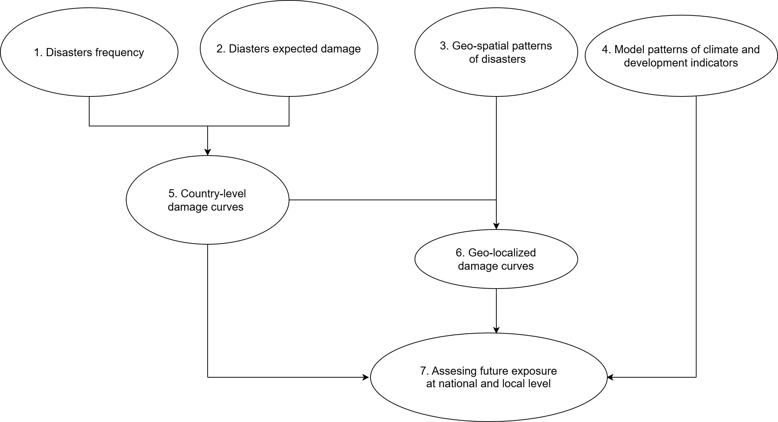
Figure 1: Architecture of the Probabilistic Geospatial Risk (PGR) model. Seven interconnected com- ponents combine disaster frequency, damage severity, geospatial patterns, and climate projections to produce geolocalized damage curves. Adapted from [1].

    - Disaster frequency model. This component estimates the probability distribution of the number of hydrometeorological disasters a country experiences per year. The model uses a Zero-Inflated Negative Binomial distribution, which captures two empirical features of the data: many country-years have zero reported disasters (the zero-inflation component), and the variance of disaster counts exceeds the mean (the negative binomial component). The model is estimated as a hierarchical Bayesian panel regression across countries and years, with country-level fixed effects, spatial random effects using the Besag–York–Molli´e (BYM) specification [13], and covariates including atmospheric CO₂, precipitation deviation, GDP per capita, and population density. The hierarchical framework enables partial pooling of information across countries, improving estimates for data-sparse countries like Lao PDR.
    - Disaster damage model. This component estimates the expected monetary cost of each disaster, conditional on its occurrence. It uses a Hurdle LogNormal distribution, which separates the process into two parts: a binary model for whether a disaster causes any reported damage, and a truncated LogNormal model for the magnitude of positive damages. This specification is well-suited to disaster cost data, which exhibits both a mass of zero- damage events and a heavy right tail—rare extreme events can generate damages orders of magnitude larger than the median [10, 9]. The covariate structure mirrors that of the frequency model, with the same hierarchical country effects allowing the model to learn country-specific relationships between economic development and disaster severity.
    - Geospatial risk model. This component models the probability of a disaster occurring at each specific point within a country. It uses a Hilbert Space Gaussian Process (HSGP) [12], a computationally efficient approximation to a full Gaussian Process that makes it fea- sible to estimate spatial patterns over tens of thousands of grid points. The HSGP learns

smooth spatial surfaces from historical disaster coordinates using a Mat´ern 5/2 kernel, ef- fectively identifying which areas are more disaster-prone based purely on the geography of past events. In the full model, these learned spatial patterns are combined with measurable geographic features—specifically, the logarithmic distance to the nearest river [15] and the logarithmic distance to the coastline—as well as country-level climate and economic covari- ates. The model is estimated at the regional scale (Lao PDR and its neighboring countries), using a binary classification framework that distinguishes observed disaster locations from synthetic non-disaster points generated across the country’s map.
    - Time series forecasting. To project the models into the future, the PGR system esti- mates Bayesian Exponential Time Smoothing (ETS) state-space models for each covariate. These models project country-level variables (real GDP, population, precipitation) and global climate indicators (atmospheric CO₂, ocean temperature deviation) forward in time. The Bayesian specification ensures that projection uncertainty is fully characterized—wider posterior intervals at longer horizons reflect the increasing difficulty of forecasting further into the future.
    - Country-level damage curves. The frequency and damage models are combined to produce the full probability distribution of annual disaster damages. By multiplying the estimated number of events by the expected damage per event across all posterior draws, the model generates a joint distribution that captures both the probability of disasters occurring and their potential severity. The key output is expressed in terms of return years: a 100- year return period (100-RY) event corresponds to the damage level that has a 1% chance of being exceeded in any given year—or equivalently, the damage level one would expect to be equaled or exceeded once every 100 years on average. Frequent events (low return years) are more common but cause less damage; rare events (high return years) are less frequent but can cause devastating damage when they occur. The Bayesian approach is particularly valuable here because disaster damage distributions are typically heavy-tailed: the mean is not a good summary of the risk, and it is precisely the tail behavior—captured by high return-year quantiles—that is most policy-relevant.
    - Geolocalized damage curves. The country-level damage curves are spatially disaggre- gated using the geospatial model’s probability surface. Each location receives a share of the national expected damages proportional to its estimated disaster probability. This produces location-specific damage curves that account for the geographic heterogeneity of risk within the country, enabling the identification of the most vulnerable areas and the prioritization of local adaptation investments.
    - Future exposure assessment. All components are integrated with the time series pro- jections to assess how risk evolves over time. As atmospheric CO₂ increases, ocean tem- peratures rise, and population grows, the model projects how disaster frequency, severity, and spatial distribution shift—producing forward-looking damage curves that quantify the escalating cost of climate inaction.

CO₂ Scenario Analysis
A central application of the PGR model is evaluating how alternative global emission pathways affect Lao PDR’s disaster risk. The IPCC’s Special Report on Emissions Scenarios (SRES)
[2] provides several trajectories for future CO₂ accumulation based on different socioeconomic assumptions. We use four scenarios that span the range of possibilities, described in Table 1. Notably, observed global CO₂ accumulation over the past two decades has tracked closest to the A1FI (high-emission) pathway [4], meaning that the most concerning projections in this analysis are also the most empirically relevant to current trends.
Table 1: IPCC SRES CO₂ emission scenarios used in the analysis.

Scenario | Level | Key Assumptions
B1 | Low | Global convergence toward a service and information econ-
 |  | omy, with emphasis on sustainability, clean energy, and re-
 |  | duced material intensity. Represents a world prioritizing
 |  | environmental and social sustainability.
B2 | Moderate-low | Locally oriented sustainability solutions with intermediate
 |  | economic development. Technological change is less rapid
 |  | but more diverse than in B1, reflecting heterogeneous re-
 |  | gional approaches to environmental protection.
A1B | Moderate-high | Rapid economic growth with global population peaking
 |  | mid-century. Energy sources are balanced across fossil and
 |  | non-fossil alternatives, with no heavy reliance on any single
 |  | fuel type.
A1FI | High | Same rapid growth and global convergence as A1B, but
 |  | with continued heavy dependence on fossil fuels. This path-
way produces the highest CO₂ accumulation and represents
the most carbon-intensive development trajectory.

The methodology for the scenario analysis proceeds as follows. For each IPCC scenario, the corresponding CO₂ trajectory—interpolated from decadal to yearly values—is substituted into the PGR model’s covariate set, replacing the baseline CO₂ projection while keeping all other variables (GDP, population, precipitation, ocean temperature) at their baseline projected val- ues. The pre-trained posterior distributions of all model parameters are then used to generate scenario-specific posterior predictive samples of disaster frequency, damages, and damage curves. This design isolates the effect of different global emission pathways on Lao’s disaster risk: any difference between scenarios is attributable solely to the CO₂ input. Figure 2 presents the four CO₂ trajectories used in the analysis.

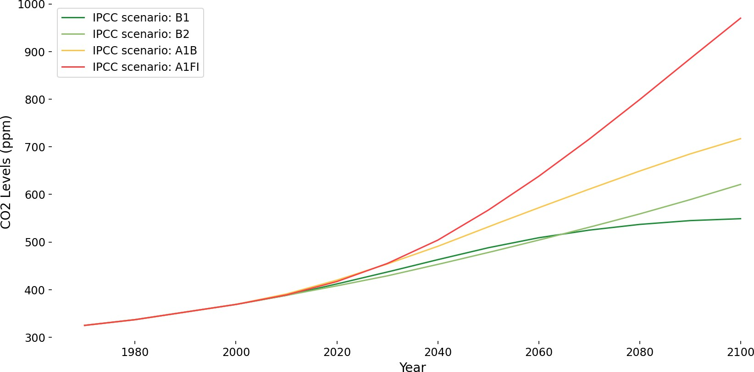

Figure 2: IPCC SRES CO₂ accumulation scenarios (B1, B2, A1B, A1FI) used as inputs to the PGR model. Higher scenarios correspond to more carbon-intensive development pathways.

Flood Wall Simulations
The second policy application of the PGR model evaluates the potential impact of local infras- tructure interventions on disaster risk. The geospatial component of the model identifies the distance to the nearest river as a key driver of flood risk at specific locations. We exploit this relationship to simulate the effect of building flood walls in specific cities.
We cannot directly introduce a flood wall into the model, as it does not contain geospatial in- formation regarding infrastructure. However, we can simulate its effect by making an equivalent change using the model’s variables. The primary effect of a flood wall is to isolate a particular point from the flood risk posed by nearby water bodies. We achieve a similar effect by artificially increasing the value of the distance-to-river variable at the grid point corresponding to each city, effectively simulating the hydrological isolation that a physical flood wall would provide.
We define two intervention scenarios:
Intermediate wall: The distance-to-river is set to the median value across the entire Laos prediction grid (approximately 48,000 grid points). This is equivalent to moving the city to a typical inland location, representing a moderate level of flood protection.
Full wall: The distance-to-river is set to the maximum value across the grid—equivalent to the most river-isolated point in Lao PDR. This represents the theoretical maximum benefit achievable through river isolation alone.
For each scenario, we recompute the full geospatial model predictions at the modified grid points and then generate new geolocalized damage curves for each city. The difference between the baseline and intervention damage curves measures the expected benefit of the flood wall in terms of reduced damages at various return periods. This methodology allows us to evaluate the current damage exposure of specific locations and to assess the potential economic returns of flood wall interventions based on expected damage reductions.

We apply these simulations to three cities: Attapeu, Vientiane, and Pakse, selected because they are population centers located near high-risk areas identified by the geospatial model.
It is important to note that this approach does not seek to replace detailed hydrological and topographical assessments. Rather, it provides a rapid, general, and cost-effective screening tool that can identify locations where more detailed engineering analysis is warranted.

Data
The PGR model draws on multiple data sources spanning disaster records, macroeconomic indicators, climate variables, and geospatial information. At the country level, disaster event counts and reported economic damages are obtained from the EM-DAT international disaster database [14]. These are merged with World Bank Development Indicators—GDP per capita and population density [18]—and with gridded precipitation data from the GPCC dataset [19], which is aggregated to country-level annual averages using national shapefiles. At the global level, two climate time series enter the model as covariates: atmospheric CO₂ concentration from NOAA’s Mauna Loa observatory [20] and ocean temperature deviation from the NOAA Global Surface Temperature Dataset [21]. For the geospatial component, we use World Bank country boundary shapefiles [18] and the HydroRIVERS global river network dataset [15], from which we compute the distance from each point to the nearest river and coastline. The analysis focuses on hydrometeorological disasters (floods, storms, and wet mass movements) recorded after 1980 that affected more than 1,000 people, yielding 5,692 events worldwide. Full details on data processing are provided in the companion paper [1].

AI-Based Geolocation of Disaster Events
A significant challenge for the geospatial component of the PGR model is the scarcity of ge- ographic coordinates in disaster databases. Out of 5,692 hydrometeorological disasters in the EM-DAT database, only 864—approximately 15%—have associated latitude and longitude coor- dinates. In contrast, 5,640 observations include a free-text “Location” field containing the names of affected places. This field is often complex: a single disaster may list multiple provinces, cities, and regions in inconsistent formats across different countries and languages.
To overcome this limitation, we developed an automated pipeline that sends each disaster’s location text, along with its country and region, to OpenAI’s GPT-4o-mini large language model [17]. The model is instructed to parse the text, identify individual locations, and return geographic coordinates for each one. A multi-stage validation process ensures data quality: the returned coordinates are spatially joined with country boundary shapefiles to verify that each point falls within the correct country, with a buffer applied to account for coastal and border imprecision. Points that fail this check are removed.
After processing, the pipeline transforms the textual location data into 2,876 individual coor- dinate points—more than tripling the original geospatial coverage of the database. Figure 3 compares the spatial representation of disaster locations before and after the AI-based geocod- ing, showing the dramatic improvement in coverage. This enriched dataset is critical for training

the HSGP geospatial model, which would otherwise be limited to the small fraction of events with pre-existing coordinates. The full methodology and validation results are detailed in [1].
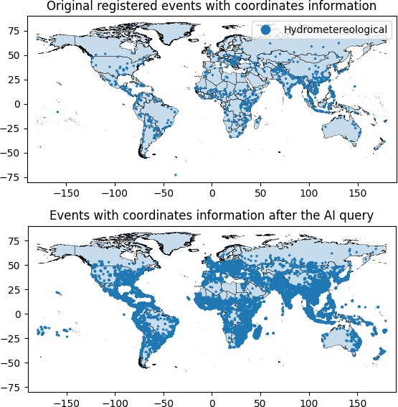

Figure 3: Disasters with geographic coordinates before and after the AI-based geocoding query. The left panel shows the 864 disasters with pre-existing coordinates in EM-DAT. The right panel shows the expanded set of 2,876 coordinate points after processing location text through GPT-4o-mini.

Synthetic Non-Disaster Points for Model Training
The geospatial component of the PGR model estimates the probability of a disaster occurring at each specific point within a country. To train this model, we need both positive examples (locations where disasters occurred) and negative examples (locations where they did not). We generate synthetic non-disaster points by randomly placing 15 points within the country boundaries for each real disaster location. This ratio was determined through extensive testing to produce high-quality posterior samples for the HSGP model.
The disaster and synthetic non-disaster points are merged into a single training dataset. For each point—whether real or synthetic—we compute the logarithmic distance to the nearest river and the nearest coastline, and assign the relevant country-level covariates for the corresponding year. All features are standardized before estimation. The geospatial model is trained at the

regional scale: for Lao PDR, the training data includes disaster points from Cambodia, Thailand, Laos, and Vietnam. Figure 4 shows the spatial distribution of real disaster points and synthetic non-disaster points across the region.
It is important to note that the disaster-to-non-disaster ratio does not affect the final probability estimates, as the model outputs are normalized by dividing each point’s probability by the sum across all points. The synthetic points serve only to provide the model with a representative sample of geographic locations against which to contrast the observed disaster patterns.

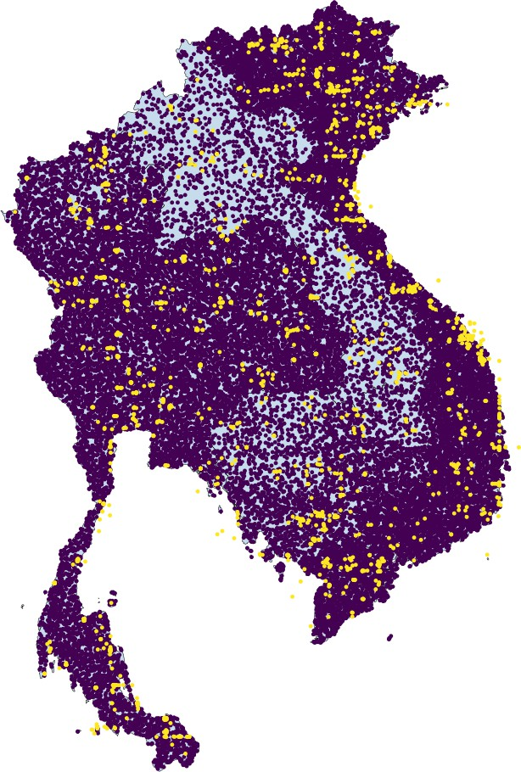

Figure 4: Disaster and synthetic non-disaster points for Cambodia, Thailand, Laos, and Vietnam. Yellow points correspond to geocoded disaster locations; purple points are randomly generated non- disaster locations used for model training.

Baseline Results
The PGR model produces baseline projections under current climate and development trends. These results establish the reference point against which policy scenarios are later compared.

Disaster Frequency
The frequency model estimates how many hydrometeorological disasters Lao PDR can expect per year. Figure 5 presents the in-sample results: historically, Lao has experienced fewer than one major disaster per year on average, with a clear upward trend in the last decade. The model captures both the central tendency and the uncertainty around the observed counts. The

zero-inflated structure is well-suited to the data, as many years have no reported disasters at all—a pattern that standard count models would struggle to accommodate.
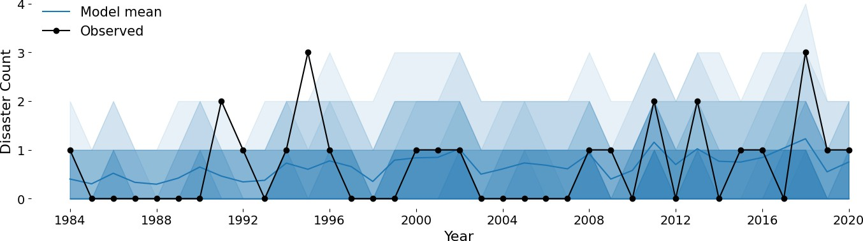
Figure 5: In-sample event frequency model results for Lao PDR. Black points correspond to the observed number of disasters, the blue line to the mean prediction, and the shaded region to the 95% HDI (lighter shading indicates lower probability).

Figure 6 shows the forward-looking projections. The model projects a clear upward trend: the mean number of yearly disasters increases to approximately 3 by 2060, with the 95% Highest Density Interval (HDI) extending up to 6 events. For context, by 2020 one could be 95% confident that the number of major hydrometeorological disasters was fewer than 3; by 2060, this upper bound doubles to 6. This escalation is driven by the combined effect of rising atmospheric CO₂, increasing ocean temperatures, and changes in precipitation patterns—all of which enter the model as covariates and are projected to intensify over the coming decades [4]. (These estimates consider only events reported to affect more than 1,000 people.)
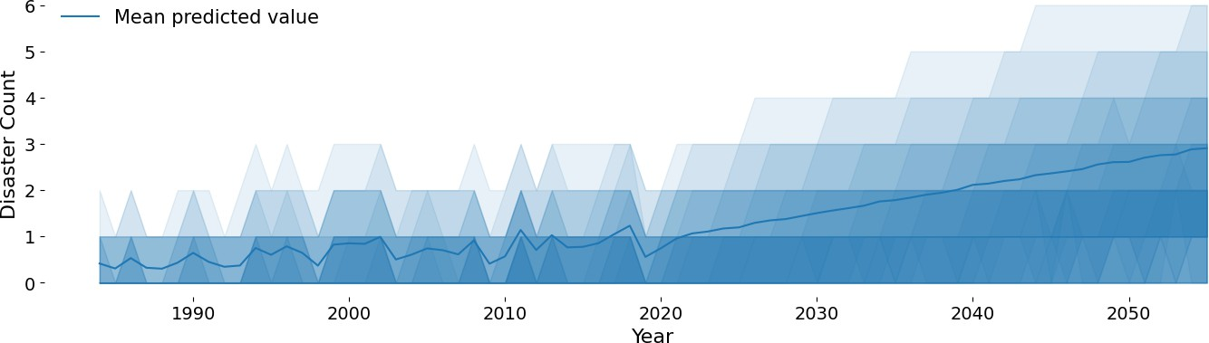
Figure 6: Projected disaster frequency for Lao PDR. The blue line shows the mean prediction, and shaded regions correspond to the 95% HDI. The model projects a clear increase in the expected number of hydrometeorological disasters.

The growing trend in disaster frequency is consistent with the broader climate science literature, which projects that warming temperatures will intensify the hydrological cycle, leading to more frequent and severe rainfall events, stronger tropical storms, and increased flood risk across Southeast Asia [5]. The Bayesian framework allows us to quantify the uncertainty around these projections: the widening HDI at longer horizons reflects the compounding uncertainty in both the climate covariates and the disaster process itself.

Disaster Damages
The damage model estimates the expected monetary cost of each disaster, conditional on its occurrence. Figure 7 shows the in-sample results. A notable pattern emerges: in the last decade, Lao experienced three disasters that surpassed all previous events in terms of damage. The 2018 flood was particularly destructive, with damages outside the 80% HDI—this event, caused by the collapse of the Xe-Pian Xe-Namnoy dam, displaced thousands and caused extensive infrastructure damage. Despite this, all reported events remain within the 95% HDI, confirming the model’s ability to capture even extreme outcomes through its heavy-tailed Hurdle LogNormal specification.
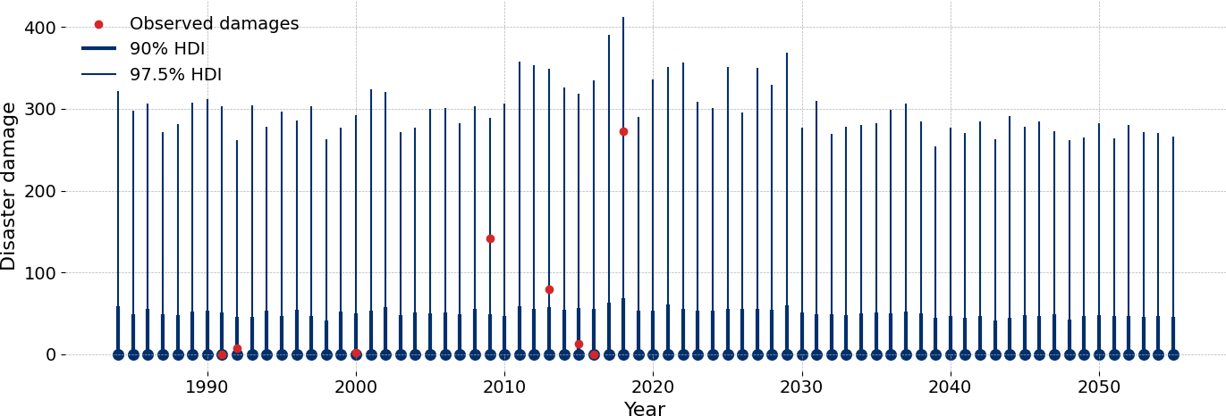
Figure 7: Damage model results for Lao PDR. Red points correspond to observed damages, the light blue line to the 97.5% HDI, and the wider blue line to the 90% HDI. Damages are expressed in 2025 USD millions.

Importantly, the model does not project a growing trend in per-event damages. This is because the damage model uses a hierarchical country-level structure that infers different relationships between covariates and damages for each country—and in the case of Lao PDR, the data does not support a strong upward trend in the cost of individual events. However, the total risk exposure is not determined by per-event damages alone: it is the product of how many disasters occur (frequency) and how costly each one is (severity). As we will see in the next section, the combination of increasing frequency with the heavy-tailed damage distribution produces a dramatic escalation in aggregate risk.

Damage Curves and Return Years
To assess the total risk exposure, we combine the frequency and damage distributions to produce damage curves—the full probability distribution of annual damages for each future year. Figure 8 presents these curves for Lao PDR. Most of the probability mass corresponds to low-damage outcomes, but as we move into the tails, damages increase sharply. The key finding is that the model projects an upward shift in the entire damage curve over time: more extreme events will become more frequent, and more frequent events will generate greater damages.

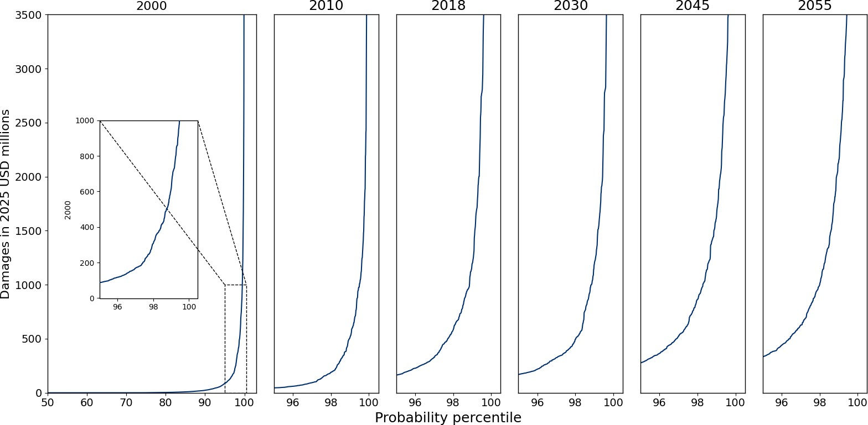

Figure 8: Damage curves for Lao PDR. Each curve shows the damage associated with each probability percentile for a given year. The upward shift indicates that extreme events become more frequent and costly over time.

Table 2 and Figure 9 express these results in terms of return years. The 100-year return period damage—the level that has a 1% chance of being exceeded in any given year—rises from ap- proximately USD 611 million in 2000 to over USD 2.1 billion by 2055, a 3.5-fold increase. The 50-year return value more than triples (from USD 308 million to USD 998 million), and the 10-year return value increases five-fold (from USD 23 million to USD 117 million).
Table 2: Projected return year damages for Lao PDR (USD millions, 2025 prices). Each value represents the expected damage from an event that occurs on average once every X years.

Return Period | 2000 | 2010 | 2018 | 2030 | 2045 | 2055
100 RY | 611 | 512 | 1,196 | 1,188 | 1,623 | 2,134
50 RY | 308 | 188 | 582 | 493 | 864 | 998
10 RY | 23 | 11 | 52 | 57 | 90 | 117
4 RY | 1 | 0 | 3 | 5 | 11 | 14

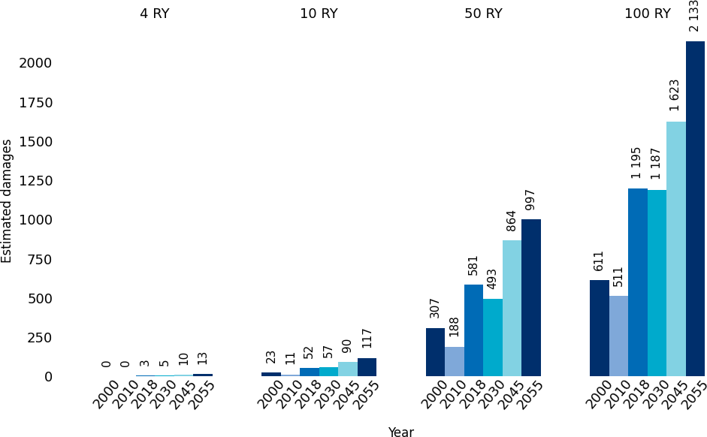

Figure 9: Return year damage projections for Lao PDR. Each group of bars shows how the mean damage for a given return period evolves over time.

To place these numbers in perspective, Lao PDR’s GDP was approximately USD 20 billion in 2023. A 100-year return period event by 2055 (USD 2.1 billion) would represent over 10% of national output—a potentially devastating shock to the economy, infrastructure, and public finances. Even more concerning is the growth in moderate return periods: by 2055, a 10-year return event is projected to cause damages exceeding USD 117 million, compared to just USD 23 million in 2000. This shift means that not only will catastrophic events become more damaging, but recurrent disasters will also impose higher recurring costs, straining government budgets, recovery capacity, and long-term development planning.

Geospatial Risk Patterns
The geospatial model identifies where within Lao PDR disasters are most likely to occur. Fig- ure 10 presents the full model’s event probability map. The model combines learned spatial patterns (via the HSGP component) with distance to rivers and coastlines to produce a risk surface. Key high-risk zones include the center-left area where major rivers converge, the area near the capital Vientiane, and the lower-right region where coastal proximity contributes to risk.

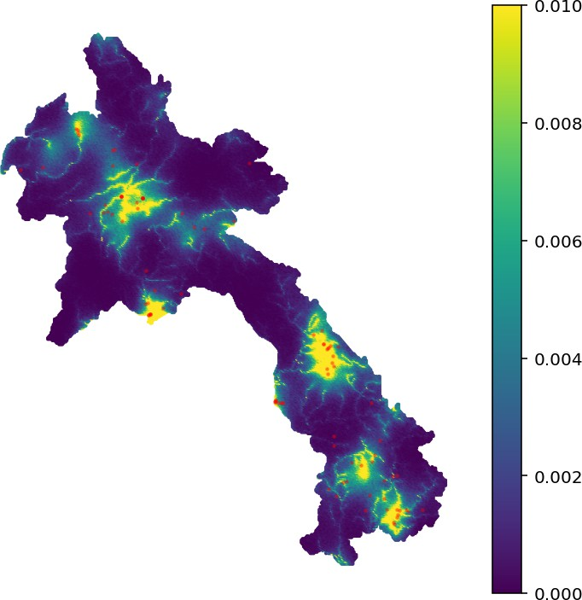

Figure 10: Full geospatial model event probability for Lao PDR (2018). Lighter colors indicate higher probability of disaster occurrence. Red points mark observed disaster locations. The model identifies river confluence areas and specific coastal zones as highest-risk.

An important feature of the full model is its ability to distinguish which river-adjacent areas are genuinely dangerous from those that are not. The distance-to-river covariate alone would assign elevated risk to every point near any river, regardless of whether that area has historically experienced disasters. By combining this covariate with the HSGP learned spatial component— which captures the geographic clustering of past disaster locations—the model can identify that proximity to rivers increases risk only in specific regions where historical disaster patterns confirm this relationship. In areas where rivers are present but disasters have not historically concentrated, the HSGP component attenuates the river-distance effect, producing a more nu- anced and accurate risk surface. This interaction between the data-driven spatial patterns and the physically motivated distance covariate is what allows the model to produce targeted risk assessments rather than indiscriminate river-proximity alerts.
Because the geospatial model’s output is normalized—each point’s probability is divided by the sum across all points—the spatial risk surface alone does not change in total intensity over time; it only describes the relative distribution of risk across locations. To understand how absolute geospatial risk evolves, we multiply each point’s local probability by the country’s projected number of disasters for that year, yielding the expected number of events at each location. Figure 11 shows how this expected count increases over the coming decades, reflecting the combined effect of rising CO₂, warming oceans, and growing population exposure. The temporal evolution reveals that risk intensifies most in areas that are already the most vulnerable—a

pattern of compound disadvantage where the communities most exposed to current risk face the steepest future increases.
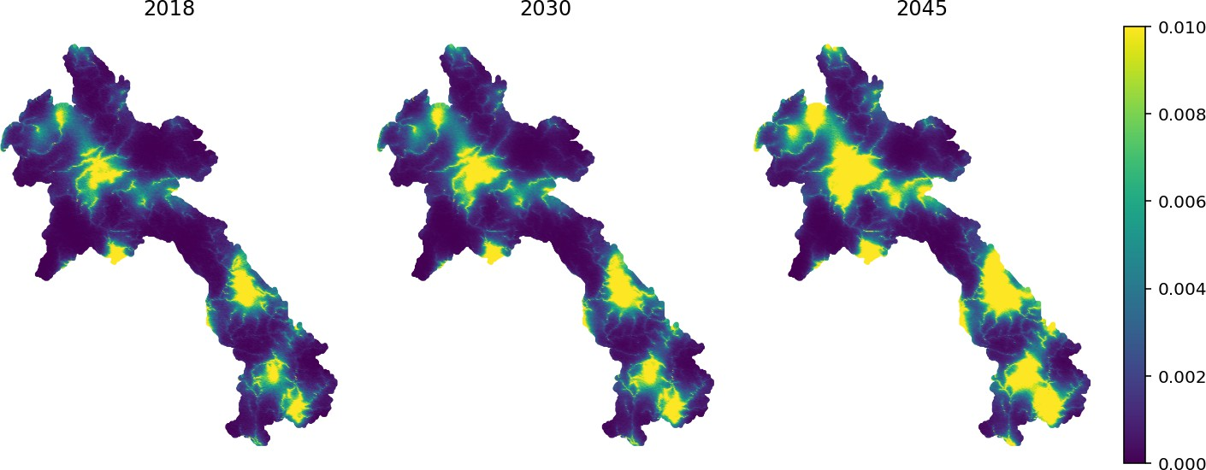
Figure 11: Expected number of disasters at each point in Lao PDR, projected over time. The maps show how local exposure intensifies as climate and demographic trends continue.

These baseline results establish that Lao PDR faces a significant and growing climate risk under current trends. In the following sections, we examine how alternative global emission pathways and local infrastructure interventions can alter this trajectory.

Results: CO₂ Scenario Analysis

Impact on Disaster Frequency and Severity
The scenario analysis reveals that higher CO₂ pathways are associated with both more frequent and more severe disasters in Lao PDR. Figure 12 presents the predicted disaster count under each scenario, showing that the highest-emission pathway (A1FI) leads to noticeably higher disaster frequencies compared to the low-emission scenario (B1), particularly after 2035.
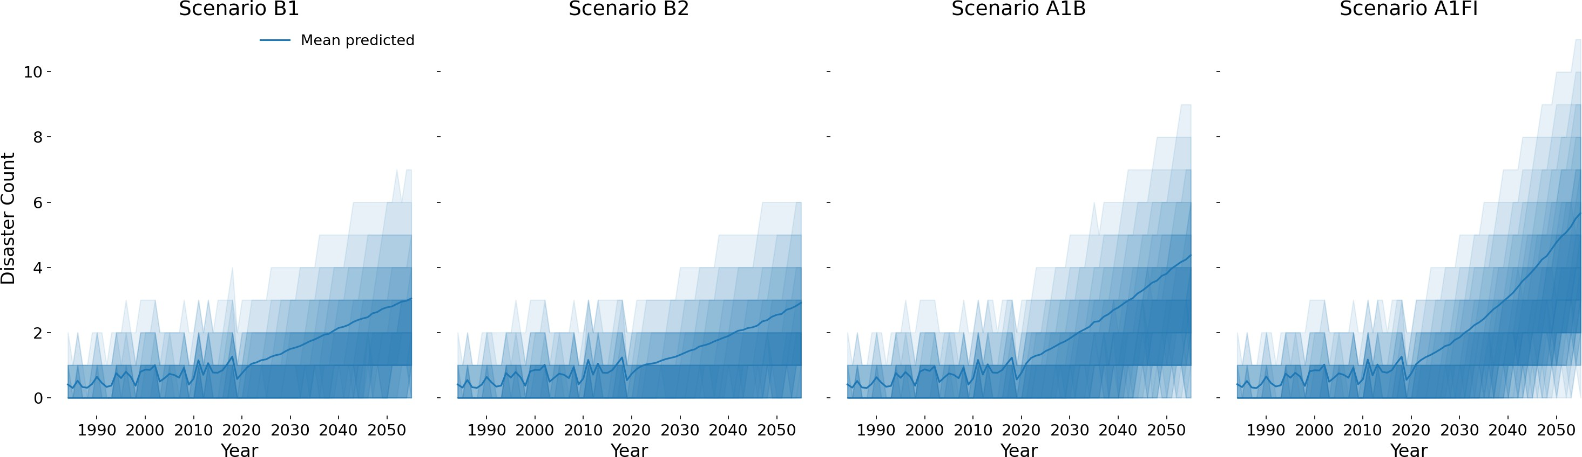

Figure 12: Predicted yearly disaster count for Lao PDR under four IPCC SRES scenarios. Shaded regions indicate the 95% high density interval. Higher CO₂ scenarios produce higher expected disaster counts.

The divergence between scenarios accelerates after 2035, when cumulative CO₂ differences be- come large enough to meaningfully shift the frequency distribution. In the near term (2025– 2030), all four scenarios produce similar disaster counts because the CO₂ trajectories have not yet diverged substantially. However, by the 2040s and 2050s, the compounding effect of higher atmospheric CO₂ concentrations becomes increasingly pronounced, leading to a widening gap between the low-emission (B1) and high-emission (A1FI) pathways. This non-linear acceleration underscores the urgency of early emission reductions: delaying action narrows the window in which meaningful divergence between pathways can be achieved.
The damage projections in Figure 13 show a similar pattern: while the median damage remains moderate across scenarios, the upper tails of the distribution—representing extreme events— diverge substantially. Under A1FI, the probability of experiencing very high-damage events grows significantly relative to B1. This is precisely where the Bayesian approach adds the most value: by estimating the full probability distribution rather than just the mean, the model re- veals that the most policy-relevant differences between scenarios lie in the tails of the damage distribution—the region where traditional point-estimate approaches provide the least informa- tion.
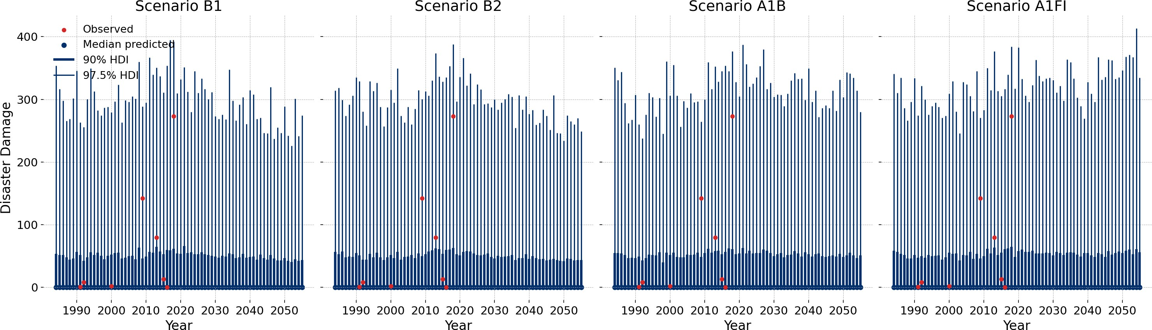

Figure 13: Predicted disaster damages for Lao PDR under four IPCC scenarios. Thinner segments correspond to the 80% probability intervals, thicker segments to the 50% intervals. The tails of the damage distribution grow substantially under higher-emission scenarios.

Impact on Return-Year Damages
The differences between scenarios become most pronounced for extreme events—precisely the region of the damage distribution that matters most for policy planning, where the Bayesian framework’s ability to estimate full posterior distributions adds the greatest value over point- estimate approaches. Figures 14, 15, and 16 compare the estimated damages at the 10-year, 50-year, and 100-year return periods across scenarios and future decades.

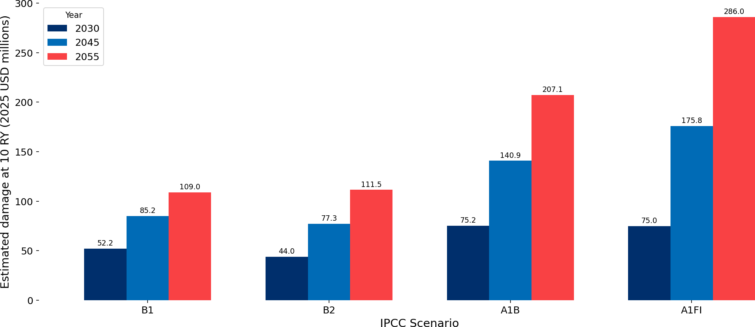

Figure 14: Estimated 10-year return period damages (USD millions) under four IPCC scenarios for 2030, 2045, and 2055. Even for relatively frequent events, the gap between low and high emission scenarios is substantial.

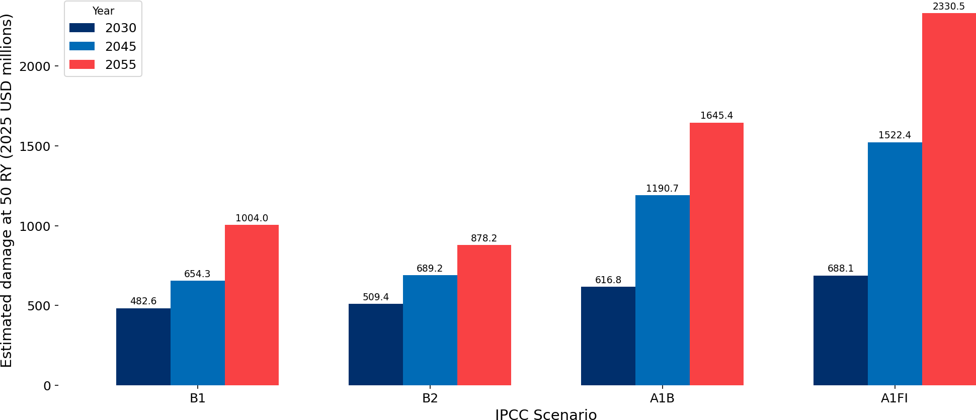

Figure 15: Estimated 50-year return period damages (USD millions) under four IPCC scenarios for 2030, 2045, and 2055. The gap between low and high emission scenarios widens over time.

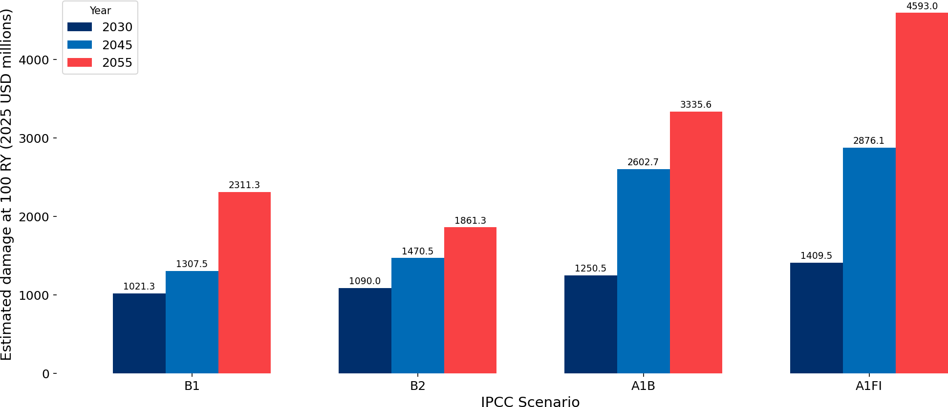

Figure 16: Estimated 100-year return period damages (USD millions) under four IPCC scenarios for 2030, 2045, and 2055.

Key findings from the scenario comparison:
By 2030, the 100-year return period damage ranges from $1,021 million (B1) to $1,410 million (A1FI)—a 38% increase between the lowest and highest emission scenarios.
By 2055, the gap widens dramatically. The 100-RY damage under B1 is $2,311 million, while under A1FI it reaches $4,593 million—a 99% increase. For the 50-RY event, the difference is 132% ($1,004M vs. $2,330M).
The 10-year return period—representing events that occur roughly once per decade— shows that emission scenarios matter not only for catastrophic tail events but also for recurrent disasters. By 2055, the 10-RY damage under A1FI ($286M) is 2.6 times higher than under B1 ($109M). These are the events that repeatedly strain government budgets and recovery capacity, and the scenario divergence indicates that higher emissions will substantially increase the recurring fiscal burden of climate-related disasters.
Even the moderate scenarios (B2, A1B) produce meaningfully higher damages than B1, indicating that partial emission reductions still yield measurable benefits.
To place the 2055 results in perspective, the USD 2.3 billion gap between the B1 and A1FI scenarios at the 100-year return period represents more than 10% of Lao PDR’s current GDP. This means that the choice between global emission pathways—a decision largely outside Lao’s control—could determine whether a catastrophic disaster event is manageable or economically devastating. The fact that even the moderate scenarios (B2 and A1B) produce damages signif- icantly above B1 reinforces the importance of pursuing the most ambitious feasible reductions: every increment of avoided CO₂ translates into measurably lower disaster risk for vulnerable countries like Lao PDR.
These results reveal a fundamental asymmetry: Lao PDR contributes negligibly to global CO₂ emissions—less than 0.1% of the global total—yet bears disproportionate consequences from higher-emission pathways chosen by major emitters. The USD 2.3 billion gap between B1 and

A1FI at the 100-year return period quantifies what might be called the adaptation premium: the additional cost that vulnerable countries must bear, or insure against, when the world fol- lows a high-emission trajectory rather than an ambitious mitigation pathway. This asymmetry strengthens the case for international climate finance mechanisms that channel adaptation sup- port to countries whose risk exposure is shaped by decisions largely beyond their control. While Lao PDR cannot meaningfully influence global emission trajectories, it can invest in local adap- tation infrastructure to reduce the impact of the disasters that do occur. The following section evaluates one such intervention.
These results demonstrate that global CO₂ emission pathways have direct, quantifiable conse- quences for Lao PDR’s disaster exposure. The divergence between scenarios accelerates over time, making early emission reductions increasingly valuable.

Results: Flood Wall Simulations

City Selection and Baseline Risk
We focus on three population centers located near high-risk areas: Attapeu, Vientiane, and Pakse. Figure 17 shows their locations on the geospatial risk heatmap, where lighter colors indicate higher disaster probability. These cities were selected to represent different risk profiles: Attapeu lies in a river-dominated risk zone in the southeast, Vientiane is the capital and largest population center with a complex multi-factor risk profile, and Pakse is a medium-sized city in the south with moderate baseline risk.
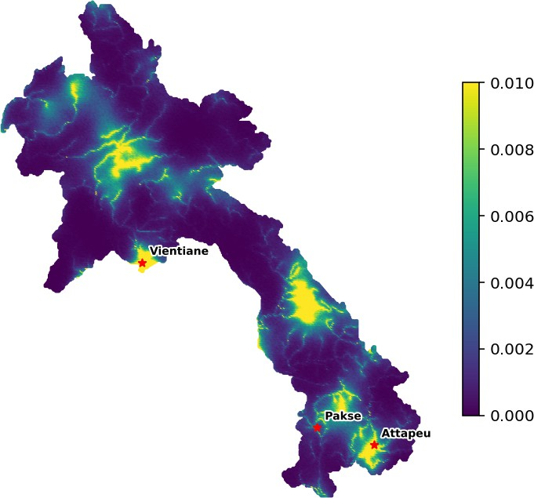

Figure 17: Geospatial risk map of Lao PDR with the three cities selected for flood wall simulations. The heatmap represents the normalized probability of disaster occurrence at each grid point.

Damage Reduction Results
Figure 18 presents the estimated damages at different return periods for each city under the three scenarios (no wall, intermediate wall, full wall). Table 3 summarizes the damage reduction

in absolute terms.
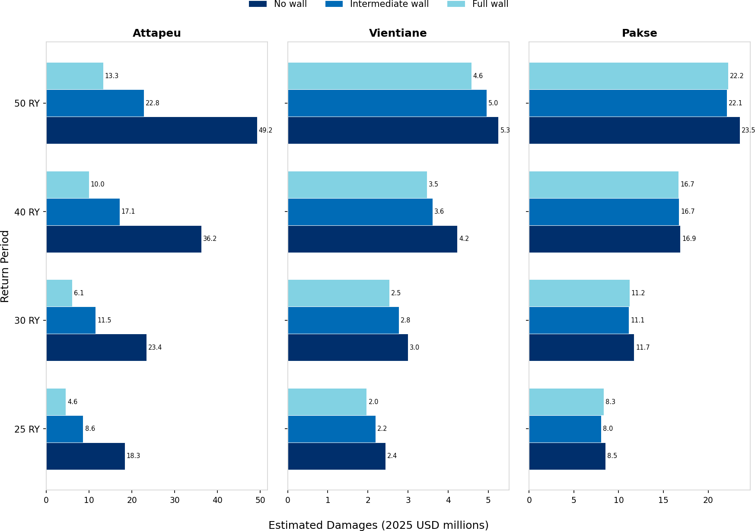
Figure 18: Estimated damages (USD millions) at 25, 30, 40, and 50-year return periods for Attapeu, Pakse, and Vientiane under three scenarios: no wall (baseline), intermediate wall (median river distance), and full wall (maximum river distance). Year 2030 projections.

Table 3: Damage reduction from flood wall interventions (USD millions), year 2030. Values represent the decrease in expected damages relative to the no-wall baseline.

City Return Period | Full Wall | Intermediate Wall
25 RY | 13.79 | 9.72
Attapeu 30 RY | 17.34 | 11.90
40 RY | 26.22 | 19.07
50 RY | 35.91 | 26.38
25 RY | 0.19 | 0.50
Pakse 30 RY | 0.51 | 0.58
40 RY | 0.18 | 0.14
50 RY | 1.32 | 1.45
25 RY | 0.47 | 0.25
Vientiane 30 RY | 0.46 | 0.22
40 RY | 0.76 | 0.62
50 RY | 0.68 | 0.30

The results reveal sharply different effectiveness across cities:
Attapeu shows the largest benefit. A full wall reduces 50-RY damages by $35.9 million (73% reduction), and even an intermediate wall achieves a $26.4 million reduction (54%).

This is because Attapeu’s risk profile is dominated by river proximity: the geospatial model’s HSGP component and the distance-to-river covariate both contribute strongly to the local risk at this location. When the effective distance to the river is increased, the model predicts a dramatic reduction in event probability, which propagates through the damage curve to produce large absolute savings. The scaling of the benefit with return period—from $13.8M at 25-RY to $35.9M at 50-RY—reflects the fact that flood walls are most valuable precisely when they are needed most: during the rarer, more extreme events that cause the greatest damage.
Pakse shows minimal benefit (5–6% reduction at 50 RY). Despite being located near rivers, Pakse’s overall risk profile is relatively low, and the river distance component contributes less to its total risk compared to Attapeu. The HSGP spatial component assigns Pakse a lower baseline probability, which limits the absolute damage savings achievable through river- based interventions. The small and inconsistent reductions across return periods suggest that other risk factors—not addressable by a flood wall—dominate Pakse’s exposure.
Vientiane shows moderate but limited benefit (13% reduction at 50 RY with a full wall). As the capital and largest urban center, Vientiane’s risk is driven more by regional disas- ter patterns captured by the Gaussian Process component—reflecting the broader cluster- ing of disasters around major population centers, high population density, and economic concentration—than by river proximity alone. A flood wall addresses only one compo- nent of a multi-factor risk profile. For Vientiane, complementary strategies such as urban drainage improvements, early warning systems, and land-use planning would likely yield greater marginal returns than river-based infrastructure alone.
This analysis demonstrates that flood wall effectiveness depends critically on the local risk de- composition. Cities where river proximity is the dominant risk factor—as identified by the geospatial model’s component analysis—benefit most from river-based interventions. In con- trast, cities where regional patterns, coastal exposure, or other factors dominate require a broader set of adaptation strategies.
These results provide a first overview of the potential benefits of flood wall interventions, and should be complemented by detailed engineering analysis before investment decisions are made. Nevertheless, the geospatial risk decomposition offers a valuable screening tool for policymakers: it identifies which cities are most likely to benefit from river-based infrastructure, helping to pri- oritize where in-depth hydrological and engineering assessments should be conducted. Without this kind of preliminary risk decomposition, a one-size-fits-all approach to flood defense could waste resources in cities where the dominant risk factors are not addressable by flood walls, while missing opportunities for high-impact interventions in cities like Attapeu.
The methodology demonstrated here is scalable to other types of infrastructure interventions. Just as flood walls are simulated by modifying the distance-to-river covariate, other interventions— such as improved drainage systems, levees, or coastal defenses—could be evaluated by adjusting the relevant geospatial covariates in the model. This flexibility makes the PGR framework a general-purpose tool for evaluating adaptation infrastructure, not just flood walls.

From a cost-benefit perspective, the damage reductions quantified above provide the “benefit” side of an investment analysis. For instance, the USD 35.9 million reduction in 50-year return period damages for Attapeu under a full wall scenario can be directly compared against the construction and maintenance costs of a flood wall to assess investment feasibility. While en- gineering cost estimates are outside the scope of this analysis, the probabilistic damage curves provide exactly the inputs needed for such an evaluation. Moreover, combining the flood wall analysis with the CO₂ scenario results from the previous section would reveal how infrastruc- ture requirements scale under different emission pathways: higher-emission scenarios, which produce larger expected damages, would correspondingly increase the economic returns from flood protection—but may also require more robust and costly defenses to achieve the same level of protection.

Conclusions
This policy note demonstrates the PGR model’s capacity to inform climate adaptation policy in Lao PDR through baseline projections, scenario analysis, and local intervention simulations. For the full methodological details, including model specifications, estimation procedures, and diagnostic results, the reader is referred to the companion paper [1].
Baseline projections reveal escalating risk. Even under current trends, the model projects that disaster frequency will approximately triple by 2060, and 100-year return period damages will rise from USD 611 million in 2000 to over USD 2.1 billion by 2055. Critically, moderate- frequency events (10-year return periods) also show a five-fold increase, implying that recurring disaster costs will grow substantially alongside catastrophic tail risks. The geospatial model fur- ther identifies specific high-risk zones—particularly river confluence areas—where this escalation will be most acute.
Global emission pathways matter for local risk. The CO₂ scenario analysis shows that higher emission trajectories translate directly into greater disaster risk for Lao PDR. By 2055, the difference between the lowest and highest emission scenarios represents a potential doubling of damages from extreme events (100-RY: $2,311M under B1 vs. $4,593M under A1FI). This underscores the importance of international cooperation on emission reductions as a means of protecting vulnerable countries.
Local interventions can be highly effective—but must be targeted. The flood wall simulations show that infrastructure investments can achieve dramatic damage reductions in cities where river proximity is the primary risk driver. In Attapeu, a full flood wall could reduce 50-year return period damages by 73%. However, the same intervention yields minimal benefit in cities like Pakse and Vientiane, where other risk factors dominate. This highlights the importance of using geospatial risk decomposition to prioritize and design infrastructure investments.

Policy recommendations:
Prioritize flood defense infrastructure in cities where the geospatial model identifies river

proximity as the dominant risk factor.
Develop complementary adaptation strategies for cities where regional disaster patterns drive risk, such as early warning systems and land-use planning.
Advocate for alignment with low-emission global CO₂ pathways, as even moderate reduc- tions in global emissions yield measurable benefits for Lao PDR’s disaster exposure.
Use the probabilistic framework to evaluate additional intervention scenarios, such as com- bined flood walls and drainage improvements, or alternative city selections.
The PGR model’s scenario-based framework provides a flexible tool for evaluating policy in- terventions before implementation, enabling evidence-based prioritization of climate adaptation investments.
Broader implications. Although this analysis focuses on Lao PDR, the PGR methodology is not country-specific. The framework can be applied to any country with historical disaster records, and the hierarchical Bayesian structure is particularly well-suited to data-scarce de- veloping countries, where it borrows strength across countries to improve local estimates. The methodology can also be extended to other hazard types—including droughts, wildfires, and extreme temperature events—by adjusting the disaster classification and relevant covariates. Furthermore, the probabilistic outputs—damage curves expressed in monetary terms at spe- cific return periods—are directly compatible with standard cost-benefit analysis frameworks, enabling development finance institutions to compare expected avoided damages against inter- vention costs.
Limitations and future work. Several limitations should be noted. The model relies on historical disaster records from EM-DAT [14], which may undercount events in earlier decades and in remote areas, potentially leading to underestimation of baseline risk. The flood wall simulation modifies the distance-to-river covariate rather than explicitly modeling engineering infrastructure; future work could integrate hydraulic models to more precisely estimate protec- tive capacity The time series projections assume continuation of historical trends and do not capture structural breaks such as rapid industrialization or major policy shifts. Key extensions that would strengthen the framework include: integrating adaptation cost estimates for full cost- benefit analysis, extending to additional Mekong region countries, and incorporating compound disaster risks—where one event triggers or amplifies subsequent events—which are expected to become more prevalent under climate change [3].
A call to action. The results presented in this note underscore the urgency of proactive climate adaptation in Lao PDR. The non-linear acceleration of risk divergence between emission scenar- ios means that the window for effective action narrows with each year of delay: early investments in both local infrastructure and international emission reductions yield disproportionately large benefits compared to equivalent investments made later. The PGR model provides the quanti- tative evidence base needed to design, prioritize, and evaluate such investments—contributing to a shift from reactive disaster response toward proactive, evidence-based climate adaptation planning for developing countries.

References
- Saldarriaga, C., Grabowski, J., and Rielaender, J. (2026). “Estimating Climate Change Risk Exposure: A Probabilistic Approach.” Working Paper, OECD Development Center.
- IPCC (2000). Special Report on Emissions Scenarios. Cambridge University Press.
- IPCC (2023). Climate Change 2023: Synthesis Report. Contribution of Working Groups I, II and III to the Sixth Assessment Report. Geneva, Switzerland.
- IPCC (2021). Climate Change 2021: The Physical Science Basis. Contribution of Working Group I to the Sixth Assessment Report. Cambridge University Press.
- IPCC (2022). Climate Change 2022: Impacts, Adaptation and Vulnerability. Contribution of Working Group II to the Sixth Assessment Report. Cambridge University Press.
- L´opez, R., Thomas, V., and Troncoso, P. (2015). “Climate Change and Natural Disasters.” Working Paper.
- Van Aalst, M. K. (2006). “The Impacts of Climate Change on the Risk of Natural Disasters.”
Disasters, 30(1), 5–18.
- Nordhaus, W. D. (2019). “Climate Change: The Ultimate Challenge for Economics.” Amer- ican Economic Review, 109(6), 1991–2014.
- Howard, P. H. and Sterner, T. (2017). “Few and Not So Far Between: A Meta-analysis of Climate Damage Estimates.” Environmental and Resource Economics, 68(1), 197–225.
- Cavallo, E. and Noy, I. (2011). “Natural Disasters and the Economy—A Survey.” Interna- tional Review of Environmental and Resource Economics, 5(1), 63–102.
- Abril-Pla, O., Andreani, V., Carroll, C., Dong, L., Fonnesbeck, C. J., Kochurov, M., Kumar, R., Lao, J., Luhmann, C. C., Martin, O. A., Osthege, M., Vieira, R., Wiecki, T., and Zinkov,
R. (2023). “PyMC: A Modern, and Comprehensive Probabilistic Programming Framework in Python.” PeerJ Computer Science, 9, e1516.
- Solin, A. and S¨arkk¨a, S. (2020). “Hilbert Space Methods for Reduced-Rank Gaussian Pro- cess Regression.” Statistics and Computing, 30(2), 419–446.
- Besag, J., York, J., and Molli´e, A. (1991). “Bayesian Image Restoration, with Two Ap- plications in Spatial Statistics.” Annals of the Institute of Statistical Mathematics, 43(1), 1–20.
- CRED (2024). EM-DAT: The International Disaster Database. Centre for Research on the Epidemiology of Disasters, Universit´e catholique de Louvain, Brussels, Belgium.
- Lehner, B. and Grill, G. (2013). “Global River Hydrography and Network Routing: Base- line Data and New Approaches to Study the World’s Large River Systems.” Hydrological Processes, 27(15), 2171–2186.

- Government of Lao PDR (2018). Post-Disaster Needs Assessment: 2018 Floods, Lao PDR. United Nations Lao PDR.
- OpenAI (2024). “GPT-4o mini: Advancing Cost-Efficient Intelligence.” OpenAI Research Blog.
- World Bank (2024). World Development Indicators. Washington, DC: The World Bank.
- Schneider, U., Becker, A., Finger, P., Rustemeier, E., and Ziese, M. (2022). GPCC Full Data Monthly Product Version 2022. Global Precipitation Climatology Centre.
- NOAA (2024). Trends in Atmospheric Carbon Dioxide. National Oceanic and Atmospheric Administration, Global Monitoring Laboratory.
- Zhang, H.-M., Huang, B., Lawrimore, J., Menne, M., and Smith, T. (2019). NOAA Global Surface Temperature Dataset (NOAAGlobalTemp). National Centers for Environmental In- formation.

