**ECE570 Mini-Project: 2 Wheel Balancing Robot**

**Authors: Jesse Jenkins, Israel Prescott, Jacob Metcalf**

Purpose:

The purpose of this robot is to maintain its balance by correcting its movement if it starts to tip. We employed an STM32 microcontroller along with a gyroscope and a PID controller to determine the necessary corrections. These corrections were then applied by interfacing the microcontroller with a PCB (Motor Driver) to regulate the voltage supplied to the motor. While the robot initially functioned as expected, its accuracy decreased over time as the error accumulated.

To enhance the robot's performance and longevity, we considered integrating an accelerometer. However, during our attempts to implement this, we encountered conflicts between the gyroscope and the accelerometers addresses. As a result, instead of persisting with the accelerometer integration, we focused on fine-tuning the existing PID controller. In optimal conditions, the robot is now capable of self-balancing for approximately 30-60 seconds.(See Figures below on how to connect the whole thing)

**Final Product**

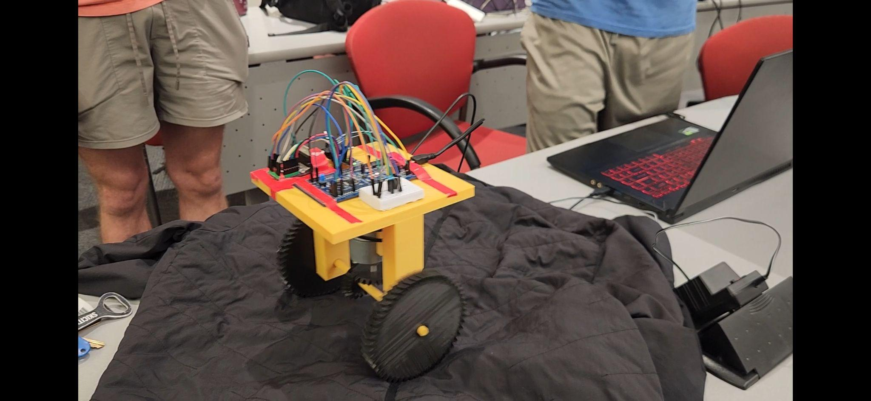

**Parts:**

STM32F0 Board

PCB(Motor Driver)-Completed as a separate class assignment and implemented in this assignment

Motor

2 Wheels

1 axle

Something to house all other parts.

**Pin Connections STM32F072 to PCB:**

| STM32F072 | PCB(Custom Motor Driver) Pin |
| --- | --- |
| PB4 | ENCB |
| PB5 | ENCA |
| PA8 | IN2 |
| PA5 | IN1 |
| PA4 | ENABLE |
| 5V | 5V |
| 3V | 3.3V |
| GND | GND |
| PA1 | I_Sense |

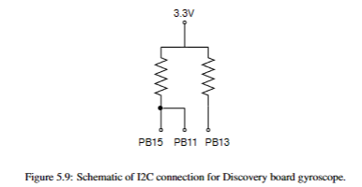

**Pin Connections PCB to Motor**

| PCB | Motor Wire(color) |
| --- | --- |
| RED | Red |
| BLK | Black |
| GND | Green |
| 5V | Blue |
| ENCA | Yellow |
| ENCB | White |



PCB(Motor Driver)

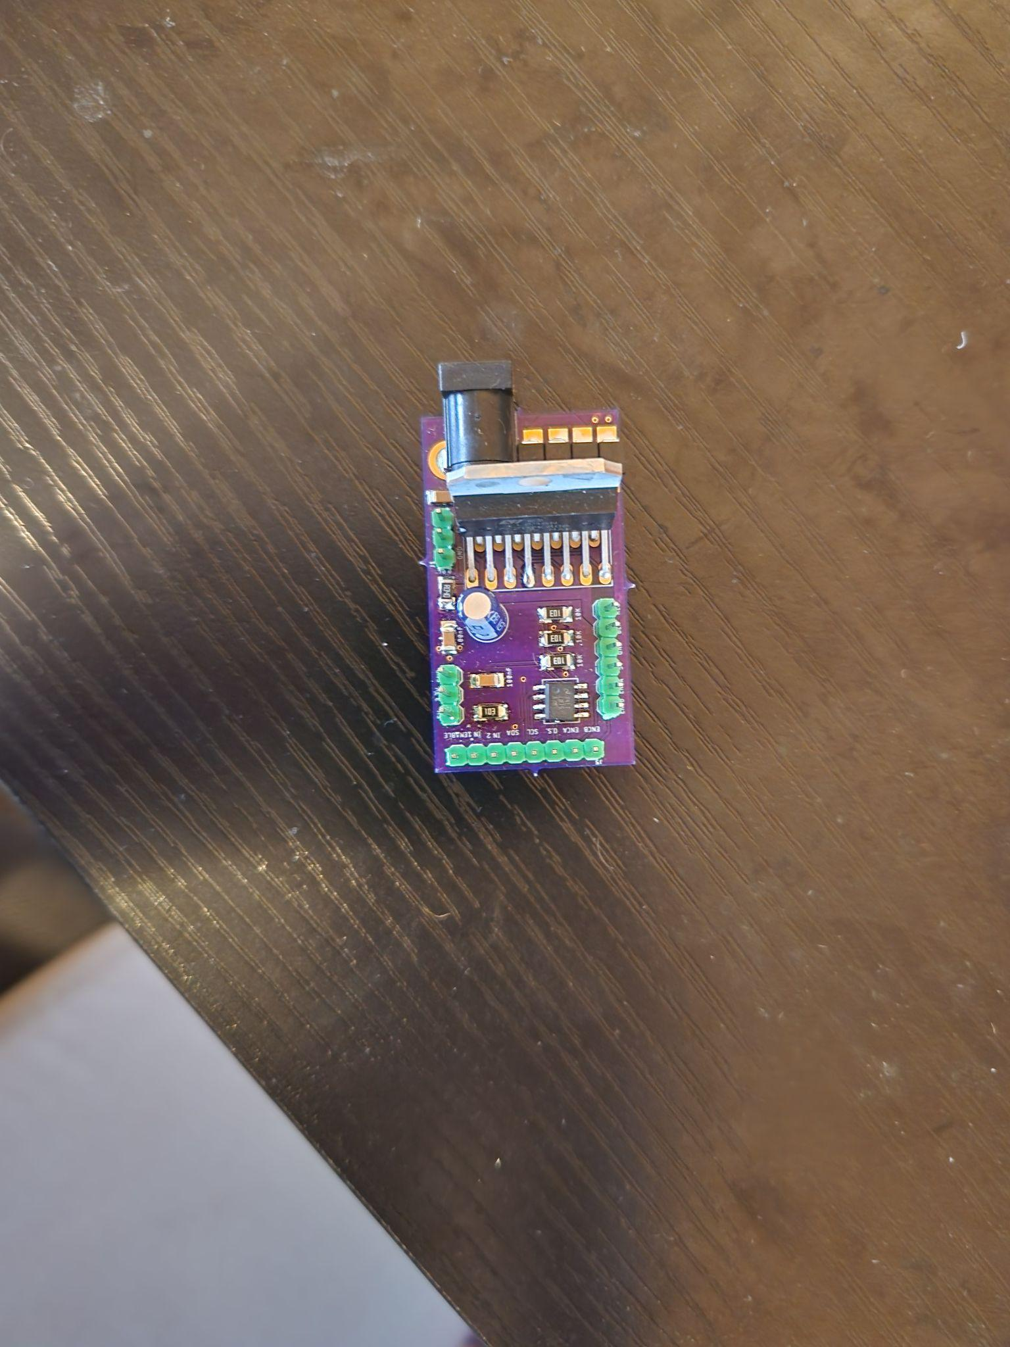

STM32F072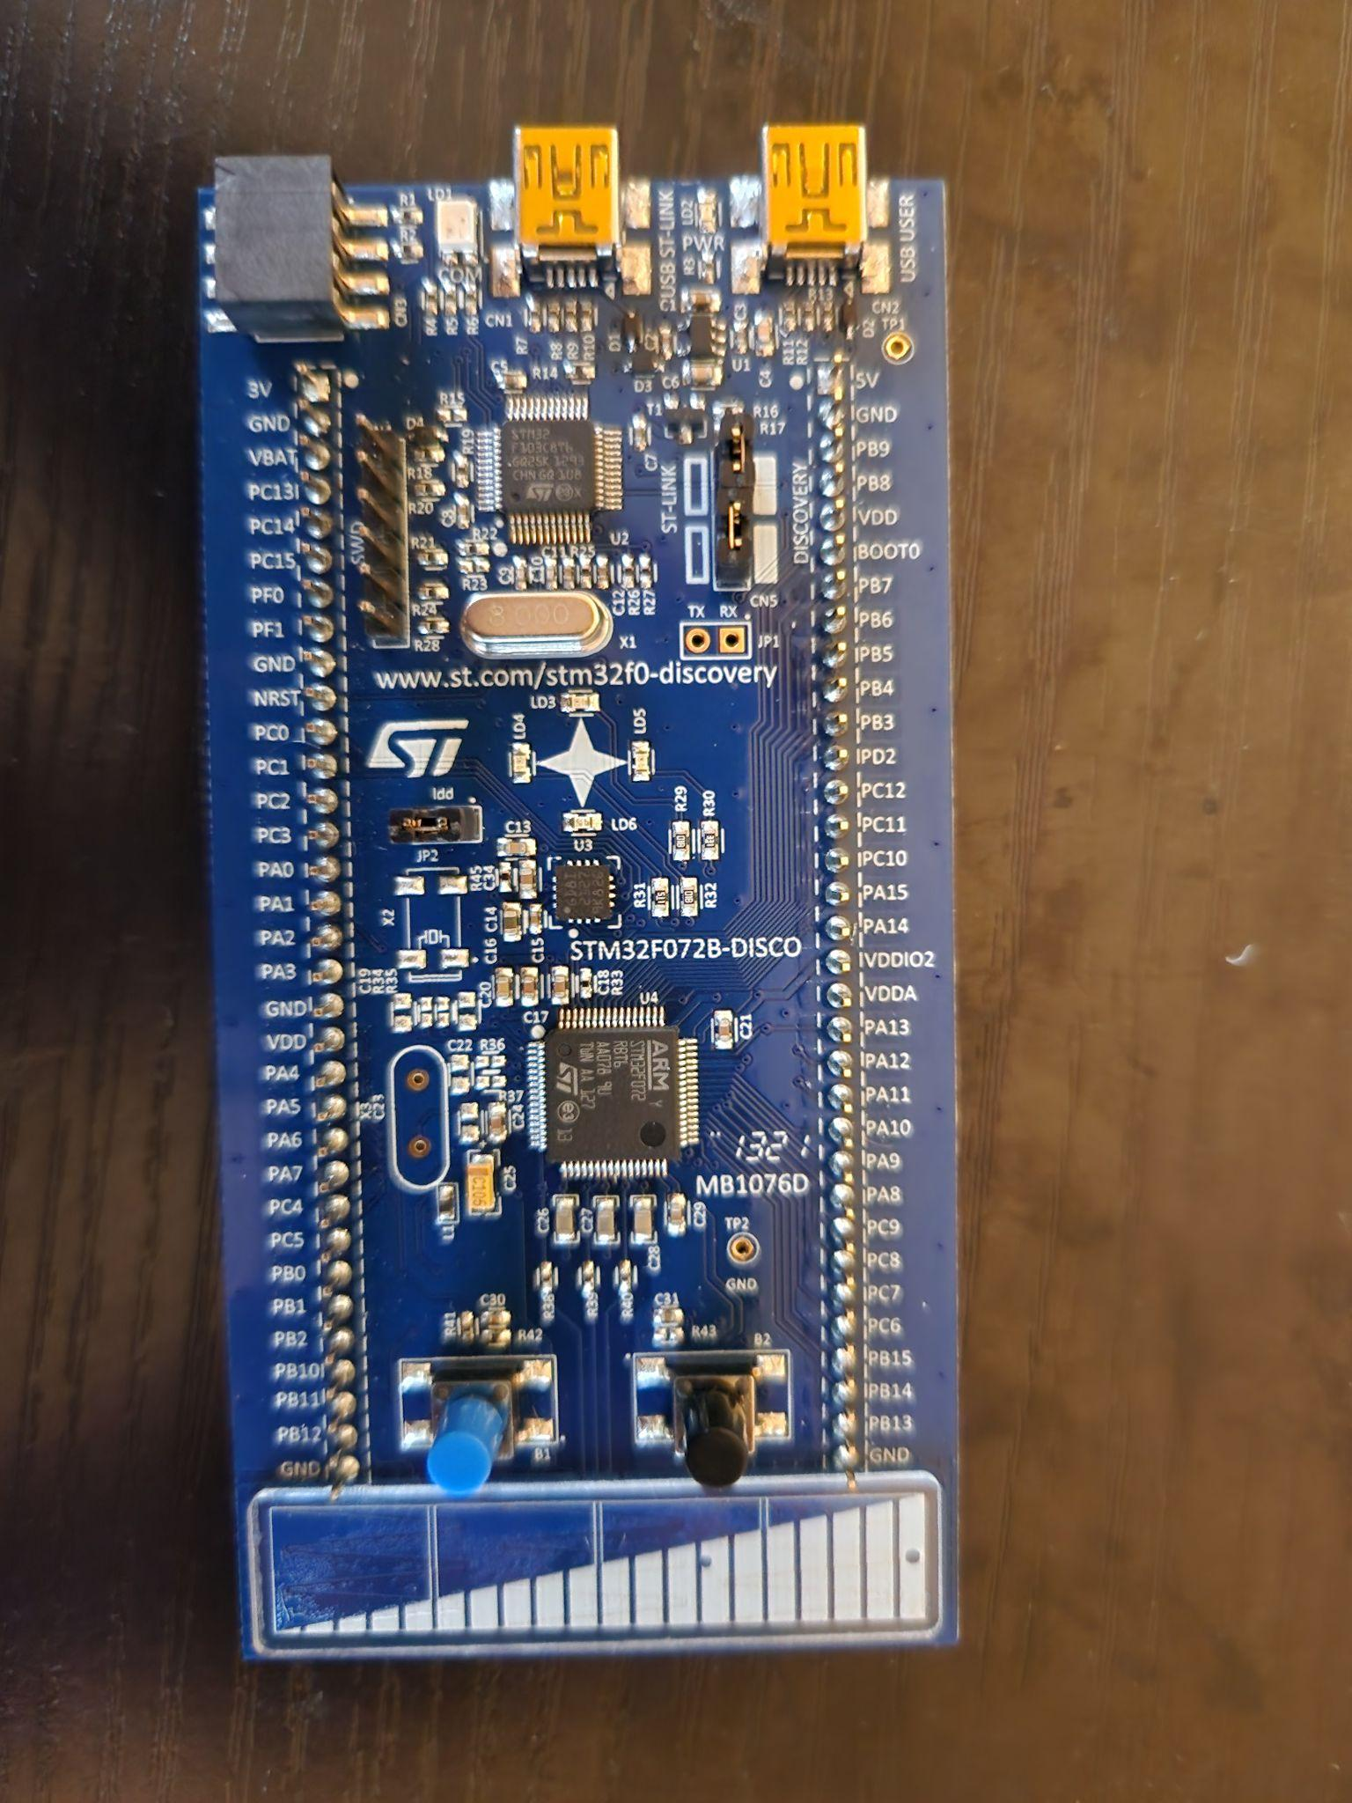

Everything Connected together before housing

