Jesse-James Black

Assignment 1

Topics 443

Questions 2

1. What do you expect to happen if an IF neuron is constantly fed a very low input current? An LIF neuron?

A IF neuron spikes once it hits a certain threshold in an integrate and fire model. The input current does not reset after each firing. With a constant very low input current the IF neuron would fire at a regular interval after the current builds up.

A LIF model a neuron will not spike until a certain threshold is met. This is found by subtracting the voltage from the input and dividing the resistance. If the very low current does not exceed this threshold the neuron will not spike.

1. What do you expect to happen if an IF neuron is constantly fed a larger input current? An LIF neuron?

A IF neuron spikes once it hits a certain threshold in an integrate and fire model. The input current does not reset after each firing. With a constant large input current, the voltage buildup would reach the threshold more regularly than with a very low input current. The IF neuron would fire at a faster regular interval.

A LIF model a neuron will not spike until a certain threshold is met. This is found by subtracting the voltage from the input and dividing the resistance. If the larger input current does not exceed this threshold the neuron will not spike.

1. What are the limitations of an LIF neuron?

Since the LIF model resets the voltage after each spike to the same value and restarts the integration process, no memory is kept beyond the most recent spike. The LIF neuron cannot adapt because of this. In order to mimic adaption past spikes would need to add up.

Programming 3

1. Simulate an LIF neuron with different input currents and plot the membrane potential, showing (a) potential decay over time and (b) spiking behavior.

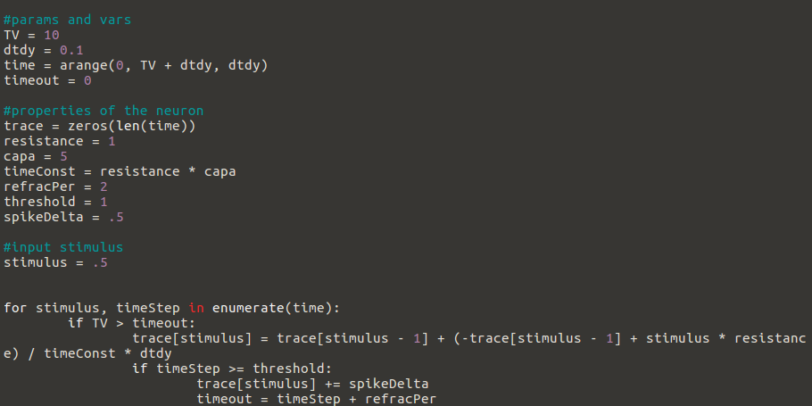

1. Plot the firing rate as a function of the input current.

0.5 stimulus

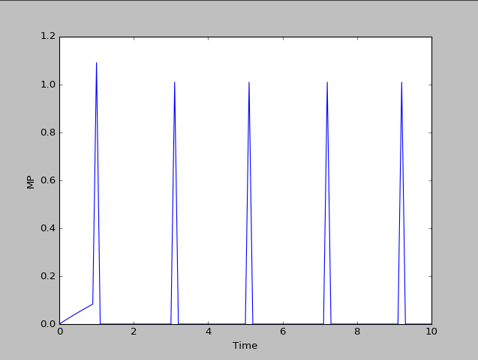

3.0 stimulus

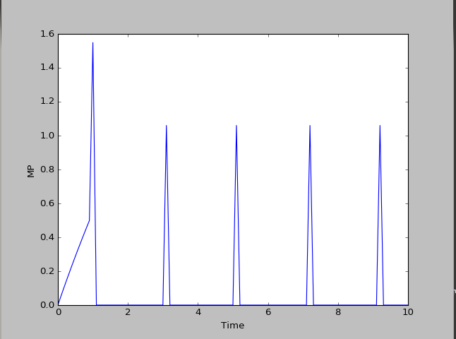

1. What happens to the firing rate as you continue to increase the input current? Why?

As you continue to increase the input current the firing rate continues to increase up to a certain point. The membrane potential increases, the threshold would be reached faster. Since the neuron fires when the threshold current has been reached, as the input current is increased so should the threshold be reached at the same rate as the current increase.

If the current is constant the neuron will show a sharper spike in a regular repeated pattern, if the current varies over time, the neuron will build up to a spike which will show a slower, more “bumpy” increase to the spike. The constant current shows a steady build up then spike, the varied shows a rougher build up

1. Simulate a neuron using the Izhikevich model.

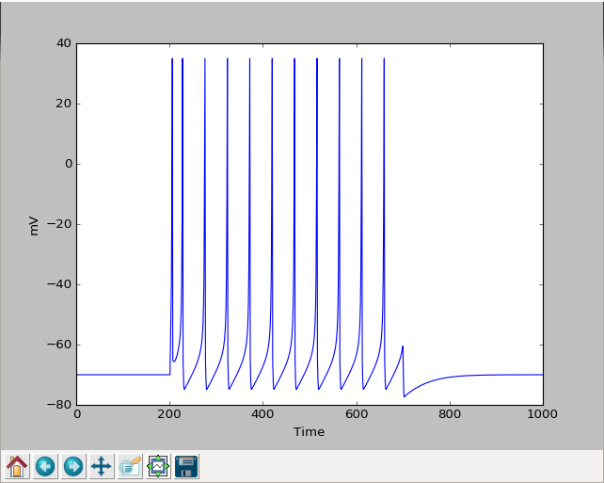

1. Simulate a neuron using the Hodgkin-Huxley model.

