Part A

Tuning antinotch
Gain = 5, 0.12668531
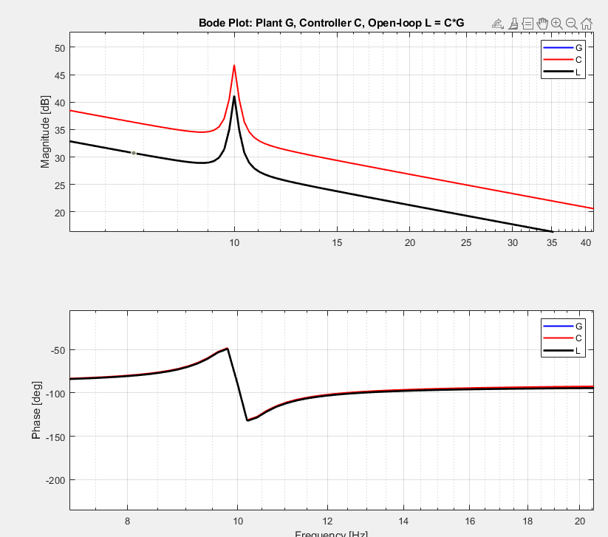
Gain = 10, e_total = 0.01610821 um
