CS 340 Project Two README
Grazioso Salvare Rescue Animal Dashboard
Jesse Carles
Southern New Hampshire University
CS 340 - Client/Server Development
Instructor: Tad Kellogg
October 12, 2026

About the Project
Grazioso Salvare is a rescue-animal training organization that needs a fast way to identify dogs that match specific search-and-rescue profiles. This project completes a full-stack dashboard that connects a MongoDB animal-shelter database to an interactive Python web application. The dashboard allows a user to view shelter records, apply rescue-type filters, inspect breed distributions, and view the location of a selected animal on a map.

Purpose and Required Functionality
The purpose of the dashboard is to turn the Austin Animal Center Outcomes data into an interface that is easier for Grazioso Salvare to use when evaluating rescue candidates. The final application provides the following required functionality:
• An unfiltered interactive data table for Austin Animal Center Outcomes records.
• Rescue filters for Water Rescue, Mountain or Wilderness Rescue, Disaster or Individual Tracking, and Reset.
• Database queries executed through the reusable AnimalShelter CRUD Python module.
• A dynamic breed-distribution pie chart that responds to the current filtered data.
• A Dash Leaflet geolocation map that displays the selected animal record.
• Single-row selection, pagination, sorting, and native table filtering.
• Grazioso Salvare branding and a unique student identifier on the dashboard.

Application Architecture
The dashboard follows the Model-View-Controller (MVC) design pattern. MongoDB is the model because it stores the animal records. Dash components are the view because they display the filter controls, data table, pie chart, and map. The Python callbacks and the reusable CRUD module act as the controller by translating user selections into database queries and sending the results back to the interface.

Tools and Rationale
Tool | Purpose / Rationale
MongoDB | Stores the shelter data as flexible documents and supports query operators such as $in, $gte, and $lte for rescue filtering.
PyMongo | Provides the Python driver used by the CRUD module to connect to MongoDB and execute queries.
Python | Provides the application logic, reusable CRUD class, callbacks, and data-processing code.
Dash / JupyterDash | Provides the client-facing web framework and callback structure for the interactive dashboard in Codio.
Pandas | Converts MongoDB query results into DataFrames so the records can be used by the table and visualizations.
Plotly Express | Creates the dynamic breed-distribution pie chart.
Dash Leaflet | Creates the geolocation map and marker for the selected animal.
Codio / Jupyter Lab | Provides the course development environment used to run, test, and capture the dashboard.

Filtering Logic
The filter controls call the CRUD module with MongoDB queries that match the rescue profiles supplied for the project. Reset uses an empty query so that all available records are returned.

Water Rescue
The Water Rescue query searches for dogs from the preferred water-rescue breeds, requires an intact female, and limits age to 26 through 156 weeks. The breed list includes Labrador Retriever Mix, Chesapeake Bay Retriever, and Newfoundland.

Mountain or Wilderness Rescue
The Mountain or Wilderness Rescue query searches for preferred breeds such as German Shepherd, Alaskan Malamute, Old English Sheepdog, Siberian Husky, and Rottweiler. It requires an intact male and an age from 26 through 156 weeks.

Disaster or Individual Tracking
The Disaster or Individual Tracking query searches for Doberman Pinscher, German Shepherd, Golden Retriever, Bloodhound, and Rottweiler. The preferred sex is intact male, and the age range is 20 through 300 weeks.

Dashboard Functionality and Testing
The dashboard was executed in Codio and tested in each required state. The screenshots on the following pages show the logo and student identifier, the interactive filter controls, the data table, the breed chart, and the geolocation map updating together.

Starting / Reset State
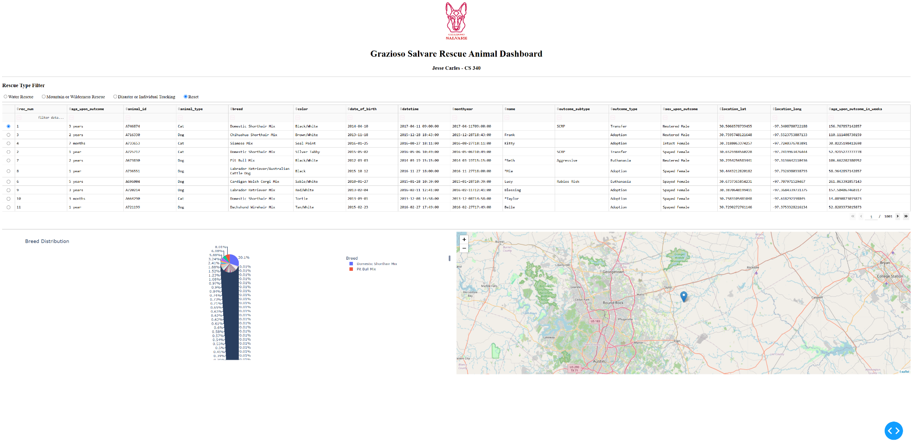

Water Rescue
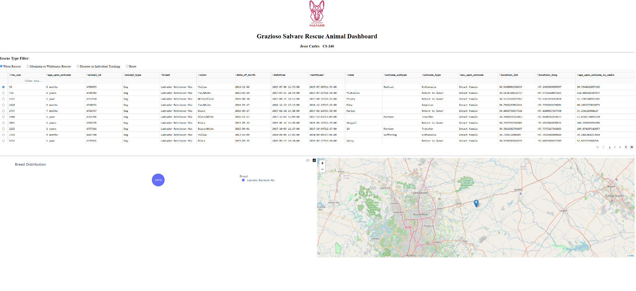

Mountain or Wilderness Rescue
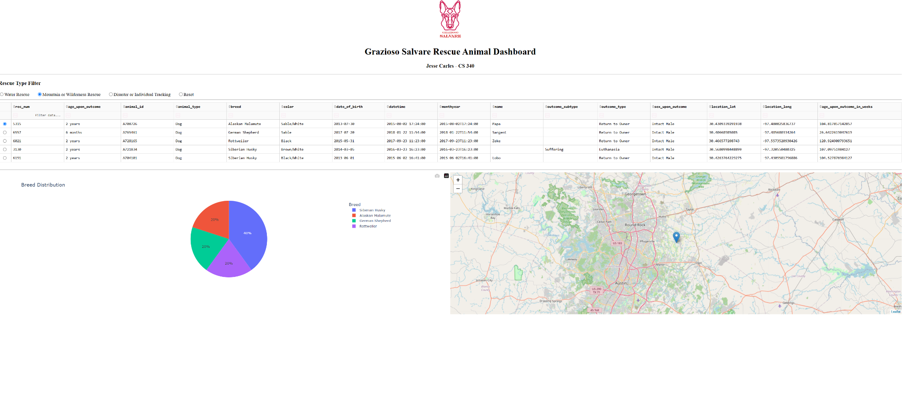

Disaster or Individual Tracking
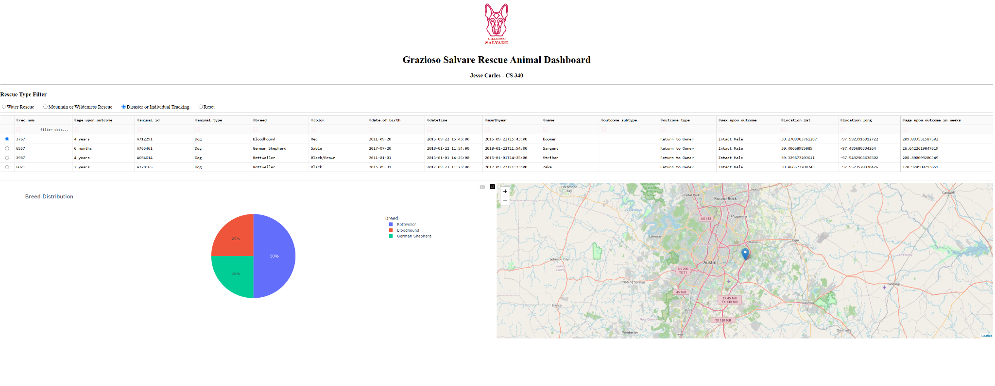

Reset After Testing
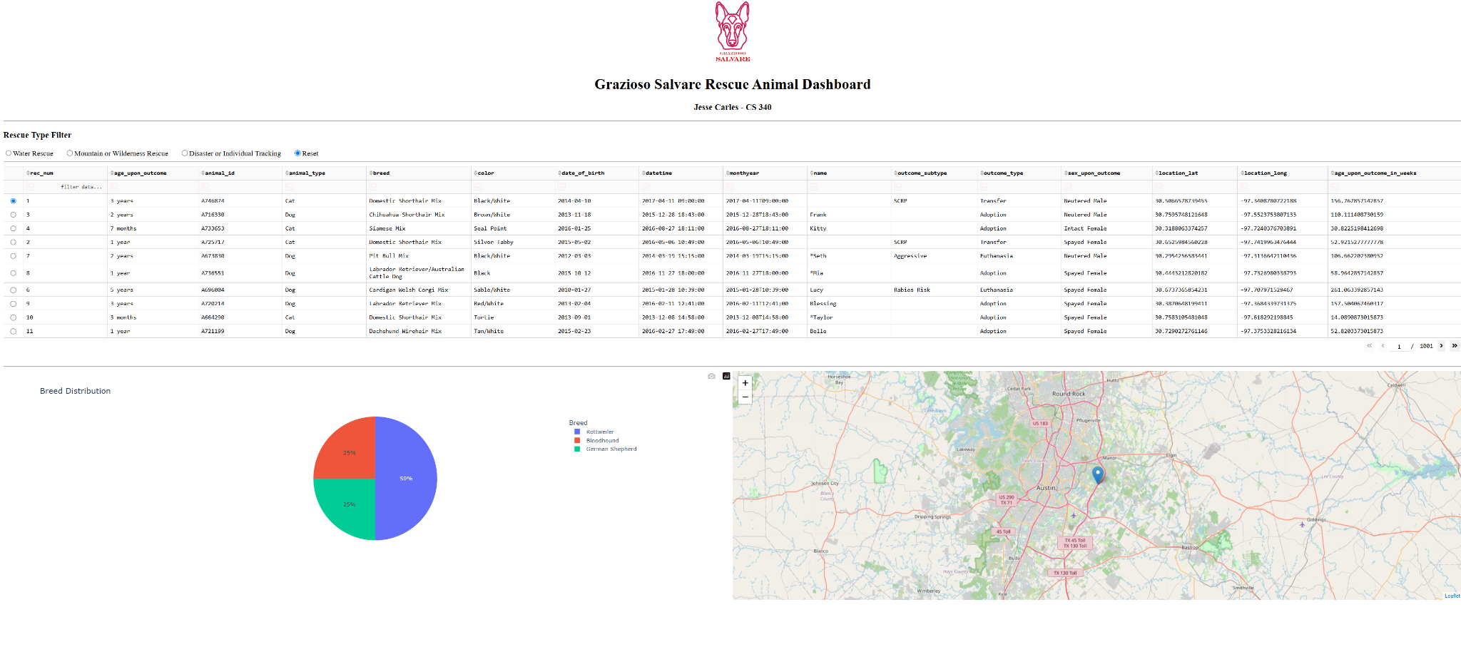

Reproducing the Project
The following steps reproduce the application in the Codio environment:
1. Place ProjectTwoDashboard.ipynb, CRUD_Python_Module.py, and Grazioso Salvare Logo.png in the same Codio code_files directory.
2. Confirm the Austin Animal Center data is available in the aac database and the animals collection.
3. Confirm the aacuser MongoDB account has the required access to the aac database.
4. Open ProjectTwoDashboard.ipynb in Jupyter Lab.
5. Import AnimalShelter from CRUD_Python_Module and instantiate the class with the database credentials.
6. Run an empty read query to populate the initial DataFrame and data table.
7. Run the notebook cell to launch the JupyterDash application through the Codio proxy.
8. Open the Dash URL and verify the Reset state.
9. Test Water Rescue, Mountain or Wilderness Rescue, Disaster or Individual Tracking, and Reset while confirming that the table, chart, and map update together.
10. Save the completed IPYNB and include it with CRUD_Python_Module.py in the Project Two code ZIP.

Challenges and Resolutions
One challenge was launching Dash from Codio. A normal localhost address such as 127.0.0.1:8050 is not directly reachable from the local browser. The issue was resolved by configuring JupyterDash for Codio and launching the application through the external Codio proxy URL.
A second challenge was displaying MongoDB records in Dash. MongoDB returns an _id field containing an ObjectId, which is not directly serializable for the DataTable. The _id column was removed from the Pandas DataFrame before passing records to the dashboard.
Another integration issue occurs when a filter changes the available table rows. The map callback was written to default to the first available row when the previous selection is no longer valid, which keeps the map synchronized with the filtered data.

Project Files
• ProjectTwoDashboard.ipynb - final dashboard source code and callbacks.
• CRUD_Python_Module.py - reusable MongoDB CRUD class developed in Project One.
• Grazioso Salvare Logo.png - dashboard branding image.
• CS340_ProjectTwo_README_Jesse_Carles.docx - project documentation and reproduction instructions.

References and Resources
• Austin Animal Center. (2020). Austin Animal Center Outcomes [Data set]. City of Austin, Texas Open Data Portal.
• MongoDB / PyMongo documentation - database connectivity and querying.
• Dash documentation - layout, core components, callbacks, and DataTable behavior.
• Plotly Python documentation - pie chart implementation.
• Dash Leaflet documentation - interactive geolocation mapping.
• Southern New Hampshire University CS 340 course materials and dashboard specifications.

